Nutritional composition, Technology and Processing technique of Finger millet (Eleusine coracana L.)
Hema Deupa^{1*}; Priyanka Shankar²
¹Department of Food and Nutrition, Babasaheb Bhimrao Ambedkar University, Lucknow, Uttar Pradesh, India; Email- hemadeopaa@gmail.com
²Department of Human Development and Family Studies, Babasaheb Bhimrao Ambedkar University, Lucknow, Uttar Pradesh, India
Abstract
Finger millet, commonly known as ragi, is an ancient millet of India (approx. 2300BC). In compared to other cereals and millets, finger millets contain higher amount of calcium, potassium, dietary fiber, and traces of micronutrients. Despite having a rich nutritional profile, studies reveal that urban populations consume less finger millet. The presence of antinutritional factors (tannins, phytate, oxalate, and phenols) inhibit maximum utilization of finger millet, however, their negative impact can be reduced by processing techniques such as malting, milling, germination/fermentation, popping, and decortication, which are used in the preparation of culinary food products. Pasta, noodles, vermicelli, and bread are some of the new products made out of millet that are gluten-free and safe for celiac disease patients. Therefore, this book chapter emphasizes the nutritive composition of finger millet and its anti-nutritional properties, post-harvesting, and processing technique.
Introduction
Finger millet/ragi (Eleusine coracana L.) is one of the oldest crops grown in India. In ancient Sanskrit literature, finger millet is referred to as “nrtta-konkdaka” which denotes “Dancing grain”, and also “rajika” or “markataka” (Achaya, 2009). The early origin of finger millet was reported from Hallur (archaeological site) in Karnataka, India near about 2300 BC (Singh, 2008). The origin of finger millet has been debated widely, although the archeological study carried out in India and outside report that from the origin, it was grown in Africa and provides linguistic evidence for “ragi” from the root term-degi in numerous Bantu languages of northern Malawi and southern Tanzania and its other species from Indian subcontinent (Fuller 2002, 2003).
Finger millet was well cultivated and harvested in many different states of India, popularly known as “nanchi” in the part of Maharashtra, and “umi” in Bihar, etc. The grains were slightly roasted (sometimes sprouted or dried), grounded, and sieved. The pinkish color flour was eaten as gruel or ball, and at times sweetened and salted. It was a popular weaning food (Achaya, 2009). In Tamil literature Sangam (600BC-200AD), “Purananuru” specify the process of drying, dehusking, and cooking of finger millet.
Structural composition of finger millet
The three primary components of the millet kernel are the seed coat, embryo and the endosperm. Finger millets come in a variety of colors such as white, tan, red, yellow, or brown; however, red millets are most widely cultivated. The outermost covering i.e., the pericarp layer is of little importance. The testa or seed coat has multiple layers, which is unique in association with pearl millet, sorghum, foxtail, and proso millet (FAO, 1995) and may be a reason behind the high fiber content of finger millet. The seed coat is closely attached to the aleurone layer and starchy endosperm, which are divided into two (corneous and floury) regions.
The corneous endosperm are compactly packed starch granules present inside the cell walls and floury endosperm are roughly packed starch granules (McDonough et al., 1986). The size of starch granules varies in different regions of finger millet kernel ranging from 3 to 21mm in comparison to proso and pearl millet (Serna-Saldiver et al., 1994). The floury starch granules have a more enormous structure than corneous endosperm and therefore are more susceptible to enzymatic digestion. However, more research is required to understand the enzyme susceptibility of starch in the corneous and floury endosperm regions of finger millet separately.
Typically, finger millet is processed with the seed coat (high in micronutrients and dietary fiber) to develop flour and the whole meal is used in the preparation of a variety of culinary products. The seed coat layers contain certain anti-nutritional factors tannins, phytates, cyanide, saponins, oxalate, and polyphenols which contribute to astringent flavor in its products and causing chelation of minerals in the gastrointestinal tract, resulting in micronutrient loss (Harris et al., 1978). Pre-treatment such as boiling, soaking, roasting, parboiling, germination, fermentation, decortication, extrusion cooking, and milling can reduce the amount of anti-nutritional components to an acceptable level. This underutilized crop can be turned into a variety of traditional value-added and commercial food products by processing techniques.
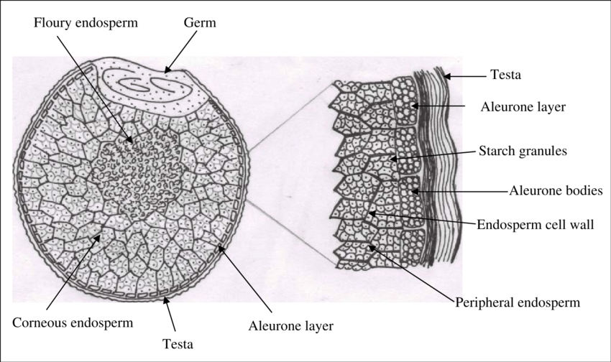
Figure1: Shows the structural diagram of finger millet (Source: https://ir.cftri.res.in/9955/ )

Anti-nutritional factors
Finger millet has the highest content of tannin (0.04-3.47%) compared to any other millet (Subhash et al., 2015). The content of tannin varies across finger millet in which the brown variety has 0.61% while the white variety has 0.05%. Excess tannin reduces iron levels in the diet, lowering the nutritional profile of grains and it further reduces protein digestibility, growth rate, feed intake, and net metabolic energy in an animal model (Gull et al., 2016). Tannins also had a negative impact on microbial enzyme activities, as well as gastrointestinal digestion and cellulose activity. Tannins have also been identified as an antioxidant as it protects our body against cell damage and further neutralize toxins. The phytate content in finger millet is 0.48%, it is a phosphorus compound that inhibits the absorption of calcium and zinc in the small intestine (Doherty et al., 1982).
Furthermore, oxalate (0.27%), an anti-nutritional component, interferes with peptic digestion by forming complexes with protein and interfering with calcium and magnesium absorption (Subhash et al., 2015). Kidney stones are also caused by oxalate. Healthy people can safely consume oxalate-rich foods; however, people who have impaired gastrointestinal function must limit their intake.
Due to its greater binding ability, phytate forms complex compounds with multivalent cations and protein molecules. Saponins (0.36%) are also found in finger millet and produce hemolytic (destruction of red blood cells) action. It affects the central nervous system, digestive system, and cardiovascular disease (CVD). It also reduces protein digestion and absorption in the intestine. Saponins reduces the risk of cancer and help to control cholesterol and blood glucose level after meal (Gull et al., 2016). Further, oxalate (0.27%) interferes with calcium & magnesium absorption and forms protein complexes that inhibit peptic acid digestion (Subhash et al., 2015). Oxalate also results in kidney stones. Healthy people can safely consume oxalate-rich food; however, those with altered gastrointestinal function must limit their intake. Oxalate levels in the human diet are limited to 50mg per day.
Nutritional composition of Finger millet
Finger millet is high in nutritive value, with 6-8% of protein, 65-75% of starch, 1-1.7% fat, 2-2.5% minerals, and 18-20% of dietary fiber. In terms of calcium, fiber, and some micronutrients, finger millet is superior to maize, sorghum, rice, and wheat (Shobana et al., 2009).
- Carbohydrates
The carbohydrate present in finger millet consists of starch (65.5%) & non-starch polysaccharides, free sugars (1.04%), and dietary fiber (11.5%) (Gopalan et al., 2009). Some studies report few varieties of finger millet have 59.5-61.2% starch,1.4-1.8% cellulose, 6.2-7.2% pentosans, and 0.4-0.6% lignins (Wankhede et al., 1979a). The dietary fiber content of finger millet is 11.5% which is more than that of polished rice, brown rice, foxtail, kodo, little, and barnyard millet. Although, the fiber content of finger millet is similar to that of wheat and pearl millet. Overall, the carbohydrate content of finger millet is similar to wheat but lower in comparison to polished rice. The starch in finger millet is made up of amylose and amylopectin, wherein the amylose content is lower (16%) (Wankhede et al., 1979b) in association with proso (28.2%), sorghum (24.0%), pearl (21.0%), foxtail (17.5%), and kodo millet (24.0%).

- Proteins
The protein content of finger millet varies widely in prolamin has major portions (Virupaksha et al., 1975). In general, millets and cereals have a lesser amount of Lysine in respect to legumes and animal sources (ICMR, 2010). Albumin and globulin protein are composed of several essential amino acids, though prolamin contains a higher portion of proline, valine, isoleucine, leucine, glutamic acid, and phenylalanine but lower lysine, arginine, and glycine. The chemical score (a measure of protein quality) of finger millet is 52 in comparison to pearl millet (63) and sorghum (37) (FAO, 1995). Methionine and cystine content of finger millets are also higher in association with milled rice. The anti-nutritional activity of grain such as protein digestibility is affected by tannin. Although, Subrahmanyan et al., (1955) stated intake of finger millet and pulses in diet can sufficiently regulate positive nitrogen (10.4%), calcium (3.0%), and phosphorus (8.7%) balance in adults. Other studies also suggest that consumption of finger millet and lysine or leaf protein (lucerne) can elevate protein digestibility, nitrogen retention, and overall nutritional status among children (Doraiswamy et al., 1969).

Table 1: Nutritive composition of various millets (all values as per 100g of edible portion)

Nutrients | Finger millet | Pearl millet | Foxtail millet | Porso millet | Wheat | Rice (white, milled) | Rice (brown, milled) | Corn grain | Sorghum | Oats | Barley (pearled raw)
Proximate composition
Energy (kcal) | 336 | 361 | 331 | 341 | 346 | 345 | 362 | 365 | 329 | 389 | 352
Protein (g) | 7.7 | 11.6 | 12.3 | 12.5 | 11.8 | 6.8 | 7.5 | 9.4 | 10.6 | 16.9 | 9.9
Carbohydrate (g) | 72.6 | 67.5 | 60.9 | 70.4 | 71.2 | 78.2 | 76.2 | 74.3 | 72.1 | 66.3 | 77.7
Total dietary fiber (g) | 11.5 | 11.3 | 2.4 | - | 12.5 | 4.1 | 3.4 | 7.3 | 6.7 | 10.6 | 15.6
Fat (g) | 1.5 | 5 | 4.3 | 1.1 | 1.5 | 0.5 | 2.7 | 4.7 | 3.5 | 6.9 | 1.2
Moisture (g) | 13.1 | 12.4 | 11.2 | 11.9 | 12.8 | 13.7 | 12.4 | 10.4 | 12.4 | 8.2 | 10.4
Minerals (g) | 2.7 | 2.3 | 3.3 | 1.9 | 1.5 | 0.6 | - | - | 1.6 | - | -
Vitamins
Thiamine (mg) | 0.42 | 0.33 | 0.59 | 0.2 | 0.45 | 0.06 | 0.41 | 0.39 | 0.33 | 0.76 | 0.19
Riboflavin (mg) | 0.19 | 0.25 | 0.11 | 0.18 | 0.17 | 0.06 | 0.04 | 0.2 | 0.096 | 0.14 | 0.11
Niacin (mg) | 1.1 | 2.3 | 3.2 | 2.3 | 5.5 | 1.9 | 4.3 | 3.6 | 3.7 | 0.96 | 4.6
Total Folic acid (µg) | 18.3 | 45.5 | 15 | - | 36.6 | 8 | 20 | - | 20 | 56 | 23
Vitamin E (mg) | 22 | - | - | - | - | - | - | - | 0.5 | - | 0.02
Source: Gopalan et al., (1999, 2004) and USDA National Database for Standard Reference, Release 28 (2016)
- Fat
The total lipids count was reported to be approx. 1.85-2.10% in seven major varieties of finger millets (Mahadevappa et al., 1978). The lipid composition is composed of 70-72% neutral lipid, primarily triglycerides, with some traces of sterols, glycolipids (10-12%), and phospholipids (5-6%). In general, finger millet lipid content comprises 8-27% of linoleic acid, 46 to 62% oleic acid, 20 to 35% palmitic, and trace amounts of linolenic acid. The fat content of finger millet is lower than that of pearl, barnyard, little, and foxtail millet, and therefore is one of the most promising contributory factors in maintaining the finger millet’s storage and shelf life.

- Micronutrients
Finger millet is an excellent source of calcium 334mg % in comparison to cereals and millet sources, and contains 283mg % of phosphorus and 3.9mg % of iron (Gopalan et al., 2009), and other trace elements. The potassium content (408mg %) in finger millet is higher than any other cereal and millet. “Hamsa” variety of finger millet has reported an unexceptional source of calcium content i.e., 660mg% (Umapathy et al., 1976). The phytic acid content is inferior to that of common millet & foxtail millet and the values vary across a different variety of finger millet (0.45 to 0.49g %). Some studies report that roughly ~49% of total calcium content is present in the husk of the finger millet. The bioavailability of minerals increases by germination and fermentation also it lowers the phytate content to around 60% in finger millet. Bio-accessibility of minerals (iron, zinc, and magnesium) can also increase by malting (Platel et al., 2010). Decortication (removing fibrous seed coat of grain) reduces the total mineral constituent but elevates the bio-accessibility of iron, calcium, and zinc, however, popping of finger millet lowers the bio-accessibility of calcium but inversely increases that of iron and zinc.
Phytochemical or phytonutrients
The phenolic content of finger millets varies with variety, with the brown variety having a higher phenolic content than the white variety (Chethan et al., 2007a). In general, the seed coat of finger millet contains various phytochemical that have numerous health benefits. Finger millet is rich in phenolic compounds, especially in both free and bounded forms (Subba et al., 2002). Caffeic acid lowers fasting glucose levels and plasma glucose levels in an intravenous glucose tolerance test in a mouse model. Furthermore, catechin improves glucose tolerance while quercitin limit glucose transport in the transfected oocyte model and glucose absorption in animal model (Matsumoto et al., 1993 & Scalbert et al., 2005). Although, the bioavailability of phenolic compounds based on finger millet is lesser, and therefore it is necessary to investigate more literature based on in vivo antioxidant activity, and long-term consequences of finger millet phenolics in human models.
Post harvesting operation
Finger millet is harvested primarily between October to November. Crop harvesting is done by two methods-
- Harvesting only panicles (ear heads): When the crops are mature, the panicles are cut with a sickle, leaving the plant stalks standing in the field. The operation is carried out all at once or at different intervals based on maturity. The gathered panicles are collected in a container or basket before being piled in an appropriate location. The panicles are staked and sun-dried for a week to a few months, as the heat produced within the heap aids in the easy separation of millets during the threshing process.
- Harvesting of stalks and panicles: This is the most common form of harvesting. In which harvested stalks are stretched out in rows for sun drying in the field for a few days. They are hurried and staked near the threshing area after drying. On rainy days the heap is stacked in the bundle form in the closed line and slanting position, covered with dried straw to keep it from dampening. After some days the covering is removed and dried in the sun for 1 to 2 days before staking in the field.
- Threshing of grains: The process of separating grain from panicles is done in the morning hours by spreading stalk or panicle, and threshing begins around 10 o’clock. Generally, threshing is done using bullocks (4 to 5 in number) trampling or with a stone roller pushed by a pair of bullocks. Bamboo sticks are used for small-scale threshing, whereas in large-scale production tractors are used by farmers for the separation of grains.
- Storage of grains: Before storing the grain, finger millets are sun dry. Farmers use different types of structures for the storage of finger millet. A closed structure is mostly preferred for storing. At present time nylon woven sacs or gunny bags are used by farmers for storage, although the duration of storage varies vividly in different regions.
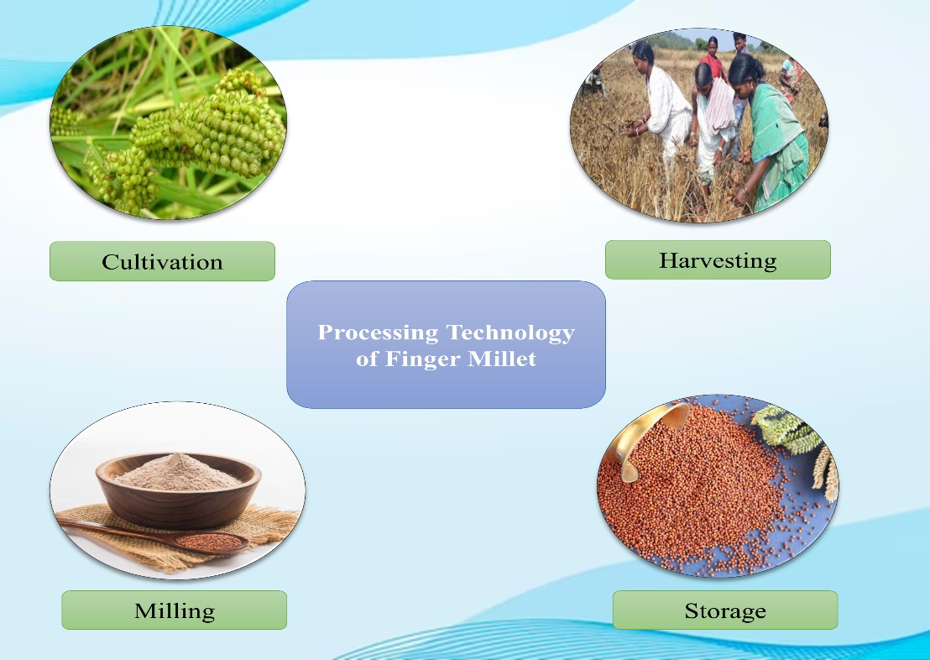
Figure 2: Shows the processing of finger millet grains
Processing of finger millet
Milling
Finger millets are usually crushed and ground into flour for the preparation of culinary food products. Initially, the grains are cleaned to eliminate foreign materials such as stalks, stones, chaff, brick, etc. They are then sent to friction mills to remove glumes (non-edible cellulose parts) and crushed. Typically, stone mills, iron discs, or emery coated discs are used for pulverization. Decortication or pearling is sometime used for dehusking of finger millets which results in grinding of the endosperm and seed coat. As a result, finger millets are often pulverized along the seed to produce a whole meal. Centrifugal shellers are also utilized for dehulling and decortication of millets.
Decortication
The decortication or “debranning” is a process of removal of seed pods or outer covering so that only the kernel remains after processing. Malleshi et al., (2006) stated that decortication is the most modern method used for producing finger millet. This method is applied in all cereals, except finger millet to the seed coat is intactly linked to the delicate endosperm. Hydrothermal processing i.e., hydration, steaming, and drying are utilized to decorticate finger millet, which strengthens the endosperm and allows it to tolerate mechanical pressure. Finger millet can be cooked as rice after decortication.
Malting
Malting is a controlled process of grain germination in moist air that results in the mobilization of enzymes (amylase, proteases, and others) that hydrolyze and change the structural component. Malting is a typical practice for specialty foods. This process improves the bioavailability of carbohydrates, protein, minerals, and some B vitamins, while inversely decreasing its anti-nutritional factor. Malting begins with the soaking of seeds in water which facilitates sprouting, followed by drying in a kiln or firing pottery. Finally, the rootlets are manually separated from the finger millet grain by hand rubbing. All these processes have an impact on the quality of malted products. Germination is the most important step in the malting process because it releases a hydrolytic enzyme that causes endosperm alteration and improves the nutritional property of grains. Malting of finger millet has been effectively used in a variety of commodities including newborn food, weaning food, confectionary items, and milk-based beverage industry (Malleshi, 2007).
Popping
It is a common traditional method for making popped millet flour. In this procedure, finger millet is mixed with an additional 3-5% water to improve the moisture content and left to temper for 2-4 hours before popping in the sand at roughly 230°C under high temperature and short time (HTST). The Millard reaction between sugars and amino acids produces a highly pleasant scent. Popped finger millet is a ready-to-eat food, but it can also be ground and blended with protein-rich foods to create supplementary diets (Premavalli et al., 2003). The popping process, however, can contaminate the food product with grit when heating, affecting the eating quality.
It is a common traditional method for making popped millet flour. In this process, finger millet is mixed with an additional 3-5% water to improve the moisture content and left to temper for 2-4 hours before popping is done under high temperature and short time (HTST) by brisking in the sand at roughly 230°C. A highly desirable aroma is produced due to Millard reaction between sugars and amino acids. Popped finger millet is a ready-to-eat food, but it can also be grounded and blended with protein-rich foods to develop supplementary foods (Premavalli et al., 2003). The popping method, however, can contaminate the food product with grit or sand while heating and can affect the eating quality. To address this constraint, air popping can be significantly employed, however, it lacks the distinct aroma that was produced previously by sand.
Conclusion
Consumption of whole grains is associated with lowering the incidence of cardiovascular disease and type 2 diabetes; thus, consumption of whole-grain finger millets may have a possible function in the prevention of various health conditions. Finger millet-based products usually lower the glycemic index (GI) in combination with vegetables and pulses may help in controlling chronic diseases in particular. Further, different processing technologies have been found and utilized in enhancing the nutritional features of millets. However, the consumption of millet grains is still a taboo among rural communities of our population, due to the unavailability of processing tools and techniques. As a result, this book chapter provides scientific justification for the use of finger millet as a therapeutic and health-promoting food.
In addition, recognizing the massive potential of millets to empower livelihoods, the socio-economic income of farmers, food, and nutritional security across the world, the Government of India (GoI) has promoted millets. Millets were rebranded as “Nutri Cereals” in April 2018, and the following year was declared the National Year of Millets, to increase millet demand and supply. When a proposal was moved by India on 5th March 2021 and supported by 72 countries, the United Nations declared 2023 as the International Year of Millet (IYM). It is necessary to give gratitude and honour to the traditional wisdom of humanity. The Department of Agriculture and Farmers Welfare has come up with muti-stakeholders from all the central government ministries, state/ union territories, farmers, retail businesses, start-ups, hotels, etc. to accomplish the objective of IYM 2023 and popularising Indian millets worldwide. Ministries from the state and central government have also focused on carrying out several activities to promote and aware the consumers as well as cultivators about the potential health benefits of millets.
Reference
Achaya, K. T. (2009). The illustrated foods of India: A-Z. Oxford University Press.
Chethan, S., & Malleshi, N. G. (2007). Finger millet polyphenols: Characterization and their nutraceutical potential. American Journal of Food Technology, 2(7), 582-592.
Doherty, C., JM, F., & LW, R. (1982). Semiautomated determination of phytate in sorghum and sorghum products. Cereal Chemistry, 59, 373-378.
Doraiswamy, T. R., Singh, N., & Daniel, V. A. (1969). Effects of supplementing ragi (Eleusine coracana) diets with lysine or leaf protein on the growth and nitrogen metabolism of children. British Journal of Nutrition, 23(4), 737-743.
Food and Agricultural Organisation (FAO) of the United Nations. (1995). Sorghum and millets in human nutrition (FAO Food and Nutrition Series, No. 27). ISBN 92-5- 103381-1.
Fuller, D. (2002). Fifty years of Archaeobotanical studies in India: Laying a Solid Foundation in (Eds. S. Settar and R. Korisettar) Indian Archaeology in Retrospect, Vol III: 247-363, Archaeology and Interactive Disciplines.
Fuller, D. Q. (2003). In K. Neumann, A. Butler & S. Kahlheber (Eds.) African crops in prehistoric South Asia: A critical review by Koln: Heinrich-Barth Institute. Food, fuel and fields. Progress in African archaeobotany (pp. 239–271).
Gopalan, C., Rama Sastri, B. V., & Balasubramanian, S. C. (2009). Nutritive value of Indian foods. National Institute of Nutrition, Hyderabad.
Gopalan, C., Ramashastri, B. V., and Balasubramanium, S. C. (2004). Nutritive Value of Indian Foods. National Institute of Nutrition, Hyderabad.
Gopalan, C., Sastri, R., and Subramaniam, B. (1999). Nutritive Values of Indian Food. National Institute of Nutrition, Hyderabad.
Gull, A., Ahmad, N. G., Prasad, K., & Kumar, P. (2016). Technological, processing and nutritional approach of finger millet (Eleusine coracana)-a mini review. J Food Process Technol, 7(593), 2.
Harris, H. B., & Burns, R. E. (1970). Influence of tannin content on preharvest seed germination in sorghum> 1. Agronomy Journal, 62(6), 835-836.
Indian Council of Medical Research (ICMR). (2010). Nutrient requirements and recommended dietary allowances for Indians. A report of the Expert Group of the Indian Council of Medical Research. National Institute of Nutrition, Hyderabad.
Mahadevappa, V. G., & Raina, P. L. (1978). Lipid profile and fatty acid composition of finger millet (Eleusine coracana). Journal of Food Science and Technology, India, 15(3), 100-102.
Malleshi N. G. (2006). Decorticated finger millet (Eleusine coracana) and process for preparation of decorticated finger millet. U.S. Patent No. 70,29,720. Washington, DC: U.S. Patent and Trademark Office.
Malleshi, N. G. (2007). Nutritional and technological features of ragi (finger millet) and processing for value addition. Food uses of small millets and avenues for further processing and value addition, 9-19.
Matsumoto, N., Ishigaki, F., Ishigaki, A., Iwashina, H., & Hara, Y. (1993). Reduction of blood glucose levels by tea catechin. Bioscience, biotechnology, and biochemistry, 57(4), 525-527.
McDonough, C. M., Rooney, L. W., & Earp, C. F. (1986). Structural characteristics of Eleusine corocana (finger millet) using scanning electron and fluorescence microscopy. Food Structure, 5(2), 9.
Platel, K., Eipeson, S. W., & Srinivasan, K. (2010). Bioaccessible mineral content of malted finger millet (Eleusine coracana), wheat (Triticum aestivum), and barley (Hordeum vulgare). Journal of Agricultural and Food Chemistry, 58(13), 8100-8103.
Premavalli, K. S., Majumdar, T. K., Madhura, C. V., & Bawa, A. S. (2003). Development of traditional products. V. Ragi based convenience mixes. Journal of food science and technology (Mysore), 40(4), 361-365.
Scalbert, A., Manach, C., Morand, C., Remesy, C., & Jimenez, L. (2005). Dietary polyphenols and the prevention of diseases. Critical reviews in food science and nutrition, 45(4), 287-306.
Serna-Saldiver, S. O., McDonough, C. M., & Rooney, L. W. (1994). The millets. In K. J. Lorenz & K. Kulp (Eds.), Hand book of cereal science and technology (pp. 271–300). New York: Marcel Dekker.
Shobana, S., Sreerama, Y. N., & Malleshi, N. G. (2009). Composition and enzyme inhibitory properties of finger millet (Eleusine coracana L.) seed coat phenolics: Mode of inhibition of α-glucosidase and pancreatic amylase. Food chemistry, 115(4), 1268-1273.
Singh, P. (2008). History of millet cultivation in India. In L. Gopal & V. C. Srivastava (Eds.), History of science, philosophy and culture in Indian civilisation, Volume V, Part I, History of Agriculture in India (up to c.1200 AD) (pp. 107–119). New Delhi: PHISPC, Centre for Studies in Civilisations. Concept Publishing Company.
Subba Rao, M. V. S. S. T., & Muralikrishna, G. (2002). Evaluation of the antioxidant properties of free and bound phenolic acids from native and malted finger millet (Ragi, Eleusine coracana Indaf-15). Journal of Agricultural and Food Chemistry, 50(4), 889-892.
Subhash, B., & Kakade, H. B. (2015). Finger Millet Processing: Review. International Journal of Agriculture Innovations and Research, 2319-1473.
Subrahmanyan, V., Narayanarao, M., Ramarao, G., & Swaminathan, M. (1955). The metabolism of nitrogen, calcium and phosphorus in human adults on a poor vegetarian diet containing ragi (Eleusine coracana). British Journal of Nutrition, 9(4), 350-357.
Umapathy, P. K., & Kulsum, A. (1976). Ragi—A poor man’s millet. Journal of the Mysore University Section A, 37, 45-48.
US Department of Agriculture, Agricultural Research Service (2016). USDA National Nutrient Database for Standard Reference. Available at: https://data.nal.usda.gov/dataset/composition-foods-raw-processed-prepared-usda-national-nutrient-database-standard-reference-release-28-0
Virupaksha, T. K., Ramachandra, G., & Nagaraju, D. (1975). Seed proteins of finger millet and their amino acid composition. Journal of the Science of Food and Agriculture, 26(8), 1237-1246.
Wankhede, D. B., Shehnaj, A., & Raghavendra Rao, M. R. (1979a). Carbohydrate composition of finger millet (Eleusine coracana) and foxtail millet (Setaria italica). Qualitas Plantarum, 28, 293-303.
Wankhede, D. B., Shehnaz, A., & Raghavendra Rao, M. R. (1979b). Preparation and physicochemical properties of starches and their fractions from finger millet (Eleusine coracana) and foxtail millet (Setaria italica). Starch‐Stärke, 31(5), 153-159.

