The Enhancement performance in full stack development

Dr. Akhil Pandey, Dr. Vishal Shrivastava ², Dr. Vibhakar Pathak ³, Er. Sangeeta Sharma ⁴
Dept of Computer Science ^{1,2,3}
Arya College of Engineering & IT
akhil@aryacollege.in¹, vishalshrivastava.cs@aryacollege.in ³, vibhakar@aryacollege.in ³, sangeetayuwansh1@gmail.com ⁴

Abstract:
This is a compact investigation of the development of the full stack improvement because of headway of innovation and the presentation of cloud. It helps provide you with a superior comprehension of what full stack improvement was and how full stack advancement developed, it shows an interpretation of the way that full stack improvement is not dead and has quite recently advanced to more readily oblige the client's needs.

Keywords:
Full Stack Advancement, Distributed computing, Systems administration Model, Full Stack Designer, Front-end Improvement, Back-end Advancement, Stack, Cloud, Programming interface, Advancement

Introduction:
Full stack improvement is a piece of web improvement that comprehensively alludes to the undertakings related with creating sites for facilitating by means of intranet or web. It is the improvement of a complete application both the front end, which we elude to as the client side, and the back-end the server side. Due to the presentation of distributed computing, there have been uncommon changes in the field of Full Stack Improvement and how it has impacted the turn of events. Distributed computing comprises of different benefits and enjoys many benefits.

Web Development:
Web Improvement is the method involved with building sites for the web or for a confidential organization which is otherwise called the

Intranet. The web advancement process incorporates website composition, web content turn of events, client-side/server-side prearranging, and network security setup, among different assignments. It could include the Improvement of static site pages for different applications for a site.

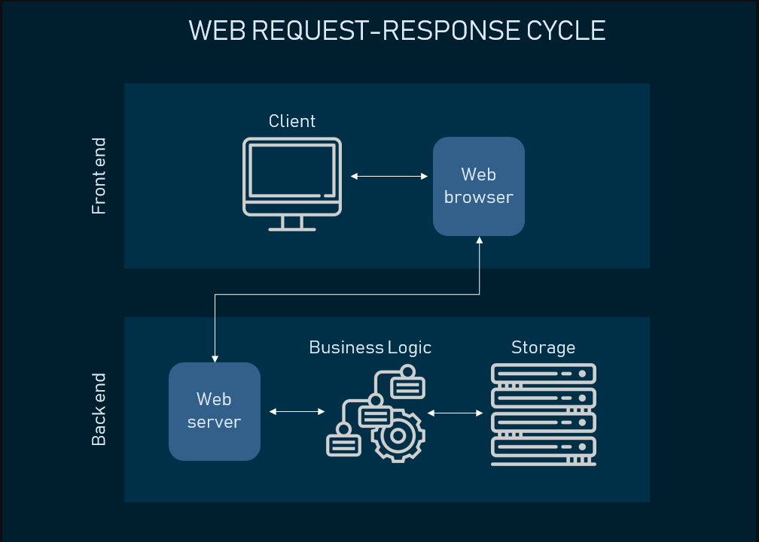

Frontend Development:
Front-end advancement is the way configuration gets carried out on the web. The pages of a site are a number of layers of construction, information, plan, content, and usefulness. All in all, Front-the end is the piece of the location where clients can see and communicate with the graphical UI (GUI) and the order line which incorporates the plan, route menus, texts, pictures, recordings, and so forth.

A portion of the Front-end Dialects incorporates HTML, CSS, JavaScript, and so on. A portion of the Front-end Systems and Libraries incorporate AngularJS, React’s, jQuery, Backtalk, and so on. [1]

Backend Development:
Back-end Improvement alludes to server-side turn of events. It is the term utilized for in the background exercises that happen while playing out any activity on a site.

All in all, the part of programming doesn't come in that frame of mind with the clients. Clients in a roundabout way access the parts created by Back-end planners through a Front-end application. Exercises, such as composing APIs, making libraries and working with framework parts without UIs are a few instances of Back-end improvement.

A portion of the Back-end Dialects incorporate PHP, Java, C++, Python, JavaScript, Node.js, and so forth, And a portion of the Back-end Systems incorporate Express, Django, Rails, Laravel, Spring, and so on.

Networking Model:
Organizing models are correspondence models and understanding the development and engineering of these models is important. They lay out an association between the source and the collector those aides in transmission of information. At the point when the conventions and the capabilities are able correspondence happens. In systems administration models, we allude to the singular bits of the gathering as layers and the assortment as a stack.

Protocol Model:
This model intently matches the construction of a specific convention suite. A convention suite incorporates the arrangement of related

Conventions that ordinarily give all the usefulness expected to individuals to speak with the information organization. The TCP/IP model is a convention model since it portrays the capabilities that happen at each layer of conventions inside the TCP/IP suite.

Reference model:
This kind of model portrays the capabilities that should be finished at a specific layer yet doesn't determine unequivocally the way in which a capability ought to be achieved. A reference model isn't expected to give an adequate degree of detail to characterize exactly the way that every convention ought to work at each layer. The basic role of a reference model is to support a more clear comprehension of the capabilities and cycles vital for network interchanges.

TCP Model:
The main layered model for correspondences inside an organization was made in the mid 1970s and is alluded to as the Web model. The TCP/IP model portrays a bunch of general plan rules and executions of explicit systems administration conventions to empower PCs to convey over an organization. TCP/IP gives start to finish network determining how information ought to be designed, tended to, sent, steered and got at the objective.

Layers of TCP/IP model:

- Application Layer: Addresses information to the client, in addition to encoding and discourse control.

- Transport Layer: Supports correspondence between across different organizations.

- Web: Decides the best way through the organization.

- Network Access: Controls the equipment gadgets and media that make up the organization.

OSI Network Model:
The OSI model is a calculated model which has been created by ISO, in the year 1984. It guides in understanding what is happening inside a systems administration framework; in this framework, information is moved forward and backward inside contiguous layers. The OSI Model comprises of 7 Layers, and they are ordinarily depicted from the top layer down. OSI represents Open Frameworks Interconnection. The OSI Model comprises of 7 Layers, and they are ordinarily depicted from the top layer down. It supports understanding what is happening inside a systems administration framework; in this framework, information is moved forward and backward inside contiguous layers.

- Application Layer: This layer gives the networking conventions to the end-client like HTTP and HTTPS.

- Show Layer: Converts information starting with one structure then onto the next and assesses the grammar.

- Determination Layer: Liable for association, re-association, and validation.

- Transport Layer: Transmission of information to various organization associations speed, sum, and so forth. Executed utilizing TCP and UDP.

- Organization Layer: Courses the information, sends it to the right objective by actually looking at each piece of information, likewise maps the objective location to the actual location accomplished by the ARP.

- Information Connection Layer: It is Perplexing and Checks for shortcomings in transmission from the actual layer and afterward changes over the information into information outlines, which is of 4 sections. Physical tending to happens is of Macintosh and LLC.

- Actual Layer: This layer generally comprises of organization links, ports, repeaters, transmitters, and so forth. Here advanced information pieces are either gotten or moved by the individual actual layer gadgets. It very well may be of the structure mechanical, electrical or radio.

Web Stack:
A web stack, likewise called a web application stack, is a gathering of a product arrangement particularly for executing sites and web applications. The assortment of layers is known as a stack. The term, 'stack', alludes to the way that the framework's parts are based upon each other. The fundamental necessities important to develop a web stack incorporate a working framework, a web server, an information base, and a content mediator. Along with the legitimate server equipment, this heap of parts guarantees that vital data about comparable web projects is sent to mentioning clients which is by and large the web program.

A couple of kinds of Web Stacks

A Light Stack is one of the instances of a web stack, a bunch of open-source programming can be utilized to make sites and web applications. The Light stack was the primary followed by different stacks. Because of the consistently expanding progress of this innovation and the improvement of new freeware, various varieties of Light stacks have emerged. A few popular models include:

- WAMP (Windows as a working framework)

- MAMP (Macintosh operating system X as a working framework)

- XAMPP (any working framework, Perl and PHP as content mediators; stage free FTP server)

- XAMPP is the most normally utilized web stack.

Linux upheld a MySQL information base and has now moved to MariaDB, which doesn't uphold SQL Infusion assaults by means of DVWA.

THE NEW Period OF WEB 2.0
Prior to the new time

At first organizations typically favored a full-stack designer and not subject matter expert. A full-stack designer is the person who is both conversant in Front-end and Back-end improvement. A specialization would mean the individual is either perfect in

fostering the Front-end or the Back-end. Organizations normally went for full-stack improvement, however the time taken by the experts would be lesser than that of a group comprising of just full-stack designers. To back this explanation up let us believe the efficiency to be 1 unit for one occasion of time for a Full Stack Engineer currently consider the all out efficiency required is four units, then it would call for four examples of investment. While for a subject matter expert, let us consider two units of efficiency for every occasion then to arrive at four units, it would require a less measure of investment and subsequently is more productive. On the off chance that any errors happen while the association of the Back-finish to the front you could add another occasion which would in any case be quicker. In this way, the proficiency, , and rough the time taken to complete the venture, Tp are characterized by the accompanying models.

ADVANTAGE OF CLOUD COMPUTING:
Distributed computing tackles critical issues in business. Acquiring many advantages through distributed computing is turning into the new ordinary.

You pay what you use: While utilizing distributed computing administrations, you just compensation for the administrations you use, which makes it more expense proficient

Adaptability: As your business advances the size of the information to be dealt with increment or diminishes cloud administrations give to change your cloud limit at whenever.

Reinforcements/information recuperation: For limited scope organizations it is hard to set up an information recuperation frameworks however distributed computing gives information recuperation choice
Equals to which maintains a strategic distance from a significant speculation.

Versatile Associate: One of the fundamental elements of distributed computing is you can work from anyplace.

Security: With regards to information, security generally

in which P is efficiency per unit time, L is the base efficiency units to be reached, and D is the quantity of errors (if any).

The efficiency per unit time can be determined utilizing the Work Efficiency Recipe.

goes under thought as each client maintains that their information should be secure. The cloud specialist co-ops give the security of information, and the information in the cloud is safer contrasted with putting away the information in hard drives since loss of delicate information for limited scope business having deficient assets toin which to is All out Result and Ti is All out Info.

After the new time

Secure information from programmers and breaks would be sad.
Site the board: Distributed computing highlights incorporate information the executives and investigation. It empowers you to oversee DNS servers, webadministrations and so on.

Because of the presentation of AJAX support, another time started the Internet 2.0 comprising of XMLHttpRequest which alludes to information move between a web server and a browser.[7] It included a lot of dreary work, and no single designer could know it all there is to be known, the presentation of new innovation included exceptional changes as far as planning and the ideas engaged with web improvement. As a few changes were being presented in both the fields of Front-end and Back-end, thus, it became troublesome 6 for people to skill oneself in this large number of fields. In this way full-stack engineers are as of now not present as it is extremely difficult, thus organizations ordinarily recruit a group of trained professionals. Here each colleague should be productive in multiple layers of web advancement. The one having various abilities are normally allocated to lead.

CLOUD COMPUTING:
In previous times there was just a single choice to store, oversee and deal with the information that was through keeping up with nearby servers or PCs. In any case, because of current headway in registering procedures, we are presently ready to control information over the web. This practice of putting away, handling and overseeing information over the web is called distributed computing. [9] A portion of the well known organizations that give distributed computing administrations incorporate

Cloud Administration Models

Programming as a help (SaaS): In SaaS, cloud suppliers deal with the foundations and stages that run the cloud. There is no need to introduce the product in the clients framework as the cloud gives everything. As the product isn't running on the clients framework there is compelling reason need to put resources into equipment decreasing the expense.

Stage as a help (PaaS): Here the client has command over applications and design settings for the application climate including network, servers, operating system and capacity.

Foundation as a help (IaaS): IaaS alludes to a web-based assistance which gives significant level Programming interface. It additionally offers containerization which gives higher performacethan virtualization as there is no hyper visor engaged with it. The limit of compartments auto-scales powerfully making you pay just for what you use. It likewise gives extra assets like firewalls, object capacity, IP addresses, VLANs and so forth.

The progression of Web improvement because of cloud

The advancement of innovation permitted us to address the client's issues better, and accordingly we went to the cloud.

Because of an expansion in the quantity of simultaneous clients, load balancers were created, they

convey application traffic among servers to forestall crashing.

Actual servers were changed to cloud-based servers which gave substantially more adaptability, in a hurry installment approach, zero upkeep and so on. Before we discuss cloud-based servers, one should comprehend distributed computing which is the accessibility of PC assets, both equipment and programming on request.

The application created was currently to be reached to a worldwide scale for better benefits, and this was made conceivable by means of server farms in a few districts. Be that as it may, presently with the cloud, this is far more straightforward as you don't need to set up your focuses.

Outlines and Joins were not so sufficient. Consequently, key-esteem stores were utilized which are essentially data sets comprising of a variety of keys, each addressing one worth these are like word references found in Python programming language.

To work on quality relapse, test suites were created which check assuming the application is as yet working after new changes have been applied to it. Relapse test suites have turned into a need.

Some Cloud Administrations that prompted enhancement

REST APIs

APIs: It gives rules with respect to how projects ought to cooperate. REST: It is by and large viewed as a sort of programming design comprising of a bunch of rules to be kept while fostering a Programming interface.

The main role is to get a reaction from a particular objective when a solicitation is made. At the point when a URL is placed, we demand for that page to show up. In the event that the solicitation is able, we get the GUI as the reaction. A Solicitation is a mind boggling process which happens inside short measures of time, and are likewise determined as Execution Issues. It comprises of four sections.

Endpoint - It is the course through which you get a reaction. Beginning with the root endpoint, which is the start of the URL, which focuses to the record and the way of the URL decides the reaction required. In the URL way, assuming there is a colon present, it alludes to a variable that will be changed likewise. The last piece of an endpoint is Inquiry boundaries which typically start with a question mark and are composed utilizing SQL. Every boundary is discrete by in light of the fact that spaces are invalid in a URL. It are likewise performed to Utilize Inquiry Boundaries SQL Infusions. Despite the fact that Question Boundaries are actually not connected with APIs, it is worth focusing on. To test endpoints order line utilities are utilized there are a few of them accessible, however the most widely recognized while coming to APIs is Twist.

Utilizing endpoints archives can be gotten to without any problem. Archives comprise of bundles. JSON is a prearranging language which is utilized to send and demand information utilizing a REST Programming interface.

- Technique - The strategy characterizes a sort and gives significance to the solicitation there are five distinct kinds of strategies the most well-known being POST. They perform activities like make, read, update and erase.

- Get - It returns the mentioned data as in read, it is additionally the default technique.

- Post - It makes another passage as in make.

- Put - It refreshes a current passage as in update.

- Erase - It erases a current passage as in erase.

- Headers - These are isolated by a colon and advise where to find the JSON record. They are generally utilized in orders for the order line.

- Information - It comprises of data to be recovered from the server. [14]

As the clients request and interests crested the UI started to create, the collaboration was improved to make it more easy to use, to accomplish this specific individuals in the separate fields were employed. Later portable application variants were presented for additional comfort of the clients.

A few improvements were made to the programming dialects itself.

- HTML - Semantic web was added, which permitted the web information to be machine-readable. Administration Laborers were added, which helped in creating web applications offline.

- CSS - It was refreshed to add advances, movements and different highlights to further develop intuitiveness.

- JavaScript - Different elements like modularization, object-arranged classes, offbeat capabilities and interoperability were added.

- HTTP - Better reserving, safety efforts and industrious meetings.

DevOps:

DevOps is a cycle that is a mixture of 2 primary cycles which are programming improvement (Dev) and innovation tasks (Operations). The principal point of the DevOps cycle is to abbreviate the product improvement life cycle while giving nonstop conveyance where the groups work in short spans which guarantees the product is being grown dependably in a manner the conveyance occurs in an exceptionally smooth interaction. One more benefit of the DevOps cycle is the way that it additionally keeps up with high programming quality all through the improvement cycle, which is assessed on two boundaries. The principal boundary is the programming projects utilitarian quality which checks assuming the useful necessities which were characterized at first have

been followed or not. The following boundary is the programming projects underlying quality which checks assuming the non-practical necessities, which support the utilitarian prerequisites, have been met or not. The DevOps activity has the accompanying usefulness modes or the more precise term being toolchains. The toolchains have been recorded underneath.

Coding - it includes code advancement and survey of the code.

Building - it includes constant mix with devices given by the task.

Testing - it includes constant testing of the task.

Bundling - it includes application and pre-sending techniques.

Delivering - it includes application discharge computerization.

Arranging - it includes foundation as code apparatuses.

Checking - it includes knowing the progressions at the application for the end clients

The main pieces of the DevOps toolchains are persistent combination and framework as a code which happens in the structure and the setup part of the code separately. [17]

NoSQL

NoSQL, otherwise called Not just SQL, is a cloud administration that gives versatile capacity, and information is put away as non-social data sets. This help has supplanted the crude arrangement of RDBMS wherein SQL questions were expected to get to the information, and this information was put away in an organized even structure comprising of lines and segments. NoSQL fluctuates in various viewpoints when contrasted with the conventional data set administration framework concerning execution, consistency, speed, usability, accessibility, adaptability, cost, and so on.
A portion of the Renowned NoSQL data sets incorporate MongoDB, Amazon DynamoDB, Redis, CouchDB, and so on.

Cloud Organization

Cloud organization is a help that is liable for dealing with the interconnections among jobs on the cloud framework. It joins mechanized undertakings into a strong work process to achieve an objective, with consents exclusion and strategy requirement.Cloud coordination obtains, conveys, and starts servers, it gains and allots stockpiling limit oversees organizing and can likewise be utilized to make virtual machines.

CI/CD:
Cloud Coordination is an assortment of devices and innovations that interfaces various frameworks and conditions. It manages trading and handling information progressively. Ceaseless Conveyance and Persistent Sending are the two purposes for arrangement where Consistent Conveyance is manual and Constant Improvement is computerized.

Conclusion:
By integrating every one of the parts, we can decipher what full stack was, the way it has developed, and why it has advanced. The effectiveness of laborers can likewise be determined as the estimation of the time taken to finish a venture. At last, individuals either see Full Sack Improvement be dead or overwhelmed. Notwithstanding, it very well may be seen from the guise that it has advanced and has been definitely enhanced to address the client's issues.

Acknowledgement:
I might want to communicate my unique thanks of appreciation to my educator Mr. Vishal Shrivastava as well as our main Mr. Arun Aryawho offered me the brilliant chance to do this magnificent undertaking on the point "The New Era of Full stack Development ", which likewise helped me in doing a great deal of examination and I came to be aware of such countless new things I'm truly grateful to them.

REFERENCES:
10 Different ways Distributed computing Can Change Web Application Improvement - , Apr. 2019. [Online]. Accessible: https://nimapinfotech.com/blog/10-ways-distributed computing can-change-web-application advancement/

Making Relapse Test Suites. [Online]. Accessible: https://it.toolbox.com/web journals/making relapse test-suites-071507

Understanding And Utilizing REST APIs, Jan. 2016. Accessible: https:

//www.smashingmagazine.com/2018/01/figuring out utilizing rest-programming interface/

Semantic Web, Blemish. 2020, page Form ID: 945184650. [Online]. Accessible: https://en.wikipedia.org/w/index.php?title=Semantic_Web&oldid=945 184650

E. Sharma, A Prologue to Administration Laborers in JavaScript, Feb. 2018. [Online]. Accessible: https://codeburst.io/an-prologue to-support laborers in-javascript-27d6376460c2

