Effectiveness of various DPSK modulation data formats on cross-polarization modulation based 80 Gbps all-optical wavelength conversion using single wideband SOA: An investigation
Sarojini R^{1*}, Selvendran S² and Sivanantha Raja A³

¹ Government College of Engineering Srirangam, Trichy,Tamilnadu, India
² Vellore Institute of Technology, Chennai, Tamilnadu, India.
³ Alagappa Chettiar Government College of Engineering and Technology, Karaikudi, Tamilnadu, India.

*Corresponding author: sarojiniraju18@gmail.com

ABSTRACT
The efficient deployment of WDM/DWDM technologies can be made possible by wavelength conversion at key optical network nodes. In this research Cross-Polarization Modulation (XPolM) based All-Optical Wavelength Conversion (AOWC) using wide band Semiconductor Optical Amplifier (SOA) is obtained. The effectiveness of various optical differential phase modulations on wavelength conversion is analysed. NRZ-DPSK/DPSK, 33%RZ-DPSK, 50%RZ-DPSK and 67%RZ-DPSK/CSRZ-DPSK are investigated here. The data rate is 80 Gb/s and the conversion bandwidth is 1.04 nm. The analysis is extended for Linear, Lorentzian and no-approximation material gain simulation models. The NRZ-DPSK performs better in terms of maximum coupled intensity and ellipticity. As CSRZ-DPSK exhibits a power spectral gain up to 12 dBm, it is proven to be a good choice. Altogether the CSRZ-DPSK with no-approximation of the material gain simulation model shows evidence of narrower spectral width.
Key words: Semiconductor Optical Amplifier (SOA), Cross-Polarization Modulation (XPolM), All-Optical Wavelength Conversion (AOWC), Differential Phase Shift Keying (DPSK), Carrier Suppressed Return-to-Zero DPSK (CSRZ-DPSK).
1 INTRODUCTION
Optical communication technology has dominated the communication sector in the past few decades. Multiplexing concepts like WDM and DWDM are employed to effectively utilize fiber bandwidth. The wavelength converters have emerged as the fundamental functionality of wavelength-routed networks to make the network transparent and allow interoperability. Wavelength converters resolve the issue of data contention [1]. In this research optical nonlinearity is used with optical gating approach to realize the wavelength conversion functionality. The saturated Semiconductor Optical Amplifier (SOA) is used as an optical gate. The optical nonlinearities refer to the ability of a device to alter its characteristics in response to the optical signal intensity. These modifications can be applied to another optical signal at different wavelength called probe signal. After wavelength conversion the information is obtained in the output probe signal. This approach offers transparency and acceptably works well over the bandwidth of 100 nm, which is the amplifier gain bandwidth. Cross-Gain Modulation (XGM) [2], Cross-Phase Modulation (XPM) [3], and Cross-Polarization Modulation (XPolM) are the SOA nonlinearities which can be realized in the optical gating approach [4]. The SOA exhibits very fast carrier dynamics, which happen in pico second time scale. Hence the wavelength conversion at the rate of Gb/s is possible. The main advantage of this optical gating is that it is abstractly simple. In this research, XPolM has been considered as a necessary nonlinearity for wavelength conversion in the optical gating approach.
Finding the most appropriate and data modulation format is crucial when high speed wavelength converters are taken into consideration. Here DPSK is considered here, as it requires only half the average optical power in optical networks and exhibits a good dispersion tolerance [5]. It also has greater transmission performance and enhanced receiver sensitivity. To reach the given BER, nearly 3 dB lower OSNR is adequate if a balanced receiver is used for the detection [6]. This is the most apparent advantage of DPSK over OOK. [7], [8] demonstrated that for an optically preamplified receiver, at a BER of 10⁻⁹, the quantum limit is 41 photons/bit for OOK without filtering. This quantum limit reduces to 22 photons/bit for DPSK with balanced detection. Hence for the optical high data rate systems that employ WDM / DWDM techniques, DPSK provides many advantages over conventional OOK format with the added design complexity in the transmitter and receiver. The relative merits of various DPSK formats and the system impairments were studied [9], [10]. The differential phase modulation formats like NRZ-DPSK/DPSK, 33%RZ-DPSK, 50%RZ-DPSK and 67%RZ-DPSK/CSRZ-DPSK are considered here.
The novelty of this investigation is that it evaluates the effectiveness of various DPSK data modulations in the context of XPolM-based wavelength conversion. This study is also broadened to take different material gain approximation models into account; Linear, Lorentzian, and no-approximation models. The wavelength conversion is accomplished at an 80 Gb/s data pace. 1.04 nm is the conversion bandwidth. The inference of this research paper is that CSRZ-DPSK is the viable option because it results in significantly higher power spectral gain up to 12 dBm. More specifically, in the no-approximation material gain simulation model, this CSRZ-DPSK data wavelength conversion exhibits a smaller spectral main lobe width.
2 OPTICAL RZ-DPSK GENERATION
Optical RZ modulation has three general forms based on its duty cycle. They are 33% RZ (RZ with 33% duty cycle), 50% RZ (RZ with 50% duty cycle), and 67%RZ (RZ with 67% duty cycle), which is popularly known as carrier-suppressed RZ (CSRZ). The driving functions for different RZ-DPSK with the MZM transfer function is shown in Figure 1. It is shown that the drive signal is biased at various specific transmission points of MZM based on its duty cycle. These functions ensure the constructive and destructive interferences for the bit 1 and 0.
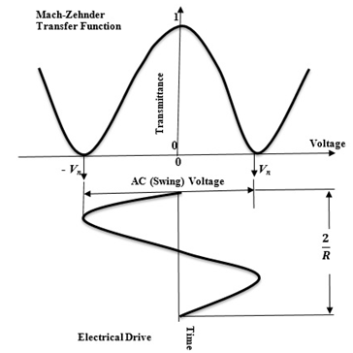(a) 33%RZ-DPSK | 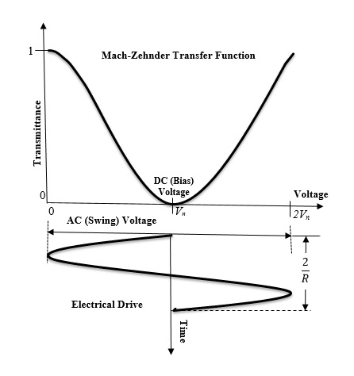(b) 50%RZ-DPSK | 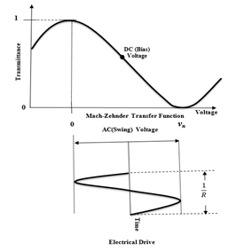(c) 67%RZ-DPSK
Figure 1 Drive setting functions for RZ-DPSK signals
The drive signal or pulse carving function is defined by equation (1)
$V_{o}\left(t\right)=Acos(2πv_{c}t-πθ)$ (1)
where $A$ is the amplitude which is set at 1 V; $v_{c}$ is the frequency of the RZ drive signal voltage; $θ$ is the phase offset as a fraction of V_{π .} The appropriate frequency and phase of the driving functions are given in Table 1. The power spectra of different RZ signals are exposed in Figure 2.
Table 1
Parameter | 33% duty cycle | 50% duty cycle | 67% duty cycle
Frequency $v_{c}$ | 40 GHz (Bit rate) | 80 GHz (Bit rate) | 40 GHz (Bit rate /2)
phase $θ$ | -90⁰ | -90⁰ | 0⁰

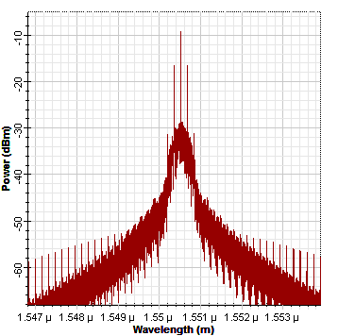 | 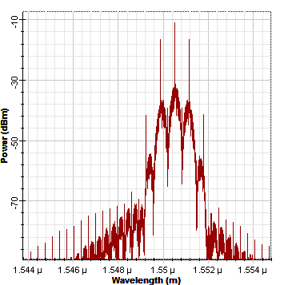 | 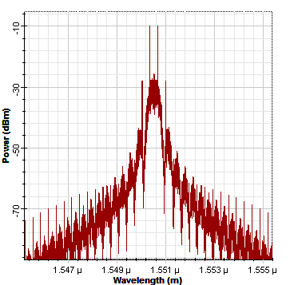
33% optical RZ-DPSK | 50% optical RZ-DPSK | 67% optical RZ-DPSK

Figure 2 Power spectra of RZ signals
3 EXPERIMENTAL SYSTEM ARRANGEMENT
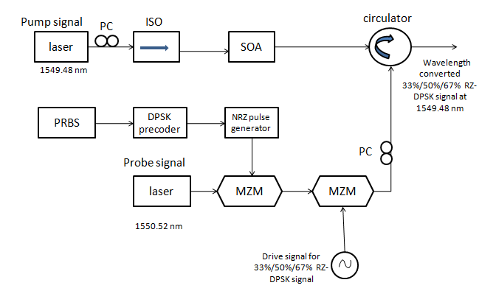
Figure 3 XPolM-based AOWC of various DPSK data modulation formats.
The experimental setup of XPolM-based AOWC is shown in Figure 3. It consists of two sections; Data modulation section and wavelength converter section. The data modulation section includes an optical laser source that emits a probe signal at 1550.52 nm wavelength with 1 dBm power, a DPSK precoder and two cascaded MZM modulators. The 2³¹-1 PRBS generates an 80 Gb/s bit stream which is given to the DPSK precoder. The NRZ-DPSK data is then intensity-modulated by the combined blocks of the NRZ pulse generator and MZM. This first MZM is driven by the input probe laser of 1550.52 nm wavelength. In the generation of RZ-DPSK, the second MZM involves and performs the function of pulse carving. This pulse carving is accomplished by the RF sinusoidal signal with the appropriate frequency and the phase. In the generation of NRZ-DPSK / DPSK, the second MZM is eliminated and no driving function is used for carving.
The wavelength converter section consists of the optical laser source called pump laser that emits light at 1549.48 nm wavelength, SOA and the circulator. The pump signal power is fixed with -4 dBm. The pump and the probe signals are counter-propagating into an SOA. The SOA is biased at the injection current of 0.37 A. The wavelength converted signal is obtained at 1549.48 nm. The parameters involved in these simulations are listed in Table 2. When two signals, pump and probe are injected simultaneously into the SOA, there is an introduction of different phase and gain compression on the TE and TM components. Consequently, the polarization state of the signal is changed, and thus, a polarization rotation is created which is referred to as Non-Linear Polarization Rotation (NPR) [11],[12] & [13].
Table 2 Parameters used
Parameters | Value
Confinement factor | 0.45
Bias current | 0.37 A
Active region length | 0.0006 m
Active region width | 1.5 e-06 m
Active region height | 0.5 e-06 m
Pump power | -4 dBm

The numerical simulation is done in two steps. In the first step the active region of the SOA is divided into several portions. The steady state condition is consideration at the boundaries [14]. The carrier density rate will only be controlled by the current bias level and the input flux in each SOA segment during the second step. This simulation is repeated for different material gain simulation models; Linear, Lorentzian and no-approximation of material gain. Each model has a specific carrier density profile. The parameters used in these simulation models are listed in Table 3. If the assumption made in the SOA electric field wave equation is such that there is a linear dependence between the carrier-induced susceptibility and the carrier density, then it is called linear approximation. Then the material gain coefficient $g_{m}$ is related to carrier density N(t) as in the Equation (2)
$g_{m}\left(t\right)=A_{g}[N\left(t\right)-N_{o}]$ (2)
where N₀ is the carrier density at the transparency point, and $A_{g}$ is the differential gain coefficient. The net gain coefficient $g$ is related to the material gain $g_{m}$ by the Equation (3)
$g\left(t\right)=Γg_{m}\left(t\right)-α$ (3)
where α is an effective loss coefficient which includes scattering and absorption losses, and Γ is the optical confinement factor defined as a fraction of the mode power within the active layer.
In Lorentzian approximation, the material gain $g_{m}$ profile follows Lorentzian line shape [15]. The Equation (4) describes the $g_{m}$ in Lorentzian approximation.
$g_{m}\left(v,n\right)=\frac{a_{0}\left(n-n_{1}\right)}{1+\frac{{\left(λ-λ_{n}\right)}^{2}}{∆λ^{2}}}$ (4)
where $a_{0}$ is the gain constant, $n$ is the carrier density, $n_{1}$ is the carrier density at transparency, $λ_{n}$ is the spectral shift, $∆λ$ is the 3-dB bandwidth of the linear gain coefficient.
The gain constant, carrier density and the gain bandwidth are not approximated in the no-approximation material gain simulation model [14].

Table 3 Different material gain ($g_{m}$) simulation model parameters of SOA
Parameters with  Description | Material gain  Define the material gain coefficient |  |  | Units
 | Linear  approx. | Lorentzian approx. | No  approx.
Gain constant a_{o}  (Differential gain coefficient) | 27.8e-21 | 27.8e-21 | - | m^2
Carrier density at transparency n  (Linear radiative recombination coefficient) | 1.4e+24 | 1.4e+24 | - | m^3
Gain peak wavelength $λ$  (Peak wavelength at transparency) | - | 1549.52 | - | nm
Gain bandwidth $∆λ$  (The 3 dB bandwidth of the linear gain coefficient) | - | 122.5 | - | nm
$n_{1}$ Active refractive index | - | - | 3.2 | -

4 RESULTS AND DISCUSSION
The numerical simulation of AOWC using XPolM is carried out for four different DPSK data modulation formats. The basic principle behind the XPolM-based wavelength conversion is NPR inside the SOA. This polarization rotation may result in either waveguide asymmetry in waveguide structure or an additional birefringence effect introduced inside the device cavity. As the active region of SOA is not of equal sides, the confinement factor $Г$ is different for TE and TM modes. This makes the device gain is polarization-dependent due to Equation (6)
$G=(Гg_{m}-∝)L$ (6)
where $Г$ is the confinement factor, $g_{m}$ is the material gain, $∝$ represents the optical losses, and $L$ is the device length [16], [17].
As the material gain directly influences the device gain which is polarization-dependent, the experiment is extended for linear, Lorentzian approximation and no approximation simulation models. Figure 4 shows the amount of signal intensities coupled with the wavelength converted signal for all four DPSK formats. Compared to other data formats, it is obvious that NRZ-DPSK has the highest level of intensity coupled with the converted beam. NRZ-DPSK couples at around -40 dBm, while RZ-DPSK data formats couple less. As a result, NRZ-DPSK performs better in terms of maximum intensity coupled with the converted signal.

Figure 4 Signal intensity coupled into wavelength converted signal for different data formats and material gain simulation models.
Figure 5 shows the ellipticity angle for different data formats. Similar to the intensity profile, NRZ-DPSK shows evidence of maximum amount of polarization rotation compared. The ellipticity angle is ~31⁰ for NRZ-DPSK while other formats have upto ~28⁰. Figures from 6 (a) to (d) illustrate the dual power spectrum of NRZ-DPSK, 33% RZ-DPSK, 50%RZ-DPSK, and CSRZ-DPSK, respectively, for the linear material gain approximation simulation model. Similarly, Figures from 7 (a) to (d) and Figures from 8 (a) to (d) illustrate the dual power spectrums for Lorentzian and no-approximation simulation models, respectively. These figures are the visual substantiation of their power spectral gains which are numerically validated in table 4. The blue and red shifted components in these figures are attributed to the residual effects of nonlinear effect such as self phase modulation (SPM). Other non-linear effects like cross-phase modulation (XPM) will also occur depending on their intensity level as a result of the interaction of two optical fields inside the active region of a SOA. This creates a phase noise that leads to the red and blue shifts.

Figure 5 Ellipticity angle for different data formats and material gain simulation models
The resolution bandwidth of the spectrum analyzer is set as 0.001 nm. It is observed that in the no-approximation model, the converted signal power spectrum of CSRZ-DPSK is narrower than other DPSK data formats. The most attractive feature of CSRZ-DPSK is that it has a power spectral gain of up to 12 dBm at a converted signal wavelength of 1549.48 nm. Table 4 shows the output spectral power gain for all DPSK formats.
Table 4 Output power spectral gain
Data formats | Power gain (dBm)
 | Linear  approx. | Lorentzian  approx. | No-approx.
NRZ-DPSK/DPSK | -30 | -31 | -42
33% RZ-DPSK | -30 | -27 | -44
50% RZ-DPSK | -25 | -20 | -27
67%RZ-DPSK/(CSRZ-DPSK) | 12 | 11 | 6
(a) NRZ-DPSK | (b) 33% RZ-DPSK
(c) 50% RZ-DPSK | (d) 67% RZ-DPSK
Figure 6 Different DPSK modulation dual spectra for the linear material gain $(g_{m})$ simulation model

(a) NRZ-DPSK | (b) 33% RZ-DPSK
(c) 50% RZ-DPSK | (d) 67% RZ-DPSK
Figure 7 Different DPSK modulation dual spectrum for the Lorentzian material gain $(g_{m})$ simulation model
(a) NRZ-DPSK | (b) 33%RZ-DPSK
(c) 50%RZ-DPSK | (d) 67%RZ-DPSK
Figure 8 Different DPSK modulation dual spectrum for the no-approximation material gain $(g_{m})$ simulation model
5 CONCLUSION
In this research the effectiveness of various optical differential phase modulations on wavelength conversion is investigated. The NRZ-DPSK, 33%RZ-DPSK, 50%RZ-DPSK and CSRZ are analyzed. Using the NPR phenomena inside the wide band SOA, XPolM-based AOWC is achieved by a suitable configuration. The data rate is 80 Gb/s. The experiment is continued for different material gain ${(g}_{m})$ simulation models. The comparisons are made in terms of the amount of power coupled (dBm), ellipticity angles (degree) and optical power spectral gain (dBm).
The pump signal is set at a wavelength of 1549.48 nm with a power of -4 dBm. The input probe signal power is 1 dBm. With the 0.001 resolution bandwidth, the input and the converted signal spectra are analyzed. The NRZ-DPSK performs better in terms of maximum intensity coupled with the converted signal and ellipticity angle. However, the CSRZ-DPSK has shown to be a potential option in terms of power spectral gain. Linear, Lorentzian and no-approximation models of CSRZ-DPSK produce a spectral gain of 12 dBm, 11 dBm and 6 dBm, respectively. The channel capacity of the WDM system can be enhanced since the main lobe of the CSRZ-DPSK with no-approximation of the material gain model is narrower than others.

REFERENCES
[1] S. J. B. Yoo, “Optical Packet and Burst Switching Technologies for the Future Photonic Internet”, Journal of Lightwave Technology, 2006, 24(12), pp.4468-4492.
[2] A D Ellis A E Kelly D Nesset D Pitcher D G Moodie and R. Kashyap, “Error free 100 Gbit/s wavelength conversion using grating assisted cross-gain modulation in 2mm long semiconductor amplifier”, IET Electronics Letters, 1998, 34(20), pp.1958–1959.
[3] A Matsumoto K Nishimura K Utaka and M. Usami, “Operational design on high-speed semiconductor optical amplifier with assist light for application to wavelength converters using cross-phase modulation”, IEEE Journal of Quantum Electronics, 2006, 42(3), pp.313-323.
[4] S H Lee and J I Song, “An XPolM-Based All-Optical SSB Frequency Up-Conversion Technique in an SOA”, IEEE Photonics Technology Letters, 2017, 29(7), pp.627-630.
[5] R Shuai X Guijin X Yinghui Z Weihu R Xuejun and W Xiaoshuang, “Research on Performance of Optical DPSK Modulation Format in All Optical Network. 10th International Conference on Communication Software and Networks (ICCSN), 2018, pp.65-68.
[6] Li Z Dong Y Mo J Wang Y and Lu C, “1050-km WDM transmission of 8/spl times/10.709Gb/s DPSK signal using cascaded in-line semiconductor optical amplifier”, IEEE Photonics Technology Letters, 2004, 16, pp.1760-1762.
[7] S R Chinn D M Boroson and J C Livas, “Sensitivity of optically preamplified DPSK receivers with Fabry-Perot filters, Journal of Lightwave Technology, 1996, 14(3), pp. 370-376.
[8] W A Atia and R S Bondurant, “Demonstration of return-to-zero signaling in both OOK and DPSK formats to improve receiver sensitivity in an optically preamplified receiver. IEEE LEOS Annual Meeting Conference Proceedings. LEOS'99. 12th Annual Meeting. IEEE Lasers and Electro-Optics Society, 1999, Annual Meeting (Cat. No.99CH37009), 1, pp.226-227.
[9] John C Mauro JC and Srikanth Raghavan, “Advanced modulation formats for fiber optic communication systems” Journal of Scientific Modeling and Simulations, 2008, 15(1-3), pp.283-312.
[10] A H Gnauck and P J Winzer, Optical phase-shift-keyed transmission. Journal of Lightwave Technology,2005, 23(1), pp.115-130.
[11] Ahvan Sharifi, Mohammad Razaghi and Vahid Ahmadi, “Analysis of nonlinear polarization rotation by an ultrashort optical pump and probe pulse in a strained semiconductor optical amplifier”, Journal of the Optical Society of America B, 2019, 36(2), pp.374-382.
[12] Xianghua Feng Jiarong Ji Guomin Zhang, “Nonlinear Polarization Rotation Characteristic Phenomenon in a Bulk Semiconductor Optical Amplifier”, Optics and Photonics Journal, 20133(2B), pp.187-191.
[13] Kennedy Brendan Philippe Severine Landais Pascal Bradley Louise and Soto Horacio, “Experimental investigation of polarisation rotation in semiconductor optical amplifiers. Optoelectronics”, IEE Proceedings, 2004, 151(2), pp.114 - 118.
[14] M J Connelly, “Wideband semiconductor optical amplifier steady-state numerical model. IEEE Journal of Quantum Electronics”, 2001, 37(3), pp.439-447.
[15] Mourad Menif Pascal Lemieux Walid Mathlouthi and Leslie Ann Rusch, “Incoherent-to-Coherent Wavelength Conversion Using Semiconductor Optical Amplifier. IEEE International Conference on Communications (ICC) (IEEE Cat. No.04CH37577), 2004 3, pp.1740-1744.
[16] Brendan F Surre KF Philippe S Bradley L and Pascal Landais, “The use of polarization effects in semiconductor optical amplifiers to perform all-optical signal processing ingeniería, Revista chilena de ingeniería”, 200715(3), pp.313–319.
[17] Agrawal GP, Fiber-Optic Communication Systems2012, 4th edition. Wiley. Germany.

