CORPORATE SOCIAL RESPONSIBILITY INTIATIVES IN INDIA
By
Dr. Geetha Bai.B.
Professor
Department of Commerce
Karpagam academy of Higher Education
drgeethabai.b@kahedu.edu.in

Abstract
Corporate Social Responsibility (CSR) is a voluntary approach in which companies take accountability for their impact on society, stakeholders, and the environment. By practicing CSR, businesses consider their societal, economic, and environmental effects, operating in ways that benefit these aspects rather than causing harm. CSR encompasses various forms, including philanthropy and volunteer efforts, contributing to societal well-being and enhancing a company's reputation. This article highlights the significance of CSR for businesses and society, emphasizing its positive impact on employee morale, customer relations, and brand image. It also discusses the implementation of CSR through ISO 26000 standards and provides examples of companies like Starbucks and Ben & Jerry's that excel in CSR initiatives.
The article explores CSR's evolution, differing opinions, and four primary pillars—environmental, ethical, philanthropic, and financial responsibility. It delves into India's CSR initiatives, mandated by the Companies Act of 2013, covering diverse domains such as eradication of poverty, education, gender equality, environmental sustainability, and more. Recent developments in Indian CSR, including digitalization, COVID-19 relief measures, and focus on impact assessment, are detailed. International CSR obligations for companies operating in India are highlighted, underlining the role of legal frameworks and recent developments in promoting sustainable development. The article concludes by emphasizing the substantial impact of CSR in India, with companies actively participating in meaningful initiatives that contribute to societal betterment and inclusive development.

CORPORATE SOCIAL RESPONSIBILITY INITIATIVES IN INDIA
By
Dr. Geetha Bai.B.
Professor
Department of Commerce
Karpagam academy of Higher Education
drgeethabai.b@kahedu.edu.in

Introduction
Corporate Social Responsibility is a voluntary business approach aimed at making companies accountable to themselves, stakeholders, and the public. The term “CSR” was first introduced by American economist Howard Bowen in his publication “Social Responsibilities of the Businessman,” earning him the title of the “Father of CSR.” in By practicing CSR, businesses consider their impact on various aspects of society, such as the economy, social aspects, and the environment. Engaging in CSR means that a company operates in a way that benefits society and the environment, rather than causing harm. CSR programs can take different forms depending on the company and industry, including philanthropy and volunteer efforts, to benefit society and enhance the company's reputation.

"If you work just for money, you'll never make it, but if you love what you're doing and you always put the customer first, success will be yours." - Ray Kroc, Founder, McDonald's. CSR is not only beneficial to the community but also valuable for the company itself. It can strengthen the bond between employees and customers with the company, boosting morale and fostering a sense of connection to the world around them. Starbucks is an example of a company that is a leader in CSR initiatives across its business. CSR programs are not limited to large corporations; smaller businesses also engage in social responsibility activities, although they may not be as well-publicized. ISO 26000 is a set of voluntary standards developed by the International Organization for Standardization to guide companies in implementing CSR It helps organizations understand social responsibility and translate CSR principles into practical actions.
CSR is an evolving concept that can benefit both society and businesses. It helps build a positive reputation, attracts customers, motivates employees, and opens new opportunities. However, there are differing opinions on its implementation and impact, and businesses should carefully consider their CSR initiatives based on their capacity and values.

Corporate citizenship
Corporate citizenship another term for CSR, refers to a company's responsibility toward society. Embracing CSR can lead to improved customer relations, employee motivation, and brand reputation. It can also attract investors and open up new opportunities and markets.
However, there are arguments against CSR, with some claiming that businesses should focus solely on profits and let government or non profit organizations handle social and environmental issues. Critics also argue that CSR may lead to higher costs for smaller businesses and that businesses lack the social skills to effectively address social problems. Corporate Social responsibility programs
Corporate responsibility programs can indeed raise morale in the workplace. When employees see that their company is actively involved in making a positive impact on society and the environment, it can create a sense of pride and purpose among the workforce. Knowing that they are working for an organization that cares about more than just profits can foster a stronger sense of loyalty and commitment among employees. Additionally, employee engagement in corporate responsibility initiatives can also boost morale. Many companies encourage their employees to participate in volunteer efforts or support philanthropic causes, which can be fulfilling and rewarding for employees. This kind of engagement can also lead to increased teamwork and a sense of camaraderie among colleagues, further enhancing the overall work environment. Corporate social responsibility can create a positive and inspiring workplace culture that motivates employees.
Prominent examples of companies that strive to be leaders in corporate social responsibility include Starbucks and Ben & Jerry's. These companies have showcased their dedication to sustainability, community welfare, and ethical business practices, resulting in a favorable reputation and strong brand recognition among consumers. They serve as illustrations of how corporate social responsibility can be advantageous for both society and businesses themselves.
Corporate social responsibility holds significant importance in contemporary business practices. It not only benefits society and the environment but also fosters a positive workplace culture and enhances brand reputation for companies. By embracing CSR initiatives, businesses can contribute to creating a better world while simultaneously reaping the rewards of increased employee engagement, customer loyalty, and investor suppor
Types of corporate social responsibility
Corporate Social Responsibility (CSR) activities can be categorized into four primary pillars: environmental responsibility, ethical responsibility, philanthropic responsibility, and financial responsibility. Each pillar addresses distinct aspects of a company's impact on society and the environment. By integrating these pillars into their business practices, companies can showcase their commitment to social responsibility and contribute positively to the world around them.

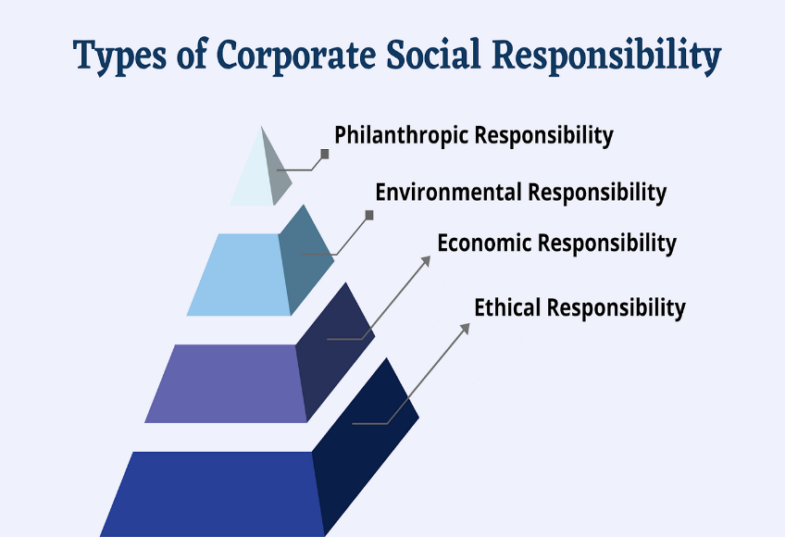
Corporate social responsibility is an essential aspect of modern business practices. It not only benefits society and the environment but also contributes to a positive workplace culture and brand reputation for companies. By embracing CSR initiatives, businesses can create a better wor while also reaping the rewards of employee engagement, customer loyalty, and investor
Corporate Social Responsibility Initiatives in India
Corporate Social Responsibility (CSR) initiatives in India encompass endeavour’s by companies to contribute to social, environmental, and community welfare, while also aligning with their business objectives. "CSR is a journey, not a destination." observed Mohandas Karamchand Gandhi. The Companies Act of 2013 in India mandates CSR expenditure for qualifying companies based on specific financial criteria. Corporations with a net worth exceeding Rs. 500 crores, annual turnover surpassing Rs. 1000 crores, or profit exceeding Rs. 5 crores are required to establish a CSR committee and allocate at least 2% of their average net profit from the preceding three financial years to CSR activities.
CSR activities in India span various domains, as outlined in Schedule VII of the Companies Act 2013. These activities include:
Eradicating Hunger, Poverty, and Malnutrition: Companies can contribute to healthcare and sanitation in rural areas, participate in the Swachh Bharat Kosh (Clean India Fund), and organize blood donation camps.
Promoting Education: Initiatives may involve providing education to children, vocational skill training, and specialized education for women, elderly, and differently-abled individuals.
Promoting Gender Equality: Activities could encompass women empowerment programs, establishing affordable hostels for women, and setting up orphanages.
Environmental Sustainability: Contributions may be directed toward maintaining ecological equilibrium, safeguarding flora and fauna, advocating for animal welfare, and conserving natural resources.
Protection of National Heritage, Art, and Culture: Companies can engage in the restoration of heritage sites, historical structures, and support for artistic endeavors.
Support for Armed Forces Veterans, War Widows, and Families: Contributions can be extended to benefit armed forces personnel and their families.
Welfare and Development of Marginalized Communities: Corporations can contribute to funds set up by the government for the welfare and development of scheduled castes, tribes, backward classes, women, and minorities.
Development of Technology in Academic Institutions: Companies can provide support to enhance technological advancements in government-approved academic institutions.
Rural Development and Slum Area Improvement: Initiatives can target the enhancement of rural areas and the upliftment of slum regions.
Legal Framework of CSR in India
The Companies Act 2013, Section 135, mandates that specific companies allocate a minimum of 2% of their average net profits from the preceding three financial years for CSR activities. This provision applies to companies with a net worth exceeding Rs. 500 crores, a turnover surpassing Rs. 1000 crores, or a net profit exceeding Rs. 5 crores in the immediately preceding financial year.
Such companies are required to establish a CSR Committee of the Board comprising three or more directors, with at least one director serving as an independent director. In cases where the appointment of an independent director isn't necessary, the CSR committee should consist of two or more directors. The CSR Committee's responsibilities encompass formulating and recommending a CSR policy to the board, outlining the company's activities in areas stipulated in Schedule VII. Additionally, the committee oversees the implementation of the CSR policy.

Recent Developments in CSR in India
Digitalization of CSR:
The government has launched an online portal for companies to register and report their CSR activities, making it easier for companies to track and manage their CSR spending.
Inclusion of COVID-19 relief measures under CSR:
The Ministry of Corporate Affairs allowed companies to undertake COVID-19 relief measures under CSR, such as providing healthcare facilities or contributing to the PM CARES Fund.
National Voluntary Guidelines on Social, Environmental, and Economic Responsibilities of Business (NVGs):
Introduced by the Ministry of Corporate Affairs, the NVGs provide guidance to companies on integrating CSR into their business operations.
Emphasis on Education:
CSR activities in India have focused on funding education programs, building school infrastructure, training teachers, and providing scholarships.
Partnership with Non-Profits:
Companies are increasingly collaborating with charitable institutions to carry out their CSR programs.

Promotion of Social Entrepreneurship:
Companies can now contribute to incubators and research organizations supporting social entrepreneurship under the CSR Rules.
Focus on Impact Assessment:
There is a greater emphasis on the need for companies to assess the impact of their CSR activities, with higher spending allowed for impact assessments of major CSR projects.
Transparency and Accountability:
Recent amendments require companies to provide detailed information in their annual CSR reports, promoting transparency and accountability in CSR reporting.
International Corporate Social Responsibility has evolved into a mandatory obligation for certain companies having international operations in India, with the legal framework and recent developments promoting sustainable development and social responsibility. Companies are increasingly expanding their CSR activities, recognizing the importance of contributing positively to society and promoting their reputation and brand image

Conclusion
CSR activities in India have had a significant impact on various social and developmental areas. Many companies have actively participated in CSR initiatives, leading to substantial contributions in education, health, rural development, and other critical sectors. Companies such as ITC, Tata Group, Infosys, and others have been actively involved in meaningful CSR activities, addressing the needs of society and making a positive impact on communities.
Overall, CSR activities in India play a crucial role in promoting sustainable and inclusive development and contribute to the betterment of society and the environment

1.UNIDO (2007) UNIDO Initiative Aims to Develop CSR Awareness Among European SMEs. http://www.ethicsworld.org/corporatesocialresponsibility/ngoinitiatives.php
2.Ethics World (2014) CSR around the World: A Seven Country Study, Study from the Society for Human Resource Management Shows Brazil Leads in Prevalence of CSR Practices. http://www.ethicsworld.org/corporatesocialresponsibility/surveysandtrends.php

3. Legal Framework for CSR in India(2014)
http//www.researchgate.net

4.csr ray kroc quotes(2016) https CSR Quotes (indiacsr.in)

5.Nayan Mitra & Dr. Rene Schmid Peter (2016) ‘Corporate Social Responsibility in India: Cases and Development after the Legal Mandate’ Springer International Publishing, Switzerland.
6.Types of corporate social responsibility to be aware (2021)(https://online.hbs.edu/blog/post/types-of-corporate-social-responsibility

6.Corporate Social Responsibility Explained With Examples(2023) https://www.investopedia.com/terms/c/corp-social-responsibility.asp (CS)

7.Why is Corporate Social Responsibility Important?(2022)
https://thebeautifultruth.org/
7. The Journey of CSR (2023)
https://taxguru.in/

