Nano Fat Therapy- A Boon to Regenerative Medicine

1.1 Background and Significance
Regenerative medicine has emerged as a revolutionary field in medical science, focusing on harnessing the innate healing potential of the body to restore or replace damaged tissues and organs. Over the years, numerous innovative therapies and techniques have been developed to enhance the regenerative process, and one such cutting-edge advancement is nano fat therapy.
Adipose tissue is a well-organized, compact tissue that contains a diverse cellular population of progenitor cells, including mesenchymal stromal cells. Because of its availability and accessibility, adipose tissue is referred to as a "stem cell depot." Anti-inflammatory, anti-fibrotic, anti-apoptotic, and immunomodulatory properties are found in adipose tissue products. (1) Autologous fat grafting is an aesthetic and reconstructive procedures that involves harvesting and injecting an individual's own fat into soft tissues to repair shape and other defects. (2)
The first 'fat grafting' technique was performed in the late 1800s, in 1893, by Gustav Neuber (1850-1932), a German Plastic Surgeon, to treat orbital defect caused by osteomyelitis (bone infection). Later, Dr. Viktor Czerny (1842-1916) relocated a lipoma to the breast to restore symmetry after a unilateral partial mastectomy in 1895. In the early twentieth century, preliminary reports on autologous fat grafting became available. It became frequently used after Illouz's introduction of liposuction in the 1980s and Coleman's standardisation of the fat grafting procedure in 1990s. Adipose-derived stem cells have been identified for the first time in 2001. Since then, substantial research has been conducted on these multipotent mesenchymal-derived progenitor cells. (3)
Tonnard et al. in 2013 has discovered a new method for mechanically processing lipoaspirate to minimise the size of fat particles required to create an injectable product known as nanofat. (4) Nanofat, a small bundle of stem cells with regenerative and tissue remodelling ability, offers translational and regenerative medicine applications. Nanofat applications can be applied in a variety of professions due to the broad range of applicability of its reconstructive and regenerative capabilities. This chapter aims to provide an overview of nano fat therapy, its applications in regenerative medicine, and its potential benefits.

1.2 Definition and Composition of Nano Fat
There are two forms of adipose tissue: thermogenically active brown adipose tissue (BAT) and energy-storing white adipose tissue (WAT). (5) White adipose tissue is made up of two major components: mature adipocytes and the stromal vascular fraction (SVF). The SVF is a diverse cell population made up of endothelial cells, smooth muscle cells, pericytes, leukocytes, fibroblasts, mast cells, preadipocytes, and multipotent adipose-derived stem cells (ASCs). Adipose tissue has the largest percentage of adult stem cells of any tissue in the body, even exceeding bone marrow. There are up to 4,500 ASCs per millilitre of fat, but only 100 to 1,000 stem cells per millilitre of bone marrow. (6)
Subcutaneous adipose tissue has the highest tissue partial oxygen tension (ptO2: 40-60 mm Hg) of any internal organ due to its high capillary density with parallel growth pattern and low oxygen consumption rate. Adipocytes in maturity are extremely fragile and have a low tolerance for mechanical stress and ischemia. On the contrary, Preadipocytes, which have no metabolic activity and are 20 times smaller than mature adipocytes, are far more resistant to traumatic and ischemic shocks. (5) ASCs regenerate by secreting cytokines and growth factors paracrinely, with larger quantities secreted under hypoxic circumstances.
These factors include angiogenic cytokines like VEGF, HGF, fibroblastic growth factor 2, and basic fibroblast growth factor, as well as hematopoietic cytokines like granulocyte colony-stimulating factor and granulocyte-macrophage colony-stimulating factor. Adipocyte regeneration is primarily mediated by ASCs and these multipotent cells along with a small fraction of adipose-multilineage-differentiating stress-enduring (Muse) cells can not only differentiate into adipocytes and endothelial cells of the vascular system, but also into bone, cartilage, skeletal muscle, neurons, and skin. (6)
Nano fat is a unique form of adipose tissue that has been mechanically and enzymatically processed to yield a potent regenerative solution. Typically harvested from the patient's own adipose tissue through a minimally invasive procedure such as liposuction, nano fat consists of a high concentration of mesenchymal stem cells (MSCs), pre-adipocytes, growth factors, and extracellular matrix (ECM) components. The extracted fat was mechanically emulsified and filtered until a liquid fat emulsion, which is known as “NANOFAT”. This concentrated cellular and molecular mixture makes nano fat an ideal candidate for regenerative therapy.
Mechanical emulsification and filtration fracture adipocytes, leaving the viable SVF intact. Although the term is a misnomer because no living fat cells exist after processing. Tonnard's approach uses mechanical disruption via small-bore luer lock connectors, followed by filtering via a 500-mm filter. The quick technique allows for the isolation of the SVF as well as certain nonviable adipocyte cell components. The active component, SVF, stimulates endothelial proliferation, collagen formation, and new cell differentiation and formation. (3)
As a milestone, nanofat was described and published in 2013, and the methodologies and definitions employed in mechanical stromal cell isolation till May 2020 were systematically explored using PRISMA by Copcu HE and Oztan S (7). As a result of these investigations, the two most commonly used acronyms, SVF and nanofat, are unable to accurately identify the end product obtained mechanically, a specific description for mechanical stromal cell extraction from adipose tissue has been made for the first time. Instead of SVF or nanofat, we advocate using the acronym TOST, which stands for total stromal-cell. Because, while mechanical methods have several advantages over enzymatic methods, the most crucial is that no dissolving chemical, such as an enzyme, is utilised, stromal cell integrity and presence are maximised.

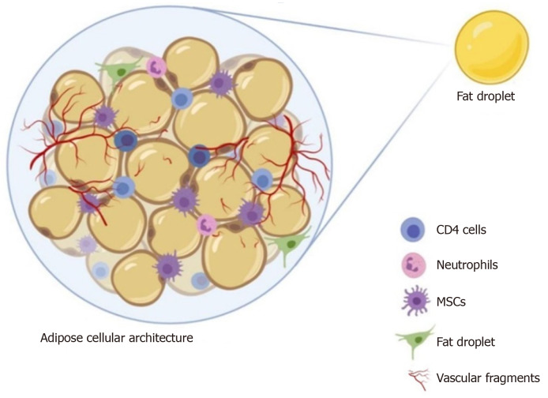
Figure 1 – Structure of Adipose Tissue (1)
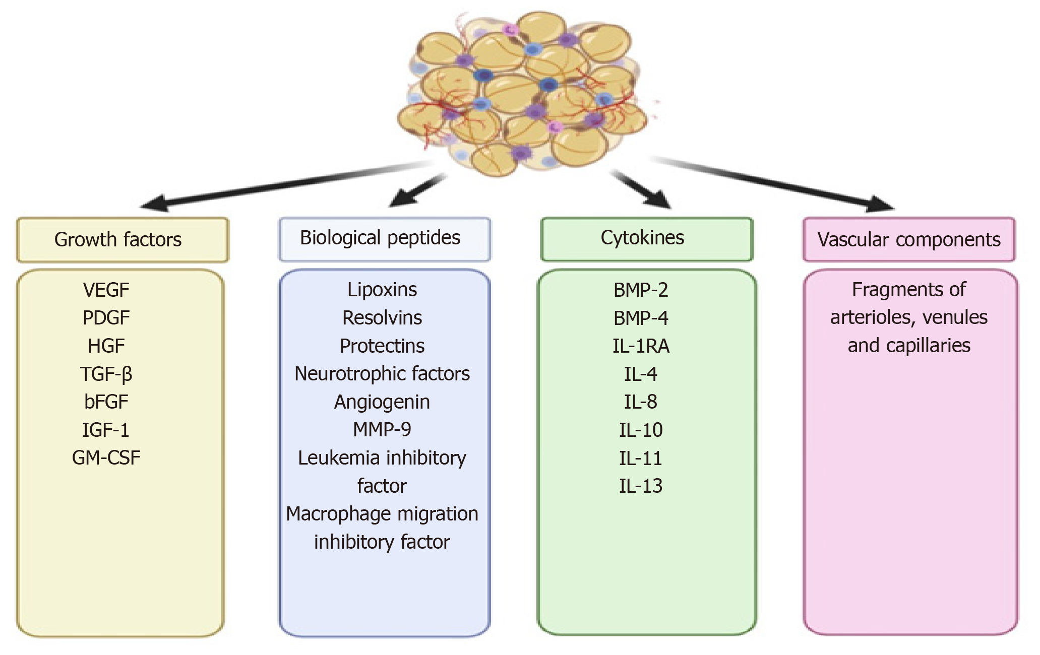
Figure 2 – Composition of Nanofat (1)

1.3 Processing of Nanofat
During fat processing, the obtained fat is cleaned of fluid, blood, cell fragments, and oil. By removing these agents, the remaining fat becomes more suitable for injection and future fat graft take. There are numerous techniques available for the processing following fat harvesting which are listed below. (8)
- Gravity separation (also known as decanting or sedimentation)
- Centrifugation,
- Cotton gauze rolling,
- Washing and filtering systems
Tonnard described a preparation protocol for harvesting nanofat (Figure 3), which included infiltrating the lower abdomen with a modified Klein solution (lidocaine 800 mg/L and adrenaline 1:1000000) before harvesting adipose tissue with a multiport 3 mm cannula with sharp side holes of 1 mm in diameter. (1)
The emulsified adipose tissue was filtered once more through a sterile nylon cloth, and the effluent was collected in a sterile container labelled "nanofat". When compared to enzymatic breakdown of adipose tissue, nanofat preparation minimises processing time, cost, and regulatory constraints.
Ferraro et al. found that centrifugation at more than 50 g caused structural damage to adipose tissue, increased necrosis and death of cells, decreased adipogenic differentiation capability, and decreased tubule formation. (9)
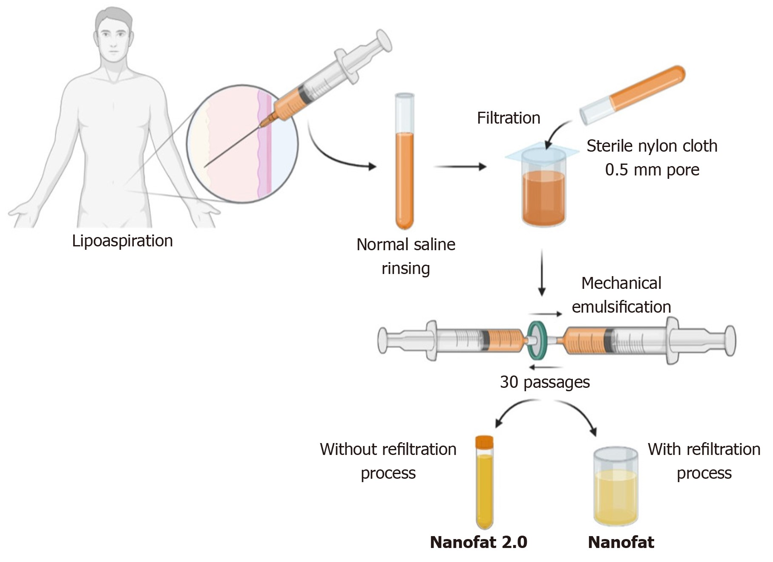
Figure 3 – Preparation of Nanofat (1)
1.4 Mechanisms of Action
Nano fat therapy works through three fundamental mechanisms: cell replacement, paracrine signaling, and ECM remodeling

1.4.1 Cell Replacement
Nano fat is rich in MSCs and pre-adipocytes, which have the ability to differentiate into various cell types, including adipocytes, fibroblasts, and endothelial cells. When injected into the target tissue or organ, these cells can replace damaged or lost cells, promoting tissue regeneration and functional restoration.

1.4.2 Paracrine Signaling
Nano fat secretes a diverse array of growth factors, cytokines, and chemokines that exert paracrine effects on neighboring cells. These factors stimulate cell proliferation, angiogenesis, and immune modulation, creating a favorable microenvironment for tissue repair and regeneration.

1.4.3 ECM Remodeling
The ECM components present in nano fat, such as collagen and elastin, play a crucial role in providing structural support and promoting tissue remodeling. Upon injection, these components contribute to restoring the architecture and integrity of damaged tissues, facilitating proper functionality.

1.5 Applications of Nano Fat Therapy in Regenerative Medicine
Nano fat therapy has shown promising results in various areas of regenerative medicine. The following sections highlight its applications in different medical fields.

1.5.1 Cosmetology
Nano fat, when injected into facial tissues, provides specific benefits in terms of facial rejuvenation and skin regeneration. The growth factors and ECM components present in nano fat stimulate collagen production, improve skin elasticity, and reduce the appearance of wrinkles and fine lines. Additionally, the regenerative properties of nano fat promote angiogenesis, improving blood flow and nourishment to the tissues, thereby enhancing the overall quality and texture of the skin.
Nanofat grafting is also used to improve the appearance of dark circles, malar bags, sunken eyes, and blepharoplasty. (1) Because of its biocompatibility, lack of immunogenicity, and availability, fat graft is regarded as the best soft tissue filler. (2)

1.5.2 Wound Healing and Scar Reduction
Nano fat therapy has demonstrated remarkable results in promoting wound healing and reducing scar formation. The regenerative components of nano fat facilitate tissue regeneration, accelerate the healing process, and minimize scar tissue formation. The paracrine signalling and ECM remodelling effects help modulate the inflammatory response, enhance neovascularization, and promote collagen remodelling, resulting in improved wound closure, reduced scarring, and enhanced functional recovery.
Nanofat grafting underneath and into the scar's substance improves the scar's quality, integrity, and texture, which improves scar tone, texture, thickness, elasticity, flexibility, and color while decreasing scar size as well. Autologous emulsified nanofat injection is a simple, outpatient surgical method for scar repair with limited issues and high patient satisfaction. It relieves the symptoms as well as the texture of all sorts of scars. In patients with significant facial burn scars, where other therapeutic choices are restricted, nanofat grafting is a potential approach. (10) It can also be utilised to improve existing surgical treatment by having regenerative effects on the treated area and preventing contracture and adhesion during post operative period. (11)

1.5.3 Orthopaedic Injuries and Musculoskeletal Conditions
Nano fat therapy has shown promising results in treating orthopaedic injuries and musculoskeletal conditions, such as osteoarthritis, tendinopathies, and cartilage defects. The regenerative properties of nano fat aid in tissue repair and regeneration by stimulating the proliferation and differentiation of MSCs into chondrocytes and osteoblasts. This promotes cartilage and bone formation, leading to pain reduction and functional improvement.
The study performed by Chen et al demonstrated that Nanofat exerted anti osteoarthritis efficacy by ameliorating joint pain symptoms and preventing cartilage degradation of OA rats through paracrine-based actions on anabolic, catabolic, and hypertrophic molecules of chondrocytes (12)
Because of the multi-differentiation capability of adipose tissue, it might be extrapolated for use in avascular necrosis of the bone, mild to moderate grades of osteoarthritis, tendinopathies, and fracture non-union. (1)

1.6 Fate of Nanofat Graft
When adipose tissue is transplanted, it is transferred, perivascular ASCs play a significant role in fat graft revascularization, which release angiogenic factors in response to ischemia. To achieve optimal graft revascularization, each fat graft droplet (G) must engage with a capillary recipient site (R) in a 1:1 ratio to generate a successful fat-recipient (GR) complex. More fat droplets than capillary recipient sites will result in insufficient neoangiogenesis, which is assumed to be the cause of fat resorption and necrosis. It was first reported by Khouri and Khouri, is known as the Stoichiometry Principle of Fat Grafting. (13)
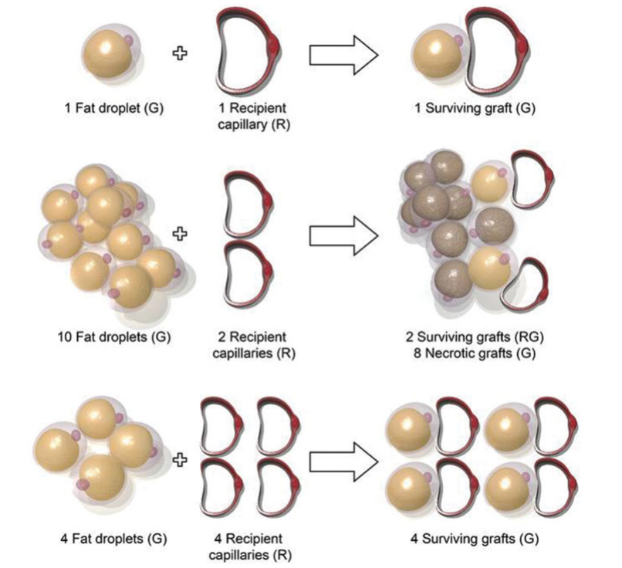
Fig 4- Stoichiometry principle of fat grafting (13)

1.7 Theories of Fat Graft Survival
At present, many hypotheses have been proposed to explain how fat grafts survive following avascular surgical implantation. (14)

1.7.1 Graft Survival Theory
According to this theory, first published by Peer et al, fat grafts survive following surgical transfer by nutrition diffusion from the plasma until neovascularization from the recipient location develops. Smaller volume grafts may thus fare better than larger volume grafts in terms of survival, because smaller volumes are better adapted to ensure complete diffusion and perfusion.

1.7.2 Graft Replacement Theory
According to this view, relatively few donor adipocytes survive the grafting procedure; instead, grafted adipocytes are substantially replaced by donor ASCs that are transported concurrently in the graft.

1.7.3 Host Cell Replacement Theory
This idea holds that no transplanted cells survive and that all cells are replaced by recipient cells. Grafted cells die and are replaced by fibrous tissue, new fat cells, and blood vessel ingrowth from the recipient tissue. As a result, the recipient site's integrity and environment are important factors of graft survival.

1.7.4 Three-Zone Survival Theory
For a few days until revascularization, the transplanted non-vascularized adipose tissue is placed under ischemia (hypoxia) and fed only by plasmatic diffusion from the surrounding host tissue. Many adipocytes die within 24 hours, and various cell death and injury-associated factors are released from dying donor tissue and injured host tissue. Inflammatory cells, such as macrophages and lymphocytes, infiltrate and secrete inflammatory cytokines, such as interleukins. Despite the death of adipocytes, ASCs are activated and try to heal the injured tissue in collaboration with infiltrating stem and progenitor cells from the bone marrow, which can be functional for up to 72 hours even in acute ischemia. (15)
According to Eto et al (16) theory 2012, when avascular fat is transported, it can be separated into three cellular zones. The survival zone, which is less than 300 m thick and contains adipocytes and ASCs that survive after grafting, is the most peripheral zone.
The regenerative zone, which is 600 to 1,200 m thick, is directly beneath the survival zone. Adipocytes perish and are resorbed in this environment, whereas ASCs survive and regenerate into new adipocytes. The central necrotic zone is the deepest zone, where no cells survive due to hypoxia. There is no regeneration in this zone, and the dead area is either resorbed or filled with fibrosis. (16)
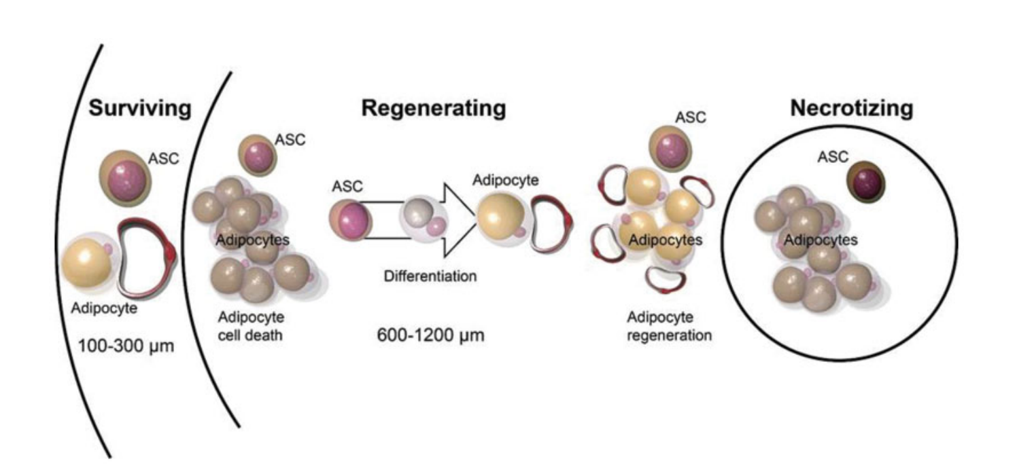
Fig 5- Three-Zone Survival Theory (13)

1.8 Complication of Nanofat Therapy

While nanofat injections for facial rejuvenation are generally considered safe, there are potential complications that can occur. These complications may vary depending on individual factors and the specific procedure performed. Some possible complications include:

1. Bruising and swelling: These are common side effects of any injection procedure and usually subside within a few days or weeks.

2. Infection: Anytime a needle or cannula is inserted into the skin, there is a risk of infection. Strict sterile techniques should be followed to minimize this risk.

3. Allergic reactions: Some individuals may have allergies to the materials used in the nanofat processing or injection. It is important to discuss any known allergies with the practitioner before the procedure.

4. Contour irregularities: Improper injection technique can result in uneven distribution of the nanofat, leading to contour irregularities in the face. This can typically be corrected with further injections or other cosmetic procedures.

5. Nerve damage: There is a small risk of nerve damage during the injection process, which can lead to temporary or permanent numbness or loss of sensation in the facial area. Proper training and expertise in facial anatomy are important to minimize this risk.

6. Hematoma: In some cases, blood vessels can be damaged during the injection
process, leading to the accumulation of blood under the skin, known as a hematoma. Hematomas may require drainage if they are large or cause discomfort.

7. Fat embolism: In rare cases, injected fat can enter the bloodstream and travel to other parts of the body, causing a fat embolism. This can be a serious complication that requires immediate medical attention.

8. Overcorrection or under correction: Achieving the desired results with nanofat injections requires skill and experience. There is a risk of either overcorrection or under correction, resulting in an unnatural appearance or unsatisfactory outcomes.

9. Granulomas or cysts: Small, filled bumps or cysts may form under the skin as a result of the injections. These are typically benign but may require additional treatment or removal.

10. Asymmetry: In some cases, the results of nanofat injections may result in facial asymmetry, where one side of the face appears different from the other. This can typically be corrected with further treatments or adjustments.

1.9 Advantages and Limitations of Nano Fat Therapy
Nano fat therapy offers several advantages over traditional regenerative approaches. It is minimally invasive, utilizing the patient's own tissue for harvesting, thereby reducing the risk of immune rejection or allergic reactions. Moreover, nano fat is readily available, as adipose tissue is abundant in most individuals. The nanoscale processing of the fat maximizes its regenerative potential by concentrating the beneficial cellular and molecular components.

However, there are certain limitations to consider. Nano fat therapy is still a relatively new field, and further research is needed to optimize the processing techniques and standardize the protocols. Long-term outcome studies are required to establish the efficacy and durability of the therapy. Additionally, regulatory approvals and cost considerations may limit its availability in certain healthcare settings.

Conclusion
Nano fat therapy represents an exciting frontier in regenerative medicine, offering a promising solution for tissue repair and regeneration. Its unique composition, consisting of MSCs, pre-adipocytes, growth factors, and ECM components, enables cell replacement, paracrine signaling, and ECM remodeling. The applications of nano fat therapy span across multiple medical fields, including facial rejuvenation, orthopedic injuries, wound healing, and scar reduction. While nano fat therapy has its advantages, further research is needed to fully understand its potential and optimize its use in clinical practice. Nevertheless, the development of nano fat therapy holds great promise for advancing regenerative medicine and improving patient outcomes.

References
- Jeyaraman M, Muthu S, Sharma S, Ganta C, Ranjan R, Jha SK. Nanofat: A therapeutic paradigm in regenerative medicine. World J Stem Cells. 2021 Nov 26;13(11):1733-1746. doi: 10.4252/wjsc. v13.i11.1733. PMID: 34909120; PMCID: PMC8641019.
- Xue EY, Narvaez L, Chu CK, Hanson SE. Fat Processing Techniques. Semin Plast Surg. 2020 Feb;34(1):11-16. doi: 10.1055/s-0039-3402052. Epub 2020 Feb 15. PMID: 32071574; PMCID: PMC7023966.
- Tonnard P, Verpaele A, Peeters G, Hamdi M, Cornelissen M, Declercq H. Nanofat grafting: basic research and clinical applications. Plast Reconstr Surg. 2013 Oct;132(4):1017-1026. doi: 10.1097/PRS.0b013e31829fe1b0. PMID: 23783059.
- Sesé B, Sanmartín JM, Ortega B, Matas-Palau A, Llull R. Nanofat Cell Aggregates: A Nearly Constitutive Stromal Cell Inoculum for Regenerative Site-Specific Therapies. Plast Reconstr Surg. 2019 Nov;144(5):1079-1088. doi: 10.1097/PRS.0000000000006155. PMID: 31454336; PMCID: PMC6818980.
- Shih L, Davis MJ, Winocour SJ. The Science of Fat Grafting. Semin Plast Surg. 2020 Feb;34(1):5-10. doi: 10.1055/s-0039-3402073. Epub 2020 Feb 15. PMID: 32071573; PMCID: PMC7023968.
- Mashiko T, Yoshimura K. How does fat survive and remodel after grafting? Clin Plast Surg. 2015 Apr;42(2):181-90. doi: 10.1016/j.cps.2014.12.008. Epub 2015 Jan 29. PMID: 25827562.
- Copcu HE, Oztan S. Not Stromal Vascular Fraction (SVF) or Nanofat, but Total Stromal-Cells (TOST): A New Definition. Systemic Review of Mechanical Stromal-Cell Extraction Techniques. Tissue Engineering and Regenerative Medicine. 2021 Feb;18(1):25-36. DOI: 10.1007/s13770-020-00313-0. PMID: 33231864; PMCID: PMC7862455.
- Xue EY, Narvaez L, Chu CK, Hanson SE. Fat Processing Techniques. Semin Plast Surg. 2020 Feb;34(1):11-16. doi: 10.1055/s-0039-3402052. Epub 2020 Feb 15. PMID: 32071574; PMCID: PMC7023966.
- Strong AL, Cederna PS, Rubin JP, Coleman SR, Levi B. The Current State of Fat Grafting: A Review of Harvesting, Processing, and Injection Techniques. Plast Reconstr Surg. 2015 Oct;136(4):897-912. doi: 10.1097/PRS.0000000000001590. PMID: 26086386; PMCID: PMC4833505.
- Bhooshan LS, Devi MG, Aniraj R, Binod P, Lekshmi M. Autologous emulsified fat injection for rejuvenation of scars: A prospective observational study. Indian J Plast Surg. 2018 Jan-Apr;51(1):77-83. doi: 10.4103/ijps.IJPS_86_17. PMID: 29928084; PMCID: PMC5992940.
- Al-Hayder S, Gramkow C, Trojahn Kølle SF. Use of autologous fat grafting for the correction of burn scar contracture in the hand: a case report. Case Reports Plast Surg Hand Surg. 2017 Aug 24;4(1):81-83. doi: 10.1080/23320885.2017.1369883. PMID: 28971111; PMCID: PMC5613903.
- Chen Z, Ge Y, Zhou L, Li T, Yan B, Chen J, Huang J, Du W, Lv S, Tong P, Shan L. Pain relief and cartilage repair by Nanofat against osteoarthritis: preclinical and clinical evidence. Stem Cell Res Ther. 2021 Aug 26;12(1):477. doi: 10.1186/s13287-021-02538-9. PMID: 34446107; PMCID: PMC8390235.
- Shih L, Davis MJ, Winocour SJ. The Science of Fat Grafting. Semin Plast Surg. 2020 Feb;34(1):5-10. doi: 10.1055/s-0039-3402073. Epub 2020 Feb 15. PMID: 32071573; PMCID: PMC7023968.
- Doornaert M, Colle J, De Maere E, Declercq H, Blondeel P. Autologous fat grafting: Latest insights. Ann Med Surg (Lond). 2018 Oct 16;37:47-53. doi: 10.1016/j.amsu.2018.10.016. PMID: 30622707; PMCID: PMC6318549.
- Mashiko T, Yoshimura K. How does fat survive and remodel after grafting? Clin Plast Surg. 2015 Apr;42(2):181-90. doi: 10.1016/j.cps.2014.12.008. Epub 2015 Jan 29. PMID: 25827562.
- Eto H, Kato H, Suga H, Aoi N, Doi K, Kuno S, Yoshimura K. The fate of adipocytes after nonvascularized fat grafting: evidence of early death and replacement of adipocytes. Plast Reconstr Surg. 2012 May;129(5):1081-1092. doi: 10.1097/PRS.0b013e31824a2b19. PMID: 22261562.

