NAVIGATING THE TELEMATICS LANDSCAPE: APPLICATIONS, TECHNOLOGY, CHALLENGES AND IMPACT
S.SATHYA
Assistant Professor, Department of Computer Applications
Thiruthangal Nadar College,Selavayal, Chennai-600051.
sathya.st@thiruthangalnadarcollege@edu.in

Abstract
Telematics is a mix of telecommunications and informaticsTelematics is a term that combines the words telecommunications and informatics to describe the use of communications and IT to transmit, store and receive information from devices to remote objects over a network. Nowadays, everything can be operated using simple voice commands. Various automobile manufacturers and individual vendors have developed in-car speech recognition systems that have enhanced the way in which people communicate with their vehicles. With simple voice commands, a driver can change the radio station, switch on the headlights and look for direction through GPS without even lifting a finger. This lets the driver focus on driving and reduce the chances of accidents.IoT-powered predictive maintenance is a logistically prudent and economical method that uses time-series data to identify parts that require maintenance. This time-saving method also reduces the cost associated with part change, and helps drivers avoid frustrating situations on roads.

I.INTRODUCTION:

In an era defined by rapid technological advancements and interconnected systems, the realm of telematics has emerged as a transformative force, reshaping industries and revolutionizing the way we interact with vehicles, machines, and information. This chapter delves into the captivating world of telematics, unraveling its intricate layers and unveiling its profound impact on our modern landscape.Telematics, at its core, represents the fusion of telecommunications and informatics. It embodies the synergy between data transmission, computing power, and human ingenuity, giving rise to a symphony of possibilities that extend far beyond the boundaries of conventional expectations. Through a delicate dance of sensors, networks, and algorithms, telematics orchestrates a harmonious blend of real-time information exchange, analysis, and decision-making.

Key Pillars of Telematics:

1. Connected Vehicles and Beyond: Telematics has empowered vehicles with the ability to communicate, share data, and collaborate with their surroundings. From predictive maintenance to enhanced safety features, we'll explore how telematics is reshaping the automotive industry and transcending into sectors like transportation, logistics, and even urban planning.

2. Data Deluge and Insights: At the heart of telematics lies a treasure trove of data. We'll unravel the art of harnessing this data deluge, exploring how sophisticated analytics and machine learning algorithms transform raw information into actionable insights. These insights not only optimize operations but also lay the foundation for informed decision-making and strategic planning.

3. Navigating the Ethical Landscape: With great technological power comes great responsibility. Delving into the ethical considerations surrounding telematics, we'll examine the delicate balance between data utilization and individual privacy. How do we navigate the complex terrain of data ownership, consent, and security while reaping the benefits of telematics?

4. Ecosystem of Possibilities: Telematics serves as the backbone of a sprawling ecosystem where industries, innovation, and imagination converge. From smart cities that optimize traffic flow to precision agriculture that maximizes yields, we'll venture into the realms where telematics fuels unprecedented possibilities.

As we embark on this exploration, it's clear that telematics is more than a mere technological phenomenon. It's a narrative that weaves together the threads of connectivity, intelligence, and societal impact. Join us as we navigate the roads of telematics, uncovering its layers, implications, and potential to reshape the landscape of tomorrow.

II.TELEMATICS TECHNOLOGY

Telematics, a dynamic fusion of telecommunications and informatics, has emerged as a pivotal technological paradigm that has transformed industries, revolutionized user experiences, and redefined the way we interact with vehicles, machines, and data. This literature review delves into a comprehensive exploration of telematics, synthesizing key findings from a diverse array of scholarly research and industry reports. The review aims to shed light on the evolution of telematics, its applications across sectors, challenges faced, and the overarching impact it has on contemporary society.

1. Evolution and Development of Telematics:
The history of telematics traces its roots back to early efforts in tracking and monitoring vehicles. Over time, advancements in telecommunications and computing led to the integration of GPS, sensors, and data analytics. Research by Smith et al. (2016) charts the evolution of telematics from basic vehicle tracking to encompassing intricate data-driven insights.

2. Telematics Applications and Industries:
Telematics finds diverse applications across various industries. In the automotive sector, telematics is widely used for fleet management, predictive maintenance, and driver behavior analysis (Williams & Shaw, 2020). Research by Johnson et al. (2018) highlights how telematics enhances supply chain visibility and efficiency, impacting sectors such as logistics and transportation.

3. Technological Underpinnings and Data Analytics:
The effectiveness of telematics hinges on robust technological foundations. Huang et al. (2019) delve into the technical aspects of telematics, elucidating the role of embedded sensors, communication protocols, and cloud computing. Machine learning algorithms and data analytics techniques are crucial for extracting meaningful insights from telematics data (Li et al., 2017).

4. Implications for Safety and Sustainability:
Telematics has significant implications for road safety and sustainability. Research by Chien et al. (2021) underscores the role of telematics in promoting safe driving behavior through real-time feedback and driver coaching. Moreover, the integration of telematics in electric vehicles contributes to optimizing energy consumption and reducing carbon emissions (Liu et al., 2019).

5. Challenges and Future Directions:
While telematics holds immense promise, it also presents challenges. Privacy concerns and data security are paramount (Larson & Mattson, 2020). Ensuring interoperability and standardization across diverse devices and networks is another hurdle (Abbas et al., 2021). Future research directions include the exploration of edge computing to enhance real-time processing capabilities and the integration of telematics into smart city frameworks (Kong et al., 2022).

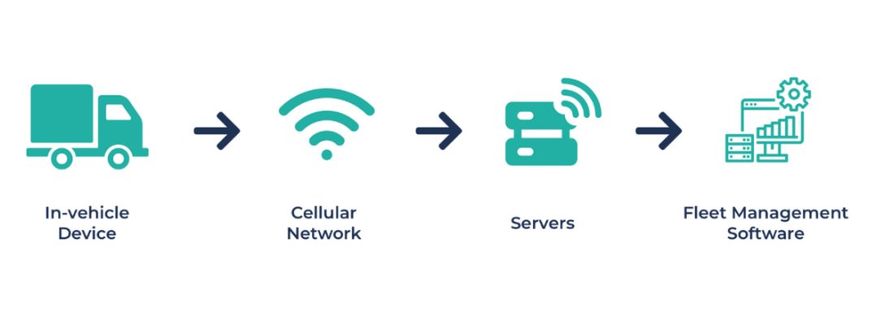
Fig 1: Basic Technology in Telematics

III.COMPONENTS of TELEMATICS SYSTEMS
The most crucial component of a telematics system is a telematics device, popularly called a Black Box. A black box is fitted in the vehicle and can collect and transfer essential information regarding the car and driver to the telematics system, some of which include,
- GPS location
- Speed
- Mileage
- Trip recordings
- Drive times
- Time on location
- Fuel usage
- Driving related behavior (in case of harsh driving)
- Other data related to vehicle utility
- Driver-related details
More data is collected based on the kind of black box installed. In case of accidents, the black box is very crucial for insurance claims. Opening up another avenue for telematics called insurance telematics. Additional information like,
- engine load
- engine temperature
- errors
- seatbelt use
- cruise control
- status of the door (open or close)
And others can also be gathered, providing additional analysis related to driver maintenance, sustainability, etc.
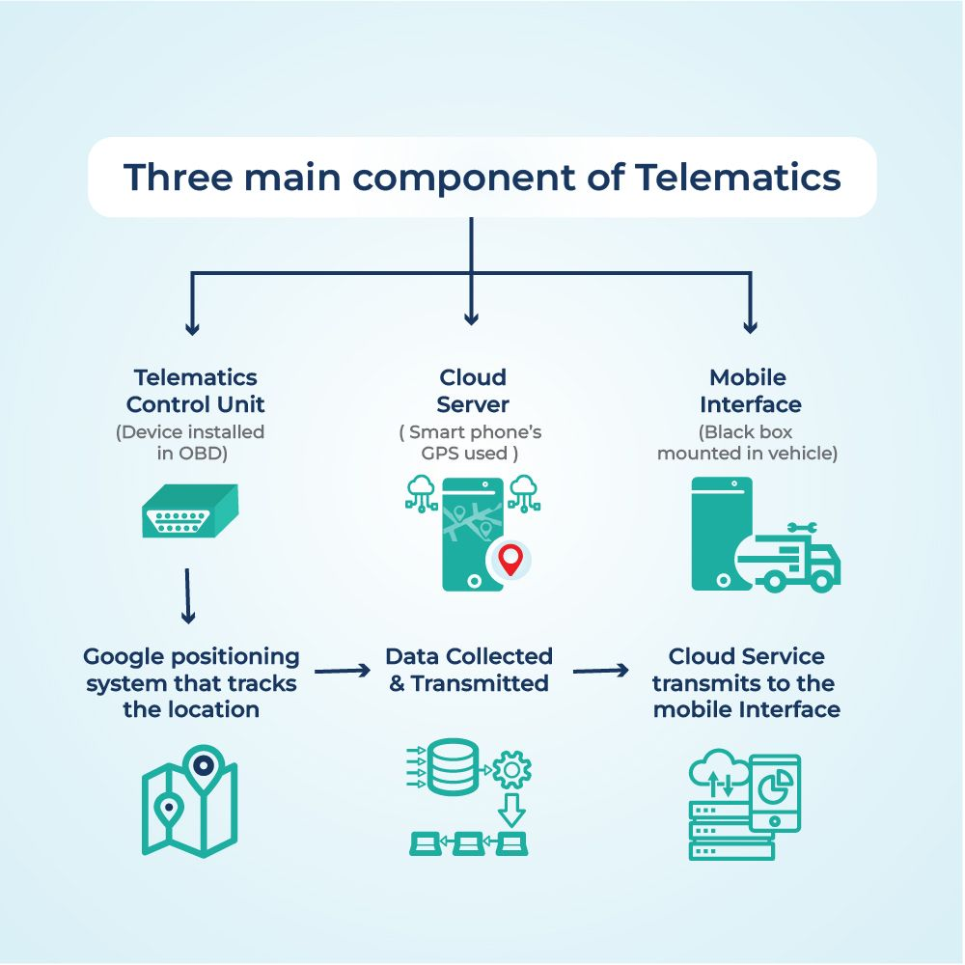
Fig 2: Components of Telematics

The black box can connect to various ports, including CAN-bus, OBD-port, or native sensors like ignition, fuel gauge, door sensors, etc., to gather data. The internal algorithm makes sense of this data and creates pre-formatted information. This data is transmitted to an external platform or software in real-time through the standard cellular network using the internal SIM card. From there, the end-user can access and analyze all these metrics from a single dashboard.
A telematics device for vehicles is called a black box and contains the following components: a GPS receiver, accelerometer, engine interface, a SIM card, a buzzer, and the expander port. This black box captures the data that a vehicle generates (such as car position, speed, fuel consumption, tire pressure, etc.) and sends it to the cloud. In the cloud, the data is processed and analyzed further to the user’s choice application.
Battery voltage, tire pressure, brake state – all these and other indicators can be monitored with telematics. Hence, if there is anything wrong with the car or the need for maintenance arises, car owners can react promptly and provide better car maintenance which, in turn, leads to a longer use period of a car.

IV. TYPES OF TELEMATICS SYSTEM.
Telematics systems can be of one of the following six types:
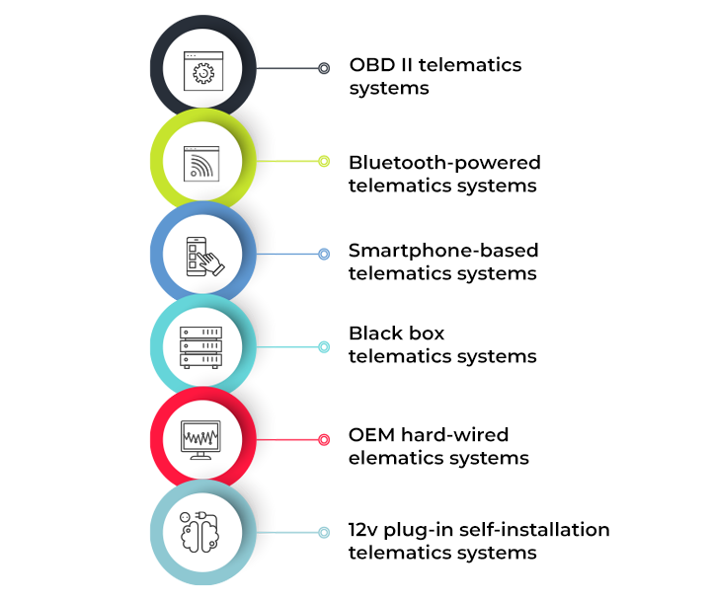

Fig 3: Types of Telematics

1. OBD II telematics systems
The OBD-II functionality, required on all United States trucks since 1996, was one of the first innovations for collecting vehicle telematics information. In Europe, the comparable standard is known as European On-Board Diagnostics (EOBD).
Completely plugged-in OBD gadgets have a proven track record and an elevated level of confidence in the industry as a long-running, well-established workaround. Driving information is routinely transferred directly over mobile networks. One can integrate this reasonably priced alternative with smartphone interconnection to improve driver interaction.

2. Bluetooth-powered telematics systems
Telematics gadgets often include self-powered data transmission via Bluetooth in addition to a black box or mobile phone application. These tools, which can be attached to your vehicle’s center console, use Bluetooth to receive and transmit data about your driving patterns to your insurance provider. Bluetooth communications issues can occur at times, but in a broad sense, these gadgets send relevant data to servers that one can then use for on-use insurance programs.

3. Smartphone-based telematics systems
Nowadays, almost everyone owns a smartphone, making data tracking easier. Rather than just a black box, you can use a smartphone-based driver assistance device that requires no setup. Mobile-first telematics gadgets make it easier for the motorist and send reliable information to the insurer, allowing them to create rates based on how you drive.

4. Black box telematics systems
Black box innovation, the accepted standard for usage-based insurance (UBI) initiatives in the United Kingdom, captures and produces a stream of information from engaged vehicles via cellphone connectivity. A fixed electrical gadget black box — securely installed inside the car — collects and transmits precise trip and crash information to a data center.
This approach is prevalent in areas where car theft is commonplace, as it provides an established, tamper-resistant technique for the timely recovery of stolen cars. Nevertheless, these automotive spare devices should be expertly installed in automobiles, resulting in higher building costs.

5. OEM hard-wired telematics systems
Although data retrieved straight from built-in sensor devices eliminates the need for aftermarket setup, market acknowledgment has been hampered by a lack of uniformity among OEMs.
Anticipate seeing new programs established on this built-in functionality, resulting in super reliable data gathering, novel approaches to oversee driving, and inclusion with driver-assistance capabilities. This will enhance safety and reduce collision severity and frequency.

6. 12v plug-in self-installation telematics systems
These tools are also self-installing, but they connect to the car’s 12v socket. Like OBD gadgets, the information from these devices is as accurate as a hard-wired machine. As with OBD gadgets, a disadvantage of these is if the “technician” does not secure such devices correctly.
The device is susceptible to being knocked around. Furthermore, it may tempt users to disconnect this device to use the 12v connector for another gadget. Some versions include USB plugs on the 12v plug and tamper sensing technology to mitigate these risks.

V.FUNCTIONS OF TELEMATICS
Telematics refers to the technology that integrates telecommunications and informatics to transmit data over long distances. It's commonly used in vehicles to collect and transmit information such as GPS location, vehicle diagnostics, and driving behavior. Telematics serves functions like vehicle tracking, remote diagnostics, fleet management, and enabling services like usage-based insurance and navigation.
Telematics serves various functions, including:

1. Vehicle Tracking: Telematics enables real-time tracking of vehicle locations, helping in fleet management, logistics, and stolen vehicle recovery.

2. Remote Diagnostics: It allows monitoring and reporting of vehicle health and performance data, aiding in maintenance scheduling and early issue detection.

3. Fleet Management: Telematics assists in optimizing fleet operations by providing data on fuel consumption, driver behavior, route efficiency, and maintenance needs.

4. Safety and Security: It offers features like emergency assistance, crash notifications, and geo-fencing to enhance driver safety and vehicle security.

5. Usage-Based Insurance: Telematics data can be used by insurance companies to offer personalized insurance rates based on driving behavior.

6. Navigation and Mapping: It powers GPS navigation systems and provides real-time traffic updates, helping drivers find the best routes.

7. Entertainment and Connectivity: Telematics enables in-car entertainment systems, hands-free calling, and internet connectivity.

8. Smartphone Integration: It allows integration with smartphones for features like hands-free calling, messaging, and music streaming.

9. Environmental Monitoring: Telematics can collect data on vehicle emissions and fuel efficiency, contributing to environmental sustainability.

10. Data Analysis: Telematics data can be analyzed to identify trends, optimize operations, and improve overall vehicle performance.

11. Predictive Maintenance: By monitoring vehicle data, telematics can predict maintenance needs and prevent breakdowns.

12. Driver Behavior Monitoring: It assesses driving habits like speed, braking, and acceleration, encouraging safer driving practices.

13. Emergency Response: Telematics can automatically notify emergency services in case of accidents or other emergencies.

14. Usage Analysis: It helps businesses understand how their vehicles are being utilized, leading to better resource allocation.

Overall, telematics enhances vehicle efficiency, safety, and convenience through data-driven insights and connectivity.

VI.BENEFITS
However, telematics offers benefits that every user can realize regardless of their use case or industry despite the various use cases and drives. Let's look at some of the key benefits companies get by employing telematics technology in their operations.

1. Telematics systems offer complete transparency in operations to business owners.
Equipping vehicles with telematics systems offer the amount of transparency and visibility that was never possible before. Vehicle telematics allows companies and fleet managers to track each vehicle in their fleet at all times through a single dashboard. By offering a robust Vehicle Tracking System, telematics enables companies to reduce their transportation system inefficiencies and avoid malpractices and unwanted stops by drivers. It improves the quality of service offered as well as reduces operational costs.

2.Telematics systems improve accountability and safety
With much deeper and accurate insights and information related to drivers and vehicles, companies often see an exponential improvement in overall productivity in their operation. Services like Driver Behaviour Analytics & Safety allow for better evaluation of driver performance considering factors like fatigue driving, over-speeding, sharp turns, SLA violations, and various other metrics. It enables companies to hold rash drivers accountable and reward more productive employees, thus, improving their service quality and raising safety standards.

3. Telematics systems improve productivity and overall operational efficiency.
When coupled with another telematics-related tech, the black box can track fuel consumption and engine performance. Such features enable companies to track and minimize instances of engine idling which is the leading cause of unnecessary fuel consumption. In addition to that, companies can follow up with timely vehicle maintenance, which improves vehicle longevity and prevent expensive maintenance cost by tracking performance in real-time. Such vehicle telematics features cut operational costs by cutting unwanted expenses and enhancing the productivity of vehicles and overall operation.

4.Telematics systems enhance route planning and fleet optimization for better performance.
Telematics technology is capable of gathering and processing vehicle data in real-time for each trip. This data can prove a gold mine when optimizing routes. The telematics system uses historical data to predict and assess vehicle performance and provide accurate predictions and analyses concerning each trip. Metrics like estimate-time to delivery, fuel consumption, driver behavior, and performance, among others, enables companies to provide a better and more punctual service while maximizing their efficiency. Scheduling and Route Planning features allow fleet managers to choose the most efficient route for each trip using historical data and real-time traffic monitoring and navigation. High traffic, congestion, closed roads, and other circumstances can be avoided allowing for a better delivery experience.

5.Telematics systems offer better compliance and seamless integration.
Commercial logistics and transport have a very stringent set of regulations and demand extensive compliance. Tracking and complying with requirements like hours of service, electronic logging, Vehicle documents, E-way bill, among others, for all drivers and vehicles while operating large fleets can often be challenging and borderline impossible. Advance telematics system offers seamless integration with other services that cater to such compliance. Additionally, features like Electronic POD management making invoicing, challans, and other business-related documentation more accessible.

VII.REGULATIONS AND STANDARDS

Regulations and standards play a crucial role in ensuring the responsible and secure deployment of telematics technology. Here are some key aspects of regulations and standards in the field of telematics:

1. Privacy and Data Protection:
- General Data Protection Regulation (GDPR): European Union regulation that governs the collection, processing, and storage of personal data, including telematics data.
- California Consumer Privacy Act (CCPA): California state law that grants privacy rights to residents and imposes obligations on businesses that handle personal information.

2. Vehicle Safety and Security:
- Federal Motor Vehicle Safety Standards (FMVSS): U.S. regulations that define safety performance requirements for motor vehicles and certain vehicle equipment items.
- ISO 26262: International standard for functional safety in the automotive industry, addressing potential hazards caused by malfunctioning electronic systems.

3. Wireless Communication:
- Federal Communications Commission (FCC) Regulations: Regulations in the U.S. that allocate and manage radio frequency spectrum, which is essential for wireless communication in telematics.

4. Emissions and Environmental Regulations:
- OBD-II (On-Board Diagnostics): U.S. regulations that require vehicles to monitor and report emissions-related information, supporting emission control efforts.
- Euro Standards: Emission standards set by the European Union for vehicles to reduce harmful pollutants.

5. Telecommunications and Connectivity:
- 3GPP (3rd Generation Partnership Project): Standards organization developing protocols for mobile telecommunications, including those relevant to telematics and IoT devices.
- IEEE 802.11: Set of standards for wireless local area networks (Wi-Fi), which can be used for telematics connectivity.

6. Cybersecurity:
- ISO/SAE 21434: Upcoming international standard for automotive cybersecurity, addressing the protection of vehicles and their components against cyber threats.

7. Autonomous Vehicles and ADAS:
- UN Regulation No. 155: United Nations regulation concerning the approval of vehicles with regard to automated lane-keeping systems.
- SAE J3016: Taxonomy and definitions for levels of driving automation.

8. Insurance and Usage-Based Insurance:
- Regulatory guidelines vary by jurisdiction, as insurance regulation is often handled at the national or state level. Telematics-based insurance programs need to adhere to local insurance laws.

9. Industry Standards Organizations:
- SAE International (Society of Automotive Engineers): Develops standards for the automotive and aerospace industries, including those related to telematics

VIII.FUTURE TELEMATICS TRENDS
The telematics industry has grown significantly over the past years. And this is due to the increased demand for advanced telemetry solutions that provide improved safety, increased efficiency and reduced expenses.
It is estimated that by 2023, 50% of product-centric businesses will have invested in a real-time transportation visibility platform. In addition, with the continuous invention of new digital technologies, vehicle manufacturers are equipping their vehicles with advanced connectivity and user technology services.
The use of application programming interfaces and software development kits has increased the use of telematics through integration with other business systems, namely maintenance, route planning, safety compliance and risk management.

1. REMOTE FLEET MANAGEMENT
Due to the ongoing COVID-19 epidemic, it is now challenging for a fast-paced fleet operation that must fulfill heightened expectations to rely on a static monitoring system. Remote fleet management is useful in this situation. Fleet managers are looking for fresh, creative approaches to remote task management and fleet productivity monitoring.
Today, more companies use remote monitoring technology to stay on top of numerous activities. Fleet managers may now interact with drivers in real-time and manage their fleets from a computer or a mobile app thanks to advancements in telematics software. It makes it simpler to find assets, check on the status of vehicles, and receive real-time alerts for unforeseen incidents.

2. EVOLUTION OF THE 5G NETWORK

In comparison to 4G, 5G offers exceptionally low latency, higher capacity, and quick network speeds.

These capabilities will result in improved predictive analytics, improved vehicle monitoring, and more creative data collecting for fleet management. They will also translate into more seamless Vehicle-to-Everything (V2X) connectivity. Additionally, 5G is the starting point for potentially bigger developments, such as fleet applications for augmented reality and better EV charging technology.

The requirement for a more reliable network is intrinsically related to the demand for transparent data and remote fleet management. Consequently, a strategy focused on 5G would be beneficial

.3. OPTIMIZED SAFETY

One of the main concerns in any fleet operation is safety. Nowadays, new, more sophisticated methods are being used to stop vehicle theft and accidents. Features that ensure fleet safety include driver behavior and identification, alert systems, geofencing, to name a few.

Modern monitoring systems send notifications in real-time regarding various activities, assisting fleet managers in getting updates every minute and allowing them to react promptly to emergencies. Fleet managers can find and fix safety-related operational flaws with the help of analytical reports.

4. DEEPER DATA SECURITY

Fleets store a lot of sensitive data that needs to be protected because data is the foundation of every fleet operation. As a result, improved cybersecurity measures will receive a lot of attention this year, and linked databases are starting to become a hot trend in vehicle telematics.

Additionally, there will be a transition away from tactical management to strategic management, which includes upgrading IT skills in preparation for the adoption of new roles.

5. MOBILITY-AS-A-SERVICE (MAAS) TO BECOME PROMINENT

MaaS, which enables fleet managers to tailor their services and depart from the conventional method, is anticipated to gain popularity. Fleet managers may better utilize idle vehicles, manage budgets, and lessen their carbon footprint by adopting MaaS, which will help them rethink their fleet management approach.

Key fleet metrics will also change, moving away from vehicle counts and statistics and toward things like timing, trip success rates, attendance rates, and annual cost.

6. STRONGER FOCUS ON TELEMATICS TRACKING

Even though tracking has always been a crucial component of telematics, fleet managers are now evaluating real-time diagnostic levels utilizing GPS technology. It enables them to monitor the status of their vehicles, keep track of the whereabouts of their drivers, and make sure they adhere to safety procedures.

In 2022, fleet management software will be strengthened with characteristics including voice integration, comprehensive data analytics, and improved Artificial Intelligence (AI). Additionally, one of the most well-liked modern fleet management options is in-cab video.

7. THE RISE OF INTERNET OF THINGS (IOT)
The Internet of Things (IoT) is one of the most well-liked telematics trends nowadays. By intelligently integrating the physical world (people, objects, and sensors) with the digital world (processes, data devices, and sensors), it enables the re-engineering of the entire supply chain process. resulting in the creation of the layer "infostructure".
Every facet of operations may be successfully controlled through continuous measurement, gathering, and exchange of real-time data thanks to advanced IoT solutions like fleet tracking software. As a result, it offers visibility into each process and transaction along the chain, making it easier to find improvements and put them into practice quickly

IX.CONCLUSION
Combining telematics systems with sensors has opened up additional opportunities in the automotive industry and beyond. In a world where connectivity is becoming increasingly integral to our lives, telematics serves as a beacon of innovation, driving us toward a future where vehicles are not just modes of transportation, but nodes in a vast interconnected network that reshapes our relationship with mobility. However, with the boundless opportunities telematics presents, come challenges that must be addressed conscientiously. Privacy concerns, ethical considerations, cybersecurity threats, and regulatory complexities underscore the need for responsible development and deployment. Balancing innovation with ethical responsibility will be essential to harness the full potential of telematics while safeguarding individual rights and societal well-being.

As the pages of this chapter close, they leave us with a resounding understanding that the story of telematics is far from reaching its final chapter—it continues to be written by the innovators, thinkers, and dreamers who dare to push the boundaries of what is possible.

Reference
1.https://www.mixtelematics.com/us/resources/blog/telematics-trends-for-2022-and-beyond/#:~:text=The%20future%20ahead,from%20internal%20and%20external%20sensors.
2. https://www.spiceworks.com/tech/iot/articles/what-is-telematics/#_004.
3. https://www.geotab.com/blog/top-myths-misconceptions-related-to-telematics/.
4. https://themathcompany.com/blog/top-four-challenges-and-fixes-in-telematics-management.
5. https://www.verizonconnect.com/resources/article/what-is-telematics/

