Understanding the Evolution of Augmented Reality and Virtual Reality in Online Retailing: A Bibliometric Analysis

¹Ms. Nikita, ²Dr. Ashish Saihjpal and ²Dr Rachita Sambyal
¹ Research Scholar, UBS, Panjab University, Chandigarh; nikita23kamboj@gmail.com; 9654324340
²Associate Professor, University Business School, Panjab University Regional Centre, Ludhiana; aksaihjpal@ubsludhiana.com
³ Assistant Professor, UIAMS, Panjab University, Chandigarh; rachita@pu.ac.in; 8968611335
Abstract
Augmented Reality (AR) and Virtual Reality (VR) are cutting-edge technologies that have acquired traction in a different industries, including online retailing. In retailing, these technologies have enhanced the shopping experience by integrating virtual elements like augumentation, media enrichment into the real world, allowing customers to visualize products in their own environments and engage them with a more immersive, interactive, and spatial enhanced experiences. By enhancing customer interactions, they have reshaped the way retailers operate and interact with customers. Thus, providing retailers a competitive edge. Experiencing the growing trend of AR/VR in online retailing, the objective of the study is to examine the AR and VR research in online retail including its antecedents, motivations, outcomes, theoretical foundations and moderating factors. The study undertook bibliometric analysis of 201 articles from Scopus database. The data was analysed using different techniques like keyword analysis, content analysis, co-citation analysis and co-occurrence analysis and thematic analysis. The study identified top top authors, countries, institutions etc. working on the AR & VR in retail. The thematic analysis identified two major themes from the literature relating to AR & VR. In the end the study proposed a research framework for future.
Keywords: Augmented Reality (AR), Virtual Reality (VR), Retailing, Bibliometric Analysis, Innovative technologies

I. Introduction

In recent times, the emergence and growth of online retailing have significantly influenced the customers’ buying intentions and their resulting experiences (Barta et al., 2023). Moreover, the recent digital revolution underway has helped retailers to have access to geographically dispersed consumer markets, build international supply chains and to swiftly respond to dynamic consumer behaviour (Al Hamli & Sobaih, 2023). With 57% of online shoppers planning to shop beyond their borders, online retailers need to adopt new technologies like augmented reality (AR), virtual reality (VR) to extend an overall immersive experience to the online shoppers. It is important to note that e-commerce format of retail has witnessed a dominant use of AR/VR followed by other formats of retail such as physical stores. The use of AR/VR in e-commerce segment accounted for 62.58 percent of the global market and was valued at 750 million US dollars in 2019. Region wise, North America is expected to offer profitable growth potential, but the Asia-Pacific area will grow at the quickest rate between 2022 and 2028 due to developing commercial markets, increased customer expectations, and increasing investments made by nations in this region (Valuates Reports, 2023).

Furthermore, it is also projected that the total market size of AR/VR in India will grow at a CAGR of 38.29% and is valued at US$ 14.07 billion by 2027. Fuelled by rising smart phone usage and broadened internet access, this trend is expected to stay. Therefore, it is expected that the global AR/VR market size will reach to US$ 250 billion by 2028 (India brand equity foundation, 2022). Recent studies have shown the influence of AR/VR in the retail sector by transforming consumer shopping behaviour, by making it more interactive, engaging, and personalised (Al Hamli & Sobaih, 2023; Yim, et al., 2017).

It is witnessed that implementing AR/VR in online retailing has the potential to enhance the customer experience. These technologies offer a wide range of benefits, such as enabling customers to try on virtual clothing, preview furniture in their own homes, or visualize how a product will look or function before making a purchase. It not only improvises customer experience but also helps retailers to reduce cost, access different consumer market, lending realism to online products hence, leading to increase in sales and rate of returns. AR/VR have capacity of shaping the future of retail by engaging the consumers in space which is an integration of real and virtual world (Hilken et al., 2017). The outcome of the study by Yim & Park (2019) states that the online consumers using the AR& VR based applications (apps) over the traditional apps were found to have more positive experiences.

II. Conceptualisation of Augmented Reality and Virtual Reality in Online Retailing

Augmented Reality (AR) has been defined by Habil et al., (2023) as “the technology that combines real and virtual objects in a real environment; runs interactively in real time and registers (aligns) real & virtual objects with each other”. AR is compatible with visual technology along with many other types of digital content or computer-generated input that mixes real imagery/environment and virtual 3D digital graphics/objects. These digital contents coexist in the same space as captured by the camera of many devices including computers, smartphones, and other gadgets in real-time (Ames, 2021). Virtual reality (VR) has been defined by Shen et al., (2021) as, “computer-simulated, interactive and immersive virtual environments that isolate the user from the surrounding physical environment, using various immersion methods”. Both AR and VR together are revolutionizing the online retail landscape and lending efficiency and productivity in the industry. Taking this into consideration, following research questions and objectives have been framed (Table 1).
Table 1: Research Questions and Objectives of the Study
S. No. | Research Questions | Objectives | Motivation
RQ1 | Which countries, authors are leading the research on AR/VR application in online retail? | To identify the most prolific sources, countries, and institutions | To contribute more to AR/VR application in retail sector.
RQ2 | Which themes of AR/VR are being researched in online retail sector? | To identify the themes of AR & VR application in retail. | To contribute to the thematic understanding of AR/VR application.
RQ3. | What are the avenues of future research agendas related to AR/VR application in online retail | To understand the antecedents of AR & VR adoption, moderators of AR & VR adoption and outcomes of AR & VR adoption in retail. | To create a research framework for future research.
Source: Authors Own

III. Research Methodology
The study conducted a bibliometric analysis on the articles related to “Augmented Reality and Online Retailing” and “Virtual Reality and Online Retail” as it is the technique most frequently employed for examining study subjects and tracing the architecture of a research field (Donthu et al., 2021; Goyal & Kumar, 2021).
A Scopus database search was conducted using a combination of most used keywords related to AR/VR and integration of AR/VR with online retailing. The keywords searched in title, abstract, and keywords included, a “Online retailing”, “E tailing”, “e store”, “online store” , “e tail” , “online retail” , “internet retailing” , “web retailing” , “e retailing” , “e commerce” , “online shopping” , “smart retail” ,”Augmented reality” , “AR” , “try on” , “Try it on” , “mobile augmented reality” , “view in your room” , “VR” , “Virtual reality” , “Virtual fit”, along with some data filters. This search resulted in 201 articles, which were then examined and accepted for the study. VOS viewer was to analyse the dataset. Table 2 and Figure 1 provide specific details of the research methodology.

Table 2. Retrieval Process of Published Articles from Scopus Database
Research procedure | Description
Database considered | Scopus database was considered for the study
Subject areas | “Business”, “Management and Accounting”, “Social Sciences”, “Economics”, “Econometrics & Finance”, “Arts and Humanities”
Document type | Article
Language | Articles published in “English” language were considered
Search criteria | Keywords, title, abstract
Exclusion criteria | Article not meeting the concerned parameters for the study were excluded
Data analysis | Using VoS viewer
Source: Authors’ own
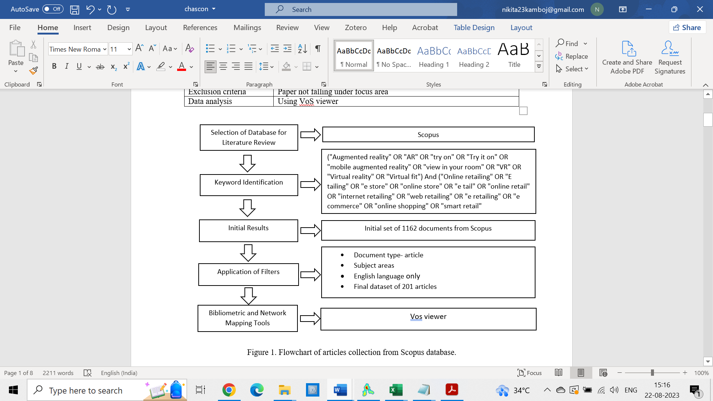
Figure 1. Flowchart of filtration process undertaken to retrieve articles from Scopus Database
IV. Results and Discussions
In this section, the key findings after undergoing the bibliometric analysis have been visually presented and discussed. Table 3 provides overview of the results obtained from VOS viewer. The results show that 201 documents collected from 115 different sources were analysed. The articles used in data anlaysis were published from 2000 to 2023 with 1278 different keywords and 193 authors. Average citation per document were 39.05 and documents per authors were 1.04.
Table 3: Information about Articles Published on Retailing and AR & VR
Description | Result
Documents | 201
Sources | 115
Keywords | 1278
Period | 2000-2023
Average citation per document | 39.05
Authors | 193
Documents per author | 1.04
Source: VOS Viewer

Year wise distribution of articles
The findings of the present study (using Scopus database) indicate that the first publication on AR & VR in online retailing appeared in 2000 (Figure 2). The same pattern of low research output continued till 2018.

Figure 2: Year-wise distribution of articles published (AR/VR in Online retailing)
The smaller number of articles published during the period 2001-2008 is probably because e- commerce as an industry was in its nascent stages and recuperating from the bubble crash of 2000. Moreover, most online retail transactions at that time involved low involvement products and common commodities like books, music CDs (Ward, 2001) and online retailers were focused on earning client trust and extending the use of online purchasing (Kolsaker & Payne, 2002). Meanwhile, efforts were also made regarding concerns relating to website layout & design, online catalogue for shopping, safe & secure transactions, recommendation systems and privacy.
Interestingly, from 2009 to 2018, on an average five articles were published per year. At that time, AR /VR started receiving attention in online shopping. This phase also saw a growing interest from researchers in the fields of AR/VR technologies (Bulearca & Tamarjan, 2010; Farshid et al., 2018; Javornik, 2016; Kim & Forsythe, 2008; Shin & Baytar, 2014). Moreover, the activities related to electronic trust in online retailing (Mukherjee & Nath, 2007), shoppers’ web interface, user acceptance of online retailing (Ahn et al., 2007), ethics in online retailing (Roman, 2007), and service failure & recovery (Holloway & Beatty, 2003) were the issues of concern. However, AR/VR in online retail also started to emerge as a separate research agenda during this phase. The first rise in published research was seen in 2019, when 20 papers were published. Following that, the number of articles continued to increase; in 2021 and 2022, 27 and 47 articles were published respectively. Already 25 papers have been published in first half of the year 2023, and more are anticipated in the coming year.
Most prolific sources
The list of the top sources that published research on AR & VR in online retailing is shown in Table 4. The 201 articles are published across 115 journals. The top journals publishing articles on the theme of AR/VR in online retail along with the publishing group is listed in Table 4.
Table 4: Most Prolific Sources
Journals | Ranking (ABDC/SSCI) | Publisher | Documents | Citations
Journal of Retailing and Consumer Services | A | Elsevier | 11 | 186
Journal of Business Research | A | Elsevier | 8 | 31
Sustainability (Switzerland) | SSCI | MDPI | 7 | 40
Electronic Commerce Research and Applications | C | Elsevier | 7 | 47
Technological Forecasting and Social Change | A | Elsevier | 6 | 12
Journal of Electronic Commerce in Organizations | B | IGI Global | 6 | 27
Behaviour and Information Technology | A | Taylor & Francis Online | 6 | 6
International Journal of Retail and Distribution Management | Scopus Q1 | Emerald Group Publishing | 5 | 333
Computers in Human Behavior | Scopus Q1 | Elsevier | 5 | 44
Internet Research | A | Emerald Group Publishing | 4 | 6
Source: VOS Viewer
Leading the list with 11 articles is the Journal of Retailing and Consumer Services, followed by Journal of Business Research, Sustainability (Switzerland), Electronic Commerce Research and Applications, Technological Forecasting and Social Change, Journal of Electronic Commerce in Organizations, Behaviour and Information Technology, International Journal of Retail and Distribution Management and Computers in Human Behavior and Internet Research. The increasing presence of AR/VR in online retail in these reputable publications is encouraging as it models the future research trends and business practices.
Most prolific authors
The findings show that 193 authors affiliated with 421 organisations in 49 countries have produced articles on AR/VR in online retail. Table 5 lists most prolific authors in order of their citations.
Table 5: Most prolific authors
Name of Author | Documents | Citations
Grabner-Kräuter S | 1 | 621
Kim J | 3 | 522
Lu Y. | 1 | 478
Jiang Z. | 1 | 398
Yim M.Y.-C. | 1 | 380
Suh K.-S. | 1 | 322
Dacko S.G. | 1 | 277
Rese A. | 1 | 215
Hsiao K.-L. | 1 | 210
Steinhoff L. | 1 | 172
Pantano E. | 1 | 168
Source: VOS Viewer
Most prolific Institute
Table 6 enumerates the research organisations with the number of citations affiliated to them. Dept. of Marketing and Intl. Mgmt., University of Klagenfurt, Austria and College of Business Administration, University of Texas-Pan American, Edinburg, United States are the main contributors with 621, and 478 citations respectively. Additionally, ongoing research in the best institutions reveals that western and industrialized nations continue to dominate this industry.
Table 6: Most Prolific Institutes Based on AR/VR in Reatil Publications
Organization | Documents | Citations
Dept. of Marketing and Intl. Mgmt., University of Klagenfurt, Austria | 1 | 621
Ebusiness Inst. - Business Technol., University of Klagenfurt, Austria | 1 | 621
College of Business Administration, University of Texas-Pan American, Edinburg, United States | 1 | 478
School of Management, Huazhong University of Science and Technology, Wuhan, China | 1 | 478
Information Systems, Department of Information Systems, National University of Singapore, Singapore | 1 | 398
Information Technology Management, Sauder School of Business, University Of British Columbia, Vancouver, Canada | 1 | 398
College of Communication, Depaul University, Chicago, United States | 1 | 380
Department of Marketing and Information Systems, Richard J. Wehle School of Business, Canisius College, Ny, United States | 1 | 380
Department of Marketing, Entrepreneurship, & Innovation, Robert J. Manning School of Business, University of Massachusetts Lowell, United States | 1 | 380
Department of Consumer Affairs, Auburn University | 1 | 331
Source: VOS Viewer
Country-wise distribution
Country wise, documents published on AR/VR in online retail are shown in Table 7. USA leads with 49 documents, followed by China in second place with 30 documents. These high figures are owing to factors, like the development of the internet, increasing telecommunication connectivity, launch of innovative tech companies, rise in risk-taking consumer behavior, and a convenience-oriented culture in the USA. On the other hand, e-commerce in China grew as a result of the rise of B2B tech companies in the late 1990s. With 28 and 15 articles, the United Kingdom and India are in third and fourth position, respectively. Online retail firms Flipkart and Snapdeal, as well as Amazon's arrival, helped India's online market to expand and evolve.
Table 7: Top countries based on AR/VR in Retail publication
Country | Documents | Citations
United States | 49 | 2495
China | 30 | 933
United Kingdom | 28 | 1136
India | 15 | 154
Germany | 14 | 845
Canada | 11 | 936
South Korea | 11 | 635
Taiwan | 11 | 365
Australia | 9 | 479
Netherlands | 8 | 450
France | 6 | 312
Source: VOS Viewer
Highest cited articles
The citation volume of an article over a certain period of time can be explored using the citation count. Generally, a considerably more referenced article tends to be more well-known and influential than one with less citations. The distribution of the most frequently cited papers on AR/VR in retailing between 1995 and 2023 is shown in Table 8.
Table 8: Highest Cited Articles
Document | Citations
Grabner-Kräuter S. & Kaluscha E.A. (2003) | 621
Lu et al.,(2010) | 478
Jiang Z. & Benbasat I. (2004) | 398
Yim et al., (2017) | 380
Kim J. & Forsythe S. (2008a) | 331
Suh K.-S. & Lee Y.E. (2005) | 322
Dacko S.G. (2017) | 277
Rese et al., (2017) | 215
Hsiao et al., (2010) | 210
Steinhoff et al., (2019) | 172
Pantano et al., (2017) | 168
Source: VOS Viewer
Most prevalent and interconnected nodes of citation network are presented in figure 3. The findings of the citation analysis show that the publications with the largest number of citations are Grabner-Kräuter et al. (2003), Lu et al. (2010), and Jiang et al. (2004), Yim et al. (2017), with 621, 478, 398 and 380 citations, respectively.
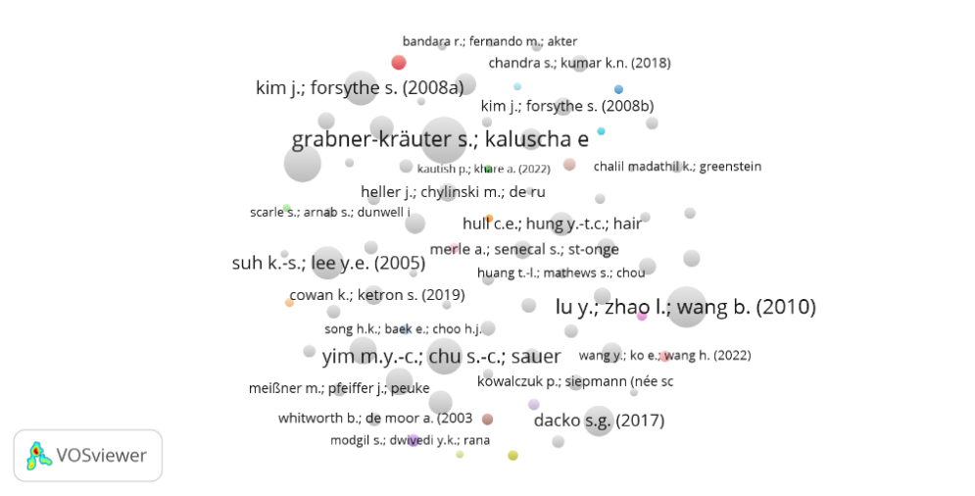
Figure 3: Citation network based on AR/VR publication

They provided a theoretical foundation for the implementation of AR/VR in retailing industry. The study on AR/VR in online shopping that has received the most citations, including those from Yim et al. (2017), Kim et al. (2008a), Suh et al. (2005), Dacko S.G. (2017), Rese et al. (2017), and others, can be regarded as influentialThus it can be inferred that the dynamics of virtual try-on in online retailing, in addition to laying the groundwork for the area, is the most influential subject in the academic community.
Keyword analysis
Total of 1278 keywords are obtained from keyword analysis of 201 articles. Table 9 indicates the significance of virtual try-ons in online purchasing by placing virtual reality at the top of the list with 80 instances. Electronic Commerce/E-commerce and augmented reality appear next in the list with 58, 52 and 51 mentions. It can be inferred that researchers are using electronic commerce, and some are using e-commerce to explain the concept. Online shopping, internet, sales and retailing with 29, 28, 22 and 18 mentions, succeeds the list. The top three keywords show depicts the emerging research trends in retail by incorporation of AR/VR technologies.
Table 9: Most prominent keywords based on AR/VR Publication
Keyword | Occurrences
Virtual Reality | 80
Electronic Commerce | 58
E-Commerce | 52
Augmented Reality | 51
Online Shopping | 29
Internet | 28
Sales | 22
Retailing | 18
Trust | 13
Consumption Behavior | 12
Purchase Intention | 12
Virtual Try-On | 9
Consumer Behavior | 8

Figure 4 shows the keyword network that demonstrates that keyword i.e., electronic commerce, virtual reality, and e-commerce are closely associated with augmented reality. Further, AR is also linked to keywords like online shopping, sales, and retailing. Research themes emerging in this domain are purchase intention and customer experience.
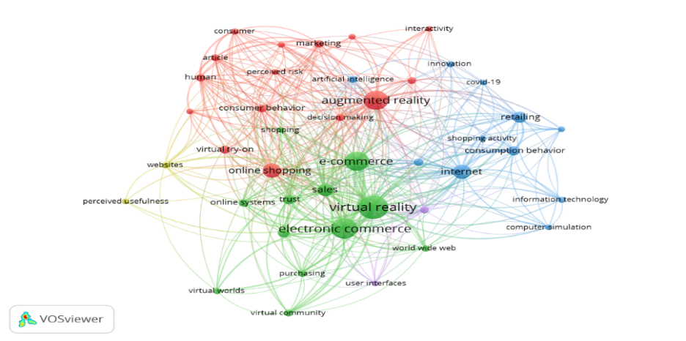
Figure 4: Network of Keyword Occurrence
Source: VOS Viewer
Co-occurrence Network
Table 10 and Figure 5 display the co-occurrence pattern based on author keywords. The findings reveal that the 13 keywords can be grouped into four groups. Five keywords make up the first cluster, five keywords make up the second, two keywords make up the third, and only one keyword makes up the fourth cluster. Cluster 1 is dominated by e- commerce, cluster 2 is dominated by augmented reality. Also keywords like, virtual reality, virtual try-on, purchase intention and retail influence the cluster divisions.
Table 10: Co-occurrence structure based on the author keywords.
Cluster 1 |  |  | Cluster 2
Node | Link | Strength | Node | Link | Strength
Consumer behaviour | 6 | 9 | Augmented Reality | 10 | 34
E- commerce | 12 | 36 | Online Shopping | 11 | 16
Electronic Commerce | 4 | 7 | Perceived Risk | 5 | 8
Trust | 6 | 8 | Personalisation | 5 | 7
Virtual Reality | 7 | 16 | Virtual try-on | 7 | 12
Cluster 3 |  |  | Cluster 4
Node | Link | Strength | Node | Link | Strength
Online Retailing | 6 | 8 | Retail | 4 | 7
Purchase Intention | 7 | 14
Source: VOS Viewer
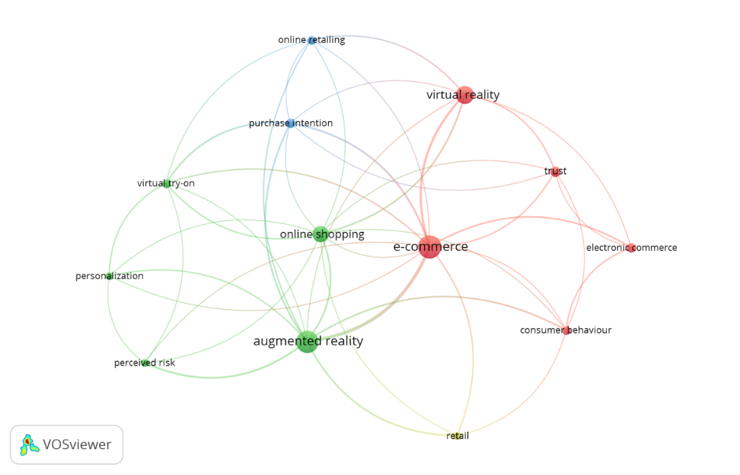
Figure 5: Author Keywords co-occurrence network
Source: VOS Viewer
Co-citation network
Co-citation is the process of citing two documents together in a third document (Small, 1973). This is an important statistic for illustrating the nature of intellectual development as co-citation aids in the emergence and development of a subject or field of study. Result of co-citation analysis revealed two clusters, as shown in Table 11. It is crucial to emphasize the influence of Hilken et al., (2017) & Rauschnabel et al., (2019) in cluster 1 and Steuer et al., (1995) and Kim & Forsythe (2008) in cluster 2.
Table 11: Co-citation Structure
AUTHOR | YEAR | CITATION
Cluster 1: Service Augmentation Using Immersive Technology
Hilken et al., (2017) | 2017 | 21
Rauschnabel et al., (2019) | 2019 | 16
Heller et al., (2019) | 2019 | 13
Hilken et al., (2018). | 2018 | 10
Javornik, A. (2016). | 2016 | 12
Cluster 2: Customer Experience from immersive technology
Steuer et al., (1995) | 1995 | 22
Kim and Forsythe (2008) | 2008 | 21
Li et al., (2001) | 2001 | 14
Hoffman and Novak (1996). | 1996 | 11
Klein, L. R. (2003) | 2003 | 9
Content analysis
The co-citation analysis was complemented by a thorough content analysis of the articles that were divided into two clusters. A common theme was found after carefully examining these two clusters. The results of content analysis are as follows.
Cluster 1: Service Augmentation using Immersive Technology
This cluster’s focal point is use of immersive technologies like AR / VR in creating simulated environment for the customers at large. Hilken et al., (2017) and Heller et al., (2019) discussed service augmentation in the context of enhancing customers’ online service experiences. The studies concluded that AR/VR-based service augmentation enhances customer value perceptions by simultaneously providing simulated physical control and environmental embedding. AR/VR-enabled interfaces improve decision making, motivates customers, ensures positive WOM and facilitates choice of higher value products. Rauschnabel et al., (2019) explained how AR/VR -apps are capable of influencing consumers’ perception and evaluation of brands. They also suggested that marketers need to evaluate mobile AR apps based on the inspiration potential. Javornik, (2016) analysed AR by studying media characteristics of interactive technologies and concluded that consumer responses are different and better in AR interaction as compared to web interaction.
Cluster 2: Customer Experience from immersive technology
This cluster’s theme focused on enhancement of customer experience using immersive technologies. Technology likes virtual try-on augments customer experience by providing functional and hedonic values (Kim and Forsythe, 2008). Interaction with the 3D products enriched customer experience by providing telepresence, involvement, enjoyment, and affordances (Li et al., 2001). Klein, (2003) concluded that immersive technologies provide surreal experiences to the customers, by lending user control and media richness which creates a sense of telepresence and influences consumers’ cognitive responses.
Research framework
Based on this following research framework is proposed for future research (Figure 6). Research have categorised antecedents of AR/VR adoption in retail as per functional and cognitive values existed in these immersive technologies. The functional values include ease of use, product availability, product information quality, security perception and internet connectivity. Cognitive values include interactivity level, trust, personalisation, spatial presence, intrusiveness, and entertainment. Outcomes of AR/VR acceptance can be subdivided into customer specific and retailer specific. Customer specific outcomes include customer satisfaction, customer loyalty, purchase intention, repurchase intention, customer experience and consumer behaviour. Retailer specific outcomes include his satisfaction, innovation, business growth, profitability, and sales. The relationship between antecedents and outcomes with AR/VR acceptance was moderated by factors like vitual tryon, demographic variables (gender, age etc), customer engagement level, purchase importance and product type. The research was predomininat by the management theories like Technology Acceptance model (TAM), e- Technology Acceptance model(e-TAM), Stimulus Organism, Response (SOR), Theory of Reasoned Action(TRA), Unified Theory of Acceptance and Use of Technology(UTAUT), Theory of Planned Behaviour(TPB) and Media Richness Theory(MRT).

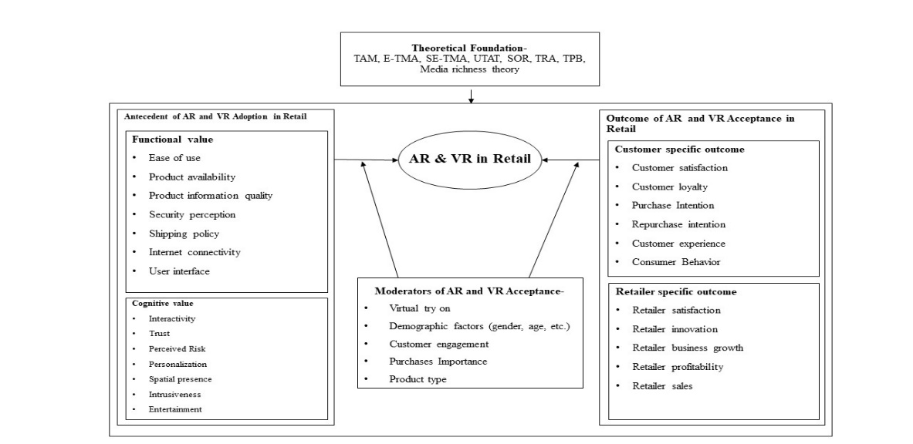
Source: Author’s Own
Figure 6: Research framework of AR/VR in Retail
V. Conclusions
AR and VR in retail is developing field and is turning to be an important research area. The bibliometric study provided a holistic overview of the research being pursued in this field. The study confirmes that over time research related to AR/VR have increase. This can be attributed to easy availablity of technology, improved technology acceptance and lower cost of technology. The studies related to AR/VR are more confined to the western economies as they have already implemeted the technology in their countries. The keyword most used were AR, electronic commerce, E-Commerce, and VR because it's the online platforms that have easily implemented the immersive technologies.
Most of the studies related to AR/VR in retail are still confined to online shopping, sales, customer experience and purchase intention. Research needs to focus on AR/VR on different sub domains of retail, like media richness, cognitive processes, perceived risk, ethics etc.
Most of the studies are confined to only two perspectives either retailer or customer. Efforts can be made to bring in other stakeholders like AR/VR implementers, legal officers, content writers etc. This study has contributed by highlighting the evolution of AR/VR in retail sector. In future research different aspects of AR/VR, different stakeholder’s perceptive can be studied. In the end, it can be concluded that AR/VR is indeed transforming the retail landscape. In the future efforts must be made by researchers to identify application AR/VR in different segments of retail.
References

- Ahn, T., Ryu, S., & Han, I. (2007). The impact of Web quality and playfulness on user acceptance of online retailing. Information and Management, 44(3), 263–275.
- Al Hamli, S. S., & Sobaih, A. E. E. (2023). Factors Influencing Consumer Behavior towards Online Shopping in Saudi Arabia Amid COVID-19: Implications for E-Businesses Post Pandemic. Journal of Risk and Financial Management, 16(1).
- Ames, E. (2021, October 6). How Augmented Reality Can Impact E-Commerce. Liveabout Dotcom.
- Barta, S., Gurrea, R., & Flavián, C. (2023). Using augmented reality to reduce cognitive dissonance and increase purchase intention. Computers in Human Behavior, 140.
- Bulearca, M., & Tamarjan, D. (2010). Augmented reality: A sustainable marketing tool. Global business and management research: An International Journal, 2(2), 237-252.
- Dacko, S. G. (n.d.). Enabling Smart Retail Settings via Mobile Augmented Reality Shopping Apps.
- Donthu, N., Kumar, S., Mukherjee, D., Pandey, N., & Lim, W. M. (2021). How to conduct a bibliometric analysis: An overview and guidelines. Journal of business research, 133, 285-296.
- Farshid, M., Paschen, J., Eriksson, T., & Kietzmann, J. (2018). Go boldly!: Explore augmented reality (AR), virtual reality (VR), and mixed reality (MR) for business. Business horizons, 61(5), 657-663.
- Goyal, K., & Kumar, S. (2021). Financial literacy: A systematic review and bibliometric analysis. International Journal of Consumer Studies, 45(1), 80-105.
- Grabner-Kräuter, S., & Kaluscha, E. A. (2003). Empirical research in on-line trust: A review and critical assessment. International Journal of Human Computer Studies, 58(6), 783–812.
- Habil, S. G. M., El-Deeb, S., & El-Bassiouny, N. (2023). The metaverse era: leveraging augmented reality in the creation of novel customer experience. Management & Sustainability: An Arab Review.
- Heller, J., Chylinski, M., de Ruyter, K., Mahr, D., & Keeling, D. I. (2019). Let me imagine that for you: Transforming the retail frontline through augmenting customer mental imagery ability. Journal of Retailing, 95(2), 94-114.
- Hilken, T., de Ruyter, K., Chylinski, M., Mahr, D., & Keeling, D. I. (2017). Augmenting the eye of the beholder: exploring the strategic potential of augmented reality to enhance online service experiences. Journal of the Academy of Marketing Science, 45(6), 884–905.
- Hilken, T., Heller, J., Chylinski, M., Keeling, D. I., Mahr, D., & de Ruyter, K. (2018). Making omnichannel an augmented reality: the current and future state of the art. In Journal of Research in Interactive Marketing , 12(4), 509–523.
- Hoffman, D. L., & Novak, T. P. (1996). Marketing in hypermedia computer-mediated environments: Conceptual foundations. Journal of marketing, 60(3), 50-68.
- Holloway, B. B., & Beatty, S. E. (2003). Service Failure in Online Retailing: A Recovery Opportunity. Journal of Service Research, 6(1), 92–105.
- Holloway, B. B., & Beatty, S. E. (2003). Service failure in online retailing: A recovery opportunity. Journal of service research, 6(1), 92-105.
- Hsiao, K. L., Lin, J. C. C., Wang, X. Y., Lu, H. P., & Yu, H. (2010). Antecedents and consequences of trust in online product recommendations an empirical study in social shopping. Online Information Review, 34(6), 935–953.
- India brand equity foundation. (2022). INDIA’S AR/VR MARKET. IBEF (India Brand Equity Foundation). https://www.ibef.org/blogs/india-s-ar-vr-market
- Javornik, A. (2016). Augmented reality: Research agenda for studying the impact of its media characteristics on consumer behaviour. Journal of Retailing and Consumer Services, 30, 252-261.
- Jiang, Z., & Benbasat, I. (2004). Virtual product experience: Effects of visual and functional control of products on perceived diagnosticity and flow in electronic shopping. Journal of Management Information Systems, 21(3), 111–147.
- Kim, J., & Forsythe, S. (2008). Adoption of virtual try-on technology for online apparel shopping. Journal of Interactive Marketing, 22(2), 45–59.
- Klein, L. R. (2003). Creating virtual product experiences: The role of telepresence. Journal of interactive Marketing, 17(1), 41-55
- Kolsaker, A., & Payne, C. (2002). Engendering trust in e-commerce: A study of gender based concerns. Marketing Intelligence & Planning, 20(4), 206–214.
- Li, H., Daugherty, T., & Biocca, F. (2001). Characteristics of virtual experience in electronic commerce: A protocol analysis. Journal of interactive Marketing, 15(3), 13-30.
- Lu, Y., Zhao, L., & Wang, B. (2010). From virtual community members to C2C e-commerce buyers: Trust in virtual communities and its effect on consumers’ purchase intention. Electronic Commerce Research and Applications, 9(4), 346–360.
- Mukherjee, A., & Nath, P. (2007). Role of electronic trust in online retailing: A re-examination of the commitment-trust theory. European Journal of Marketing, 41(9–10), 1173–1202.
- Pantano, E., Rese, A., & Baier, D. (2017). Enhancing the online decision-making process by using augmented reality: A two country comparison of youth markets. Journal of Retailing and Consumer Services, 38, 81-95.
- Rauschnabel, P. A., Felix, R., & Hinsch, C. (2019). Augmented reality marketing: How mobile AR-apps can improve brands through inspiration. Journal of Retailing and Consumer Services, 49, 43-53.
- Rese, A., Baier, D., Geyer-Schulz, A., & Schreiber, S. (2017). How augmented reality apps are accepted by consumers: A comparative analysis using scales and opinions. Technological Forecasting and Social Change, 124, 306-319.
- Roman, S. (2007). The ethics of online retailing: A scale development and validation from the consumers’ perspective. Journal of Business Ethics, 72(2), 131–148.
- Shen, B., Tan, W., Guo, J., Zhao, L., & Qin, P. (2021). How to promote user purchase in metaverse? A systematic literature review on consumer behavior research and virtual commerce application design. Applied Sciences (Switzerland), 11(23).
- Shin, E., & Baytar, F. (2014). Apparel fit and size concerns and intentions to use virtual try-on: Impacts of body satisfaction and images of models’ bodies. Clothing and Textiles Research Journal, 32(1), 20-33.
- Small, H. (1973). Co‐citation in the scientific literature: A new measure of the relationship between two documents. Journal of the American Society for information Science, 24(4), 265-269.
- Steinhoff, L., Arli, D., Weaven, S., & Kozlenkova, I. V. (2019). Online relationship marketing. Journal of the Academy of Marketing Science, 47(3), 369–393.
- Suh, K. S., & Lee, Y. E. (2005). The effects of virtual reality on consumer learning: An empirical investigation. MIS Quarterly, 673-697.
- Valuates Reports. (2023). Ar in Retail Market USD 6736.2 Million By 2028 With A CAGR of 20.0% - Valuates Reports. Valuates Reports. https://www.openpr.com/news/2989235/ar-in-retail-market-usd-6736-2-million-by-2028-with-a-cagr-of-20-0
- Ward, M. R. (2001). Will online shopping compete more with traditional retailing or catalog shopping?. Netnomics, 3, 103-117.
- Yim, M. Y. C., & Park, S. Y. (2019). “I am not satisfied with my body, so I like augmented reality (AR)”: Consumer responses to AR-based product presentations. Journal of Business Research, 100, 581–589.
- Yim, M. Y. C., Chu, S. C., & Sauer, P. L. (2017). Is Augmented Reality Technology an Effective Tool for E-commerce? An Interactivity and Vividness Perspective. Journal of Interactive Marketing, 39, 89–103.

