IoT Devices and Their Effect on
Human Health: A Review

Nakul Sharma
Dept. of Artificial Intelligence and Data Science
Vishwakarma Institute of Information Technology Pune, India
nakul777@gmail.com

Mandar P. Diwakar
Dept. of Artificial Intelligence and Data Science
Vishwakarma Institute of Information Technology, Pune, India
mpdiwakar30@gmail.com

Renu Kachhoria
Dept. of Artificial Intelligence and Data Science
Vishwakarma Institute of Information Technology, Pune, India
renu.kachhoria@viit.ac.in

ABSTRACT
Internet-Of-Things(IoT) is the ability of introducing processing and computational power in object(s) and things of everyday use. This chapter concerns with accessing the effect of radiations being emitted from IoT based devices. IoT based devices are source of various types of radiations. These radiations and their effect on human health are discussed. The international perspective wrt restriction imposed by various nations and the world organizations is also discussed. The chapter concludes with recommendations related to literature surveyed.

Keywords—IoT;Radiation;Devices;IR,Bluetooth;Human;Health

INTRODUCTION

Internet of Things refers to enhancing the capabilities of a static object(s), thing(s) to inculcate dynamic aspects within its environment. This includes introducing sensors, increasing the processing ability of the device to connect and exchange data in real-time environment. An example of IOT based device is sensor based cameras used in traffic lights. IOT devices on being connected with cloud or internet transmit real –time data for processing. This is pre-processed and then sent to different AI-ML modeling platforms for analysis. In case, any traffic rule violation is detected, the vehicle’s owner is sent a message by the traffic police of the alleged violation[1][2].
IoT being a disruptive technology has brought in the concept of smart environments and ecosystems which integrate IoT devices in every aspect of human life. IoT finds its application in different non-computing domains as well such as supply chain, management, monitoring, commerce etc. [4]. In the industrial ecosystem, supply and its trail towards meeting the demand of a product has the use of IoT. IoT is being used to check the location where goods are present at a given point of time. IoT is also useful to give a timeline as to when the goods will arrive at the destination. IoT also helps in smart delivery and smart feedback of the product to the customer.

The application of IoT is not just restricted to a particular segment of business, but expands into all pervasive spheres of human life. These include health, transport, energy, security, communications, Infotainment.Figure-1 gives more detailed applications of IoT.
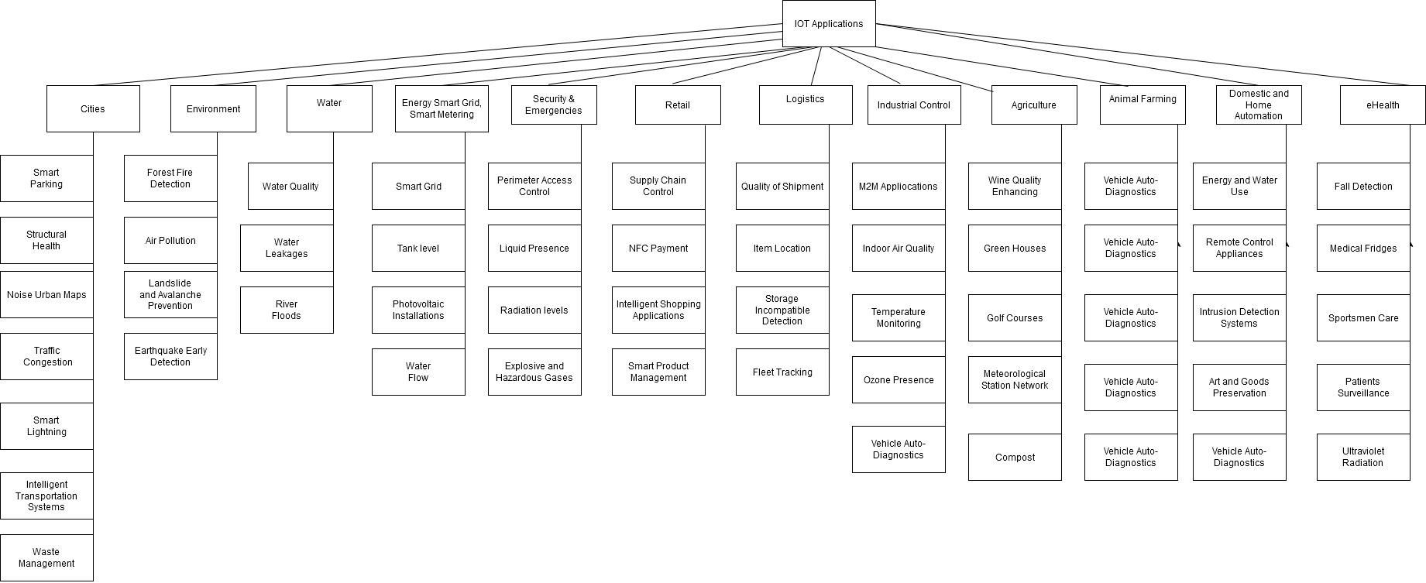

Figure: 1 IoT Thrust Areas [4]

INTERNET OF THINGS (IOT) SYSTEM ARCHITECTURE

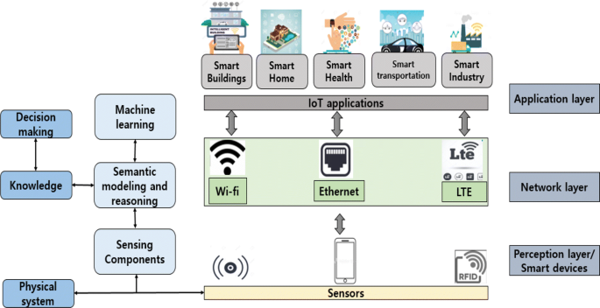
Figure 2: IOT System Architecture [2]

Sensors: In the image, sensor nodes are represented as small devices strategically placed throughout the monitoring area. These nodes are equipped with EMF detectors and wireless communication capabilities.

Wireless Communication: Arrows connecting the sensor nodes to a central hub indicate the use of wireless communication protocols, such as Zigbee or LoRaWAN, to transmit EMF data to a centralized location.

Central Hub: At the heart of the architecture, a central hub is depicted, acting as the gateway for all incoming EMF data from the sensor nodes. This hub aggregates, processes, and normalizes the data before forwarding it to the cloud for further analysis.

Cloud Infrastructure: A cloud-based infrastructure is illustrated as a cluster of servers in the image. This cloud is responsible for storing the vast amount of EMF data received from multiple sensor nodes. It provides the necessary computational power for data analytics and machine learning.

Data Analytics and Machine Learning: The image may show an abstract representation of data analytics and machine learning algorithms, represented by interconnected nodes and lines. These algorithms analyze the EMF data stored in the cloud, identifying patterns, correlations, and potential health risks associated with EMF exposure.

User Interface and Mobile Application: A depiction of a user-friendly mobile application or web interface is shown, enabling users to access their real-time EMF exposure levels. The interface may display exposure trends, safety thresholds, and personalized recommendations for reducing EMF exposure.

Real-time Notifications and Alerts: The image may include icons representing real-time notifications and alerts, symbolizing the ability of the system to send timely warnings to users when their EMF exposure exceeds safe limits.

Data Privacy and Security: Security features are illustrated, such as encryption icons and lock symbols, signifying the architecture's emphasis on data privacy and protection.

WIRELESS TECHNOLOGY / ELECTROMAGNETIC FIELD EXPOSURE

The Internet of Things (IoT) has revolutionized various industries by enabling the seamless integration of connected devices and the efficient exchange of data. In the context of wireless technology and electromagnetic field (EMF) exposure, IoT offers innovative solutions to monitor and manage potential health risks. This architecture focuses on safeguarding human health by employing IoT technology to measure EMF levels, analyze data, and provide real-time insights to users, thereby promoting awareness and proactive risk mitigation. The Internet of Things (IoT) architecture for human health and Radio Frequency Radiation (RFR) based radiation involves the integration of various connected devices, sensors, and data analytics to monitor, manage, and mitigate potential health risks associated with RFR exposure. Here's an overview of the components involved:
- Sensor Devices: IoT relies on sensor devices to collect data from the physical environment. In the context of RFR, these sensors could include electromagnetic radiation detectors that measure the intensity and frequency of RFR emissions from various sources such as cell towers, Wi-Fi routers, and other wireless communication devices.
- Wearable Devices: Wearable health monitoring devices, such as smart watches and fitness trackers, can also play a role in this architecture. These wearables can monitor vital signs, physical activity, and other health-related metrics, providing a holistic view of an individual's health.
- Data Communication: Data collected by the sensors and wearable devices are transmitted through various convenient transmission protocols, trending Wi-Fi, and also low power Bluetooth and Zigbee to a central data processing hub.
- Cloud Infrastructure: In the cloud, data from multiple sources is stored, processed, and analyzed. Cloud-based solutions provide the scalability and computational power needed to manage large datasets efficiently.
- Interpretations and Learning Algorithms : learning algorithms are helping to analyze the collected data, identify patterns, and correlate RFR exposure levels with potential health impacts. This helps in understanding the risks associated with RFR exposure and supports evidence-based decision-making.
- User Interface and Mobile Applications: Mobile applications and user interfaces allow individuals to access their health data, including RFR exposure levels. Users can also receive real-time alerts if RFR exposure exceeds safe limits.
- Data Privacy and Security: Given the sensitive nature of health data, robust security measures are essential to protect the privacy of users. Encrypted data optimization, advanced access controls, and data protection regulations are also crucial aspects of the given architecture.
- Integration with Health Systems: The IoT architecture can be integrated with existing healthcare systems, allowing healthcare providers to access relevant health data for better patient care and remote monitoring.
- Education and Awareness: Education and awareness initiatives are vital to inform the public about the potential risks of RFR exposure and the importance of using IoT devices to monitor and manage their health proactively.
- Policy and Regulation: Governments and regulatory bodies play a crucial role in setting safety standards and regulations related to RFR exposure. The IoT architecture should comply with these standards to ensure public safety.

It is important to note that this architecture is a general IOT framework, and the specific implementation may vary depending on the use case, location, and available technology. Further developments are expected to enhance the accuracy and reliability of IoT-based health monitoring systems.

Overview of Wireless Technology
The emergence of wireless communication technology has brought about a revolution in our methods of communication by facilitating the transmission of data and information without the limitations of physical connections. This technology is based on the use of electromagnetic waves to establish wireless connectivity between different devices such as smartphones, laptops and IoT devices. Examples of wireless technologies include Wi-Fi, Bluetooth, cellular networks and satellite communication. By eliminating the need for physical connections, wireless technology has significantly increased mobility in order to improve connectivity. It facilitated seamless data exchange which has contributed to the growth of smart devices like Internet of Things (IoT) and mobile computing. A significant amount of research has been conducted to address concerns about the potential health effects of exposure to electromagnetic fields (EMF) and radiofrequency radiation (RFR). It has influenced regulatory guidelines and raised public awareness. wireless technology continues to be upgraded and evolving. It is important to consider the potential risks with benefits associated with use of wireless technology. It should ensure that it is used safely and responsibly [5][6].
Electromagnetic Fields (EMF)
Electromagnetic fields (EMF) are a type of energy that arises from the movement of electrically charged particles which gives rise to waves of electric and magnetic fields [10]. When using electronic devices and wireless communication you might see some fields that are completely normal and harmless! For instance, when you turn on your smartphone's Wi-Fi or cellular data function it emits electromagnetic waves that facilitate a connection with nearby Wi-Fi routers or cell towers which enable wireless communication. High-voltage power lines that transport electricity over long distances produce EMF due to the electric currents flowing through them. Similarly, underground power cables also generate EMF as they distribute electricity to different locations. Any electrical system that includes power outlets and wiring in buildings emits EMF when in use. Power inverters which convert direct current (DC) to alternating current (AC) can also emit EMF during this process. Welding machines and soldering tools are examples of equipment that produce EMF as part of their operation. Large-scale industrial microwaves used in various sectors can also generate EMF during their functioning. Charging stations for industrial forklift batteries may emit EMF while charging the batteries. Devices like walkie-talkies and handheld radios emit EMF during communication. Transmitters that use batteries to send signals or data may also produce EMF. Certain industrial processes and equipment that involve the use of strong magnets can generate EMF as well.[11][12].

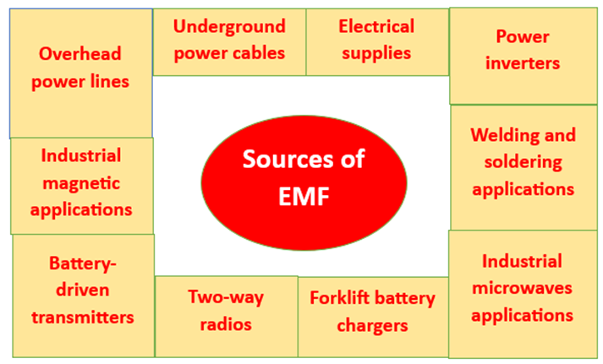

Figure: 4 Sources of EMF

It is important to note that exposure to EMF has been linked to various health risks which includes cancer, reproductive problems and neurological disorders. Therefore, it is important to limit exposure to EMF as much as possible, especially in the workplace where such sources are prevalent. Understanding the sources of EMF and how they operate is a crucial step in minimizing exposure and maintaining a safe working environment. Additionally, proper protective equipment and safety protocols should be implemented to reduce the risk of exposure to EMF. To ensure a safe working environment, it is crucial for individuals working in close proximity to equipment emitting low-level electromagnetic fields (EMF) to be fully aware of their potential exposure and the associated health hazards.
Adequate training and education on the potential risks of EMF exposure is highly recommended for workers operating in close proximity to EMF-emitting equipment to mitigate any potential health hazards. It is essential to take precautionary measures as regulatory guidelines and safety protocols are in place to limit EMF exposure and protect against any possible health hazards. Therefore, it is crucial to follow the necessary safety procedures to avoid any adverse health effects associated with exposure to EMF [7][8][9].

Electromagnetic Fields (EMF) exposure
Exposure to Electromagnetic Fields (EMF) pertains to the existence of electromagnetic radiation in the surrounding environment that has the potential to interact with living organisms such as the human body. There are various sources of EMFs which includes power lines, electrical appliances, wireless communication devices and industrial equipment. EMFs can be classified into two main types based on their frequency: Extremely Low Frequency (ELF) EMFs and Radiofrequency Radiation (RFR). ELF EMFs have lower frequencies and are usually associated with power lines, electrical wiring and household appliances. On the other hand, RFR includes higher-frequency electromagnetic waves used in wireless communication technologies like Wi-Fi, Bluetooth, cell phones and radio and television broadcasting. ELF EMFs are generally non-ionizing radiation and have low health risks at typical exposure levels. Meanwhile, RFR is also non-ionizing radiation but due to its increasing prevalence in modern life, concerns have been raised about potential health effects from prolonged exposure. Exposure to EMFs can happen through direct contact with electronic devices or by being in the vicinity of EMF-emitting sources. The level of exposure depends on factors such as the strength of the EMF source, distance from the source and the duration of exposure. Although the scientific community has conducted numerous studies to evaluate the health effects of EMF exposure. Still there is ongoing debate and research on potential long-term health risks. Common health concerns linked to EMF exposure include possible links to cancer, neurological disorders, reproductive health issues and disruptions in sleep patterns. To address these potential risks various international organizations such as the World Health Organization (WHO) and the International Commission on Non-Ionizing Radiation Protection (ICNIRP) have developed guidelines and safety limits to regulate EMF exposure and protect public health. These guidelines are regularly updated based on the latest scientific research.
ELF EMFs is a type of electromagnetic field that does not have enough energy to cause direct DNA damage and break chemical bonds. This makes them non-ionizing radiation. The associated risks of exposure to ELF EMFs are generally considered low at typical exposure levels in daily life. Despite the low risks associated with ELF EMF exposure a concern has been raised about potential long-term health effects. Ongoing research is focused on potential links to childhood leukemia and other health conditions. Apart from childhood leukemia research has explored potential links between ELF EMF exposure and other health conditions such as brain tumors, Alzheimer's disease and cardiovascular diseases. The evidence for these associations remains limited and requires further investigation to establish any definitive causal relationships.
RFR is a type of electromagnetic radiation that covers a range of frequencies from 3 kilohertz (kHz) to 300 gigahertz (GHz). This form of radiation falls under the category of non-ionizing radiation as it lacks sufficient energy to break chemical bonds or ionize atoms and molecules. Ionizing radiation may contain X-rays and gamma rays. As a result, RFR is considered less hazardous to human health with a lower likelihood of causing DNA damage or cancer.
Radiofrequency radiation (RFR) is a pivotal constituent of diverse wireless communication technologies such as cellular networks (2G, 3G, 4G, and 5G), Wi-Fi, Bluetooth and satellite communication. RFR serves as the medium for data transmission and reception on smartphones, laptops, tablets and other mobile devices. In broadcasting RFR waves are utilized for transmitting radio and television signals that facilitate the delivery of audio and video content over the air. Microwave ovens utilize RFR at higher frequencies to produce electromagnetic waves for cooking and heating food. Radar technology, which is crucial for aviation, weather monitoring and military applications employs RFR for detecting and tracking objects. Additionally, certain industrial processes use RFR for heating materials such as in the manufacturing of plastics and other materials. RFR is an integral part of modern-day technological advancements and its usage is anticipated to increase in the future. Despite its widespread use, concerns have been raised regarding the potential health hazards linked with prolonged exposure to RFR. Hence, it is imperative to ensure that safe levels of RFR exposure are maintained. Further research is required to comprehensively understand the impact of RFR on human health and the environment. [13] [14] [15]

Health Effects of EMF/RFR Exposure:

Extensive research has been conducted on the health effects of exposure to Electromagnetic Fields (EMF) and Radiofrequency Radiation (RFR). Although the results of many studies remain inconclusive or contradictory some have suggested potential associations with certain health conditions. It is important to note that the majority of research conducted to date has not provided clear and consistent evidence of adverse health effects resulting from typical EMF/RFR exposure levels encountered in daily life. Studies have investigated the potential links between EMF/RFR exposure and cancer, particularly brain tumors and childhood leukemia but the evidence is not consistent and the underlying biological mechanisms remain unclear. Research has explored the possibility of EMF/RFR exposure being associated with neurological conditions such as Alzheimer's disease and other cognitive impairments. However, limited evidence is available and further research is needed to establish any causal relationship. Some studies have looked into the impact of EMF/RFR exposure on reproductive health, including fertility and pregnancy outcomes. The evidence is inconclusive with some suggesting possible associations but others finding no significant effects. There is some evidence to suggest that EMF/RFR exposure may influence sleep patterns and quality but here also the results have been mixed and require further investigation. [13] [14] [15]

Biological Mechanisms of Interaction:

The biological mechanisms of how EMF/RFR may interact with living organisms are not entirely understood and continue to be a subject of research. As non-ionizing radiation, EMF/RFR does not directly break chemical bonds or cause ionization of atoms and molecules which is the primary mechanism through which ionizing radiation can damage DNA. However, researchers have identified several potential biological responses to EMF/RFR exposure at the cellular and molecular levels which includes the influence of calcium ion channels in cell membranes, affecting calcium levels within cells. Which can have various cellular effects. Some studies suggest that EMF/RFR exposure may increase the production of reactive oxygen species (ROS) that leads to oxidative stress. This can impact cellular functions. At higher power levels RFR can lead to thermal effects that may cause tissues to heat up. This is the principle used in microwave ovens for cooking food. EMF/RFR exposure has also been associated with changes in gene expression although the significance and implications of these changes are still being explored. Biological interactions between EMF, RFR and living organisms are complex and not yet fully understood but researchers have identified potential effects. These interactions involve how EMF and RFR fields influence cellular and molecular processes [16] [17].
Calcium ions (Ca2+) play a crucial role as signaling molecules in many cellular processes and EMF and RFR exposure can affect the movement of calcium ions across cell membranes, potentially altering intracellular calcium levels. A real-time example of this mechanism is illustrated by the use of smartphones. When making a call or accessing the internet via Wi-Fi, cellular data and smartphones emit RFR to communicate with nearby cell towers or routers. Some studies have indicated that RFR exposure may influence the calcium ion channels in certain cell types, including neurons in the brain, which are responsible for transmitting electrical signals in the nervous system. Modulation of calcium ion channels in neurons due to RFR exposure could potentially alter their excitability and signaling, but the impact of such changes on human health is still under investigation. It is important to note that the overall scientific consensus on the health effects of EMF/RFR exposure remains uncertain. Although the biological response is complex, not all studies have observed the same effects, and many studies have used higher exposure levels than typical real-world scenarios. However, regulatory bodies have established guidelines and safety limits to protect public health and the majority of research studies have not demonstrated consistent and clear evidence of adverse health effects from properly regulated devices and infrastructure. Ongoing research continues to improve our understanding of potential biological interactions and the scientific community is working to identify the mechanisms by which EMF and RFR exposure may affect living organisms. While the impact of these fields on calcium ion flux is one potential mechanism other processes may also be affected. It is essential to continue conducting research to improve our understanding of these interactions and to ensure that proper safety measures are in place to protect public health.
Furthermore, the mechanisms by which EMF and RFR fields influence cellular and molecular processes are not limited to calcium ion flux. Other potential mechanisms include changes in gene expression, oxidative stress, and DNA damage. However, further research is needed to fully understand these processes and their potential effects on human health. [16] [18]

HUMAN HEALTH AND RFR BASED RADIATION

Human health is a well investigated subject. There are several treatments as well as preventive measures which are in place for various diseases and ailments. There are several organizations as well which give guidelines to prevent or suggest methods of treatment. The various methods of treatment range from allopathic, homeopathic, Ayurveda, alternative natural cure. There are both communicable as well as non-communicable diseases which ought to be cured. Mortality or fatality rate of different diseases is different. Cancer and brain tumor in general have lesser amount of mortality rate as compared to other diseases.

In our study we found literature from several researchers which claim that Bluetooth, IR, Wifi did cause cancer and brain tumor. However, there were also studies which showed that these radiations have little effect on the body tissues and they don’t cause any long term effect.

The main communication technologies used by the IOT devices are 2G, 3G, 4G, 5G, 6G, Bluetooth, Radio Frequency and Wi-Fi technologies. The threat perception of these technologies causing various types of cancers and brain tumor cannot be ruled out. There are various independent researchers who have pointed out the effects the EMF, Bluetooth and IR radiations on cell growth [3].

Figure-3 denotes international perspective to radiation. There are governments as well as international organizations who have given their recommendations regarding radiation [3].

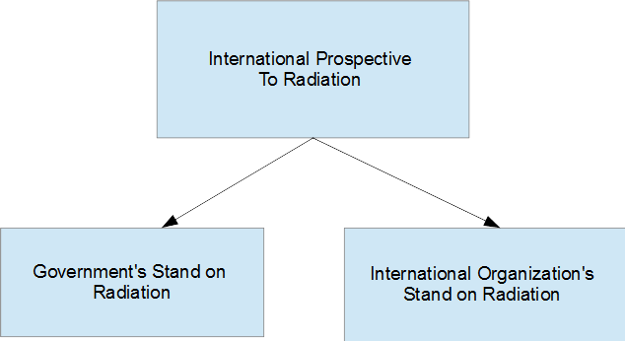
Figure: 4 International Prospective to Radiation

Government’s Stand on Radiation from Towers

These include stand taken by French Polynesia, France, India, Greece, Belgium, and Korea [3].

France has imposed several restrictions and has passed several guidelines on monitoring radiations. Besides banning WiFi in nursery schools, it has also imposed a default closure of WiFi in schools unless required by the faculty. France has also mandated that cell phones cannot be sold without handset and reduce head exposure to mobile phone. In addition, cell phones cannot be advertised to those below 14 years of age. India has only limited radiations from cell towers to 1/10 of the International guidelines. In addition, Korea has specified Specific Absorption Rate (SAR) information to be display on all portable devices and mobiles using EMF radiation while the same mandate is been asked by India but has been restricted to only mobiles. It is only Greece which has out rightly stopped installation of mobile phone base stations on several commercial and health related places [3].

International Organization’s Stand on Radiation

World Health Organization (WHO) has classified Radio Frequency Radiation with range from 100 MHz to 300 GHz as possibly causing cancer or brain tumor. This classification includes all types of radiations including WiFi used in IoT devices [3].

International organizations like ICNIRP, IEEE and national organization’s like FCC, have defined as maximum RF exposure limit in line with the WHO’s recommendations. These exposure limits prevent heating of the exposed tissue for long time [3].

INDUSTRIAL APPLICATIONS OF IOT
IOT is now extensively used in all aspects of engineering and computing. IoT is now being used for value creation using Barcodes, RT location tracking, WiFi, GPS tracking, Mobile computing, Security sensors, Passive RFID, Condition sensors, NFC, GPRS/4G, Grid sensors, Meshed Networks, Telematics. IOT is also used to create “Future Factories” which contain ambient assistance, ambient intelligence, ubiquitous computing. The concept of Smart Factory does automation of every process and include smart/intelligent technology, smart equipment, smart infrastructure, smart product, smart applications. These principles are already ordained in Industry 4.0/5.0/6.0[3] . Smart Factories also envision digital product memories from open-loop process [4].

IOT devices are also retrofitted in different devices which are used for Intralogistics, Resource optimization, maintenance. These devices do however, need to be tested for the overall concerns of human health related to radiation [4].

RECOMMENDATION FORM THE LITERATURE REVIEW
IoT encompasses several areas in its applicability. There are professionals, field workers, laborers who are constantly working in the areas where IoT devices are being deployed. As pointed out by several international organizations, the level of exposure must be checked for each professional working in that area. As IOT devices are being employed to empower all its ecosystem, the radiations emitted in the range of 100 MHz-300 GHz may be possibly causing cancer and brain tumor [3]

In addition, the general people must be made aware of the harmful effects arising out of constant exposure of these radiations. It is imperative that a holistic study on radiations emanating from IoT based devices is conducted not just for humans but also on animals and other living beings where these devices are deployed.

The trust areas where the IoT-based devices are employed must be categorized according to the frequency and the duration for which the radiation is emitted and the effect of such exposure on all the living beings. The restrictions must be imposed on the amount of data, which can be transferred in sensitive areas or buildings such as senior citizens homes or children’s areas.

CONCLUSION
This chapter highlights the effects of radiations emanating from various devices employed in the IoT domain. It is imperative that a holistic approach is adopted while creating and sustaining infrastructure in IoT ecosystem. The holistic must address the health concerns caused by IoT based devices. IoT devices are being used to facilitate human health as well. But the threat to human health itself must not be created from the usage of such devices. Several studies have pointed out the effect of both long-term exposure and short-term exposure to radiations. Some of the nations have taken cognizance and have made laws to restrict the spread of radiations. The research on radiations caused by IoT devices, the studies and literature of such research must be made available to public for awareness and necessary precautions.

REFERENCES

- Dieter Uckelmann, M. Harrison, and Florian Michahelles, Architecting the Internet of Things. Berlin, Heidelberg: Springer Berlin Heidelberg, 2011.
- X. Wang, Y. Han, V. C. M. Leung, D. Niyato, X. Yan, and X. Chen, Edge AI : convergence of edge computing and artificial intelligence. Singapore: Springer, 2020.
- F. M. Clegg et al., “Building science and radiofrequency radiation: What makes smart and Healthy Buildings,” Building and Environment, vol. 176, p. 106324, 2020. doi:10.1016/j.buildenv.2019.106324
- ‌ Ovidiu Vermesan and P. Friess, Internet of Things : converging technologies for smart environments and integrated ecosystems. Aalborg Denmark: River Publishers. Copyright, 2013.
- Anna-Lena, Kampen., Marcin, Fojcik., Rafal, Cupek., Jacek, Stój. (2021). Low-Level Wireless and Sensor Networks for Industry 4.0 Communication – Presentation. 474-484. doi: 10.1007/978-3-030-88113-9_38
- Young, B., Choi., Matthew, E., Bunn. (2021). The Security Risks and Challenges of 5G Communications. 3(2):46-53. doi: 10.4018/IJCRE.2021070104
- Alberto, Modenese., Fabriziomaria, Gobba. (2021). Occupational Exposure to Electromagnetic Fields and Health Surveillance According to the European Directive 2013/35/EU. International Journal of Environmental Research and Public Health, 18(4):1730-. doi: 10.3390/IJERPH18041730.
- Beatriz, L., Barros., Artemisa, Rocha, Dores., Matilde, A., Rodrigues. (2020). Effects of safety and health training in metalworking small-sized enterprises: a comparative study of two training methods. 4(1):48-61. doi: 10.24840/2184-0954_004.001_0004.
- Maria, Lindholm., Arto, Reiman., Seppo, Väyrynen. (2020). On Future Occupational Safety and Health Challenges. 4(1):108-127. doi: 10.24840/2184-0954_004.001_0009.
- Mohammad, Rezaei., M., Baharian., Karim, Mohammadpour-Aghdam. (2021). An Analysis of the Magnetic Field Antenna. IEEE Transactions on Antennas and Propagation, 69(7):3654-3663. doi: 10.1109/TAP.2020.3044650.
- Naren., Anubhav, Elhence., Vinay, Chamola., Mohsen, Guizani. (2020). Notice of Retraction: Electromagnetic Radiation Due to Cellular, Wi-Fi and Bluetooth Technologies: How Safe Are We?. IEEE Access, 8:42980-43000. doi: 10.1109/ACCESS.2020.2976434
- Corentin, Regrain., Julien, Caudeville., René, de, Seze., Mohammed, Guedda., Amirezza, Chobineh., Philippe, De, Doncker., Luca, Petrillo., Emma, Chiaramello., Marta, Parazzini., Wout, Joseph., Sam, Aerts., Anke, Huss., Joe, Wiart. (2020). Design of an Integrated Platform for Mapping Residential Exposure to Rf-Emf Sources. International Journal of Environmental Research and Public Health, 17(15):5339-. doi: 10.3390/IJERPH17155339
- S., Tofani. (2002). Electromagnetic field exposure system for the study of possible anti-cancer activity. IEEE Transactions on Electromagnetic Compatibility, 44(1):148-151. doi: 10.1109/15.990721
- Dragan, Poljak. (2011). Electromagnetic Fields: Environmental Exposure. 259-268. doi: 10.1016/B978-0-444-52272-6.00422-0
- David, O., Carpenter., Cindy, Sage. (2008). Setting prudent public health policy for electromagnetic field exposures.. Reviews on environmental health, 23(2):91-117. doi: 10.1515/REVEH.2008.23.2.91
- Piotr, Piszczek., Karolina, Wójcik-Piotrowicz., Krzysztof, Gil., Jolanta, Kaszuba-Zwoińska. (2021). Immunity and electromagnetic fields.. Environmental Research, 200:111505-111505. doi: 10.1016/J.ENVRES.2021.111505
- Wojciech, Ciesielski., Tomasz, Girek., Zdzisław, Oszczęda., Jacek, A., Soroka., Piotr, Tomasik. (2021). Towards recognizing the mechanisms of effects evoked in living organisms by static magnetic field. Numerically simulated effects of the static magnetic field upon simple inorganic molecules.. F1000Research, 10:611-. doi: 10.12688/F1000RESEARCH.54436.1
- Martin, L., Pall. (2013). Electromagnetic fields act via activation of voltage-gated calcium channels to produce beneficial or adverse effects. Journal of Cellular and Molecular Medicine, 17(8):958-965. doi: 10.1111/JCMM.12088

