CONDUCTING POLYMERS FOR ELECTRONIC APPLICATIONS

Jesslyn John. P

Department of Chemical Sciences

Indian Institute of Science Education and Research

Kolkata, West Bengal, India

Princy K.G
Department of Chemistry
Carmel College(Autonomous),
Mala, Kerala, India.
Email: princy.k.g@carmelcollegemala.ac.in

ABSTRACT
Investigations into conducting polymers have been thorough due to their remarkable characteristics, such as tunable electrical conductivity, outstanding mechanical and optical properties, simple methods of synthesis, as well as superior environmental stability when compared to traditional inorganic materials. The synergistic benefits of utilizing conducting polymer composites have enabled them to be widely implemented in the electrical, electronics and optoelectronic industries. This chapter provides an explanation about the conduction mechanism, methods of preparation, applications and properties of conducting polymers like polyaniline, polyacetylene, polythiophene, polypyrrole, etc. Microwave conductivity and mechanism of electrical conduction in conductive polymers and conductive rubber blends are also discussed.
Keywords-conducting polymers, conduction mechanism, polyacetylene, polyaniline, polypyrrole, polythiophene, poly(p-phenylene), microwave conductivity and conductive elastomers.
- INTRODUCTION
Polymers are substances made up of very large molecules, which are called macromolecules, made up of many repeating units called monomers. Conjugated polymers have the potential to increase their conductivity to metallic levels. This has caught the attention for chemists, physicists and also for scientists belonging to various disciplines. Numerous scientists have tried to combine processability of polymers and many other attractive properties with the electrical characteristics of metal or semiconductor [1].
As the name indicates, conducting polymers are polymeric materials which can conduct electricity. These are also referred to as intrinsically conducting (ICP) polymers. Conjugated bonds exist along the backbone of the polymers. These compounds can have metallic or semiconductor conductivity. Generally speaking, these materials show properties different from thermoplastics. They can have high electrical conductivities but shows different mechanical properties from other commercially produced polymers. Electromagnetic behavior can be altered by the methods of synthesis and by modern dispersal methods.
In 1977, a major discovery was made in the field of conducting polymers. Discovery of polyacetylene which can be changed into conducting material by the oxidation of electron acceptors (Iodine, Arsenic) or the reduction of the oxidant (Lithium). The resulting material shows conductivity higher than the original untreated sample. Redox reactions can take place in the vapor phase, in the solution, or in the electrochemical phase.
In 1979, it was discovered that poly (p-phenylene) can also be oxidized by AsF₅. This discovery led to the discovery of several new conducting systems that are poly aromatic based, such as poly (pyrrole), poly (p-phenylene sulfide), polythiophenes, polyanilines etc.[1, 2].

- TYPES OF CONDUCTING POLYMERS

There are two types of conducting polymers:- extrinsically conducting polymers and intrinsically conducting polymers. Extrinsically conducting polymers are composites where a conductive material like carbon black is dispersed in an insulating polymer like poly(ethene). Intrinsically conducting polymers are the polymeric materials which conducts electricity without any addition of impurities [1, 3].
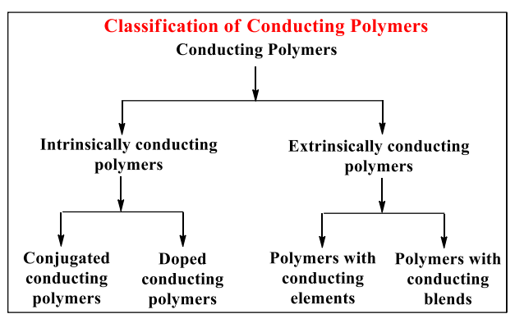
- Intrinsically Conducting Polymers

Conjugated polymers that have alternate single and double bonds are called Intrinsically Conducting Polymers. Sigma bond backbone of conjugated polymers are formed by the overlapping of sp² hybrid orbitals of carbon atoms. The residual orbitals of the carbon atoms undergo lateral overlapping with the adjacent p_{z}-orbital, resulting in the formation of π-bonds. The electrons that participate in the formation of π-bonds exhibit delocalization throughout the the polymer chain, leading to the creation of both a valence band and a conduction band. In instances where the energy difference between these two bands is minimal, the electrons can undergo excitation from valence band having the lower energy to the conduction band having higher energy, resulting in enhanced level of conductivity.
Conjugation alone does not provide adequate means to confer conductivity upon a polymer. The conductivity levels of pristine polymers, can be elevated from an insulating state (ranging from 10⁻¹⁰ to 10⁻⁵ S/cm) to a conducting state (ranging from 0.1 to 10⁵ S/cm) through a process known as "Doping".

Doping
The conductivity 'Ϭ', of any conducting polymer depends on the free-carrier concentration, n; and the mobility of carrier, µ given by the relation,
Ϭ = ne µ
where 'e' represents the electronic charge. Since band gaps in conjugated polymers are comparatively high, the free carrier concentration is very low at normal temperatures. Thus, although carrier mobility in conjugated polymer is high, the conductivity is low because of low free carrier concentration[1,3].
The process of treating a virgin polymer with a powerful oxidizing/reducing agent is called doping. This method either removes electrons from the polymer or donates them by creating a charge carrier in the polymer to improve its conductivity.
Polymer + donor dopant →polymer ⁻ dopant ⁺
Polymer + acceptor dopant → polymer ⁺ dopant ⁻
The carrier concentration in conjugated polymer molecules can be enhanced by doping. Doping in polymer molecules involves the transfer of charge and the subsequent generation of charged species. In the case of polymers, an electronic excitation is associated with a disruption or loosening of the lattice surrounding the exciton. Structural defects are formed in the polymer chain due to structural and electronic excitations. When an electron is removed from a polymer molecule, an unpaired spin remains in the valence band. When an electron is added to a polymer molecule, the unpaired spin is in the conduction band. This is called p-doping and n-doping respectively [1,4]
Electron-attracting substances are typically referred to as oxidative dopants. Examples for p-type dopants include Br₂, AsF₅, H₂SO₄, HClO₄, PF₅, SbF₆, CH₃F, NOF, NO₂, NO⁺SbCl₆⁻, SO₃, FeCl₃, etc. Reductive or n-type dopants are electron donating reagents. Examoles for n-type dopants include sodium naphthalide, molten potassium, Na/K alloy, Lil etc. Doping can be carried out by different methods. They are vapour phase doping, solution doping and electrochemical doping.
In the case of conducting polymers, the doping process can be reversed. i.e. the conducting polymer can be changed into an insulator by neutralizing back it to the undoped state. The reversal to neutrality is referred to as compensation. Compensation occurs when oxidatively doped polymers are exposed to electron donors, and conversely, reduced polymers are exposed to electron acceptors. This property is applicable in the design of rechargeable batteries [1].
- Extrinsically Conducting Polymers
Extrinsically conducting polymers can be prepared by dispersing conducting elements like metallic fibers, carbon black, metallic oxides etc. in non-conducting polymer matrix. These materials are called conductive element filled polymers. The minimum quantity of the conducting particles needed for converting an insulating polymer to conducting polymer is called percolation threshold.
When conventional polymers are blended with proper conducting polymers, we get blended conducting polymers. Polymers produced by this process have superior physico-chemical, mechanical and electrochemical properties and are also easy to process.
An example of an extrinsically conductive polymer is a matrix made of poly(ethylene) filled with conducting carbon black. When carbon black particles are in contact with each other, they conduct. When they are not in contact with each other, it acts as an insulator. The electrical conductivity of the material vary with the change of temperature. At high temperatures, the poly (ethylene) matrix expands, pulling the carbon black particles away from each other. This causes the conductivity to decrease. At lower temperatures, the poly(ethene) contracts, bringing the carbon black particles closer to each other, and the conductivity increases.
- THEORY OF ELECTRICAL CONDUCTIVITY
In conventional polymers such as polyethylene, the outermost electrons are present in sp³ hybridized carbon atoms. Such “sigma-bonding electrons” are tightly held and are localized. So, they do not add to the conductivity. In this type of polymers, there is a large energy gap between conduction band and valence band. Since the energy gap is high, these materials are non-conducting.
Conducting polymers are part of sp² hybridized carbon atoms with an unpaired electron in a p_{z} orbital. Since the p_{z} orbitals, which are parallel to each other, overlap with each other resulting in delocalized set of orbitals. The electrons present in these delocalized set of orbitals impart high mobility when the material is “doped” by oxidation and remove some of these electrons. Hence, the conjugated p-orbitals give rise to a one dimensional electronic band, and the electrons within this band become mobile when it is partially emptied. Semiconducting polymers (conjugated materials) exhibit an energy gap that lies between that of insulators and conductors. At room temperature, they demonstrate low conductivity, with only a marginal flow of electric current[2].
- ELECTRICAL CONDUCTIVITY OF COMMON CONDUCTING POLYMERS

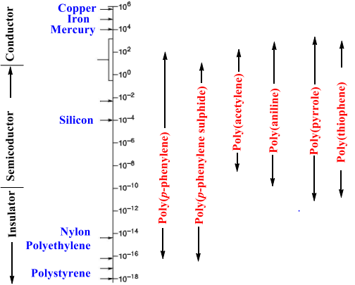
- SYNTHESIS OF CONDUCTING POLYMERS
Due to the fact that electrical conducting power of conducting polymers depends on the way they are synthesized, there are many preparatory methods that can be used to improve their conductivity. The most common and well-known methods are addition, condensation, electrochemical, as well as ring opening and plasma polymerization. Other methods that have been developed in the last few years include: Wittig reaction, Diels-Alder elimination, Ziegler-Natta catalysis, Nucleophilic displacement reactions, Friedel Craft’s reaction, etc. It is important to consider the incorporation of extended pi-electron conjugation in the design of polymer synthetic method.[1].
- Polyacetylene
Poly(acetylene), PA is the simplest conjugated polymer which was first synthesized. The repeating unit of polyacetylene is [C₂H₂]_{n}. It is synthesized by the polymerization of acetylene. It’s conductivity is comparable with metals on doping with oxidizing agents like iodine vapour. Oxidation generates charge carriers which induces p-type conductivity in the conjugated polyene structure. Polyacetylene can exist in two isomeric forms: cis and trans. The trans isomer is thermodynamically more stable than cis- isomer. Conductivity of polyacetylene lies in the range of 10⁻⁵ Scm⁻¹, but on doping, its conductivity can be increased up to 10² - 10³Scm⁻¹ [1, 5].
Polyacetylene can be synthesized by different methods like precursor-assisted synthesis, catalytic polymerization and non-catalytic polymerization starting from pure acetylene or other monomer derivatives. Using Ziegler–Natta catalyst, such as Ti(O-nBu)₄/Al(C₂H₅)₃, acetylene can be polymerized to polyacetylene. The compound primarily exists as the cis isomer, exhibiting a significant level of crystallinity. The transformation to the more stable trans isomer can be initiated through the application of heat or by doping.
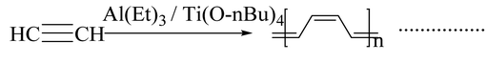
Luttinger catalysts employed in the synthesis of polyacetylene comprise a mixture of a hybrid reducing agent and a complex of a group [VIII] metal, such as nickel chloride. These catalysts utilize hydrophilic solvents, such as tetrahydrofuran, water-ethanol, or acetonitrile, to facilitate their catalytic activity.
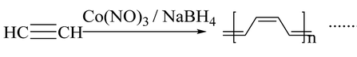
The electrochemical polymerization of acetylene falls within the category of non-catalytic polymerization. The process involves the anodic oxidation of a monomer precursor in the presence of appropriate electrolytes on the surface of an inert metal. Polyacetylene can also be prepared by retro Diels- Alder reaction.
Synthesis of polyacetylene films was conducted through the ring-opening polymerization of 1,3,5,7-cyclooctatetraene by Korshak et al. This method exemplifies the synthesis of polyacetylene without the utilization of an acetylene monomer. Light-induced synthesis, i.e., irradiation of acetylene gas with UV also produces polyacetylene.

Properties of Polyacetylene
- Cis-polyacetylene film is more flexible and stretchable compared to the trans isomer, which is more fragile.
- Cis and trans isomers of polyacetylene are thermally stable.
- Polyacetylene is insoluble in commonly used solvents.

Uses of Polyacetylene
- The high electrical conductivity of doped polyacetylene makes it suitable for use in electrical wiring or electrode materials in lightweight rechargeable batteries.
- A sensor for measuring glucose concentration can be made using tri-iodide oxidised polyacetylene.
- Poly(diacetylene)s
Poly(diacetylene)s (PDAs) are conducting polymers which are closely related to polyacetylene. They are synthesized by the 1,4 topochemical polymerization of diacetylenes[1].
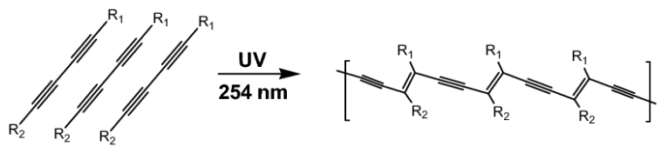
- Poly(p-phenylene)
Phenyl group polymers encompass a vast category of conducting polymers that exhibit superior thermal and oxidative stability in comparison to other polymers. The polymer backbone is made up of phenyl rings as repeat units. Direct oxidation of the benzene molecules is commonly used for the synthesis of poly(p-phenylene). This process can be achieved using a reagent system, which can be either single or binary. In the binary system, a combination of a Lewis acid and an oxidant system is utilized. Alternatively, a single reagent system, such as FeCl₃, can act as both a Lewis acid and an oxidative system on its own. The production of poly(p-phenylene) is achieved through the coupling of benzene using AlCl₃/CuCl₂ at a temperature of 350°C in a solvent like benzene [6].
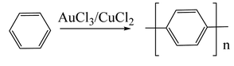
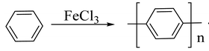
The first chemical synthesis of poly(p-phenylene) was carried out using a metal coupling reaction called Wurtz–Fittig reaction.
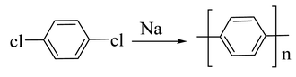
The Ullman reaction can also be used for the synthesis of poly(p-phenylene)s.
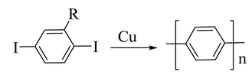
- Polyaniline
Polyaniline(PANI) is a conducting polymer that holds great promise and has been extensively studied among its counterparts in the field of conducting polymers, due to its electrical conductivity, optical as well as its mechanical properties. The conductivity of polyaniline depends on concentration of the dopant, and pH. When the pH is below 3, it provides a conductivity similar to that of metals. Polyaniline exists in three different forms. According to their oxidation state, they are classified as emeraldine, leucoemeraldine, and pernigraniline. In its completely oxidized state, it exhibits insulating properties and only attains conductivity when moderately oxidized [1, 7].
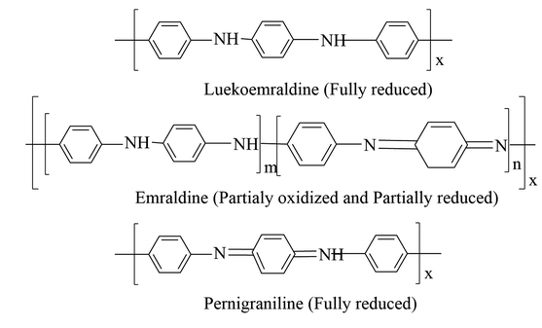
Polyaniline is synthesized using a chemical oxidation method. In this method, the aniline monomer is mixed with a suitable oxidizing agent at low temperature with a suitable acid. The color of the reaction medium changes to green when polyaniline is formed. The oxidizing agent used in this method is ammonium persulfate. Other commonly used oxidizing agents include ceric ammonium nitrate, ceric ammonium sulphate and potassium dichromate.
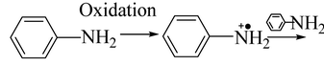
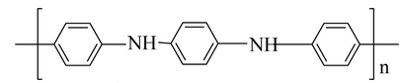
The process of synthesizing polyaniline involves interfacial polymerization, where an aniline monomer is dissolved in an organic solvent like toluene or an oxidizing agent and acid-containing water as dopant. Polymerization occurs in the interface between two immiscible liquids in the micro emulsion technique for the synthesis of poly aniline, but the surfactant used will be different. The electro polymerization method and electro spinning method are also used for the synthesis of polymer having fibrous morphologies along with nano or micro diameters.
Properties of Polyaniline
- The electrical conductivity ranges from10⁻¹⁰ to 10² s/cm.
- In its reduced and oxidized forms, it has band gapes of 4.3 and 2.7 eV respectively.
- High chemical stability
- High thermal resistance
- Electrical properties of polyaniline-based composition do not change even at high temperatures like 230-240 ℃.

Applications of Polyaniline

Polyaniline is a chemical compound that is used in the production of printed circuit boards (PCBs).

It is the base element used to make N-doped (doped) carbon materials.

Polyaniline has the ability to change its color in different oxidation states, which can be used to create sensors or electrochromic devices (electromechanical devices).

Polyaniline-based sensors, printed emeraldine, are widely employed in the electronic industry

E. Poly(p-phenylene sulphide)
Poly(p-phenylenesulphide), PPS is an organic polymer consisting of aromatic rings with sulphide linkage. PPS is a semi crystalline thermoplastic having high melting point (285 to 296 °C). It has excellent solvent resistance, and it is insoluble in common solvents below 200 °C. The polymer is synthesized through the reaction between sodium sulphide and 1,4-dichlorobenzene in a polar solvent like N-methylpyrrolidone at an elevated temperature (250°C)[1,8].
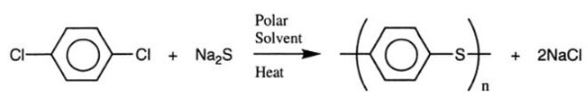
Polyphenylene sulphide can also be prepared through the homopolymerization of thiophenol in the presence of H₂SO₄ or by means of oxidative condensation of thiophenol in the presence of SOCl₂ and a Lewis acid.
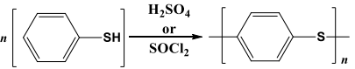
Polyphenylene sulphide can also be prepared by self-condensation of metal-p-halogenothiophenoxide.
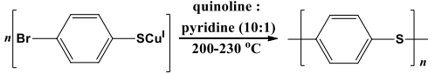

Properties of poly(p-phenylene sulphide) (PPS):
- Polymer (PPS) is a rigid, opaque, high melting point polymer (280 ℃).
- It has high resistance to heat, bleaches, acids, alkalies, sunlight, and abrasion.
- It resists dyeing and absorbs only a small amount of solvent.
- It has good conductive properties if dopants or oxidants are added.
- It has excellent mechanical strength and dimensional stability.

Applications of poly(p-phenylene sulphide) (PPS):
- Uses of PPS in automotive industries include manufacturing of fuel injection systems, electric brakes, water pump impellers, bulb housing, etc.
- Uses of PPS in electronic industries include manufacturing of hard disk drives, connectors, switches, sockets, etc.
- It also find applications in the medical industry for making medical fibers, surgical instruments and membranes.
- It is also used in fiber extrusion and chemical-resistant and non-stick coatings.

- Polypyrrole
Polypyrrole (PPy) is an organic conducting polymer which has excellent electrical conductivity, environmental stability and minimal toxicological issues. In its undoped state, it behaves like an insulator and on doping with electron acceptors such as Br₂ or I₂, it shows an electrical conductivity of 10⁻⁵ Sm⁻¹ [9].
Polypyrrole, as a black powdery material was initially synthesized through the chemical oxidation of pyrrole monomer in the presence of H₂O₂.
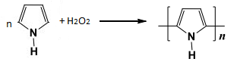
Polypyrrole can also be synthesized by electrochemical method.
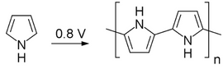
Polypyrrole has been extensively synthesized using chemical polymerization techniques, which involve the oxidative polymerization of the monomer-pyrrole by a chemical oxidant in either an anhydrous or non-anhydrous solvent, or by chemical vapor deposition. Generally, aqueous or anhydrous ferric chloride or other metal salts, such as iron(III), copper(II) or ammonium sulfate, are commonly used as oxidizing agents. In addition to metallic salts, polypyrrole has also been synthesized with a halogen electron acceptor (e.g., bromine, iodine) in a variety of solvents. But ferric chloride is the most powerful oxidizing agent. Water is the optimal solvent for the chemical polymerization process with respect to desirable conductivity characteristics.
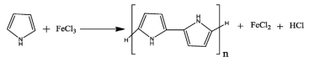
Because of the presence of highly reactive N-H group, side reactions and crosslinking can be prevented by the preparation of poly(pyrrole) by Stille Coupling or thermolysis sequence.

Properties of Polypyrrole:
- Polypyrrole in the virgin(undoped) state is an insulator, however, its oxidized derivatives can be used as good electrical conductors with conductivity ranging from 2 to 1,000 S/cm.
- Thermal stability can be improved, when treated with an acid or base such as sulphuric acid or sodium hydroxide.
- Polypyrrole is resistant to corrosion and chemically stable due to its cross-linking properties.
- Its glass transition temperature lies between 160 and 170℃.

Applications of Polypyrrole:
- Polypyrrole is utilized in a variety of applications, including electronic devices and chemical sensors.
- Polypyrrole is used as catalyst support for fuel cells and as a potential vehicle for drug delivery.
- Polypyrrole is employed in the coating of silica and reverse phase silica to produce anion exchange material..
- Polythiophene
Polythiophenes and their derivatives are of significant importance due to their ability to withstand environmental conditions, their ability to withstand extreme temperatures, and their high optical properties in comparison to other conductive polymers. Polythiophenes were first chemically manufactured in the 1980s through the Yamamoto-Lin-Dudek route [1, 10].
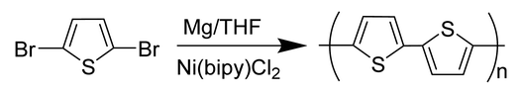
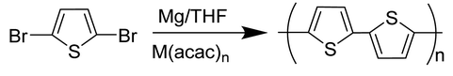
Polythiopene can be made by the standard chemical oxidation process. The oxidizing agent used in this process is Ferric chloride (FeCl₃).
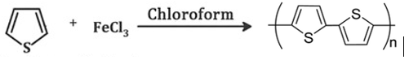
Other sophisticated methods may also be employed, such as organo-molecular coupling reaction, direct sol-gel synthesis, oxidation synthesis, template-assisted synthesis, electrolysis, hydrothermal or solvothermal process.

Properties of Polythiophene:
- Polythiopene is characterized by its high conductivity (generally exceeding 100 s/cm), thermal stability, and chemical stability.
- It is a red solid that does not readily dissolve in a wide range of solvents. However, when treated with oxidizing agents known as electron-acceptors, the material undergoes oxidation, resulting in a dark color.
- It is transparent and has excellent optical properties.
Applications of Polythiophene
- Polythiopene is commonly employed in solar cells due to their capacity to form a more direct connection with metal electrodes.
- Polythiopene is also employed in the production of polymer batteries and electro chromic devices.
- Polythiopene is also interacting with receptors for the detection of metal ions or chiral molecules.
- Polythiopene is used as a therapeutic tool for prion diseases.
- Poly(p-phenylene vinylene)
Poly(p-phenylene vinylene), also known as PPV, was the initial electroluminescent substance employed in the production of organic light-emitting diodes due to its exceptional optical characteristics. It is generally prepared by Wittig coupling reaction involving the coupling of an aromatic bisphosphonium salt and a dialdehyde[1, 11].
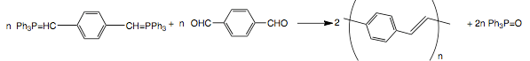
The coupling between ethylene and aromatic dibromides via a Heck reaction can also be used for the synthesis of poly(p-phenylene vinylene).
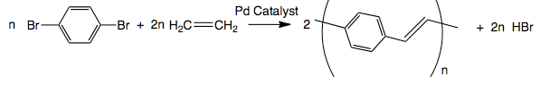
Suzuki coupling reaction can be used for the synthesis of poly(p-phenylene vinylene) through Pd-catalyzed coupling between alkyl-substituted aryldiboron acids and dibromo aromatic compounds. Other methods of synthesis include electro polymerization, benzoin condensation, metathesis polymerization, ring-opening polymerization and chemical vapor deposition.
PPV is a diamagnetic polymer and it’s intrinsic electrical conductivity is very low and ranges between 10 and 13 S/cm. The electrical conductivity can be enhanced on doping with iodine, ferric chloride, alkali metals, or acids. But, these doped materials are relatively unstable. The low optical band gap and vivid yellow fluorescence of photovoltaic (PPV) technology make it suitable for different applications, like LEDs, photo detectors, optoelectronic devices and photovoltaic devices.
- Poly(p-phenylene oxide)
Poly(p-phenylene oxide)s, PPO are also known as poly(p-phenylene ether)s, or simply as polyphenylene oxides. They are commonly prepared from phenols by different oxidative coupling methods and step-growth polymerization reactions. The oxidation of 2,6- dimethylphenol using copper catalyst in the presence of oxygen to synthesize PPO was initially reported by Hay in 1959[12].
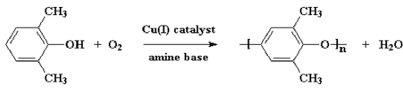
This is a high-performance plastic with an amorphous structure. It’s glass transition temperature is 215°C. Their moisture absorption capacity is very low and resistant towards hydrolysis and can be changed into flame retardant. These materials are deemed valuable for engineering thermoplastic applications due to their thermal, oxidative and chemical stability.
- TEMPERATURE CHARACTERISTICS OF CONDUCTORS
Temperature characteristics are important regarding the potential applications of the conductor. Generally, as the temperature increases, the conductivity of the metal decreases due to charge carrier scattering and hence the resistance increases. Such materials are said to have positive temperature coefficient (PTC) of resistance. As the temperature of a semiconductor increases, the number of carriers increases and therefore the conductivity increases. Thease materials possess a negative temperature coefficient (NTC). For typical polymeric conductors such as polyacetylene, the situation differs depending on the doping concentration[1].
Although many conductive polymers exhibit metallic conductivity, the temperature dependence of conductivity is different from that of metals; but similar to semiconductors. This can be explained based on the presence of potential barriers between highly conductive regions. These barriers are caused by conjugation defects or other inhomogeneities within the polymer chains. The charge carriers must tunnel or jump over the potential barriers. Since tunneling is independent of temperature, the temperature dependence of conductivity must result from other processes like charge energy, thermal motion of the charge carriers that affect transfer of charge between highly conductive regions [1].
The energy needed to get an electron away from the electrically neutral island is considerable if the highly conductive region or island is small (less than 20 nm). The conductivity is temperature-dependent and only constrained by the charging energy when the voltage difference between two adjacent islands is small enough for thermal activation to create charge carriers. Charge carriers follow the path with minimum resistance.
The charging energy becomes insignificant once the highly conductive zone has a size larger than approximately 20 nm. Sheng's second inhomogeneous conductor model is based on fluctuation-induced tunneling of charge carriers between highly conductive islands. Larger conductive zones, usually of the order of micrometers, can be encompassed under this approach. According to this theory, the continuous thermal movement of charge carriers inside a conductive island induces continuously varying voltages in the gaps between adjacent islands. The above model can well explain the effects such as doping leading to unevenly distributed charge carriers(dopants), interchain transport, fibrillar morphology, and transport through grain boundaries [13,14].
Difference between hopping mechanism and tunneling is evident from the conductivity value at zero temperature. Phonons promote tunneling between localized electronic states, and when the temperature drops to zero, the hopping conductivity vanishes. Since the tunneling process is temperature-independent and solely depends on the shape and height of the potential barrier separating the charge carriers, the conductivity cannot be extrapolated to zero. Fewer states fall into the permitted energy range as the temperature drops, and the average hopping distance rises. This reduces the possibility of jumping and reduces conductivity [1].
- ELECTRICAL CONDUCTIVITY AND CARRIER TRANSPORT
Many studies have been conducted to characterize and understand electrical transport mechanism in conductive polymers. Charge carrier concentration and charge carrier mobility are the limiting factors for conductivity in conductive polymers. Numerous potential carriers are produced during the doping process, but they must be mobile to contribute to conductivity. The three factors that contribute to career mobility are interchain transport, intramolecular transport, and interparticle interactions. These three components combine to create a complex network of resistance that affects the charge carriers' effective mobility. As a result, both the microscopic (intra- and interchain) and macroscopic (interparticle) levels are used to estimate mobility and conductivity.
Similar to all organic materials, ionization of the conjugated polymers causes distortion in the lattice around the ionized states. As charge carriers move through the polymer, this lattice distortion reduces their mobility. The charge carrier transport mechanism in conducting polymer systems is more analogous to amorphous semiconductors (hopping transport) as disorder plays such a significant role in these systems [15,16]
- CHARGED DEFECTS IN CONJUGATED POLYMERS:
THEORY OF CONDUCTION
Studies on conducting polymers have primarily focused on ionic and radical sites, often known as charged defects and neutral defects, respectively. The movement of the defect can be represented as a solitary wave, or in the terminology of field theory, as a "soliton. "Radical defects are called neutral solitons. Anionic and cationic defects are charged solitons. Charged solitons (anions or cations) are responsible for spinless transport as they carry charge but spinless.
A radical ion with charge and spin is the first species produced when a conjugated polymer is ionized. Radical ions are referred to as polarons. A polaron can have a lattice relaxation (distortion) and either a positively charged hole site (radical cation) or a negatively charged electron site (radical anion). According to theoretical models, the exothermic reaction between two radical ions (polarons) in the same chain results in the formation of a dication or dianion (bipolaron), which ultimately imparts spinless conductivity [17-20].
- MICROWAVE CONDUCTIVITY
Dielectric characteristics including permittivity, conductivity, dielectric constant, and polarization are used to categorize dielectric materials. Similar to all organic materials, ionization of conjugated polymers produces large distortion in the lattice around the ionized state. As the charge carriers move through the polymer, this lattice distortion reduces their mobility. The mechanism of charge carrier transport is like that of amorphous semiconductors, since disorder is so prevalent in conducting polymer systems.
Radar development and design are the forerunners of microwave technology. Radar beam steering in the early stages of development uses phased array technology. This is a very complex design and requires mechanical work to control the beam. When microwave frequencies are applied, poly(o-toluidine) readily undergoes dipole polarization. These properties find its use to develop radar electron beam shaping systems. In the development of microwave communication lines, materials with poor electrical conductivity and strong microwave conductivity find use. These are also used for satellite communications that prevents stray signals and allows microwave signals to pass through it[1].
Perturbation theory is applied in the calculation of complex permittivity and conductivity of dielectric materials. If the dielectric material is placed within a cavity resonator at the point of maximum electric field, the contribution of the magnetic field to the disturbance (perturbation) will be minimal [21-24].
- CONDUCTING POLYMER BLENDS
Polymer blends are a mixture of a polymer and one or more materials with relatively different physical or chemical properties. This blend helps to improve mechanical, electronic, and thermal properties compared to the pure polymer. In recent years, conducting polymer composites have gained a lot of interest as they are used for numerous applications in various fields of the electrical and electronic industry. Common organic solvents cannot be used to dissolve the majority of conductive polymers, making them very difficult to cast into films and other shapes which are essential for a variety of applications. The conductivity of conducting polymers, such polyacetylene, changes with time as a result of interactions with factors like air and oxygen. So conducting polymers are unstable in the air and the processing difficulties can be overcome by blending composite materials with other polymers. Incorporating conductive polymers into host polymer substrates to form blends, composites, or interpenetrating bulk networks help to combine electrical conductivity and mechanical strength of polymers. Conducting polymer blends having interpenetrating network can be made by the in situ polymerization of monomers within a conventional linear polymer matrix. Conductive polymer blends with low percolation thresholds are used for antistatic applications [25,26].

- ELECTRICALLY CONDUCTIVE ELASTOMERS
Elastomers that are insulators can be made conducting by adding particulate or colloidal fillers like carbon black having high intrinsic conductivity. Conductive rubber compounds were used for the first time to prevent corona discharge within cables. Large amounts of carbon blacks, graphite or metal powders are used to make conductive rubber. Acetylene black and other conductive blacks can be added to create conductive rubbers with enhanced mechanical qualities. Furnace-soot-filled rubber displayed antistatic properties. Situations that involve the handling of explosive (or flammable) vapors, powders, or liquids use non-insulating antistatic rubber. [27,28].
Carbon black forms aggregates or network structures in the polymer matrix that induces electrical conductivity. The extent of conductivity depends on carbon black content, chain structure, nature of carbon black, nature of polymer, time of mixing, temperature, and degree of dispersion of carbon black in the polymer matrix.
- MECHANISM OF ELECTRICAL CONDUCTION IN ELASTOMERS
Carbon black particles are fused together to form "clusters" of individual particles. These clusters are the working units of carbon black loaded rubber vulcanizates. If the amount of carbon black is small, the conductivity of the elastomer will be minimum. It can be seen that above a certain level, as the amount of carbon black increases, the conductivity increases significantly and tends to asymptotize to a definite value. This area of ​​increased conductivity is called percolation region. In this area, conductivity is controlled by a barrier that prevents charge carriers (electrons) moving from one cluster of carbon black to another cluster that is close to each other but not in contact. Electrons must overcome a potential barrier to pass through the carbon black aggregate. Actually electrons "jump" across this gap or the movement of electrons in these systems relies on tunneling activated by thermal fluctuations in potential [ 28].
The tunneling current is an exponential function of the gap width existing between neighbouring aggregates of carbon black, and there is virtually no conduction between aggregates separated by larger gaps. When the concentration of carbon black increases, the aggregates are packed more densely and compacted together. This reduces contact resistance and improves conductivity. When high load is present, the contact resistance existing between the aggregates becomes insignificant, further addition of carbon black cannot significantly increase the conductivity. This creates a "continuous chain" during high loads.
For composites having normal loads and temperatures, the main conduction mechanism is either thermal activation of electrons across the gap of the potential barrier or tunneling assisted by thermal fluctuations. Conduction is also controlled by the intrinsic conductivity of the carbon black.
Similar to loading, electrical conductivity is also influenced by the "structure" or bulkiness of carbon black particles since bulkier aggregates take up more space in the composite. According to Janzen's theory, highly structured carbon blacks have a relatively low percolation threshold. High-structure carbon black conducts better than low-structure carbon black at a given loading.
The degree of carbon black dispersion in the percolation zone has a significant impact on conductivity. The creation of channels between islands of carbon black, where carbon black is included and filled with rubber, causes the conductivity of carbon black and rubber composites to increase quickly during the early mixing stage. The conductivity steadily diminishes as the distance between individual aggregates grows in the later stages of mixing, where the aggregates are broken.
The conductivity of carbon black diminishes with increasing particle size. It was argued that decreasing particle size should lead to smaller gap widths and more conducting pathways per unit volume on geometrical explanations. Additionally, it has been noted that chains can be formed out of smaller particles rather than coarse particles.
The conductivity changes with temperatures below the percolation threshold are influenced by thermally activation. The temperature dependence of conductivity above the percolation threshold can be attributed to both the breakdown and reformation of carbon clusters with varying temperature. At normal and elevated temperatures, rubber compounds with normal carbon black content exhibit a decrease in conductivity with increasing temperature. This is because the gap width increases due to thermal expansion of the rubber. Compounds with very low concentration of carbon black exhibit the opposite behavior. At relatively high temperatures, the conductivity becomes increasingly active as the temperature increases. Rubber behaves like a semiconductor at this temperature. In this region, the distance between the carbon black aggregates is large enough to allow extrinsic conduction, and the conductivity arises from charge carriers in the rubber matrix [29, 30].
- REFERENCES

Princy K.G, Rani Joseph, C. Sudha Kartha, Conducting Polymers and Conductive Elastomers, LAMBERT Academic Publishing, 2010.[Princy K.G., Ph.D. Thesis, Studies on Conducting Polymers and Polymer Composites, 2002; dyuthi.cusat.ac.in]

Abhishek Kumar Mishra, Conducting Polymers: Concepts and Applications, Journal of Atomic, Molecular, Condensate and Nano Physics Vol. 5, No. 2, 159–193, 2018.

3.
- https://en.wikipedia.org › wiki › Conductive_polymer.
- Hari Singh Nalwa, Handbook of Organic Conductive Molecules and Polymers, Vo!.2, John Wiley and Sons, England, 11, 1997.
- V.A. Lopyrev , G.F. Myachina , O.I. Shevaleyevskii and M.L. Khidekel, Polyacetylene. Review, 30, (10), 2151-2173, 1988.
- Martin B. Jones and Peter Kovacic, Polyphenylene,Comprehensive Polymer Science and Supplements, 5, 465-472, 1989.
- A.G. Macdiarmid, J.C. Chiang, A.F. Richter and A.J. Epstein, Polyaniline: a new concept in conducting polymers, Synthetic Metals, 18, (1–3), 285-290, 1987.
- Peiyuan Zuo, Abbas Tcharkhtchi, Mohammadali Shirinbayan, Joseph Fitoussi and Farid Bakir, Overall Investigation of Poly (Phenylene Sulfide) from Synthesis and Process to Applications-A Review, Macromolecular Materials and Engineering, 304 (5), 1-27, 2019.

Tat'yana V Vernitskaya and Oleg N Efimov, Polypyrrole: a conducting polymer; its synthesis, properties and applications, Russ. Chem. Rev., 66, 443, 1997.

R. D. McCullough, The chemistry of conducting polythiophenes, Adv. Mater., 10(2), 1998.

Ruyu Li, Yanjiao Mo, Rong Shi, Peng Li, Chengyu Li, Zhenjiang Wang, Xun Wang, and Shengbiao Li, Synthesis and properties of poly(p-phenylene vinylene) derivatives with hyperbranched structure and containing a nitro substituent, Monatsh Chem., 145(1), 85–90, 2014.
- Dwain M. White, Poly(p-phenylene oxide)s, Comprehensive Polymer Science and Supplements, 5, 473-481, 1989.
- P.Sheng and J. Klafter, Hopping conductivity in granular disordered systems, Phys.Rev., B 27 ,2583, 1983.
- Sheng, E.K.Sichel and J. l. Gittleman , Carbon Black Polymer Composites, Phys.Rev. Lett., 40, 1197, 1978.
- Encyclopaedia of Polymer science and Engineering, second edition, Vol.5i Mark Bikales over Berger Menges John Wiley and Sons Inc., 1986.
- N. F. Mott and E. A. Danis, Electronic Processes in Non crystalline Materials, 2 ed., Clarendon press, Oxford, 1979.

W. P. Su, J. R. Schrieffer, and A. J. Heeger, Solitons in Polyacetylene, Phys. Rev. Lett. 42,1698, 1979.
- M. J. Rice, Solitons and polarons in conducting polymers,Phys. Left. A. 71, 152, 1979.
- Y. R. Lin-Liu, and K. Maki, Continuum model for solitons in polyacetylene, Phys. Rev. B 26, 955, 1982.
- J. Tinka Gammel, and J. A. Krumhansl, Theory of optical absorption in trans-polyacetylene containing solitons, Phys. Rev. B 24, 1035, 1981.
- M. Martinetlit P.A. Rolla and E. Tombari, IEEE Trans. Microwave theory and Techniques, 33, 779, 1985.
- Y. Xu, F.M. Ghannouchi and R.C.Bosisio, IEEE Trans. Microwave theory and Techniques, 40, 143, 1992.
- S. Biju Kumar, Honey John, Rani Joseph, M. Hajian, L.P. Ligthart, K.T. Mathew, Journal of the European Ceramic Society, 21, 2677, 2001.
- Honey John, K.T.Mathew and Rani Joseph, Proceedings of the fourteenth Kerala Science Congress, 518, 2002.
- T.A. Skotheim, Handbook of conducting polymers, Marcel Dekker, New York, 1986.
- J. Margolis, Conducting Polymers and Plastics, Chapman and Hall,London, 1993.
- J. A. Chilton, and M. T. Goosey, 'Special Polymers for Electronics and Optoelectronics', London, Chapman and Halt, 18, 1995.
- K. G. Princy, Rani Joseph and C. Sudha Kartha, Studies on conductive silicone rubber compounds ,J. Appl. Polym- Sci., 69 1043 1998.
- A. l. Medalia, Electrical Conduction in Carbon Black Composites, Rubber Chem. Technol., 59, 432, 1986.
- K. Sircar, Electrical conductivity of polystyrene-rubber blends loaded with carbon black . Rubber Chem. Technol., 54, 820, 1981.

