Biocatalyst Optimization for Industrial Purposes

Abstract:
Biocatalysts, a remarkable group of catalysts, have been provided to us by nature. In the course of evolution, biocatalysts have evolved to ensure the survival of living organisms. But now, biocatalysts are also contributing to industrial development. However, the extent of this contribution is heavily reliant on our ability to modify and customize nature's catalysts to meet the specific requirements of industrial processes. To attain this goal, rational redesigning methods such as recombinant DNA technology and biocatalyst improvement through breeding techniques can greatly contribute. In addition, the combination of various techniques can be utilized to create entirely new biocatalysts. The use of an optimized biocatalyst in the chemical, food, and pharmaceutical industries can lead to innovative methods for producing energy and chemicals from renewable sources.
Keywords: Biocatalyst, recombinant DNA technology, DNA shuffling, abzymes.
- Introduction:
Biological systems have immense potential to convert simple molecules into more complex molecules. Enzymes play a major role in this process by providing aid for the conversion of a vast number of structures of different molecules. Presently, there is ever increasing need for renewable energy sources, and biocatalyst appears as a promising option. In the course of evolution, enzymes have developed in such an order which increases the chances of survival for that organism but they also possess the potential to be utilized for the purpose of industrial application for the production of articles like laundry detergents or for the synthesis of new drugs. When either the enzymes or the whole organism is used in applied chemical processes, it leads to some problems like limited period of activation of an enzyme where the enzyme turns off after accumulation of a little amount of product, as it is an essential and crucial mechanism to regulate the flow of product of enzymes in the body. But this same regulatory mechanism creates a hindrance to the chemical process to produce the desired product. There is also a high chance of degradation of the enzyme by the chemical process as nature does not simply provide a compatible enzyme for the chemical process that we want to carry out. Earlier, the identification of new biocatalysts can only be done through labor-intensive screening to obtain the desired activity of microorganisms in the microbial culture. Most of the biocatalyst currently in use is derived from a very small fraction of living organisms that can be cultured in controlled environmental conditions, also known as ‘microbial weed’. A fraction of these organisms can survive in harsh or extreme conditions like extensively high or low temperature, pH, or salt. While some organisms can utilize enzyme pathways to produce biologically active compounds that are highly valuable. Now, the desired genes for their useful activity can be easily collected from natural biodiversity by effective screening technologies and by newly developed methods to collect the desired genes from the natural environment, which can be further expressed by recombinant organisms (Rondon et al., 1999). This method also allows the catalytic activity of those organisms that are not possible to culture. Screening from huge libraries of DNA or microorganisms may not present the best method to obtain a good catalyst. Some problems can be addressed by utilizing techniques like crystallization or immobilization that can increase the stability of structures of proteins that are weak. But the best method to tackle all the problems all at once is to craft the enzyme itself. The arrival of recombinant DNA technology leads to a revolution in the possibilities of biological design as it opened a whole new world of possibilities to alter the DNA sequences in a highly controlled manner and express products of those genes in a huge variety of living organisms ranging from minute unicellular bacteria to large multicellular animals. DNA recombinant technology enables us to redesign catalysts found in nature at the molecular level and to produce them in higher quantities by incorporating them into fast-growing populations of bacteria. Broadly categorizing, we can say that there are two methods, one is fine-tuning the existing biocatalyst by rational design, or screening for useful genes in libraries which are randomly generated and selected by suitable methods (Adam et al., 1998).
- Rational redesign:
The utilization of recombinant DNA technology is possible only after a proper understanding of both structure and functioning of an enzyme, which is in fact unknown for the majority of enzymes. It's possible that we may not know the molecular basis of a desired function, even if we're aware of the characteristics of an enzyme. Despite the obstacles, the utilization of biological design has been on the rise due to the introduction of recombinant DNA technology and the invention of site-directed mutagenesis twenty years ago. The major significant reason is the database of protein sequence and structure which has grown exponentially. It was only possible after realizing the fact that all different types of protein present today have evolved from simpler ancient molecules. The development of protein diversity is attributed to several factors including the accumulation of random mutations, fusion with other proteins, and segment shuffling. Occasionally, some sequences remain conserved during the course of evolution and these conserved sequences of new biocatalysts can be compared from thousands of molecules in the database to find a similar protein whose function and structure may be known. So, on the basis of this information, the structure and properties of the new biocatalyst can be speculated. Much evidence has shown that the evolution of new enzymes in nature can take place only by minor modifications in the structure of their active site (Xiang et al., 1999). So, if the detailed structure of the enzyme is known, the activity of one enzyme can be transformed into the activity of another related enzyme by modifying its active-site structure. One of the major challenges for a biocatalyst engineer is to provide new features which are not available in natural sequences as those features do not provide any evolutionary benefits. Most of today's enzymes have been created using structure-based protein engineering methods from the 1980s. While these methods yielded significant results, they were expensive and produced outcomes at a slow pace. Even though some properties specifically enzyme specificity works well in terms of site-directed mutagenesis and structure-based design but this approach is inappropriate for engineering industrial biocatalyst, due to their long list of performance specifics that are required to be fulfilled (Cedrone et al., 2000). In the case of the pharmaceutical industry, the selection and implementation of a new catalyst is usually concluded within a period of a few months.
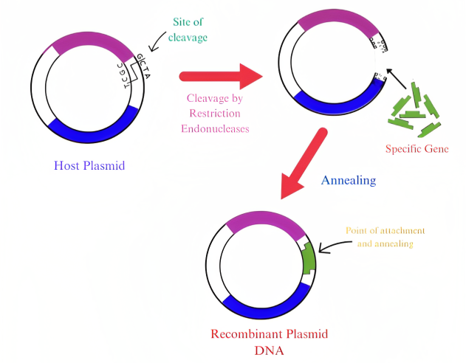
Figure 1: Recombinant DNA technology

- Breeding a better catalyst:
The protein design technique involving random mutagenesis, gene recombination, and high screening is another significant factor contributing to the expansion of biological design possibilities (Arnold & F.M., 2000). Laboratory evolution is different from natural evolution as it is more direct and it can also be considered as breeding (Ness et al., 2000). A whole generation of molecules can be bred in a short duration period like a few days by imposing environmental conditions for selective pressure. As recombinant cells are used to produce the desired products which are usually unrelated to the biological functioning of the cell, the recombinant cell can be used to carry out reactions that are not usually seen in nature. Since it is possible to breed molecules for multiple traits at the same time by altering conditions for the selection or screening, it opens up many different possibilities to craft industrial biocatalysts. Even though biocatalysts can be evolved in the laboratory in many ways, they are basically composed of two fundamental steps. The first step is to create a set of mutant biocatalysts and the second step involves the selection of those sets of mutant biocatalysts that exhibit the desired properties. This process is considered to be iterative so in order to obtain large changes, small changes are accumulated over many generations. One of the highly successful biocatalyst design strategies is to carry out multiple rounds of sequential random mutagenesis on ever-improved versions of mutant biocatalysts. One of the major problems that is associated with biocatalysts, which makes it tough to manipulate them by utilizing structure-based design is the enantioselectivity of enzymes (Reetz et al., 1999). The enantioselectivity of enzymes can be influenced by minor changes like changes in the enzyme structure or even changes to the condition under which the reaction takes place. Understanding the reaction becomes more challenging due to the unpredictable effects of these changes. However, enantioselectivity can be manipulated by laboratory evolution. A recent study showed that by performing sequential mutagenesis and screening over three generations, the enantioselectivity of a hydantoinase was inverted to favor L-5-(2-methylthioethyl) over D-5-(2-methylthioethyl). Additionally, the activity of the hydantoinase increased by five times (May et al., 2000). In laboratory evolution, several properties of biocatalysts have been modified, including stability, substrate specificity, product inhibition, functioning in non-natural environments such as organic solvents, and expression in a recombinant host. An appropriate example is the evolution involving aspartate transaminase to acquire 2.6 $×$ 10⁶ times higher activity for valine which is a non-native substrate. A point mutation can be considered an effective mechanism for fine-tuning to create biological diversity along with methods implemented by nature such as recombination. From recent studies, it can be stated that recombination is a highly useful tool in laboratory evolution. With the help of DNA shuffling, it is possible to create gene libraries that contain hybrid genes. This is achieved through homologous recombination of genes obtained from closely related parents. This results in the development of genes that can potentially produce proteins from any or all parents. This also allows us to shuffle genes derived from multiple parents which can be obtained from organisms of the same species or even different species. Shuffling of genes from different parents is not possible in nature but it can be used as a highly effective tool for rapid adaptation. DNA shuffling technique can even be used to craft enhanced biocatalysts whose features are not present in the parent enzymes and is not even known to be present in nature (Ness et al., 2000). The combination of pathway engineering and molecular biology has the potential to resolve many issues of biological design.
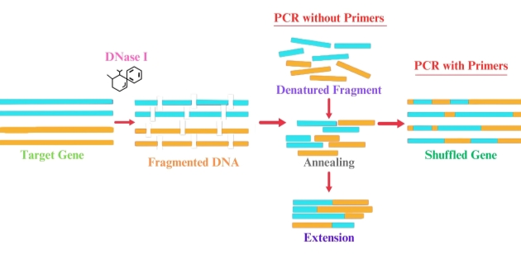
Figure 2: DNA shuffling

- De novo catalyst design:
There are many instances where natural molecules may not offer the best starting point for evolution. Since enzymes consist of hundreds of amino acids in their enzyme framework. Therefore, producing them in large quantities is inconvenient, especially for protein-based drugs. Apart from this, sometimes the biological pathway can be too clumsy for practical use like the biological oxidation reaction carried out by large multiprotein complexes which also require expensive cofactors. This makes the biological oxidation reaction a less obvious choice for industrial processes. So, putting it briefly, enzyme structures may not be optimized enough to be used as chemical reagents for a particular transformation. One possible solution for this problem is to persuade protein structures that are evolved for purposes different from catalytic function, to function as catalysts. One example is catalytic antibodies also known as abzymes, which are produced as a response for the molecules that imitate the transition state of a reaction (Patten & P.A., 1996). But it has some drawbacks like low stability, low turnover rate as well as less expression, all of which are crucial factors for an ideal enzyme (Barbas et al., 2000). As a result, the development of antibody catalysts for commercial purposes was obstructed. Another possible solution to the problem is to create a whole new protein catalyst by utilizing different breeding practices. One way is to produce new functional proteins by examining the homologous recombination of unrelated sequences while another way is to screening for larger libraries in order to obtain any rare but more useful option (Riechmann et al., 2000).
- Conclusion:
An ideal biocatalyst should carry out predictable results and can be used as routine tools. Now, with the help of laboratory evolution techniques, it has enabled us to develop improved biocatalysts within a reasonable time period. The advancements in automation and high throughput screening have led to increased adoption and application of biocatalysts. Now, the evolutionary methods may seem like the best suitable approach to create new commercial biocatalysts, but rational designs like de novo design are also becoming increasingly popular.
Reference:
Adam, M. W. W. & Kelly, R. M. Finding and using hyperthermophilic enzymes. Trends Biotechnol. 16, 329–332 (1998).
Arnold, F. H. (ed.) Evolutionary Protein Design (Adv. Protein Chem. 55) (Academic, San Diego, 2000).
Barbas, C. F. III, List, B., Rader, C., Segal, D. J. & Turner, J. M. From catalytic asymmetric synthesis to the transcriptional regulation of genes: in vivo and in vitro evolution of proteins. Adv. Protein Chem. 55, 317–366 (2000)
Cedrone, F., Ménez, A. & Quéméneur, E. Tailoring new enzyme functions by rational redesign. Curr. Opin. Struct. Biol. 10, 405–410 (2000).
May, O., Nguyen, P. & Arnold, F. H. Inverting enantioselectivity by directed evolution of hydantoinase for improved production of L-methionine. Nature Biotechnol. 18, 317–320 (2000).
Ness, J. E., del Cardayre, S. B, Minshull, J. & Stemmer, W. P. C. Molecular breeding—the natural approach to enzyme design. Adv. Protein Chem. 55, 261–292 (2000).
Patten, P. A. et al. The immunological evolution of catalysis. Science 271, 1086–1091 (1996).
Reetz, M. T. & Jaeger, K.-E. Superior biocatalysts by directed evolution. Top. Curr. Chem. 200, 31–57 (1999).
Riechmann, L. & Winter, G. Novel folded protein domains generated by combinatorial shuffling of polypeptide segments. Proc. Natl Acad. Sci. USA 97, 10068–10073 (2000).
Rondon, M. R., Goodman, R. M. & Handelsman, J. The Earth’s bounty: assessing and accessing soil microbial diversity. Trends Biotechnol. 17, 403–409 (1999).
Xiang, H., Luo, L., Taylor, K. L. & Dunaway-Mariano, D. Interchange of catalytic activity within the 2- enoyl-coenzyme A hydratase/isomerase superfamily based on a common active site template. Biochemistry 38, 7638–7652 (1999).

