**A TECHNIQUE FOR DETERMINING THE RISK OF ACQUIRING CARCINOMA OF THE LUNGS**

**Ms.MH.Vahitha Rahman1, Dr.M.Vanitha**2

1Ph.D Research Scholar, Department of Computer Applications, Alagappa University, Karaikudi, India,

2Assistant Professor, Department of Computer Applications, Alagappa University, Karaikudi, India

1vahithanadeer16@gmail.com, 2vanitham@alagappauniversity.ac.in

**ABSTRACT**

Medical imaging takes photos of a patient's body or illness for diagnosis and research. Diagnostic radiography describes medical imaging techniques, and the radiographer must take high-quality images to diagnose diseases. Medical imaging may fall under biomedical engineering, medical physics, or medicine, depending on the scenario. Therefore, many medical imaging approaches enhance other disciplines of research and industry. Medical imaging has become a prominent scientific imaging subject due to advances in computerised medical image reconstruction, analytic methods, and computer-aided diagnostic systems. Computed tomography imaging has advanced, helping radiologists diagnose a broad variety of illnesses by examining images in detail. A CT scan is an X-ray imaging technology used to study a patient's anatomy and physiology. The CT image is rebuilt using the X-ray absorption profile. CT scans are often used to assess and diagnose the brain, liver, chest, abdomen, pelvis, spine, and CT-based angiography. Lung cancer is caused by cell growth in lung tissues. Untreated, this cancer may metastasize and infect nearby tissue or organs. Lung cancer is one of the most common. Cigarette smoking causes most lung cancers. Screening and early detection may boost lung cancer survival. Competent lung cancer detection systems can identify tumours accurately. CT scan images are usually used to diagnose "Enhancement," "Segmentation," and "Feature extraction" comprise computer-aided lung cancer diagnosis. These stages may be done in many ways. Pre-processing, segmenting, feature extraction, and classification are involved. This research reveals a way to accurately identify lung cancer cells in CT images.

**Keywords- Medical Imaging, Lung Cancer, Enhancement, Segmentation, Feature extraction**

1. **INTRODUCTION**

The term "digital image" refers to the process of altering a visual representation that is just two dimensions deep through the use of a digital computer. In a more comprehensive context, it refers to the manipulation of data that is stored in a two-dimensional manner using a digital medium. Binary digits, which may encode either real or complex numbers, are frequently used to represent the discrete values that make up a digital picture. A digital picture can be described as a two-dimensional grid of these values. The first thing that has to be done in order to complete the process is to transform an image into a digital format. This image might be in the form of a transparency, slide, photograph, or X-ray. The image is first analogue, then it is converted into digital form, and last it is stored in the memory of the computer as a matrix of binary values. After that, the digitised picture may be subjected to processing, or it may be displayed on a television monitor that has the capacity for high resolution. In order to display the image on the screen, it is first saved in a buffer memory that enables rapid access so that it may be displayed. Because of this buffer memory, the display on the monitor is refreshed at a frequency of 25 frames per second, which results in a display that is unbroken and seems to be seamless.

**Image Preprocessing**

The use of a median filtering method on the original picture in order to remove unwanted noise is the first step in the preprocessing stage. This step is done in order to prepare the image for further processing. The removal of noise that has in some way compromised the quality of an image is the purpose of a technique known as median filtering. A statistical framework serves as the foundation for the approach that was used in this investigation. Traditional filters are meticulously designed to provide a certain frequency response to the signal that they process. The non-linear operation of median filtering is widely used in the area of image processing as a way of mitigating the presence of "salt and pepper" noise. This is done as a means of reducing the overall amount of noise that is present. The efficacy of a median filter outperforms that of a convolution filter in situations where the goal is to both reduce noise and preserve edges. The median filter is a form of nonlinear digital filtering that is regularly used for the goal of removing noise, and it is one of the most widely used filtering methods overall. It is standard practice in image preprocessing to reduce noise as part of an effort to improve the precision of edge recognition in an image. This objective may be accomplished in a number of ways.

**STAGE OF SEGMENTATION**

The first step in image processing involves the segmentation of objects and boundaries (lines and curves) inside a picture. The initial picture undergoes a conversion process resulting in a binary image, whereby each pixel can only possess one of two distinct values. In the context of binary images, it is customary to use black and white as the two primary colours, but other colour combinations are also permissible.The process of boundary tracing is of utmost importance for some objects, particularly those that have internal holes. It is crucial to carefully identify the beginning point and determine the appropriate direction for this task. In this context, pixels that do not belong to the main body are being tracked. The Sobel technique is used to detect edges inside an image by analysing the picture's gradient. The picture gradient refers to the variation in the intensity of an image. The image's intensity will reach its highest value in areas where two distinct sections are separated, indicating the presence of an edge. The magnitude of the gradient will be higher in regions where the intensity value is quite high. The Sobel operator uses the maximum value to identify edges inside an image.

**FEATURE EXTRACTION**

When estimating the size of a tumour, feature extraction is an extremely important step. The area, perimeter, and irregularities the index are three distinct mathematical parameters that are used extensively in the process of determining the size of a tumour.

**Classification Stage**

In this study, the lung cancer will be classified using data mining techniques such as sequential minimal optimisation (SMO), J48 decision tree, naive Bayes, and logit boost. Following the classification process, the experimental results obtained from these techniques will be compared to determine the most efficient and accurate method. In order to facilitate our analysis, we will employ various data attributes including age at diagnosis, gender, marital status, smoking habits, panparag usage, tobacco consumption, geographical location, occupation, physical exercise, symptoms experienced, treatment received, tumour size, and cancer stage. Additionally, we will incorporate the size of the nodule as a classification attribute during the feature extraction process. The ultimate objective of this endeavour is to accurately classify the cancerous nodule as either benign or malignant.

The suggested technology is designed to identify lung cancer at three distinct stages: early, intermediate, and advanced. The system has many sequential processes, including Preprocessing, Feature selection, Feature extraction, and Classification using Support Vector Machines .

1. **A REVIEW OF THE WORKS**

**Semantic and content-based medical image retrieval for lung cancer diagnosis with the inclusion of expert knowledge and proven pathology**

In this study, we explore the use of computed tomography scan data from the chest in the identification and diagnosis of lung cancer. Having an accurate ground truth in lung cancer CAD systems is crucial and time intensive. This study contributes to the field by, among other things, employing content-based image retrieval and algorithms for identification and categorization of nodules to compile a database of lung nodules with verified pathology. The identification of benign, malignant, and metastatic nodules has been the subject of a research and analysis including 246 individuals. Using data from the Lung Image Database Consortium maintained by the National Cancer Institute, USA, the study team was able to attain an overall accuracy of 92.8% at recall 0.1 and an overall mean accuracy of 82.0%. Finally, validations were conducted using test cases from PGIMER, Chandigarh, with an overall accuracy of 88%. As shown in experiments, the suggested parameters and analysis boost semantic performance while simultaneously decreasing computing complexity, the amount of time spent reading and analysing all slices by doctors, and retrieval times.

**A Graph-based approach to the retrieval of volumetric PET-CT lung images**

PET-CT scans, which combine positron emission tomography with computed tomography, are now standard for the detection, localization, and evaluation of many forms of cancer. As a result, the quantity of PET-CT information stored in hospitals and similar facilities has grown exponentially. Possibile clinical uses for the capacity to examine these massive image databases include evidence-based diagnosis, physician training, and biological research. By including visual characteristics into the search process, content-based image retrieval is an alternative to traditional text-based retrieval. The capacity to take into account illness localization during the similarity assessment is what makes graph-based CBIR approaches exceptional methodologies for medical CBIR. However, the vast majority of graph-based CBIR research have relied on 2D key slice techniques and so have failed to take use of the rich volumetric data intrinsic to contemporary medical imaging like multi-modal PET-CT. In this research, we provide a graph-based CBIR approach that makes use of 3D spatial characteristics collected from volumetric ROIs. We employ a graph-edit distance to compare PET-CT scans that are otherwise comparable except for the relative positioning of cancers and other organs in 3D space. Our research hopes to uncover how effective these graphs may be in 3D PET-CT CBIR. We demonstrate that our approach achieves encouraging accuracy when collecting clinical PET-CT images of lung cancer patients.

**A graph-based approach for the retrieval of multi-modality medical images**

This study recovers medical volumes from two imaging modalities taken sequentially on the same scanner. The combination of PET-CT and positron emission tomography has improved cancer detection, localisation, and staging.Multi-modality volume retrieval for cancer patients is problematic since tumours and organs typically have complementary geometric and topologic qualities. These traits and linkages utilised in tumour staging and classification may be graphed. Graph-based techniques work well for spatial similarity retrieval. However, naïve graph representation of all relationships obscures tumor-anatomy linkages.It propose a graph structure constructed from entire networks that constrains tumour vertex connections to account for malignancies and organs' geographic proximity. This lets retrieval be depending on cancer location. It also provide a similarity matching method that considers network nodes' distinct feature sets from different imaging modalities. Our method replicates patient-specific structural alterations but emphasises cancer-organ linkages. When tumours are limited to linked anatomical structures, graphs may distinguish between equivalent images based on tumour location. It evaluated our retrieval approach using clinical PET-CT datasets. Our method retrieved multi-modality images using spatial features. Our graph-based retrieval system outperformed gray-level histograms and state-of-the-art methods like visual words employing the scale-invariant feature transform.

**Graph-Based Retrieval of PET-CT Images using Vector Space Embedding**

Content-based image retrieval methods that employ graphs to encode image attributes and assess image similarity using graph edit distance have good retrieval accuracy. However, such methods are computationally intensive. This work presents a graph-based CBIR method that improves retrieval efficiency. We construct a vector space embedding for every graph using their distances from prototype graphs, thus each vector component reflects a prototype distortion. This is done offline. The Euclidean distance of vector embeddings is quicker than the graph edit distance for picture comparison. Lung tumour patients' 50 PET-CT volumes were used to assess our study. Our approach is 21 times quicker than graph edit distance with a mean average accuracy difference of less than 4%.

**Multi-view Laplacian Support Vector Machines**

Multi-view Laplacian support vector machines are used to offer a new semi-supervised learning approach. The conventional formulation of SVMs includes manifold and multi-view regularisation as a natural transition from supervised to multi-view semi-supervised learning. A replicating kernel Hilbert space optimisation issue for a function becomes a limited-dimension Euclidean space optimisation problem. We first establish a theoretical limit on the generalisation performance of the offered approach, then formulate the empirical Rademacher complexity, which significantly affects the bound. Comparing the actual Rademacher complexity with this constraint may reveal how regularisation terms affect generalisation performance. We provide experimental results from synthetic and real-world data sets that verify multi-view Laplacian SVMs work.

**Lung Cancer Diseases Diagnostic Asistance Using Gray Color Analysis**

Anyone treating patients in a hospital faces a serious risk: diagnosis errors. Medical therapy isn't always precise. Misdiagnosed lung cancer is one of the worst diseases. Some practitioners “read” cancers in x-ray rontgen images as a terminal tumour. A general practitioner uses the patient's history, radiologic examination, and physical examination to diagnose. This work investigates grey image indexing and retrieval. The statistical distribution of Harralick feature from picture sample determines the characteristics. The similarity measure between query and database pictures gives accurate retrieval results using the specified invariant characteristics.

**Correlation between Biopsy Confirmed Cases and Radiologist’s Annotations in the Detection of Lung Nodules by Expanding the Diagnostic Database Using Content Based Image Retrieval**

Lung cancer computer-aided diagnostic systems need accurate and timely ground truth. In this study, we examined the Lung Image Database Consortium database of pulmonary computed tomography scans and used content-based image retrieval to annotate unlabeled images with diagnoses using the limited diagnostically labelled data. By utilising CBIR repeatedly and employing pathologically proven instances, we increase CAD system diagnostic data from 17 to 121 nodules. We tested the strategy using a CAD system that searches different lung nodule sets and gets related nodules from the diagnostically labelled dataset. This system's precision calculation Undiagnosed query nodules employ diagnosed dataset and computer-predicted malignancy data as ground truth. Our findings suggest that CBIR expansion may classify undiagnosed pictures to enhance CAD system performance. It also showed that minimal knowledge of biopsy-confirmed instances helps doctors flag undiagnosed patients and prevent unneeded biopsies as second opinions.

**Expanding diagnostically labeled datasets using content-based image retrieval**

Having reliable baseline data is essential in CAD systems. However, there is a scarcity of databases that provide medical photographs accompanied by diagnostic data. To annotate unlabeled pictures with diagnoses, we create a content-based image retrieval method using lung computed tomography scans to take use of the limited images with diagnostically labelled data. We increase the depth and breadth of CAD systems' diagnostic tools by repeatedly implementing this CBIR technique. To test the efficacy of the strategy, we built a computer-aided diagnosis system that searches the diagnostically labelled dataset for nodules that look like those in the patient's lung tissue but have not yet been identified. The system's accuracy is determined by comparing radiologist and computer-predicted malignancy statistics for the undiagnosed query nodules to the ground truth. Based on our findings, CBIR expansion is a useful technique for labelling pictures that have yet to be diagnosed, which may then be used to boost the efficiency of CAD programmes.

1. **METHODOLOGY**

The major cause of cancer fatalities in both sexes is lung cancer. Lung cancer accounted for 13% of cancer diagnoses and 28% of cancer deaths in 2003, according to the American Cancer Society. Lung cancer patients had a 15% 5-year survival rate. Diagnosed when the sickness is confined, rates may reach 49%. Only 15% of lung cancer cases are recognised early or primary, hence CT nodule identification is crucial. CAD is essential for cancer screenings. Only 20% of malignancies are identified early, when removal is most beneficial. Due to the lung's backdrop structure, a radiologist may miss 30% of a lung nodule on a chest radiograph. The radiologist preprocesses imaging data and indicates the probable nodule location using CAD.

Lung cancer requires particular attention as the major cause of cancer deaths globally. This requires early lung nodule identification in CT images. Lung cancer nodule detection may be helped by blocking adjacent bronchi, ribs, and blood arteries. A more sophisticated chest architecture shows a more potential nodule region, which is subsequently classed by contrast, form, and size. Simple rule-based classification produces many false positives. This lung nodule identification approach overcomes the problem. This research includes numerous image processing methods, including median filter, bit plane slicing, dilatation, flood fill, outlining, and lung border extraction. For learning and classification, Support Vector Machine is used. Medical image databases may hold hundreds or thousands of pictures. CAD is effective for early lung cancer detection. CT scans cannot identify early-stage lung cancer due to low false positive rates and sensitivity. The device under development may automatically identify lung cancer by reducing false positives. Lung CT images are processed using many ways outlined in the analysis report. The segmentation process continues using a clustering method. Finally, Support Vector Machine improves classification and lung nodule identification. CT chest images eliminate testing using the supplied approach. Several studies suggest content-based access to medical imaging data for clinical decision making to simplify clinical data management.

**Median filter Algorithm**

The median filter is the most famous image processing order-statistics filter. This filter replaces the pixel value with the median of its neighborhood's grey levels.The median includes the original pixel value. Median filters are extensively used because they reduce random noise well. Mediator filters minimise blurring more than linear smoothing filters of same size.

This method removes salt and pepper noise from damaged images.

W, a 3x3 two-dimensional window, is selected initially. This window focuses on damaged image pixel p(x, y).The second stage arranges window pixels in ascending order. The median, maximum, and lowest pixel values (Pmed, Pmax, and Pmin) are calculated from the sorted vector V0. The start and end elements of vector V0, Pmin and Pmax, indicate the minimum and maximum values. The median value, Pmed, is the vector's middle element.In Step 3, a processed pixel is uncorrupted if its P(x, y) value falls within Pmin and Pmax. Importantly, Pmin must be more than 0 and Pmax less than 255. The pixel stays uncorrupted and unaltered. Otherwise, p(x, y) is corrupted. Step 4: A corrupted pixel p(x, y) might have two outcomes:In the first scenario, replace the damaged pixel p(x, y) with Pmed if Pmin is less than Pmed, which is less than Pmax, and Pmed is between 0 and 255.Pmed may be a noisy pixel if scenario 1's parameters are not satisfied. This scenario requires calculating the difference between every pair of surrounding pixels in the sorted vector V0. This creates VD, which contains the computed discrepancies.Find the highest vertical disparity (VD) and the original picture pixel (V0) that matches the processed pixel.Steps 1–4 are repeated until the complete image is processed.

**Support Vector Machine**

Classification and regression problems are both within the scope of Support Vector Machine (SVM), a supervised machine learning technique. However, its primary use is in the realm of classifying data. In this method, each data point is represented by a single coordinate in an n-dimensional space (where n is the total number of features). Then, we classify the data by identifying the hyper-plane that effectively separates the two groups.

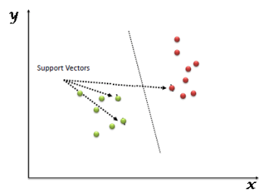

Simply put, a support vector is an observational coordinate. To divide these two categories (hyper-plane and line), Support Vector Machine provides the most cutting-edge boundary.

1. **EXPERIMENTAL RESULTS**

The use of computer-aided diagnosis, often known as CAD, has been more popular in the area of radiology in recent years, notably for the detection of cancerous tumours. CAD systems give radiologists with a straightforward and time-saving method of improving their detection methods. This is accomplished by capitalising on the capabilities of a CT scan. Therefore, as a result of this, there is a reduction in both the amount of time that is necessary and the quantity of work that is required of radiologists. The process of image segmentation is an essential step in the majority of image analysis systems. This is due to the fact that the segmentation that is produced after image segmentation plays a large part in a variety of methods for the description and identification of pictures. For the purpose of grey level segmentation in this investigation, a local thresholding approach was used, with particular emphasis placed on run length coding methods. In order to carry out the process of segmentation, seeds, which point to the presence of objects or background in certain locations across an image, need to be extracted. On the topological surface, the locations of the marker sites have been chosen such that they overlap with regional minima. The quality in question In the discipline of image processing, the extraction of pictures is of critical significance. In this sector, a wide number of techniques and methods are used in order to recognise and differentiate certain portions, shapes, or qualities that are included inside a picture. In the current investigation, a mathematical strategy is used to the process of extracting important information for the goal of estimating the extent of a malignancy. Calculating the area, perimeter, and eccentricity of the tumour will allow you to accomplish this goal. The process of feature extraction is a vital step in identifying the normalcy or abnormality of a picture, which ultimately determines the final results. This phase is required because the final outcomes are influenced by the normalcy or abnormality of the image. The ensuing procedure of categorization relies heavily on these extracted traits as its primary building block. The following format is used to convey the characteristics:

The amount of pixels a nodule takes up is represented by its "area," which is a scalar variable. The calculation is made by adding up all the "1" pixel regions in the binary image. The perimeter is a scalar quantity that represents the total length of the boundary of a pixelated object. It is obtained by summing the lengths of the linked boundaries of the pixels in a binary picture. "Eccentricity" is a measure of how far out of the norm a given form is; it is defined as a number greater than 1 for perfectly circular shapes and less than 1 for all others.

The detection process plays a crucial role in avoiding serious stages and reducing the disease's distribution to other parts of the body, making lung cancer the most dangerous abnormality or disease in the world based on stage at which the cancer cells in the lungs are detected. The process of improving images, segmenting them, and extracting features may be broken down into several stages for more precise results. Lung nodule identification in CT scans is therefore a dynamic field of study, with much room for improvement through the incorporation of advances in computer-aided diagnosis. Using segmentation by run length coding, this approach extracts the volume of a lung cancer. picture processing techniques such as local thresholding, picture segmentation (seed growing), and feature extraction are shown in the graphics above. This approach allows for straightforward analysis of cancer development in neighbouring scanning reports by straightforward estimation of tumour size using area and perimeter obtained in this study.

Plan of Action

Input Image

Preprocessing

DWT and Classification

Edge Detection

Thresholding

Result Image

**FIG 1 CT ORIGINAL IMAGE FIG 2 SALT & PEPPER OUTPUT**

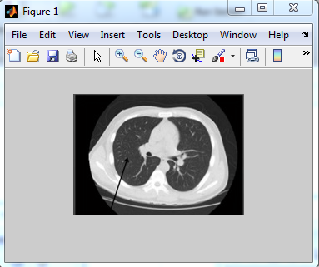 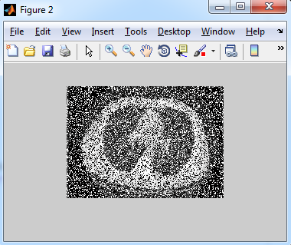

**FIG 3 K-MEDIAN OUTPUT**

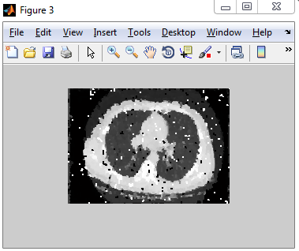

**FIG 4 LUNG CANCER AFFECTED CT IMAGE RESULTS**

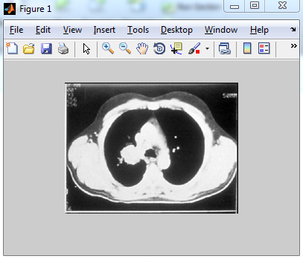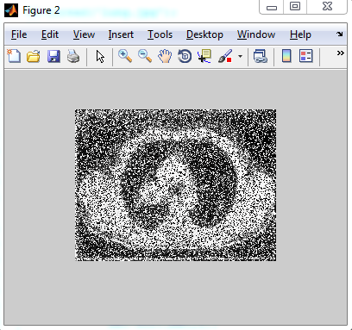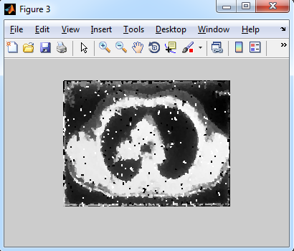

**FIG 5 VALID LUNG CT IMAGE FIG 6 CANCER AFFECTED LUNG CT IMAGE**

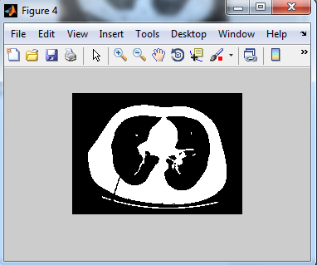 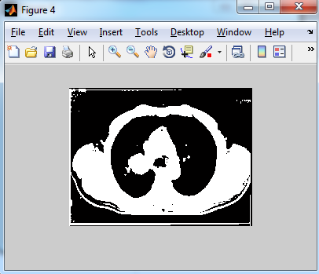

**FIG 7 DECOMPOSED OUTPUT**

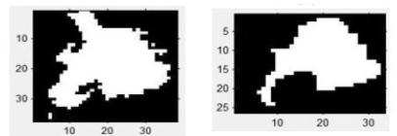

1. **CONCLUSION**

A innovative, streamlined, and effective instrument has been developed to enhance educational research centred on lung cancer. The use of greyscale thresholding, decomposition, and multiview support vector machine (SVM) operations in this application facilitates the display and segmentation of detected nodules in CT images obtained from the Lung Image Database Consortium (LIDC). Over time, this technology will confer benefits to the fields of lung cancer research and education.

During the next time, there are plans to include further functionalities related to the detection of both benign and malignant nodules. Furthermore, there will be an application of three-dimensional nodule segmentation techniques. The objective of these developments is to improve the accuracy of nodule estimation.

**REFERENCE**

1. Gindi, T. A. Attiatalla, and M. M. Sami, “A Comparative Study for Comparing Two Feature Extraction Methods and Two Classifiers in Classification of Early stage Lung Cancer Diagnosis of chest x-ray images”, *J. of American Science*, vol. 10, no. 6, pp. 13-22, Apr. 2014.
2. Aggarwal, P.; Vig, R.; Sardana, H.K., "Semantic and contentbased medical image retrieval for lung cancer diagnosis with the inclusion of expert knowledge and proven pathology," *Image Information Processing (ICIIP), 2013 IEEE Second International Conference on* , vol., no., pp.346,351, 9-11 Dec. 2013
3. Zeng, H. Lin, and W. Wang, “Development of a Data Integration and Visualization Software for LIDC”, *J. Softw.,* vol. 8, no. 9, pp. 2297-2304, Sep. 2013.
4. database of pulmonary nodules," *Image Processing. 2002. Proceedings. 2002 International Conference on* , vol.3, no., pp.III-149,III-152 vol.3, 2002
5. G. Xiuhua, S. Tao, W. Huan, and L. Zhigang, “Theory and Applications of CT Imaging and Analysis-Prediction Models for Malignant Pulmonary Nodules Based on Texture Features of CT Image”, *InTechopen J.*, pp. 63-76, Apr. 2011.
6. Gile, N.; Wang Ning; Nathalie, C.K.; Siewe, F.; Lin Xudong; Xu De, "A case study of image retrieval on lung cancer chest Xray pictures," *Signal Processing, 2008. ICSP 2008. 9th International Conference on* , vol., no., pp.924,927, 26-29 Oct. 2008
7. Giuca, A.-M.; Seitz, K.A.; Furst, J.; Raicu, D., "Expanding diagnostically labeled datasets using content-based image retrieval," *Image Processing (ICIP), 2012 19th IEEE International Conference on* , vol., no., pp.2397,2400, Sept. 30 2012-Oct. 3 2012
8. K. Clark, B. Vendt, and K. Smith et al., “The Cancer Imaging Archive (TCIA): maintaining and operating a public information repository”, *J. of digital imaging*, vol. 26, no. 6, pp. 1045- 57, 2013.
9. K. Suzuki, M. Kusumoto, S. I. Watanabe, R. Tsuchiya, and H. Asamura, “Radiologic Classification of Small Adenocarcinoma of the Lung: Radiologic-Pathologic Correlation and Its Prognostic Impact”, *The Annals of Thoracic Surgery*, vol. 81, no. 2, pp. 413-419, 2006.
10. Kawata, Y.; Niki, N.; Ohmatsu, H.; Kusumoto, M.; Kakinuma, R.; Mori, K.; Nishiyama, H.; Eguchi, K.; Kaneko, M.; Moriyama, N., "Three-dimensional CT image retrieval in a
11. Kawata, Y.; Niki, N.; Ohmatsu, H.; Kusumoto, M.; Kakinuma, R.; Mori, K.; Nishiyama, H.; Eguchi, K.; Kaneko, M.; Moriyama, N., "Searching similar images for classification of pulmonary nodules in three-dimensional CT images," *Biomedical Imaging, 2002. Proceedings. 2002 IEEEInternational Symposium on* , vol., no., pp.189,192, 2002
12. Kumar, A.; Jinman Kim; Lingfeng Wen; Dagan Feng, "A Graph-based approach to the retrieval of volumetric PET-CT lung images," *Engineering in Medicine and Biology Society (EMBC), 2012 Annual International Conference of the IEEE* , vol., no., pp.5408,5411, Aug. 28 2012-Sept. 1 2012
13. M. O. Lam, T. Disney, D. S. Raicu, J. Furst, and D. S. Channin, “BRISC-an open source pulmonary nodule image retrieval framework” *J. Digit. Imaging*, vol. 20, No.1, August, pp. 63–71, 2007.
14. N.G. Yadav, “Detection of lung nodule using Content Based Medical Image Retrieval” *International Journal of Electrical, Electronics and Data Communication, ISSN (p): 2320-2084,* Volume-1, Issue-2, April-2013
15. Paulus, P.; Gaol, F.L., "Lung Cancer Diseases Diagnostic Asistance Using Gray Color Analysis," *Computationa lIntelligence, Modelling and Simulation (CIMSiM), 2010 Second International Conference on* , vol., no., pp.355,359, 28-30 Sept. 2010
16. R. M. Haralick, K. Shanmugam, and I. Dinstein,”Textural Features of Image Classification”, *IEEE Transactions on Systems, Man and Cybernetics*, vol. SMC-3(6), Nov. 1973.
17. R. Owens, 'Binary Images', Homepages.inf.ed.ac.uk, 1997. [Online] Available:http://homepages.inf.ed.ac.uk/rbf/CVonline/local_copies/Owens/lect2/node3.html. [Accessed: 21- Dec- 2014].
18. R. Siegel, J. Ma, Z. Zou, and A. Jemal, “Cancer statistics, 2014”, *CA Cancer J. Clin.*, vol. 64, no. 1, pp. 9–29, Feb. 2014. [Online]. Available: http://dx.doi.org/ 10.3322/caac.21208
19. R. V. D. Boomgard, and R. V. Balen, “Methods for Fast Morphological Image Transforms Using Bitmapped Images”, *CVGIP: Grap. Models and I. Processing*, vol. 54, No. 3, pp. 254-258, 1992.
20. S. Chen, K. Suzuki, and H. MacMahon, “Development and evaluation of a computer aided diagnostic scheme for lung nodule detection in chest radiographs by means of two stage nodule enhancement with support vector classification”, *Med. Phys. J.*, vol. 38, no. 4, pp. 1844- 1858, March 2011.
21. S. G. Armato III, A. P. Reeves, and L. Bidaut et al., “The lung image database consortium (LIDC) and image database resource initiative (IDRI): a completed reference database of lung nodules on CT scans”, *Med. Phys. J.*, vol. 38, no. 2, pp. 915-931, 2011.
22. Sluimer, I.; Schilham, A.; Prokop, M.; Van Ginneken, B., "Computer analysis of computed tomography scans of the lung: a survey," *Medical Imaging, IEEE Transactions on* , vol.25, no.4,pp.385,405,April2006 doi: 10.1109/TMI.2005.862753