THE STATE OF KIDNEY TRANSPLANTATION: A REVIEW
Dr Juveria Badar^{1*}, Atika Amrooz¹, Adiba Mehrooz¹, Dr Syed Mohammed Kazim², Dr M A Aleem², Dr Nabeela Fatima²
¹Department of Pharmacy, Nizam Institute of Pharmacy, Deshmukhi, Telangana, India-508284
²Department of Pharmacy Practice, Nizam Institute of Pharmacy, Deshmukhi, Telangana, India-508284
Corresponding Author:
Dr Juveria Badar,
Department of Pharmacy Practice,
Nizam Institute of Pharmacy, Deshmukhi.
Email: juveriabadar23@gmail.com
Phone: +91-8688611200

ABSTRACT:
Treatment of choice for those with end- stage renal illness is constantly a order transplant. Over the 5 decades, the field of order transplantation has been expanded. End- stage renal complaint cases that are on the waiting list and latterly admit a order transplant have a advanced chance of long- term survival than those who continue entering dialysis. In addition, transplant recipient constantly have advanced quality of life and have a 1 decade survival advantage over dialysis recipients. The liability of surviving order comity is constantly loftiest among family members. Successful living- patron transplants, still, are also constantly performed using feathers from unconnected benefactors, similar as familiarity, associates, or members of a religious community. Preemptive order transplantation, frequently known as a transplant before dialysis is needed, may also be profitable for some cases. The health enterprises connected to a order transplant include those directly related to the procedure and organ rejection. The adverse consequences of taking immunosuppressive medicines, which are used to stop the body from rejecting a given order, are another threat.
- INTRODUCTION:
People with end- stage renal complaint can live longer and have better quality of life because to order transplantation. The two surgical ways used for both procurement and broadcasting are open and laparoscopic. End- stage renal complaint is the primary surgical suggestion.
The ideal therapy strategy for people with dialysis is kidney transplantation. Inspite of many issues to be resolved, such as the scarcity of organ donors, immunological challenges, and the requirement for long-term immunosuppression, which is linked to an elevated risk of infections and cancers.
- ANATOMY OF KIDNEY:
The feathers are placed on either side of the chine, in retroperitoneal space. The left order is deposited slightly advanced than the right part, since the liver is placed on the right axis of the abdominal depression, over the right order. Each of the part weighs about 0.125 to 0.175 kilogram and 0.115 to 0.155 kilograms in men and ladies singly. The order generally estimates roughly 0.11 to 0.14 meters in length, 0.06 centimeters in range and is about 0.04 meters broad. The feathers are defended by fatty tissue, thew, and caricatures of reverse. Perirenal fatty tissues, additionally known as the renal fat pad, safeguard the feathers from exterior strength or harm. The feathers possess a medium dent called the renal hilum, which is inlet and outlet point for structures that provide or refuse the feathers similar as the jitters.

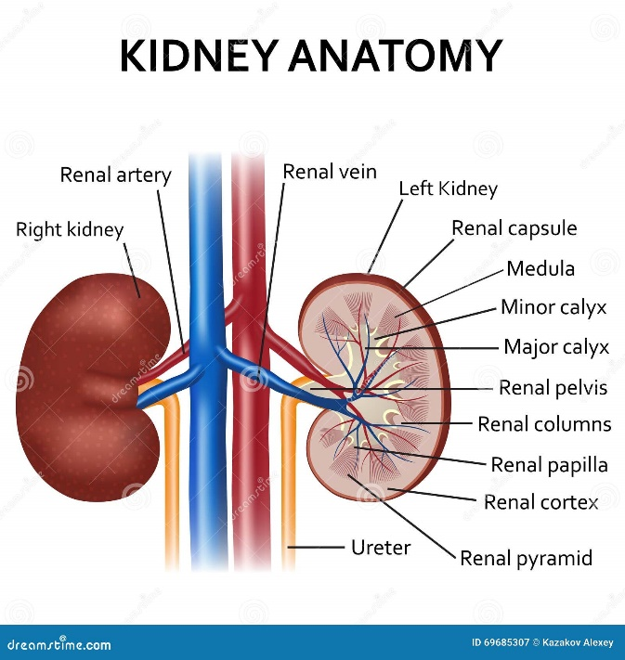
Fig-1: Anatomy of kidney [Adapted from dreamstime.com]
- INDICATIONS FOR KIDNEY TRANSPLANTATION:
End- stage renal disease ( ESRD) is flattering more prevalent. Diabetes and hypertension are the two main etiologies of renal failure.( 1) Pre renal (chronic or acute ischemia), intrinsic renal ( glomerulonephritis, focal- segmental glomerulosclerosis), or post renal( influx nephropathy, inhibition) orders are used to classify other causes of CKD/ ESRD. If a person with chronic kidney disease (CKD) developed to stage 4, which is identified by decreasing in GFR levels lower than 30 mL/ min/1.73 m, they should seek advice from health care experts and admit information regarding renal failure and treatment possibility, including grafts.( 2)
4. ANASTOMOSIS:
Problems linked with ureteral junction in order graftings are largely current, inspite of occurrence of colorful variety of catheter. The contemporary catheter accoutrements and arrangment styles possess few drawbacks. This research practices to give a volition next to probing ureteral junctions with a numerous catheters and alter arrangement system in a mice prtotype of order grafts. Procedures in outbred mice which aimlessly split to Set I sham operation, Set II autologous ureteral anastomosis, and Set III isogenic order grafting with ureteral junctions. For the anastomosis, a numerous catheter escorted by preliminarily set 11- 0 silk was fitted with in the ureter. The catheter and ureter were fixed with 11- 0 silk sutures. The order mass and serum creatinine investigated. The ureteral and kidney sections was cut out for biological examinations.
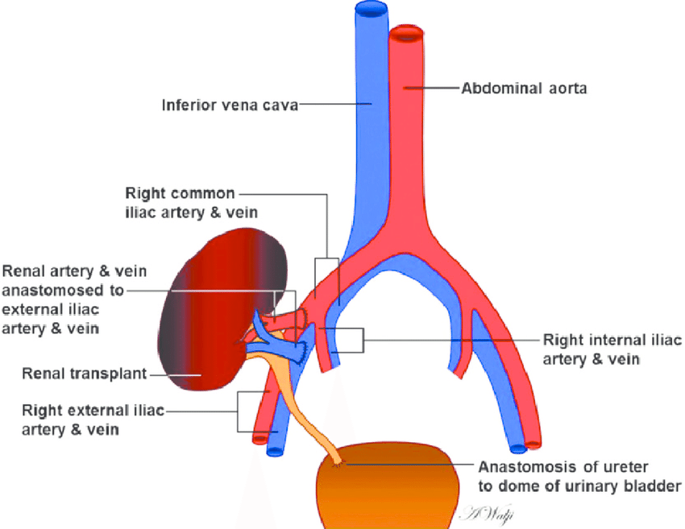
Figure-2: Diagramatic representation of a kidney transplant shows the positions of vascular and urologic anastomoses [Adapted from Low G et al[3]]

This research requires swapping benefactors which are inharmonious escorted by donors therefore, rather, particular devote a order to suitable philanthropist. [4] The interchange obtain satisfaction of alive devotion but evade the threat of incongruity. [5] Benefactors navigates to philanthropist areas and suffer renal extripation contemporaneously indeed when execute in other areas and at far locales. Live- patron interchange policy represents worldwide. [6,7]
- TYPES OF TRANSPLANTS:
There are two different types of transplant:
- Live
- Diseased or cadaveric
Over cadaveric grafts, living-associated kidney transplantation remarkably ameliorate graft survival. This advantage has historically been attributed to superior histocompatibility matching in living related transplants, which are shared by first-degree relatives, as opposed to cadaveric transplants, which have comparatively poor histocompatibility matching. This opinion is reinforced by data demonstrating that recipients of live related donor grafts experience chronic rejection less frequently than recipients of cadaveric transplants. [8,9]
The majority concur that the primary risk factor for the emergence of chronic rejection is an acute rejection episode. [10] Recent research from a single location found that non-immunologic variables are crucial for cadaver recipients but not for living donor grafts, where an episode of acute rejection is the sole substantial risk factor for long-term graft loss. [11] Good long-term results with living unrelated grafts have shown the significant role that alloantigen-independent variables play in the development of chronic rejection in this regard. [12] These characteristics, which appear to work in concert with early acute rejection episodes to speed the course of long-term graft failure in cadaveric transplantation, include cold ischemia preservation injury and older donor age. [13,14]
- TYPES OF DONORS:
A young individual who experiences a major head injury that is insulated from the brain and results in death is the ultimate deceased organ patron, whose thoracic and abdominal organ function is complete. Such a departed patron supply magnificent graftable organs escorted by occasion to attain prompt allograft corollary and abiding case constancy. As the size of the philanthropist staying inventory and the numeral of staying list mortality increases, aged benefactors and benefactors escorted by attribute previously allowed to avert More and more people are relying on organ donation.[15] The client's social and medical history (age, history of hypertension or diabetes, risk of spreading contagious illness and/or malice), the cause of death (traumas, cerebrovascular accident), the mode of death (brain deaths, cardiac death), the deconstruction of the allograft (vessel abnormalities), and the morphology on vivisection (glomerulosclerosis, interstitial nephritis) are used to determine the clinical attribute separate "borderline"[16,17] Kauffman advises using the term "expanded" to refer to the patron whose organs may be linked to poorer outgrowth because the term "borderline" may be viewed negatively by both the instances and programs that plant them.[18] Because these allografts have a higher rate of delayed graft function, more frequent acute rejection events, and decreased long-term graft performance, they are regarded as coming from the enlarged pool. This may be caused by a number of variables, including as a prolonged cold ischemia time (CIT), elevated immunogenicity, impaired ability to repair towels, and impaired function with decreased nephron mass.[19] But recently, Ojo et al. shown that, in contrast to stay-listed dialysis cases, expanded feather donors recognize the benefit of redundant life-times.[20] Even so, some centers continue to prefer not to utilize them because their placement is frequently sensitive and takes a long time.
USE OF ANTI THYMOCYTE GLOBULIN (ATG):
Antithymocyte globulin (ATG) is a good seeker drug to help and treat both acute T cell (TCMR) and antibody- intermediated rejection (ABMR) due to its capacity to deplete T and B cells, to inhibit B and T cell cooperation as well as leucocyte adhesion, and to induce certain'tolerogenic'nonsupervisory T cell and dendritic cell(DC) populations. ATGs have been widely utilized as an induction treatment in renal transplantation for high-risk immunological conditions for many years, despite little support from randomized clinical trials. As a first-line treatment for TCMR, ATG has also been employed, particularly in cases of severe acute TCMR with vascular lesions (Banff II orders) and as a deliverance treatment for steroid-resistant acute TCMR. Nevertheless, its advantage over others. Anew, there's a absence of sufficiently generated clinical trials with abreast immunosuppression. While efficacity isn't disagree, the multitudinous brief- and everlasting side goods create a threat – aid evaluation against additional lower poisonous curatives delicate, and regretably some of the side goods are correalated with subordinate everlasting issues with contemplate to case and graft survival. Indeed, ATG sequel in intense reduction and revision of the philanthropist's vulnerable structure, which presumably describe the advanced threat of opportunistic infections and cancer. [21]
7.1 WARM ISCHEMIC TIME:
Although warm ischemia has the ability to change the personality of transplanted feathers, nothing is known about how it will affect long-term problems. Then, we studied United States order transplant donors to ascertain the relationship between warm ischemia time—the interval between an organ being removed from a cold storage facility and being reinfused with warm blood—and death or graft failure. Possible rendering fault was attributed to twinkle counts under ten. Thus, the reference group was decided to be the 10- to-under-20-minute span. Mortality and graft failure (return to regular dialysis or preventive retransplantation) adjusted for benefactor, patron, immunologic, and surgical variables were the main outcomes.
An essential contribution to medicine and the treatment of patients with terminal organ failure has been transplantation. Strategies to extend graft and patient survival are an essential topic of investigation given the relative failure of organs. The ischemia-reperfusion injury that all solid organs experience after implantation is one of the topics that has received more in-depth research. Previous research has demonstrated that unfavorable ischemic responses impair organ recovery. Reactive oxygen species production, apoptosis activation, and stimulation of the innate and adaptive susceptible system are some of the apparent molecular pathways. [22,23,24] These pathways may cause delayed graft function, which is linked to poor long-term graft and case survival, and order transplants that do not work immediately after surgery. [25,26]
7.2 COLD ISCHEMIC TIME:
A patient is kept in cold storage after laparoscopic junking for transplanting to preserve the viability of their cells. Cold ischemia can lessen cellular harm, but it cannot completely reverse it. The production of reactive oxygen species boosts mitochondria in response to hypoxia. Because oxygen is required to produce adenosine triphosphate (ATP), ischemia cells often use glycolysis to produce ATP, which produces lactic acid as a byproduct and causes intracellular acidosis. Following the depletion of glycolytic substrates, this anaerobic energy production halts. Poor ATP synthesis leads to excessive Na/K ATPase pump activity, which disturbs the balance between intracellular potassium ions and external sodium ions required for cell function. Injury to all aspects of cells up to the cell cycle can occur from these changes. Inflammation and oxidative damage may result from the reperfusion of an ischemic condition, which is known as a paradoxical miracle recognized as ischemia-reperfusion injury. Ischemia-induced microvascular damage increases leukocyte clogging and fluid filtration in capillaries and postcapillary venules. The injured endothelial cells urge the release of seditious intercessors and proteolytic enzymes and store new reactive oxygen species. A large percentage of sublethally injured cells can be prevented from heading on apoptosis by one of them, titled caspases. Those alterations could have an impact on delayed graft function (DGF) after transplantation. The clinical assessment of acute rejection in DGF instances may be challenging. Rejection may occasionally be discovered too late, after irreversible lesions develop. On the other hand, this unusual type of acute order injury can also be accompanied by a poor graft outcome or perhaps a single instance of rejection. When the order injury is mild and the bestowed order isn't affected by natural morbidity, the form process can be adaptive with many consequences. The form process can be maladaptive and may contribute to the development of tubulointerstitial fibrosis when the injury is more severe or when there are preceding order anomalies. Transsubstantiating growth factor- and other profibrotic factors have increased levels that can promote fibroblast differentiation, extracellular matrix fusion, and epithelial-to-mesenchymal transition.[27]
- COMPLICATIONS:
8.1 Hemorrhage: In any surgery, hemorrhage is always a possibility, both during surgery and in the immediate aftermath. There may be no classic bleeding symptoms. Patients who frequently take beta-blockers may not have characteristic tachycardia in reaction to hypovolemia. Furthermore, due to parenchymal compression, they may be hypertensive rather than hypotensive. There may be a palpable tumor or protrusion close to the incision, and they frequently report of sudden, severe flank pain. Maintaining a high level of clinical suspicion is important and can call for another operation. It's crucial to keep in mind that haemorrhage perhaps obstruct beyond sectionalize area of the kidney in the retroperitoneum, an result that would not be anticipated after the allograft was placed intraperitoneally. [29]
8.2 Thrombosis: Although very uncommon, renal vein thrombosis carries a substantial risk of transplant loss. This phenomena may show up as new-onset hematuria, abrupt-onset oliguria/anuria, and/or graft failure in the early postoperative phase. Even rarer, but frequently just as damaging, and manifesting identically in the receiver, is arterial thrombosis. In the crises of a rapid fall in UOP in a formerly working allograft, ultrasound should be requested as it is frequently diagnostic. Due to technical faults and/or clamp injury, a elevated suspicion for vascular problems should be kept during the early postoperative phase. [29]
8.3 Infection: Since patients are immediately put on immunosuppression following surgery, infections are frequent. They are most severely immunosuppressed in the first three to six months following surgery, It makes them more susceptible to getting sick at that time. The two common nosocomial and bacterial illnesses are urinary tract infections (UTIs) and surgical site infections (SSIs) that are most frequently seen in the first month following transplantation. For unusual or opportunistic pathogens, high suspicion must be maintained, especially in the months that follow. The cytomegalovirus, Epstein-Barr virus, and polyomavirus (BK-type) are among the viral infections that are frequently tested. In order to lessen the possibility of infection in the first three to six months, patients are frequently prescribed preventive doses of antibiotics and antivirals, most frequently Bactrim for PCP and Valcyte for CMV, as well as some kind of anti-fungal protection[29]
8.4 Arterial stenosis: This late consequence frequently has no symptoms. When there is decreased graft function (higher serum creatinine), ultrasonography examination frequently leads to its identification. Angiography can be used for transluminal angioplasty and is both diagnostic and therapeutic. [29]
8.5 Lymphocele: During the exposure of the iliac vessels, the concomitant lymphatics are disrupted, which results in this complication. When doing this dissection, lymphatic tissue should be ligated carefully whenever possible. Patients could exhibit swelling and soreness above the transplanted kidney. As an alternative, the collection can infect the graft, compress it, and impair its function. Percutaneous drainage is used to treat lymphoceles that are symptomatic. To rule out a urine leak, fluid creatinine in the drain aspirate should also be evaluated. Peritoneal window drainage surgery may be used to treat persistent lymphocele. [29]
8.6 Urinoma: This condition typically develops throughout the initial week after transplantation. Patients may experience pain and edema where the incision is made, reduced graft function from compression, or infection, similar to lymphocele. Usually, an increased creatinine level in the fluid aspirate supports the diagnosis. also to reduce this danger as the delayed complication of ureteral stenosis, several centers preemptively insert a ureteral stent at the moment of anastomosis. Urine leaks usually only require bladder decompression and the insertion of a Foley catheter. However, ureteroneocystostomy correction and surgical intervention may be required. [29]
- GRAFT REJECTION AND APOPTOSIS:
Recent research investigated into whether apoptosis contributes to the demise of organs during acute and/or chronic transplant rejection. The TUNEL approach is typically used to identify apoptotic cells, and in certain investigations, the presence of Fas and/or Fas-L expression was also checked. If apoptotic and Fas-expressing cells are present in the transplanted organ, one can presume that the Fas/Fas-L system plays a part in graft degradation. According to one theory, T cells and mononuclear cells that invade the allograft may express Fas-L, which could cause Fas-positive graft cells to undergo apoptosis. Due to this strategy, Wang and colleagues found Fas-L mRNA by reverse transcriptase-polymerase chain reaction during acute rejection but not in chronic rejection in a rat model of renal allograft rejection.[30] TUNEL-positive (i.e., apoptotic) cells have been documented following rejection occurrences in biopsies of human kidney allografts. However, there is still debate regarding whether such cells show up during acute vs chronic rejection. Yet in particular instances acute rejection was primarily associated with tubular epithelial cell apoptosis.[31,32], In other probes, it was predominantly detected with chronic kidney allograft rejection. [33] Reverse transcriptase-polymerase chain reaction can detect Fas-L mRNA in acute but not chronic rejection of human kidney transplants, which is consistent with experimental findings.[30,34]
- MAINTENANCE THERAPY:
Today, compared to just a few decades ago, the first-time outcomes of organ transplantation are noticeably better, and early acute rejection rates are much lower.[35,36] These developments mostly result from treatment plans that combine powerful oral immunosuppressant elements. However, [37] graft survival rates after the initial graft have not improved correspondingly.[36] The most common cause of late graft loss is now recognized to be alloimmunity presenting as late rejection, both clinically and subclinically, mostly related with patron-specific antibodies (DSAs).4 Class 2 HLA mismatching, young age, and medication nonadherence (MNA) are the main independent factors of late rejection and de novo DSAs. [38,39] In fact, a hypothesis has emerged that suggests HLA mismatching, particularly class 2 mismatching, creates the conditions for de novo DSA conformation and/or T cell - intermediated rejection (TCMR). [40] In more than half of the cases when a de novo DSA develops, it causes antibody- intermediated rejection (ABMR), which simmers over time and eventually leads to habitual ABMR, which is reflected in the vivisection as transplant glomerulopathy. Early TCMR and MNA are used to identify the interstitial fibrosis and tubular atrophy that are found in late post-transplant necropsies for reason. [39] According to the model, continuous ABMR and/or TCMR lead to alloimmune- intermediated late graft loss, and both of these processes are sped up in the presence of patient MNA or croaker-guided immunosuppressive reduction. Two key methods emerge from this approach to address long-term transplant problems: class 2 HLA matching and early identification/reversal of patient MNA. [40]
REFERENCES:
- Leichtman AB, Cohen D, Keith D, O'Connor K, Goldstein M, McBride V, Gould CJ, Christensen LL, Ashby VB. Kidney and pancreas transplantation in the United States, 1997-2006: the HRSA Breakthrough Collaboratives and the 58 DSA Challenge. Am J Transplant. 2008 Apr;8(4 Pt 2):946-57.
- National Kidney Foundation. KDOQI Clinical Practice Guideline for Hemodialysis Adequacy: 2015 update. Am J Kidney Dis. 2015 Nov;66(5):884-930.
- Low G, Crockett AM, Leung K, Walji AH, Patel VH, Shapiro AJ, Lomas DJ, Coulden RA. Imaging of vascular complications and their consequences following transplantation in the abdomen. Radiographics. 2013 May;33(3):633-52.
- Delmonico FL: Exchanging kidneys—Advances in living-donor transplantation. N Engl J Med 350: 1812 –1814, 2004
- Roth AE, Sonmez T, Unver MU: Kidney exchange. Q J Economics 119: 457 –488, 2004
- Park K, Moon JI, Kim SI, Kim YS: Exchange donor program in kidney transplantation. Transplantation 67: 336 –338, 1999
- Kranenburg LW, Visak T, Weimar W, Zuidema W, de Klerk M, Hilhorst M, Passchier J, IJzermans JN, Busschbach JJ: Starting a crossover kidney transplantation program in the Netherlands: Ethical and psychological considerations. Transplantation 78: 194 –197, 2004
- Knight RJ, Kerman RH, Welsh M, et al. Chronic rejection in primary renal allograft recipients under cyclosporine-prednisone immunosuppressive therapy. Transplantation 1991; 51: 355.
- Matas AJ, Humar A, Payne WD, et al. Decreased acute rejection in kidney transplant recipients is associated with decreased chronic rejection. Ann Surg. 1999; 230: 493.
- Almond PS, Matas A, Gillingham K, et al. Risk factors for chronic rejection in renal allograft recipients. Transplantation 1993; 55: 752.
- Matas AJ, Gillingham KF, Humar A, Dunn DL, Sutherland DER, Najarian JS. Immunologic and nonimmunologic factors: different risks for cadaver and living donor transplantation. Transplantation 2000; 69: 54.
- Terasaki PI, Cecka JM, Gjertson DW, Takemoto S. High survival rates of kidney transplants from spousal and living unrelated donors. N Engl J Med 1995; 333: 333.
- Troppmann C, Gillingham KJ, Benedetti E, Almond PS, Gruessner RW, Najarian JS, Matas AJ. Delayed graft function, acute rejection, and outcome after cadaver renal transplantation. The multivariate analysis. Transplantation. 1995 Apr 1;59(7):962-8.
- Knight RJ, Burrows L. The combined impact of donor age and acute rejection on long-term cadaver renal allograft survival. Surgery. 1999 Mar 1;125(3):318-24.
- Kauffman HM, Bennett LE, McBride MA, Ellison MD. The expanded donor. Transplantation Reviews. 1997 Oct 1;11(4):165-90.
- Becker YT. Use of marginal donors in kidney transplantation. Graft. 2000;3:216-0.
- Randhawa P. Role of donor kidney biopsies in renal transplantation. Transplantation. 2001 May 27;71(10):1361-5.
- DE FIJTER JW, Mallat MJ, Doxiadis II, Ringers J, Rosendaal FR, Claas FH, Paul LC. Increased immunogenicity and cause of graft loss of old donor kidneys. Journal of the American Society of Nephrology. 2001 Jul 1;12(7):1538-46.
- Ojo AO, Hanson JA, Meier-Kriesche HU, Okechukwu CN, Wolfe RA, Leichtman AB, Agodoa LY, Kaplan B, Port FK. Survival in recipients of marginal cadaveric donor kidneys compared with other recipients and wait-listed transplant candidates. Journal of the American Society of Nephrology. 2001 Mar 1;12(3):589-97.
- Lee CM, Scandling JD, Pavlakis M, Markezich AJ, Dafoe DC, Alfrey EJ. A REVIEW OF THE KIDNEYS THAT NOBODY WANTED: Determinants of Optimal Outcome: 1. Transplantation. 1998 Jan 27;65(2):213-9.
- Couvrat-Desvergnes G, Salama A, Le Berre L, Evanno G, Viklicky O, Hruba P, Vesely P, Guerif P, Dejoie T, Rousse J, Nicot A. Rabbit antithymocyte globulin–induced serum sickness disease and human kidney graft survival. The Journal of Clinical Investigation. 2015 Dec 1;125(12):4655-65.
- A. Siedlecki, W. Irish, D.C. Brennan. Delayed graft function in the kidney transplant. Am J Transplant, 11 (2011), pp. 2279-2296
- C. Ponticelli. Ischaemia-reperfusion injury: a major protagonist in kidney transplantation Nephrol Dial Transplant, 29 (2014), pp. 1134-1140
- M. Cavaille-Coll, S. Bala, E. Velidedeoglu, et al.
- Summary of FDA workshop on ischemia reperfusion injury in kidney transplantation . Am J Transplant, 13 (2013), pp. 1134-1148
- S.G. Yarlagadda, S.G. Coca, R.N. Formica Jr., et al. Association between delayed graft function and allograft and patient survival: a systematic review and meta-analysis Nephrol Dial Transplant, 24 (2009), pp. 1039-1047
- S.N. Tapiawala, K.J. Tinckam, C.J. Cardella, et al.
- Delayed graft function and the risk for death with a functioning graft. J Am Soc Nephrol, 21 (2010), pp. 153-161
- Abramyan S, Hanlon M. Kidney transplantation.
- Wang J, Nonomura N, Ichimaru N, et al. Expression of Fas and Fas ligand in renal grafts with acute and chronic rejection in the rat model. J Interferon Cytokine Res 1997; 17: 369.
- Kato S, Akasaka Y, Kawamura S. Fas antigen expression and its relationship with apoptosis in transplanted kidney. Pathol Int 1997; 47: 230.
- Ito H, Kasagi N, Shomori K, Osaki M, Adachi H. Apoptosis in the human allografted kidney: analysis by terminal deoxynucleotidyl transferase-mediated dUTP-biotin nick end labeling. Transplantation 1995; 60: 794.
- Laine J, Etelaemaeki P, Holmberg C, Dunkel L. Apoptotic cell death in human chronic renal allograft rejection. Transplantation 1997; 63: 101
- Sharma VK, Bologa RM, Li B, et al. Molecular executors of cell death: differential intrarenal expression of Fas ligand, Fas, granzyme B, and perforin during acute and/or chronic rejection of human renal allograft. Transplantation 1996; 62: 1860.
- Srinivas MK. TR Kaplan B 2004 Lack of improvement in renal allograft survival despite a marked decrease in acute rejection rates over the most recent era. Am. J. Transplant. 2004 Mar;4(3):378.
- Lamb KE, Lodhi S, Meier‐Kriesche HU. Long‐term renal allograft survival in the United States: a critical reappraisal. American journal of transplantation. 2011 Mar;11(3):450-62.
- Ekberg H, Tedesco-Silva H, Demirbas A, Vítko Š, Nashan B, Gürkan A, Margreiter R, Hugo C, Grinyó JM, Frei U, Vanrenterghem Y. Reduced exposure to calcineurin inhibitors in renal transplantation. New England Journal of Medicine. 2007 Dec 20;357(25):2562-75.
- Wiebe C, Gibson IW, Blydt-Hansen TD, Pochinco D, Birk PE, Ho J, Karpinski M, Goldberg A, Storsley L, Rush DN, Nickerson PW. Rates and determinants of progression to graft failure in kidney allograft recipients with de novo donor-specific antibody. American Journal of Transplantation. 2015 Nov 1;15(11):2921-30.
- Wiebe C, Gibson IW, Blydt-Hansen TD, Karpinski M, Ho J, Storsley LJ, Goldberg A, Birk PE, Rush DN, Nickerson PW. Evolution and clinical pathologic correlations of de novo donor-specific HLA antibody post kidney transplant. American journal of transplantation. 2012 May 1;12(5):1157-67.
- Wiebe C, Nickerson P. Strategic use of epitope matching to improve outcomes. Transplantation. 2016 Oct 1;100(10):2048-52.

