**TOPIC: “Urban Flooding and its both Agriculture as well as Engineering Mitigation measures”**

**Author Name: Adil Majeed1, Nuzhat Bint Nazir1, Naveed Najam1 and Dr. Purshotam Singh2**

**1Ph.D Soil and Water Conservation Engineering, COAE&T, SKUAST-KASHMIR**

**2Professor Agronomy, Directorate of Extension, SKUAST-K, Shalimar**

**ABSTRACT**

Urbanization has sealed natural soils by pavements, roofs, and other impervious surfaces, constraining natural infiltration and evapotranspiration and convertingrainfall into runoff (Recanatesi et al. 2017). High intensity rainfall can cause flooding when the city sewer system fails to carry theamounts of runoff offsite.Urban floodingis the accretion of land or property in a built environment, particularly in more densely populated areas, caused by rainfall overwhelming the capacity of drainage systems. A number of major cities and towns in India reported a series of devastating urban floods in the recent decade. Urban floodingis significantly different from rural flooding as urbanization leads to developedcatchments, which increases the flood peaks from 1.8 to 8 times and floodvolumes by up to 6 times (NDMA Guidelines). Challenges of urban flooding have been studied taking instances of Srinagar, city selected for respective rationale. Srinagar is flooded due to unplanned urbanization. The mainstream techniques for urban-flooding mitigation included green roofs, non-vegetated roof,trees, permeable pavements, water-retaining pavements, infiltration trenches, rain barrels, rainwatertanks, bioretentions, soakaways, and underground tanks (Liu *et al.*2019).

**Keywords:** Urbanization, Urban flooding**,** urban storm water management;green roofs;permeable pavements;low-impactdevelopment;bio-retention.

**Introduction**

**Urbanization**

Urbanization involves the shift in population from rural to urban settlements. Urbanization has replaced natural permeable surfaces with roofs, roads, and other sealed surfaces, which convert rainfall into runoff. Almost 50% of the world’s population lives in cities, which is expected to rise to 68% by 2050.

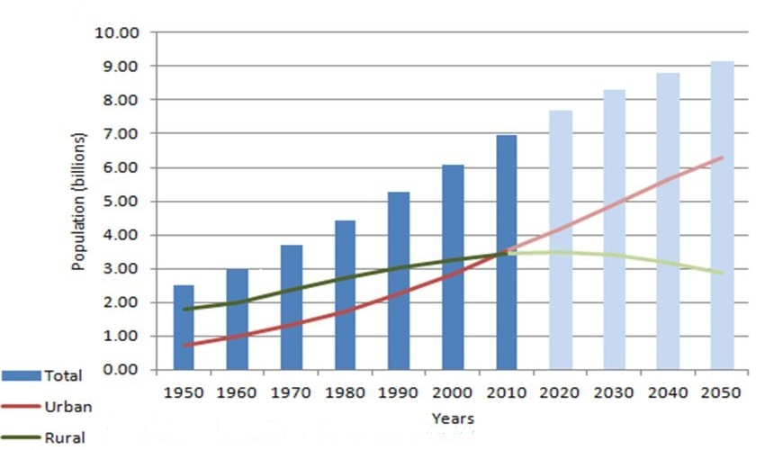

Flood is in itself abbreviates from Finally Loss Occurred after Opportunities Denied.The definition of flood in engineering term is one such a high stage in a water coarsei.e. river, drain or their tributary or in a water retaining body i.e. lake, pond, reservoir ,seas, ocean or other low lying areas- the level at which water over flows over its banksand inundates the adjoining areas. Urban Flood is influenced by various human intervention in addition to the natural factors viz rainfall, river-flow and tidal-surge, topography. Such catastrophic events are happening for the last many years in the country. Urban flooding is significantly different from rural flooding as urbanizationleads to developed catchments, which increases the flood peaks from 1.8 to 8 times andflood volumes by up to 6 times. There is a peculiarity in Urban Flood as its prime reason is surface water runoff. Surface runoff is the excess water from rain or melting snow that flows over the earth’s surface without getting absorbed. In the urban landscape, it is controlled and managed artificially through drains which flush out the runoff from the city, unlike in rural settings where the runoff is absorbed naturally by farmlands and ponds. Urban Flooding has attained unanticipated dimensions in these times.

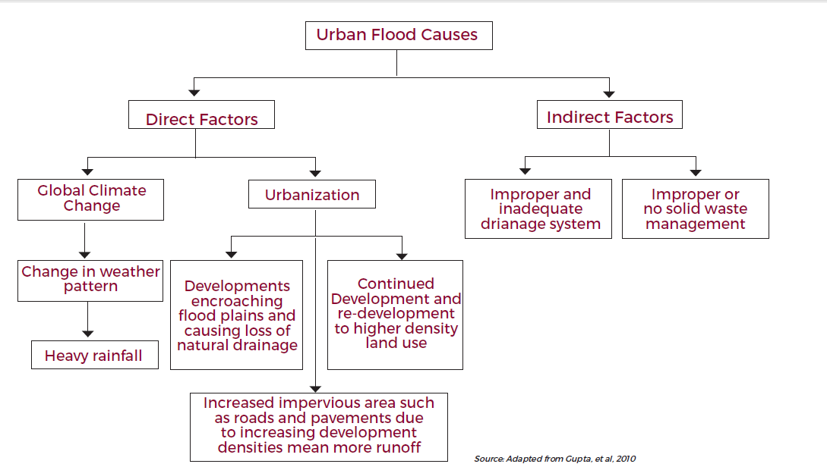

**Case study 1**

**Root Causes**

The rapid and uncontrolled urbanisation is at the root of urban floods and relateddamages in srinagar. In the period 1994–2004 alone, Asia accounted for one-third of1562 flood disasters. Urbanization in developing countries doubled from less than 25%in 1970 to more than 50% in 2006. It is estimated that at least 13 cities of the world thatare prone to natural hazards will have a population in the 10–25 million range, with nineof them in Asia. In 2001, there were 285 million people in India residing in 35 metrocities. This is estimated to exceed 600 million by 2021 in over a 100 metro cities as the trend is on a rise. These facts validates that the man-made causes are responsible forrecurring and prolonged floods in cities like Kashmir.

**Climate Change so overlooked**

The year 2005 was recorded as the hottest year of the century and coincidently the worsturban flooding was reported in Mumbai on July 26-27. During those two days, the citywitnessed an unprecedented 944 mm of rainfall in 24 hours. In the same year, 10 severeurban floods were reported from across the country. It affected more than 500,000people. In 2006, again 22 cities reported floods and increased up to 35 was experiencedin 2007. The minimum temperatures in the Himalayan region are projected to rise by 1degree Celsius to 4.5 degree Celsius. The intensity of rainfall is likely to increase by 1-2 mm per day. These factual indicators are evident to that there is a direct impact ofclimate change over the frequency of flooding.

**City Prelude**

Kashmir is a valley in the northernmost state of India, Jammu & Kashmir. This state is amulti-hazard prone region with natural disasters like earthquakes, floods, landslides, avalanches, high velocity winds, snow storms etc. Most of the valley regions of the stateare fed by rivers like Jhelum, Indus and Chenab.

**Flooding Chronology**

It all started on 30th August 2014 with a cyclonic circulation coupled with a freshWestern disturbance moving towards the state. On 1st September, Rainfall started. Innext 2 days landslides claimed 10 lives. Next day cloudburst occurred in the catchmentarea of Doodh Ganga - tributary to Jhelum. The river breached embankment and reached7-8 metres by September 6th.

The city received 156.7 mm of rainfall on September 5alone. In September of 2016, rainfall in Srinagar crossed its10-year-high mark 151.9 mm of rainfall within 24 hours.The floodwater started receding from September 11, but tillSeptember 13 more than 70 per cent of Srinagar was stillsubmerged, with tens of thousands of people stranded.Centre called the flood a `national calamity'. By 9thSeptember death toll reached 215.[5] The worst affectedareas were Bandipur, Gandipur, Srinagar, Poonch, etc andsome areas were cut off from the rest of the region.

[Refer Map ]



**Causes**

**Degraded Catchment Area**

Dal Lake has a highly degradedcatchment area through which the main tributaries, Nullah Erin and Madhumati, drainout into the lake. Jhelum is like a saucer (bowl) having no outlet for water. Silt hasaccumulated in all of its major tributaries and the flood channels are blocked.



**Location Map of J&K –Wetlands and Riverstream.**

**Reduced Wetlands**

The municipal limits of the city was 83 sq km in 1971 which went up to 103.3 sq km in1981 and presently covers more than 230 sq km (37% increase).The wetlands of Nadru, Nambal, Narkara Nambal and Hokarsar have been replaced by residential colonies. Dal Lake, Anchar Lake, Manasbal Lake and Wular Lake are the large wetlands in theregion. Since 1911, area of Wular Wetland has shrunk from 157 sq km to 86 sq km (45%).Dal Lake area had almost reduced to one-third in 1980s and has further reduced toone-sixth. It has lost almost 12 metres of depth.

In addition, wetlands like BatamalooNambal, Rekh-i-Gandakshah, Rakh-i-Arat andRakh-i-Khan and the streams of the Doodh Ganga and Mar Nalla have also experiencedconsiderable shrinkage [Refer Map].

**Case study 2**

MITIGATION MEASURES FOR FUTURE

Greenroofs are investigated more and more often to determine how they can improve the quality of the urban environment. In addition to their ability to reduce problems of urban storm water runoff quantity (Mentens et al., 2006) and quality (Berndtsson et al., 2006), greenroofs also have

the following benefits: helping to keep buildings cool insummer and also to reduce a building’s energy consumption(Del Barrio, 1998; Eumorfopoulou and Aravantinos, 1998;Theodosiou, 2003; Wong et al., 2003a; Liu and Baskaran,2005) reducing the temperature fluctuation in the roof membrane(Liu, 2003) improving air quality by catching a numberof polluting air particles and gases, and smog as well.

|  |  |
| --- | --- |
| **Runoff-Control Sites** | **Facilities** |
| On the ground | trees, pervious pavements, water-retaining pavements, infiltration trenches |
| Above the ground | green roofs, non-vegetated roof |

Runoff can be controlled above, on the ground

**Ground Surface Techniques**

**Permeable Pavements:** Rainwater falling on a permeable pavement is infiltrated to the base, which serves as a reservoir to store and infiltrate rainwater.

**Water-Retaining Pavements**: It is Cement-based paver that holds water at the top layer and evacuates the water via evaporation, and retains about 15 kg/m2 rainwater. *(Yamagata etal.*2008).

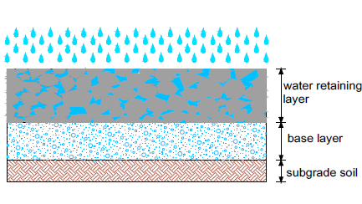

***Rainwater Barrels:*** *Small chamber installed nearby a building for collecting rainwater from the downspout. The overflow can be discharged to the rain garden.*

*235 L rain barrel can reduce 3–44% runoff from a traditional roof, depending on the local weather and the rainfall depth. (Litofsky et al. 2014)*

*189 L rain barrel used to store rainwater from a 186 m2 roof is sufficient to irrigate 14 m2 garden, reducing 1.4–3.2% annual runoff from the roof.(Jennings et al.2013)*

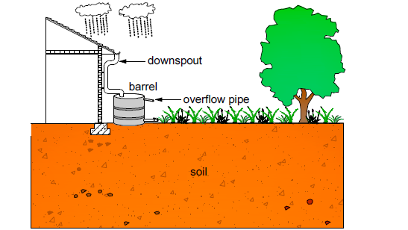

***Bioretention***

***Rain Gardens****: Rain gardens, or bio retention are being adopted urban areas to reduce storm water volume, to attenuate peak flow, and to infiltrate rainwater.(Yang et al. 2013)*

*Rain garden composing of a 0.6 m depth well-permeable soil with a perforated pipe underlain found that only 0.8% of inflow left the gardens as overflow, meaning that most of the inflow (99.2%) finally discharges as subsurface flow. (Dietz et al. 2005)*

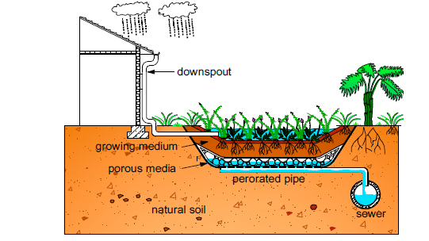

***Vegetated Filter Strips:***

A vegetative filter strip is usually built nearby an impervious surface to allow runoff from the impervious surface flowing evenly through the strip for intercepting and slowing runoff.It is found that the strip can eliminate outflow from 20 of 23 rain events and that the total runoff volume reduction is 85%.  ***(Hunt et al. 2010)***

**Above the ground**

**Non-Vegetated Roofs:**

Non-vegetated roofs such as ballast roofs or soil roofs reduce runoff as well.Gravel-covered roof and the soil roof can delay the start of runoff for a quarter to a half of an hour, depending on the rainfall depth and rainfall intensity.*(VanWoert et al. 2005)*

**Green roofs**: Rainwater falling on a green roof is retained and detained by plants and soils; additional rainfall leads to overflow.

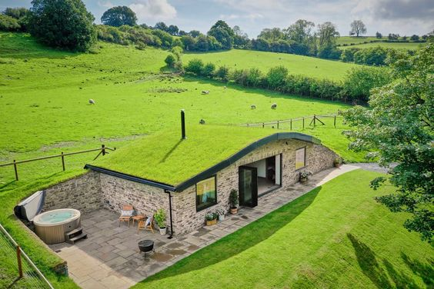

* **Materials and methods**
* **Site description**
* The studied greenroof was established in May 2003 and is situated near the city centre of Tartu, Estonia.
* **Material:**
* Green roof consists of the following layers:
* Modified bituminous base roof,
* Plastic wave drainage layer (8 mm),
* Rock wool for rainwater retention (80mm)
* Substrate layer (100mm) with LWA (66%),
* Humus (30%)
* Clay (4%).
* Distance between roofs is approximately 350 m.
* The length of the greenroof is 18 m, and its width 6.60 m; its height from the ground is 4.5 m.
* Plant cover was 45% of the whole roof area.
* The most common plant species were
* *Sedum acre (planted and seeded; cover percent 55%),*
* *Thymus serpyllum* (20%),
* *Dianthus carthusianorum (5%)*
* *Cerastiumtomentosum* (all seeded; 3%);
* *Veronica filiformis (occasional species; 7%).*
* The reference roof is a modified bituminous membrane roof.
* **Sampling and analysis**
* The measuring period was from June 2004 to April 2005.
* Stormwater runoff was measured for two similar light rain events and for one heavy rain event.
* Storm water runoff was manually measured on an hourly basis with 20-l canisters.
* If the canister filled with water in less than 1h, then water volumes were added.
* The greenroof had two outflows (gr1 and gr2), and there was one outflow for the reference roof (rr).
* Roof runoff samples were taken during light rain runoff (21 September 2004), during heavy rain runoff (31 August 2004) and after the melting of the snowcover (26 March 2005, 27 March 2005, and 30 March 2006).

**Results**

* The key parameters of measured rain events and roof runoff results (gr1 and gr2 greenroof outflows; rr—reference roof) ,**nr--no runoff**

|  |  |  |  |  |  |  |  |  |  |
| --- | --- | --- | --- | --- | --- | --- | --- | --- | --- |
| **Runoff measurement time** | Rain (mm) | Rain duration (min) | Runoff volume (mm) | | | | | | |
| gr1 | | gr2 | | Gr (gr1+gr2) | | rr |
| 2 August, 16.30h to  3 August,  23.00h | 0.8 | 100 | 0.1 | 0.2 | | 0.3 | | 1.9 | |
| 1.3 | 80 |
| 14 September 18.00h to  16September, 15.00h | 1.4 | 35 | 0.04  0.03  0.07 | 0.04  0.04  0.08 | | 0.08  0.07  0.15 | | 1.3  1.0  2.3 | |
| 1.0 | 20 |
| 31 August, 21.00h to 06  September, 11.00h | 6.8 | 60 | 5.3 | 5.9 | | 11.2 | | 11.9 | |
| 5.3 | 85 |
| 3.7 | 130 | 1.9 | 3.0 | | 4.9 | | 4.4 | |
| 0.8 | 75 |
| 1.0 | 170 | 0.6  nr  7.8 | 1.1  nr  10.0 | | 1.7  nr  17.8 | | 1.1  0.1  17.5 | |
| 0.5 | 60 |
| 0.1 | 195 |

Melting of the snow cover (gr1 and gr2—greenroof outflows, rr—reference roof), median temperature of air and substrate (at a depth of 100mm in the substrate layer), and sunshine conditions of studied roofs

|  |  |  |  |  |  |  |  |
| --- | --- | --- | --- | --- | --- | --- | --- |
| Day | Runoff volume (mm) | | | | Median temperature (◦C)  Air substrate | | Sunshine description |
| gr1 | gr2 | gr(gr1+gr2) | rr |
| 22.03 | 0.7 | 1.0 | 0.8 |  | −1.0 | −1.6 | Sunny |
| 23.03 | 0.03 | 0.05 | 0.08 |  | −0.3 | −1.2 | Cloudy |
| 24.03 | 1.6 | 2.7 | 4.3 | 0.4 | 3.5 | −0.3 | Sunny/cloudy |
| 25.03 | 3.5 | 5.5 | 9.0 | 14.6 | 5.8 | 0.3 | Sunny |
| 26.03 | 0.7 | 1.9 | 2.6 | 9.9 | 3.4 | 0.4 | Sunny/cloudy |
| 27.03 | 0.2 | 0.3 | 0.5 | 1.6 | 0.2 | 0.1 | Sunny/cloudy |
| 28.03 | 0.07 | 0.1 | 0.17 | 0.2 | −0.5 | 0.1 | Sunny/cloudy |
| 29.03 | 0.05 | 0.03 | 0.08 | 0.02 | −2.5 | −0.1 | Cloudy |
| 30.03 | 0.02 | 0.04 | 0.06 | 0.06 | 0.1 | 0.1 | Sunny |
| 31.03 | 0.2 | 0.6 | 0.8 | 2.0 | 2.8 | 0.3 | Sunny |
| 01.04 | 0.1 | 0.4 | 0.5 | 1.8 | 1.2 | 0.2 | Sunny/cloudy |
| 02.04 | 0.4 | 1.1 | 1.5 | 1.4 | 3.4 | 0.5 | Sunny |
| 03.04 | 0.8 | 2.1 | 2.9 | 0.8 | 8.9 | 1.5 | Sunny |
| 04.04 | 0.4 | 1.2 | 1.6 |  | 7.6 | 1.5 | Sunny |
| 05.04 | 0.1 | 0.5 | 0.6 |  | 11.5 | 2.4 | Sunny |
| 06.04 | 0.07 | 0.05 | 0.12 |  | 6.0 | 1.8 | cloudy |
| 07.04 | 0.02 | 0.02 | 0.04 |  | 5.8 | 3.0 | cloudy |
| Sum | 9.0 | 17.6 | 26.6 | 32.8 |  |  |  |

***Conclusions***

* The cause of Srinagar flood has both humans and nature pulverized the perpetual flooding tribulations.
* Flooding caused in Srinagar is due to topography, reduced watershed and uncontrolled urbanization and due to siltation of the major water body. As migration and Development are interdependent processes, increased demand on the resources becomes imperious.
* There are so many mitigation measures but a greenroof can effectively retain light rain events that do not occur too soon after one another, if the substrate layer is not fully saturated.
* The greenroof can retain rainfall more efficiently if the preceding days are rainless and the substrate layer is dry.
* The greenroof can also retain a moderate rain even when the substrate layer is wet from previously fallen rain
* The greenroof can distribute the runoff over a longer period.
* Snow cover of the greenroof melted during 1 day, while melting of the substrate layer lasted 12 days.

**References**

Agarwal, S., Fulzele, T.U. and Aggarwal, G., 2014. Flood recovery management in jammu and kashmir: A tool for Resilience. *Asian Journal of Environment and Disaster Management*, *6*(3):215-229.

Dar, M.U.D., Shah, A.I., Bhat, S.A., Kumar, R., Huisingh, D. and Kaur, R., 2021. Blue Green infrastructure as a tool for sustainable urban development. *Journal of Cleaner Production*, *3(18):*128-474.

Gupta, A.K. and Nair, S.S., 2010. Flood risk and context of land-uses: Chennai city case. *Journal of Geography and Regional Planning*, 3(12):365-372.

Gupta, A.K. and Nair, S.S., 2011. Urban floods in Bangalore and Chennai: risk management challenges and lessons for sustainable urban ecology. *Current Science*, pp.1638-1645.

Qin, Y., 2020. Urban flooding mitigation techniques: A systematic review and future studies. *Water*, 12(12):35-79.

Richa, A., Gupta Anil, K. and Mohammad, Y., 2012. Flood resilience through climate-change adaptation: A case of Gorakhpur, Eastern Uttar Pradesh in India. *International Research Journal of Environment Sciences*, 1(2):25-28.