Sustainable Agri-Med Iot Network (Samin)

Dr. Anil L. Wanare

Professor, JSPM’s BSIOTR, Pune

Dept. of Electronics & Telecom. Engineering

Savitribai Phule Pune University, Pune, India

alwanare_entc@jspmbsiotr.edu.in

Dr. Arun Patil

Dean, JSPM’s BSIOTR, Pune

Dept. of Mechanical Engineering

Savitribai Phule Pune University, Pune, India

patil.mailme@gmail.com

ABSTRACT

The forthcoming technological developments include two prominent technologies such as Cloud Computing Application (CCA) and the Green Internet of Things (GIoT). These technologies are now becoming the topic of debate in the agricultural and medical sectors. This section digs through a complete analysis of green cloud computing (CCA) and the Green Internet of Things (G-IoT) in the goal of an environmentally conscious future. Furthermore, it expands on this discussion by looking at the possible reductions in energy consumption that may be realised through the integration of these two approaches (CCA and G-IoT) in agriculture and health care sectors.

Keywords— Green Internet of Things (GIoT), Cloud Computing Applications, GIoT-based Agro Applications, Medical Applications, Sensor-Cloud, GIoT-AHAS

# INTRODUCTION

A plethora of objects and beings live in the present-day world. The Internet of Things (IoT)[2] is a spectacular breakthrough in technology that intends to integrate various entities and items over the world wide web which involves electronic gadgets such as smartphones, modern computers, automobiles and many other devices, all of which have their own IP address. This connectedness enables them to communicate with one another on a worldwide scale. The proliferation of interlinked physical entities, which exemplify the IoT idea, is growing rapidly [2]. Transport, agribusiness, healthcare, automation in industries, and reactions to all kinds of disasters, whether natural, man-made, or an amalgamation of both, are among the domains where IoT-driven solutions are being utilised. This chapter primarily focuses on two critical IoT applications: agro and medical. A plethora of sensor networks embedded within the human organism or our living environs allow for an accumulation of useful data indicating both physical and mental human health [2][3].

The Internet of Things empowers physical entities to observe, listen, process information, and carry out tasks collaboratively. This fosters the exchange of information and coordinated decision-making among these entities. Ultimately, every facet of human existence, encompassing the realms of cyber, physicality, social interactions, and cognition, will become interconnected and intelligent on a global scale, constituting the smart world. This paradigm marks a significant milestone in human history and has garnered considerable attention from academia, business, industries, governments, and various organizations. Additionally, the concept of the Green Internet of Things (G-IoT) strives for a sustainable smart world by curbing the energy consumption of IoT-based applications [4][5].

Cloud Computing stands as a prominent and transformative emerging technology, a promising paradigm that renders computing as a utility [1][2]. This framework enables seamless utilization of cutting-edge software, extensive data access, substantial data storage, and intricate statistical computations through the Internet. It empowers users to procure resources following a pay-as-you-go model [3], ensuring cost-effectiveness by charging only for the resources consumed. A significant benefit of Cloud Computing is its capacity to furnish statistical computing and substantial data storage on demand, eliminating the need for substantial investments in computing infrastructure, such as computational tools. Notably, statistics from Mark Hachman reveal that global data centers collectively consumed an astonishing thirty billion watts of electricity in 2012, a magnitude akin to the output of thirty nuclear power plants [8]. The energy required to cool these servers and substantial data centers for a year is equivalent to the power needed to sustain five million households over the same duration [9]. Consequently, it is imperative to explore innovative approaches to optimize the power consumption of these substantial data centers, namely, the cloud [9]. Basic agriculture trends and network has been shown below in figure1.

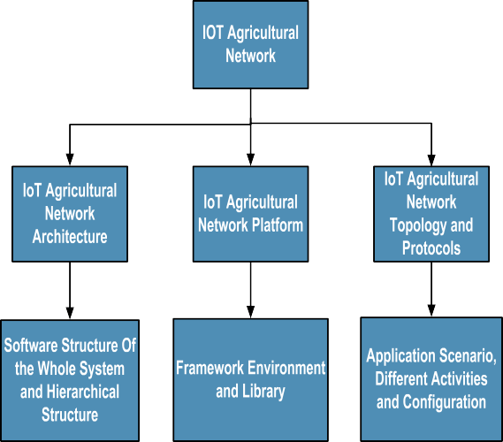

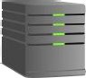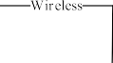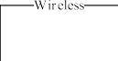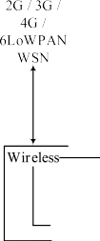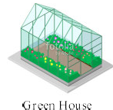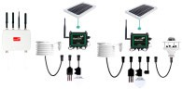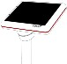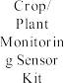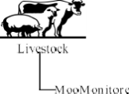

Figure1. Agricultural trends and basic IoT agricultural network.

Green Internet of Things (G-IoT) driven statistical computing embodies ecologically mindful computing. This concept revolves around endeavors aimed at optimizing power consumption and energy efficiency while concurrently minimizing costs and CO2 emissions [10]. The sensor integrated approach, exemplified by the sensor-cloud architecture, ingeniously amalgamates cloud infrastructure with sensor networks. This synthesis empowers real-time monitoring of data-intensive applications that span across dispersed geographical domains [11][2].

Sensor networks find widespread utility in the deployment of health-centric applications, encompassing tasks like monitoring patients' blood sugar levels, blood pressure, and sleep activity patterns [12][13]. In these applications, health facilities respond appropriately based on the data acquired from patient sensors. Monitoring the health status of patients in real time, especially as they move unpredictably, poses a considerable challenge. Thus, the establishment of an efficient computational mechanism becomes imperative to track patients' health status during their spontaneous mobility. Addressing the data-intensive and dynamically evolving demands of sensor networks benefits from the intricate fusion of computational and storage capabilities provided by cloud computing applications tailored for extensive data processing [14][15].Consequently, sensor-cloud platforms have garnered escalating popularity in the contemporary landscape. This chapter introduces a sustainable G-IoT Agriculture and Healthcare system employing a sensor-cloud integration model, denoted as GIoT-AHAS. The Internet of Things (IoT) revolutionizes commonplace objects into intelligent entities, harnessing its foundational technologies encompassing ubiquitous and pervasive computing, embedded devices, communication technologies, sensor networks, Internet protocols, and diverse applications [1][4]. Despite their distinct characteristics, both the Internet of Things (IoT) and cloud computing stand as two distinct yet interconnected technologies that have seamlessly woven into the fabric of our global existence [4].

The Internet of Things (IoT) is commonly marked by its association with real-world small-scale entities, widely dispersed, and possessing restricted storage and processing capacities. These characteristics raise crucial considerations encompassing reliability, performance, security, and privacy. On the contrary, cloud computing boasts virtually boundless capabilities concerning storage and processing potency. It stands as a well-established, sophisticated technology, having partially addressed several of the challenges posed by the Internet of Things through the integration of novel IoT-related advancements. Consequently, applications that synergistically blend the strengths of both cloud and IoT technologies have the potential to significantly reshape the present and future digital landscape, ushering in transformative disruptions [13]. This chapter is structured as follows: In Section 'b,' an initiation into ubiquitous statistical computing is offered, accompanied by an exploration of the prerequisites for a genuinely pervasive application and a concise introduction to green computing. Section 'c' delves into a presentation of the proposed architecture, encompassing its requirements and the integration of green IoT applications. Additionally, this section highlights the role of Information and Communication Technologies (G-ICT) in furnishing green components, including green Radio Frequency Identification (G-RFID), green Wireless Sensor Networks (G-WSN), green Cloud Computing (G-CC), green Machine-to-Machine communication (G-M2M), and green Data Centers (G-DC) for the infrastructure of GIoT-AHAS. Ultimately, Section 'd' encompasses the conclusion and offers insights into future directions for this chapter

# RELEVANT WORK AND RESEARCH MOTIVATION FOR GIOT-AHAS

## **Ubiquitous Computing**

Ubiquitous computing represents a multifaceted paradigm encompassing lifestyle, engineering, and technological innovation all at once. This concept revolves around technologies that seamlessly infiltrate every facet of a user's life, operating inconspicuously in the background and delivering value without causing disruption. This approach is also known as pervasive computing [17]. The genesis of ubiquitous computing can be traced back to 1988, when Mark D. Weiser introduced this groundbreaking idea to the computing community [17],[18]. Weiser articulated it as a transformative shift in computation, envisioning a world where computing is interwoven into the fabric of human existence—where people inhabit a realm of work, play, and daily life that seamlessly integrates with computing [18], [19]. Ubiquitous computing imagines an environment where individuals are enveloped by a multitude of networked computers, some worn or carried, others encountered while on the move, many of them integrated into physical objects, all functioning harmoniously and inconspicuously. This orchestration occurs with minimal human attention, resulting in an unobtrusive and natural interaction. In essence, this paradigm heralds an era where advanced computers envelop a single user and dissolve into the physical surroundings. Its components span a wide range of scales in daily life, each unobtrusively tailored to common tasks. At the core of ubiquitous computing are four fundamental components: wearable devices, customizable sensor nodes, networked appliances, and intelligent labels that resonate with the concept of the green Internet of Things (G-IoT). The pursuit of ubiquitous computing rests on the foundation of five pivotal goals termed ATSAT: Availability, Transparency, Seamlessness, Awareness, and Trustworthiness. These attributes collectively shape the ideal user experience in a ubiquitous computing landscape. Taking a broader perspective on ubiquitous services within the context of ubiquitous computing, it becomes evident that these services adhere to the SCALE criteria—Scalability, Connectivity, Adaptability, Liability, and Ease-of-use—intertwined with the tenets of the GIoT-AHAS concept [19],[20].

The goals of ubiquitous applications are threefold: to mitigate time loss resulting from delays, lower the costs associated with intermediaries, and diminish inaccuracies inherent in conventional medical procedures, as outlined in existing literature [21]. Delays, often referred to as "lag," stem from the time required for manual data entry, paper-based communication, or human-mediated information transmission. These delays can contribute to significant revenue losses within the medical sector. By integrating IoT devices, the time gap between data input into a system and its availability for digital processing can be notably reduced, thereby addressing the challenge of lag and enhancing the efficiency of information processing.

 

Figure 2: Figure 3.

GIoT-AHAS network platform based on G-IoT agricultural and healthcare network

big data analysis. platform based on cloud.

Furthermore, in the realm of ubiquitous agriculture and healthcare, end-users will transmit data from diverse origins and receive immediate access to real-time information, knowledge, and pertinent expertise. They will actively seek out relevant and valuable insights. Once these aforementioned criteria are met, an application can genuinely be considered ubiquitous. Such an application would adopt a linear spatial structure, seamlessly embedded to fulfill specific functions or a limited set of tasks. It would embody pervasiveness, establishing connections between devices that remain inconspicuous yet consistently accessible for real-time interactions. Context-awareness would be its hallmark, enabling it to correlate environmental changes with digital computing systems. The application would demonstrate intelligence in mobility, harnessing advanced technologies while in motion [21],[22]. Furthermore, it would be wearable, harmonizing with the user's hands, voice, eyes, or focus as they engage with the surrounding physical environment. The application's heightened sentience would empower it to perceive its surroundings and respond adaptively. Operating in harmony with its surroundings, it would serve as an ambient companion, facilitating users in their everyday activities, tasks, and routines. This assistance would seamlessly integrate hidden information and intelligence from the interconnected IoT network that binds these devices together [22].

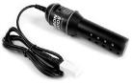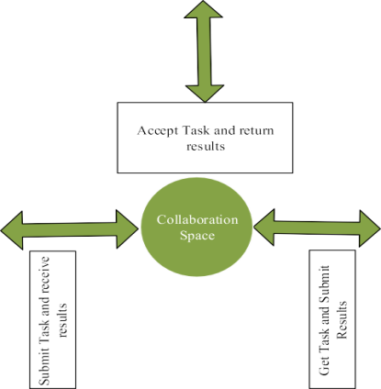

Figure 4. Green IoT Agriculture and Healthcare Applications (GIoT-AHAS)

## **Green cloud Computing**

The notion of sustainable computing started expanding in recent years, and it is becoming increasingly popular. Aside from broad concern about environmental problems, such interest arises from economic worries, as both energy expenditures and electrical needs for the IoT industry across the globe are increasing [23]. The ecologically responsible utilisation of digital sophisticated computers and related resources is known as green computing. Incorporating environmentally friendly central processor units, servers, and devices as well as reducing resource usage and properly disposing of e-waste, are examples of such practises [22],[23]. Green computing is the study and practice of efficient and environmentally friendly computation, and the concept beneath energy-effective programming is to conserve power by obtaining sophisticated software to make use of less of the higher power consumption hardware, instead of retaining the same flexibility in code on lower power hardware.

Green computing, also known as Green G-ICT and IFG Standard, green G-IT, or G-ICT sustainability, is the investigation and practice of environmentally friendly computation or IT. Murugesan V. et al. define Green IT as the investigation and application of effectively and efficiently creating, producing, utilising, and disposing of desktops, laptops, servers, and their associated components such as monitors, printing devices, storage media, and networking and communications systems with little or no effect on the planet [24]. In addition, the subsequent primary four complimentary approaches ought to be tackled for green computing in order to thoroughly and effectively handle the environmental implications of statistical computing. The following terminologies have been used in relation to our GIoT-AHAS:

1. Green Use: Minimising computers and other information system energy usage while utilising them in an environmentally conscious (eco-friendly) style [25].
2. Green Disposal: Refurbishing and using outdated devices, as well as discarding unneeded workstations along with other electronic devices (re-usable).
3. Green Design: The development of environmentally friendly and ecologically friendly parts, devices, accessories, servers, and cooling equipment.
4. Green Manufacturing: The production of electronic parts, desktops, and other technological equipment's associated subsystems with low or insignificant environmental impact.

Green cloud computing (G-CC) encompasses a variety of focus areas and actions, such as development for ecological sustainability, energy-efficient computation, power management, big data centre design, layout, architecture, and location, server virtualization, environmentally conscious disposal and reuse and recycling, compliance with regulations, green metrics, evaluation instruments, and method, environment-related risk mitigation, employing energy from renewable sources, and environmental labels of GIoT-AHA offerings.

# GREEN IOT AGRICULTURE AND HEALTHCARE APPLICATIONS (GIOT-AHA SYSTEM)

We concentrated on discussing ubiquitous computing, the prerequisites for really ubiquitous applications, and the basic principles of green cloud computing in order to correlate them to the GIoT-AHA System. In this part, we covered the fundamental ideas of G-IoT supported green G-IoT technology components related to the GIoT-AHAS System, as well as the architecture of the GIoT-AHAS applying the sensor-cloud integration approach.

## **GIoT-AHAS Architecture**

Sensor-cloud computing (SSS) is seen as one of the most effective technological enablers for agro and health care surveillance systems. Sensor-Cloud Computing (SSS) is an innovative CC notion that takes data from physical sensors and communicates it to a CC architecture. It also efficiently handles sensor data, which is utilised for various applications that monitor. First, we'll look at sensor-cloud terms, as shown below.

According to the hypothesis put up by IntelliSys e "An architecture which permits true pervasive computing utilising sensors as an interface among physical and cyber worlds, the information compute clusters as the cyber spine and the worldwide web as the communication channel" [26].

MicroStrains have put out yet another article. Sensor-Cloud is defined as "a one-of-a-kind sensor data storage, visualisation, and remote management platform that uses powerful cloud-based computing technologies that offer outstanding data scalability, rapid visualisation, and user-programmable research." Sensor-Cloud, which was originally built to facilitate long-term sustainable deployment of Micro Strain wireless sensors, now supports any web-connected third-party gadget, sensor, or sensor network via a simple Open Data application programming interface (API)" [27].

Sensor-cloud computing (SCC) [28] is a novel approach gaining significant attention from academia and business communities. It is inspired by complementing:

1. The omnipresent data sensing and data collecting abilities of wireless sensor networks.

2. SCC's robust data storing and processing capabilities.

To be more specific, the fundamental application concept of sensor-cloud is to gather distinct monitoring sensory data via different locations using ubiquitous sensors or physical sensors, a number of readily available as well as wearable sensors such as accelerometer sensors, proximity, ambient light, and temperature sensors [28] offered by the sensor network provider. The acquired raw sensory data is then sent to the cloud service provider's cloud for storing and subsequent data processing. Once the cloud accumulates and analyses the raw sensory data with data centres, the processed or valued sensory data is given on request to the service user's applications. Sensor network providers serve as sources of data for cloud service providers (GIoT-AHAS) in this whole model. Service users are the big data requesters for cloud service providers.

There are multiple benefits with sensor-cloud integration (SCI) that benefit consumers, wireless sensor networks, plus the cloud, including: Clients can access the essential sensor data via the cloud whenever and wherever they have a network connection, rather than being confined to their desks, i.e. twenty-four-seven service. By allowing wireless sensor networks to be utilised in numerous applications, their utility could be expanded. he services offered by the cloud could be considerably enhanced by being able to supply the services provided by wireless sensor networks (for instance, agricultural and medical surveillance in this system, GIoT-AHAS). The analytical findings indicate that a sensor-cloud might surpass a conventional wireless sensor network by boosting the sensor's lifetime by 3.35% and reducing energy consumption by 37.55% through boosting the performance (e.g., data processing speed, response time, visualisation) of network system with enormous data storage and processing capability of cloud. All of these are highly desirable for smart world and green HEIs in India if used correctly.

## **GIoT-AHAS Requirements**

We have outlined and simply summarised the following broad green G-ICT wants for GIoT-AHAS design:

* Switch off unneeded services: If the amenities are continually on, they will drain a lot of power. The energy usage will be lowered if the services are only used when necessary. For instance, sleep scheduling [30] is a frequently employed strategy for reducing energy usage in wireless sensor networks through dynamically waking and sleeping sensor nodes.
* Only send info that is required: Big-data transmission (for example, large-sized multimedia data) utilises a significant amount of energy. Supplying information that is only required by consumers can dramatically reduce the use of energy. Predictive delivery of data based on user behaviour analysis is one way for providing consumers with only the information they need [30].
* Reduce the distance of the data path: This serves as another simple way to decrease energy use. Routing methods [30] that take into account the distance of the chosen data path might prove particularly energy-efficient. Furthermore, network functioning techniques [32] that cater to routing requirements are possibly the ideal methods to accomplish substantially shorter data paths.
* Reduce the distance of the wireless data path: To reduce the length of the wireless data path in a wireless sensor network, adopt energy-efficient architectural designs [32] for wireless communication networks. Furthermore, a cooperative relaying approach [33] for wireless communications is very promising in terms of energy efficiency, as it uses relay nodes to overhear the transmission and transmit the signal to the intended node, which results in considerable diversity gains [33].
* The trade-off computation for communications: Compressive sensing [34] is a novel ideal approach of detecting the signal with a substantially fewer quantity of linear measurements given that the underlying signal is sparse. It can also improve energy efficiency in both the system and the sensor.
* Advanced communication techniques: Modern methods of communication have begun to develop as a means of achieving green communications. For an instance, a cognitive-radio (CRS) system [35] that is conscious of its surroundings and may alter its ways of functioning (operating frequency, modulation scheme, waveform, transmitting power, etc.) through sophisticated software and hardware manipulation may enhance spectrum-usage efficiency and reduce the issue of spectrum over-crowding by employing the best algorithms.
* Renewable green energy sources: Unlike conventional sources, renewable sources of energy such as oxygen, fresh water, solar energy, timber, and biomass, fuel cell, and geothermal energy are replenished naturally and may be reused. As a result, using renewable sources of energy can have significant effects on reducing dependency on fuel and CO2 emissions [35], [36].

# APPLYING GREEN INTERNET OF THINGS (G-IOT) TO AHAS

When considering green G-IoT, one must first evaluate the many meanings of IoT, and it is expected that the subsequent boom in the period of cloud computing will be outside the domain of the conventional desktop [37]. In alignment with this insight and based on useful literature, a unique paradigm known as the Internet of Things has been rapidly gaining momentum in recent years. The Internet of Things (IoT) is defined as "a global network of interconnected objects uniquely addressable based on accepted communication standards" [1] [2], with the Internet as the centre of convergence. The underlying premise is that objects are all around us, measuring, inferring, understanding, and even modifying their surroundings to find the most effective solutions. G-IoT is driven by recent advancements in a wide range of gadgets and communication technologies, but IoT includes not just complicated gadgets like smart phones, but additionally everyday items [12]. These objects, serving as sensors or actuators, can interact with one another to achieve a similar goal [12][13].

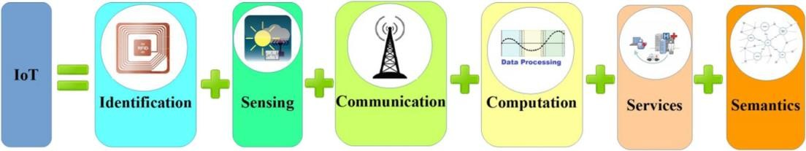 Without hesitation, the most important aspect of IoT is its effect on potential consumers' daily lives. IoT has significant benefits both at place of employment and residence, and it can play an important part in the future across sectors such as assisted living, health, the agricultural sector, intelligent transportation, and plenty more. Significant implications are also envisaged for commercial enterprises (e.g., logistics, industrial automation, commodities transportation, agriculture monitoring, security, healthcare monitoring, and so on). Figure 2 depicts the components in the IoT [4][5] context. Identification, sensing, communication technologies, computing, services, and semantics are the six basic elements of IoT.

Figure 5. Building Blocks of G-IoT to AHAS

Classification and identification are critical in naming and matching services to demand. Electronic product codes and ubiquitous codes are examples of IoT identifying methods. Sensing is the collection information from linked items and its transmission to a database, data warehouse, or data centre. The collected data is then analysed in order to execute specifications according to desired services. Humidity sensors, temperature sensors, wearable sensing devices, mobile phones, and other types of sensors can be used. Advanced communication technologies connect different items to provide particular services as needed. Wi-Fi, Bluetooth, IEEE 802.15.4, Z-wave, LTE-Advanced, Near Field Communication (NFC), ultra-wide bandwidth (UWB), and other IoT protocols for communication can be obtained [34]. Cloud computation is performed by hardware processing devices (e.g., microcontrollers, microprocessors, system on chips (SoCs, RC, etc.), field programmable gate arrays (FPGAs), and advanced software applications. Numerous hardware systems (e.g., Arduino, UDOO, Friendly ARM, Intel Galileo, Raspberry PI, Gadgeteer) and software systems (e.g., TinyOS, LiteOS, Riot OS) have become available. Because it is very strong in processing diverse big-data in real-time and retrieving all types of relevant knowledge from the obtained data, the cloud platform is a particularly significant computing aspect of G-IoT.

G-IoT services are classified into four types: identity-related services, information aggregation services, collaborative-aware services, and ubiquitous services. Identity-related services serve as the foundation for a variety of other services because every application that maps real-world items into the virtual world must first recognise those items. Services for information aggregation collect and summarise raw data that must be processed and reported. Collaborative-aware services use the acquired data to make decisions and respond appropriately. Ubiquitous services are intended to give collaborative-aware services to anybody, at any time and from any location, upon request. Semantics refers to the ability to obtain knowledge intelligently in order to give relevant services [1]. Identifying resources, employing resources, modelling information, acknowledging and analysing data are common steps in this method. Regularly used semantic technologies include resource description frameworks (RDF), web ontology language (OWL), and efficient XML exchange (EXI).

# GREEN IOT FOR AHA SYSTEM (G-IOT TO AHAS)

To support a green G-IoT, the IoT must be energy efficient. Every device in the agricultural and medical application worlds, in specific, is required to be furnished with extra sensory and communication add-ons in so that it can feel and communicate with one another properly in a limited amount of time, costing more energy. Furthermore, as an outcome of increased interest and backing from numerous organisations, demand for power will skyrocket. All of this results in green G-IoT, which prioritises reducing IoT energy consumption, a prerequisite for fulfilling the technologically evolved globe sustainable. Green IoT can be summarised as follows [5], with energy efficiency being a critical component during the development and creation of IoT. "The ecologic technologies (hardware or software) adopted by G-IoT to either expedite the reduction of the greenhouse effect of existing applications and services or decrease the impact of G-IoT itself." In the first scenario, IoT will help to reduce the greenhouse effect; however, in the second instance, IoT's greenhouse footprint will be further reduced. To have little or no adverse environmental effects, every stage of the life cycle of green G-IoT should focus on green design, green manufacture, green use, and finally green disposal/recycling [15].

# GREEN IOT FOR AHA SYSTEM (G-IOT TO AHAS)

The following section starts with a summary of G-ICT and then moves on to describe green technologies that can be used with the G-AHA system. G-ICT refers to any facility, technology, or application associated with communication and information technology that enables users to acquire, save, transmit, and alter a variety of data. The following components are required for identification, sensing, communication, and computing, which are IoT aspects mentioned in Section c of the chapter.

1. RFID (radio-frequency identification): A small electronic device consisting of a tiny chip and an antenna that electronically recognises and tracks tags connected to objects and functions on a predefined frequency range [32].
2. WSN (wireless sensor network): A network of autonomous sensors that are physically distributed and work collectively to monitor physical or environmental parameters.
3. c. WPAN (wireless private area networks): A short-range wireless connection used to connect devices in one individual's workstation [33].
4. d. WBAN (wireless body area network): A wireless network comprised of wearable or mobile computer systems (e.g., sensors, actuators, etc.) positioned on or within the body [8-10].
5. e. HAN (home area network): A type of local area network (LAN) which links electronic devices within or around the house [19].
6. f. NAN (neighbourhood area network): A subset of Wi-Fi hotspots and local area networks that are wireless (WLANs) which enables customers to connect to the internet quickly and cheaply [20].
7. M2M (machine-to-machine): a breakthrough that allows wireless and wired devices to communicate with each other [21].
8. Cloud computing (CC) is a game-changing computing paradigm that offers easy, on-demand access to a shared pool of programmable resources (for example, networks, servers, storage, applications, and services). By incorporating CC into a mobile environment, mobile cloud computing (MCC) might move a major amount of data and storage operations off mobile devices (e.g., smart phones, tablets, etc.) to the cloud [8].[15].
9. Big Data Centre (BDC): a physical or virtual repository for the storage, management, and distribution of information and data [22].
10. Green RFID (G-RFID): A radio-frequency identification paradigm composed of an abundance of radio-frequency tags for identification and just a handful of tag readers. The RF identification tag is a small microchip encapsulated in a glue-based label that is adhered to a radio (which is utilised for signal reception and transmission) and carries a unique identifier.

Radio-frequency identification tags have been utilised to hold data about the objects to whom they've been attached. Radio-frequency identification tag readers commence the data transfer by emitting a query signal, which is then followed by replies from surrounding Radio-frequency identification tags. The broadcast range of radio-frequency identification systems is generally short (a few metres). Furthermore, numerous transmitting bands are used, ranging from low frequencies at 124-135 kHz to ultrahigh frequencies at 860-960 MHz.

The active tags and passive tags (ATPT) constitute the two varieties of RF identification tags. Active tags employ cells to power signal transmission and enhance transmission ranges, whilst passive tags, which lack built-in batteries, have to receive energy from the reader signal through the induction principle [5]. See also [14], [23], and [25] for information on green radio-frequency identification (G-RFID).

1. Because radio-frequency identification tags have been difficult to get rid of in general, reducing their size should be considered in order to minimise the amount of non-biodegradable material used in the manufacturing process (e.g., biodegradable Radio-frequency identification tags, printable Radio-frequency identification tags, paper-based Radio-frequency identification tags).
2. Energy-efficient methods and procedures should be used to optimise tag estimates, dynamically change transmission level power, avoid tag collision, and preventprevent overhearing, and so on.

**Green Wireless Sensor Networks (G-WSN):**

A Wireless Sensor Network consists of a number of sensor nodes plus a base station (which is additionally referred to as a sink node). The sensor nodes have computing power, electricity, and data storage limitations, however the base unit is highly resilient. Sensor nodes with multiple on-board sensors collect data from the environment (e.g., humidity, temperature, acceleration, etc.) at first. Following that, they work together to deliver ad hoc sensory data to the base station. A commonly used commercial WSN system is built on the IEEE 802.15.4 standard, which incorporates the physical and medium access control (MAC) layers for low-power and low-bit-rate communications [5].

 

Figure 6. Farm remote monitoring in agriculture And Low power G-WSN topology.

The following strategies must be used in the green wireless sensors network (G-WSN):

1. To conserve energy, enable sensor nodes only operate whenever essential and spend the balance of their existence in a state of sleep.
2. Depletion of energy (e.g., wireless charging, using energy harvesting technologies that create power from our surroundings (e.g., sun, kinetic energy, vibration, temperature differentials, and so on);
3. Transmission power management, modulating optimisation, cooperative communication, directional antennas, and energy-efficient cognitive radio (CR) are examples of radio optimisation approaches.
4. Energy-efficient routing approaches (e.g., cluster designs, energy as a routing measure, multiple paths routing, relay node placement, node mobility);
5. Data reduction mechanisms (e.g., aggregation, adaptive sampling, compression, network coding).

**Green Cloud Computing (G-CC)**

Resources in the GCC are categorised as services, such as IAAS (Infrastructure as a Service), PAAS (Platform as a Service), and SAAS (Software as a Service). GCC provides diverse resources (e.g., high-performance computing resources and high-capacity store) to customers based on their requests. Instead of controlling and upholding their own resources, clients can access a huge and well-managed pool of resources. As greater numbers of applications are migrated to the cloud, more resources must be installed and greater amounts of electricity is utilised, resulting in increased ecological challenges and CO2 emissions [17].With respect to green GCC, potential solutions are shown as follows [33],[34].

1. Use of advanced hardware and software that reduces energy usage. In this context, hardware alternatives should aim towards developing and produce energy-efficient gadgets. Significant software offerings should strive to deliver effective software designs that consume a smaller amount of energy while utilising fewer resources;
2. Power-saving virtual machine methods (e.g., VMT consolidation, VMT migration, VMT placement, VMT allocation);
3. Different environmentally friendly allocation of resources structures (e.g., auction-based distribution of resources, gossip-based resource allocation, etc.) along with associated task management mechanisms;
4. Effective and precise mathematical models and methods to evaluate conserving energy strategies
5. Green GCC schemes based on cloud-supporting technology (e.g., networks, enhanced communications, and so on).

# GREEN MACHINE TO MACHINE (M2M)

Massive M2M nodes that proactively acquire information being tracked have been installed in the M2M sector in terms of Machine to Machine (M2M) connections. The wireless network passes the information collected to the base unit to be examined in the wireless network domain. In the application area, the base unit also enables numerous Machine to Machine (M2M) applications through the network. Figure 7 depicts the Machine to Machine (M2M) mechanism:

 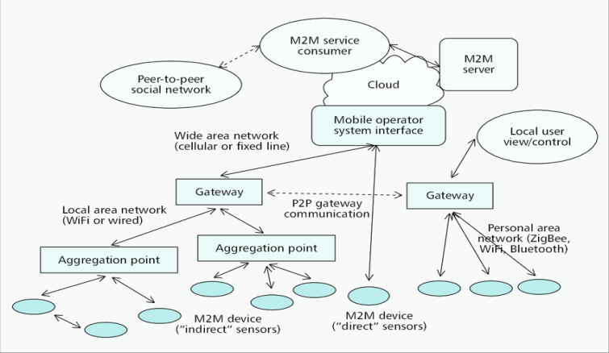

Figure 7: A high-level M2M system architecture with big data and G-IoT

With the large machinery associated with Machine-to-Machine communication, green Machine to Machine (M2M) will be consuming an enormous amount of energy, especially in the Machine-to-Machine domain.

To improve energy efficiency, these strategies could potentially be utilised [28][30]:

1. Effectively alter the power used for transmission (e.g., to a minimum required level);
2. Build effective communications protocols (e.g., routing protocols) using algorithmic and dispersed computation methods;
3. Task planning, where the goal is to migrate certain nodes to low-power operation/sleeping mode in order to ensure that just a portion of nodes that are connected stays active while retaining the functions (e.g., data gathering) associated with the original network;
4. Collaborative energy-saving methods (e.g., with overload prevention and resource allotment);
5. Leverage energy harvesting and the benefits of green cognitive radio (G-CR) (e.g., spectrum sensing, spectrum management, interference mitigation, power optimisation).

Green Data Centre (GDC): The primary function of Green Data Centre G-DCs is to store, handle, process, and distribute diverse data and applications produced by people, objects, and systems, among other things. G-DCs require massive quantities of energy while interacting with diverse data and applications, which leads to substantial operating expenses and enormous carbon dioxide footprints (Co2). In addition, as the production of massive volumes of information by different pervasive and omnipresent IoT-based devices or items (e.g. smart mobile phones, digital active sensors, etc.) on the path to a smart globe grows, the energy economy for G-DCs gets increasingly important [14]. Regarding Green Data Centre G-DCs, the following features may be used to increase energy effectiveness [15], [24], and [33].

1. Employ natural or environmental sources of energy (for example, water, wind, and solar electricity, heat pump technology, geothermal energies fuel cells, etc.);
2. Utilise economical dynamic and effective power-management methods (for example, Turbo boost, sphere);
3. Create environmentally friendly devices techniques, as well as vary-on and vary-off techniques (e.g., leveraging the benefits of dynamic voltage and frequency scaling)
4. Create innovative energy-efficient data centre layouts to accomplish power conservation (e.g., nano green data centres).
5. Create energy-aware modern routing schemes that aggregate traffic generated to a portion of the network and power off unused equipment;
6. Create efficient and precise big data centre power models;
7. Enlist the assistance of communication and computational methods (e.g., optical advanced communication, virtual machine to machine migration, placement optimisation, and so on).

# CONCLUSION

We've spoken on universal empirical computation, the prerequisites for genuinely ubiquitous computing technologies as well as applications, including environmentally friendly computation in this chapter. Following that, an overview of technologies like green information and computational methods permitting novel technologies, followed by a demonstration of Green Internet of Things (GIoT) Agriculture and Healthcare Application System (GIoT-AHAS) architecture using sensor-cloud computing integration, as well as a summary of the benefits of sensor-cloud integration to GIoT-AHAS. Wireless sensor networks (WSNs) have several inherent issues that digital sensor-cloud green systems may address: 1) Eco-friendly big information management system 2) Effective and significant resource utilisation 3) The GIoT-AHAS has an elevated utility expense. The green digital sensor-cloud architecture is a cost-effective method that makes use of the current green IoT-based cloud platform. Furthermore, the following potential developments in Green Internet of Things (GIoT) Agro and Health care Application System (GIoT-AHAS) structure with digitised environmental sensor-cloud convergence are emphasised:

1. Application design ought to be met with to an overall Green Internet of Things (GIoT) Agro alongside Health care Application System (GIoT-AHAS) energy consumption context, with a focus on fulfilling service, excellent quality, and noteworthy effectiveness;
2. The features and utilisation need of distinct applications call for an enhanced knowledge;
3. Realistic energy usage models of different elements of Green Internet of Things (GIoT) Agriculture and Healthcare Application System (GIoT-AHAS) are needed;
4. Economic challenges, digital Sensor-Cloud service access necessitates the involvement of both a greener digital sensor service provider and a statistics computation and cloud service supplier. Despite the fact that they have autonomous user management, services and effective management, payment forms and techniques, and price.

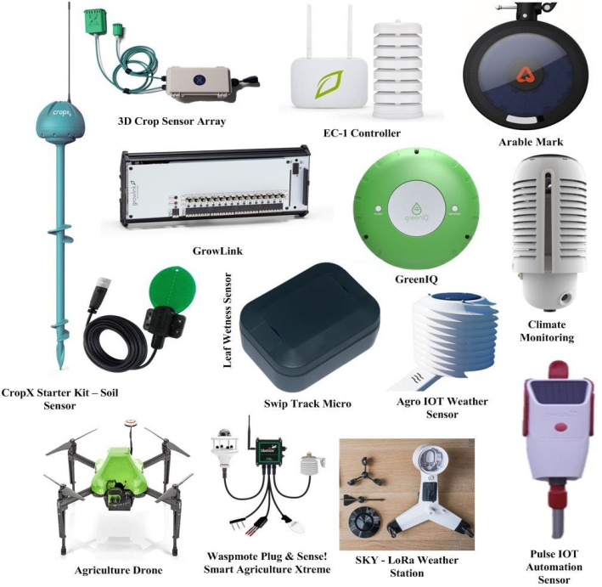 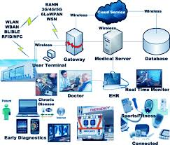

Elements considered for the Green Internet of Things Agriculture and Healthcare Application System (GIOT-AHAS).

##### REFERENCES

1. Chandra Sukanya Nandyala and Haeng-Kon Kim, “ IoT Agriculture and Healthcare Application” International Journal of Smart Home Vol. 10, No. 4 (2016), pp. 289-300.
2. Gorlatova, M., Sarik, J., Grebla, G., Cong, M., Kymissis, I., Zussman, G.: Kinetic energy harvesting for the internet of things. IEEE J. Sel. Areas Commun. **33**, 1624–1639 (2015)
3. Takruri, M., Attia, H.A., Awad, M.H.: Wireless charging in the context of sensor networks. Int J Appl Eng Res **11**(12), 7736–7741 (2016)
4. Khodr, H., Kouzayha, N., Abdallah, M., Costantine, J., Dawy, Z.: Energy-efficient IoT sensor with RF wake-up and addressing capability. IEEE Sens. Lett. **1**(6), 1–4 (2017)
5. L. Atzori, A. Iera and G. Morabito, “The Internet of Things: A survey”, Comput. Netw., vol. 54, no. 15, (2010), pp. 2787-2805.
6. C. Perera, C. H. Liu, S. Jayawardena and M. Chen, “A survey on Internet of Things from industrial market perspective”, IEEE Access, vol. 2, (2014), pp. 1660-1679.
7. M.Hassanalieragh, A.Page, T.Soyata, G.Sharma, M.Aktas, G.Mateos and S.Andreescu, “Health monitoring and management using internet-of-things (IoT) sensing with cloud-based processing: Opportunities and challenges”, In Services Computing (SCC), 2015 IEEE International Conference on (2015), pp. 285-292.
8. L. Da Xu, W. He and S. Li, “Internet of Things in industries: A survey”, IEEE Trans. Ind. Informat., vol. 10, no. 4, (2014), pp. 2233-2243.
9. A. Al-Fuqaha, M.Guizani, M. Mohammadi, M. Aledhari and M. Ayyash, “Internet of things: A survey on enabling technologies, protocols, and applications”, Communications Surveys & Tutorials, IEEE, vol. 17, no. 4, (2015), pp.2347-2376.
10. C.Zhu, V.Leung,L.Shu andE. C. H Ngai, “Green Internet of Things for smart world”, Access, IEEE, vol. 3, (2015), pp.2151-2162.
11. J.Zhou, T.Leppanen, E.Harjula, M. Ylianttila, T.Ojala, C.Yu andH.Jin, “Cloudthings: A common architecture for integrating the internet of things with cloud computing”,in: CSCWD, IEEE, (2013).
12. M.Weiser, “The computer for the 21st century. Pervasive Computing”, IEEE, vol. 1, no.1, (2002), pp.19-25.
13. [http://www.koreaittimes.com/story/defining-perfect-ubiquitous-healthcare-information-system.](http://www.koreaittimes.com/story/defining-perfect-ubiquitous-healthcare-information-system)
14. S.Murugesan, “Harnessing green IT: principles and practices”, IEEE IT Professional, (2008), pp. 24–33.
15. J.Gubbi, R.Buyya, S.Marusic andM.Palaniswami, “Internet of Things (IoT): A vision, architectural elements, and future directions”, Future Generation Computer Systems, vol. 29, no.7, (2013), pp.1645- 1660.
16. A, K.Evangelos,D. T.Nikolaos andC. B.Anthony, “Integrating RFIDs and Smart Objects into a Unified Internet of Things Architecture”, Advances in Internet of Things, (2011).
17. A.Botta, W.de Donato, V. Persico and A.Pescapé, “Integration of cloud computing and internet of things: a survey”, Future Generation Computer Systems, vol. 56, (2016), pp.684-700.
18. F. K.Shaikh, S. Zeadally and E.Exposito, “Enabling Technologies for Green Internet of Things”, (2015).
19. A. Juels, ”RFID security and privacy: A research survey”, IEEE J. Sel.Areas Commun., vol. 24, no. 2, Feb. (2006), pp. 381-394.
20. C. Zhu, L. Shu, T. Hara, L.Wang, S. Nishio and L. T. Yang, “A survey on communication and data management issues in mobile sensor networks'', Wireless Commun. Mobile Comput., vol. 14, no. 1, Jan. (2014), pp. 19-36.
21. J. A. Gutierrez, M. Naeve, E. Callaway, M. Bourgeois, V. Mitter and B. Heile, IEEE 802.15.4: “A developing standard for low-power low-cost wireless personal area networks”, IEEE Netw., vol. 15, no. 5, Sep./Oct. (2001), pp. 12-19.
22. S.-H. Han and S. K. Park, “Performance analysis of wireless body area network in indoor off-body communication”, IEEE Trans. Consum.Electron. vol. 57, no. 2, May (2011), pp. 335-338.
23. U. Saif, D. Gordon and D. J. Greaves, “Internet access to a home area network”, IEEE Internet Comput., vol. 5, no. 1, Jan./Feb. (2001), pp. 54-63.
24. C. P. Mediwaththe, E. R. Stephens, D. B. Smith and A. Mahanti, “A dynamic game for electricity load management in neighborhood area networks,'' IEEE Trans. Smart Grid.
25. M. Weyrich, J.-P. Schmidt and C. Ebert, ``Machine-to-machine communication,'' IEEE Softw., vol. 31, no. 4, Jul./Aug. (2014), pp. 19-23.
26. M.Dayarathna, Y. Wen and R.Fan, “Data Center Energy Consumption Modeling: A Survey”.
27. V. Namboodiri, and L.Gao,”Energy-aware tag anticollision protocols for RFID systems. Mobile Computing”, IEEE Transactions on vol. 9, no.1, (2010), pp.44-59.
28. T. Li, S. S.Wu, S. Chen and M. C. K. Yang, “Generalized energy-efficient algorithms for the RFID estimation problem,'' IEEE/ACM Trans. Netw., vol. 20, no. 6, (2012), pp. 1978-1990.
29. D. K. Klair, K.-W. Chin and R. Raad, “A survey and tutorial of RFID anti-collision protocols,'' IEEE Commun. Surveys Tuts., vol. 12, no. 3, (2010), pp. 400-421.
30. G. Anastasi, M. Conti, M. Di Francesco and A. Passarella, “Energy conservation in wireless sensor networks: A survey,'' Ad Hoc Netw., vol. 7, no. 3, (2009), pp. 537-568.
31. T. Rault, A. Bouabdallah, and Y. Challal, “Energy efficiency in wireless sensor networks: A top-down survey,'' Comput. Netw., vol. 67, (2014), pp. 104-122.
32. F. Farahnakian“Using ant colony system to consolidate VMs for green cloud computing,'' IEEE Trans. Services Comput., vol. 8, no. 2, (2015),pp. 187-198,.
33. C.H. Chang, R. Y. Chang and H.-Y. Hsieh, “High-fidelity energy-efficient machine-to-machine communication”, in Proc. IEEE 25th Annu.Int. Symp. Pers., Indoor, Mobile Radio Commun., (2014), pp. 91-96.
34. Tian, X., Zhu, Y.H., Chi, K., Liu, J., Zhang, D.: Reliable and energy-efficient data forwarding in industrial wireless sensor networks. IEEE Syst. J. **11**(3), 1424–1434 (2017)
35. Basnayaka, D.A., Haas, H.: A new degree of freedom for energy efficiency of digital communication systems. IEEE Trans. Commun. **65**(7), 3023–3036 (2017)
36. Qureshi, F.F., Iqbal, R., Asghar, M.N.: Energy-efficient wireless communication technique based on cognitive radio for the Internet of Things. J. Netw. Comput. Appl. **89**, 14–25 (2017)
37. Yi, G., Park, J.H., Choi, S.: Energy-efficient distributed topology control algorithm for low-power IoT communication networks. IEEE Access **4**, 9193–9203 (2016)
38. Zhu, C., Leung, V.C., Wang, K., Yang, L.T., Zhang, Y.: Multi-method data delivery for green sensor-cloud. IEEE Commun. Magazine **55**, 176–182 (2017)
39. Maksimovic, M.: Greening the future: green internet of things (G-IoT) as a key technological enabler of sustainable development. 283–311 (2018)
40. hiraj A.: Alvi Energy efficient green routing protocol for internet of multimedia things. In: IEEE International Conference on Intelligent Sensor, Sensor Networks and Information Processing (ISSNIP) IEEE (2015)
41. Jain, A., Mishra, M., Peddoju, S.K., Jain, N.: Energy efficient computing green cloud computing. In: International Conference on Energy-Efficient Technologies for Sustainability pp. 978–982. IEEE. (2013, April)
42. Shuja, J., Ahmad, R.W., Gani, A., Ahmed, A.I.A., Siddiqa, A., Nisar, K., Zomaya, A.Y.: Greening emerging IT technologies: techniques and practices. J. Internet Serv. Appl (2017)
43. I. Lee and K. Lee, ‘‘The Internet of Things (IoT): Applications, invest- ments, and challenges for enterprises,’’ *Bus. Horizons*, vol. 58, no. 4, pp. 431–440, 2015.
44. S. Chen, H. Xu, D. Liu, B. Hu, and H. Wang, ‘‘A vision of IoT: Appli- cations, challenges, and opportunities with china perspective,’’ *IEEE Internet Things J.*, vol. 1, no. 4, pp. 349–359, Aug. 2014.
45. M. Sto?es, J. Van?k, J. Masner, and J. Pavli?k, ‘‘Internet of Things (IoT) in agriculture-selected aspects,’’ *Agris On-Line Papers Econ. Inform.*, vol. 8, no. 1, pp. 83–88, 2016.
46. P. P. Ray, ‘‘Internet of Things for smart agriculture: Technologies, prac- tices and future direction,’’ *J. Ambient Intell. Smart Environ.*, vol. 9, no. 4, pp. 395–420, 2017.
47. C. Kamienski, J.-P. Soininen, M. Taumberger, R. Dantas, A. Toscano,T. S. Cinotti, R. F. Maia, and A. T. Neto, ‘‘Smart water management platform: IoT-based precision irrigation for agriculture,’’ *Sensors*, vol. 19, no. 2, p. 276, 2019.
48. T. Ojha, S. Misra, and N. S. Raghuwanshi, ‘‘Wireless sensor networks for agriculture: The state-of-the-art in practice and future challenges,’’ *Comput. Electron. Agricult.*, vol. 118, pp. 66–84, Oct. 2015.
49. Elijah, T. A. Rahman, I. Orikumhi, C. Y. Leow, and M. N. Hindia, ‘‘An overview of Internet of Things (IoT) and data analytics in agricul- ture: Benefits and challenges,’’ *IEEE Internet Things J.*, vol. 5, no. 5, pp. 3758–3773, Oct. 2018.
50. X. Zhang, J. Zhang, L. Li, Y. Zhang, and G. Yang, ‘‘Monitoring citrus soil moisture and nutrients using an IoT based system,’’ *Sensors*, vol. 17, no. 3, p. 447, 2017.
51. C. A. González-Amarillo, J. C. Corrales-Muñoz, M. Á. Mendoza- Moreno, A. F. Hussein, N. Arunkumar, and G. Ramirez-González, ‘‘An IoT-based traceability system for greenhouse seedling crops,’’ *IEEE Access*, vol. 6, pp. 67528–67535, 2018.
52. B. Windsperger, A. Windsperger, D. N. Bird, H. Schwaiger, G. Jung- meier, C. Nathani, and R. Frischknecht, ‘‘Greenhouse gas emissions due to national product consumption: From demand and research gaps to addressing key challenges,’’ *Int. J. Environ. Sci. Technol.*, vol. 16, no. 2, pp. 1025–1038, 2019.
53. D. O. Shirsath, P. Kamble, R. Mane, A. Kolap, and R. S. More, ‘‘IoT based smart greenhouse automation using Arduino,’’ *Int. J. Innov. Res. Comput. Sci. Technol.*, vol. 5, no. 2, pp. 234–238, 2017.
54. G. Corkery, S. Ward, C. Kenny, and P. Hemmingway, ‘‘Monitoring envi- ronmental parameters in poultry production facilities,’’ in *Proc. Comput. Aided Process Eng.-CAPE Forum*, 2013, pp. 1–12.
55. *Cowlar*. Accessed: Jun. 24, 2019. [Online]. Available: [https://www](http://www/). cowlar.com/store/product
56. *Cow Intelligence*. Accessed: Jun. 24, 2019. [Online]. Available: http:// [www.scrdairy.com/cow-intelligence/sensehub.html](http://www.scrdairy.com/cow-intelligence/sensehub.html)
57. X. Hi, X. An, Q. Zhao, H. Liu, L. Xia, X. Sun, and Y. Guo, ‘‘State-of-the- art Internet of Things in protected agriculture,’’ *Sensors*, vol. 19, no. 8, p. 1833, 2019.
58. Y. Zhang, Q. Chen, G. Liu, W. Shen, and G. Wang, ‘‘Environment param- eters control based on wireless sensor network in livestock buildings,’’ *Int.*

*J. Distrib. Sensor Netw.*, vol. 12, no. 5, 2016, Art. no. 9079748.

1. W.-L. Chen, Y.-B. Lin, Y.-W. Lin, R. Chen, J.-K. Liao, F.-L. Ng, Y.-Y. Chan, Y.-C. Liu, C.-C. Wang, C.-H. Chiu, and T. H. Yen, ‘‘AgriTalk: IoT for precision soil farming of turmeric cultivation,’’ *IEEE Internet Things J.*, vol. 6, no. 3, pp. 5209–5223, Jun. 2019.
2. J. Muangprathub, N. Boonnam, S. Kajornkasirat, N. Lekbangpong,
3. A. Wanichsombat, and P. Nillaor, ‘‘IoT and agriculture data analysis for smart farm,’’ *Comput. Electron. Agricult.*, vol. 156, pp. 467–474, Jan. 2019.
4. K. L. Krishna, O. Silver, W. F. Malende, and K. Anuradha, ‘‘Internet of Things application for implementation of smart agriculture system,’’ in *Proc. Int. Conf. I-SMAC (IoT Social, Mobile, Anal. Cloud) (I-SMAC)*, Feb. 2017, pp. 54–59.G. Eason, B. Noble, and I.N. Sneddon, “On certain integrals of Lipschitz-Hankel type involving products of

Bessel functions,” Phil. Trans. Roy. Soc. London, vol. A247, pp. 529-551, April 1955. (references)

1. J. Clerk Maxwell, A Treatise on Electricity and Magnetism, 3rd ed., vol. 2. Oxford: Clarendon, 1892,

pp.68-73.

1. I.S. Jacobs and C.P. Bean, “Fine particles, thin films and exchange anisotropy,” in Magnetism, vol. III, G.T.

Rado and H. Suhl, Eds. New York: Academic, 1963, pp. 271-350.

1. K. Elissa, “Title of paper if known,” unpublished.
2. R. Nicole, “Title of paper with only first word capitalized,” J. Name Stand. Abbrev., in press.