A framework that uses augmented reality to enhance students' critical thinking skills and boost their learning outcomes in the field of Physics

Harun¹
^{harun.e11421@cumail.in,}

Abstract : Physics, a scientific discipline concerned with the characteristics of energy and matter, draws heavily on principles from Mathematics, Mechanics, Optics, Electricity, Magnetism, and Thermodynamics. However, many students struggle to comprehend these concepts due to the lack of visual representation, which contributes to a waning interest in STEM subjects. To address this challenge, augmented reality (AR) technology emerges as a powerful tool, offering students an immersive experience with lifelike three-dimensional virtual objects to facilitate learning.

"This research paper centers on the creation of an augmented reality (AR)-based learning environment designed to assist students in grasping various Physics concepts, such as magnetic fields, electric current, electromagnetic waves, Maxwell's equations, and Fleming's rules for electromagnetism. In order to evaluate the impact of the AR intervention on students' learning and critical thinking abilities, an experimental study was carried out with a participant pool of 80 engineering students who were divided into two groups: the AR teaching group (N = 40) and the conventional teaching group (N = 40). The AR teaching group experienced the subject matter through the AR-based learning environment, while the conventional teaching group received instruction through traditional teaching methods.

The findings of the experiment revealed that the AR-based learning environment had a significantly positive effect on students' critical thinking skills and learning outcomes. By providing students with the ability to visualize abstract Physics concepts, the AR experience improved their comprehension and engagement with the subject matter."
Keyword : Augmented reality, Virtual Objects, Learning , thinking , virtualization.

Introduction: Conventional teaching involves a teacher guiding students to acquire knowledge through recitation and memorization techniques, often relying on text, videos, projections, traditional learning tools, such as pen, paper, and two-dimensional (2D) images, having lack the ability to offer real-time practice and experience with 3D content. However, recent research has shown that using 3D animated content can significantly enhance learners' immersive experience. Given the evolving pedagogical approach in engineering education, there is a shift towards incorporating new methods of learning. However, modern methods, particularly those incorporating augmented reality (AR), offer more benefits to students as they enhance engagement and enthusiasm during the learning process [32, 35]. AR provides an interactive learning experience by superimposing graphics, videos, text, and audio onto the real world, making even abstract content more tangible and hands-on for students [1, 21]. This technology fosters engagement and interactivity with the learning content, thereby improving learning outcomes [3, 16, 30].

"Critical thinking plays a vital role in science learning, empowering students to tackle complex problems through logical reasoning and decision-making skills [10, 20]. Among various learning methods, AR-based learning media has been proven to effectively encourage critical thinking. AR achieves this by allowing students to interact with virtual components using simple operations like drag, drop, grab, and flip, surpassing the limitations of conventional teaching systems.

Physics holds immense significance in engineering courses as it forms the bedrock for various engineering concepts and theories. Nonetheless, students often encounter difficulties in visualizing certain concepts and phenomena [23]. In this study, an AR application is developed to aid students in understanding electromagnetism. The AR-based learning environment (ARLE) aims to achieve the following learning objectives:

1. Promote experiential learning over passive reading.
2. Facilitate understanding of abstract Physics concepts.
3. Enable visualization of phenomena in 3D and interaction with virtual objects.

The interactive ARLE focuses on the behavior of magnetic field lines, electric current, DC operated motors, and the working of generators in Physics. It enables students to visualize and interact with virtual components related to these concepts, such as bar magnets, current-carrying conductors, galvanometers, and power supplies. Additionally, students can gain insight into the significance of Maxwell's equations, such as Gauss's law in magnetism. The ARLE is designed to enhance students' learning and training skills, thereby improving their conceptual understanding, critical thinking ability, and knowledge retention [31]. Through the use of ARLE, students can experience fundamental Physics concepts in an immersive manner."

The paper addresses two main research questions:
1. What impact does AR-based intervention have on students' learning gain compared to the conventional teaching method?
2. How does AR influence students' critical thinking ability compared to traditional teaching methods?

The paper's structure includes a literature review on AR in education in Section 2, followed by the methodology for deploying the ARLE system on engineering students in Section 3. Section 4 presents the analysis of the results from the ARLE-based study. Finally, Section 5 contains the discussion and conclusions drawn from the research.

Literature Review:

Augmented reality (AR) and virtual reality (VR) have become prevalent in education, enhancing students' learning experiences and knowledge. Several research papers have investigated the impact of AR on learning skills, engagement, and cognition [6, 10, 12]. In engineering education, various AR/VR-based experiences exist, but there is limited research focused specifically on using them in Physics to demonstrate abstract phenomena to students. While some AR-based interaction techniques have been used to teach magnetism concepts, they often lack sufficient interactivity. Previous studies suggest that although the magnetic field can be visualized using AR techniques, the experience remains static, lacking a 3D model and real-time interaction [24].

Certain studies have successfully integrated AR in Physics education. For example, Dünser et al. [15] used hand-held devices and AR applications to teach the basic concept of magnetism, demonstrating how AR facilitates experiences with intangible Physics concepts. In another study, Sonntag et al. [34] virtually generated magnetic induction lines and designed a magnetic model through a teaching application. Matsutomo et al. [28] further enhanced the model by distributing and plotting induction lines using a computer-generated bar magnet. Additionally, Ibanez et al. [23] developed an AR application that effectively improves the understanding of electromagnetic concepts and their phenomena, resulting in higher comprehension levels compared to web-based applications.

Previous research has explored various AR-based learning environments, simulations, and games that use computer-generated 3D models to teach complex topics in an engaging manner [11, 14, 22, 26, 39]. AR technology also helps reduce the teacher's workload, making the learning process more manageable [25]. Furthermore, AR applications have proven to be valuable in simulating complicated theoretical concepts, such as interactive inquiry-based microparticle experiments [7], and challenging experiments like convex imaging-based experiments [4].

Methodology :

- Participants

The research sample consisted of students with a background in Electrical Engineering. A total of 80 engineering students participated in the study, all of whom had little to no prior knowledge of AR technology. Table 2 provides detailed information about the participants. To eliminate any potential teacher bias, the same faculty member taught both groups during the study.

TABLE 1 | Participants details
Gender | AR group | Conventional teaching group
Male | 34 | 35
Female | 6 | 5
Total | 40 | 40

- Material

The Augmented Reality Learning Environment (ARLE) proposed in this study is an interactive application designed to improve students' comprehension of various Electrical Engineering concepts. These include electric motors and generators, electromagnetism, the working principles of galvanometers, voltmeters, ammeters, and Gauss's law (Maxwell equations). The ARLE incorporates marker-based technology, interactive 3D models, and animations to enhance virtual objects by overlaying them in real-time using the device's camera. The 3D models and animations were developed using Autodesk Maya, while the application itself was created using Unity 3D and C#.

- Design of Experiment

The flowchart of the Augmented Reality Learning Environment (ARLE) is illustrated in Figure 1. It shows the sequence of actions that take place during the AR system's gameplay. When the camera identifies the designated marker, the AR visualization initiates, allowing students to access AR content associated with a specific learning activity, depending on the type of marker used. Each learning activity is linked to a different paper marker.

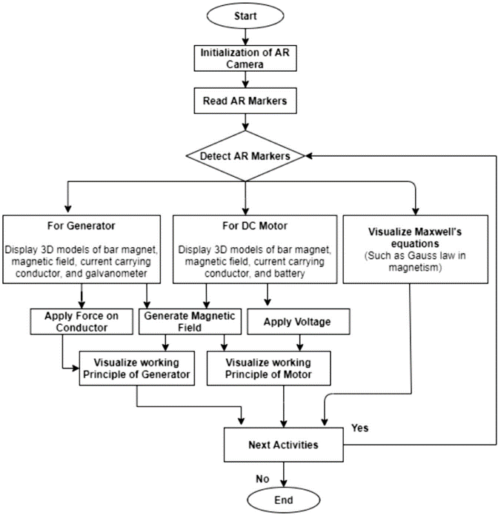

Fig 1: Flow chart of the developed system.

Within the Augmented Reality Learning Environment (ARLE), students have the opportunity to interact with various concepts, such as generating magnetic fields, observing the behavior of a magnetic field generated by a bar magnet's North and South Poles, exerting force in a conductor, and altering the supply DC voltage. Audio and video instructions are provided to guide students throughout the ARLE experience. The user interface presents five options for selecting different AR learning activities. Once an activity is chosen, the corresponding AR view appears on the user's screen.

Figure 2 displays the AR view associated with the selected learning activity, while Figure 3 illustrates the visualization of a generator. Additionally, Figure 4 and Figure 5 showcase the AR views of "Maxwell's equation" and "Solenoid carrying current," respectively. In Figure 4, students can observe the effect of changing voltage in the case of a motor, while Figure 5 demonstrates the concept of Gauss's law in magnetism, enabling students to visualize the magnetic field generated by the current-carrying solenoid.

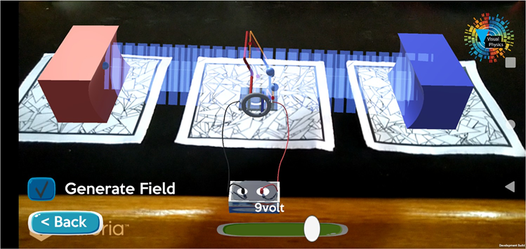
Fig 2: DC motor virtualization

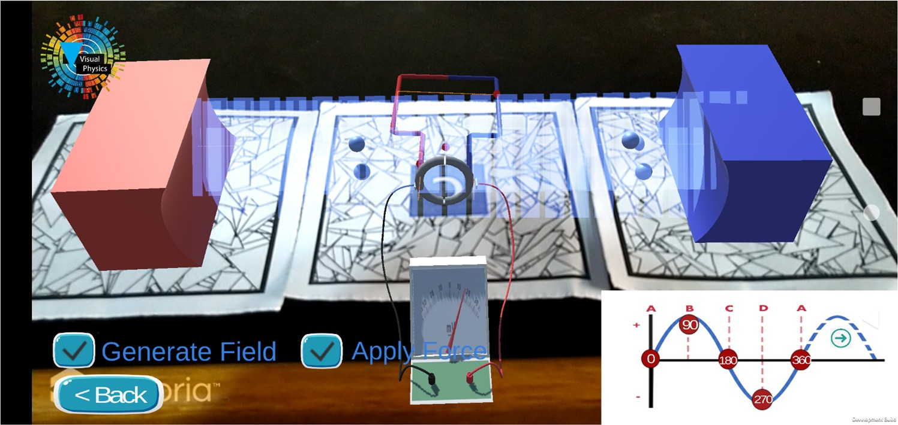
Fig 3: AC motor virtualization

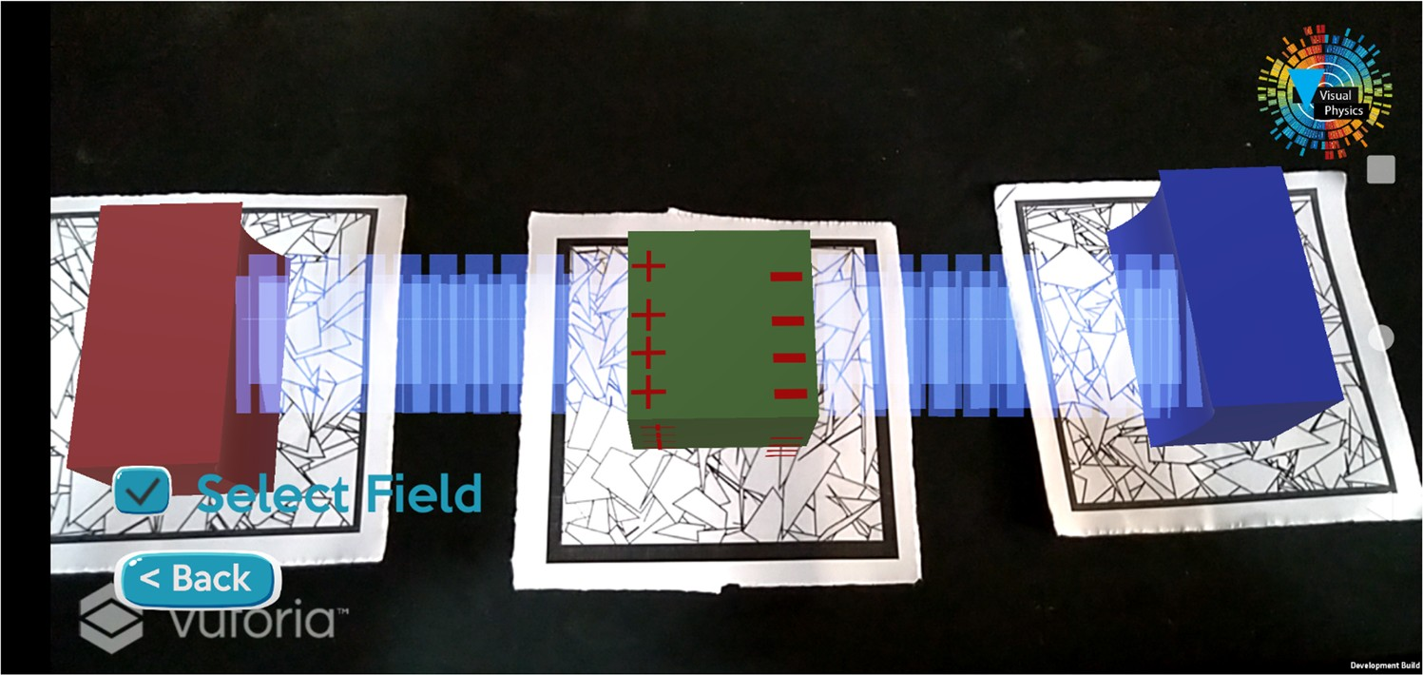
Fig 4: Virtualization of Gauss law in magnetism

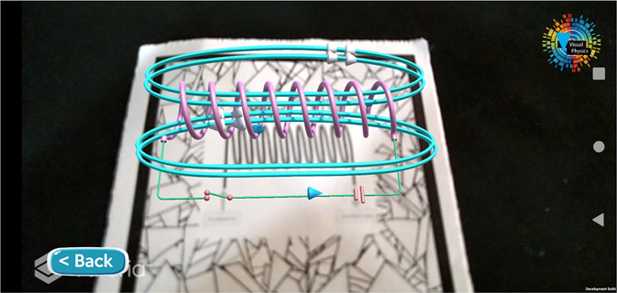

Fig 5: Virtualization of solenoid

The complete ARLE system is developed as a mobile application, utilizing 3D models of bar magnets, conductors, batteries, galvanometers, spheres, cubes, and tori as game objects. These game objects are controlled through C# scripts, which dictate the gameplay behavior.

The learning activity was conducted in a Physics research laboratory. Initially, the students received a basic introduction to fundamental Physics concepts, including Maxwell equations, magnetism, Gauss's law in magnetism, Fleming's rule, the basic principles of motors and generators, and galvanometers. This introductory session familiarized them with the subject matter and the process of experimental research. Participation in this learning activity was voluntary, and students joined based on their interest. They were informed that their pretest and posttest scores would not be used for general course evaluation.

After the introductory session, the students were randomly divided into two groups: the AR teaching group and the conventional teaching group. The randomization process was conducted by a faculty member who was unaware of the experimental study to ensure complete randomized distribution of students. Before the intervention, a pretest was individually administered to evaluate the students' basic knowledge of the phenomenon and to ensure equal learning ability in both groups. The pretest consisted of a questionnaire with 15 multiple-choice questions related to the subject matter, where students had to choose the correct answer among four options within a time limit of 20 minutes.

The AR teaching group consisted of 40 students who received training using the ARLE approach, while the conventional teaching group also had 40 students taught through traditional lecture-based methods. To ensure impartial assessment, the same teacher taught both groups while being aware of the different interventions.

Throughout the learning process, the AR teaching group received training to understand principles such as motors and generators, Maxwell's equations, electricity, magnetism, and Fleming's rule using the ARLE approach. They were also guided in understanding the behavior of magnetic fields and current-carrying conductors through the ARLE, addressing the difficulties faced in visualizing magnetic field lines generated by current-carrying solenoids [23, 40]. The learning activity lasted for 60 minutes for each group.

After the learning activity, both groups took a posttest, which consisted of 10 multiple-choice questions (1 mark each) and 5 multiple-choice questions (2 marks each), with a maximum score of 20. The time limit for completing the posttest was 20 minutes for both groups. Additionally, students were asked to fill out a Critical Thinking Questionnaire, and the AR teaching group students were interviewed to provide feedback and suggestions regarding the ARLE.

Figure 6 shows the research design tailed to conduct the entire procedure.

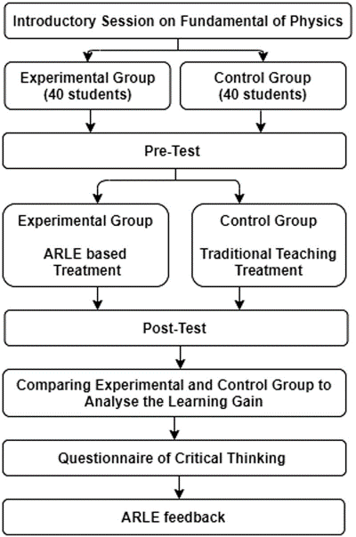

Fig 6: design flow of the experiment conduct.

- Measuring equipment’s

The measurement instruments utilized in this study include a knowledge test and a Critical Thinking Questionnaire. The knowledge test was used to assess students' understanding of fundamental Physics concepts, while the Critical Thinking Questionnaire was employed to evaluate their critical thinking skills.

The knowledge test followed a pretest and posttest design. The pretest aimed to gauge students' knowledge before the experiment, while the posttest assessed their knowledge after the intervention. The pretest comprised 15 multiple-choice questions, with a maximum score of 15, and the posttest consisted of 15 multiple-choice questions, with a maximum score of 20. Both the pretest and posttest were designed by a teacher with six years of experience in the relevant field.

Critical thinking involves the process of analyzing, synthesizing, and evaluating information to form judgments and draw conclusions. It encompasses various aspects, including Interpretation, Analysis, Evaluation, Inference, and Explanation. Interpretation involves expressing the meaning of various experiences, judgments, beliefs, rules, events, and procedures. Analysis entails identifying relationships among concepts, descriptions, statements, and questions. Evaluation refers to assessing the credibility of representations and descriptions based on students' perceptions and experiences. Inference involves identifying reasonable conclusions and forming hypotheses. Explanation entails presenting the results of specific reasoning and providing justifications for that reasoning based on perceptions and experiences.

The Critical Thinking Questionnaire utilized to measure students' critical thinking abilities was adapted from a questionnaire created by Chai et al. [9]. It consists of six items, such as "I will think about whether what I have learned in this learning activity is correct or not" and "In this learning activity, I will try to understand the new knowledge from a different point of view." Students were asked to respond on a 10-point scale, ranging from 1 to 10.

Analysis of results :

The data obtained from the experimental study underwent analysis using the SPSS software to determine the study's outcomes. Prior to applying any statistical tests to the collected data, the normality of the data was assessed. Descriptive statistics for the pretest, posttest, and critical thinking scores are presented in Table 2, suggesting that the data follows a normal distribution. As a result, an independent sample t-test can be utilized to determine the difference between the two groups.

Analysis of Knowledge Test:

Initially, a t-test was conducted to assess the students' knowledge of fundamental Physics concepts before the experiment. The t-test analysis of the pretest, as shown in Table 3, indicates that there is no significant difference between the mean scores of the two groups, with a p-value greater than 0.05.

Subsequently, after the experiment, Levene's test was performed to examine the equality of variances in posttest scores for both groups. The p-value of Levene's test was greater than 0.05, and the F-value was 0.574, suggesting insufficient evidence to conclude a difference in variances between the two groups. Thus, equal variance was assumed between the groups. Following this, a t-test was conducted to determine the difference in knowledge between the two groups after the interventions. Table 4 displays the t-test analysis of posttest scores.
.

TAB LE 2 Descriptive statistics of pretest, posttest, and critical thinking

Variable | N  Statistic | Mean Statistic | SD  Statistic | Variance Statistic | Skewness  Statistic | SE | Kurtosis  Statistic | SE
Pretest | 80 | 11.385 | 3.052 | 9.376 | 0.423 | 0.279 | −0.814 | 0.522
Posttest | 80 | 13.935 | 3.139 | 9.791 | −0.086 | 0.269 | −0.964 | 0.522
Critical thinking | 80 | 8.187 | 1.501 | 2.256 | −0.812 | 0.269 | −0.029 | 0.542
Abbreviations: SD, standard deviation; SE, standard error.

TAB LE 3 t‐Test analysis of pretest

 |  |  |  |  |  |  | Interval of the difference
Dependent variable Group | N | Mean | SD | t | df | p | Lower Upper
Pretest AR teaching group | 40 | 11.31 | 3.038 | −0.228 | 77 | .827 | −1.522 1.222
Conventional teaching | 40 | 11.44 | 3.122
group
Abbreviations: AR, augmented reality; SD, standard deviation; SE, standard error.

TAB LE 4 t‐Test analysis of posttest
95% Confidence interval of the difference
Dependent variable | Group | N | Mean | SD | t | df p Cohen's d | Lower | Upper
Posttest | AR teaching group | 40 | 15.76 | 2.533 | 6.13 | 78 .000 1.374 | 2.397 | 4.702
 | Conventional teaching | 40 | 12.16 | 2.535
group
Abbreviations: AR, augmented reality; SD, standard deviation; SE, standard error.

Analysis of critical thinking ability

To begin with, Levene's test was utilized to assess the equality of variance in the critical thinking abilities of both groups. The p-value for Levene's test was found to be less than 0.05, and the corresponding F-value was 8.704, indicating that the variance is not equal between the two groups. Therefore, assuming equal variance between the groups was not appropriate. Instead, a Welch t-test was conducted to analyze the difference in critical thinking abilities of the two groups. The results of the Welch t-test are presented in Table 5.

TAB LE 5 Welch t‐test analysis of critical thinking ability
95% Confidence interval of the difference
Dependent variable Group
N Mean SD t
df
p Cohen's d Lower
Upper

Critical thinking | AR teaching group | 40 | 8.74 | 1.107 3.694 67.22 .001 | 0.807 | 0.501 | 1.748
ability | Conventional teaching | 40 | 7.63 | 1.543
group
Abbreviations: AR, augmented reality; SD, standard deviation; SE, standard error.

Conclusion :

The primary objective of this study was to assess the impact of Augmented Reality Learning Environment (ARLE) on the learning gain and critical thinking abilities of engineering students. The ARLE was designed to offer an active learning experience to students, focusing specifically on the fundamentals of electromagnetism. The experimental study involved dividing students into two groups, each receiving different teaching interventions – one group taught with ARLE and the other with a conventional teaching approach. The results of the experiment demonstrate that ARLE had a positive effect on the students' learning gain and critical thinking abilities when compared to the conventional teaching approach.

In terms of knowledge gain, the posttest score mean for the AR teaching group was 15.70, whereas it was 12.15 for the conventional teaching group. This significant difference indicates that the AR intervention significantly enhanced the learning gain of engineering students. The use of ARLE allowed students to interact with 3D virtual content, aiding their visualization of various Physics concepts. This led to a deeper understanding of the core principles and improved their ability to retain knowledge and apply it practically. These findings align with previous studies conducted by Ibanez et al., Chang et al., and Singh et al.

Moreover, the study revealed a notable difference in the critical thinking abilities between the two groups. The mean value of critical thinking for the AR teaching group was 8.7, compared to 7.6 for the control group, indicating that the AR intervention significantly enhanced the students' critical thinking abilities. This improvement can be attributed to the higher engagement of students during learning activities using ARLE, which effectively increased their learning motivation. Students reported that ARLE allowed them to visualize abstract Physics concepts, facilitating better understanding. The immersive experience provided by ARLE, enabling visualization and interaction with 3D virtual animated content, heightened students' attention, interaction, and motivation.

Overall, this study provides evidence that AR enhances knowledge, attention, and practical skills among students. It indicates that students are enthusiastic and motivated to learn through digital teaching platforms and environments. Especially during the pandemic of COVID-19, AR and VR technology can prove to be valuable tools for teachers and academics in developing effective online learning environments and providing an immersive learning experience to students. While developing AR/VR learning environments requires time and investment, academic institutions should support researchers and educators in this endeavor, as it holds great potential as a valuable resource for students and teachers during online teaching.

REFERENCES
- H. Altinpulluk, Determining the trends of using augmented reality in education between 2006‐2016, Educ. Inf. Technol. 24 (2019), 1089–1114.
- I. M. Astra, and F. Saputra, The development of a Physics Knowledge Enrichment Book “optical Instrument Equipped with Augmented Reality” to improve students’ learning outcomes, J. Phys.: Conf. Ser. 1013 (2018), 012064.
- C. Avilés‐Cruz, and J. Villegas‐Cortez, A smartphone‐based augmented reality system for university students for learning di- gital electronics, Comput. Appl. Eng. Educ. 27 (2019), 615–630.
- R. I. Barraza Castillo, V. G. Cruz Sánchez, and
O. O. Vergara Villegas, A pilot study on the use of mobile aug- mented reality for interactive experimentation in quadratic equations, Math. Probl. Eng. 2015 (2015), 1–13.
- M. Bower et al., Augmented Reality in education—cases, places
and potentials, Educ. Media Int. 51 (2014), 1–15.
- S. Cai et al., Applications of augmented reality‐based natural
interactive learning in magnetic field instruction, Interact. Learn. Environ. 25 (2017), 778–791.
- S. Cai, X. Wang, and F.‐K. Chiang, A case study of augmented
reality simulation system application in a Chemistry course, Comput. Human. Behav. 37 (2014), 31–40.
- A. Cerrato, G. Siano, and A. De Marco, Experience augmented reality: From education and training applications to assessment procedures, Qwerty 13 (2018).
- C. S. Chai et al., Assessing multidimensional students’ percep- tions of twenty‐first‐century learning practices, Asia Pacific Educ. Rev. 16 (2015), 389–398.
- S.‐C. Chang, and G.‐J. Hwang, Impacts of an augmented reality‐ based flipped learning guiding approach on students’ scientific
project performance and perceptions, Comput. Educ. 125 (2018), 226–239.

- K.‐H. Cheng, and C.‐C. Tsai, Affordances of augmented reality in science learning: Suggestions for future research, J. Sci. Educ. Technol. 22 (2013), 449–462.
- T. H. C. Chiang, S. J. H. Yang, and G.‐J. Hwang, Students’
online interactive patterns in augmented reality‐based inquiry activities, Comput. Educ. 78 (2014), 97–108.
- Y. D. Choi, and H. J. Yun, Vector field platform for visualizing electric and magnetic fields in matter using Mathematica, J. Korean Phys. Soc. 74 (2019), 530–541.
- Á. Di Serio, M. B. Ibáñez, and C. D. Kloos, Impact of an aug-
mented reality system on students’ motivation for a visual art course, Comput. Educ. 68 (2013), 586–596.
- A. Dünser et al., Creating interactive Physics education books with augmented reality, Proc. 24th Aust. Comput. Interact. Conf. OzCHI 2012.
- A. Echeverría et al., Exploring different technological platforms for supporting co‐located collaborative games in the classroom, Comput. Human. Behav. 28 (2012), 1170–1177.
- J. Franklin, and A. Ryder, Electromagnetic field visualization in virtual reality, Am. J. Phys. 87 (2019), 153–157.
- J. D. González et al., Impact of the use of virtual laboratories of
electromagnetism in the development of competences in en- gineering students, J. Phys.: Conf. Ser. 1247 (2019), 012018.
- R. Gusmida, and N. Islami, The development of learning media for the kinetic theory of gases using the ADDIE Model with augmented reality, J. Educ. Sci. 1 (2017), 1.
- H. Heflin, J. Shewmaker, and J. Nguyen, Impact of mobile technology on student attitudes, engagement, and learning, Comput. Educ. 107 (2017), 91–99.
- K. T. Huang et al., Augmented versus virtual reality in education:
An exploratory study examining science knowledge retention when using augmented reality/virtual reality mobile applications, Cyberpsychol. Behav. Soc. Netw. 22 (2019), 105–110.
- M.‐B. Ibanez et al., Support for augmented reality simulation
systems: The effects of scaffolding on learning outcomes and behavior patterns, IEEE Trans. Learn. Technol. 9 (2016), 46–56.
- M. B. Ibáñez et al., Experimenting with electromagnetism using
augmented reality: Impact on flow student experience and edu- cational effectiveness, Comput. Educ. 71 (2014), 1–13.
- F. Mannus et al., Augmenting magnetic field lines for school
experiments, 2011 10th IEEE Int. Symp. Mix. Augment. Real., IEEE, 2011, pp. 263–264.
- A. Mart et al., Supporting teacher orchestration in ubiquitous
learning environments: A study in primary education, IEEE Trans. Learn. Technol. 8 (2015).
- J. Martín‐Gutiérrez et al., Augmented reality to promote colla-
borative and autonomous learning in higher education, Comput. Human. Behav. 51 (2015), 752–761.
- J. Martín‐Gutiérrez et al., Virtual technologies trends in educa-
tion, Eurasia J. Math. Sci. Technol. Educ. 13 (2017), no. 2, 469–486.
- S. Matsutomo et al., Real‐time visualization system of magnetic
field utilizing augmented reality technology for education, IEEE Trans. Magn. 48 (2012), 531–534.
- M. Ozdemir et al., The effect of augmented reality applications in
the learning process: A meta analysis study, Eurasian J. Educ. Res. 18 (2018), 1–22.
- S. Park, and C. Kim, Boosting learning‐by‐teaching in virtual
tutoring, Comput. Educ. 82 (2015), 129–140.
- D. Prit Kaur, A. Mantri, and B. Horan, A framework utilizing augmented reality to enhance the teaching–learning experience of linear control systems, IETE J. Res. 2063 (2018), 1–10.
- G. Singh et al., Evaluating the impact of the augmented reality learning environment on electronics laboratory skills of en- gineering students, Comput. Appl. Eng. Educ. 27 (2019), 1361–1375.
- M. Sirakaya, and E. Kiliç Çakmak, Investigating student atti-
tudes towards augmented reality, Malaysia Online J. Educ. Tech. 6 (2018), no. 1, 30–44.
- D. Sonntag et al., Hybrid learning environments by data‐driven
augmented reality, Procedia Manuf. 31 (2019), 32–37.
- S. Tumkor, Personalization of engineering education with the mixed reality mobile applications, Comput. Appl. Eng. Educ. 26 (2018), 1734–1741.
- Y.‐H. Wang, Using augmented reality to support a software
editing course for college students, J. Comput. Assist. Learn. 33
(2017), 532–546.
- X. Wei et al., Teaching based on augmented reality for a tech- nical creative design course, Comput. Educ. 81 (2015), 221–234.
- H.‐K. Wu et al., Current status, opportunities and challenges of augmented reality in education, Comput. Educ. 62 (2013), 41–49.
- M.‐T. Yang, and W.‐C. Liao, Computer‐assisted culture learning in an online augmented reality environment based on Free‐Hand Gesture Interaction, IEEE Trans. Learn. Technol. 7 (2014), 107–117.
- E. Özdemir, and M. Coramik, Reasons of student difficulties with right‐hand rules in electromagnetism, J. Balt. Sci. Educ. 17 (2018), 320–

