ACCIDENT AVOIDING AND VEHICLE CONTROL SYSTEM USING AURDINO WITH ULTRASONIC SENSORS

¹B Siva Kumar Reddy,
Professor, Dept. of ECE,
CMR Engineering College, Hyderabad, Telangana-501401, India
Bsivakumar100@gmail.com

1.K Jyothika, 2.B Prathyusha ,3.B Shravani ,4.G Ganitha,
5.G Manogna Student, Dept. of ECE,
CMR Engineering College, Hyderabad, Telangana-501401, India
218r1a0495@cmrec.ac.in

ABSTRACT

Accident detection systems in minimizing severity of road incidents by early warnings to drivers. This introduces a system for accident detection using ultrasonic sensors that incorporates a buzzer feedback mechanism to alert drivers of potential collisions. The ultrasonic sensors strategically placed in vehicles to continuously monitor the surrounding environment for potential obstacles or vehicles. The buzzer emits a distinct sound pattern that alerts the driver to the potential danger, enabling them to take immediate action. To ensure accurate and reliable detection, multiple ultrasonic sensors are strategically positioned around the vehicle to minimize blind spots and improve coverage. By leveraging the principles of ultrasonic technology, this system can detect objects and measure distances accurately in real-time. The ultrasonic sensor emits high-frequency sound waves and analyzes their reflections to determine the proximity of objects in its surroundings. This abstract provides an overview of the accident avoiding system, its key components, and its potential benefits. By sending a trigger pulse to the sensor module, the program initiates a measurement. By setting a threshold distance, the system can determine whether an object is too close, triggering an accident avoiding mechanism. It includes sounding an alarm, or initiating steering maneuvers to avoid collision. The system continuously monitors the surroundings, providing real-time feedback and enabling timely responses to potential hazards.
Keywords: Collision avoidance, accident prevention, Arduino, smart vehicle
- INTRODUCTION
In recent years, road accidents have become a significant concern due to their devastating impact on human lives and property. To address this issue, various technologies have been developed to assist drivers in detecting and avoiding potential collisions. This introduction presents an accident avoidance system that utilizes Arduino, a buzzer, and ultrasonic sensors to enhance driver safety and prevent accidents [1]. The accident avoiding system incorporates an Arduino microcontroller, which serves as the brain of the system [2]. The Arduino processes sensor data, makes real-time decisions, and triggers appropriate actions to prevent collisions.

The system also utilizes ultrasonic sensors that emit high-frequency sound waves and measure the time it takes for the waves to bounce back after hitting an object. This data is used to determine the distance between the vehicle and nearby obstacles or vehicles. The key component of the system is the buzzer, which provides audible feedback to the driver [3]. When the ultrasonic sensors detect an object or vehicle within a predefined safety threshold, indicating a potential collision, the Arduino activates the buzzer [4]. The buzzer emits a distinctive sound pattern that alerts the driver to the imminent danger, enabling them to take immediate evasive action and avoid the collision.

The integration of Arduino, the buzzer, and ultrasonic sensors provides a comprehensive and reliable accident avoidance system [5]. The Arduino's processing capabilities allow for real-time analysis of sensor data, ensuring timely warnings and responses. The buzzer, with its audible feedback, enhances driver awareness and responsiveness, providing an additional layer of safety to visual observations. Moreover, the system can be expanded to include multiple ultrasonic sensors placed at strategic positions around the vehicle. This arrangement minimizes blind spots and provides a more comprehensive view of the surroundings, improving the accuracy and reliability of the collision detection system [6].

The accident avoiding system has the potential to significantly reduce the occurrence of accidents by providing drivers with timely warnings and enabling them to make informed decisions. By leveraging the capabilities of Arduino, the buzzer, resistors,and ultrasonic sensors, this system offers a practical and cost-effective solution for enhancing road safety [7]. In today’s world there is a severe increase in the use of vehicles. Such heavy automobile usage has increased traffic and thus resulting in a rise in road accidents [8]. This takes a toll on the property as well as causes human life loss because of unavailability of immediate preventive and safety facilities [9]. Complete accident prevention is unavoidable but at least repercussions can be reduced. This embedded system can prevent the accident to occur and proper preventive measures are taken in this system [10].

Additionally, an accident avoiding system using ultrasonic sensors can serve as a valuable aid for inexperienced or distracted drivers. By continuously monitoring the vehicle's surroundings, it can provide alerts or even automatic interventions if it detects potential hazards, helping prevent accidents that may occur due to lack of attention or inexperience [11].
- RESEARCH METHODOLOGY

Designing an accident-avoiding system using ultrasonic sensors involves a systematic research methodology to ensure its effectiveness and reliability. Here's a step-by-step guide to the research methodology:
1.Literature Review: Conduct an extensive review of the existing literature and research papers related to accident-avoidance systems, ultrasonic sensors, and similar technologies. Understand the principles, methodologies, and best practices utilized in previous works.
2.Problem Definition: Clearly define the problem statement and the objectives of the accident-avoiding system. Determine the specific scenarios and conditions in which the system should prevent accidents.
3.Sensor Selection and Evaluation: Evaluate various ultrasonic sensors available in the market to identify the most suitable ones for the accident-avoidance system. Consider factors such as range, accuracy, response time, power consumption, and environmental conditions.
4.System Architecture Design: Develop the system architecture based on the selected sensors and the desired functionality. Decide on the number and placement of ultrasonic sensors on the vehicle to ensure optimal coverage for accident detection.
5.Data Collection: Set up a controlled environment to collect data for training and testing the system. Create scenarios that mimic potential real-world accident situations and record data from ultrasonic sensors and other relevant sensors on the vehicle.
6.Data Preprocessing: Process and clean the collected data to remove noise and inconsistencies. Perform data augmentation techniques if necessary to increase the diversity of the dataset.
7.Algorithm Development: design and implement the accident-avoidance algorithm that uses the data from ultrasonic sensors to make real-time decisions. The algorithm should be able to interpret sensor data accurately and trigger appropriate actions to avoid accidents.
8.Simulation and Testing: Utilize simulation tools and testing environments to evaluate the system's performance under various conditions. Conduct extensive testing to ensure the system can reliably detect potential collisions and respond appropriately.
9.Performance Evaluation: Define performance metrics such as accuracy, false-positive rate, and reaction time. Evaluate the system's performance against these metrics and compare it with existing accident-avoidance systems to measure its effectiveness.
10.Iterative Improvement: Based on the evaluation results, make necessary improvements to the system architecture, algorithm, and sensor configuration. Iterate through testing and evaluation to fine-tune the system's performance.
11.Real-world Testing: Conduct field tests in controlled real-world scenarios to validate the system's effectiveness and safety. Gather feedback from test participants and consider their suggestions for further improvements.
12.Documentation and Reporting: Document the entire research process, including the system design, implementation, testing results, and conclusions. Prepare a comprehensive report summarizing the research findings and the accident-avoidance system's performance.
Following this research methodology will help ensure the development of a robust and reliable accident-avoiding system using ultrasonic sensors. Keep in mind that safety is of paramount importance, so thorough testing and validation are critical before implementing such a system in real-world applications.

SYSTEM MODEL

Here is a brief explanation of block diagram shown in Figure 1 of the accident avoiding system using ultrasonic sensor. The accident avoiding system using ultrasonic sensors and a buzzer is designed to enhance road safety by detecting potential collision scenarios and alerting drivers to take preventive actions. The system comprises several key components and functions. Ultrasonic sensor are strategically placed around the vehicle to provide a comprehensive view of the surroundings vehicle and nearby objects. System is controlled by a microcontroller unit, such as Arduino. It analyzes the distances and makes decisions based on predefined safety thresholds. The MCU compares the measured distances with the predefined safety thresholds. If the calculated distance falls within the critical range, indicating a potential collision, the system proceeds to the next step. When a collision scenario is detected, the system triggers a buzzer to provide an audible warning to the driver. The buzzer emits a distinct sound pattern that alerts the driver to the imminent danger, prompting them to take immediate evasive action. Upon hearing the audible warning from the buzzer, the driver becomes aware of the potential collision and can respond accordingly. They can apply brakes, steer away, or take any necessary action to avoid the accident. The system continuously monitors the distances between the vehicle and surrounding objects in real-time. It updates the sensor data and reevaluates the potential collision scenarios to provide instant warnings and timely response . The system resets and waits for the next potential collision scenario. By combining the functionality of ultrasonic sensors, a microcontroller unit, and a buzzer, this accident avoiding system provides a reliable and effective means of detecting potential collisions and alerting drivers. It enhances driver awareness, promotes prompt response, and contributes to overall road safety by mitigating the risks of accidents.

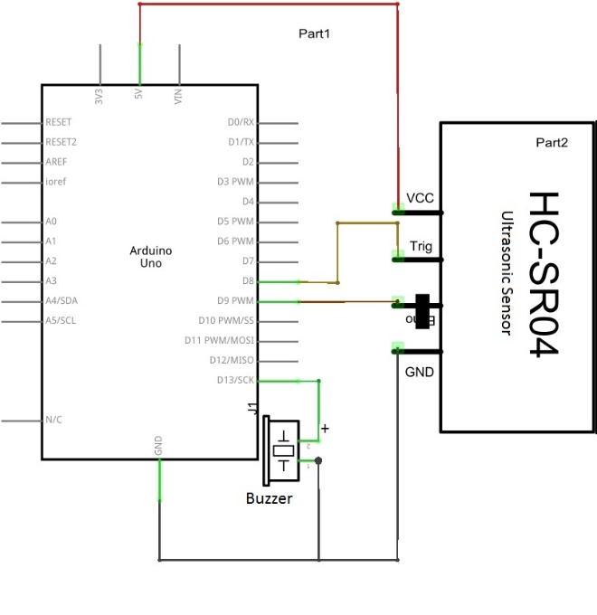
Fig 1. Block diagram

- RESULTS AND DISCUSSIONS

The experimental setup shown in Figure 2 typically consists of an ultrasonic sensor, a microcontroller, and a Buzzer any obstacles in its path, while the microcontroller processes the sensor data and controls the beep sound based on the distance. The microcontroller generates different frequencies of beep sounds based on the measured distance. The system is programmed to assign different beep frequencies to specific distance ranges: Within a safe distance range, no beep sound is produced. As the vehicle approaches an obstacle, the beep frequency gradually increases. At a critical distance, a continuous and higher-frequency beep sound is emitted to alert the driver of the imminent collision. It is essential to note that the specific frequencies and distance ranges used for the beep sounds will depend on the system's design, user preferences, and applicable regulations.
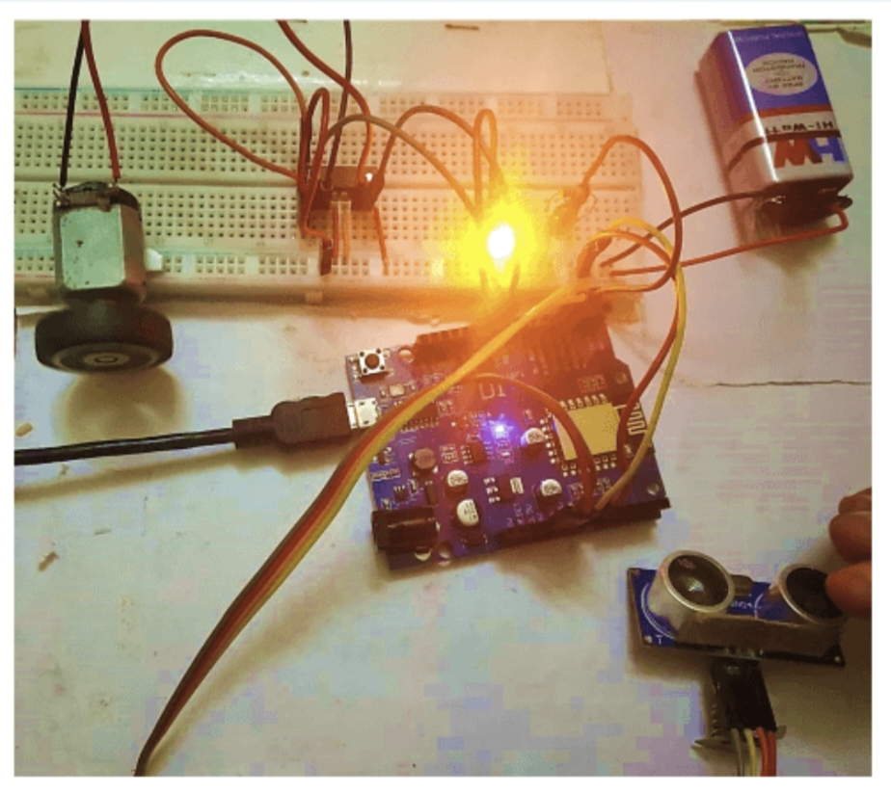
Figure 2: Experimental setup

CONCLUSION

In conclusion, the accident avoiding detection system using ultrasonic sensors and a buzzer offers significant benefits in enhancing road safety and preventing accidents. By providing early collision detection, improved driver awareness, and prompt response capabilities, the system risks on the road Important to note that an accident avoiding system based solely on ultrasonic sensors may have limitations. These sensors have a limited range and may not be suitable for detecting fast-moving objects or obstacles at longer distances. Therefore, integrating ultrasonic sensors with the system's capabilities and overall effectiveness

REFERENCES

[1] Borenstein, Johann, and Yoram Koren. "Obstacle avoidance with ultrasonic sensors." IEEE Journal on Robotics and Automation 4.2 (1988): 213-218.
[2] Tyson, John J., Katherine C. Chen, and Bela Novak. "Sniffers, buzzers, toggles and blinkers: dynamics of regulatory and signaling pathways in the cell." Current opinion in cell biology 15.2 (2003): 221-231.
[3] Banzi, Massimo, and Michael Shiloh. Getting started with Arduino. Maker Media, Inc., 2022
[4] Prajapati, Urvish, B. Siva Kumar Reddy, and Abhishek Rawat. "Modeling a data rate-based peripheral security system in GNU radio." Integrated Intelligent Computing, Communication and Security (2019): 353-361.
[5] Jamson, A.H., Lai, F.C. and Carsten, O.M., 2008. Potential benefits of an adaptive forward collision warning system. Transportation research part C: emerging technologies, 16(4), pp.471-484
[6] Jin, Zhenyu. Interaction Between Virtual and Reality: Real-Time Collision Detection for UAVs in VR Scenario. Diss. Lehigh University, 2023.
[7] Reddy, Bathula Siva Kumar. "Experimental validation of non-orthogonal multiple access (NOMA) technique using software defined radio." Wireless Personal Communications 116.4 (2021): 3599-3612.
[8] Reddy, B. Siva Kumar, et al. "Design and Implementation of Novel FPGA Based LFSR for IOT and Smart Applications." 2022 IEEE International Women in Engineering (WIE) Conference on Electrical and Computer Engineering (WIECON-ECE). IEEE, 2022.
[9] Hobbs, M., et al. "Unhealthy environments are associated with adverse mental health and psychological distress: cross-sectional evidence from nationally representative data in New Zealand." Preventive Medicine 145 (2021): 106416.
[10] Forte, A., & Bruckman, A. (2005). Why do people write for Wikipedia? Incentives to contribute to open–content publishing. Proc. of GROUP, 5, 6-9.

