Functionally Graded Materials

Naveen Kumar S N Devarajaiah R M
Department of Mechatronics Engineering Department of Mechatronics Engineering
Acharya Institute of Technology Bangalore-107 Acharya Institute of Technology Bangalore-107
Karnataka India Karnataka India
e-mail: naveenkumarsn@acharya.ac.in e-mail: devarajaiahrm@acharya.ac.in

ABSTRACT

Functionally Graded Materials (FGM) are heterogeneous materials that have been artificially designed to meet the demand for a variety of contradicting essential qualities. They have numerous uses, including those in the automotive, gas and oil, defense, and in space industries. This chapter provides an overview of FGM materials, types of FGMs, processing methods, applications and challenges. This chapter provides readers a more comprehensive picture of FGM. In this chapter a summary of aluminium based FGMs, Magnesium based FGMs and Copper Tungsten based FGMs are also discussed. The applications of FGMs as well as challenges in production of FGMs are also discussed.

Keywords: Advanced Materials; Functionally Graded Materials; Processing Methods; Classifications; Challenges

- INTRODUCTION

Nearly all technological fields require novel materials. Due to the growth of contemporary industries and their increasing demand for components that act differently based on demand, there is a need to create materials whose properties vary over the cross section. Functionally Graded Materials (FGM) are the materials that are formed by various composition of two or more materials in a gradient manner. This include variation in microstructure, composition and mechanical properties along particular direction, unlike the properties of Individual constituent materials. The main advantages of FGM are having different microstructure and properties in different regions of the same materials in a controlled manner, because of the non-uniform distribution of the constituent materials. The FGMs were initially manufactured for thermal barrier applications, but with technological development in industries and processing methods the applications were increased drastically [1]. The FGMs can be designed and developed for limitless of applications based on the requirements and constituent materials. The FGM are the composite materials where the constituent material doesn’t mix to form any other alloy, but in FGM the volume and distribution of reinforcement varies continuously from the inner to the outer section. The distribution of reinforcement creates continuously changing microstructure and properties in a controlled manner according to the distribution of reinforcement. FGMs are becoming more and more popular as the newest class of sophisticated materials, with a wide range of applications in various technical and scientific sectors. Because of compositional changes and size variations, the properties of FGMs shift in a particular direction. FGMs can be single-phase or composite materials with consistently changing functional properties along a single axis. Materials with distinct qualities can be created by altering the composition and size of the alloying element or reinforcement in base metal. Materials can be created with specific functions and applications. A non-homogenous structure is created by the gradual variation in the volume of reinforcement combined with the matrix constituent material. This non-homogenous structure offers a gradual variation in many important properties, including wear resistance, hardness, specific heat, thermal conductivity, and other properties. Varying reinforcing particles with varying characteristics, size distributions, and morphologies can be used in matrix materials to create these differences. The potential applications of materials with non-homogeneous microstructure and properties creates the need of production of advanced composite materials such as FGM. Aluminium being the commercially available lightweight material, there are numerous uses for aluminum and its alloys. Due to their excellent and desirable qualities, such as high stiffness, ductility, higher strength to weight ratio, high thermal strength, stability, and conductivity, as well as the fact that they are more readily available and less expensive than other commonly used low-density alloys (Mg, Be, or Ti-based alloys), they are widely used in industries and for research projects. One of the main materials utilized in the automotive sector is aluminum. The most often used materials for common applications are aluminum, various aluminum alloys, and composites. The majority of automobile parts are subject to both heat and mechanical loads. When one material cannot satisfy the needs of several qualities, functionally graded aluminum can be a good option. Because of these, there is lot of potential for research on aluminium, FGMs and also aluminium based FGMs.

- CLASSIFICATION OF FGMs

- Classification according to the FGM structure
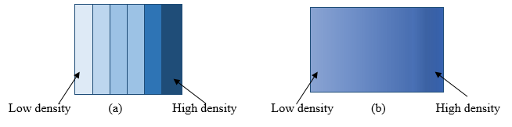
Different types of FGMs can be produced depending on types of reinforcement, type of gradient formed, Microstructure, type of matrix material and processing methods. Based on the cross section, FGMs are classified as thin FGM’s and Bulk FGMs. Thin FGMs are manufactured by processing methods such as vapour deposition, plasma spraying, chemical deposition and other coating methods. Bulk FGMs can be manufactured by different methods such as centrifugal casting and powder metallurgy. Depending on the spatial distribution, they are classified into Layered FGM and Continuous Structured FGM (Figure1) [1].
Fig. 1 Representation of (a) layered FGM and (b) continuous FGM [1]

The change in microstructure or distribution of reinforcement is in layered manner in layered FGM, where the change is gradual over certain direction in continuous FGM. Based on the microstructure or based on the distribution of the reinforcement material within the matrix material the physical and mechanical properties will vary. Weak interlayer bonding, rapid changes in thermal and mechanical properties, such as the coefficient of thermal expansion between adjacent layers, and changes in Young's modulus are issues with multilayer FGMs. The development of continuous structured FGMs, in which the microstructure or composition of the FGM varies continuously in particular direction, can solve these issues. The properties including strength, toughness, and hardness of the continuous gradient materials vary continuously over the segment.

- Classification According to the physical state during processing
Methods can be generically categorized into solid state procedures, liquid state processes and deposition processes according on how FGM is being processed. Deposition techniques are uses advanced techniques in coating or deposition method, that are applied to produce small, highly accurate products. While solid-state-based FGMS are employed to produce FGMs with layered form of gradient, liquid-state techniques are typically used for big products with continuous gradient. The porosity type of FGM gradient in the material changes when the bulk material's spatial location shifts or changed [2].

C. Classification according to the type of gradient
Based on type of gradient FGMs can be generally classified into Composition gradient, microstructure gradient and porosity gradient. By varying these, the property of the materials can be varied according to the requirements. In composition type of FGM the composition of the material, which changes from one component to another and results in many phases with various chemical structures, determines the kind of FGM gradient. The microstructure changes can be done by varying the rate of solidification. The FGM gradient's microstructure can be generated during the solidification process, extinguishing the material's surface. This kind of material can produce distinct microstructures from the surface to the interior by allowing the core to cool slowly [2].

D. Classification according to the field of application
FGMs find their applications in different and severe to sensitive operating conditions. They can be used in heat exchangers, small sensors or even in fusion reactors and biomedical implants. Various combinations of material can be prepared according to the required applications. Based on area of application FMS are classified as aerospace, biomedical, automotive, defence smart structures, sport equipment etc.,
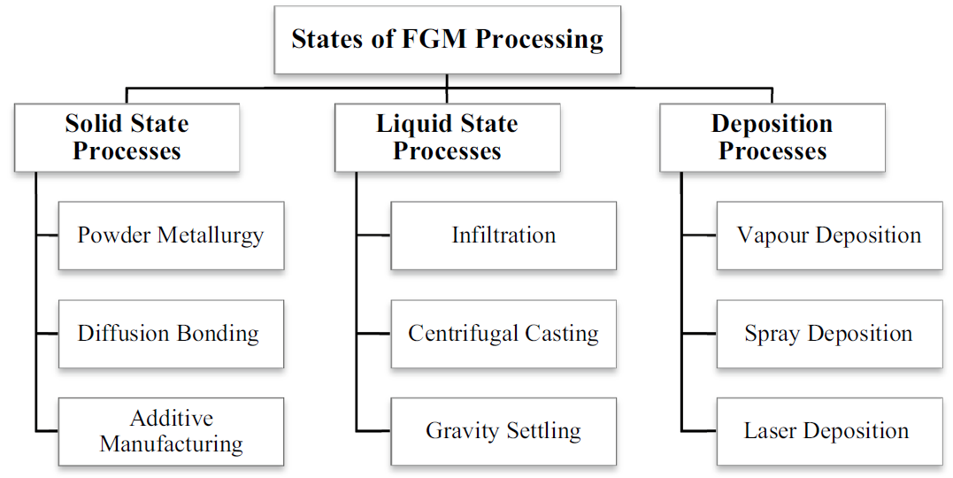
Fig 2 Classification based on physical state during processing [2]

- MANUFACTURING PROCESSES

FGMs need to be produced using special production techniques. FGMs are processed using a variety of techniques, including powder metallurgy, centrifugal casting, thermal spray coating, chemical/physical vapor deposition, the sol-gel process, and others. Due to its simplicity and numerous other special advantages, centrifugal casting is one of the most often used processes to create FGMs. Additionally, FGMs can be created using additive manufacturing, allowing for precise control over factors such as density, volume, and material deposition direction. Nair et al. have successfully used the Gradient Slurry Disintegration and Deposition (GSDD) process to FGM.
A. Centrifugal casting
Centrifugal casting is a simple manufacturing method for developing FGM that uses centrifugal force to produce symmetrical shaped products. When compared to other processing processes, centrifugal casting delivers improved mechanical qualities, fine microstructure, and clean cast with less porosity. The fundamental reason for the gradual dispersion of reinforcement materials in the matrix mixture is the difference in densities between the matrix and reinforcement. Materials with different densities are employed as matrix and reinforcement, and the difference is used during centrifugal casting to its advantage. Centrifugal casting involves pouring liquid metal into a prepared mould and allowing molten particles to travel through the mold due to centrifugal force, resulting in a continuously variable distribution of reinforcing particles.
Centrifugal casting can be classified into two types based on the phase of reinforcement during casting. The in-situ processing method and the solid particle processing method are the two methods. In-situ centrifugal casting both the matrix material and the reinforcement material are melted during the procedure or solid reinforcement material melts during the processing. In Solid particle method only the matrix material is melted and reinforcement remains in solid form and distributed in matrix material. Despite the centrifugal casting method's strong potential for the mass production of FGMs, it is difficult to control the distribution of reinforcing or secondary particles. Figure 3 shows a schematic of a centrifugal casting machine.
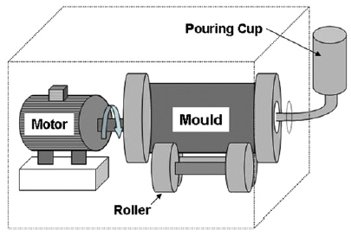
Fig. 3 Schematic diagram of the Centrifugal casting machine [3].

- Powder metallurgy
In order to create FGMs, powder metallurgy is an important production process. Powder metallurgy is a commonly used process to create FGMs due to easy control of composition, microstructure. The cost and shrinkage mismatch between the layers of FGMs are also reduced using this procedure. The process for producing FGM by powder metallurgy involves mixing components in powder form according to a predetermined distribution, layering those materials in accordance with the distribution requirement, and then sintering. The characteristics of FGMs formed by the powder metallurgical method are significantly influenced by temperature, pressure, and sintering time. [5].
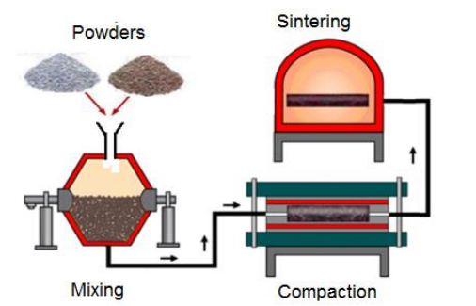

Fig 4. Powder metallurgy process [13]
Gorkem Kirmizi et al, reported mechanical and ballistic behavior of Silicon Carbide (SiC) reinforced aluminium composite. Aluminium (Al7075) and SiC layered composite are formed using the powder metallurgical process. Following layers are made up of five distinct Al7075 and SiC mixtures, with the first layer being aluminum alloy and the subsequent layers containing 15, 30, 45, and 60% SiC particles by weight. As part of the powder metallurgy process, Al7075 and SiC powders were compressed at varying pressures and sintered at various temperatures. Following that, FGM composed of Al7075/SiC and AA7075 foam arranged in series were created in order to get 5-layer FGM. [6].

- Thermal spraying
The development of contemporary tools and procedures in material processing technology, thermal spraying is increasingly being used in commercial, military, and aerospace applications. Thermal spraying procedures include a variety of techniques, including flame spraying, thermal barrier coating, plasma spraying, high voltage oxygen fuel spraying (HVOF), electric arc wire spraying, etc. At various working temperatures, different approaches are used. While the electric arc spraying was done at temperatures around 4000°C, plasma spraying uses temperatures between 1200°C and 1600°C. Electric arc spraying method employs electrical current to melt the coating materials, while flame and HVOF spraying uses combustion of fuel[11]. Shi et al has worked on functionally graded aluminium alloy using thermal spray deposition method, in this work SiC particles were deposited on aluminium Al6066 alloy using spray deposition method. The SiC particles used had an average particle size of 8µm. The deposition FGM was created using a special apparatus. To create the FGM, a controlled deposition of reinforcement particles on molten aluminum alloy was achieved. [12].
D. Laser cladding
The laser cladding process is also called as laser deposition process, this is layer formation process in which a layer of ceramic or metal powder is deposited on the substrate material using a high intensity laser. A high-powered LASER beam is made to fall on the surface of the metal, this melts the surface of the base metal, and powder ingredients are subsequently fed into the molten pool using nozzles. The molten pool mixes with the powder that is injected into the surface of the base metal and deposits a coating of it there. This technique is employed when the melting points of the base metal and reinforcing materials differ significantly. This can also be used to deposit layers only where they are needed in particular locations.

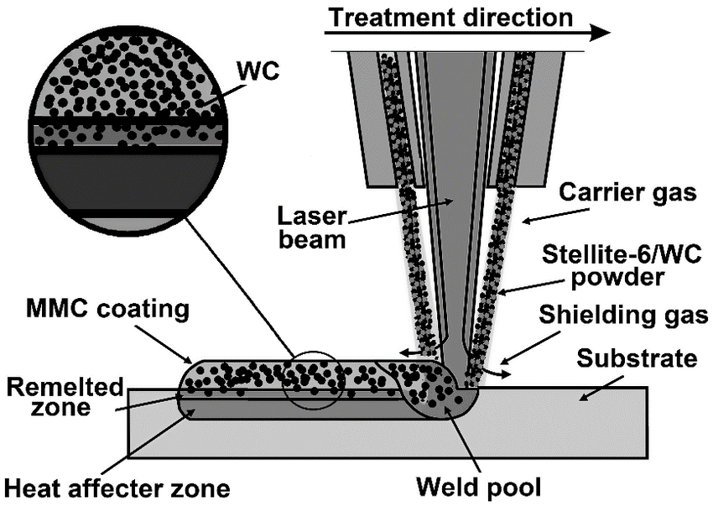

Fig 4. LASER cladding [10]

- MAGNESIUM BASED FGMs

Magnesium alloys are particularly desirable as lightweight structural materials in a variety of applications. Mg alloys' excellent specific strength, which is on par with steel, makes them ideal for use in the automotive and aviation industries. However, they have disadvantages like low corrosion resistance, limited cold forming capabilities, and low creep resistance. Mg-based composite materials have been created to address the mechanical characteristics deficiencies mentioned above. A FGM, on the other hand, is typically a combination of two materials or phases that have properties that gradually change from one side of the sample to the other. This seamless transition enables the development of superior and many properties without the need for any weak mechanical interfaces. The gradual alteration of attributes can also be customized for various applications and service contexts.
A centrifugal process was used to produce magnesium-based FGM from the alloy ZK60A (Mg-5.5 mass% Zn 0.6 mass% Zr). The applied G numbers, are are 40, 80, and 120. where the G number represents the centrifugal force in units of gravity, The specimen had a cylindrical shape and measured 18mm in length. Using SEM, the microstructures of the manufactured FGM specimens were examined. To investigate the chemical compositional gradients within the manufactured FGM specimens, energy dispersive Xray analysis was used. It was discovered that the concentration of Zr in the specimens increases in the direction of the centrifugal force, but the chemical composition of MgZn₂ shows no or very little gradient. Also, change in hardness in the direction of the centrifugal force was observed. [8]
It was found that a centrifugal process may be used to successfully create Mg-based FGM, which have graded chemical compositions and mechanical properties. For Zn, a graded chemical composition was found. Zn was found to be in higher percentage in the sample's outer region. [8]
Due to its biodegradation behavior and physical similarities to real human bone, magnesium (Mg) is a prospective replacement for the current orthopedic implant materials. Mg metal in orthopedic applications might decrease the possibility of "stress shielding effect" due to its biomimetic mechanical characteristics. Biomedical implants are the main applications of mg based FGMs. Being light weight the Mg based FGMs finds their applications in automobile and aerospace applications as well. At low temperature applications Mg based FGMs can be one of the best suited materials with light in weight.

- COPPER AND TUNGSTEN BASED FGMs

Copper and Tungsten are the two materials that possesses distinct properties, combining these two materials with distinct properties to produce FGM can lead to the material with interesting properties. Those materials can be used for following potential applications.
1. Thermal Management: Copper is an excellent conductor of heat, while tungsten has a high melting point and is less thermally conductive. By creating an FGM that gradually transitions from copper to tungsten, we could develop a material that efficiently conducts heat away from a source while also providing a heat-resistant surface.
2. Electrical Conductivity: Copper is also known for its high electrical conductivity, which is crucial in many electronic applications. Tungsten, on the other hand, has higher resistance. Designing an FGM that starts with high electrical conductivity copper and gradually transitions to tungsten could provide a material that develops gradient in electrical conductivity and resistance.
3. Mechanical Strength and Durability: Tungsten is much denser and stronger than copper. An FGM that transitions from copper to tungsten could be used in applications where you need a material that's both strong and tough while maintaining some level of ductility.
4. Radiation Shielding: Tungsten is often used in radiation shielding due to its high atomic number and density. An FGM that shifts from copper to tungsten could provide a material that's effective in absorbing and blocking radiation while also being relatively lightweight.
5. Wear Resistance: Tungsten is known for its excellent wear resistance, making it suitable for applications involving friction and abrasion. Combining copper with high malleability and tungsten with high hardness to develop FGM could create a material that has both wear-resistant and easy in machining.
Tungsten Copper FGM provide the opportunity to combine a copper rich phase with good thermal electrical and electrical conductivity with a refractory tungsten rich phase with a low thermal expansion coefficient and high strength. The potential application of this FGM can be First wall construction a nuclear fusion experiment. The thermo-mechanical stress between the Tungsten oriented plasma and the Copper-rich heat sink would be reduced by a smooth transition from the tungsten-rich phase to the copper-rich phase. A graded structure between the contact area and the bulk materials could also be useful in electrical contact applications [2]. Due to their exceptional ability to withhold ceramic particles, along with aluminium, copper, and titanium were the most often used metal matrix materials. The required mechanical, electrical, thermal, and tribological properties may be integrated at both low and high temperatures due to the metal-ceramic combination in FGM. The challenge in producing copper and tungsten based FGM is to achieve desired composition gradient with maintaining structural integrity.

- ALUMINIUM BASED FGMs

Aluminum-based FGM (Al-FGMs) involve aluminum as one of the key constituents. Aluminum and its alloys are widely used in various industries due to their lightweight, good mechanical properties, and excellent corrosion resistance. However, in certain applications, the homogeneous properties of traditional aluminum materials might not provide the best performance. This is where FGM come into play. In Al-FGCs, the composition of the composite changes gradually from one end to the other, allowing for tailored properties. This means that properties such as thermal conductivity, mechanical strength, thermal expansion, and more can be optimized to match the requirements of a specific application. Here are a few examples of how Al-FGCs could be utilized.
- Thermal Management: Al-FGCs could be designed to have a higher thermal conductivity on one side and a lower thermal conductivity on the other. This would be useful in applications where heat needs to be efficiently transferred away from a heat source while maintaining thermal insulation in another direction.
- Structural Components: FGCs can be designed to have high strength on one end and high toughness on the other, allowing for more efficient use of materials in structural components. For example, aircraft components could benefit from this kind of tailored strength and toughness distribution.
- Wear-Resistant Coatings: By gradually changing the composition from a hard and wear-resistant material to a more ductile material, Al-FGCs could create coatings that are both hard on the surface for wear resistance and tough underneath to absorb impact.
- Joining Dissimilar Materials: Al-FGCs can provide a transition zone between two different materials, reducing stress concentrations that often occur at the junction of dissimilar materials.
- Electrical Conductivity: Al-FGCs can be designed to have varying electrical conductivity, useful in applications where electrical or thermal conductivity needs to be controlled.
Creating these composites involves advanced manufacturing techniques such as powder metallurgy, Centrifugal casting, additive manufacturing (3D printing), and other methods that allow for precise control over material distribution. The challenge lies in designing the composition gradient and ensuring a smooth transition without introducing weak points or defects in the material. Aluminum-based FGM hold significant promise for various industries, offering tailored solutions to a wide range of engineering challenges.

- APPLICATIONS OF FGMs

FGMs are engineered materials that have varying properties, such as composition, microstructure, and mechanical characteristics, which change gradually over their volume. This gradient in properties offers several unique advantages and has led to various applications in different fields. Following are some of the important applications of FGM [9].
- Thermal Barrier Coatings (TBCs): FGMs are used in TBCs to create a gradual transition from a thermally insulating layer to a thermally conductive substrate. This gradient helps to reduce thermal stresses and improve the durability and efficiency of components in high-temperature environments, such as turbine blades in jet engines.
- Biomedical Implants: FGMs are employed in biomedical implants to create a smooth transition between the implant material and the surrounding tissue, reducing the risk of rejection or inflammation. For example, FGM hip implants can have a gradual transition from a biocompatible material on the outer surface to a stronger, load-bearing material deeper within the implant.
- Functionally Graded Ceramics: In ceramics, FGMs are used to design materials with tailored mechanical, thermal, and electrical properties. These materials find applications in cutting tools, wear-resistant parts, and even in electronics for their ability to combine properties that are not possible in a single material.
- Aerospace Components: FGMs are utilized in aerospace applications to develop lightweight components with improved mechanical properties. Components like rocket nozzles, which experience extreme temperature and pressure gradients, can benefit from FGMs to enhance their structural integrity.
- Energy Generation and Storage: FGMs can be used in energy generation and storage systems, such as solid oxide fuel cells and batteries. By designing materials with graded properties, it's possible to enhance the performance and efficiency of these devices.
- Optics and Photonics: FGMs are used in optical and photonic applications to create materials with varying refractive indices. This can be used to reduce reflection, control light propagation, and improve the efficiency of devices like lenses, prisms, and waveguides.
- Automotive Components: FGMs can be used in automotive parts to create materials with varying mechanical properties, such as high strength on the surface for wear resistance and lower density and increased toughness deeper within the component.
- Electronic Packaging: In electronics, FGMs can help manage the thermal stresses that occur due to the mismatch in coefficients of thermal expansion between different materials in integrated circuits and electronic packaging.
- Structural Components: FGMs can be used in structural components like bridges, buildings, and infrastructure to provide optimized mechanical properties that withstand varying loads and environmental conditions.
Overall, the applications of FGM span a wide range of industries and fields, demonstrating their versatility in solving engineering challenges and enabling the development of improved and innovative technologies.

- CHALLENGES FACED IN THE PRODUCTION OF FGMs

While FGMs offer numerous advantages, they also come with their own set of challenges that researchers and engineers need to address. Some of the key challenges in FGM production and usage are mentioned below
- Design Complexity: Designing FGMs with specific gradients and properties requires a deep understanding of materials science, mechanics, and manufacturing processes. The complexity of designing FGMs increases with the number of desired property gradients.
- Material Selection and Compatibility: Selecting suitable materials with compatible properties for the gradient can be challenging. Ensuring that the materials bond well, have similar thermal expansion coefficients, and do not undergo chemical reactions or phase changes at the interface is crucial.
- Manufacturing Methods: Producing FGMs with controlled gradients is a significant challenge. Conventional manufacturing methods may not be suitable, requiring the development of specialized techniques like powder metallurgy, additive manufacturing (3D printing), and directed energy deposition.
- Quality Control and Characterization: Ensuring the uniformity and accuracy of the gradient throughout the material is difficult. Characterizing FGMs to verify their properties across the gradient requires advanced testing techniques and equipment.
- Stress and Thermal Gradients: FGMs are often subjected to thermal and mechanical gradients due to environmental conditions or operational requirements. Managing these gradients to prevent cracking, delamination, or other forms of failure is crucial for their reliability.
- Cost and Scalability: Manufacturing FGMs can be expensive and time-consuming, especially when specialized equipment or processes are involved. Scaling up production while maintaining quality can be a challenge.
- Computational Modeling: Developing accurate computational models for FGMs is complex due to the varying properties across the material. Predicting behavior under different loading and environmental conditions requires sophisticated modeling techniques.
- Joining and Bonding: Connecting FGMs to other components or materials can be problematic due to the varying properties. Achieving strong and durable bonds without compromising the integrity of the gradient is a challenge.
- Durability and Aging: FGMs must demonstrate long-term durability and aging resistance. Understanding how the gradient properties change over time and under different stressors is important for ensuring the material's reliability.
- Standardization and Certification: Establishing standardized testing methods, quality control procedures, and certification processes for FGMs is essential for their widespread use in various industries.
- Lack of Data and Guidelines: The relatively recent emergence of FGMs means that there might be a lack of comprehensive data, guidelines, and best practices for their design, manufacturing, and application.
- Multidisciplinary Collaboration: Developing FGMs requires collaboration among experts in materials science, engineering, manufacturing, and other fields. Effective communication and cooperation are necessary to overcome the challenges associated with integrating diverse knowledge areas.
Despite these challenges, ongoing research and advancements in materials science, manufacturing technologies, and computational modeling are steadily addressing many of these issues, making FGMs increasingly viable for a range of innovative applications.

- SUMMARY

One of the promising class of advanced materials of the future is the FGM. Depending on the matrix materials and the type of particle distribution, FGM have different features. It is important to pay close attention to the production and processing factors in order to control the different properties of FGMs. A number of manufacturing processes, including powder metallurgy, thermal deposition methods, laser cladding, thermal spraying, centrifugal casting etc., can be used to create FGMs. Each production technique has its own benefits and drawbacks.
Different processing methods such as laser cladding, thermal deposition Powder metallurgy and Centrifugal casting are commonly used manufacturing methods of FGM. Controlling the composition and structural integrity during the use of the part is critical. These FGM can be used in different applications such as manufacturing of different automobile parts like piston rings, brake rotor disc, gear wheels etc., with better properties than the conventional homogeneous composite materials. Different properties such as the tensile strength, wear-resistance, hardness thermal conductivity, heat resistance and other properties can be tailored based on the requirements in FGMs. Gradient in composition, microstructure or porosity the required properties can be obtained. Controlling the gradient in the form of distribution of reinforcement particle is one of the challenges in the production of FGMs to control the properties of the material.

REFERENCE

[1] S.N. Naveen Kumar, R.M. Devarajaiah and T. Ram Prabhu Review on aluminium based functionally graded composites, Materials Today: Proceedings 39 (2021) 1743–1749
[2] Islam M. El‑Galy, Bassiouny I Saleh, and Mahmoud H. Ahmed, functionally graded materials classifications and development trends from industrial point of view, Springer Nature Switzerland AG 2019
[3] O. Carvalho, M. Buciumeanu, S. Madeira, D. Soares, F.S. Silva and G. Miranda, Optimization of AlSi–CNTs functionally graded material composites for engine piston rings, Materials and Design 80 (2015) 163–173
[4] A.C. Vieira P.D. Sequeira, J.R. Gomes and L.A. Rocha, Dry sliding wear of Al alloy/SiC_{p} functionally graded composites: Influence of processing conditions Wear 267 (2009) 585–592
[5] Zeming He, J. Ma and G.E.B. Tan Fabrication and characteristics of alumina–iron functionally graded materials Journal of Alloys and Compounds 486 (2009) 815–818
[6] Gorkem kirmizi, Halil Ark and Henifi Cinici, Experimental study on mechanical and ballistic behaviors of silicon carbide reinforced functionally graded aluminium foam composites, Composites Part B 164 (2019) 345–357
[7] O. Carvalho, M. Buciumeanu, S. Madeira, D. Soares, F.S. Silva, G. Miranda, Optimization of AlSi–CNTs functionally graded material composites for engine piston rings, Mater. Des. 80 (2015) 163–173.
[8] O.Ozer, J.M.Missiaen, C.Pascal, S.Lay, Tungsten Copper Functionally Graded Materials: Possible Applications and Processing through the powder Metallurgy Route. Trans Tech Publications, Switzerland, Materials Science Forum Vols. 534-536 (2007) pp 1569-1572
[9] Mehdi Bayat, B. B. Sahari, A. M. S. Hamouda, M. Saleem, and E. Mahdi, On the Stress Analysis of Functionally Graded Gear Wheels with Variable Thickness, International Journal for Computational Methods in Engineering Science and Mechanics, 9 (2008) 121–137
[10] D Bartkowski, W Matysiak and K Wojtko Stellite-6 surface layers reinforced with hard and refractory WC particles produced on steel for metal forming IOP Conference Series: Materials Science and Engineering 393 012093 9 (2018)
[11] Minoo Naebe, and Kamyar Shirvanimoghaddam, Functionally Graded Materials: A review of fabrication and properties Applied Materials Today 5 (2016) 223–245
[12] J. L. Shi, H. G. Yan, B. Su, J. H. Chen, S. Q. Zhu, and G. Chen, Preparation of a Functionally Gradient Aluminum Alloy Metal Matrix Composite Using the Technique of Spray Deposition Materials and Manufacturing Processes, 26 (2011) 1236–1241
[13] Agripa Hamweendo, Terence Malama, and Ionel Botef Titanium-Nickel Alloys for Bone Tissue Engineering Application via Cold Spray International Conference on Competitive Manufacturing DOI: 10.13140/RG.2.1.4046.9527

