Soil Cement Column Analysis Using Industrial Waste Material on PLAXIS 2D

Yashita Mishra  Student, Department of Civil Engineering Buddha Institute of Technology  Gorakhpur, India  bit19ce025@bit.ac.in | Vivek Gupta  Student, Department of Civil Engineering Buddha Institute of Technology  Gorakhpur, India  vivekgupta62898@gmail.com | Khushboo Singh  Student, Department of Civil Engineering Buddha Institute of Technology  Gorakhpur, India  om54809@gmail.com
Rohit Yadav  Student, Department of Civil Engineering Buddha Institute of Technology  Gorakhpur, India  rohityadav8544@gmail.com | Baijnath Nishad  Asst. Prof., Department of Civil Engineering Buddha Institute of Technology  Gorakhpur, India  baijnah.nishad01@gmail.com

Abstract— Deep stabilization in form of stabilized soil columns is a well-known method often used in
infrastructure projects. If we talk about stabilization there are many techniques surrounded in your head just like deep soil mixing, lime stabilization, freezing of the soil, heating of the soil, soil nailing etc. But, instead all the techniques are not suitable for all kind of soil and different material with different properties. Here are the different prospective which shows one of the mentioned technique above. Instead various prefabricated or in-situ casted concrete piles are conventionally used. This master thesis project investigates if cement stabilized soil column can be used where conventional concrete piles are standard and comparing bearing capacity and settlements. The greatest difficulty for this technique is the accurate calculation and the analysis done for the prefabrication of the column. Not a single mistake can be ignored if we want this project to be on top. In a construction project there are numerous foundation problem’s that are connected during the execution phase. Soil in natural form has a strong bearing capacity in general it does not require any kind of extra strength and bearing capacity but some soils are exception and require special kind of attraction in case of strength parameters. The load applied on this special kind of soil are specified and cannot be changed due to the extra strength provided, in this thesis we used proving rings for unconfined compression test with load intensity of 20KPa and 25KPa. Depending upon the loading conditions and nature of the soil, a suitable technique which is also economical needs to be adopted. This paper gives overview of the technique used in ground improvement technique and the zero industrial waste material used as a replacement and makes the world much lighter in case of waste materials.

I.INTRODUCTION
Soil cement column are generally applicable for soil which has very poor parameters and cannot bear any load compared to other soils. Parameters involved bearing capacity, water content, active pore pressure, settlement, consolidation, etc.
In this paper we are providing some research and some finite element work in the form of software analysis which will be helpful for the construction engineers, transportation engineers, geotechnical engineers and others for easy and early work completion.
PLAXIS 2D is used as Finite element analysis software.
Other laboratory tests are also mentioned with various calculations.
In this introduction we are going to acknowledge about different questions raised which are
- What is Ground Improvement Techniques?
- What are the uses of Industrial Waste Materials?
- How is PLAXIS 2D helpful for this project?
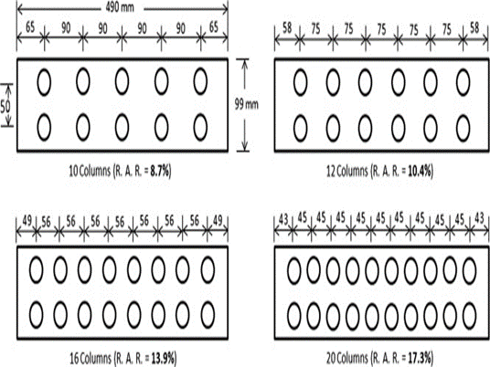
Figure: Arrangement of the soil cement column

  - WHAT IS GROUND IMPROVEMENT TECHNIQUES (GIT)?
Ground improvement technique is a modern technique used for the better future of the soil with low parameters and bearing capacity which cannot even hold some house. The soil type like Kaolin and soft clay are the major example to use ground improvement technique. the different type of ground improvement technique is-
- Dynamic compaction
- Jet grouting
- Deep soil mixing
- Ground freeze
- Lime stabilization
- Prefabricated vertical drains
Installation of the columns are done with the help of augur and binding material is used to keep the column in place.
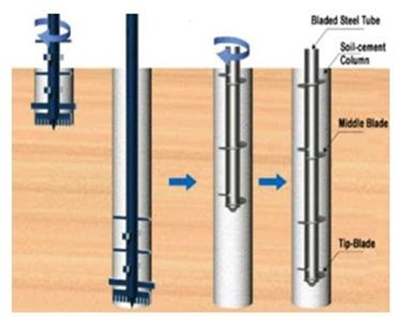
Figure: Installation of the soil cement column

  - USING GIT FOR TRANSPORTATION.

The main motive of this project is to use this technique in all the different field of the civil engineering specially with construction and earthwork.
The road construction in hilly areas or mountains are impossible with different curves and slopes also different region contain different types of soil with different parameters, construction of soil cement column in the type of soil with poor stability parameters help in the better improvement of the stability parameters. The connection of the regions is improved and transportation and supplying of products are easier.

1.3 INDUSTRIAL WASTE MATERIAL

Parameters | Fly Ash | Steel Slag
Moisture Content | 3% | 19.77%
Fineness | 34% | 95%
Size | 10-100 micron | 0-80 micron
Annual Usage | 22million tones | 8.3million tones
Compressive Strength | 61.4 MPa | 70MPa

The industrial materials used are zero waste material and these are the materials which are useless in the world in a very large amount.
Different percentage are used as to mix it with soil for deep soil mixing and tested in the laboratory
The different parameter test is also done in the laboratory for the industrial waste material which is mentioned further.
1.4GOAL AND OBJECTIVE
This project aims to produce a superior overall understanding of ground improvement with the help of PLAXIS 2D. In this project, we used the practical method of analysis of column as well as the software method. The use of PLAXIS 2D is the modern method for the analysis of column with different waste material like combination of different percentage of fly ash, slag and dolomite.
The following designed goals are provided from this thesis work-
- The Goal of this thesis work is to complete the project in a very less duration as compare to the other project duration. Project cost as well as project duration is reduced.
- The objective of the thesis is to provide easy access for the student to know more about the deep soil mixing, alternative of the materials, finite element analysis, use of PLAXIS 2D as a soil software.
- The most important and the last purpose of the thesis work is to eliminate the project without any hard work and waste of time which has no future and is complete waste for the civil engineers.
- If I talk about civil engineering everybody knows it as only construction but civil engineering is a lot more then construction and site.

II. EASE OF USE
STUDY AREA
2.1 GENERAL
LABORATORY INVESTIGATION
Soil cement columns is difficult to be constructed on loose soil like kaolin soil, who’s physical and chemical property is not acceptable. To increase the properties of the soil we are using waste industrial material with properties which enhances the property of the soft clay.
The different work and test presented in the laboratory are listed below-
- SPECIFIC GRAVITY
- GRAIN SIZE ANALYSIS
- WET SIEVING AND HYDROMETER TEST
- VANE SHEAR TEST
- ATTERBERG’S LIMIT TES
- COMPACTION PROCTOR TEST
- UNCONFINED COMPRESSION TEST

- SPECIFIC GRAVITY
- KAOLIN SOIL
BOTTLE NO. |  |  | 50ml | 50ml
BOTTLE(W1)gm |  |  | 29 | 28.9
BOTTLE+SOIL(W2)gm |  |  | 49.3 | 48.8
BOTTLE+SOIL+WATER(W3)gm |  |  | 89 | 92
BOTTLE+WATER(W4) gm |  |  | 77 | 80
SPECIFIC GRAVITY (G) |  | 2.42 |  | 2.51
Average =2.47

- STEEL SLAG
BOTTLE NO. | 50ML | 50ML
BOTTLE(W1)gm | 684.4 | 684
BOTTLE+SOIL(W2)gm | 734 | 734
BOTTLE+SOIL+WATER(W3)gm | 1593 | 1594
BOTTLE+WATER(W4) gm | 1561 | 1563
SPECIFIC GRAVITY (G) | 2.61 | 2.63

Average=2.48
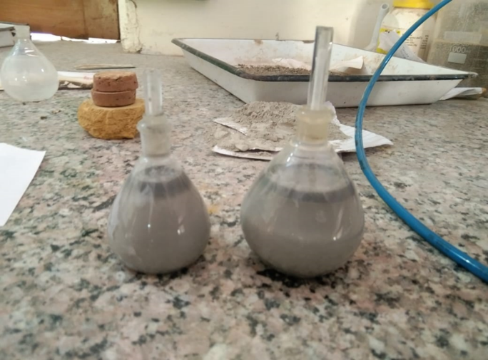
Figure: Specific Gravity test

- GRAIN SIZE ANALYSIS

S No. | Sieve size | Weight retained in seive | Cumulative weight retained in seive | % weight retained | %weight passing
1. | 75mm | 8.4 | 0.084 | 0.084 | 99.91
2. | 2.00mm | 33.7 | 0.421 | 0.337 | 99.5
3. | 1.00mm | 86.7 | 1.28 | 0.867 | 98.7
4. | 425 microns | 0 | 1.28 | 0 | 98.7
5. | 212 microns | 58.4 | 1.87 | 0.584 | 98.1
6. | 150 microns | 100.5 | 2.81 | 1.005 | 97.17
7. | 75 microns | 43.4 | 3.31 | 0.434 | 96.6
 | Pan | 65.1 | 3.46 | 0.651 | 96.04

particle size (mm) |  | % finer by wt.
4.75 |  |  | 100
2 |  |  | 100
1 |  |  | 100
0.425 |  |  | 100
0.25 |  |  | 100
0.125 |  |  | 99.52
0.075 |  |  | 96.08
0.01533 |  |  | 90.031
0.01106 |  |  | 86.7579
0.00792 |  |  | 85.121
0.00572 |  |  | 81.847
0.004164 |  |  | 76.936
0.003075 |  |  | 75.299
0.002198 |  |  | 73.662
0.001624 |  |  | 65.4777
0.001179 |  |  | 60.566
0.000372 |  |  | 40.9235

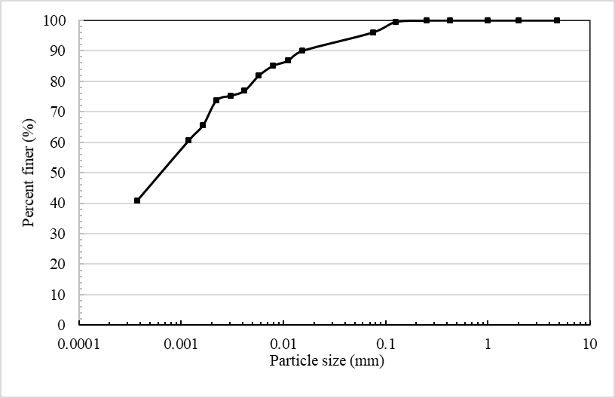

- WET SIEVING AND HYDROMETER ANALYSIS

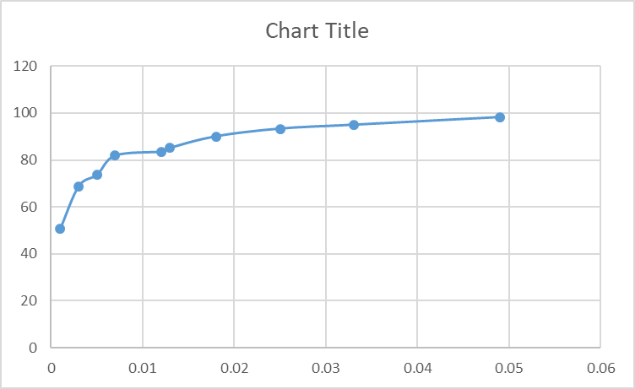

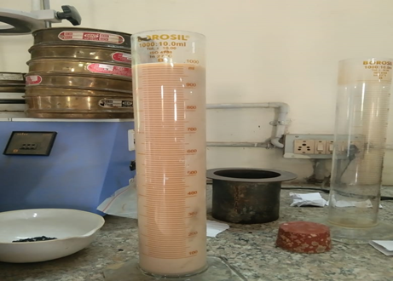

Figure: Hydrometer test

- VANE SHEAR TEST

Initial reading | Final reading | difference | Spring constant | T= diff*spring constant | G | S=T*G | Average S
180 | 73 | 107 | 6 | 3.56 | 0.27 | 0.96 | 0.24
188 | 134 | 54 | 6 | 1.8 | 0.27 | 0.486 | 0.28
183 | 147 | 36 | 6 | 1.2 | 0.27 | 0.324 | 0.31
183 | 158 | 25 | 6 | 0.8 | 0.27 | 0.216 | 0.37
184 | 165 | 19 | 6 | 0.6 | 0.27 | 0.162 | 0.43
183 | 166 | 17 | 6 | 0.5 | 0.27 | 0.135 | 0.52

Graph: VANE SHEAR Graph

- ATTERBERG’S LIMIT TEST

LIQUID LIMIT | 43.8
PLASTIC LIMIT | 26.0
SHRINKAGE LIMIT | 25.1
PLASTICITY INDEX

2.2 DATA COLLECTION
2.2.1 TEST RESULT FOR UCS TEST
A laboratory procedure as listed step by step below, was attempted to be developed for preparing, curing and testing the soil mixed specimen applicable to the wet method of soil mixing. This procedure was similar to that described by Strength.

Graph: Unconfined compression test

%slag in soil | strength | 7 days | 14 days
10 | 743.79 | 739.5647 | 763.9714
15 | 866.2743 | 1272.848 | 1335.855
20 | 843.7991 | 841.1023 | 1101.909
25 | 827.8339 | 1121.763 | 1452.357
30 | 847.0941 | 950.4266 | 1089.023
TABLE: UCS TEST

LITERATURE REVIEW
PLAXIS 2D is intended to provide a tool for practical analysis to be used by geotechnical engineers who are not necessarily numerical specialists. Quite often practicing engineers consider non-linear finite element computations cumbersome and time-consuming.
The steps for the analysis of the column on PLAXIS 2D IS provided below-
- Draw the design of column with all the surrounding structure in AUTOCADD. If necessary, we can also draw the design directly on PLAXIS 2D.
- Import the file in (*geo) file type so that it is easy to open in PLAXIS 2D.
- With the help of arrow select the material for the surrounding. The materials are-
- EMBANKMENT
- PEAT
- SAND
- SOIL CEMENT COLUMN
- Select the correct parameters for the above materials for the structure to be perfect. The structure should be as shown.

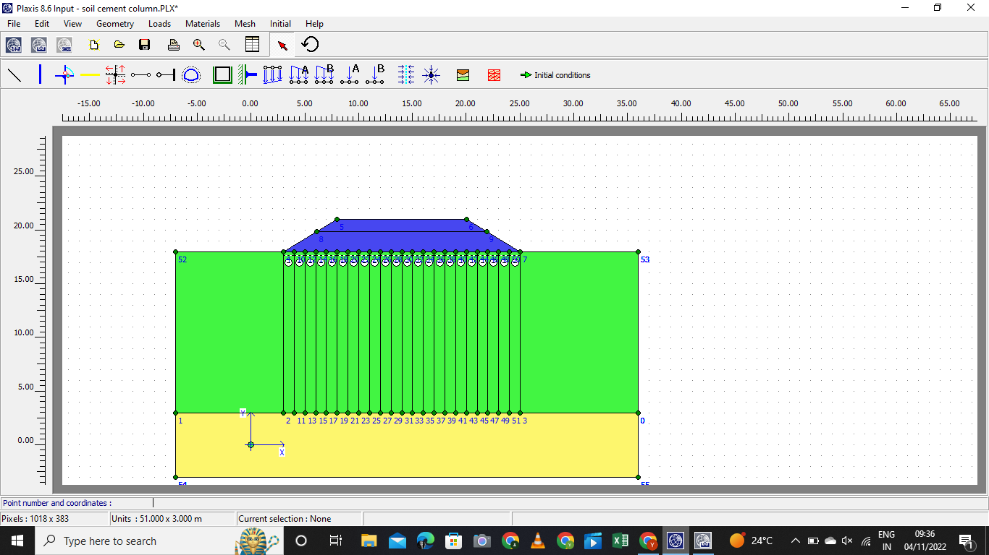

- Select the mesh which is the most important part of the analysis by which the further step will be proceeded.
- After the general mesh is created select the initial condition and check for the active pore pressure, consolidation, settlement.
- Check the stress which will be effective normal stress, shear stress.
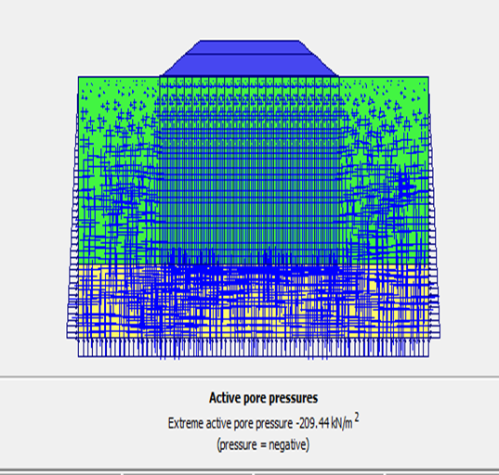

- Vertical deformation will check the phase deformation.
- Now for the last step click calculation on the bar and the calculation will take place for the below phases-
- Consolidation (15years)
- Duration (5days)
- Settlement
- Vertical displacement.
- For the calculation is done correctly the graph will be curved for the displacement with duration(time).

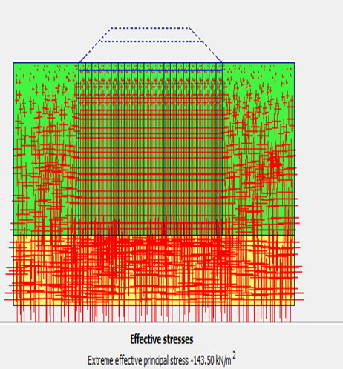

GENERAL
3.1ROLE IN RESEARCH
PLAXIS 2D is very less known in the world of civil engineering so the use and the benefit of the software plays a major role in the file of research.
Soil cement column also help in the construction of the structure at the places whose soil does not support the structure when constructed.
The laboratory and the software analysis with duration and the correction of the mistake done for years.
The thesis is helpful for the further study of the soil cement column analysis with industrial waste material.

PLAN OF WORK

JULY | - Identification of Project  - Basic Test Performance
AUGUST |  | Initialization and Finalization Of Mixing Process Of Column Material.
SEPTEMBER |  | Data Collection Of Physical Test as well as 2D Analysis
OCTOBER |  | Preparation of The Data and Comparison on PLAXIS 2D
NOVEMBER |  | Finalization of the Project on the basis of Transportation
DECEMBER |  | Compilation of the Data According to the NHAI Survey
JANUARY |  | Compilation of the Project

3.3 SAMPLING PROCEDURE

MIXING OF THE SOFT CLAY WITH FLYASH, SLAG, NaOH, DOLOMITE WITH DIFFERENT PERCENTAGE.

SAMPLES MADE ARE CURED FOR 7,14,28 DAYS FOR BETTER STRENGTH DETECTION FOR UCS TEST.

DATA ANALYSIS AND TEST RESULT DETECTION BY SOFTWARE DRAFT.

COMPARATION BETWEEN THE EXPERIMENTAL RESULT AND THE SOFTWARE DRAFT.

METHODOLOGY
4.1 GENERAL
4.1.1 EXPERIMENTAL STUDY
For the experiment samples were made with the soil mixed with different industrial waste material with different percentage and different weight.
The mixer was made according the density of the material (soil, fly ash, steel slag, monolite, NaOH) used.
The different percentage for which we performed the UCS test were for –
- SOIL+10%SLAG
- SOIL+15%SLAG
- SOIL+20%SLAG
- SOIL+25%SLAG
- SOIL+30%SLAG
The UCS test was performed on different dates from 0days, 7dyas, 14days and 28days.the samples made was in the shape of cylinder as shown in the figure below

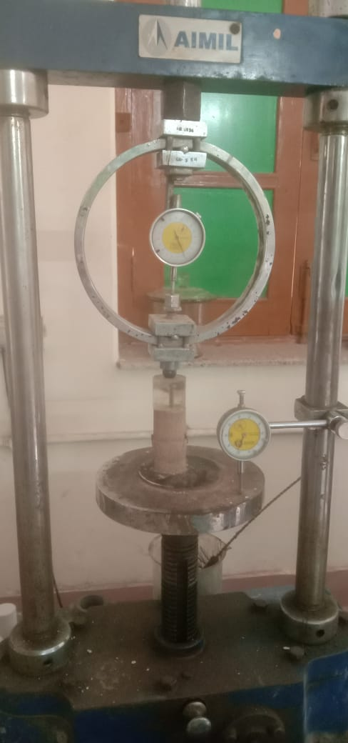

4.1.2 PREPARATION OF SOIL CEMENT COLUMN
The sample made were checked time to time. But first the weight of the sample is check according to the diameter and the height. The sample created for this thesis work was of following ratio-
- Weight=230gm-350gm
- Height=6cm-7.6cm
- Diameter= 3.6cm-4.5cm
The samples ratio was for the UCS test with two different weight of proving ring which was-
- 20KPa
- 25KPa
The sample when made was kept in closed room for curing. during the curing time the samples were thoroughly check and moisture was provided time to time so that the weight and the sample should not change till the time of testing.

  - SOFTWARE ANALYSIS
- DEFORMED MESH

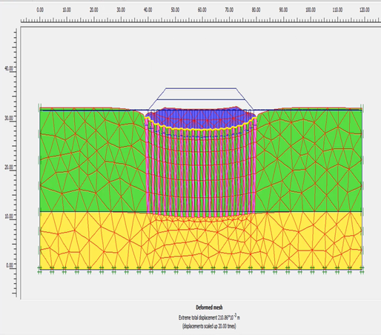

- _{VERTICAL DISPLACEMENT}

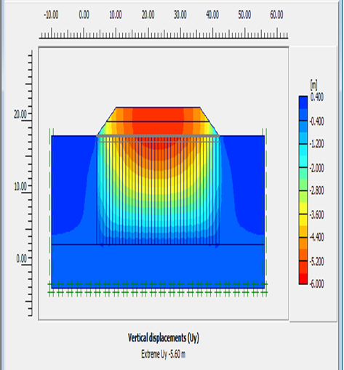

RESULT FOR THE SOFTWARE ANALYSIS
The result shown is the displacement happen with duration when the soil cement column will be constructed on soft clay or any other soil with low bearing capacity soil like kaolin with low parameters are suitable example for this thesis work and if I further describe the example this thesis is totally performed with KAOLIN SOIL, FLYASH, SLAG, DOLOMIT. The graph represented is between
- time (X axis)
- Displacement (Y axis)

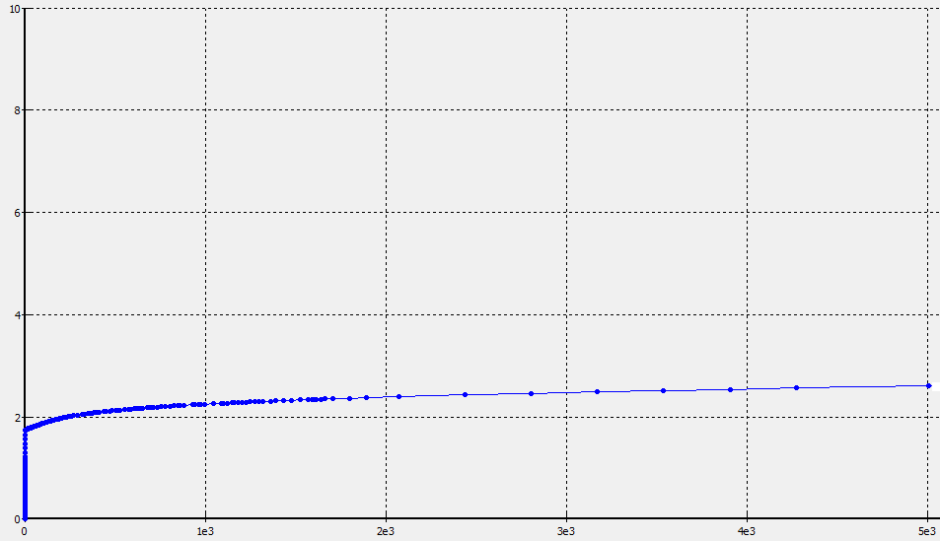

Graph:2 Time and Displacement graph.

CONCLUSION
6.7.1 General
In this chapter, the findings of the research work carried out this thesis are summarized and the conclusion emerging from the study presented.

6.7.2 Summary
This paper presents both the laboratory study and numerical simulation of the consolidation behaviour of composite ground. The consolidation mechanism of the composite ground is revealed and the effect of the area ratio and cement content on the consolidation characteristics is presented.
The following conclusion can be made from this thesis work-
Relative property of kaolin soil and the basic property of the soil and the strength for the ground improvement techniques application directly or indirectly. The property of the slag and the strength of the slag provided when mixed with the soil (clay). The strength checked at different curing time and different percentage of slag mixed
The table of the physical properties of soil are given below-
Test | Result
Particles≥50mm | 0
Particles≤63mm | 98%
Liquid Limit | 54
Plastic Limit | 31
Plasticity Index | 23

obtained from the physical model tests. It was seen that the predicted consolidation settlements by using the composite coefficient of consolidation and that by using the finite element method are comparable within an acceptable error.

REFERENCE
- https://research.iitgn.ac.in/stl/#

- CONSOLIDATION BEHAVIOR OF SOIL-CEMENT COLUMNS IMPROVED GROUND Suksun Horpibulsuk, B.Eng. (Hons), M.Eng., Ph.D. Professor and Chair of School of Civil Engineering, Suranaree University of Technology, 111 University Avenue, Muang District, Nakhon Ratchasima 30000, THAILAND

- Ground improvement using soil–cement columns: Experimental investigation Ahmed Farouk *, Marawan M. Shahien Structural Engineering Department, Faculty of Engineering, Tanta University, Egypt Received 28 February 2013; revised 1 May 2013; accepted 29 August 2013

- TH-03 BEHAVIOURIAL STUDY ON GEOPOLYMER COLUMN IN SOIL M.Somu alias Ramya, .S.P.Jeyapriya PG scholar, Government College of Technolgy, Coimbatore, ramyagcecivil@gmail.com Assistant Professor, Government College of Technolgy, Coimbatore

- NUMERICAL ANALYSIS OF GEOSYNTHETIC ENCASED FLY ASH COLUMN IN EXPANSIVE SOIL 1Ritakshi Ayare, 2Shraddha Kokate, 3Pranali Hubale, 4Rohan Deshmukh, 5PriyankaSalunkhe, 1,2,3 BE final year student, 4Assistant Professor, 5Associate Professor 1Department of Civil Engineering, 1Terna Engineering College, Nerul, Navi Mumbai 400706, Maharashtra, India.

- Deep stabilization with cement stabilized soil columns -A laboratory study Djupstabilisering med cementkolumner - En laborativ studies.

