AI-Enhanced Drug Discovery and Pharmaceutical Development

Mr. P.J. Ghule*
Department of Pharmaceutics
Mula Rural Institute of Pharmacy, Sonai
Tal – Newasa, Dist – Ahmednagar
Mail ID: prashantpharma07@gmail.com

Mr. P.A. Kale
Department of Pharmaceutical Chemistry
Mula Rural Institute of Pharmacy, Sonai
Tal – Newasa, Dist – Ahmednagar

Ms. S.P. Kale
Department of Pharmaceutical Chemistry
MES, College of Pharmacy, Sonai
Tal – Newasa, Dist – Ahmednagar

Abstract:
Artificial intelligence (AI) has arose as a strong form that harnesses manlike information and supports facilitated resolutions to complex challenges. Remarkable progresses in AI science and machine intelligence present a life-changing excuse in the drug finding, expression, and experiment of drug portion of drug or other consumable forms. By applying AI algorithms that resolve far-reaching organic dossier, containing genomics and proteomics, analysts can label disease associated goals and think their interplays accompanying potential drug applicants. This authorizes a more adept and point or direct at a goal approach to drug finding, with growing the tendency of profitable drug approvals. Furthermore, AI can influence lowering growth costs by optimizing research and incident processes. Machine learning algorithms assist in exploratory design and can anticipate the pharmacokinetics and toxicity of drug aspirants. This power allows the prioritization and addition of lead compounds, lowering the need for thorough and damaging animal experiment. Personalized cure approaches maybe eased through AI algorithms that resolve physical-globe patient dossier, superior to more persuasive situation consequences and revised patient devotion. This review aims to reveal and equate the various uses of AI science that aid computerization and boost profit in drug incident, specifically in novel drug aim labeling and design, drug repositioning, biomarker labeling, and active patient layer, through investigation of various affliction countryside’s. In addition, it will further climax by virtue of what these sciences are interpreted into the hospital. This example shift will bring about even better progresses in the unification of AI in automating processes inside drug growth and finding, permissive the contingency and sensibility of accomplish future accuracy and embodied cure.

Keywords: artificial intelligence, drug development, drug discovery, QbD, R&D.

The emerging pharmaceutical field:
The pharmaceutical industry has historically been conservative, focusing on the research and development of small-molecule drugs known for their stability, therapeutic potency, and acceptable toxicity to consumers. One of the essential methods in pharmaceutical research and development has been the systematic screening of molecular variants in combinatorial libraries. This approach aims to identify novel molecules with advantageous properties that can be utilized in healthcare.
However, this traditional approach is facing challenges in meeting the ever-growing demands of the healthcare industry. Several reasons contribute to the limited success of this method in developing new medicines. First, extensive research and exploration of small-molecule drugs have led to the identification of most synthetic alternatives, leaving fewer unexplored candidates for future development. This results in a scarcity of new and promising molecules.
Furthermore, there are already highly stable and effective drugs available for many therapeutic areas, making it challenging for new molecules to surpass the efficacy of existing medications. As a result, the pharmaceutical industry faces an increasingly difficult path through clinical trials, as potential new drugs must demonstrate substantial improvements over well-established treatments to gain regulatory approval.
Another significant factor affecting the viability of this traditional approach is the aggressive competition from generic drug companies. As patents for existing drugs expire, generic manufacturers can produce and sell equivalent versions at lower costs, reducing the profitability of developing new molecules with limited product protection strategies.
As the pharmaceutical landscape continues to evolve, it is essential to explore alternative avenues for drug development. One of the most promising directions is the growing field of bio molecular drugs. Unlike small-molecule drugs, biomolecules are large entities composed of multiple molecular units, such as proteins and nucleic acids. Examples of successful bio molecular drugs include insulin and adalimumab (marketed as Humira), which have made significant contributions to the biopharmaceutical market.
However, using biomolecules as pharmaceuticals presents its own challenges. Biomolecules tend to be more labile and often require infusion into the bloodstream for delivery. Additionally, modulating the pharmacokinetics of these drugs is complex due to the limited range of available routes of administration. To address these challenges, drug delivery has emerged as a multidisciplinary field, focusing on the development of innovative methods to deliver pharmaceuticals effectively and efficiently. Nanotechnology, with its ability to interact effectively with the human body and control drug distribution, has been a major focus of drug delivery research [1,2].

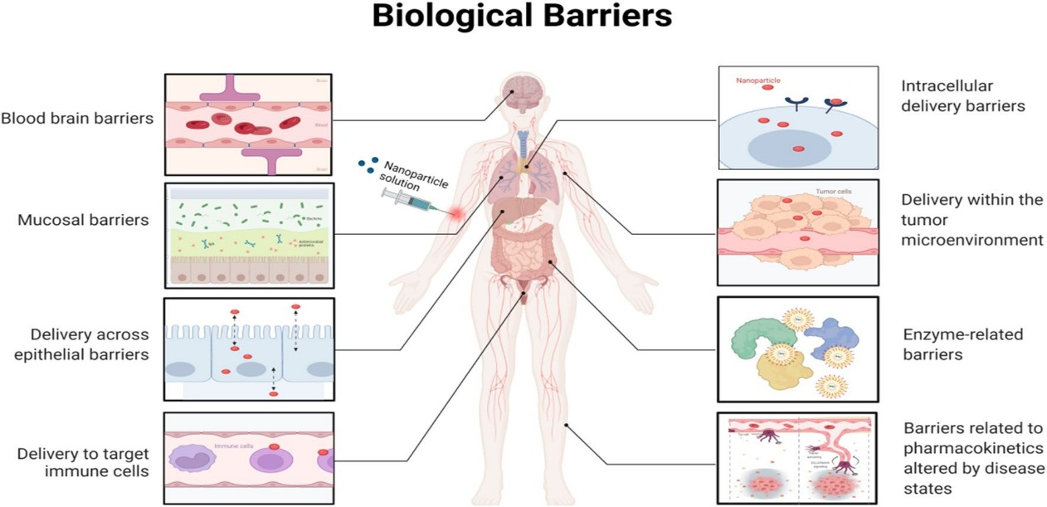

Fig. 3 Highlighting some of the sequential biological barriers that nanoparticles (NPs) must overcome to achieve precision drug delivery. As discussed in this review, smarter NP designs that optimize delivery can significantly improve the effectiveness of precision medicines, hence expediting their clinical translation
Figure 1: Introduction to drug delivery and biological barriers [3]
In this context, artificial intelligence (AI) has shown great promise. AI can aid in the design of drug delivery systems and improve drug development processes. However, the full potential of AI in the pharmaceutical industry is yet to be fully harnessed. The implementation of AI in drug development is limited by the availability of large, standardized datasets to train the algorithms effectively. [4, 5]
In conclusion, the traditional approach of developing small-molecule drugs through systematic chemical screening faces challenges in providing novel solutions to the ever-evolving healthcare industry. As a response, the pharmaceutical field is exploring new directions, such as biomolecular drugs and drug delivery systems, to meet the increasing demands of patients and healthcare providers. The integration of artificial intelligence into pharmaceutical research and development holds great potential to revolutionize drug discovery and improve patient care. [6,7,8]

Drug Delivery and Nanotechnology:
The biotech and pharmaceutical industries have traditionally focused on meeting technical requirements, such as mastering genetic modification of cells to produce high-quality biomolecules on an industrial scale. However, simply producing protein and nucleic acid-based drugs is not enough to ensure their therapeutic success. These biomolecules are often fragile and can be unstable, affecting their biological drug stability and efficacy. For example, many humanized monoclonal antibody therapies are provided as liquid suspensions or lyophilized powders for injection, limiting the opportunities for pharmacokinetic control and product life cycle management [9,10].
To overcome these challenges, drug delivery systems are being developed to improve the stability and efficacy of biomolecular drugs. Drug delivery aims to enhance the therapeutic application of drugs by formulating them in ways that overcome natural degradation and improve their penetration through physical barriers. One essential goal is to achieve drug accumulation at the site of action, enhancing the therapeutic effect while reducing toxicity. Nanotechnology has emerged as a promising approach for drug delivery systems because it allows interactions at the cellular and subcellular levels, molecularly interacts with biomolecules, and escapes immune system activation [11,12].
Nano medicine refers to submicron-featured systems that actively benefit from nanofeatures to improve their pharmacokinetics compared to their native form. For example, drug delivery systems can use Nano sized colloidal or dimensional features to actively modulate the pharmacokinetics of an active pharmaceutical compound (API). Systems like liposomes use nano- to micron-sized structures to deliver API payloads to the site of action or confer unique mechanisms of action to the active molecule.
In summary, drug delivery systems and nanomedicine offer ways to improve the stability, efficacy, and therapeutic impact of biomolecular drugs. By actively incorporating nanosized features into the design of pharmaceutical products, researchers and developers can enhance the pharmacokinetics and overall effectiveness of treatments, leading to improved patient outcomes [13, 14].

Quality-by-design R&D
The transition from a trial-and-error approach to quality-based rational engineering, known as Quality by Design (QbD), has been instrumental in the advancement of drug delivery systems. The core of the QbD approach is the definition of the Quality Target Product Profile (QTPP), which outlines the essential properties required by the final product to achieve its intended purpose. In drug delivery systems, the QTPP connects product quality features to its mechanism of action, aiming to achieve specific therapeutic effects, such as localized drug accumulation in targeted tissues [15].
To achieve the QTPP, critical quality attributes (CQAs) are identified, which are the product qualities directly linked to the desired therapeutic effect. Critical process parameters (CPPs) and critical material attributes (CMAs) are defined as process parameters and material qualities that impact the CQAs during manufacturing. These parameters and attributes are controlled in manufacturing control plans to ensure the desired product quality is achieved consistently [16, 17, 18].
An example of QbD in drug delivery is potentiating the effect of an anticancer drug, such as doxorubicin, by promoting its local accumulation in solid tumors. The QTPP of the delivery system would be the local drug accumulation at the tumor site, and the CQAs would include attributes such as particle size, charge, and colloidal stability.
Artificial intelligence (AI) can play a crucial role in the QbD process. AI can manage large datasets and provide informed predictions to identify the CQAs connected with the desired QTPP. AI can gather information from different databases to predict accurate ADME (Absorption, Distribution, Metabolism, and Excretion) and toxicity profiles, which are essential for patient safety [19, 20].
Furthermore, AI can support process engineering and development by exploring material quality and production parameter ranges to evaluate their impact on CQAs independently. AI can aid in scaling up the manufacturing process, characterization, and validation, making drug development more efficient and reliable.
In conclusion, Quality by Design has been instrumental in the advancement of drug delivery systems, and artificial intelligence can further enhance this approach by providing informed predictions, managing large datasets, and supporting process engineering and development. The integration of AI in pharmaceutical development holds great promise for improving the efficiency and effectiveness of drug delivery systems, ultimately benefiting patient care [21, 22].

Artificial intelligence in drug delivery modeling
AI has the potential to significantly enhance the design of Nano systems for drug delivery by providing advanced insights into the biological environment and leveraging this knowledge to engineer effective drug products. The human body is a complex system, but for drug delivery purposes, it can be simplified into compartments separated by biological membranes. These membranes act as barriers that drugs must permeate to reach their intended target [23].
Passive diffusion through membranes occurs based on physicochemical gradients and relies on the molecular features of the drug. On the other hand, active diffusion involves energy-activated cellular systems and complex biological interactions. The design of drug delivery systems using the QbD approach is focused on identifying and leveraging specific transport mechanisms that impact drug pharmacokinetics.
AI can play a significant role in the QbD process by aiding in research, analysis, and modeling of multilayered data related to membrane interactions and drug distribution. It can help in parameterization and simulation, enabling a more systematic evaluation of models. System biology databases can support AI applications by providing solid information for AI training [24, 25].
AI can also assist in evaluating the impact of drug delivery systems on drug pharmacokinetics, such as deposition and toxicity. For instance, AI tools can aggregate information from multiple sources to predict the effectiveness of a drug delivery system for specific APIs. This can be beneficial for drug repurposing or adapting drug pharmacokinetics to meet patient needs.
However, a hurdle to AI implementation is the availability of databases with consistent information. Active AI, capable of sensing and verifying current knowledge, could help consolidate the required information for future AI applications. AI-controlled experiments could create coherent and well-documented databases, enabling more precise simulations and recommendations for drug delivery systems.
In conclusion, AI can contribute significantly to the rational design of Nano systems for drug delivery. By leveraging its capabilities in data analysis, modeling, and parameterization, AI can aid in the development of effective drug delivery systems that enhance drug pharmacokinetics and target-specific therapeutic effects [26, 27].

Artificial intelligence application in pharmaceutical product R&D:
The research and development (R&D) process in drug delivery can be simplified into two main phases: the early phase and the late phase of R&D.
In the early phase of R&D, the focus is on translating the initial idea into a design and creating a prototype based on the hypothetical mechanism of action defined in the early research stage. The prototype is iteratively refined through testing, keeping in mind the intended mechanism of action. Simple lab-scale production processes are used to produce small volumes of the product for early evaluation. Key challenges in this phase include the detailed design of the product and ensuring the correct realization of the prototype with a scalable process. Early proof of efficacy and safety is crucial, especially for new pharmacological entities and consumer products. [28]
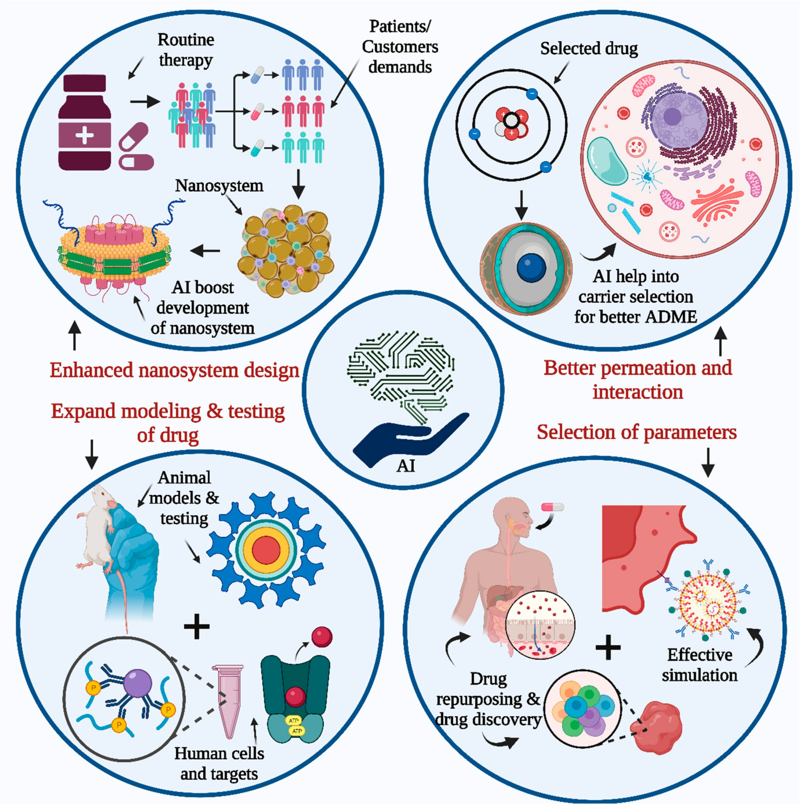
Figure 2: AI contribution to drug development and research. [29]
The late-stage development is more focused on the robustness of the actual manufacturing process and scalability development. It involves the ability to produce increasing volumes of the intended pharmaceutical products at a defined quality. This scalability is essential to unlock further testing and development opportunities. Late development extends beyond the production phase and encompasses the entire product life cycle management.
Both phases of R&D are vital for the successful development of drug delivery systems. In the early phase, the emphasis is on designing and creating a prototype that aligns with the intended mechanism of action. It allows researchers to test and refine the product before advancing to larger-scale production. In the late phase, the focus shifts to ensuring the scalability and reliability of the manufacturing process, allowing for large-scale production and successful commercialization of the product. [30,31]
Throughout the entire R&D process, the application of AI can be valuable. AI can aid in data analysis, model development, parameterization, and simulation, enabling a more systematic evaluation of drug delivery systems. By leveraging AI, researchers can accelerate the development of drug delivery systems and improve their efficacy, safety, and scalability. [32]

Artificial intelligence application in prototyping and early development: an example scenario
In the early phase of drug delivery research and development, there are often limitations on the number of administration routes for a given molecular entity, which is determined by the molecule's chemical properties and intended application. During this phase, researchers explore a wide range of excipients, devices, and materials to formulate the initial prototype of the drug product. However, the choice of materials for screening is often influenced by the investigator's experience and the company's R&D history, leading to biased selections.

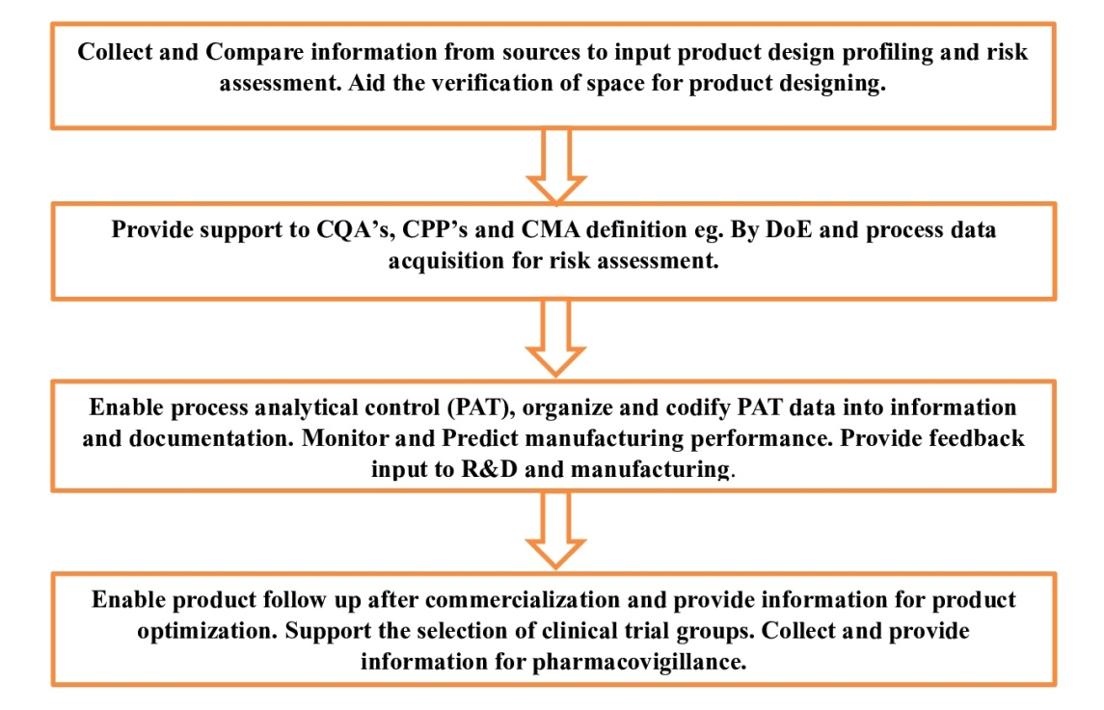
Figure 3: Schematic of product development roadmap using quality-by-design approach.

The lack of comparable data and the difficulty in comparing different materials further complicate the decision-making process. Researchers typically rely on their existing knowledge and familiarity with certain excipients and materials, which might not always result in the most optimal formulations. Additionally, considerations for consumer-related preferences are often not fully taken into account at this stage.
Here, AI can play a crucial role by assisting scientists in selecting the best excipients and combinations for screenings and refining the prototypes based on the outcome results. Passive AI can leverage databases of excipient interaction screenings and molecular stability data to provide systematic suggestions for screenings. On the other hand, active AI, such as a robotic arm capable of mixing and measuring parameters, can perform experimental arrays and evaluate the impact of qualitative differences among materials from different suppliers. This not only increases automation in the lab environment but also allows for highly consistent and comparable data across projects and departments [33].
For advanced formulations, like Nano formulations or liposomes, AI can help overcome biases and accelerate unbiased technology testing. AI systems can provide evidence-based screening suggestions, explore innovative combinations, and identify knowledge gaps to spur innovation in the R&D pipeline [34].
Furthermore, stability studies are essential during early-stage development to ensure sustainable manufacturing, distribution, and use of the formulated molecule. AI, particularly deep learning and neural networks, can be applied to predict stability under various conditions, even when comprehensive long-term stability studies are limited by time and resources.
In summary, AI can significantly enhance the early phase of drug delivery research and development by providing data-driven decisions, unbiased material selection, and efficient stability predictions. This enables researchers to make informed choices and accelerates the development of effective drug delivery systems [35].

Artificial intelligence in late-stage development: an example scenario
In late-stage pharmaceutical development using Quality by Design (QbD) principles, one of the main goals is to ensure the product quality profile from clinical testing to continuous optimization and throughout the product's life cycle management. This stage of development can vary depending on the specific product being developed. It involves integrating information from various sources, including R&D outcomes, manufacturing technology, process development, qualification, and quality control. Late-stage development plays a crucial role in providing the necessary background for clinical trials, ensuring safety measures for volunteers, and supporting regulatory submissions.
Clinical trials are conducted to collect systematic data from sizeable groups of volunteers, ranging from healthy individuals in early phases to heterogeneous groups of patients in later phases and pharmacovigillance. The collected data are analyzed and reported to regulatory agencies to support product applications. Basic statistical comparisons, such as equivalence tests with placebos and benchmark products, are commonly used to assess product efficacy in the early phases. However, in later phases and with pharmacovigillance, the focus shifts to monitoring interactions and side effects.
Manufacturers invest significant effort in producing relevant documentation and continuously optimizing their processes. Regulatory communication and revision are resource-intensive tasks for both companies and regulatory agencies. As new products become more heterogeneous, it becomes challenging for agencies to keep up with traditional evaluation standards. Therefore, clear, rich, and highly standardized documentation is essential to support product applications. The implementation of AI could aid in gathering and structuring information to produce reports compatible with submission requirements. Additionally, AI could assist agencies in efficiently processing and analyzing the provided documentation, potentially shortening filing and trial times.
The adoption of AI in regulatory processes could facilitate information sorting, translation, and communication between regulatory agencies and submitters. AI-aided interpretation of scientific and industrial documentation prior to regulatory panel interviews could streamline the regulatory approval process, making it more efficient and cost-effective.
While the full implementation of AI in regulatory processes might require further development and consideration, the idea of using AI to improve information management, documentation, and communication in late-stage pharmaceutical development is promising. It has the potential to enhance regulatory efficiency, reduce barriers, and accelerate product approvals, ultimately benefiting both pharmaceutical companies and regulatory agencies [36].

Artificial intelligence in manufacturing development and control
In traditional manufacturing processes, standardization and repeatability are crucial for producing batches of materials with well-defined quality attributes. The selection of units, materials, and parameters is often based on past experience and knowledge, leading to limited options. For example, filtration units in sterile production typically use a few commercially available filters with defined pore sizes and geometries. Similarly, solvents and plasticizers used in granulation or extrusion units are mostly selected from commonly used combinations of excipients and reagents [37].
The implementation of passive AI in pharmaceutical manufacturing can provide tailored solutions and support for technology units and commercial providers. By utilizing databases of chemical and physical attributes of materials, AI can help in selecting the most appropriate materials and process units, leading to economic advantages and the development of more robust manufacturing processes.
In the context of continuous manufacturing, where processes are time-resolved and units are operated simultaneously, AI can play a crucial role in system engineering, process control, and real-time analysis. AI can aid in predicting and optimizing process efficiency, detecting and responding to failures in real-time, and providing online process analytical control technologies. By integrating AI with process analytical technologies, such as UV, NIR, and FTIR, continuous manufacturing can achieve better process control and adaptability [38].

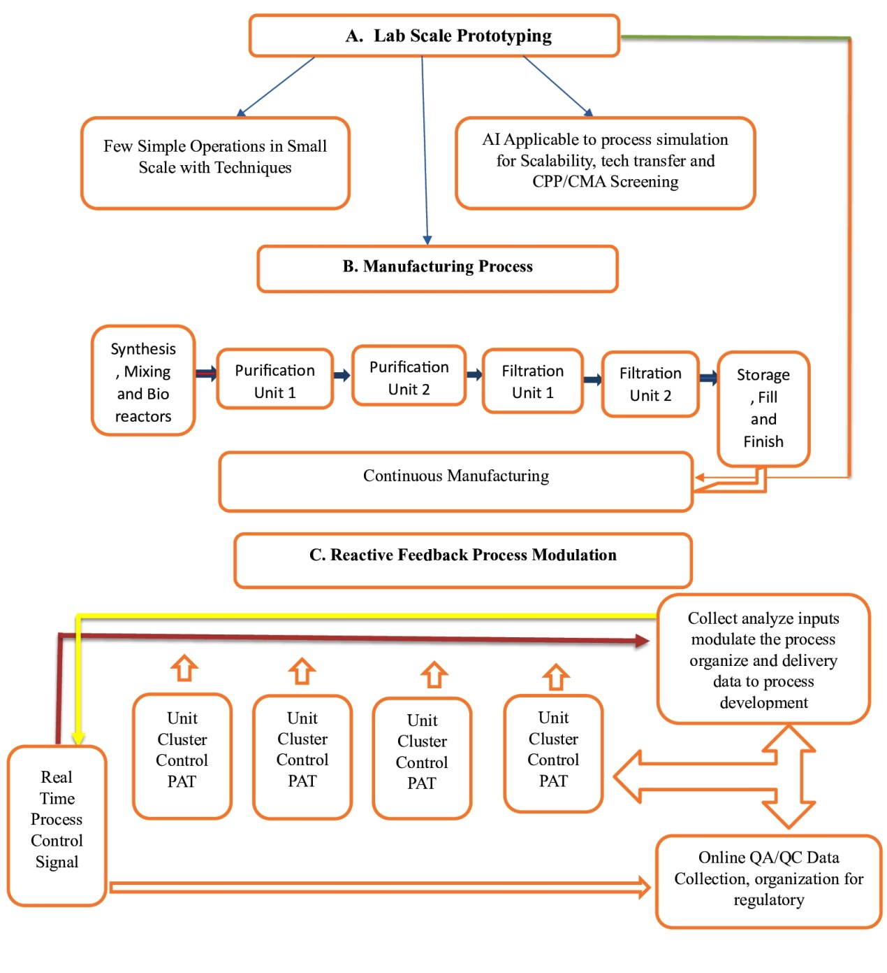
Figure 3: Manufacturing Stages and batch manufacturing

AI can facilitate the transition from traditional batch manufacturing to continuous manufacturing by optimizing process parameters, shortening reaction times, and ensuring high-quality production. An AI system trained during process development and validation can be used to control parameters within predefined ranges, leading to a flexible and adaptive process control strategy.
Overall, the application of AI in pharmaceutical manufacturing can lead to more efficient and robust processes, better product quality, and streamlined regulatory submissions. By leveraging AI's capabilities, the pharmaceutical industry can embrace advancements in continuous manufacturing and achieve greater process efficiency and product innovation [39].

Landscape of AI implementation in the drug delivery industry
The adoption of AI technology in drug delivery is still in its early stages, and there is a clear room for improvement. Although there are over 300 indexed products or close-to-commercial technologies in the field of Nano featured drug delivery systems, the overall perception of the industry's maturity is misleading. Few innovative drug delivery concepts have been widely implemented, and there is a lack of new inventions being propagated across different applications [40].
In the drug delivery field, many innovators are small to medium enterprises, which face escalating risks during the development of new technologies. The technological readiness levels (TRLs) for drug delivery can range from early preclinical prototyping to commercial scale and quality manufacturing. AI can play a significant role in mitigating risks during the early system design and development stages (TRL 3-6) and in implementing smart manufacturing processes to improve process robustness, scalability, and transfer (TRL 4 and onward) [41, 42].
One of the major challenges for AI developers in the drug delivery field is the need for highly specialized AI systems tailored to specific technological niches. This requires fast and simplified popularization of AI platforms usable by personnel with average IT/data expertise. Customization of AI systems should also be transparent, allowing control over built-in biases and ensuring data security for high-tech companies.
In terms of data safety, AI developers must address concerns about the long-term impact of proprietary industrial data in AI systems. The modality of "forgetting" sensitive industrial data once it is acquired by an AI system needs to be carefully managed to ensure data privacy and security.
To facilitate the adoption of AI in drug delivery, developers need to strike a balance between specialization and generic platforms that allow for customizable development. Creating open platforms with flexible options for customization could encourage wider adoption and collaboration across the drug delivery industry. With the right implementation and advancements, AI has the potential to revolutionize drug delivery and bring about more efficient and innovative solutions to improve patient outcomes [43].

Conclusion: the way forward
In conclusion, the adoption of AI in pharmaceutical technology and drug delivery holds great promise and opportunity, but there are understandable delays in its implementation within the pharmaceutical industry. The main non-technological factors hindering the widespread use of AI in this field are the lack of standardized databases and a conservative regulatory approach to traditional pharmaceutical manufacturing.
Data accumulation and standardization are critical for efficiently training AI systems, but pharmaceutical sciences have been slower in codifying and standardizing data compared to other scientific fields. However, initiatives like the Pistoia Alliance and actions by private pharmaceutical groups are showing promise in addressing this issue.
The conservative regulatory approach, which requires AI systems to be locked to specific codes after training, limits the long-term learning capabilities of AI in regulating activities like manufacturing and clinical trials. However, with the growing acceptance of Quality by Design (QbD) approaches and the industry 4.0 movement, the pharmaceutical industry is undergoing rapid transformation, making it more receptive to AI applications [44].
The type of AI implementation that would provide the greatest benefit to the pharmaceutical field remains a question. It could involve using AI as a simple tool to enhance robotic operations and increase productivity or utilizing it as a passive tool for knowledge/data mining and organization. Deep learning technology already partially fulfills these roles, but its inconsistent data produced in the pharmaceutical field has hindered its widespread implementation.
An interactive AI capable of exploring and actively integrating required knowledge for further application could be the most fruitful experience. This could be achieved through a simple robot capable of mixing and measuring to fill knowledge gaps in incomplete databases and consolidate current results with verifications. Embracing such interactive AI solutions could pave the way for more efficient and innovative advancements in pharmaceutical technology and drug delivery [45].

References:
- Scannell JW, Blanckley A, Boldon H, Warrington B. “Diagnosing the decline in pharmaceutical R&D efficiency.” Nat Rev Drug Discov (2012),11, pp 191-200.
- Munos B. “Lessons from 60 years of pharmaceutical innovation.” Nat Rev Drug Discov 2009,8, pp 959-968.
- Saquib W, Zhibin L, Fangyingnan Z, Anna C, Ubaldo A, and Jun W. Engineering nano-drug biointerface to overcome biological barriers toward precision drug delivery. Journal of Nanobiotechnology (2022), 20, pp 395.
- Troiano G, Nolan J, Parsons D, Van Geen Hoven C, Zale S. “A Quality by Design approach to developing and manufacturing polymeric nanoparticle drug products.” AAPS J (2016), 18, pp 1354-1365.
- Trivedi B. “Quality by design (QbD) in pharmaceuticals.” Int J Pharm Pharm Sci (2012), 4, pp 17-29.
- Trivedi B. “Quality by design (QbD) in pharmaceuticals.” Int J Pharm Pharm Sci (2012), 4, pp 17-29.
- Roe R. “Designing the lab of the future: Robert Roe discusses the role of Pistoia Alliance in creating the lab of the future with Pistoia’s Nick Lynch.” Sci Comput World (2018), pp 20-22.
- Lee CKH, Choy KL, Chan YN. “A knowledge-based ingredient formulation system for chemical product development in the personal care industry.” Comput Chem Eng (2014), 65, pp 40-53.
- Cui Y, Cui P, Chen B, Li S, Guan H. “Monoclonal antibodies: formulations of marketed products and recent advances in novel delivery system.” Drug Dev Ind Pharm (2017), 43, pp 519-530.
- Wong CY, Martinez J, Dass CR. “Oral delivery of insulin for treatment of diabetes: status quo, challenges and opportunities.” J Pharm Pharmacol (2016), 68, pp 1093-1098.
- Tuncer Degim I, Celebi N. “Controlled delivery of peptides and proteins.” Curr Pharm Des (2007),13, pp 99-117.
- Rosen H, Abribat “T. The rise and rise of drug delivery.” Nat Rev Drug Discov (2005), 4, pp 381-385.
- Weissig V, Guzman-Villanueva D. “Nanopharmaceuticals (part 2): products in the pipeline.” Int J Nanomed (2015), 10, pp 1245.
- Etheridge ML, et al. “The big picture on nanomedicine: the state of investigational and approved nanomedicine products.” Nanomed Nanotechnol Biol Med (2013), 9, pp 1-14.
- Trivedi B. Quality by design (QbD) in pharmaceuticals. Int J Pharm Pharm Sci 2012;4:17-29.
- International Conference of Harmonization (ICH). Pharmaceutical quality system Q8-Q12, ,http://www.ich.org/products/guidelines/quality/article/quality-guidelines.html. [accessed January 2018].
- Troiano G, Nolan J, Parsons D, Van Geen Hoven C, Zale S. A Quality by Design approach to developing and manufacturing polymeric nanoparticle drug products. AAPS J 2016;18:1354-65.
- Rathore AS, Winkle H. Quality by design for biopharmaceuticals. Nat Biotechnol 2009;27:26-34.
- Yu LX. Pharmaceutical quality by design: product and process development, understanding, and control. Pharm Res 2008;25:781-91.
- Hrkach J, et al. Preclinical development and clinical translation of a PSMA-targeted docetaxel nanoparticle with a differentiated pharmacological profile. Sci Transl Med 2012;4.
- Huang J, et al. Quality by design case study: an integrated multivariate approach to drug product and process development. Int J Pharm 2009;382:23-32.
- Cheng F, Zhao Z. Machine learning-based prediction of drugdrug interactions by integrating drug phenotypic, therapeutic, chemical, and genomic properties. J Am Med Inform Assoc 2014;21:e278-86.
- Hassanzadeh P, Atyabi F, Dinarvand R. The significance of artificial intelligence in drug delivery system design. Adv Drug Deliv Rev 2019;151152:169-90.
- Rafienia M, Amiri M, Janmaleki M, Sadeghian A. Application of artificial neural networks in controlled drug delivery systems. Appl Artif Intell 2010;24:807-20.
- Cui P, Wang S. Application of microfluidic chip technology in pharmaceutical analysis: a review. J Pharm Anal 2018;9.
- Esch EW, Bahinski A, Huh D. Organs-on-chips at the frontiers of drug discovery. Nat Rev Drug Discov 2015;14:248-60.
- Kim S, et al. Vasculature-on-a-chip for in vitro disease models. Bioengineering 2017;4:8.
- Aksu B, et al. A quality by design approach using artificial intelligence techniques to control the critical quality attributes of ramipril tablets manufactured by wet granulation. Pharm Dev Technol 2013;18:236-45.
- Lalitkumar K. Vora et al. Artificial Intelligence in Pharmaceutical Technology and Drug Delivery Design. Pharmaceutics 2023, 15, 1916, 1-46.
- Rathore AS. Roadmap for implementation of quality by design (QbD) for biotechnology products. Trends Biotechnol 2009;27:546-53.
- Xu X, Khan MA, Burgess DJ. A quality by design (QbD) case study on liposomes containing hydrophilic API: I. Formulation, processing design and risk assessment. Int J Pharm 2011;419:52-9.
- Eaton MAW, Levy L, Fontaine OMA. Delivering nanomedicines to patients: a practical guide. Nanomed Nanotechnol Biol Med 2015;11:983-92.
- Gams M, Horvat M, Ozek M, Lu ˇ ˇstrek M, Gradiˇsek A. Integrating artificial and human intelligence into tablet production process. AAPS PharmSciTech 2014;15:1447-53.
- Rowe RC, Roberts RJ. Artificial intelligence in pharmaceutical product formulation: knowledge-based and expert systems. Pharm Sci Technol Today 1998;1:153-9.
- Khalid MH, Tuszynski PK, Szlek J, Jachowicz R, Mendyk A. From black-box to transparent computational intelligence models: a pharmaceutical case study. Proceedings—2015 13th International Conference on Frontiers of Information Technology (FIT 2015) 2016;114-18.
- Carlson M. The Robotic Reporter. Digit J 2015;3:416-31.
- Kleinebudde P, Khinast J, Rantanen J. Continuous manufacturing of pharmaceuticals. Wiley; 2017.
- Read EK, et al. Process analytical technology (PAT) for biopharmaceutical products: Part I. concepts and applications. Biotechnol Bioeng 2010;105:276-84.
- Aksu B, et al. Strategic funding priorities in the pharmaceutical sciences allied to Quality by Design (QbD) and Process Analytical Technology (PAT). Eur J Pharm Sci 2012;47:402-5.
- Venditto VJ, Szoka FC. Cancer nanomedicines: so many papers and so few drugs!. Adv Drug Deliv Rev 2013;65:80-8.
- Eaton MAW, Levy L, Fontaine OMA. Delivering nanomedicines to patients: a practical guide. Nanomed Nanotechnol Biol Med 2015;11:983-92.
- Department of Defense. Technology Readiness Assessment Deskbook; 2005.
- Ragelle H, Danhier F, Préat V, Langer R, Anderson DG. Nanoparticle-based drug delivery systems: a commercial and regulatory outlook as the field matures. Expert Opin Drug Deliv 2016;1-14.
- Lamberti MJ, et al. A study on the application and use of artificial intelligence to support drug development. Clin Ther 2019;41:1414-26.
- Henstock PV. Artificial intelligence for pharma: time for internal investment. Trends Pharmacol Sci 2019;40:543-6.

