Artificial Intelligence is Booming ,Is it a Curse or a Boon.
Abstract.

Artificial Intelligence (AI) has emerged as one of the most transformative technologies of the modern era, with its potential impact reaching far and wide across various industries and aspects of human life. However, the question of whether AI is a boon or a curse remains a contentious topic, generating discussions on its ethical, economic, and societal implications. This chapter aims to explore and demonstrate both the negative aspects of AI based -any tools of AI .It shedding light on its potential as a boon and its potential as a curse, while emphasizing the importance of responsible development and deployment.
Keywords:ChatGpt,Aritificial Intelligence.

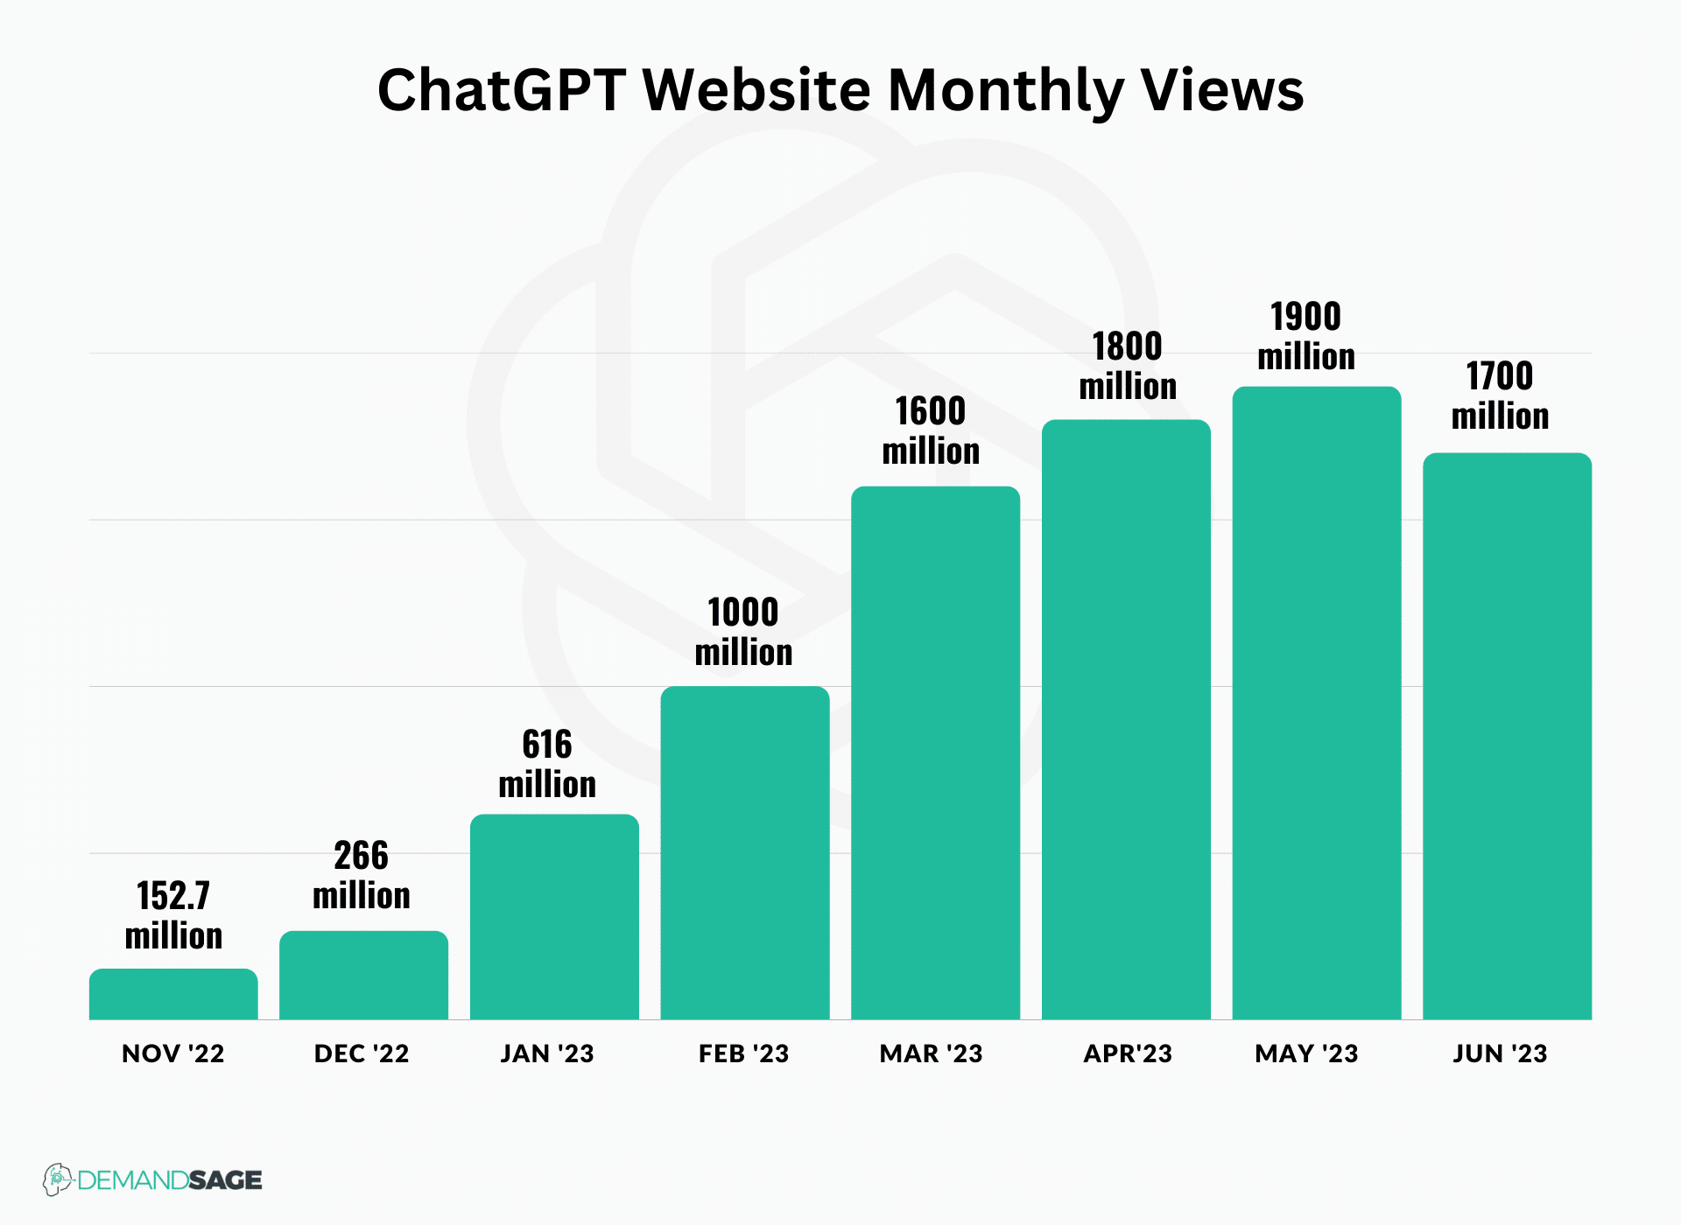

Ai as boon of are summarized with the following
- Enhancing Efficiency and Productivity: One of the most significant benefits of AI lies in its ability to enhance efficiency and productivity across different sectors. AI-powered automation streamlines complex processes, reducing human error and increasing accuracy. In industries like manufacturing, AI-driven robots can tirelessly perform tasks without tiring, leading to increased output and reduced production costs.
- Healthcare Advancements: AI is revolutionizing healthcare through accurate diagnostics, personalized treatment plans, and drug discovery. Machine learning algorithms can analyze vast amounts of medical data to identify patterns that might be beyond human capacity. This has the potential to lead to earlier disease detection and more effective treatments..
- Education and Learning: AI has the potential to customize learning experiences for students. Adaptive learning platforms can identify individual learning styles and paces, tailoring educational content to suit the needs of each student. This can result in improved retention and understanding of concepts.
- Environmental Sustainability: AI can play a pivotal role in addressing environmental challenges. By analyzing climate data and predicting environmental changes, AI can contribute to more informed decision-making. Energy management systems powered by AI can optimize energy consumption, reducing waste and promoting sustainable practices.
- Innovations in Research: AI accelerates scientific research by analyzing large datasets, identifying correlations, and generating hypotheses. In fields like astronomy, genomics, and particle physics, AI helps scientists process vast amounts of data, leading to breakthrough discoveries.
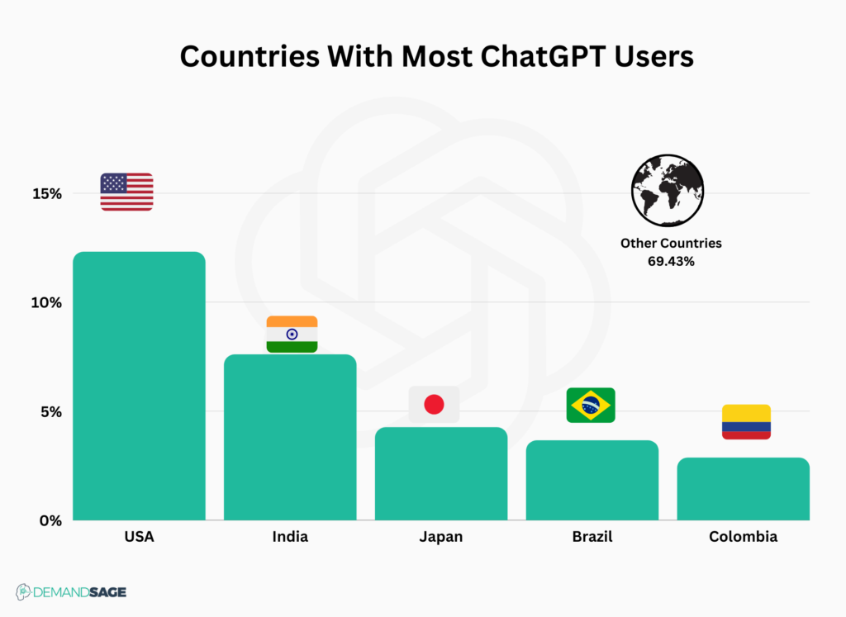
Ai A Curse:
I think that we will get into the equivalent of a nuclear arms race with AI. And if we don't build it, the other guys are for sure going to build it, and so then it'll escalate."by James Cameroon. According to Mr Cameron, the biggest danger lies in the weaponization of the new technology.

Table 3: Artificial Intelligence dangers warned in 1980’s itself.
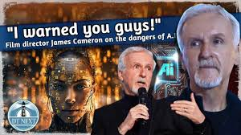 Job Disruption: The rise of AI and automation has led to concerns about job displacement. Routine tasks that were once performed by humans are now being taken over by machines. This could potentially lead to unemployment and socioeconomic inequality, particularly for low-skilled workers.

Privacy Concerns: AI's ability to process and analyze massive amounts of data raises significant privacy concerns. As AI systems become more sophisticated, they can potentially infringe on individuals' privacy rights by extracting sensitive information without consent.

Bias and Fairness: AI systems are only as unbiased as the data they are trained on. If the training data is biased, AI algorithms can perpetuate and even amplify existing biases, leading to unfair decisions in areas like hiring, lending, and criminal justice.

Ethical Dilemmas: As AI becomes more integrated into society, ethical dilemmas arise. For instance, autonomous vehicles must make split-second decisions that raise questions about whose lives should be prioritized in a potential accident. Developing ethical frameworks for AI remains a challenge.

Dependency and Control: Over-reliance on AI systems can lead to a loss of control over critical systems. If AI systems malfunction or make incorrect decisions, the consequences could be severe, especially in sectors like finance, healthcare, and transportation.

Conclusion

In the grand tapestry of technological advancement, AI stands as a double-edged sword, possessing both remarkable potential and concerning pitfalls. Its transformative capabilities have the power to reshape industries, solve complex problems, and improve human lives. However, the risks associated with unchecked AI development and deployment are equally substantial.

The way forward lies in responsible AI development. It is crucial for governments, industries, and researchers to collaborate in establishing ethical guidelines and regulations that govern the use of AI. Transparency in AI systems, unbiased training data, and accountability mechanisms are essential to mitigate the potential negative consequences of AI.

In conclusion, whether AI is a boon or a curse hinges on how humanity harnesses its potential and addresses its challenges. By striking a balance between innovation and ethical considerations, we can navigate the path ahead and ensure that AI remains a force for good in our rapidly evolving world.

