IOT Based Soil Moisture Monitoring and Control System
Mrs.Shuchita Mudgil Shri.Rohan Rajoriya
Lecturer IT Sr.Lecturer IT
Kalaniketan Polytechnic College Jabalpur Kalaniketan Polytechnic College Jabalpur
shuchitamudgil@gmail.com rohanrajoriya@gmail.com

Abstract:
Crop development and yield are influenced by variables such as temperature, humidity, and soil moisture. Regarding agriculture.In a field, soil moisture is a crucial factor in the plant's growth. Agriculture productivity rises as a result of ongoing soil moisture monitoring and maintenance at the required level in the field. Modern technology known as the Internet of Things (IoT) is used commonly used in a variety of industries, household settings, and the disciplines of agriculture, medicine, and the military. IoT technology is employed in this suggested system to continuously monitor soil moisture levels in agricultural fields. Real-time data can be easily accessed by the user via their mobile phones. The schedule for the irrigation system can be planned using the data collected. The suggested solution is small, simple to use, portable, robust, available anywhere to retrieve data, and advantageous economically.
Keywords: IOT, Thinkspeak , soil moisture sensor
Introduction:
Almost half of the land area on the world is used for food production. Agriculture now occupies about 40% of the planet's land and uses 85% of the fresh water supply. Globalization and population increase are to blame for the annual rise in water conservation. Reduced agriculture water use became a serious concern for all countries as a result. Measuring soil moisture for agricultural applications is essential for better irrigation systems since it enables farmers to better manage their farmland.
The Internet of Things (IoT) is a technology that improves Internet connectivity between digital and physical things and creates communication between them. The gathered data are exchanged from person to person, machine to machine, or machine to machine as well as saved and managed in the cloud. The development of IoT would lead to the discovery of fresh approaches to maximise agricultural produce and lessen difficulties that impede crop growth. With the IOT, it is possible to connect the monitoring of weather forecasts, soil temperature and humidity, soil moisture level, remote water valves, and pest management. Data collected from the sensors is then transmitted to the farmers via mobile phones. Both small-scale and large-scale agricultural modelling consider soil moisture as a key factor. The amount of root moisture in the soil is a major factor in the growth of vegetation and crops. Knowing the extent of the soil's moisture helps farmers assess the state of their fields and take appropriate action. The amount of soil water is determined by soil moisture. Over-irrigating plants can deprive them of oxygen, causing them to putrefy, and result in soil fungus illnesses [3]. According to research, excessive irrigation destroys roughly 80% of the crop, which lowers crop output growth. On the other side, dry fields can occur from a lack of water, which prevents plants from getting adequate nutrients to grow crops. IOT and use cases are crucial in the sector of agriculture business to meet the rising need for determining the status of soil moisture. By placing a moisture sensor in a sample pot, we tested one of the use cases. The sensor data is fed into the Thinkspeak cloud platform interface to aid in the timely decision-making of the intended individuals. To view the moisture level at any time or anywhere in the world, data is instantly available on the app.

Literature Survey:
Monitoring the field's volumetric soil moisture content is important for the pavement's performance.
Understanding how soil moisture affects performance is essential. In this study [1][2][3], a system employing an Arduino Uno board and a homemade soil moisture sensor was proposed. The most notable aspect of this system is its ability to assess soil moisture along depth, which can help predict when water will be supplied to the crop roots. This increases the management of water resources and cost effectiveness.
The most crucial factor in a plant's growth is watering.Water should therefore be supplied to plants at the appropriate times as needed. This paper's[4] proposal used sprinkler systems, pipelines, and a nozzle to create an autonomous plant watering system. An ATmega328 micro-controller is utilised to manage the entire system, and it is programmed to sense the moisture level and water according to them.
Using this method, water saving is thus attainable. According to these methods[5], [6], a wireless sensor network is designed utilising an Arduino, a grove moisture sensor, and a water flow sensor. The system's status will be shown on a web page and communication between them is done via the Zigbee protocol.
The strategy outlined in this paper[7] calls for developing a system to track soil moisture content using IOT, mobile computing, and cloud computing. The CC3200 launch pad is connected to a soil moisture sensor, and data is recorded using AT&T M2X cloud technology. The user uses the blynk application on an Android phone to monitor the status anywhere and make decisions quickly.

Design and Implementation:

Using the MQTT protocol, the nodemcu board, which serves as a client in this system, publishes the sensor data into the topic Thinkspeak/DEVICE ID/state in the Thinkspeak Message Broker. The published data will be instantly stored in the Thinkspeak cloud and made accessible in the cloud platform's visualisation tool. The client must subscribe to the commands started using cloud workflow on the subject "Thinkspeak/DEVICE ID/commands" in order to receive the stored data from the Thinkspeak cloud MQTT broker.
- NodeMCU
An open source IoT platform called NodeMCU uses ESP8266-12E chips. It is inexpensive, compatible with breadboards, incorporates a USB to serial chip, and can be powered by a straightforward USB to micro USB adapter. This module comprises software that runs on the ESP8266 wifi SoC from the Espressif system and is designed for the development of ESP8266-based Internet of Things applications. Access to the GPIO (General purpose Input/Output) subsystem is made possible through this development board. There are a many number of ESP8266-based modules available, and each one has pros and cons depending on the application it is intended for.

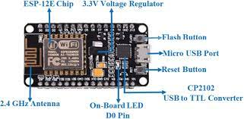
Fig1 : Nodemcu (ESP8266)
- Soil Sensor

The volumetric water content of the soil as well as moisture loss from evaporation and plant uptake are measured using soil moisture sensors. Water is the most crucial element for the existence of all plants. The amount of water needed to irrigate plants is calculated using this soil moisture sensor. This module is an LM393 comparator with an integrated potentiometer for altering the soil wet/dry sensing sensitivity in accordance with plant needs.
Frequency domain sensor and neutron moisture gauze are the two different types of soil moisture sensors. An oscillating circuit in a frequency domain sensor monitors the water content of the soil. The fundamental idea is that it measures the soil's dielectric properties. This controls how quickly electromagnetic waves travel through soil. The soil's dielectric increases as its water content does, making it possible to calculate how much water the soil contains. The other is neutron moisture gauze, which uses the water's neutron moderator qualities. The fundamental idea is that as a radioactive source decays, fast neutrons are released into the atmosphere, and as neutrons collide with protons, they rapidly slow down. The volumetric amount of water that the soil contains can be calculated by monitoring the density of slowed-down neutrons surrounding moisture sensor probes.
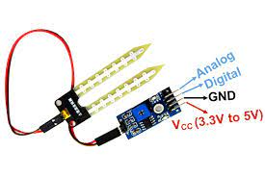

Fig 2 : Soil Moisture Sensor

- LM393 Driver: To compare the soil moisture level with the predetermined threshold value, an LM393 comparator is employed. This gadget, which comprises of two separate low voltage comparators, is made to work across a broad range of voltages using just one power source. Despite using a single power supply voltage for operation, the voltage range includes ground.

- Micro Submersible Mini Water Pump DC 3-6V And Relay Module
This DC 3-6 V Mini Micro Submersible Water Pump is a compact, inexpensive submersible pump motor that runs from a 2.5 – 6V power source. It can use up to 120 litres per hour and only use 220 mA of current. An electrical switch controlled by an electromagnet is known as a power relay module.

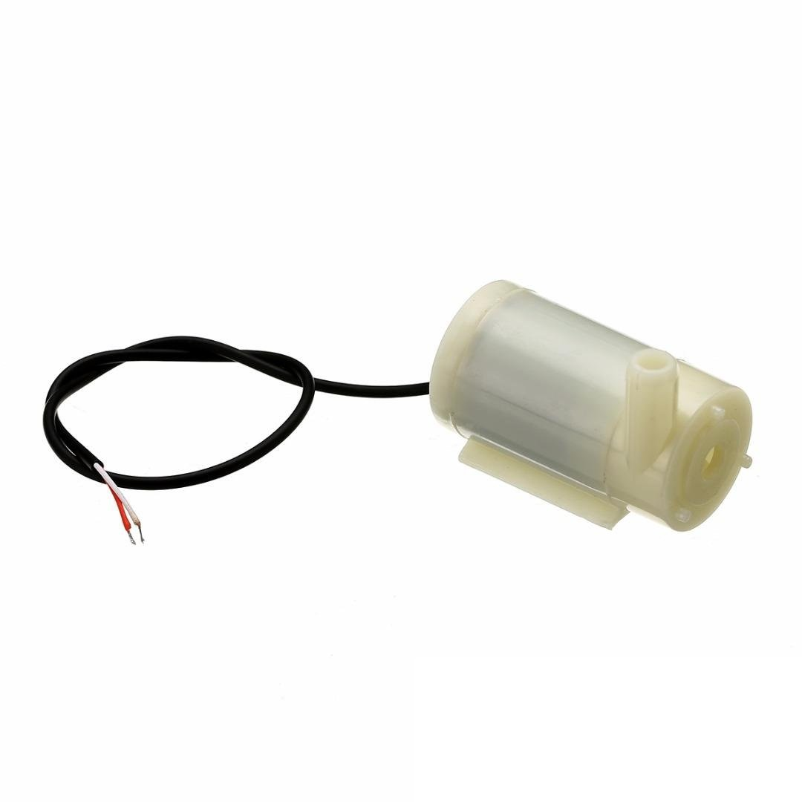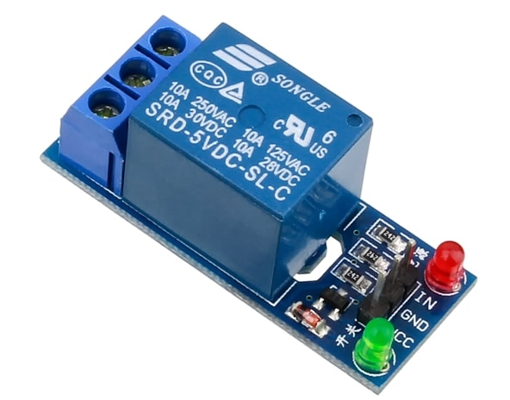
Fig 3 : Water pump and Relay module
- Thingspeak IOT Cloud platform :
Procedure and Steps for Executing the Project :
The "Thingspeak IOT Cloud platform" is the foundation for the entire project.
Some of the main attributes of this IOT platform are listed below:
- Public/Private view,
- Channel Settings,
- API-keys,
- MATLAB analysis, and
- Add Visualizations are all available.

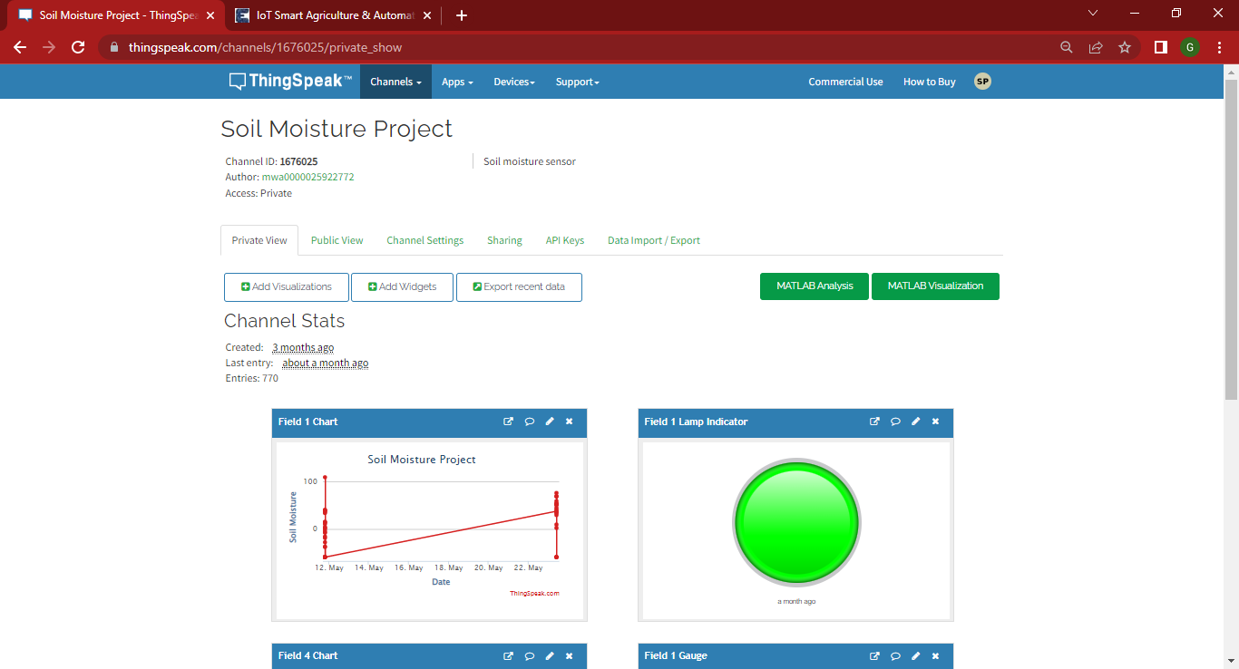
Fig 4:Thinkspeak Cloud

- Locate the URL www.thingspeak.com in the browser's address bar and type THINGSPEAK IOT CLOUD into the search field.
- Create a MathWorks account to gain access to all of ThingSpeak's capabilities.

Fig 5 : Creating MathWorks account
Configuring the Thingspeak server

Step 1: Go to https://thingspeak.com/ and register an account by entering your information.
Step 2: Create a New Channel by selecting "Channel" and entering the information requested in the image below.

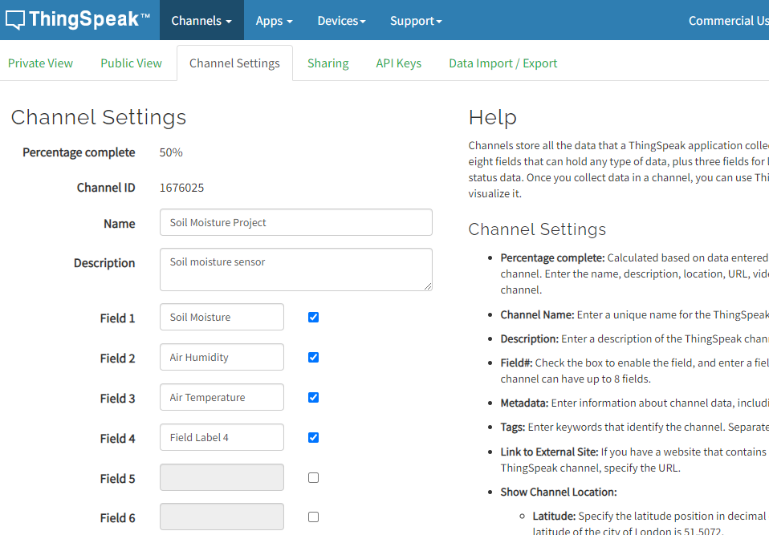

Step 3: Select "Write API Key" after clicking on API Key. Copied the API Key. This is crucial; the Code Part will require it.
Note: Our project's API-KEY is 23O35SDOSRKMQ6LF.
The API - KEY varies depending on the console.

Step 4: Select "Private View" and modify the display window as necessary. The Thingspeak Setup Part has concluded. Let's get to the programming section now.

Step 5: Arduino IDE - The code editor into which all of the project's codes have to be pasted in order for it to function.

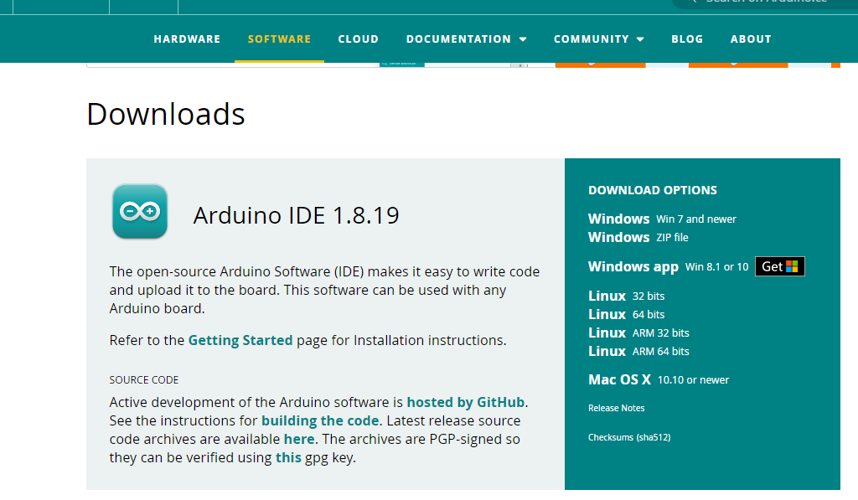

https://www.arduino.cc/en/software
Program Source :
The IoT Smart Agriculture & Automatic Irrigation System with ESP8266 Source Code is quite straightforward. Direct uploading of the code to the NOdeMCU Board is possible.

Change the Thingspeak API Key, WiFi SSID, and password in the section of code below. The calibration of the soil moisture sensor value, which includes AirValue and WaterValue, is the most crucial component of this code. Read this post: Calibrating Soil Moisture Sensor Value to find out how to calibrate and get the right reading. Do not omit this step, please. This could lead to the erroneous soil moisture reading and occasionally could cause the motor to turn on continuously.

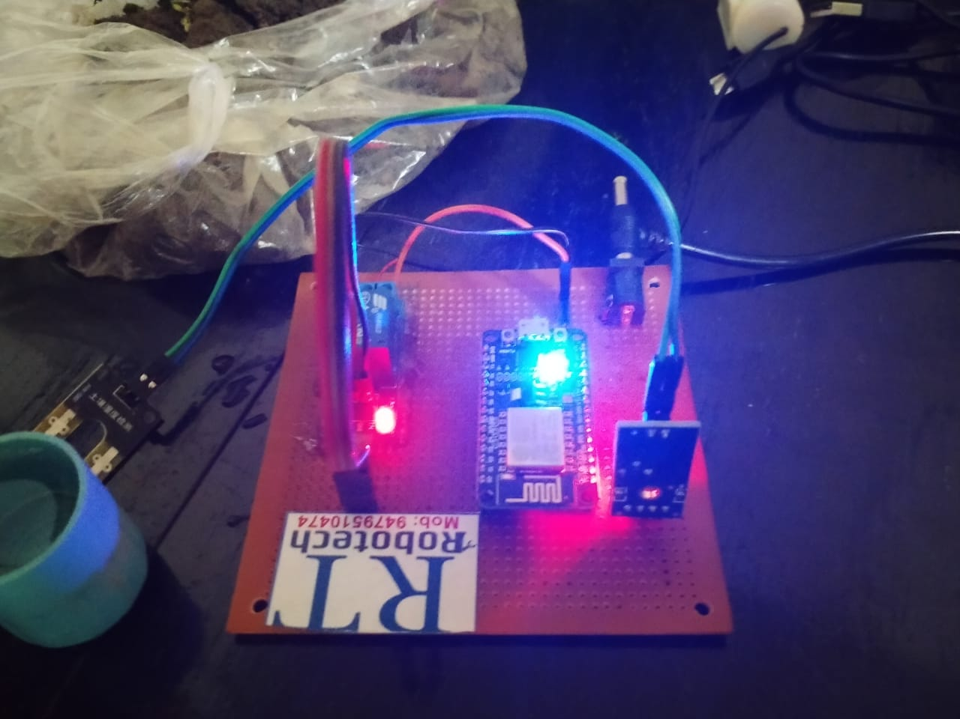
Fig 6 : Complete Working Project
TESTING AND RESULTS :

This water pump must be completely submerged in the liquid. For irrigation purposes, the exit pipe is kept in a field. The soil moisture sensor is also submerged in the soil. When you turn on the gadget, real-time data is shown. The water pumps switch on and irrigate the field until the appropriate moisture is reached when the soil moisture content decreases. Check out the video below to see how it functions completely. Using Thingspeak Server, you may access the data online from anywhere in the world. Visit the Thingspeak server's private view to do that. You may check the temperature, humidity, and soil moisture as well as the status of the relay.

Fig :7 Result on Thingspeak Cloud

Conclusion &Future Work
It can deliver water with extreme accuracy and prevent water wasting. User takes less manpower because handling is done automatically. It can precisely determine the soil moisture levels with the aid of the sensors. Using sensors, it can quickly detect and regulate the temperature, humidity, and sun radiation.
This clever irrigation system gives plants more time to get watered and creates the best conditions for growth. It saves time and allows for the addition of a timer delay for automatic watering based on the environmental conditions. This intelligent watering system is adaptable to changing environmental conditions.

REFERENCES:

[1] Matti Satish Kumar, T Ritesh Chandra, D Pradeep Kumar and Dr.M. Sabarimalai Manikandan,Monitoring moisture of soil using low cost homemade Soil Moisture Sensor and Arduino UNO 2016 3rd International Conference on Advanced Computing and Communication Systems(ICACCS-2016), Jan-22&23,2016, Coimbatore,INDIA.
[2] Fatiha binti Abdullah, Nina korlina Madzhi, Faridatul Aima Ismail,Comapartive investigation of soil moisture sensors material using three soil types 2015 IEEE 3rd International Conference on Smart Instrumentation, Measurement and Applications(ICSIMA 2015),24-25 November 2015,putrajaya, Malaysia.
[3] Ibrahim Al-Bahadly, Jonathan Thompson, Garden Watering System Based on Moisture Sensing, 2015 Ninth International Conference on Sensing Technology.
[4] Drashti Divani, Pallavi patil, Prof. Sunil K. Punjabi, Automated Plant Watering System, 2016 International Conference on Computation of Power, Energy Information and Communication (ICCPEIC). [5] M.Usha Rani, S.Kamalesh, Web Based Service to Monitor Automatic Irrigation System for the Agriculture Field Using Sensors
[6] G. Nisha , J.Megala, Wireless Sensor Network Based Automated Irrigation And Crop Field Monitoring System, 2014 Sixth International Conference on Advanced Computing (ICoAC).
[7] P. Divya Vani and K. Raghavendra Rao, Measurement and Monitoring of Soil Moisture using Cloud IoT and Android System, Indian Journal of Science and Technology, Vol 9(31), DOI: 10.17485/ijst/2016/v9i31/95340, August 2016.
[8] F. Meneghello, M. Calore, D. Zucchetto, M. Polese and A. Zanella, "IoT: Internet of Threats? A Survey of Practical Security Vulnerabilities in Real IoT Devices," in IEEE Internet of Things Journal, vol. 6, no. 5, pp. 8182-8201, Oct. 2019. doi: 10.1109/JIOT.2019.2935189
[9] N. Y. Parotkin and V. V. Zolotarev, "Information Security of IoT Wireless Segment," 2018 Global Smart Industry Conference (GloSIC), Chelyabinsk, 2018, pp. 1-7. doi: 10.1109/GloSIC.2018.8570144
[10] S. Siboni et al., "Security Testbed for Internet-of-Things Devices," in IEEE Transactions on Reliability, vol. 68, no. 1, pp. 23-44, March 2019. doi: 10.1109/TR.2018.2864536
[11] Y. Liu, Y. Kuang, Y. Xiao and G. Xu, "SDN-Based Data Transfer Security for Internet of Things," in IEEE Internet of Things Journal, vol. 5, no. 1, pp. 257-268, Feb. 2018 doi:10.1109/JIOT.2017.2779180
[12] P. Fremantle and P. Scott, “A survey of secure middleware for the Internet of Things,” PeerJ Computer Science, vol. 3, p. e114, May 2017.

[13] https://create.arduino.cc/projecthub/jfrankie/iot-system-to-monitor-soil-moisture-with-arduino-5e370c

[14] https://how2electronics.com/monitor-soil-moisture-sensor-nodemcu-thingspeak/

