Cultural diversity in English language classrooms of Modern Era

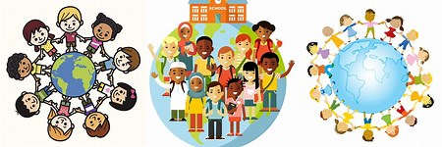

English language classrooms around the world have become increasingly diverse in recent years. This diversity is not only reflected in the various nationalities and linguistic backgrounds of students but also in their cultural identities and experiences. This cultural diversity brings both challenges and opportunities for teachers and students alike. In this article, we will explore the significance of cultural diversity in English language classrooms and discuss strategies for promoting an inclusive and enriching learning environment.

The Changing Face of English Language Education

English has undoubtedly become a global lingua franca, used for communication among people from different linguistic backgrounds. This has led to a remarkable increase in the number of non-native English speakers learning the language. Consequently, English language classrooms now feature students from diverse cultural backgrounds. This shift presents several advantages, such as broadening students' perspectives and fostering intercultural understanding.

Challenges of Cultural Diversity

While cultural diversity enriches the educational experience, it can also pose challenges. One of the primary challenges is language proficiency. Students may have varying levels of English proficiency, which can affect their ability to communicate effectively in the classroom. Additionally, cultural differences can lead to misunderstandings and miscommunication, which may hinder the learning process.

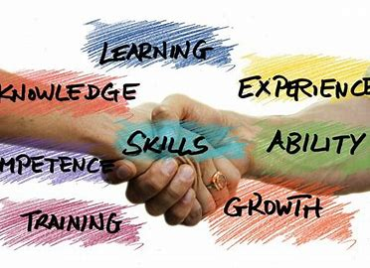

Strategies for Fostering Inclusivity

To create an inclusive and effective learning environment in culturally diverse English language classrooms, educators can implement the following strategies:

Acknowledge and Celebrate Differences:
Recognize and celebrate the diverse cultural backgrounds of your students. Encourage them to share their traditions, customs, and experiences, and use these as valuable teaching resources.

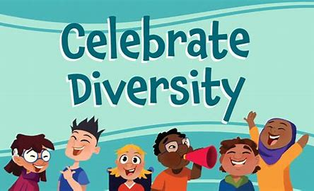

Promote Multilingualism:
Embrace multilingualism by allowing students to use their native languages when necessary. This can ease communication barriers and show respect for their linguistic diversity.
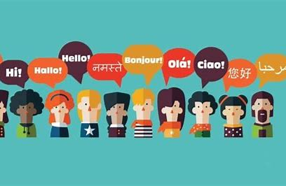

Cultural Sensitivity:
Educators should be culturally sensitive and aware of potential cultural biases. This helps in avoiding unintentional misunderstandings and conflicts.
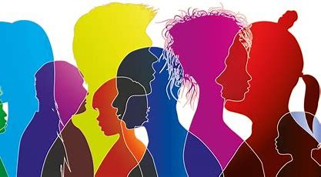

Inclusive Curriculum:
Incorporate diverse perspectives and materials in your curriculum. Use texts, media, and activities that represent a wide range of cultures and backgrounds.

Collaborative Learning:
Encourage group work and collaborative projects. Working together on tasks can help students learn from each other and build cross-cultural communication skills.

Regular Feedback and Assessment:
Provide regular feedback to students regarding their language proficiency and cultural competence. This can help them monitor their progress and identify areas for improvement.

Professional Development:
Teachers should engage in professional development to improve their cultural competence and teaching methods for diverse classrooms.

Conclusion:

Cultural diversity in English language classrooms is a reality that educators and students must embrace. By acknowledging, respecting, and celebrating this diversity, teachers can create inclusive and enriching learning environments. When students from various cultural backgrounds come together to learn English, they not only enhance their language skills but also foster a deeper understanding of the world and its diverse cultures. In the process, they become better equipped to communicate and collaborate.

