Bioremediation of organic Wastes using Different Earthworms
C. Birundha* and N.Uma Maheswari
PG and Research Department of Microbiology,
Sengamala Thayaar Educational Trust Women’s College (Autonomous),
Sundarakkottai, Mannargudi,Thiruvarur (dist),Tamilnadu-614016.
*Corresponding author Email: binthuyoga1699@gmail.com.
Abstract
Vermicomposting is one of the most feasible and environment friendly technique for the bioconversion of biodegradable wastes into a useful and high quality vermicompost. Vermiculture of wild earthworms namely Eisenia foetida, Eudrilus eugeniae, Perionyx excavates and vermicomposting of different organic wastes such as Cattle dung, plant debris, paper waste, and food waste using both wild and cultured species of earthworms are investigated. The waste is converted into useful manure by reducing the harmful effects of waste. These bioassays are sensitive and cost-effective for the monitoring of environmental contamination. The vermicompost produced from organic wastes contains higher amounts of humic substances, which plays a major role in growth of plants.The detoxification of biodegradable wastes by earthworms and the role of final vermicompost in plant growth and development. Earthworms can be used to biodegradable organic waste and the worm cast produced can go a long way to increase soil fertility for maximum yield during agricultural activity. Vermicomposting by Eisenia fetida can eﬀectively reduce the toxicity and total concentration of heavy metals, as well as bacterial composition and diversity are greatly changed during the vermicomposting process. Vermicompost is one of the nutrient-rich organic manure in the world and has shown a positive role in growth and development of the plant.
Keywords: Vermiculture, Organic wastes, Worm cast, Vermicomposting, Earthworms.
Introduction
Management of solid organic wastes has become one of the biggest problems developing nations are facing today. The rapid increase in the volume of waste is one aspect of the environmental crisis accompanying recent global development. Waste is a valuable material in a wrong place. Organic wastes comprise house hold food wastes, agricultural wastes, human wastes and animal wastes (Appelhof, 2007). As global population continues to increase, more organic wastes are bound to be produced causing increase in their environmental and agricultural challenges. These challenges are worse in developing countries due to poor waste management techniques. As a result, the waste turns out to cause health problems and the enormous nutrients in it get lost hence the need for efficient waste management technique.
Aristotle said around 2,350 years ago that “Earthworms are intestines of the earth,” which was found to be correct and verified only in the twentieth century. Darwin also stated that “No other creature has contributed to the building of earth as earthworm.” The science of raising and breeding earthworms is called “Vermiculture,” which is generally performed to harvest the potential of earthworms for waste reduction and fertilizer production (Sinha et al., 2010). The process of vermicomposting involves the production of an organic fertilizer, also known as vermicompost, by biodegradation of organic waste with the help of earthworms to avoid waste disposal and to produce high-quality compost.
The role of earthworms in the breakdown of organic debris on soil surface and soil turn over process was first highlighted by Darwin in 1881 (Kale and Bano, 2008; Berkelaar, 2009). Agricultural waste is the most wasted form of energy and is widely available in developing countries where around 70% of the rural population primarily depends on agriculture (Jimenez-Lopez et al., 2020).It remains debatable whether vermicomposting is efficient in reducing the number of human pathogens in industrial and agricultural waste. Vermicomposting is a mesophilic process where the temperatures are generally kept below 35EC to prevent the worms from dying. However, according to the standards of Environmental Protection Agency (EPA), the compost should be exposed to high temperature (55–70EC) for at least 72 h (Edwards et al., 2010).Vermicomposting, a bioremediation process in which worms are used to convert organic waste materials into humus-like material known as verimcompost, serves as a means of recovering organic waste nutrients through an efficient means producing organic fertilizer for agriculture purpose (Lazcano et al., 2008; Berkelaar, 2009; Beetz, 2010; Rhonda, 2011).The goal of vermicomposting is to process organic materials as quickly and efficiently as possible using the product of vermiculture which its goal is to continually increase the number of worms in order to obtain a sustainable harvest (Glenn, 2006; Asha-Aalok, & Soni, 2008).The process of vermicomposting involves a collective action of microorganisms and earthworms to convert waste into useful manure. Vermicomposting has been effectively used to detoxify industrial wastes, converting them to a manure rich in humic substances and promoting plant growth (Bhat et al., 2018). Although microorganisms are responsible for the decomposition of organic waste, earthworms are the drivers for this process by conditioning the substrate and altering its biological activity. The final vermicompost contains different compounds such as nitrogen, phosphorus, potassium (NPK), organic carbon, micronutrients, and microflora (Iqbal et al., 2015).Microorganisms such as bacteria, actinomycetes, and fungi are the most important microorganisms that play an important role during vermicomposting (Liu et al., 2021). The microbial populations of earthworm’s gut and cast produces an extensive variety of natural materials such as polysaccharides, including cellulose, sugar, lignin, chitin, starch, and polylactic acid, thereby accelerating the process of composting (Aira et al., 2007). A wide range of stomach-related enzymes such as amylase, cellulase, chitinase, protease, lipase, and urease are present in earthworms and the microorganisms because of decomposition of organic matter (Munnoli et al., 2010). Now there is an all round recognition that adoption and exploitation of vermiculture biotechnology, besides arresting ecological degradation, could go a long way towards meeting the nutrient needs of the agricultural sector in a big way.
Vermiculture and Vermicompost
Vermiculture is the artificial rearing or cultivation of earthworms, and the technology is the scientific process of using them for the betterment of human beings. Vermicompost, also called worm compost, vermicast, worm casting, worm poop or worm manure, is the excreta of earthworm which is rich in humus. Earthworms consume animal droppings or farm yard manure along with other farm wastes and pass them through their body, converting them into vermicompost or worm humus. Therefore, earthworms not only convert organic wastes into valuable manure but keep the environment healthy (Anon, 2017).Vermiculture can easily be done in any available space: balcony of an apartment, in the basement of a house or even in a heated garage if the worm bin used is suitable and well maintained to avoid odours. This technique can ultimately be used to fertilize home garden and produce a greater quality and quantity of crops for the family. Worm farming is a useful practice in developing nations where fertilizer is difficult to be accessed by peasant farmers, since it can easily be used to convert animal waste, food scraps and other dead organic matter into a nutrient rich fertilizer. Vermicomposting, a conversion of the organic wastes or garbage by earthworms into vermicompost and the multiplication of earthworms are simple process and can be handled by even small farmers.
Advantages of vermicomposting
1) Vermicompost is an eco-friendly natural fertilizer prepared from biodegradable organic wastes free from chemical inputs.
2) It does not have any adverse effect on the soil, plant and environment.
3) It improves soil aeration, texture and tilt, thereby reducing soil compaction.
4) It improves water retention capacity of soil because of its high organic matter content.
5) It promotes better root growth and nutrient absorption.
6) It improves nutrient status of soil – both macronutrients and micronutrients.
Vermicomposting of agricultural waste procedure:
Agricultural lignocellulosic waste can be successfully vermicomposted to produce a good-quality manure (Fig. 1). This lignocellulosic waste when mixed in different proportions with cattle manure and vermicomposted by adding Eisenia feotida earthworms showed decreased total organic carbon (268–320 g/kg) and increased NPK content in the waste after 105 days of vermicomposting. It also increased the heavy metal content with their benefit ratio ranging between 0.06 and 5.1 (Sharma et.al.,, 2019).

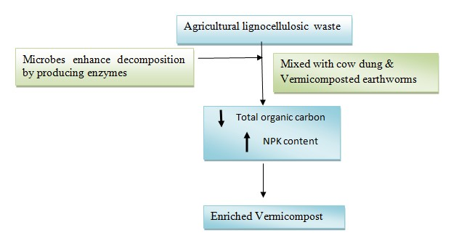

Figure:1 Vermicomposting and microbial decomposition of agricultural wastes.

Collection of waste materials and earthworms
- Collected the biodregradable waste such as cattle dung , paper waste, plant debris, food waste were collected from in and a land the Mannargudi, Thiruvarur district Tamilnadu, India.(Fig:2)
- Using by the three types of earthworm species Eisenia fetida, Eudrilus eugeniae and Perionyx excavates for preparation of vermicomposting.(Fig:3).

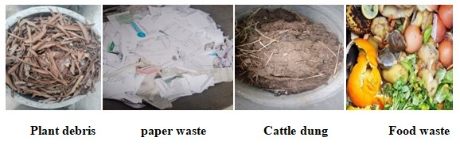
Figure.2 Collection of waste materials

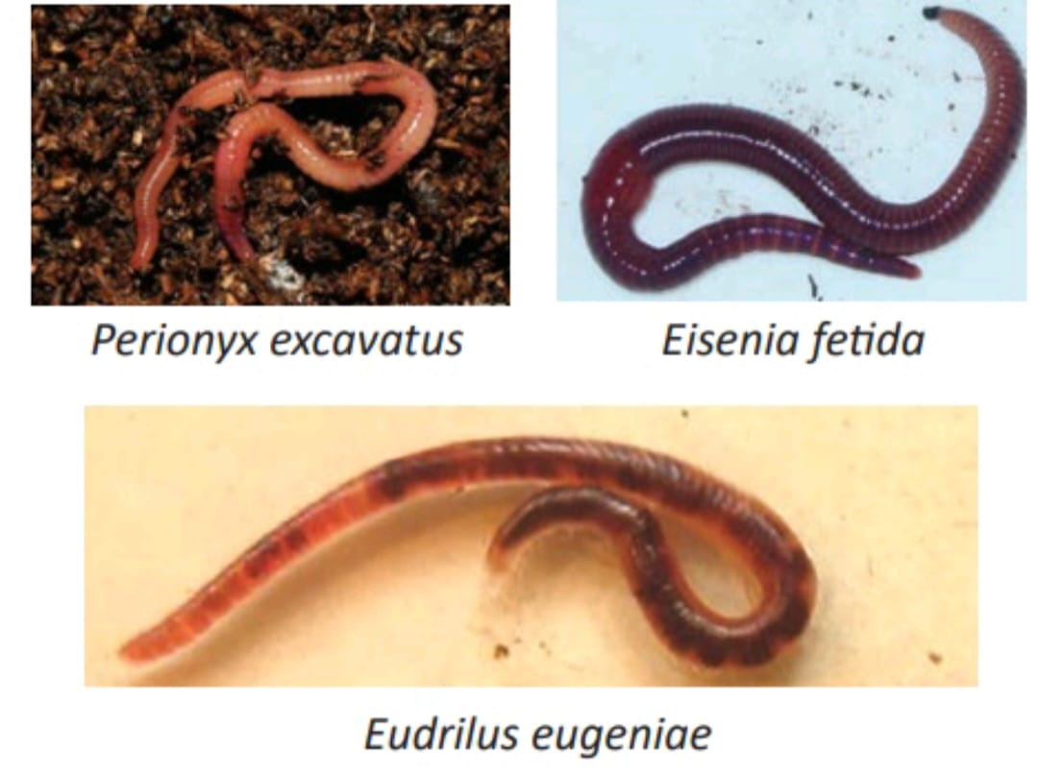
Figure: 3 Potential species for Earthworms vermiculture

Processing of Vermicomposting

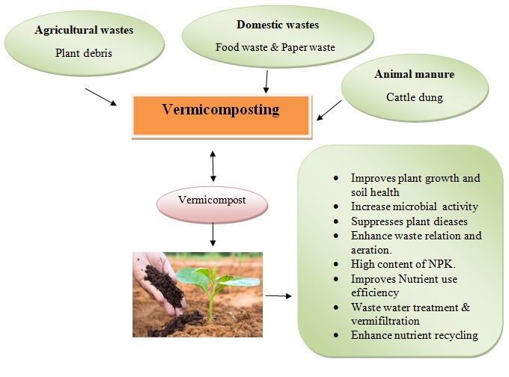
Figure: 4 The process of vermicomposting of different types of organic wastes
“Vermicomposting is a process in which the earthworms convert the organic waste into manure rich in high nutritional content.” Vermicomposting is a process based on earthworms and microorganisms, whose joint action provides degradation and detoxification of organic waste as well as conversion into a product to be used for agronomic purposes. This eco-friendly method is cost effective and is the best among other remediation processes. (Fig: 4). Following of processing step below flow chat. (Fig: 5).

Figure: 5 The process of vermicomposting
Benefits of vermicomposting
Vermicompost with good physicochemical properties and fortified with all nutrients and plant growth-promoting bacteria are organic amendments for enhancing soil fertility, promoting plant growth, and controlling pathogen infection for sustainable agriculture. Vermicompost has a plethora of benefits, most importantly as follows:
(1) It acts as biofertilizers, restores soil nutrients, stabilizes soil, and enhances soil fertility at a long-term period;
(2) It attends to social issues and recycles waste; and
(3) It is shown to be a profitable enterprise as a circular economy.

The process of bioremediation:
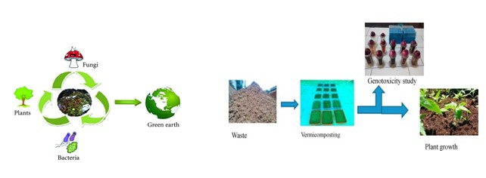
Figure: 5 Bioremediation of vermicomposting process
Bioremediation compain the vermicompost processs following steps flow chat below:
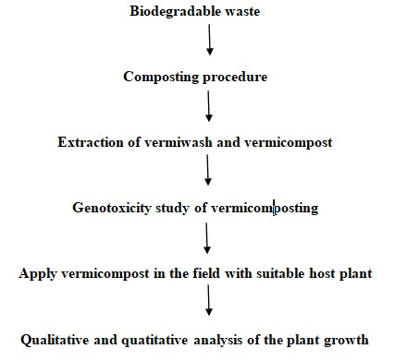
Role of vermicompost in plant growth
Vermicompost is rich in microbial population (fungi, bacteria and actinomycetes) which makes it fit for plant growth (Tomati et al., 1987). Vermicompost also hold enzymes and harmones that increases plant growth and reduces plant diseases (Abbasi and Ramasamy, 1999; Hussain et al., 2017). Many researchers have reported plant growth hormones (auxin, cytokinins, humic substances) produced by microbes from vermicompost (Muscolo et al., 1999; Atiyeh et al., 2002). Many researchers (Senesi et al., 1992; Garcia et al., 1995; Masciandaro et al., 1997; Elvira et al., 1998) have observed that the final vermicompost obtained from cattle dung, sewage and paper mill sludge contains large quantities of humic substances, which plays a major role in plant growth and development. Hence, vermicomposting and vermiculture technology are economically sound and environmentally safe technology for solid waste management. India, where a lot of organic solid waste is accessible could produce million tons of vermicompost and will minimize the use of inorganic fertilizers, shows that below (Tab: 1)
S.NO. | Waste  Substrate | Earthworms | Duration | Physio chemical analysis and heavy metals | Plant name | Plant growth
1. | Cattle dung | Eisenia foetida | 120 days | There was a decline in total organic carbon, electrical conductivity while the higher content of nitrogen, phosphorous and pH was reported in the ﬁnal feed mixtures. | Tomato  (Lycopersicum esculentum L.) | Germination percentage of tomato seeds was found maximum at 15% vermicompost treatments than higher treatments. All the growth, and yield parameters increased
2. | Plant debris
3. | Paper waste
4. | Food waste |  |  | There was a decrease in pH, organic carbon content,organic matter, C:Nratio, and increase in ash content,electrical conductivity, nitrogen, potassium and phosphorus content in post vermicompost
Table: 1 Details of waste substrate composted by earthworms and analysis of the tomato plant

Advantages of bioremediation:
- Cost effective
- Bioremediation is a natural process
- Environment Friendly
- Less energy and supervision
- Low capital expenditure
Conclusion
One of the identified earthworms (Eisenia fetida) is presented in the cattle dung vermicompost. Is only one of the most common species of earthworm that has been identified worldwide as having the best potential for breaking down organic materials. It represents an alternative approach in waste management since it is a process for handling organic wastes. During vermicomposting, the interactions between detritivorous earthworms and microorganisms modify the biochemical and physical properties of the organic waste and accelerate the stabilization of organic matter. Understanding the mechanisms of microbial transformations that occur during vermicomposting of organic matter can also help in developing strategies for efficient disposal of organic wastes. Therefore, developing nations such as Nigeria can use the advantage of vermitechnology not only in municipal waste management but its application in crop production to enhance agricultural produce since it can be started off on a small scale with little inexpensive materials and equipment. The dumping of wastes/sludges in an environment without proper treatment may contaminate the soil and other fauna which causes many health hazards. The results of many authors indicated that the vermitechnology is a useful technique in minimizing the toxicity of wastes/sludges. The collaboration between earthworms and microbes in vermitechnology helps in reduction of organic waste and production of the final vermicompost which is well stabilized and finely divided material with best physicochemical and biological features. Microorganisms and earthworms interact at various levels to digest the organic waste and convert it to useful manure, and the produced manure depending on the microbial inoculum used exhibit different properties and beneficial effects on plant growth. Finally that the vermicompost could act as a suitable plant growth media as it contains a higher amount of soil enzymes and growth hormones.

Reference
- Abbasi, S.A., Ramasamy, E.V., 1999. In: Biotechnological Methods of Pollution Control. Orient Longman, Universities Press India Ltd., Hyderabad, pp. 168.
- Anon, (2017). Vermiculture and Vermicompost, Department of Agriculture, Andaman and Nicobar Administration, Port Blair. diragri@and.nic.in.
- Atiyeh, R.M., Subler, S., Edwards, C.A., Bachman, G., Metzger, J.D., Shuster, W., 2002. Effect of vermicompost and compost on plant growth in horticulture container media and soil. Pedobiologia 44, 579–590
- Appelhof, M. (2007). Worms eat my garbage, 2nd Edition. Kalamazoo: Mich Flowerfield Enterprises.
- Asha-Aalok, A. K., & Soni, P. (2008). Vermicomposting: A better option for organic solid waste management”. Journal of Human Ecology, 24(1), 59-64.
- Edwards C.A., Arancon N.Q., Sherman R.L. (2019) Vermiculture technology: earthworms, organic wastes, and environmental management. CRC press; 2019 Jan 23.
- Garcia, C., Ceccanti, B., Masciandaro, G., Hernandez, T., 1995. Phosphatase and β-glucosidase activities in humic substances from animal wastes. Bioresour. Technol. 53, 79–87.
- Glenn, M. (2006). Manual of on-farm vermicomposting and vermiculture. Organic Agriculture Center of Canada (OACC).
- Ghosh, C. (2004). “Integrated vermi-Pisciculture – an alternative option for recycling of solid municipal waste in rural India,” Bioresource Technology, 93, 71-75
- Hussain, N., Abbasi, T., Abbasi, S.A., 2017. Enhancement in the productivity of ladies finger (Abelmoschus esculentus) with concomitant pest control by the vermicompost of the weed salvinia (Salvinia molesta, Mitchell). Int. J. Recycl. Org. Waste Agric. 6, 335–343.
- Jimenez-Lopez C., Fraga-Corral M., Carpena M., García-Oliveira P., Echave J., Pereira A.G., Lourenço-Lopes C., Prieto M.A., Simal-Gandara J. (2020) Agriculture waste valorisation as a source of antioxidant phenolic compounds within a circular and sustainable bioeconomy. Food Func. 11(6): 4853–4877. https://doi.org/10.1039/D0FO00937G.
- Kale, E. D., & Bano, K. C. (1988). Earthworm cultivation and culturing techniques for production of vermicompost. Agricultural Science Colorado, 22, 339-344.
- Lazcano, C., Gomez-Brandon, M., & Dominguez, J. (2008). Comparison of the effectiveness of composting and vermicomposting for the biological stabilization of cattle manure. Chemosphere, 72(7), 1013-1019.
- Liu X.C., Chen L., Li S.Q., Shi Q.H., Wang X.Y. (2021) Effects of vermicompost fertilization on soil, tomato yield and quality in greenhouse. [Ying Yong Sheng tai xue bao] J. Appl. Ecol. 32(2): 549–556. https://doi.org/10.13287/ j.1001-9332.202102.022.
- Senesi, S., Saiz, J.C., Miano, T.M., 1992. Spectroscopic characterization of metal humic acid like complexes of earthworms composed organic wastes. Sci. Total Environ. 117, 111–120.
- Sinha R.K., Valani D., Chauhan K., Agarwal S. (2010) Embarking on a second green revolution for sustainable agriculture by vermiculture biotechnology using earthworms: reviving the dreams of Sir Charles Darwin. J. Agricult. Biotech. Sustain. Develop. 2(7): 113–128. https://doi.org/ 10.5897/JABSD.9000017.
- Sharma K., Garg V.K. (2019) Recycling of lignocellulosic waste as vermicompost using earthworm Eisenia fetida. Environ. Sci. Pollut. Res. Int. 26(14): 14024–14035. https://doi.org/10.1007/s11356-019-04639-8.
- Tomati, U., Grappelli, A., Galli, E., 1987. The presence of growth regulators in earthworm-worked wastes. In: Bonvieini Paglioi A.M., Omodeo, P. (Eds.) On Earthworms. Proceedings of International Symposium on Earthworms: Selected Symposia and Monographs, Unione Zoologica Italiana, Mucchi, Modena, Italy, pp. 423–435.

