"The Genetic Underpinnings: Deciphering the Inheritance Pattern of Thalassemia"

Abstract
Thalassemia, a congenital blood illness brought on by incorrect haemoglobin synthesis, causes anaemia and other health issues. Understanding its genetics is crucial for understanding how it is passed on and how it affects the affected individuals and their families. The impact of the condition on RBC, the pathogenesis of thalassemia, clinical presentation and diagnostics, thalassemia therapy, and future prospects of thalassemia developments and promising paths are the main topics of this chapter. Additionally, it looks at the genetic foundation, pattern of inheritance, and structure and function of haemoglobin in RBC. We also offer historical context and comments on the identification and discovery of thalassemia from eminent experts in the area.
Key words : inheritance pattern , thalassemia ,health issue, blood.

Introduction
Thalassemia is an autosomal recessive genetic disorder. Thalassemia, a group of inherited blood illnesses typified by impaired haemoglobin production, can cause anaemia and a range of other potential health problems. The body's ability to transport oxygen is dependent on red blood cells. There are actually two types of thalassemia: beta and alpha. Gene mutations that result in inadequate or disordered globin proteins are the main cause of these disorders, respectively. One of these proteins may occasionally not even exist. Heme (Fe++) uses a fold or concise formed by the globin chains for transporting oxygen. On chromosomes 16 and 11, respectively, are the genes that code for the alpha and beta globin proteins[1].thalassemia is a kind of haemolytic anaemia’s resulting due to increase in the rate of red cell destruction haemolytic anomia classification is given bellow.
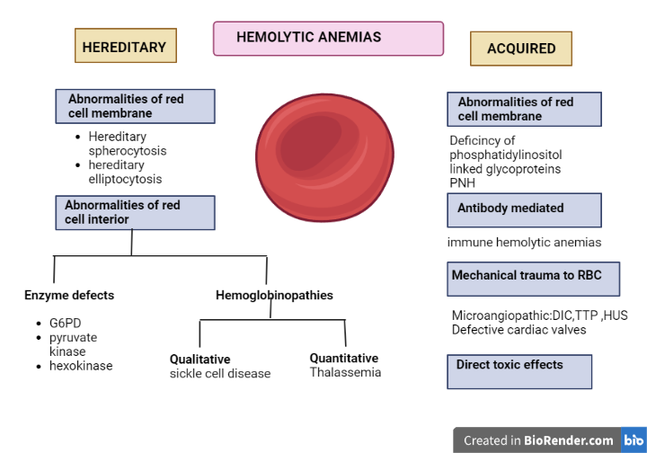
Fig1: classification of Haemolytic anemias
Background knowledge and research: In 1925, an American physician named Thomas Cooley discovered a group of individuals who had huge spleens and severe anaemia. This disorder, once known as "Cooley's anaemia," is now known as thalassemia major.
A physician by the name of George Whipple saw cases of newborns in Sicily, Italy, in 1927 who had a severe form of anaemia that he named "Mediterranean anaemia." Later, the terms for beta thalassemia and this expression were used interchangeably.
- Types of thalassemia
Alpha thalassemia:

- One gene mutation: results in a silent carrier who may pass the disease to their progeny but has no symptoms or warning signs.
- Two gene aberrations: Mild or trait alpha-thalassemia, which is a term for small-scale symptoms.
- Three gene abnormalities, often known as intermediate alpha-thalassemia or haemoglobin H disease, result in symptoms that might be moderate to severe.
- Two instances of the four gene defects are severe alpha-thalassemia and hypdrops fetalis, which are frequently deadly before or soon after delivery.

Beta thalassemia
- Alpha-thalassemia trait or beta-thalassemia minor, which are both terms used to denote moderate indications or symptoms triggered by a single gene mutation.
- Two gene anomalies are responsible for Cooley's anaemia, one of the main symptoms of beta-thalassemia which can range in intensity from mild to severe.[7,8].

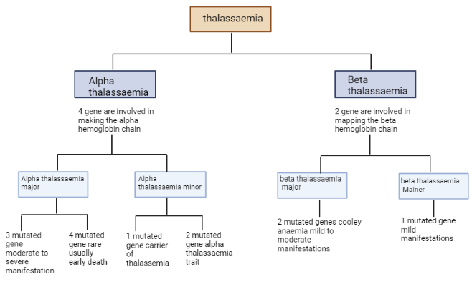

Fig6: Diagnostic flow chart for determining thalassemia

- Genetics and etiology :

The frequent genetic condition known as beta-thalassemia is caused by changes in the beta-globin gene that decrease the amount of beta-globin produced. Thalassemia has been linked to more than 200 distinct mutations that alter the expression of the beta globin gene to varied degrees. Nucleotide substitutions and frameshift insertion-/deletion-type modifications that impact molecular processes including the splicing process, translation, and transcription of the beta -globin gene inhibit or limit the formation of beta-globin chains. Patients with thalassemia must all go through molecular testing.
Heme and the two alpha and two beta globin chains of haemoglobin unite to produce a tetramer that carries oxygen in the blood. The red bone marrow produces this iron-containing protein in order to generate erythrocytes. The capacity of globin polypeptides to bind heme moleculesBy reversibly adhering to it, erythrocytes may be able to transport oxygen from the lungs to other areas of the body. [2].

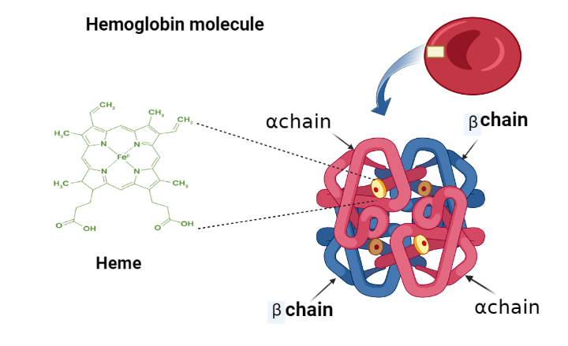

Fig3: Structure of haemoglobin.

- Haemoglobin genetics

Human Hb comprises of proteins with symmetricaly combined of α-like and β-likeglobin dimers that combine to create a tetrameric structure, as well as functional units. core comprises cis-acting regulatory elements that control the expression of the globin gene. Within 30–70 kb upstream of the α-globin gene cluster, multispecies conserved sequence (MCS) regions (MCS-R1, 2, 3, and 4) were found. MCR-R2, also known as HS-40, is a single DNase hypersensitive site that is crucial for α-globin gene expression [5]. β-globin gene expression is regulated by the locus control region (LCR), which consists of five DNase I hypersensitive sites (HS-1, 2, 3, 4, and 5). β-globin LCR (β-LCR) spans 34 kb upstream of the ε-globin gene.

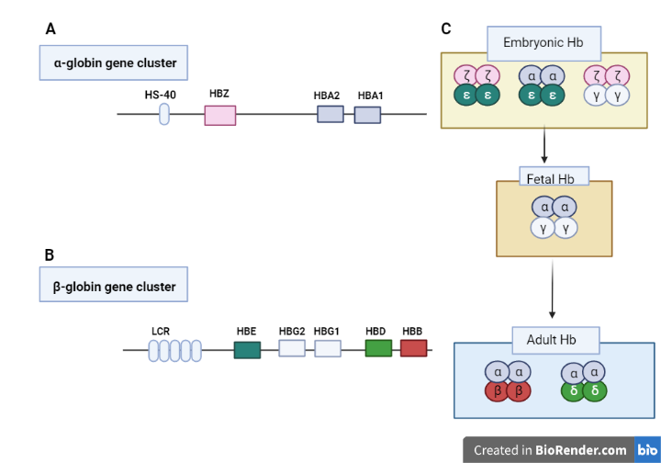
Fig4: The human alpha and beta-globin gene assortments are located on chromosomes 16 and 11, respectively. The α-globin gene cluster includes 3 functional globin genes, the embryonic ζ gene (HBZ) and 2 fetal/adult α, α1 and α2, genes (HBA1 and HBA2) (A). The β-globin gene cluster contains 5 functional genes, the embryonic ε gene (HBE), 2 fetal Gγ and Aγ genes (HBG2 and HBG1), and adult δ and β- (HBD and HBB) genes(B). HS-40 and the locus control region (LCR) regulate α- and β -globin gene expression, respectively. Embryonic, foetal, and adult phases of haemoglobin expression are shown. (C).

- Pathophysiology of thalassemia

Before being able to comprehend Understanding the pathophysiology of typical globin gene synthesis and haemoglobin production is necessary to understand the pathophysiology of thalassemia. Understanding the typical physiology of haemoglobin gene production and the production of haemoglobin is necessary before one can comprehend the pathophysiology of thalassemia[6].
Alpha- and beta-thalassemia's pathogenesis involves abnormal globin chain synthesis. The disorders alpha- and beta-thalassemias are both monogenic, which implies a genetic aberration is the underlying root cause of the disease. The clinical symptoms of thalassemias can be brought on by a variety of mutational occurrences, including deletions, insertions, and point mutations (substitutions). The changed genetic sequence results in the production of a nonfunctional or flawed gene product (protein), which prevents the new globin chain from properly transporting oxygen to peripheral tissues. Two alpha and two beta (or gamma) chains, as well as an iron heme ring, make up the four globin chains that make up haemoglobin. The number of gene mutations and whether the damaged region is within the alpha or beta splice of the haemoglobin molecule define the kind of thalassemia.
Alpha-thalassemia is a condition marked by an excess of beta chain synthesis and an inadequate alpha-hemoglobin chain synthesis. Four genes make up the alpha region of haemoglobin, two of which reside on chromosome 16 and are inherited from each parent. as previously mentioned, there is a connection among the number of gene mutations and the severity of the condition.
Beta-thalassemia is a condition marked by an excess of alpha chains and an imbalance in the synthesis of beta-hemoglobin chains.The two genes that make up the beta portion that comprises the haemoglobin chain are located on chromosome 11, and each gene is derived from a different parent. As was already established, there is a correlation between the number of gene mutations and the severity of the disease.
The number of genes lost on each globin-cluster determines how severe the sickness is. irrespective of the kind of mutation, the thalassemias are inherited in a Mendelian autosomal recessive way. 22 pairs of numbered chromosomes (autosomes) along with a pair of chromosomes that determine sex. A man has both an X and a Y chromosome, whereas a female has two X chromosomes. The father, who has the choice of handing down either an X or a Y chromosome, determines the child's sex at random.

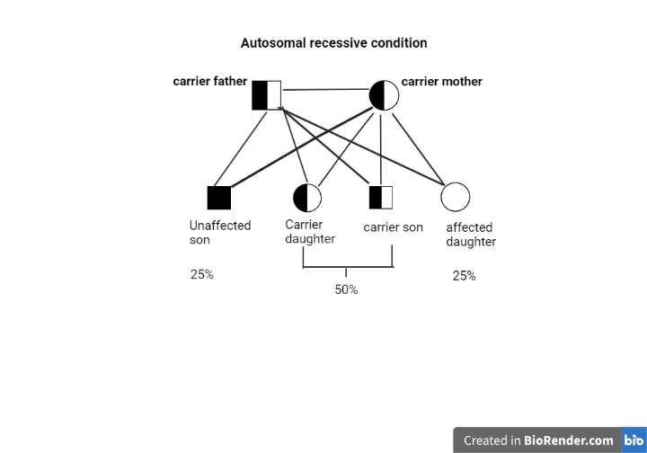
Fig5: if mother and father both are carrier then probability of progeny is 25% unaffected ,50% carrier and 25% affected progeny.
The total number of genes lost on each globin-cluster determines how severe the sickness is. irrespective of the kind of mutation, the thalassemias pass down in a Mendelian autosomal recessive way. 22 pairs of chromosomes with serial numbers (autosomes) along with a pair of chromosomes that determine sex. A man has both an X and a Y chromosome, while a female has two X chromosomes. The father, who has the choice of handing down either an X or a Y chromosome, determines the child's sex at random.
People who have a family history of thalassemia are prone to be impacted since the illness is hereditary. Additionally, the sickness is more common among people of Italian, Greek, Middle Eastern, Asian, and African origin than in those of other specific nationalities[7].
- Clinical Manifestation and Diagnosis
There are several types of thalassemy. The kind and severity of your ailment will affect the signs and symptoms that you experience.Symptoms and indications of thalassemia include
- Fatigue,
- weakness,
- pale or yellowish complexion,
- abnormalities of the facial bones,
- slow development,
- swollen abdomen,
- dark urine

Since symptoms frequently show up within the first two years of a child's life, severe and relevant instances of thalassemia are frequently found in youngsters.

To find thalassemia, your doctor can conduct a variety of blood tests, including those listed below.

- a complete blood count (CBC) that measures the quantity (and size) of red blood cells in addition to haemoglobin. Patients with thalassemia have fewer normal RBCs and less haemoglobin than the general population. Additionally, their red blood cells may be smaller than normal.
- The reticulocyte count, a sign of developing red blood cells, suggests that your body's bone marrow may not be producing enough RBCs.
- Studies on iron will show if thalassemia or a deficiency in iron is the cause of your anaemia.
- Haemoglobin electrophoresis is used to diagnose beta thalassemia.
- Genetic testing is used to diagnose alpha thalassemia.

Identification of carriers, which is crucial for this genetic disorder, is made feasible through haematological testing. When microcytic hypochromic characteristics are found in beta- and alpha-thalassemia carriers (heterozygotes) with or without anaemia, an examination for differential diagnosis is necessary to rule out iron-deficient anaemia. Pro analysis is a chemical that can be ferritin or zinc. [9] Evidence on family history and ethnicity could prove useful when addressing the medical diagnosis of thalassemias. The haematological features, such as RBC shape and indices, provide the foundation for identifying a thalassemia carrier, followed by the separation and analysis of Hb fractions. Figure:6 reports a flowchart for identifying thalassemia carriers.
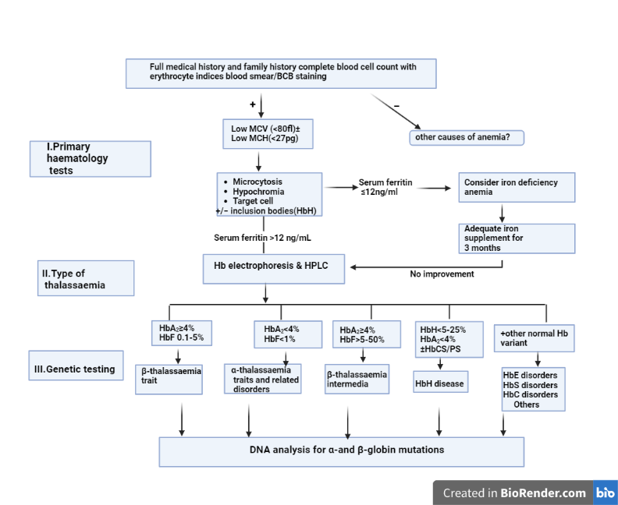
Fig6: Diagnostic flow chart for determining thalassemia
Additionally, it is suggested against screening neonates for thalassemia because it is too late for prophylaxis; instead, the screening could concentrate on other age groups. At the premarital or early prenatal period, numerous carrier screening procedures are used internationally. These classes might be classified as mandatory or optional. All couples must now undergo hemoglobinopathy testing before gaining the all-clear to be married in a small number of Islamic high-risk countries, including Iran, Saudi Arabia, and the Palestinian Territories.
- Thalassemia treatment:
Blood transfusions and iron chelation are often main treatments for thalassemia.
- Blood transfusions
During a blood transfusion, red blood cells are introduced into a vein to refill the body's regular supply of normally functioning RBC and haemoglobin. For severe or moderate thalassemia, transfusions are given every four months, and for beta thalassemia major, they are given every two to four weeks. Transfusions may be required for people with beta thalassemia intermedia or haemoglobin sickness, for instance, if an infection is present.
Occasional blood transfusions
may be advised for patients who suffer from haemoglobin disease or intermediate beta thalassemia. A transfusion may be required specifically when the human body is under stress, such as during an illness, pregnancy, or surgery.
regular transfusions of blood:

It can be required for those with beta thalassemia major (every 3–4 weeks). These blood transfusions sustain normal levels of haemoglobin and red blood cells.
- folic acid supplements
Taking folic acid supplements may assist your body in creating healthy blood cells.
- Iron chelation therapy

The removal of excess iron from your body is one step in the iron chelation process. Following blood transfusions, iron excess is possible. An excess of iron might harm your organs. If you often receive transfusions, you will need iron chelation medication (which you can get as a pill).
- Deferasirox is taken as a tablet once daily. Skin rash, nausea, and diarrhoea are examples of potential side effects.
- Deferiprone is a drug that, if other remedies don't work, you could use. It may make you more susceptible to infections if it reduces your WBC count.
- Deferoxamine is a liquid drug that is carefully injected beneath the skin, usually over the course of an overnight period. It takes time and could feel a little unpleasant throughout this therapy. Visual problems and hearing loss are possible symptoms.

- Bone marrow and blood transplantation

Only a stem cell and bone marrow transplant from a compatible related donor may cure thalassemia.HLA, a protein present on the cell surface, is used to determine if a donor and recipient of a contribution are compatible. During the surgery, your doctor will infuse donor bone marrow stem cells into your circulation. Within a month, the transplanted cells will begin producing fresh, healthy blood cells.
- Other treatment
To treat thalassemia, a doctor may advise combining hydroxyurea and the medication luspatercept (Reblozyl). Due to luspatercept, those with moderate to severe thalassemia-related anaemia may need fewer blood transfusions. When used to treat sickle cell disease, hydroxyurea can help lower the risk of thalassemia-related health problems.
Plenectomy is the name of the procedure used to remove the spleen. Your doctor could advise having a splenectomy if you have been given a diagnosis of mild to severe thalassemia in order to relieve your symptoms. However, removing the spleen reduces the body's ability to fight infections.
Every three weeks, you'll be given a medicine called lupatercept, which may aid in your body's production of more red blood cells. It is authorised in the US to treat transfusion-dependent beta thalassemia.
- Thalassemia's Future Prospects: Advances and Promising Directions
Those who suffer from thalassemia, a hereditary blood disease, now have hope for better care and eventual therapies because to developments in the science and medicine of the disease. The following situations and directions for thalassemia are optimistic.
Gene editing and gene therapy: In order to correct genetic abnormalities and reinstate regular haemoglobin production, researchers are investigating the use of viral vectors to deliver functional copies of the damaged HBB gene into bone marrow stem cells as a kind of gene therapy for the treatment of thalassemia.
The precise and long-lasting thalassemia mutation editing made possible by CRISPR-Cas9 gene editing technology offers a focused therapy.
Fetal Hemoglobin Induction: As foetal haemoglobin has a larger capacity for delivering oxygen than adult haemoglobin, researchers are investigating pharmacological agents and gene regulatory techniques to boost the synthesis of foetal haemoglobin in thalassemia patients.
Therapies using ex vivo stem cells: Patients with thalassemia can benefit from ex vivo stem cell therapies by having their bone marrow or hematopoietic stem cells removed, genetically modified to produce healthy haemoglobin, and then reinfused back into the patient.
Treatments for Non-Transfusion-Dependent Thalassemia (NTDT): A milder form of thalassemia without frequent blood transfusions is known as NTDT. In order to manage symptoms, minimise iron overload, and enhance overall quality of life, researchers are investigating innovative drugs.
Enhancements Iron Chelation Therapies: For patients with thalassemia getting blood transfusions, iron chelation treatment is required. Researchers are developing iron chelators that are efficient, practical, and have fewer adverse effects in order to improve patient adherence and results.
Precision therapies and personalised medicine: Because of advancements in genomic medicine, customised therapies based on genetic variations and the severity of the disease are now feasible.
Conclusion: Understanding the genetic basis and inheritance pattern of thalassemia is crucial for the diagnosis, management, and future therapy of this complex blood disease. With this knowledge, researchers, healthcare workers, and families are better equipped to deal with the challenges brought on by thalassemia and work towards developing better treatments and prevention measures. We anticipate more advancements in genetics and molecular medicine to strengthen our ability to combat thalassemia. Two cutting-edge therapeutic approaches, gene therapy and gene editing, have the potential to transform the lives of thalassemia patients and give them hope for a future free from the burden of their condition.

References:
- Shafique F, Ali S, Almansouri T, Van Eeden F, Shafi N, Khalid M, Khawaja S, Andleeb S, Hassan MU. Thalassemia, a human blood disorder. Braz J Biol. 2021 Sep 3;83:e246062. doi: 10.1590/1519-6984.246062. PMID: 34495151.
- Poonam Tripathi Genetics of Thalassemia June 17th, 2022 Reviewed: July 26th, 2022 Published: October 18th, 2022 DOI: 10.5772/intechopen.106748.
- Stamatoyannopoulos G. Control of globin gene expression during development and erythroid differentiation. Experimental Hematology. 2005;33(3):259-271. DOI: 10.1016/j.exphem.2004.11.007.

- Lee JS, Cho SI, Park SS, Seong MW. Molecular basis and diagnosis of thalassemia. Blood Res. 2021 Apr 30;56(S1):S39-S43. doi: 10.5045/br.2021.2020332. PMID: 33935034; PMCID: PMC8093999.

- Thein SL, Rees D. Haemoglobin and the inherited disorders of globin synthesis. In: Hoffbrand AV, Higgs DR, Keeling DM, Mehta AB, eds. Postgraduate haematology. 7th ed. Hoboken, NJ:Wiley-Blackwell, 2015:72-97.

- C. Michael Gibson, Shyam patel, Neel Patel thalassemia pathophysiology.

- Thalassemia - Symptoms and causes (2021). Available at: https://www.mayoclinic.org/diseases- conditions/thalassemia/symptoms-causes/syc-20354995 (Accessed: 8 September 2021).

- https://www.news-medical.net/health/Thalassemia-Pathophysiology.aspx.

- https://www.mayoclinic.org/diseases-conditions/thalassemia/symptoms-causes/syc-20354995.

- Hashemieh M, Timori Naghadeh H, Tabrizi Namini M, Neamatzadeh H, Hadipour Dehshal M. The Iran Thalassemia prevention program: success or failure? Iran J Ped Hematol Oncol 2015; 5: 161– 6

- https://my.clevelandclinic.org/health/diseases/14508-thalassemias#:~:text=Management%20and%20Treatment&text=Standard%20treatments%20for%20thalassemia%20major,red%20blood%20cells%20and%20hemoglobin.

- https://www.nhlbi.nih.gov/health/thalassemia/treatment#:~:text=Blood%20transfusions%20are%20the%20main,healthy%20blood%20through%20this%20line.

