Enhancing the Listening Skill of Tertiary Level Students Using Web Series and Movies
Hema.S¹  ¹Research Scholar, Department of English, School of Social Sciences and Languages,  Vellore Institute of Technology, Vellore. | Gandhimathi S.N.S.^{2*}  ²Assistant Professor, Department of English, School of Social Sciences and Languages,  Vellore Institute of Technology, Vellore.

ABSTRACT

Watching web series and English movies can significantly aid in language learning. They provide students with authentic speech, vocabulary, culture, and accents. Additionally, watching with subtitles can help improve listening and comprehension skills. It is a highly effective and enjoyable method to learn a new language. By watching shows and movies, students can learn how native speakers communicate in various situations and contexts. Listening is an essential skill when it comes to language learning. It facilitates improving speaking skill and introducing learners to new vocabulary and grammar in context. As a result, listening is a crucial element in language acquisition and communication. Watching web series and English movies can improve engineering students' listening skill. They can learn various accents, dialects, and jargon, practice critical thinking, improve comprehension, and become motivated to learn more. The study determines how English movies and web series improve the listening skill of Engineering students and also analyses how audio-visual resources help improve the student's listening skill. This study uses a quantitative method; a survey was conducted among engineering students. A total of 66 responses have been obtained from the survey. The study's main findings have proved that audio-visual resources significantly improved students' listening skill. Students who were taught using audio-visual resources scored higher on the post-test than those who did with the traditional method. Moreover, students utilising audio-visual resources have shown increased satisfaction, engagement, and confidence in their listening skills. Moving forward, the research aims to devise data-driven guidelines and best practices to integrate web series and films into diverse academic disciplines seamlessly.
Keywords: Listening skill, web series, movies, effective method, development of extensive
Learning.

- INTRODUCTION

Communication is vital in our daily lives, allowing learners to interact with others, express themselves and exchange ideas and thoughts (Abdikarimova et al., 2021). Humans instinctively learn their native language through social interaction from a young age. However, at an international level, it is essential to be proficient in both our native and global languages like English. It is the most commonly used language studied worldwide and is crucial for communication, education, commerce, and entertainment (Runde & Nealer, 2018). Nevertheless, acquiring a new language can be difficult and monotonous for some learners, mainly if they depend on conventional approaches like textbooks and grammar drills. Therefore, finding alternative and effective ways to learn more engaging and enjoyable English is essential. Similarly, effective listening is a crucial component of productive communication. Learners can use various techniques to improve listening skill, such as watching web series, movies, or comparable media. The use of web series can be a highly effective tool for teaching English language skills (Liando et al., 2018b). The Global Media Journal indicates that web series and online streaming content have become increasingly popular with young people and are gradually replacing traditional television (How Can Film Help You Teach or Learn English? 2014). This study focuses on using such media to enhance listening skills for engineering students. Numerous university engineering students possess personal media devices like laptops, personal computers (PCs), and compact gadgets like smartphones and tablets. They use these devices for several activities, like viewing movies from pen drives, streaming videos online, or downloading video files. Likewise, web series offer students valuable exposure to English, used in real-life situations outside the classroom. This particularly applies to interactive language, which is the kind of language used in everyday conversations. Through web series, students can gain exposure to natural expressions and the natural flow of speech (Wolfson, 1976). Web series may provide the opportunity to experience this kind of immersive language input for learners who do not live in an English-speaking environment.
When considering the leisure activity of viewing movies, it is evident that students display a range of behaviours and perspectives about the influence of English-language films on enhancing their oral communication and listening skill. In contrast, others may need more awareness of this aspect and engage in movie-watching for entertainment. Based on the information above, research was undertaken to investigate Engineering students' perspectives on using English movies and series to enhance their listening skill. The main objective of this study is to determine how English films and web series improve the listening skill of Engineering students and also analyse how audio-visual resources help improve the student's listening skill. As per the British Council, listening is the primary skill we learn from birth and the most frequently used communication skill. In English language teaching, students are taught listening skill to help them comprehend spoken English in various contexts. Listening exercises help them to improve their understanding of different accents, dialects, and speech patterns while enhancing their vocabulary, grammar, and pronunciation. There are multiple ways to introduce listening skill in English language teaching. One approach is to use authentic sources such as songs, movies, and web series. These sources offer great exposure to real-life English and make learning listening skill engaging and fun. When learning English, web series can be a valuable resource for students looking to improve their listening and comprehension skills. By exposing learners to authentic English language content, web series can help them develop their vocabulary and grammar skills (The Power and Importance of Listening, n.d.). However, it is important to remember that web series should be used in addition to traditional language learning methods, not as a replacement. Teachers should guide their students on using web series effectively and encourage active engagement with the content. While web series can be an excellent tool for improving listening skill, they should always be used alongside other language learning methods. This study explores how watching English movies and web series can improve listening skill among engineering students and identifies contributing factors. Results can provide insights on using these media to enhance listening skill.

- RESEARCH QUESTIONS

- How do English language movies and web series enhance the listening skills of engineering students?
- Is incorporating audiovisual resources into English language teaching feasible, especially in listening skills among tertiary-level learners?

- REVIEW OF LITERATURE

According to a study by Rastislav Metruk, the use of movies and TV programs can improve the listening skills of EFL learners. Extensive viewing is a popular method for achieving this, but teachers and students must pay attention. However, the amount of time spent watching English movies and TV programs did not significantly impact EFL learners' listening abilities. (Metruk, 2019).
Eny Kusumawati has examined English movies with subtitles to improve viewers' understanding of the content. Participants in the survey have comprehended subtitled movies better than those without subtitles. However, the study also showed that subtitles did not affect participants' vocabulary comprehension. (Kusumawati, 2019).
Pham Thi Thuy Dung has discussed the effectiveness of audiovisual media in enhancing students' listening skills. The study has reported that videos markedly improved comprehension among students, who also exhibited a favourable disposition towards this learning mode. (Pham, 2021).
Research by Intan et al. (2022) has shown that audiovisual media can positively affect students' listening abilities and improve their performance. This study, which has utilised library research methods, specifically examined how incorporating audiovisual media could enhance students' listening skills based on previous studies and expert theories.

According to a study by Liando et al. (2018), who has done research at a university in North Sulawesi, students majoring in English believe that watching English movies can enhance their listening and speaking abilities. The study has focused on students enrolled in Listening and Speaking courses. It employed a three-part questionnaire to collect data on the respondents' background, perceptions of English movie-watching, and level of agreement concerning the effectiveness of English movies. The results have indicated that English primary students can improve their listening skills by watching English movies, and subtitles can aid in understanding conversations. English movies are also considered more effective than other media for educational purposes.

Amsberry (2009) has investigated the impact of the listener's attitudes, experience, and knowledge on their perception of accented speech. Accented speech comprehension can be improved through increased awareness of accent-related issues and regular listening practice. Active listening techniques allow staff to communicate more effectively with international patrons. Effective listening is a process of hearing, understanding, interpreting, and acting upon information to match the speaker's intent. Listening entails decoding and interpreting verbal statements and nonverbal cues such as tone of voice, facial expressions, and physical posture.

(Albiladi et al., 2018) suggests that using movies for teaching and learning English among adult learners has found that movies are perceived as authentic language-learning sources and can effectively improve language skills such as speaking, listening, reading, vocabulary, and writing. The study also revealed that movies significantly improve English language skills, especially speaking and listening. These provide authentic input, motivate students, and offer more opportunities for enhancing speaking and listening skills.

- METHODOLOGY

The researcher has used the quantitative method to get the accurate results. The purpose of this specific study, which is exploratory, is to investigate the varied impacts that web series and movies of English Language material have on engineering students. The researcher has used purposive random sampling to examine 66 responses from engineering students. Using Google Forms, close-ended questions were created and shared with respondents by email and WhatsApp.
Discussion

The survey consisted of 22 questions. Six of these questions were designed to collect information about the respondents' demographics, while the remaining 16 questions were based on their opinions. The questionnaire comprised one open-ended descriptive question and a few objective-type questions. There were three types of multiple-choice questions like yes-or-no, questions with a range of opinions from strongly agree to strongly disagree, and questions with numerical ranges.
The researcher obtained and analysed data from 63 participants. The survey questions covered general demographic information such as age, gender, and mother tongue. Based on the research gap, most respondents were first-, second-, or third-year engineering students. The sample population mainly comprised engineering students with an average age of 19.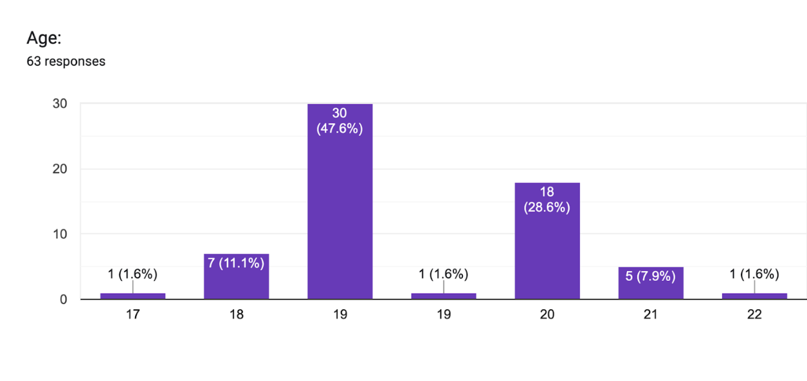
Figure 1: Age of the Respondents
This study is based on responses from youth, which clearly shows that sixty-three respondents provided data, which were collected and examined. General demographic questions concerning age, gender, and mother language were asked. The research gap indicates that first-, second-, or third-year engineering majors comprised most of the study's participants. Most people on the lot were engineering students, with an average age of 19.
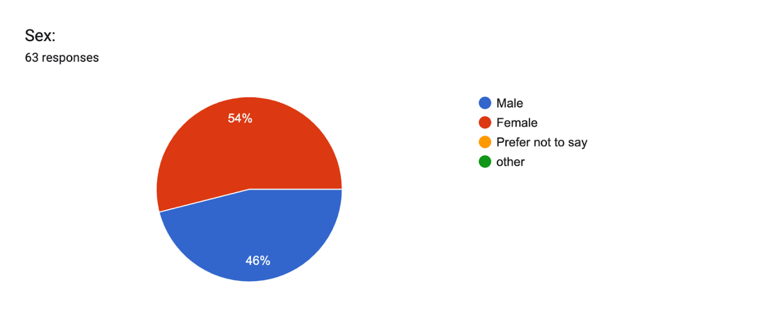
Figure 2: Gender of the Respondents
When categorising the respondents based on gender, it can be seen that 46% are men and 54% are women. Movies or television shows helped 50.8% of respondents to a fundamental question acquire a new language. According to the question, it may be assumed that respondents like to utilise TV shows and movies to learn languages.
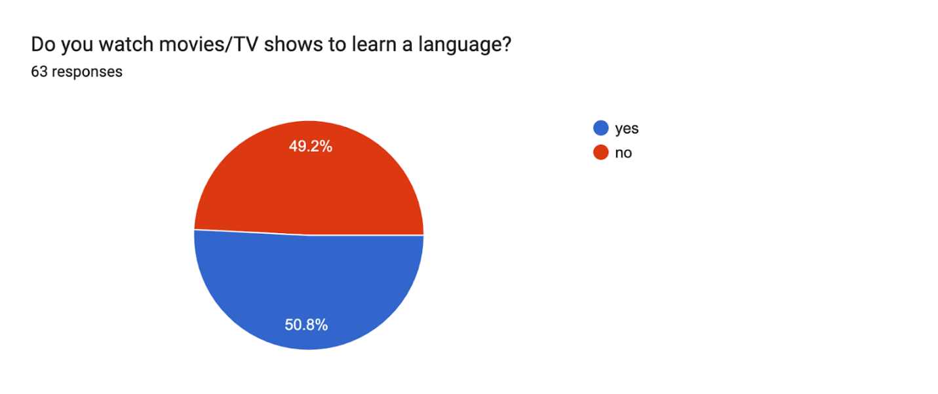
Figure 3: Feedback from the respondents

From the question given above, it is explicit that the participants inquired why they watch movies and web series. According to the statistics, 54% of respondents use movies and web series to become good at language speaking, while 46% use it only for fun.
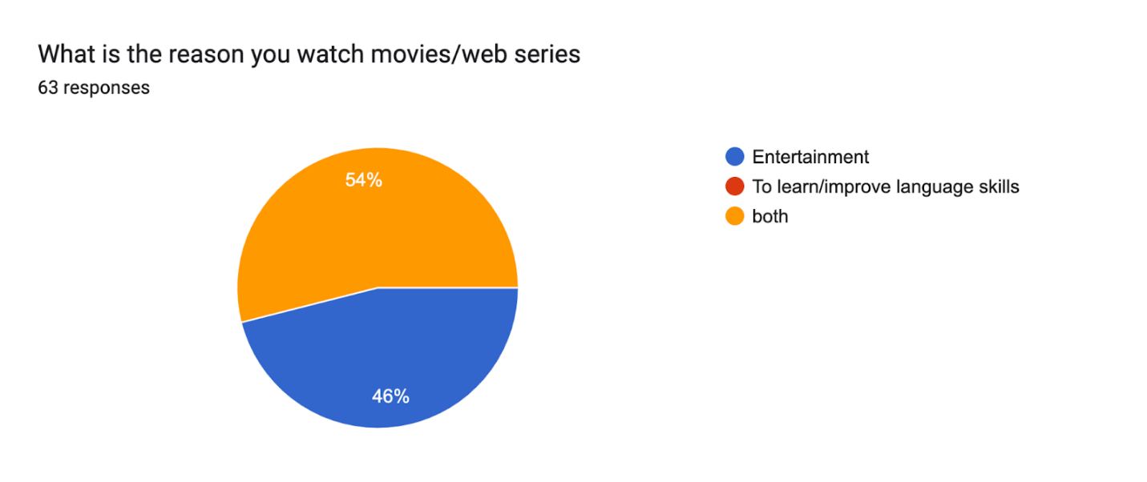
Figure 4: Feedback from the respondents
The respondents indicated that subtitles did help with better language understanding when asked whether they did. The topic was posed as to whether it would be beneficial to read aloud while picturing. Moreover, subtitles make video material accessible to a larger audience, which includes deaf and multilingual individuals. Subtitles are one of the finest ways to improve language skills in reading and listening. 31.7% of the sample strongly agreed, making up 57%. Some of them had different opinions, and 9.5% were unsure. 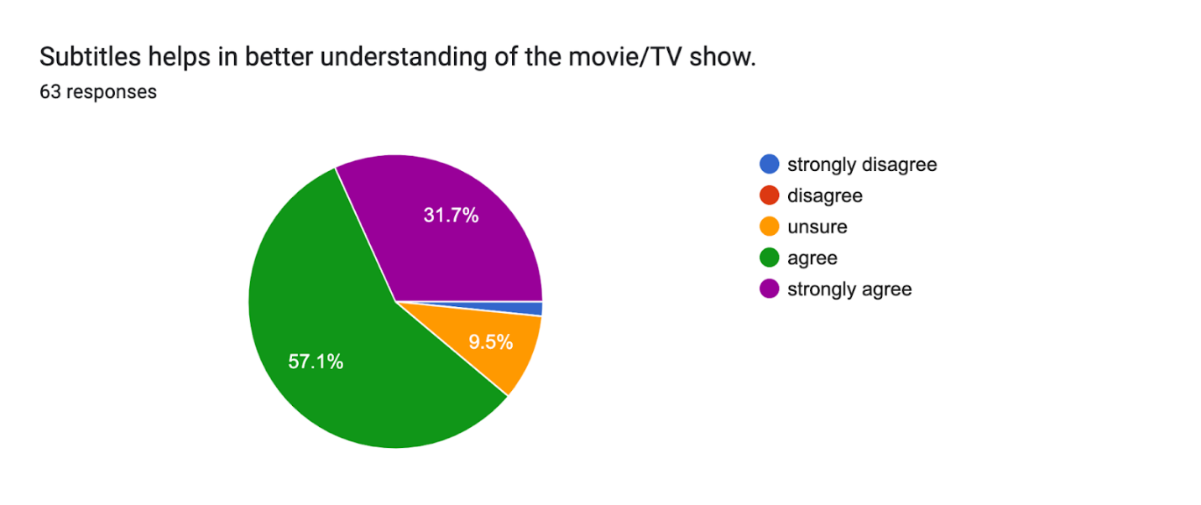
Figure 5: Feedback from the respondents
The respondents were questioned about whether they viewed media in other languages or not, as well as whether it helped them to learn other languages or not. This inquiry was made to understand the reasons underlying media consumption better. 54% strongly agreed, 19% were doubtful, and 23.8% of respondents agreed.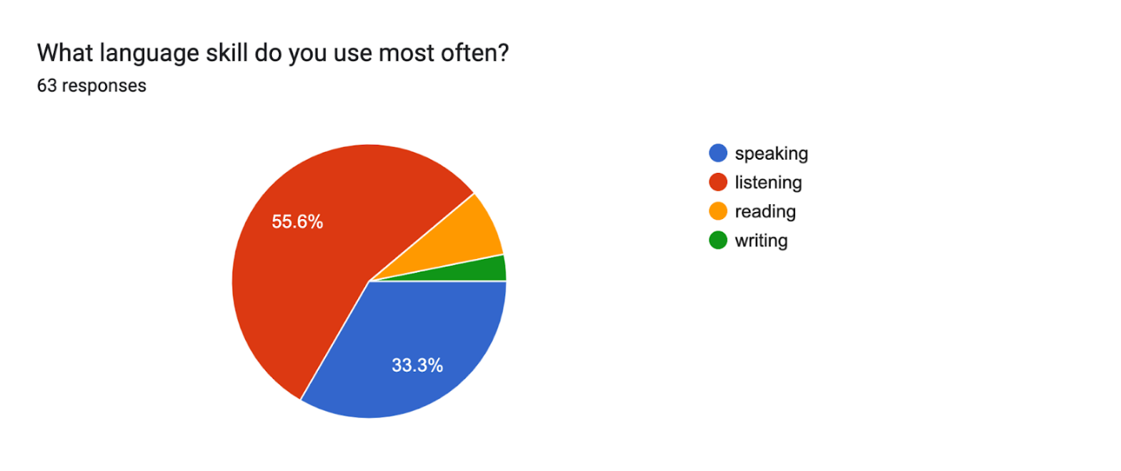
Figure 6: Feedback from the respondents
The next question focused on clarifying how verbal fluency affects television and movies. Talking effectively throughout frequent interactions helps you automatically generate sentences. Ensuring that your pronunciation of words is intelligible and crystal clear is crucial. It is a vital component of dialogue. The majority, or 71.4% of respondents, concurred; 15.9% strongly concurred; 11.1% were neutral; and a minor percentage disagreed.

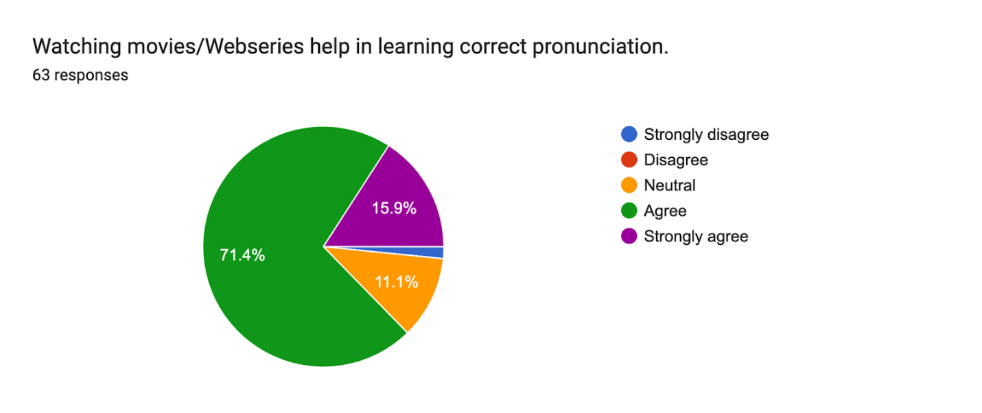
Figure 7: Feedback from the respondents
The responders were asked whether viewing movies or web series helped them enhance their vocabulary. An extensive vocabulary benefits all communication forms, including speaking, writing, listening, and reading. Vocabulary building is an essential language skill in addition to improving communication skills. This question determined whether respondents watched movies or web series to learn new terminology. 61.9% of respondents agreed, followed by 28.6% who strongly agreed, 7.9% who were indifferent, and a small percentage who disagreed.

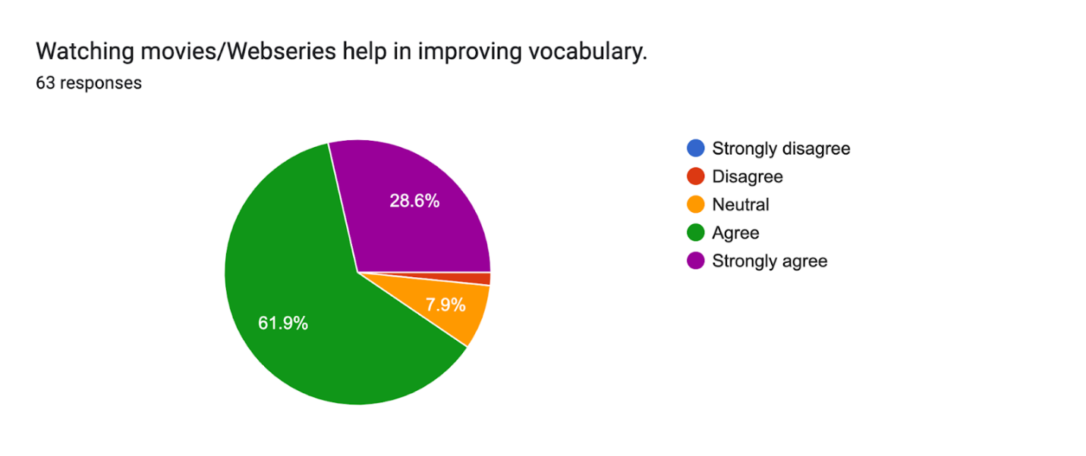
Figure 8: Feedback from the respondents
The last open-ended question asked of the students indicated the methods they would want to use to become better at listening. Many thought that YouTube videos and audiobooks would make suitable replacements for movies and web series.

- RESULTS

The study's main findings have proved that audiovisual resources significantly improved students' listening skill. Students who were taught using audio-visual resources scored higher on the post-test than those who did with the traditional method. Additionally, students who have used audiovisual resources reported higher satisfaction, engagement, and confidence in their listening skill. Similarly, audio-visual sources included several helpful features that supported students listening skill, such as visual cues, authentic language, subtitles, diverse topics, and interactive elements.
Also, the study's finding emphasises that engineering students who have watched English language movies and web series improved their listening skill significantly. In addition, they reported that they are highly motivated and enjoy learning English. At the same time, the students were exposed to different accents, dialects, vocabulary, and expressions by watching English language movies and web series, which improved their listening comprehension and pronunciation. Moreover, they developed their critical thinking, problem-solving, and intercultural skills by engaging with the content and context of the movies and web series. These findings suggest that watching English language movies and web series can be an effective and enjoyable way for engineering students to improve their listening skill. Therefore, the study has concluded that audiovisual resources can be effective and inspiring for enhancing students' listening skills.

- CONCLUSION

The present study has found that using audiovisual resources in English language teaching can be a fun and effective method for improving students' listening skill in the modern era. The study also provides suggestions and implications for teachers, learners, and researchers who want to use or explore audiovisual resources for teaching and learning English. Based on the findings of this study, some implications and suggestions for future research are that teachers should consider using web series and movies as supplementary materials to enhance their students’ listening skill and motivation. Teachers can also design various tasks and activities to guide their students before, during, and after watching web series and movies. For example, teachers can provide pre-viewing questions, vocabulary lists, comprehension quizzes, discussion prompts, summaries, reviews, or creative projects. Second, learners should take advantage of the availability and accessibility of web series and movies to practice their listening skill outside the classroom. Finally, researchers can also examine the factors that influence the success or failure of using web series and movies in English language teaching, such as the teacher’s role, learner autonomy, curriculum design, assessment methods, or technological support. Therefore, the study recommends utilising web series and movies as valuable and innovative resources for teaching and learning English in the 21st century.

REFERENCES

Abdi Karimova, M., Tashieva, N., Kyzy, A. T., & Abdullaeva, Z. (2021). Developing student's verbal communication skills and speech etiquette in English language teaching. Open Journal of Modern Linguistics, 11(01), 83–89. https://doi.org/10.4236/ojml.2021.111007
Albiladi, W. S., Abdeen, F., & Lincoln, F. (2018). Learning English through Movies: Adult English Language Learners’ Perceptions. Theory and Practice in Language Studies, 8(12), 1567. https://doi.org/10.17507/tpls.0812.01
Amsberry, D. (2009). Using effective listening skills with international patrons. Reference Services Review, 37(1), 10–19. https://doi.org/10.1108/00907320910934959
How can film help you teach or learn English? (2014, October 21). British Council. Retrieved September 1, 2023, from https://www.britishcouncil.org/voices-magazine/how-can-film-help-you-teach-or-learn-english
Intan, S., Yusuf, S. B., & Sari, D. F. (2022). A review on using audiovisual media in improving listening skills among junior high school students. English Education Journal, 13(2), 303–316. https://doi.org/10.24815/eej.v13i2.25932
Kusumawati, E. (2019). The Effect of Watching English Movies with Subtitles on ESP Students’ Content and Vocabulary Comprehension. A Study Conducted at an Indonesia Polytechnic Engineering. Science, Engineering, Education, and Development Studies (SEEDS). https://doi.org/10.20961/seeds.v2i2.27514
Liando, N., Sahetapy, R. J., & Maru, G. (2018a). ENGLISH MAJOR STUDENTS’ PERCEPTIONS TOWARDS WATCHING ENGLISH MOVIES IN LISTENING AND SPEAKING SKILLS DEVELOPMENT. Advances in Social Sciences Research Journal. https://doi.org/10.14738/assrj.56.4627
Metruk, R. (2019). USING ENGLISH MOVIES AND TV PROGRAMS FOR DEVELOPING LISTENING SKILLS OF EFL LEARNERS. Information Technologies and Learning Tools, 70(2), 227. https://doi.org/10.33407/itlt.v70i2.2488[]
Pham, D. T. (2021). The effects of Audiovisual Media on Students’ Listening Skills. International Journal of TESOL & Education, 1(1), 13–21. http://i-jte.org/index.php/journal/article/view/3
Runde, D. F., & Nealer, E. (2018, April 10). English Language Proficiency and Development. CSIS. Retrieved September 5, 2023, from https://www.csis.org/analysis/english-language-proficiency-and-development
The power and importance of listening. (n.d.). TeachingEnglish. https://www.teachingenglish.org.uk/professional-development/teachers/knowing-subject/magazine/power-and-importance-listening
Wolfson, N. (1976). Speech events and natural speech: some implications for sociolinguistic methodology. Language in Society, 5(2), 189–209. https://doi.org/10.1017/s0047404500007028

