Application of Diesel Engine Using Power Plant
Benjamin Franklin Selvanayagam¹, Priyan K², Ragul Prasad N³,Koushik S⁴
Associate Professor¹, Final Year Students^{2, 3, 4}
Department of Mechanical Engineering,
Sri Ramakrishna Institute of Technology.
Corresponding Author:sbenjaminfranklin1344@gmail.com

Abstract
A generating station in which diesel engine is used as the prime mover for the generation of electrical energy is known as diesel power station. In a diesel power station, diesel engine is used as the prime mover. The diesel burns inside the engine and the products of this combustion act as the working fluid to produce mechanical energy. The diesel engine drives alternator which converts mechanical energy into electrical energy. As the generation cost is considerable due to high price of diesel, therefore, such power stations are only used to produce small power. Although steam power stations and hydro-electric plants are invariably used to generate bulk power at cheaper costs, yet diesel power stations are finding favour at places where demand of power is less, sufficient quantity of coal and water is not available and the transportation facilities are inadequate. A majority of the world’s energy is provided by a few members of the conventional sources of energy: Fossil Fuels. Fossil fuels are natural energy sources formed by processes such as the decomposition of buried organic matter. The decomposing matter is buried deep underneath the surface over time and is exposed to heat and pressure in the earth’s crust for millions of years. Fossil fuels consist mainly of carbon-rich fuels such as coal, petroleum and natural gas. This plants are also standby sets for continuity of supply to important points such as hospitals, radio stations, cinema houses and telephone exchanges.
1. Introduction
While humans have been harnessing energy from the sun, wind, and water for thousands of years, technology has changed significantly over the course of history, and these ancient energy types have developed into state-of-the-art innovative power generation sources. Power Plants are classified as 1.Diesel power plant 2.Coal fired thermal power plant 3.Gas thermal power plant 4.Geothermal power plant 5.Biomass thermal power plant 6.Nuclear thermal power plant. In diesel power plant. The design and layout of the plant are quite simple. It occupies less space as the number and size of the auxiliaries is small. It can be located at any place. It can be started quickly and it can pickup load in a short time. There are no standby losses. It requires less quantity of water for cooling. The overall cost is much less than that of steam power station of same capacity. The thermal efficiency of the plant is higher than that of a steam power station. It requires less operating staff. Coal fired thermal plant used coal as the source. In India, power is produced using both conventional such as thermal, nuclear, hydro and renewable like wind, solar, biomass etc source. Even though a large portion of the electrically produced – 75 percentage of the total is produced using coal-fired thermal power plants. In gas thermal power plant the fuel sources in gas thermal plants are gases or oils. A thermal power station that burns natural gas to produce electricity is known as gas-fired power station or a natural gas power plant. In geothermal power plant underground fluids are used by geothermal power plants to generate heat. Biomass thermal power is generated using bagasse, rice husk, straw, cotton stalk, coconut shells, phase, Nuclear power plants are nuclear fission to generate heat. A nuclear power plants operation phase typically lasts the longest during its entire cycle.

2. Essential Elements of Diesel Power Plant
(i) Air intake system
(ii) Fuel supply system
(iii) Cooling system
(iv) Exhaust system
(v) Engine starting system
(vi) Lubricating system

3. Air Intake System
This system supplies necessary air to the engine for fuel combustion. It consists of pipes for the supply of fresh air to the engine manifold. Filters are provided to remove dust particles from air which may act as abrasive in the engine cylinder. Because a diesel engine requires close tolerances to achieve its compression ratio, and because most diesel engines are either turbocharged or supercharged, the air entering the engine must be clean, free of debris, and as cool as possible. Also, to improve a turbocharged or supercharged engine’s efficiency, the compressed air must be cooled after being compressed. The air intake system is designed to perform these tasks. Air intake systems are usually one of two types, wet or dry. In a wet filter intake system, as shown in the Figure 4.1, the air is sucked or bubbled through a housing that holds a bath of oil such that the dirt in the air is removed by the oil in the filter. The air then flows through a screen-type material to ensure any entrained oil is removed from the air. In a dry filter system, paper, cloth, or a metal screen material is used to catch and trap dirt before it enters the engine. In addition to cleaning the air, the intake system is usually designed to intake fresh air from as far away from the engine as practicable, usually just outside of the engine’s building or enclosure. This provides the engine with a supply of air that has not been heated by the engine’s own waste heat. The reason for ensuring that an engine's air supply is as cool as possible is that cool air is denser than hot air. This means that, per unit volume, cool air has more oxygen than hot air. Thus, cool air provides more oxygen per cylinder charge than less dense, hot air. More oxygen means a more efficient fuel burn and more power. After being filtered, the air is routed by the intake system into the engine's intake manifold or air box. The manifold or air box is the component that directs the fresh air to each of the engine’s intake valves or ports. If the engine is turbocharged or supercharged, the fresh air will be compressed with a blower and possibly cooled before entering the intake manifold or air box. The intake system also serves to reduce the air flow noise.

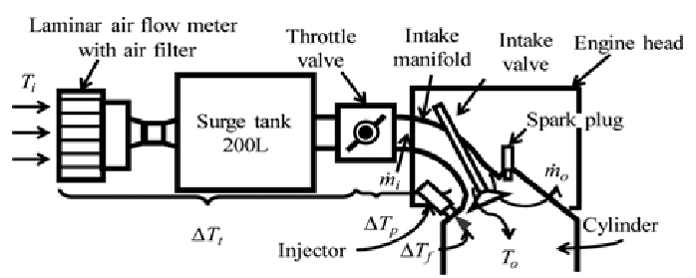
Figure: 1 Air Intake System
4. Fuel Supply System
It consists of storage tank, strainers, fuel transfer pump and all day fuel tank. The fuel oil is supplied at the plant site by rail or road. The oil is stored in the storage tank. From the storage tank, oil is pumped to smaller all day tank at daily or short intervals. From this tank, fuel oil is passed through strainers to remove suspended impurities. The clean oil is injected into the engine by fuel injection pump. A fuel supply system in a diesel engine provides measures, injects and atomizes the fuel. Thus, it is also referred to as the "heart" of an engine. Apart from it, the types of injectors directly affect how well an engine performs. Additionally, fuel injection systems are more expensive since they are produced with remarkable accuracy. Fuel will flow either due to gravity or through a fuel feed pump, which is available to give energy to an injection pump through a filter. Then, it supplies the cylinder heads' built-in injectors with fuel.
4.1 Types of Fuel Injection System:

4.1.1 Air Injection System
In this system, the air is first compressed using a compressor to very high pressure. After that, fuel is metered and pumped to a nozzle, which is also connected to a source of high-pressure air.Next, when this nozzle is opened, the air blows the gasoline into the engine and delivers a well-atomised spray. However, since this system is expensive and complicated, this method is no longer used.

4.1.2 Solid Injection System
People mostly replace the injection method with this one. This is a direct injection of the atomised, under-pressure fuel into the combustion chamber. Above all, it requires a pump to supply the gasoline at high pressure (as high as 300 bar abs). Also, it can be further divided into the three following widely employed systems

4.1.3 Common Rail System
In this instance, filters allow fuel to pass from the storage tank to a low-pressure pump. The low-pressure pump moves fuel from the high-pressure pump to the common rail. As a result, high-pressure fuel is gathered in the common rail, and the necessary amount of fuel is then sent to the injectors and cylinders via metering devices. This method is typically used with multi-cylinder and Cummins engines.

4.1.4Individual Pump System
In this case, fuel passes through filters, low-pressure pumps, and the storage tank. This low-pressure pump distributes the fuel to 4 different metering and pressure pumps.The fuel will be pumped to individual injectors that are available in the cylinder heads using these independent metering and pressure pumps. Also, these are employed in big, slow-moving engines.

4.1.5. Distributor System
In distributor systems, fuel will move from a storage tank through filters to the low-pressure pump, then to the metering and pressure pumps. This fuel distributor device distributes and sends the necessary amount of fuel to each injector and cylinder using the fuel metering and pressure pump. Later, it is made use of in small and medium-sized engines.

4.1.6 Multipoint Fuel Injection System
At all engine speeds and loads, a multipoint fuel injection system is utilized to provide an air-fuel mixture of the right strength. It helps in providing the necessary quantity to each cylinder of a multi-cylinder engine.
4.2 Types of Nozzles
In diesel engines, there are 3 types of nozzles those are:
4.2.1 Single Hole: These are nozzles with 0.2 mm diameter and are primarily used in combustion chambers. Good mixing of air is challenging in this case. Also, it has the tendency to dribble.
4.2.2 Multiple Holes: The usual size of multiple hole-type nozzles is 0.35 to 1.5 mm and generally has 4 to 18 holes.
4.2.3 Pintle: In this case, the spindle is equipped with a projection called a pintle. It prevents weak injection and dribbling, which peeks out from the nozzle's mouth. Moreover, you can also find a conical or cylindrical form of the nozzle to avoid dribbling.
4.3 Types of Injectors
Primarily, there are three types of injectors:
4.3.1Air Blast Injectors: These are utilized in systems that inject air. However, methods for injecting air are no longer used since they call for multistage compressors. Therefore, these injectors are no longer in use.
4.3.2Mechanically Operated Injectors: The same mechanism that was once used to run IC engine valves now operates them.
4.3.3Automatic Fuel Injector: All automotive CI engines use these Automatic Fuel Injectors. They consist of a needle valve that raises the fuel pressure. Apart from it, the gasoline pump is what generates this fuel pressure.

4.4 Electronic Fuel Injection System

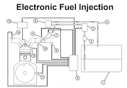
Figure: 2 Electronic Injections System
Electronics were first introduced in 1965, and now electronic components account for about 30–40% of the cost of automobiles. In this regard, electronics and computers are used in cars to get maximum power and optimum economy. Electronic fuel injection systems use a variety of sensors to measure characteristics like temperature, gas pressure, throttle position, air flow rate, etc. Then the Electronic Control Unit (ECU), essentially a computer, receives this data via sensors. Later, this ECU processes the data and controls injectors or other devices to have optimum power, the best economy, and minimal emissions. Regardless of the type of fuel supply system in a diesel engine, the purpose of a diesel fuel system remains unchanged. It is to precisely and timely inject pressurized and atomized fuel into each engine cylinder. In a diesel engine, combustion happens when this fuel surge and hot compressed air combine.
5. Cooling System
The engine cooling system consist of coolant pumps, water cooling towers or spray pond, water treatment or filtration plant & Connecting Pipe Works. The heat produced due to internal combustion, drives the engine. But some parts of this heat raise the temperature of different parts of the engine. High temperature may cause permanent damage to the machine. Hence, it is essential to maintain the overall temperature of the engine to a tolerable level. Cooling system of diesel power station does exactly so the cooling system is required to carry heat from diesel engine to keep its temperature within safe limits. The water pump circulates water to cylinder of diesel engine to carry away the heat. The cooling tower is used for the same water reused. The cooling system requires a water source, water pump and cooling towers. The pump circulates water through cylinder and head jacket. The water takes away heat from the engine and it becomes hot. The hot water is cooled by cooling towers and is re-circulated for cooling.
5,1Types of Cooling System
5.1.1 Open Cooling System: A Plant near the river may utilize the river water for cooling & discharging again the hot water into river. This type of cooling system is known as open cooling system.
5.1.2 Closed Cooling System: The Cooling Water is circulated again & again and only water lost due to leakage, evaporation etc. is made up by taking make up water from supply source.

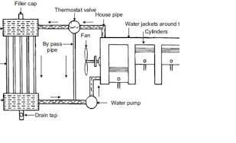

Figiure:3 Engine Water Cooling System
6. Lubrication System:
Engine lubrication system consists of lubricating oil pump, oil tanks, filters, coolers, purifiers & connecting pipes. This system provides lubricating oil to moving parts of the system to reduce the friction between them wear & tear of the engine parts. This system minimizes the water of rubbing surface of the engine. Here lubricating oil is stored in main lubricating oil tank. This lubricating oil is drawn from the tank by means of oil pump. Then the oil is passed through the oil filter for removing impurities. From the filtering point, this clean lubricating oil is delivered to the different points of the machine where lubrication is required the oil cooler is provided in the system to keep the temperature of the lubricating oil as low as possible. It is then cooled through heat exchanger by means of cold water and then it is fed to the engine.

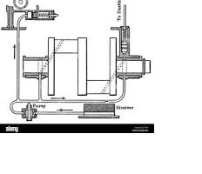

Figure:4 Engine Lubrication system

The exhaust system collects the exhaust gases from the cylinders, removes harmful substances, reduces the level of noise and discharges the purified exhaust gases at a suitable point of the vehicle away from its occupants..The exhaust system collects the exhaust gases from the cylinders, removes harmful substances, reduces the level of noise and discharges the purified exhaust gases at a suitable point of the vehicle away from its occupants. The exhaust system can consist of one or two channels depending on the engine. The flow resistance must be selected so that the exhaust backpressure affects engine performance as little as possible. To ensure that the exhaust system functions perfectly, it must be viewed as a whole and developed accordingly. This means that its components must be coordinated by the design engineers in line with the specific vehicle and engine. Every internal combustion engine produces "exhaust noise" due to the pulsating emission of gases from the cylinders. This noise has to be silenced by reducing the sound energy of the exhaust gas flow. There are two basic options here: Absorption and reflection of the sound in the silencer. These two principles are generally combined in a single silencer. Exhaust chambers and exhaust flaps are other sound-absorbing and sound-modifying elements that can be used to eliminate especially undesirable frequencies from the outlet noise.Catalytic converters also have a sound-absorbing effect.
7. Exhaust System

The exhaust system is itself a system subject to vibration, it produces noise itself through natural frequencies and vibration which are transmitted to the car body. Careful coordination of the entire system is therefore necessary here. This includes design and positioning of the individual elements of the exhaust system and their flexible mountings. In addition to all the complex functions which the exhaust system has to perform, it is also subject to extreme stresses. The fuel-air mixture in the cylinders is abruptly heated to temperatures up to 2,400 °C. This causes it to expand greatly before escaping into the exhaust system at supersonic speed. This noise level resembles the crack of an explosion and must be reduced by approx. 50 dB(A) as it travels from the engine exhaust valve to the end of the exhaust system. Apart from temperature and pressure stresses, the exhaust system must also cope with vibrations from the engine and bodywork as well as vibrations and jolting from the carriageway. The exhaust system additionally has to resist corrosion attacking from the inside caused by hot gases and acid, and from the outside in the form of moisture, splashed water and salt water. There is also the risk that the catalyst may be poisoned through sulphur or lead present in the fuel.
Today's exhaust systems have very little in common with the simple exhausts used in the past. In more modern cars, they basically consist of a front section with
- the exhaust manifold,
- the purification system and
- the connecting pipes, together with a rear section with the silencer system and pipes.
The entire system is connected to the floor pan by means of flexible mounting elements. The number of catalytic converters and silencers depends on the type of engine, engine performance and the required emission values. If the exhaust system consisted only of rigid pipes, the rear silencer would vibrate violently – with the risk of subsequent breakage. For this reason, modern exhaust systems are built with mass dampers and decoupling elements. They prevent major deflections of the exhaust system and also prevent smaller vibrations being passed from the engine to the exhaust system and entering the interior as acoustic pulses. Mass dampers and decoupling elements thus improve ride comfort while increasing the service life of the exhaust system.
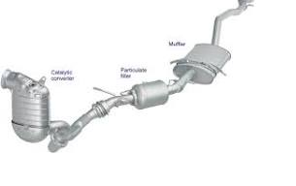
Figure:5 Engine Exhaust System
8. Starting System
The Importance of Starting Systems A functional machine needs a running engine, and if the engine doesn’t crank, it doesn’t start. A properly operating and reliable starting system is a must for keeping a machine productive. For many years, diesel engines have mostly used electric motors to crank them over to start the combustion process. For some applications, an air or hydraulic motor will create the torque needed to turn the engine over. Many years ago, diesel engines were sometimes started with a smaller gas engine called a pup engine for a pup engine on an older diesel engine. Another way to get a diesel engine started was to start it on gasoline and then switch it over to run on diesel fuel. This was a complex solution to a simple task because the engine had to have a way to vary its compression ratio, and it needed a spark ignition system and a carburetor. As 12V electrical systems became more popular and electric motor design improved, electric starters were able to get the job done. Many large diesel engines will use a 24V starting system for even greater cranking power. A diesel engine needs to rotate between 150 and 250 rpm to start. The purpose of the starting system is to provide the torque needed to achieve the necessary minimum cranking speed. As the starter motor starts to rotate the flywheel, the crankshaft is turned, which then starts piston movement. For a small four-cylinder engine, there doesn’t need to be a great deal of torque generated by a starter. But as engines get more cylinders and bigger pistons, a huge amount of torque will be needed to get the required cranking speed. Some heavy-duty 24V starters will create over 200 ft-lb of torque. This torque then gets multiplied by the gear reduction factor between the starter motor pinion gear and ring gear on the engine’s flywheel. This is usually around 20:1.A starter assembly engaging with a flywheel ring gear. Figure 7–2 A typical arrangement of a heavy-duty electric starter on a diesel engine. Some larger engines will need two or more starters to do this. Some starters for large diesel engines will create over 15 kW or 20 hp! When a starter motor starts to turn the engine over, its pistons start to travel up in the cylinders on compression stroke. There needs to be between 350 and 600 psi of pressure created on top of the piston. This is the main resistance that the starter has to overcome. This pressure is what is needed to create the necessary heat in the cylinder so that when fuel is injected it will ignite. If the starting system can’t crank the engine fast enough, then the compression pressure and heat won’t be high enough to ignite the fuel. If the pistons are moving too slowly, there will be time for the compression to leak by the piston rings. Also the rings won’t get pushed against the cylinder, which again allows compression pressure to leak into the crankcase. When this happens, the engine won’t start or it starts with incomplete combustion. Incomplete combustion equals excessive emissions.
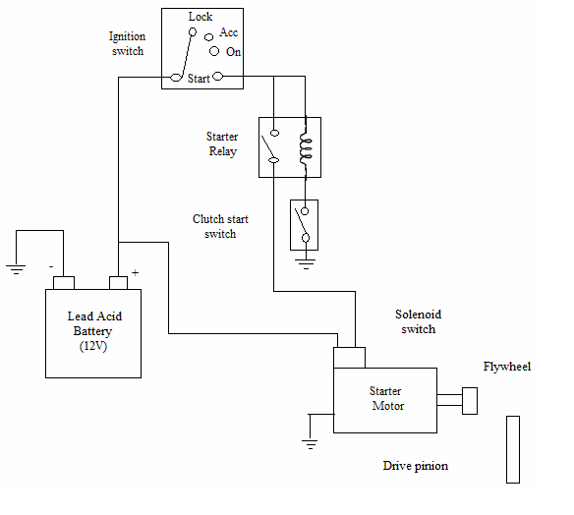
Figure:6 Engine Starting System

This is another reason to have a properly operating starting system. The faster a starter can crank a diesel engine, the faster it starts and the quicker it runs clean. This engine cranking task is much more difficult in colder temperatures especially if the engine is directly driving other machine components such as hydraulic pumps, a torque converter, or a PTO (power take-off) drive shaft. Cold engine oil adds to the load on the starter, and this load may increase by three to four times what it would normally be in warmer weather. Engine oil that is the wrong viscosity (too thick) for the temperature will greatly increase the engine’s rolling resistance. Adding to this problem is the fact that a battery is less efficient in cold temperatures. When engineers design a cranking system, they must take into account cold weather cranking conditions and will quite often offer a cold weather starting option. This would likely include one or more of the following: bigger or more batteries, higher output starter, larger battery cables, battery blankets, oil heaters, diesel fired coolant heater, electric immersion coolant heater (block heater), and one or more starting aids like an ether injection system or an inlet heater. One more recent difficulty added to starting systems is a result of electronic controls on some engines. Some ECMs may need to see a minimum number of engine revolutions at a minimum speed before it will energize the fuel system. This equates to longer cranking times and more strain on the cranking system. Some electronic engines will crank for five seconds or longer even when the engine is warm before the ECM starts to inject fuel and the engine starts. It’s important that a machine’s starting system works properly and you should be aware of how the main components of a system work.
9.Maintenance of Diesel Electric Power Plant
At the time of diesel engine or diesel electric power plant, following points are considered during maintenance period.
a. To maintain the operating condition of diesel engine at every half hour.
b. To maintain the correct record of the instrument reading in log sheet.
c. To maintain the record of instrument temperature, pressure, electrical load, flow etc.
d. To check the level of fuel oil periodically.
e. Filterized the fuel and remove unwanted impurities.
f. Clean the fuel tank at regular interval.
10.Advantages of Diesel Power Station
1. This is simple in design point of view.
2. Required very small space.
3. It can also be designed for portable use.
4. It has quick starting facility; the small diesel generator set can be started within few seconds.
5. It can also be stopped as when required stopping small size diesel power station, even easier than it’s starting
6. As these machines can easily be started and stopped as when required, there may not be any standby loss in the system.
7. Cooling is easy and required smaller quantity of water in this type power station.
8. Initial cost is less than other types of power station.
9. Thermal efficiency of diesel is quite higher than of coal.
10. Small involvement is less than steam power station.
11. It requires less operating staff.
12. The overall cost is much less than that of steam power station of same capacity.
11.Disadvantages of Diesel Power Station
1. As we have already mentioned, the cost of diesel is very high compared to coal. This is the main reason for which a diesel power plant is not getting popularity over other means of generating power. In other words the running cost of this plant is higher compared to steam and hydro power plants.
2. The plant generally used to produce small power requirement.
3. Cost of lubricants is high.
4. Maintenance is quite complex and costs high.
5. The plant doesn’t work satisfactorily under overload conditions for a longer period.
6. The cost of lubrication is generally high.
7. The maintenances charges are generally high
12.Applications
1. The diesel oil is used as a fuel in power generation.
2. It produces AC as well as DC Voltages.
3. It is used where small power is generation is requirement.
4. In case of any emergency diesel engines are used.
5. It is also used for peal load during small period of time.
6. It is used to restart the boilers.
7. It is used in remote places.
8. It can be used in areas having low load factor

