Futuristic Trends in
Management

Impact Of Blockchain In Digital Marketing

A
ABSTRACT
Blockchain has emerged as a highly promising technology in the IT domain. It is an open, immutable, distributed public ledger that can be accessed by several parties involved in the transaction and acts as a universal depository of all transactions between the involved parties. The increasing acceptance of cryptocurrency worldwide is one of the major factors driving market growth. Commercial and central banks across the world are now using blockchain technology for payment processing and issuing of their digital currencies. In October 2008, Satoshi Nakamoto launched bitcoin with a White Paper, creating and deploying bitcoin’s original implementation. Satoshi Nakamoto, the unknown person/group behind Bitcoin, described how the blockchain technology, a distributed peer-to-peer linked-structure, could be used.
Each company, by blockchain, digital Marketing, marketing security reaches customers through different channels. Fastest, cheapest, most transparent way increases customer satisfaction.

Author
Aradhna singh
Assistant Professor
Deparment of Management
Hardayal Technical Campus
Mathura

KEYWORDS: Technology, marketing,bitcoin, Central Bank, Commercial
INRODUCTION: Blockchain technology could enable businesses to create more personalized marketing campaigns by allowing them to securely store and analyze customer data. This could include data such as purchase history, preferences, and demographics, which could be used to create targeted ads and offers.
Blockchain technology is an advanced database mechanism that allows transparent information sharing within a business network. A blockchain database stores data in blocks that are linked together in a chain.
What is blockchain technology:
Blockchain technology is a decentralized, distributed ledger that stores the record of ownership of digital assets. Any data stored on blockchain is unable to be modified, making the technology a legitimate disruptor for industries like payments, cybersecurity and healthcare.
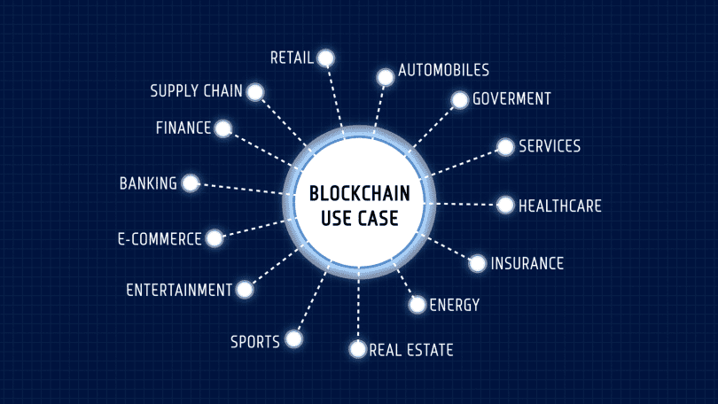

How Does a Blockchain Work?
You might be familiar with spreadsheets or databases. A blockchain is somewhat similar because it is a database where information is entered and stored. But the key difference between a traditional database or spreadsheet and a blockchain is how the data is structured and accessed.
A blockchain consists of programs called scripts that conduct the tasks you usually would in a database: Entering and accessing information and saving and storing it somewhere. A blockchain is distributed, which means multiple copies are saved on many machines, and they must all match for it to be valid.
The blockchain collects transaction information and enters it into a block, like a cell in a spreadsheet containing information. Once it is full, the information is run through an encryption algorithm, which creates a hexadecimal number called the hash.
The hash is then entered into the following block header and encrypted with the other information in the block. This creates a series of blocks that are chained together.

Transaction Process
Transactions follow a specific process, depending on the blockchain they are taking place on. For example, on Bitcoin's blockchain, if you initiate a transaction using your cryptocurrency wallet—the application that provides an interface for the blockchain—it starts a sequence of events.
In Bitcoin, your transaction is sent to a memory pool, where it is stored and queued until a miner or validator picks it up. Once it is entered into a block and the block fills up with transactions, it is closed and encrypted using an encryption algorithm. Then, the mining begins.
Objective of the Study:
This report is depends on secondary source like report published by government of India, e- journals and internet.
Research methodology:
The methodology comprised of four stages; identification, selection, evaluation and validation. Initially, the available blockchain platforms are identified, followed by selecting a suitable blockchain platform using a multi-criteria decision-making method such as Simple Multi Attribute Rating Technique (SMART).

Benefit of the study:
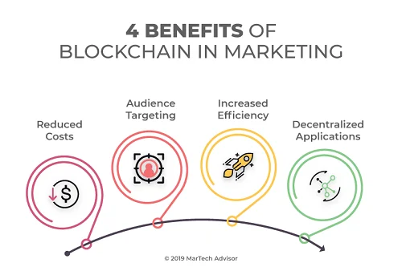

Benefits of Blockchain in Digital Marketing
- Improved Security.
- Buying Ads Without Third-Party.
- High-Quality Consumer Information.
- Improved Trust Building.
- Acceptance of Alternate Payment

let’s look at the blockchain strategies and best
practices that are transforming the marketing landscape.
1 Influencer Marketing
2. Affiliate Marketing
3. Loyalty Programs
4. Data Protection
5 User Awards
6. Ad Fraud Prevention
7. Blockchain-Based Social Platforms
Organizations that attract customers with social media marketing make it safe for customers to
shop on social media by facilitating their business with Blockchain-based social media platforms. Platforms such as Peepeth and mastodon.social are solving the exact same problem. Socrates Journal of Interdisciplinary Social Studies, 2021, Year 7, Volume 10
8. Social Commerce Along with these solutions, e-commerce has been bestowed with several other solutions. AT&T is collaborating with Microsoft and IBM to create a suite of blockchain products that includes a solution that ensures the authenticity of products.
Finding:
Blockchain increases trust, security, transparency, and the traceability of data shared across a business network — and delivers cost savings with new efficiencies. Blockchain for business uses a shared and immutable ledger that can only be accessed by members with permission.
Suggestionn:
Blockchain technology could enable businesses to create more personalized marketing campaigns by allowing them to securely store and analyze customer data. This could include data such as purchase history, preferences, and demographics, which could be used to create targeted ads and offers.
Conclution: Blockchain technology creates a permanent and immutable record of every transaction. This impenetrable digital ledger makes fraud, hacking, data theft, and information loss impossible.
Reference:
- Abderahman Rejeb, J. G. (2020). How Blockchain Technology Can Benefit Marketing: Six Pending Research Areas. https://www.frontiersin.org/articles/10.3389/fbloc.2020.00003/full. Accessed Date
- Adıgüzel, S. (2019). Contribution of Blockchain Applications on the Economy in Global Logistic. International Journal of Scientific and Technological Research, Vol.5, No.10(www.iiste.org ISSN 2422-8702 (Online), DOI: 10.7176/JSTR/5-10-13 Vol.5, No.10, 2019 96 | P a g e www.iiste.org).
- Antoniadis Kontsas S., S. K. (2021). Blockchain Applications in Marketing. Blockchain
- Finance Market Size, Forecast Report to 2027

- Ghose, A. (2018). What Blockchain Could Mean for Marketing. Harward Business Review,
- https://hbr.org/2018/05/what-blockchain-could-mean-for-marketing. (May 08 2021].).
- https://www.google.com/search?q=blockchain+in+marketing+research+methodology&oq=blockchain+in+marketing+research+methodology&aqs=chrome..69i57j33i160l2j33i22i29i30.34157j0j7&sourceid=chrome&ie=UTF-8

