IOT BASED STEERSMANSHIP SYSTEM FOR VISUALLY IMPAIRED HUMAN RACE

Tejeshwini C S
Information Science and Engineering
Vidya Vikas Institute of Engineering and Technology,
Mysore, India
thejanaveen.vviet@gmail.com
Priyanka D
Information Science and Engineering
Vidya Vikas Institute of Engineering and Technology,
Mysore, India
priyankapal.d@gmail.com

Dr. Archana B Indira
Computer Science and Engineering Computer Science and Engineering
Vidya Vikas Institute of Engineering and Technology, Proudadevaraya Institute of technology,
Mysore,Karnataka, India Vijaynagar,karnatakaIndia
archanashashikumar3612@gmail.com indira@pdit.ac.in

ABSTRACT
By using this smart cane, blind people can easily contact the physical environment, which is the vision of our steersman ship system. If we are attentive, we will quickly realize that they need help to walk. With the help of this intelligent blind cane, people can move around with confidence. Today, blind people use a standard blind cane to orient themselves while walking from one place to another. Although the standard cane is the most commonly used tool for visually impaired people today, it cannot help them identify risks at all levels of barriers. In this context, we propose a completely new intelligent method to assist blind or visually impaired people. The technology is used to give blind people the same mobility and confidence as sighted people. It also provides guidance and information to avoid obstacles such as people, water and sensor-based obstacles. The technology is linked to navigation from GPS navigation so that the locus of the blind human being can be accurately determined.
Keywords— IoT, Navigation System, Visually Impaired, Sensors.

INTRODUCTION

.
Our steersman ship system, For humans to exist, the ability to see is essential. But some people have become immobilized by their ignorance. In this essay, we suggest a navigation technique or tool that is advantageous to the blind. People may see objects in front of them and move through both familiar and foreign terrain with the aid of this blind stick. The blind person's phone vibrates or plays an audio message to alert them of impediments, which are detected by IR sensors. Mobility and independence for visually impaired people are defined as the capacity to move with assurance, swiftness, and safety in one's immediate environment; however they cannot be attained without technology. We have developed a way that aids the blind individual. It can safeguard the blind person with the aid of GSM/GPS, users of a telegraph program on an android phone or computer worn by the blind person, and the administrator to detect obstacles in front of them.

II.EASE OF USE

It efficiently recognizes numerous objects in the immediate area using computer vision and correctly warns the user as necessary. This device might be the first step in making it possible for people who are blind to travel without canes.

III.METHODOLOGY
- It serves as an example of the proposed paradigm in this situation. A microprocessor called Raspberry Pi is use to collect all the data.
- A buzzer alerts the user if there is an obstacle in front of the stick before the web camera starts recording video using Tensor Flow object detection. Finds the object and then uses the speaker to address it.
- The GPS module determines the user's locus every 30 seconds.
-A fire sensor's job is tasked with locating nearby flames.- A water sensor is used to locate water nearby.
- A light sensor allows the user to determine whether it is day or night using a light sensor by listening to the speaker.

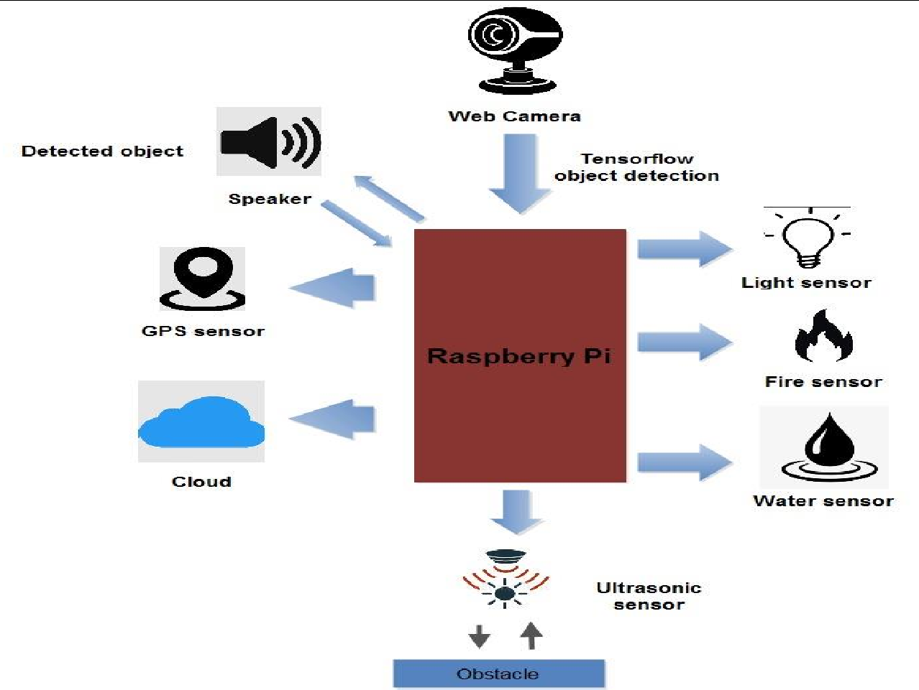

Fig: Architectural View of System

IV.MODELING AND ANALYSIS

- A GPS receiver can receive geolocus and time data from a GPS system at any point on or near the earth where there is an unhindered line of sight to four or more GPS satellites.
- Ultrasonic Sensors: Ultrasonic/level sensors employ ultrasonic waves to measure distance, as the name suggests. An ultrasonic wave is emitted by the sensor head, which then detects the wave that is reflected back from the target. By measuring the time between transmission and reception, ultrasonic and level sensors determine the distance to a target.
- Buzzer: A buzzer, often known as a beeper, is an electronic or piezoelectric sound signaling device. Buzzers and beepers are frequently employed as railway horns, alarm clocks, timers, and confirmation devices for human input such as mouse or keyboard clicks.
- Fire sensor: using various technologies, smoke detectors can detect tiny particles in the air to identify fires. Once they detect that these particles exceed a certain threshold, they trigger the alarm so that you and your family can escape.
- Water sensors can find leaks if they are positioned in locations where water shouldn't be. When Wi-Fi is activated, the sensor can notify the homeowner via a smartphone app.
Light sensors detect the existence of light and transform its energy into an electrical signal. After being converted to electrical energy, the frequency spectrum of radiation from an infrared to an ultraviolet light source can be monitored.
- Raspberry Pi: A credit card-sized, low-cost computer, the Raspberry Pi connects to a computer monitor or TV and is controlled by a regular keyboard and mouse. People of all ages can learn computer science and programming in languages like Scratch and Python with the aid of this potent small gizmo.
Speaker: the Speaker acts as the representative, of the Chamber and delivers messages and speeches, e.g. to the Governor. He is also responsible for defending the privileges and rights of the House of Representatives and its members.
- Webcam: A webcam is a commonplace digital camera that is incorporated into computers. Its main function is to send pictures over the Internet. It is frequently used for instant chat software and for image capturing.
- Tensor Flow Object Recognition: Tensor Flow object recognition is a computer vision method. As the name suggests, it helps identify, locate, and track an object in an image or video.

IV.RESULTS AND DISCUSSION
A promising technological application that has the potential to improve the quality of life for many persons with visual impairments is the creation of an IoT-based steering system for the blind human race. This system gives users up-to-the-minute information about their surroundings and guides them to their chosen location by combining sensors, GPS technology, and machine learning algorithms.

V.CONCLUSION
In the next stage of assistive apps, The Blind Stick acts as a flexible interface for simple and practical interior and exterior mobility for visually impaired persons. It is both inexpensive and safe. As a result, obstacles are effectively detected in the user's direction. It offers quick response times, low-cost, dependable, lightweight, low-power, and efficient navigation. By extending the range of the ultrasonic sensors and introducing technologies to gauge the strength of incoming barriers, wireless networking between the device's components would improve its extra functions. With this strategy, we specifically targeted blind and visually challenged people in all developing nations. For additional versatility and convenience of usage, a vibrator can be connected. This includes a mechanism to find the individual via application.

REFERENCES

- P. Chavan, K. Ambavade, S. Bajad, R. Chaudhari and R. Raut, "Smart Blind Stick," 2022 6th International Conference On Computing, Communication, Control And Automation (ICCUBEA, Pune, India, 2022, pp. 1-4
- C. Akbay, Ş. Kılıç, Ş. Kaya, H. Ünsal and E. H. Şen, "Smart Walking Stick Design For Blind People," 2022 Medical Technologies Congress (TIPTEKNO), Antalya, Turkey, 2022, pp. 1-4
- R. K. Kaushal, K. Tamilarasi, P. Babu, T. A. Mohanaprakash, S. E. Murthy and M. J. Kumar, "Smart Blind Stick for Visually Impaired People using IoT," 2022 International Conference on Automation,
Computing and Renewable Systems (ICACRS), Pudukkottai, India, 2022, pp. 296-300
- N. Loganathan, K. Lakshmi, N. Chandrasekaran, S. R. Cibisakaravarthi, R. H. Priyanga and K. H. Varthini, "Smart Stick for Blind People," 2020 6th International Conference on Advanced Computing and Communication Systems (ICACCS), Coimbatore, India, 2020, pp. 65-67
- N. Dey, A. Paul, P. Ghosh, C. Mukherjee, R. De and S. Dey, "Ultrasonic Sensor Based Smart Blind Stick," 2018 International Conference on Current Trends towards Converging Technologies (ICCTCT), Coimbatore, India, 2018, pp. 1-4.

