Introduction, Scope and Application of Nanotechnology
Tejaswini Pagarª
ªDepartment of Chemistry, Mahatma Gandhi Vidyamandirs Loknete Vyankatrao Hiray Arts, Science and Commerce College Panchavati, Nashik 422 003, India (Affiliated to Savitribai Phule Pune University, Pune.)
Introduction:
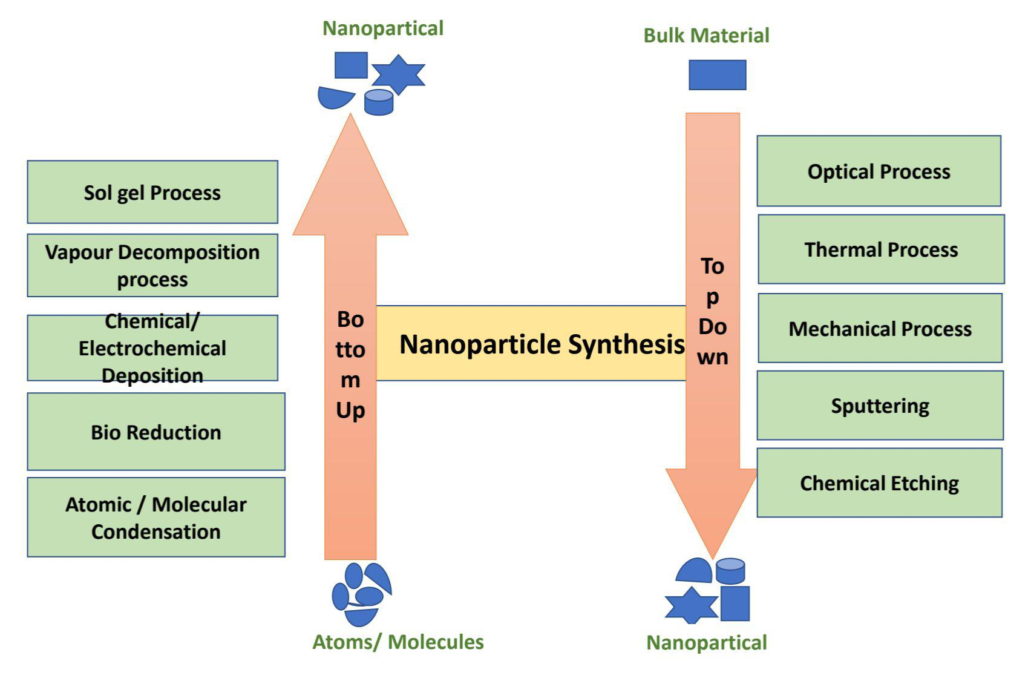
The American physicist and Nobel Prize laureate Richard Feynman introduced the concept of nanotechnology in 1959. During the annual meeting of the American Physical Society, Feynman presented a lecture entitled “There’s Plenty of Room at the Bottom” at the California Institute of Technology (Caltech). In this lecture, Feynman made the hypothesis “Why can’t we write the entire 24 volumes of the Encyclopaedia Britannica on the head of a pin?”, and described a vision of using machines to construct smaller machines and down to the molecular level [1]. This new idea demonstrated that Feynman’s hypotheses have been proven correct, and for these reasons, he is considered the father of modern nanotechnology. After fifteen years, Norio Taniguchi, a Japanese scientist was the first to use and define the term “nanotechnology” in 1974: “Nanotechnology mainly consists of the processing of separation, consolidation, and deformation of materials by one atom or one molecule” [2]. Feynman discovered this new field of research catching the interest of many scientists, two approaches have been developed describing the different possibilities for the synthesis of nanostructures. These manufacturing approaches fall under two categories: top-down and bottom-up, which differ in degrees of quality, speed, and cost. The top-down approach is essentially the breaking down of bulk material to get nano-sized particles. This can be achieved by using advanced techniques such as precision engineering and lithography which have been developed and optimized by industry during recent decades. Precision engineering supports the majority of the microelectronics industry during the entire production process, and high performance can be achieved through a combination of improvements. These include the use of advanced nanostructure based on diamond or cubic boron nitride and sensors for size control, combined with numerical control and advanced servo-drive technologies. Lithography involves the patterning of a surface through exposure to light, ions, or electrons, and the deposition of material onto that surface to produce the desired material [3]. The bottom-up approach refers to the build-up of nanostructures from the bottom: atom-by-atom or molecule-by-molecule by physical and chemical methods which are in a nanoscale range (1 nm to 100 nm) using controlled manipulation of self-assembly of atoms and molecules. Chemical synthesis is a method of producing rough materials that can be used either directly in products in their bulk-disordered form or as the building blocks of more advanced ordered materials. Self-assembly is a bottom-up approach in which atoms or molecules organize themselves into ordered nanostructures through chemical-physical interactions. Positional assembly is the only technique in which single atoms, molecules, or clusters can be positioned freely one by one [3]. The General concept of top down and bottom up and different methods adopted to synthesize nanoparticles by using these techniques are summarized in Figure1

Figure.1 Bottom up and Top down method.
In 1986, K. Eric Drexler published the first book on nanotechnology “Engines of Creation: The Coming Era of Nanotechnology”, which led to the theory of “molecular engineering” becoming more popular [4]. Drexler described the build-up of complex machines from individual atoms, which can independently manipulate molecules and atoms and thereby produce self-assembly nanostructures. Later on, in 1991, Drexler, Peterson, and Pergamit published another book entitled “Unbounding the Future: The Nanotechnology Revolution” in which they use the terms “nanobots” or “assemblers” for nano processes in medicine applications and then the famous term “nanomedicine” was used for the first time after that [5].
Definitions:
The prefix ‘nano’ is referred to as a Greek prefix meaning ‘dwarf’ or something very small and depicts one thousand millionths of a meter (10−9 m). We should distinguish between nanoscience and nanotechnology.
- Nanoscience is the study of structures and molecules on the scales of nanometres Ranging between 1 and 100 nm, and the technology that utilizes it in practical applications such as Devices etc. is called nanotechnology [6].
- The simplest definition of nanotechnology is “technology on the nanoscale.” Subsequently, various definitions of nanotechnology have evolved. This original definition requires further development, such as a definition of what is meant by nanoscale. Thus, we cannot properly define nanotechnology unless we define “nanoscale,” that is, a scale covering 1–100 nm. A brief definition of nanotechnology is an “atomically precise technology” or “engineering with atomic precision” [7].
- Nanotechnology is connected with systems and materials, the components and structures of which represent novel, significantly improved chemical, physical, and biological properties, processes, and phenomena because of their nanoscale size.
- The dictionary definition of nanotechnology is “the design, characterization, manufacture and shape and size-controlled application of matters in the nanoscale” [8].
- Nanotechnology is a branch of knowledge, within a sub-classification of technology in colloidal science, chemistry, Physics, biology, and other scientific fields, encompassing the study of phenomena At the nanoscale [9].
The reason for a catalyst’s performance is a powerful function of its particle size and size distribution. The chemical properties of NPs provide them with advantages as catalysts, such as their large surface-to-volume ratio, surface morphology, and electronic properties, all of which are linked to particle size [9,10]. Considerable advances are being made in fields that contribute to the manufacture and detailed understanding of the nature (particle size, composition, and structure) and function of NPs as catalysts for the improved performance of chemical reactions [11]. This definition suggests the presence of two conditions for nanotechnology. The first is an Issue of scale: nanotechnology is concerned with using structures by controlling their shape and size at the nanometer scale. The second issue has to do with novelty: nanotechnology must deal with small things in a way that takes advantage of some properties because of the nanoscale [12]
History:
Nanoparticles and structures were used by humans in the fourth century AD, by the Romans, which demonstrated one of the most interesting examples of nanotechnology in the ancient world. The Lycurgus cup, from the British Museum collection, represents one of the most outstanding Achievements in the ancient glass industry. It is the oldest famous example of dichroic glass. Dichroic glass Describes two different types of glass, which change color in certain lighting conditions. This means That the Cup has two different colors: the glass appears green in direct light, and red-purple when Light shines through the glass (Figure 1) [13].

Figure 2. The Lycurgus cup. The glass appears green in reflected light (A) and red-purple in light (B) [13].
In 1990, scientists analyzed the cup using transmission electron microscopy (TEM) to Explain the phenomenon of dichroism. [14]. The observed dichroism (two colors) is due to the presence of nanoparticles with 50–100 nm in diameter. X-ray analysis showed that these nanoparticles are silver-gold (Ag-Au) alloys, with a ratio of Ag: Au of about 7:3, containing in addition about 10% copper (Cu) dispersed in a glass matri2 [15,16]. The Au nanoparticles produce a red color as a result of light Absorption (~520 nm). The red-purple color is due to the absorption by the bigger particles while the Green color is attributed to the light scattering by colloidal dispersions of Ag nanoparticles with a size of 40 nm. The Lycurgus cup is recognized as one of the oldest synthetic nanomaterials [6]. A similar effect is seen in late medieval church windows, shining luminous red and yellow colors due to the fusion of Au and Ag nanoparticles into the glass. Figure 4 shows an example of the effect of these nanoparticles with different sizes on the stained glass windows [17]
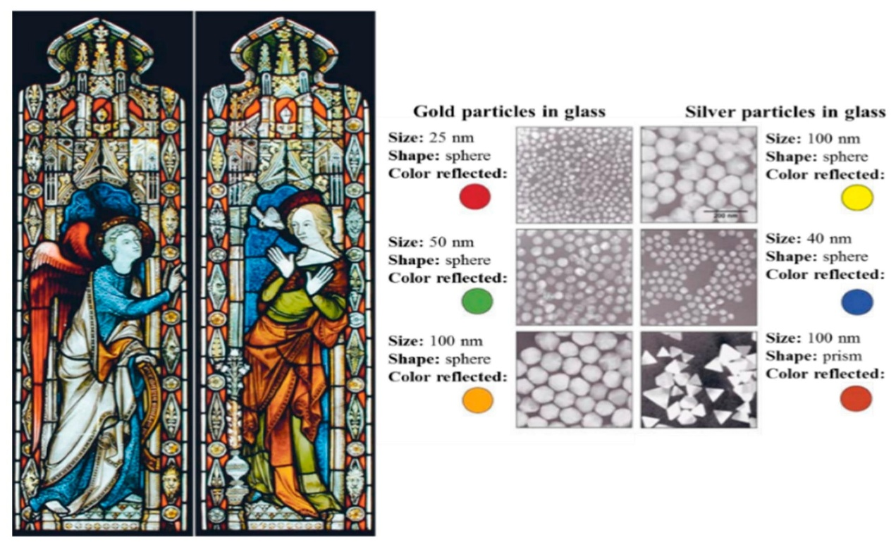
Figure 3. Effect of nanoparticles on the colours of the stained glass windows [17].
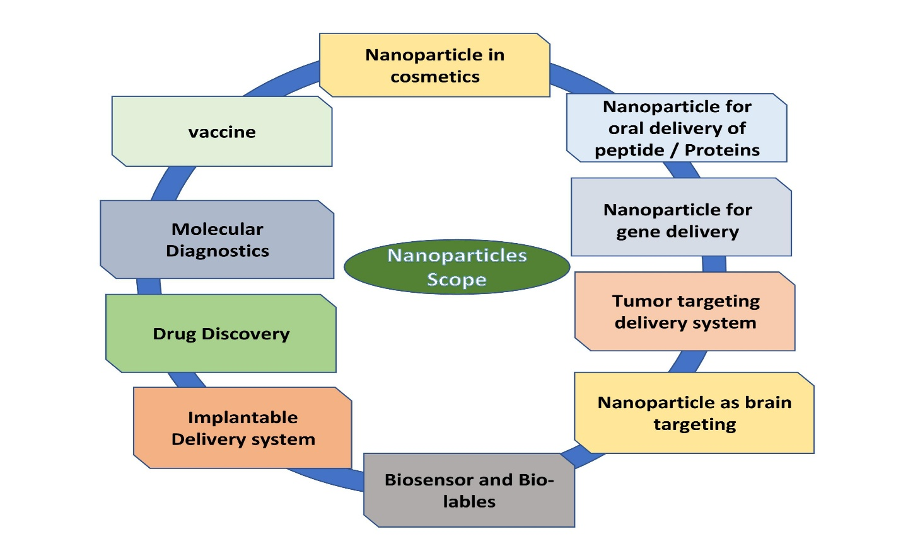
Scope of Nanotechnology:
Figure- 4. Scope of Nanotechnology
- Nanomaterials were developed for many applications in many fields such as Medicine, drug delivery, electronics, fuel cells, solar cells, food, and space, etc.
- Nanoparticles are used increasingly in catalysis to boost chemical reactions.
- This reduces the quantity of catalytic materials necessary to produce desired results, saving money and reducing pollutants.
Two big applications are in petroleum refining and automotive catalytic converters.
- Nanochemistry is used in chemical, materials and physical science as well as engineering, biological, and medical applications. Silica, gold, polydimethylsiloxane, cadmium selenide, iron oxide, and carbon are materials that show its transformative power.
- Nanotechnology for brain drug delivery.
- One of the subjects that are developing the fastest is nanotechnology, which has the potential to completely transform sectors like manufacturing, agriculture, electronics, pharmaceuticals, and the military.
- Applications for nanomaterials are widely used in
Food and agricultural systems as intelligent carriers of agrochemicals, nanoformulations, nano biosensors for accurate farming and food packaging, nanobioremediation, nanofibres for genetic engineering, etc.
- In the future, nanotechnology could also enable objects to harvest energy from their environment.
- New nano-materials and concepts are currently being developed that show potential for producing energy from movement, light, variations in temperature, glucose, and other sources with high conversion efficiency.
Types of nanotechnology:
- Nanoparticle: Nanomaterials are materials that have been engineered or manipulated at the nanoscale, leading to new properties or behavior compared to their bulk counterparts. Some examples of nanomaterials include carbon nanotubes, nanoparticles, and quantum dots. Carbon nanotubes, for example, are incredibly strong and conductive, making them useful in a wide range of applications, such as electronics, energy storage, and materials science. Nanoparticles are tiny particles with at least one dimension on the nanometre scale, they can be made of different materials such as metals, oxides, and polymers and have unique properties that can be used in different fields like medical, cosmetic, and environmental. Quantum dots are tiny semiconductor particles that can be used in displays, solar cells, and medical imaging
- Nanomedicine: Nanomedicine is the application of nanotechnology to the medical field. It involves the use of tiny particles and devices at the nanoscale to diagnose and treat diseases. Examples include targeted drug delivery systems and diagnostic nanoparticles. Targeted drug delivery systems use nanoparticles to deliver drugs directly to specific cells or tissues, reducing side effects and increasing the efficacy of the treatment. Diagnostic nanoparticles can be used to detect diseases at an early stage, or even to image the inside of the human body with high resolution.
- Nanoelectronics: Nanoelectronics involves the use of tiny transistors and other electronic components at the nanoscale, to create faster and more efficient electronic devices. Examples include nanoscale transistors and memory devices. These tiny transistors and components allow for smaller, more energy-efficient electronic devices that can process and store more data than traditional electronic devices.
- Nanocomposite: Nanocomposites are those composites in which one phase has nanoscale morphology like nanoparticles, nanotubes, or lamellar nanostructure. They have multiphases, so are multiphasic materials, at least of the phases should have dimensions in the range of 10–100 nm.
- Nanolithography: Nanolithography is a growing field of techniques within nanotechnology dealing with the engineering of nanometre-scale structures on various materials. The modern term reflects on a design of structures built in the range of 10⁻⁹ to 10⁻⁶ meters, i.e. nanometre scale.
- Nanobiotechnology: Nanobiotechnology is the study of the smallest biological items of nanoscale 1-100 nm to create devices and systems of the equivalent range that employ for new purposes. It is a new field of science that introduces special physicochemical and biological properties of nanostructures and their applications in various areas such as medicine and agriculture. Metal nanoparticles are dominant compounds affecting fungal diseases both in humans and plants.
- Microscopy, Spectroscopy, Nanorobotics, Wet nanotechnology, Nanofluidics, Nanoelectromechanical relay, Nanophotonics, Optoelectronics etc.

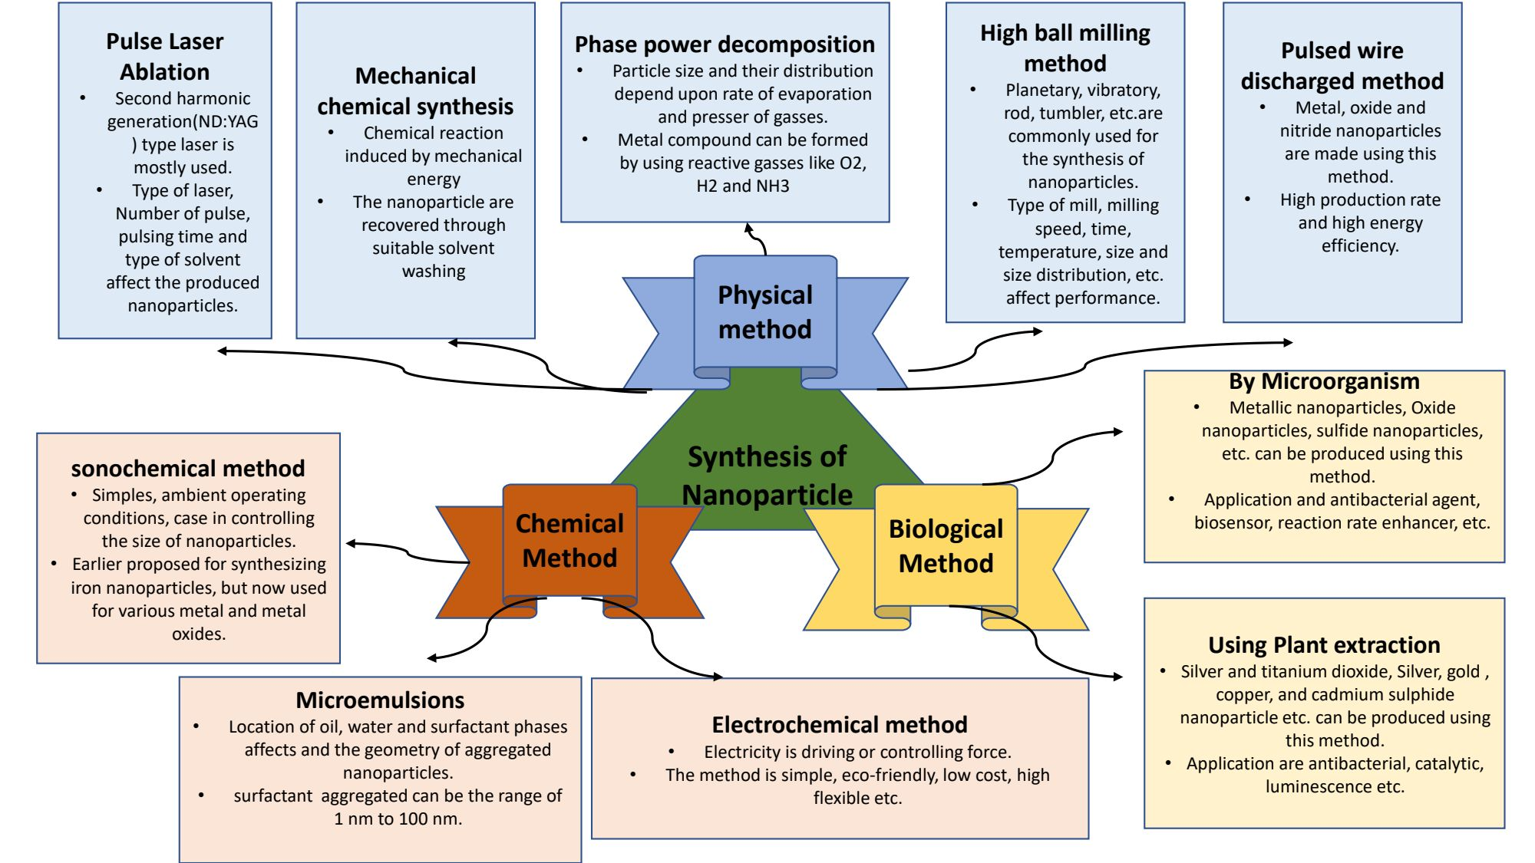
Synthesis of Nanomaterials:
FIgure 5: Different methods for the synthesis of nanomaterials
Different forms of nanomaterials can be created using a wide range of procedures including particles, colloids, thin films, tubes, rods, clusters, wires, powders, and more. These methods are categorized into three main techniques for creating a nanomaterial, as depicted in Figure 1. The approach created is dependent on the materials of interest and the type of nanostructures, such as quantum dots (QDs), nanowires, nanorods, and nanoplates.
Application:
- Medical Science: Cancer Treatment, Drug Delivery, Imaging Tools and Equipment, Tissue Engineering, Gene Therapy, Treating Wound Injuries.
- Textiles: Making anti-bacterial, stain-resistant, wrinkle and fuzz-resistant textiles.
- Devices: Glucose, Sensors, Lithium-Ion Batteries, Thin Film, Solar Panels, High-Efficiency Sensors.
- Material Science: Flexible Materials, Lightweight Armours, Stealth Materials, Wear-Resistant Coatings, Anti-Corrosive Paints, Masks.
- Environment Conservation: Water and Air Purification Membranes, Detection of Harmful Chemicals Oil Spills.
- Nanocomposites: Nanoparticles and nanotubes have an important role to play in composites. Carbon fibers and bundles of multi-walled CNTs are used in polymers to enhance and control connectivity.
- Nano lubricants: The inorganic materials of nanospheres are used as lubricants. They are more durable as compared to conventional solid lubricants.
- Nanocoating and Nanostructured Surfaces: Coatings with thickness at nano or atomic scales are in active production.
Reference:
- Feynman R.P. There’s plenty of room at the bottom. Eng. Sci. 1960;23:22–36. [Google Scholar].
- Taniguchi N., Arakawa C., Kobayashi T. On the basic concept of nano-technology; Proceedings of the International Conference on Production Engineering; Tokyo, Japan. 26–29 August 1974.
- Iqbal P., Preece J.A., Mendes P.M. Supramolecular Chemistry. John Wiley & Sons, Ltd.; Chichester, UK: 2012. Nanotechnology: The “Top-Down” and “Bottom-Up” Approaches.
- Drexler E.K. Engines of Creation: The Coming Era of Nanotechnology. Anchor Press; Garden City, NY, USA: 1986. [Google Scholar].
- Drexler E.K., Peterson C., Pergamit G. Unbounding the Future: The Nanotechnology Revolution. William Morrow and Company, Inc.; New York, NY, USA: 1991. [CrossRef]
- Mansoori, G.; Fauzi Soelaiman, T. Nanotechnology—An Introduction for the Standards Community. J. ASTM Int. 2005, 2, 1–22.
- National nanotechnology initiative: leading to the next industrial revolution. Washington, DC: National Science and Technology Council; 2000.
- Abad E. Nano dictionary. Basel: Collegium Basilca; 2005
- Mansoori GA, Soelaiman TAF. Nanotechnology introduction for the standards community. J ASTM Int 2005;2(6):17–38.
- Mansoori GA, Mohazzabi P, McCormack P, Jabbari S. Nanotechnology in cancer prevention, detection and treatment: bright future lies ahead. World Rev Sci Technol Sustain Dev 2007;4(2–3):226–57.
- Mansoori GA, Vakili-Nezhaad GR, Ashrafi AR. Some mathematical concepts are applicable in Nanothermodynamics. Int J Pure Appl Math Sci 2005;2:58–61.
- Allhoff, F. On the Autonomy and Justification of Nanoethics. Nanoethics 2007, 1, 185–210. [CrossRef]
- The British Museum. Available online: www. britishmuseum.org /research/ collection _ online/collection_ Object_details.aspx?objobjec=61219&partId=1
- Barber, D.J.; Freestone, I.C. An investigation of the origin of the color of the Lycurgus Cup by analytical Transmission electron microscopy. Archaeometry 1990, 32, 33–45. [CrossRef].
- Freestone, I.; Meeks, N.; Sax, M.; Higgitt, C. The Lycurgus Cup—A Roman nanotechnology. Gold Bull. 2007, 40, 270–277. [CrossRef]
- Wagner, F.E.; Haslbeck, S.; Stievano, L.; Calogero, S.; Pankhurst, Q.A.; Martinek, K.-P. Before striking gold in gold-ruby glass. Nature 2000, 407, 691–692. [CrossRef].
- The New York Times. Available online: www.nytimes.com/imagepages/ 2005/ 02/ 21/ science/20050222_ NANO1_GRAPHIC.html

