Human Papilloma Viruses
Anto P V¹, G Sridhar², Vidyaa Nayaki³, Vignesh Kanna Balaji⁴
- PhD scholar, Department of Microbiology, Shri Sathya Sai Medical College and Research Institute, Sri Balaji Vidyapeeth (deemed to be University)
- Professor, Department of Microbiology, Shri Sathya Sai Medical College and Research Institute, Sri Balaji Vidyapeeth (deemed to be University)
- Assistant Professor, Department of Microbiology, Shri Sathya Sai Medical College and Research Institute, Sri Balaji Vidyapeeth (deemed to be University)
- Assistant Professor, Department of Microbiology, Shri Sathya Sai Medical College and Research Institute, Sri Balaji Vidyapeeth (deemed to be University)

Introduction
Cervical cancer is mostly caused by HPV, and of all the high risk Papillomaviruses, HPV16 has received the most research. All HPVs are composed of double-stranded deoxyribose nucleic acids (DNA) that measure about 8.0 KB in length and encode 8 genes as well as an LCR or URR that is 1 KB in size (Figure 2.4). The major capsid protein and the minor capsid protein are encoded by the structural genes L1 and L2, respectively, while the early proteins are encoded by six non-structural genes (E1, E2, E4, E5, E6, and E7).
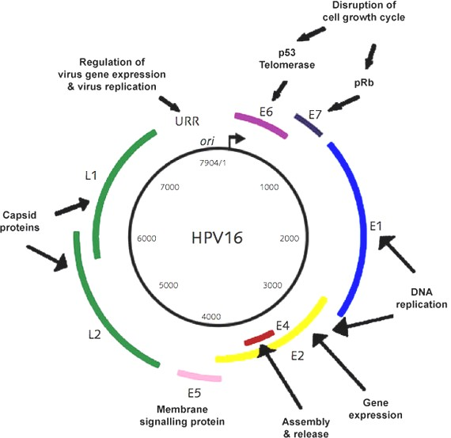
1.Schematic diagram showing the genome of HPV type 16 Long control region, Promoter p99 and p680, early gene (E1, E2, E4, E5, E6 and E7) and capsid gene (L1 and L2).

(Source: Burd EM. 2003)

Natural course of HPV infection

Most HPV-infected individuals do not experience the clinical signs like burning, itching, or vaginal discharge that are typical of most genitourinary infections. Since the host immune system usually treats HPV infections, the majority of instances do not progress to illness. Genital warts appear in 8% of female HPV 6 or 11 infected patients. According to a 10-year cohort study of 20,000 women engaged in health maintenance, about 7% of HPV-positive women had CIN 3 or cervical cancer. However, the process by which the HPV infection is removed by our host system is currently unknown
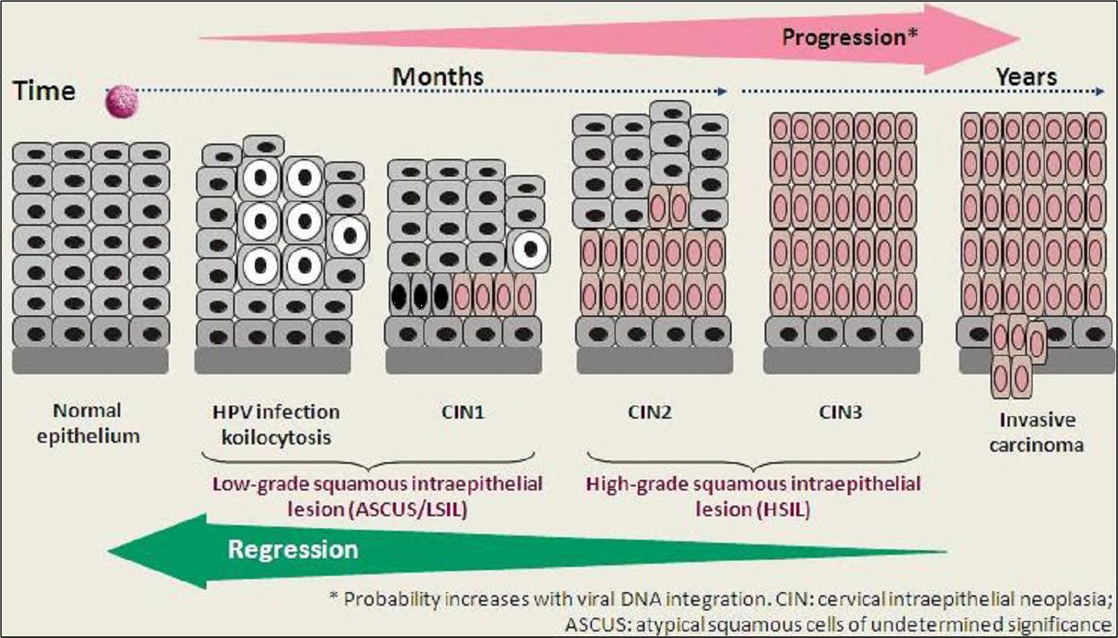

2.Natural course of HPV infection (Source: Burd EM. 2003)

HPV Transmission

Since it can be spread through direct skin or mucous to skin contact, HPV is not just a sexually transmitted disease. Though HPV infection is widespread among humans worldwide, different geographical regions have differing prevalence rates. An estimated 50 to 80 percent of sexually active men and women have an HPV infection over their lifetime. The risk of infection rises with the number of sex partners and starts to occur at the time of sexual activity.

HPV Clinical Manifestation

Depending on the kind of HPV infected, an HPV infection in humans may result in one of three probable outcomes. Both men and women may develop anogenital warts on and near the anus as a result of the illness. The second is latent infection, in which case the infected area maintains normal cytology but exhibits striking symptoms. The final one is an infection linked to high-risk HPV strains, in which the virus alters infected cells and causes intraepithelial neoplasia in the urethra, penile, vagina, or cervical tissues. The duration of HPV's incubation ranges from three to four weeks to months or even a year, and the latency mostly depends on the viral dose ingested. Accordingly, the viral load and type of HPV infection determine whether an infection is latent, subclinical, or symptomatic. 90% of women recover from HPV infections, whether they were caused by high- or low-risk types.

HPV Viral life cycle

Basal cells are infected by the human papillomavirus, which enters the keratinocyte mostly through damaged epithelium When keratinocytes move on the basal membrane during the process of healing a lesion, virions bound to the HSPG transfer to the receptor on those cells and subsequently enter the cells. The viral genome is delivered to the nucleus after viral entrance and uncoating. In the basal cells layer, it is typically maintaining the low copy number (50–100 copies/cell). The E1 and E2 proteins made this possible by attaching to the site of replication and then attracting additional DNA polymerases and proteins required for DNA replication. The aforementioned protein, together with the proteins E5, E6, and E7, contribute to preserving the viral genome and promote cell proliferation, both of which increase the number of HPV-infected cells and the number of cells that will create viruses. The E4 gene will be triggered for its expression, causing an increase in viral genome replication and a significant increase in the number of virus copies per cell. The expression of the late proteins L1 and L2 takes place concurrently. The L1 and L2 assemble in the granular region to form the capsid and release the virions into the epithelium.
Cervical cancer Screening
There are various approaches for detecting cervical cancer and preventing it, such as cervical cytology, HPV DNA testing, and direct visual examination of the cervix. However, it has been discovered that there has been no clinically significant decline in the prevalence of cervical cancer in developing nations like India during the previous three decades.
This is mostly caused by inadequate diet, which reduce the immune system performance; hereditary factors could also be to blame for the disease's high prevalence. However, the mortality rate from cervical cancer has decreased as a result of good screening in affluent nations. In the United States, the mortality rate from cervical cancer has decreased by 70% as a result of the advent of cytological tests like Papanicolaou (Pap) smears.
Cost, acceptability, infrastructure requirements, and technological complexity are all crucial aspects of HPV screening. Visual examination of the cervix is a screening method that has gained popularity. Visual inspection using acetic acid (VIA) and visual inspection using Lugo's iodine (VILI) are the two methods used to carry it out. After applying 5-5% acetic acid to the cervix for one minute, it is checked under white light by calposcopy. When an aceto white region is seen close to the squamocolumnar junction (SCJ), the test is considered positive. Acetic acid administration is followed by reversible intracellular protein coagulation to produce aceto whitening. If the test is positive, the cervix area in the other type of VILI test turns mustard yellow. The main advantage of the test is that its give immediate result for treatment.
A sensitive test for the detection of HPV is the Hybrid capture-2 HPV DNA test (Mayrand et al., 2007; Pimple et al., 2010). 13 different HPV HR types can be identified with the test, which is based on the amplification of HPV DNA by the polymerase chain reaction (PCR) and detection by hybridization to DNA and RNA probe. The test's specificity is compromised because it cannot detect cervical abnormalities.

Treatment
The standard treatment for High grade lesions in developed nation are excision procedure known as cold knife cone biopsy and the loop electrosurgical excision procedure (LEEP).In cold knife cone biopsy hot spatula like metal knife is used for scoping up the affected areas. In LEEP wire loop electrically heated is used for scoping. In CINIII cases various level of hysterectomy is done spending on the severity. Cryotherapy is also used for treatment of lesions over small areas in CINII and CINIII.

Human Papillomavirus Vaccines

There are two different strategies employed for development of HPV vaccines against HPV based cancer. These are prophylactic vaccine and therapeutic vaccine.

Prophylactic Vaccines

There are now two preventative vaccines that have been created and put on the market. The first is the bivalent (HPV16 and 18) Cervarix® (made by GlaxoSmithKline), and the second is the quadravalent (HPV 6, 11, 16, and 18) Gardasil® (manufactured by Merck and Co.). Both vaccines are based on virus-like particles (VLPs) and are expressed in insect cells, SF9 cells (for Cervarix®) and Saccharomyces cerevisiae (for Gardasil®).
Because VLPs lack viral DNA, they are not contagious. The vaccinations are advised for immunising young adolescent women before the onset of puberty because the VLPs resemble virions and elicit virus-neutralizing antibodies. The vaccinations have a population-wide sero-conversion rate of 100%.

Therapeutic vaccines

Therapeutic HPV vaccinations target the cells that have the tumor-specific antigen on their surface in an effort to prevent or eradicate the disease. Protein-based vaccinations needed the protein to be absorbed by the APC and then presented as a processed peptide fragment by the MHC. The protein produces CD+ cytotoxic T lymphocytes, also known as killer T cells, after endocytosis. As it is expressed constitutively in HPV-infected pre-malignant and malignant cells, HPV 16 E6 and E7 are oncoproteins that bind to p53 and pRB, respectively, and are used as an attractive candidate therapeutic vaccine against CIN II, CIN III, and cervical cancer. A benefit of using full length E6 and E7 proteins over peptides is that they contain all of the epitopes for each MHC haplotype.
There are several methods used to create vaccinations, including DNA vaccines, peptide-based vaccines, and live vector vaccines. Bacterial vectors used in live vector-based vaccinations include Listeria monocytogenes, Salmonella typhimurium, and Salmonella typhi. Adenovirus and vaccinia virus are viral vectors used in vaccines. The technology is attractive as a strategy for HPV vaccination because to the system's ability to deliver antigens directly to dendritic cells. The ability of the live vector vaccine to multiply itself within the host cells increases their immunogenicity and facilitates the efficient distribution of the antigen.
The use of live vector vaccine has drawbacks since its potency can be impaired because the host would produce neutralising antibodies during immunisation and there could be a chance of toxicity.
Antigen-specific immunotherapy may benefit from the use of DNA vaccines since they are safer, more stable, and capable of sustaining antigen expression in cells for longer periods of time than RNA or proteins. Since the DNA vaccination does not cause the patient to produce neutralising antibodies, it can be given repeatedly.

Serological assays
The assay corresponds with the levels of the HPV neutralising antibody that is preferred to measure the antibody response following vaccination or infection because the antibody should be functional in terms of viral neutralisation to provide protection. For the purpose of conducting sero-prevalence investigations in various nations, a number of tests have been developed for the detection of antibodies specific to particular HPV types. Pseudovirion-based neutralisation assays (PNA), competitive luminex immunoassays (CLIA), VLP-ELISAs, and glutathione-Stransferase L1-based immunoassays (GST-L) are the assays that are most frequently employed in serology.
The PNA is the industry standard because it offers a relevant assessment of the immune response to HPV following infection or vaccination. Although it is challenging to apply this test in large-scale research like sero-epidemiological studies or therapeutic trials because it is time-consuming, expensive, and requires a qualified person to perform.
As an alternative to the PNA, the antibody response to HPV infection or vaccination is assessed by CLIA, VLP-ELISA, and GST-L1 capture ELISA. The main capsid protein L1 is present in the virus-like particles that serve as the basis for the CLIA and VLP ELISA. The neutralising and non-neutralizing antibodies are measured using VLP Elisa VLP coated on a polystyrene plate.
An ELISA that uses capture technology to detect both neutralising and non-neutralizing antibodies is the GST L1 immunoassay. It is typically used to identify a wide variety of HPV types. As the L1 is allowed to be in the proper conformation by the glutathione casein during GST capture ELISA antigen, this aids in capturing the conformation-specific antibodies that cannot be detected by other assays employing the denatured L1 produced in E. coli.
It is described as the level of antibody activity that defines whether a subject is positive or negative, as well as the diagnostic test's sensitivity, specificity, and predictive value.

Reference
- Aggarwal, R., Gupta, S., Nijhawan, R., Suri, V., Kaur, A., Bhasin, V., Arora, S. K. (2006). Prevalence of high-risk human papillomavirus infection in women with benign cervical cytology: a hospital based study from North India. Indian Journal of Cancer
- Alexander, E. R. (1973). Possible etiologies of cancer of the cervix other than herpesvirus.
- AlObaid, A., Al-Badawi, I. A., Al-Kadri, H., Gopala, K., Kandeil, W., Quint, W., Al- Aker, M. and DeAntonio, R. (2014). Human papillomavirus prevalence and type distribution among women attending routine gynecological examinations in Saudi Arabia. BMC Infectious Diseases;
- Beutner, K. and Tyring, S. (1997). Human papillomaviruses and human disease. Am J Med
- Biswas, A. (2000). Special Article Human papillomavirus (HPV) and Cervical cancer. Journal Indian Med.Assoc.;
- Burd, E. M., (2003). Human Papillomavirus and Cervical Cancer. Clin Microbiol Rev.
- Chaturvedi, A. K. (2010). Beyond cervical cancer: burden of other HPV-related cancer among men and women. J Adolesc Health.
- Federschneider, J. M., Yuan, L., Brodsky, J., Breslin, G., Bentensky, R. A., Crum, C. P. (2004). The borderline or weakly positive Hybrid Capture II HPV test: a statistical and comparative (PCR) analysis. AMJ Obstet Gynecol.
- Kahn, J. A., Lan, D., Kahn, R. S. (2007). Sociodemographic factors associated with high- risk human papillomavirus infection. Obstet gynecol.
- Zur-Hausen, H., and Gissman, L. (1980). Papillomavirus in viral oncology.
- Zur-Hausen, H. (2002). Papillomaviruses and cancer: from basic studies to clinical application. Nat Rev Cancer
- Franceschi, S., Rajkumar, R., Snijders, P. J. F., Arslan, A., Mahe, C., Plummer, M., Sankaranarayanan, R., Cherian, J., Meijer, C. J. L. M. and Weiderpass, E. (2005). Papillomavirus infection in rural women in southern India. British Journal of Cancer
- Stanley, M. (2003). Immune intervention in HPV infections: current progress and future developments. Immune intervention in HPV infections: current progress and future developments: Expert Review of Vaccines
- Stanley, M. (2008). Immunobiology of HPV and HPV vaccines. Gynecologic Oncology,109, supplement .

