Advancements in Operation Theatre and Anaesthesia: The Role of AI
Mr Mudasir Mohi Ud Din (Assistant Professor) Guru Nanak Mission Hospital and Collge

Introduction

The art of medicine is inarguably one of the most prestigious fields of work. The evolution of this field has been documented over decades, with each era showcasing its own area of expertise. Advancements in surgical procedures and anaesthesia have revolutionized the way medicine is practised today. With the rise of technology, Artificial Intelligence (AI) has also entered the realm of healthcare, working towards improving efficiency and innovation. This article will delve into the advancements in operation theatre and anaesthesia, along with the role of AI in this field.

Advancements in Operation Theatre:

The operation theatre is the heart of all surgical procedures. The goal of any surgical procedure is to intervene in the patient's body without causing any significant harm or pain. Maintaining optimal conditions in the operation theatre is imperative to ensure the patient's successful surgery.

Advancement in technology has broadened the scope of minimally invasive surgeries. Minimally invasive surgeries use smaller incisions to accomplish the same surgical goals as traditional surgeries. These smaller incisions result in less pain, faster recovery time, and shorter hospital stays for the patient.

One of the latest surgery advancements in the field of laparoscopic surgery. This surgical technique uses small incisions and a camera to operate on internal organs. This technique has been used to complex surgeries such as gallbladder removal, appendectomy, and colon resections with less postoperative discomfort.

Another important advancement in the operation theatre is the use of robotic systems for surgery. Robotic systems can be used in a variety of procedures, including urological, gynaecological, and gastrointestinal surgeries. These systems utilize a camera and robotic arms that can be controlled by the surgeon to perform delicate operations.

The latest development in the operation theatre is 3D printing technology. Surgeons use 3D printing to create exact replicas of organs, bones or tissues to plan and practice surgeries beforehand. This technology has revolutionized the way in which operations are carried out, giving surgeons greater precision and accuracy.
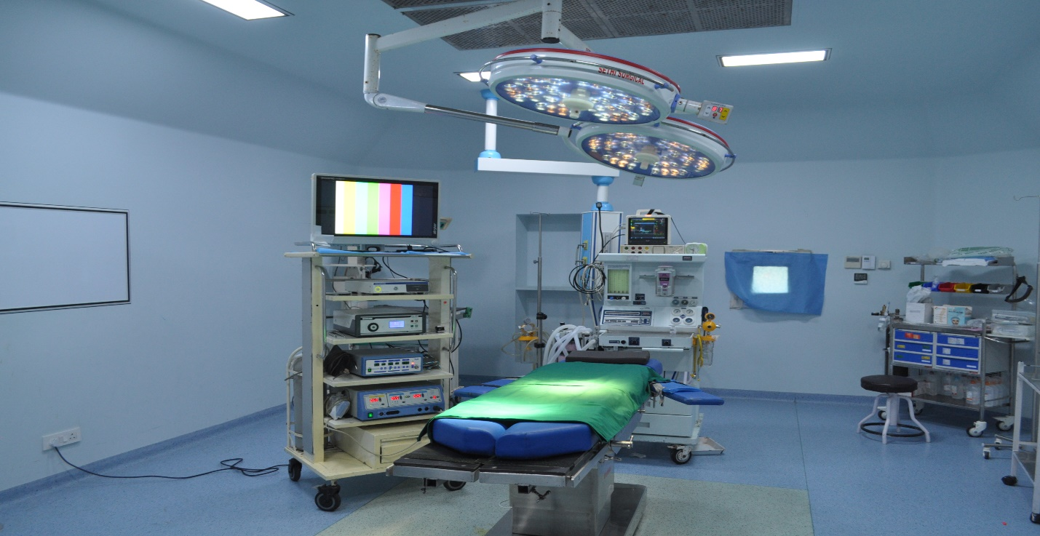

Advancements in Anaesthesia:

Anaesthetists have a crucial role to play in any surgical procedure. Their aim is to monitor and maintain the patient's vital functions during the operation, ensuring that the patient is comfortable, and the surgery is performed without any complications.

With advancements in the field of anaesthesia, the use of local anaesthesia has become increasingly popular. Local anaesthesia blocks sensation to a region of the body, allowing the patient to remain awake during the surgery while also numbing the area being operated on. This technique has fewer side effects and has been introduced in dental and ophthalmic surgeries.

The use of epidural anaesthesia has also gained popularity. Epidural anaesthesia involves the injection of anaesthetics in the epidural space outside the spinal cord. It is used to numb the pelvic region during childbirth and major abdominal surgeries.

Another important development in the field of anaesthesia is the use of regional anaesthesia. This technique involves the injection of anaesthesia into the nerves that supply sensation to a specific area of the body. Regional anaesthesia is used to numb the arm or leg during orthopaedic surgeries, providing analgesia for up to 24 hours, freeing patients from the use of opioid drugs that might result in complications.

Role of AI in Operation Theatre and Anaesthesia:

Over the last decade, Artificial Intelligence has played a significant role in transforming the field of medicine. AI has the potential to revolutionize the way in which surgical procedures are performed, and anaesthesia is administered.

AI systems can analyze and interpret vast amounts of data in real-time. These systems can monitor the patient's vital signs during surgeries, alerting the medical staff to any changes that may indicate a potential complication. This real-time analysis of patient data can be lifesaving, allowing medical professionals to respond immediately to any cardiac or respiratory distress.

AI-assisted robotic surgery systems have been developed that can perform highly precise surgical procedures with greater accuracy compared to traditional methods. Robotic systems using AI can give surgeons the ability to control a robotic arm equipped with sensors and cameras that can create highly detailed 3D visualizations of the surgical area.

The use of AI in anaesthesia has gained importance due to the risks associated with administering anaesthesia. AI systems can analyze real-time data from a patient's physiology, predicting and minimizing any potential complications. This real-time analysis, combined with machine learning algorithms, can help anaesthetists adjust the anaesthesia administration according to the patient's requirements.

AI systems can also predict the number of opioids a patient might require post-surgery, allowing for a reduction in opioid use, thereby reducing the risk of addiction.

Conclusion

The advancements in operation theatre and anaesthesia have revolutionized the way surgery is performed. The rise of AI has brought efficient machine-learning algorithms and systems that can help medical professionals deliver an optimal surgical experience. With advancements in robotics, 3D printing, and AI-assisted surgical procedures, we are witnessing a rapid transformation of the surgical field.

As we move towards exciting future possibilities, one might question how the role of the surgeon and anaesthetist might change. While AI systems aid in surgery, they are not meant to replace human expertise. As long as there are innovative medical professionals using their expertise, thinking critically and adjusting algorithms and surgical techniques accordingly AI and technology can facilitate the best possible outcomes for the patient. Together, technology and medical professionals can usher in a new era of surgical expertise that promises patients efficient, safe, and remarkable surgical experiences.

