Manganese Biocatalysis
Gopinath Mavankal, PhD
SGS TECHNOLOGIE LLC
Jacksonville, Florida, USA
gmavankal@gmail.com
ABSTRACT
Manganese, a 3d transition metal with variable oxidation states(-3 to +7), is ubiquitous in the earth's crust, has low toxicity, and as a catalyst in cyanobacterial Photosynthesis, accumulated Oxygen in the ocean, which gradually escaped into the atmosphere displacing methane sometime between 2.4 – 2.1 billion years ago¹. Cyanobacteria evolved from an anaerobic environment to produce Oxygen which wiped out much of anaerobic life and gave rise to aerobic metabolism. Manganese thus plays a central role in evolution. This chapter describes biophysical and biochemical studies of Manganese as biocatalysts from a chemical and biological perspective. The dissertation work done by the author dictates the choices in this chapter that are thus more like vignettes considering the vast amount of ongoing work in the area of Manganese biocatalysts. Manganese, a catalyst that produces hydrogen from water, might turn out to be the key to a carbon-neutral green economy of the future.
I. INTRODUCTION
The electron transport chain (ETC) of mitochondria and chloroplasts are similar organelles in that they can synthesize adenosine triphosphate (ATP)⁴⁰. The protein complexes embedded and spanning across the organelles' membrane form a chain that receives and releases electrons. Mitochondrial ETC uses chemical energy from redox reactions, while chloroplasts use light energy. This chapter provides a review and comparison of the Manganese at the active site of two enzymes that are involved in Photosynthesis as an electron donor that splits water to produce the Oxygen we breathe and in mitochondria as part of an enzyme that accepts electrons from Oxygen superoxide radicals to prevent those radicals from causing damage. The results from dissertation⁵ by this author are used because they address a question different from looking at the intact in vivo catalytic site itself. High cationic (1M Ca⁺⁺) and anionic (1M Cl⁻) washes of the preparations result in dissociating extrinsic or surface-bound proteins from the complexes. While the effect of these washes in removing extrinsic proteins was known, biophysical investigations of the impact of the removal of the proteins on the Manganese center were not known. The work in the dissertation showed that it opened the Manganese catalytic site (uncouple one of four Manganese). Electron Spin Resonance data showed it closed the cluster again (couple all four Manganese) through alternating treatments. Oxygen evolution upon illumination measurements suggested that the three Manganese cluster appears sufficient for catalysis. Thus not all Manganese in the intact active site was essential for the action⁶, though this contradicts the current models²⁵. This chapter will also review the Manganese in Superoxide Dismutase in the mitochondria that remove free radicals of Oxygen before they can cause damage by converting them to Oxygen. Manganese thus plays a role in oxidizing water to Oxygen and reducing Oxygen radicals to Oxygen. In one case, it catalyzes by pushing electrons and, in the other, by pulling electrons from the substrate. Biologically, the superoxide anion O₂^{.-} and reactive oxygen species (ROS) play a dual role, a beneficial and a harmful one³⁷. The chapter discusses current models of Manganese as a biocatalyst, biophysical tools for investigating it, and chemical modeling of natural Manganese-bearing enzymes.
II. ETC in Mitochondria(Respiration) and Chloroplasts (Photosynthesis)
Both mitochondria and chloroplasts use an electron transport chain to generate ATP, but the processes differ in terms of location and input/output molecules. An electron transport chain (ETC) is a series of protein complexes located in the inner mitochondrial membrane (in eukaryotes) or the plasma membrane (in prokaryotes). It plays a crucial role in cellular respiration and Photosynthesis, where it transfers electrons and generates ATP (adenosine triphosphate), the energy currency of cells. In cellular respiration, the ETC is part of the aerobic respiration process. During the breakdown of glucose in the presence of Oxygen, earlier steps generate NADH (Nicotinamide adenine dinucleotide) and FADH2 (Flavin adenine dinucleotide) molecules. These high-energy electron carriers donate their electrons to the ETC. The electron transport chain comprises several protein complexes, including NADH dehydrogenase, cytochrome b-c1 complex, cytochrome c, and cytochrome oxidase. These complexes are embedded within the mitochondrial or plasma membrane and contain specific electron carrier molecules such as flavin mononucleotide (FMN), iron-sulfur clusters, and heme groups. The flow of electrons through the ETC occurs sequentially. Initially, NADH donates its electrons to the first complex of the ETC, often called Complex I. From there, the electrons move to the subsequent complexes through sequential redox reactions, where electrons are shuttled between electron carrier molecules. As the electrons move through the ETC, they lose energy. This energy transports protons (H+) across the mitochondrial or plasma membrane, creating an electrochemical gradient. This gradient drives ATP synthesis by a process called oxidative phosphorylation. At the end of the ETC, Oxygen acts as the final electron acceptor, combining with protons to form water. This step ensures the continuation of the electron flow, as Oxygen is a strong electron acceptor.
- Mitochondria (Respiration)
a. Location: The electron transport chain in mitochondria is located in the inner mitochondrial membrane.
b. Input: The input molecules are reduced coenzymes, specifically NADH and FADH2, produced during glycolysis, the citric acid cycle, and fatty acid oxidation.
c. Output: The output is ATP, produced through oxidative phosphorylation. Oxygen (O2) is the final electron acceptor, creating water (H2O) as a byproduct.
B. Chloroplasts (Photosynthesis)
a. Location: The electron transport chain in Photosynthesis is located in the thylakoid membrane of chloroplasts.
b. Input: The input molecule is light energy absorbed by pigments such as chlorophyll. This energy is captured in the form of electrons in a molecule called chlorophyll
c, Output: The output molecules are ATP and NADPH, that power the synthesis of carbohydrates during the Calvin cycle (also known as the dark reactions of Photosynthesis).
III. Water Oxidation: The Molecular components and processes.
Four membrane-spanning multi-subunit protein complexes present in the thylakoid membrane of chloroplasts work in concert to convert light energy into chemical energy². In the late 1960s, Murata identified "state transitions" based on photochemical quenching observed in the kinetics of chlorophyll fluorescence⁴. The complex that acts as the antenna for light energy uses protein-bound pigments that interact with two of the four complexes, namely, Photosystem I and Photosystem II. The functional identification of the protein complexes involved in the process is often restricted by what can be purified and isolated for study³. Fluorescence analyses indicate that the affinity of the light-harvesting complex for PSI and PSII differ in affinity, and the stoichiometry of the association is also different. The cytochrome b6f complex carries out a cyclic energy transfer such that part of the electrons transferred from PSII to PSI are cycled back to PSI. It must be noted that the thylakoid membrane provides the separation between the stroma and the inner compartment of the thylakoids, as shown in Figure 1⁵.
Figure 1. Transverse Section: Schematic Diagram of the chloroplast⁵
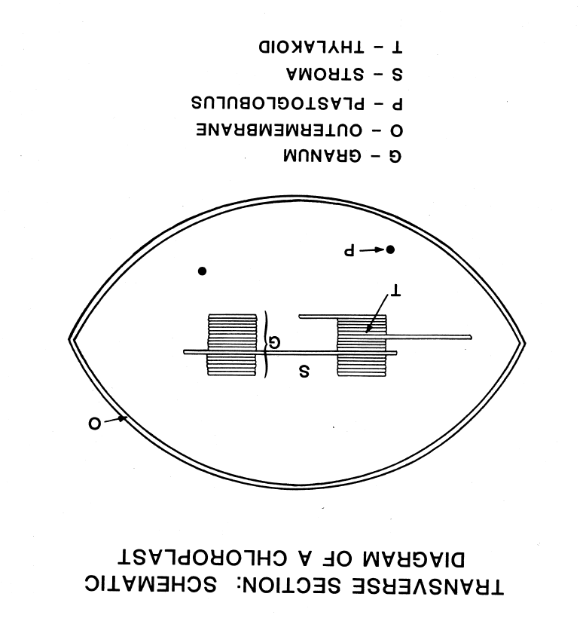
The lipid bilayer's separation between the stroma and the inner compartment of the thylakoids creates the structure for charge separation. In the lumen of the thylakoid lie exposed water channels among the protein surfaces, a catalytic site the Reaction Center (RC). The RC is the location for four Manganese ions, a cluster, as they are held in place through covalent bonds that include bridging oxygen atoms to form a specific geometric pattern of a tetramer. Three of four Manganese are more tightly coupled, as revealed through Electron Paramagnetic Resonance studies⁵. Furthermore, it was observed that Calcium added to the medium was necessary to leach out one of the four Manganese in preparations of photosystem II, whose activity was measured using the oxygen electrode response to light the preparation was exposed to⁵. Reconstitution of this activity showed that a 3-Manganese center could produce Oxygen just as the preparation that was not treated with Calcium and thus retained all four managanese^{6,7}. The manganese cluster is the catalytic site for water oxidation to Oxygen with a resultant charge separation whereby the protons and the Oxygen are released to the thylakoid lumen. At the same time, the electrons that are sourced from water are directed through the electron transport chain where Plastoquinone resides on the other side of the membrane, as described in the review². The reaction can be represented as
Equation 1. 2H2O+2PQ+4H+stroma/cytoplasm−→hvO2+2PQH2+4H+lumen
Figure 2. S-states of the oxygen-evolving complex (OEC) ⁵
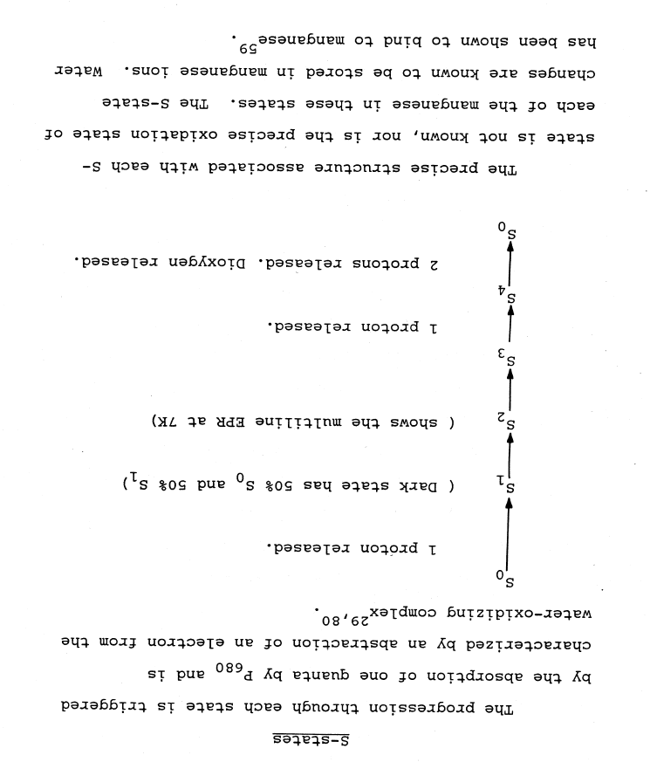
Figure 2⁵ reproduced from the dissertation, describes the use of Manganese Electron Paramagnetic Resonance (EPR) to probe the manganese cluster's functional organization. The findings published and cited in the dissertation suggest that a three-manganese subcomplex is an active site for water oxidation. We found the Manganese signal while searching for porphyrin intermediates that might be trapped in thylakoid membranes isolated from spinach. Cycling the membrane in low and high salt conditions produced Manganese EPR signals that cycled without diminution. These observations resulted in the hypothesis that one of four Manganese from the cluster separated from the 4Mn-cluster in low salt and was restored to the 4 Manganese forms in high salt. Though high Calcium chloride was known to remove three extrinsic proteins, the ability of these preparations to evolve Oxygen, as measured using the Clark electrode when illuminated with light, was found to be intact. Though the recently published model of a four manganese with Ca and five oxygen atoms model of the catalytic cluster²⁵ is well characterized, it does not necessarily imply that they are essential elements of the catalytic center. The results shown here are different from other data on which the recent models are based because these results follow from separating and reconstituting the active center Manganese center. 3-Mn and 4-Mn preparations evolved Oxygen in the Clarke oxygen electrode that measures the polarographic current produced by dissolved Oxygen. The EPR signal allowed the designation of 3-Mn and 4-Mn centers. Figure 3⁵ shows the amplitude of the EPR Manganese signal when the sample is in high chloride (2.0 M NaCl) and low chloride (35mM NaCl). The preparation could be cycled through this series several times without losing the Manganese EPR signal amplitude. One of four Manganese could be extracted only in high Calcium Chloride washed membranes. The data in Figure 3 suggests that there are two pools of Manganese in the Photosystem II preparation, data not shown here but described in the published work⁵.
Figure 3A. Chloride depletion and re-addition cycles the signal intensity of the Q band EPR spectra ⁵
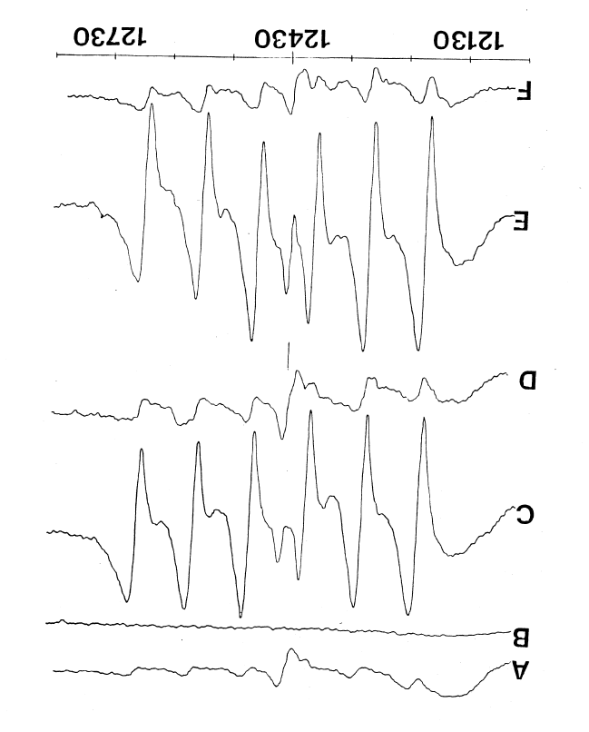

Figure 3B. Chloride depletion and re-addition cycles the signal intensity of the Q band EPR spectra - key ⁵
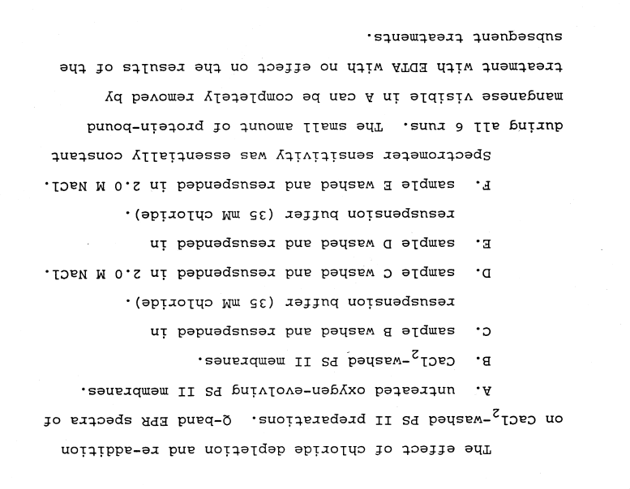
A model that explains the data shown in Figures 3A and 3B and other data in the published work⁵ is shown in Figure 4.
Figure 4. Model of the organization of Manganese in PS II ⁵
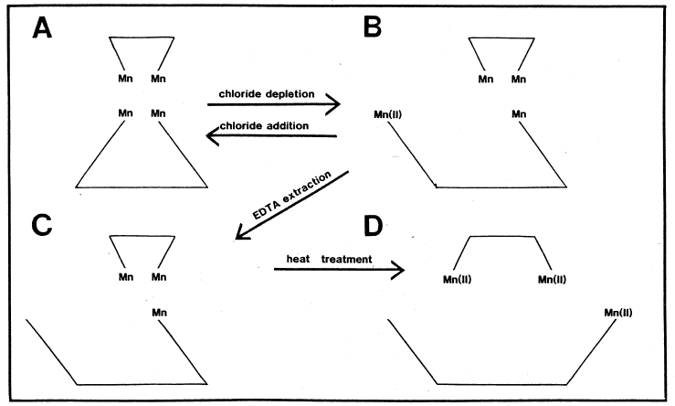
Panel C in Figure 3A corresponds to panel B in Figure 4, where the uncoupled Mn(II) results in the hyperfine structure of the G-Band EPR signal. EDTA treatment that results in the loss of 1 of 4 Manganese also results in the loss of extrinsic proteins ( 33 kDa and 17 kDa). Proteins released by Calcium chloride treatment were added to the 3-Mn preparation generated from EDTA wash. Recovery of Oxygen evolution (27 % from 35%) is shown in Tables 1A and 1B.
Table 1A. Recovery of steady-state oxygen evolution rates by reconstitution⁵
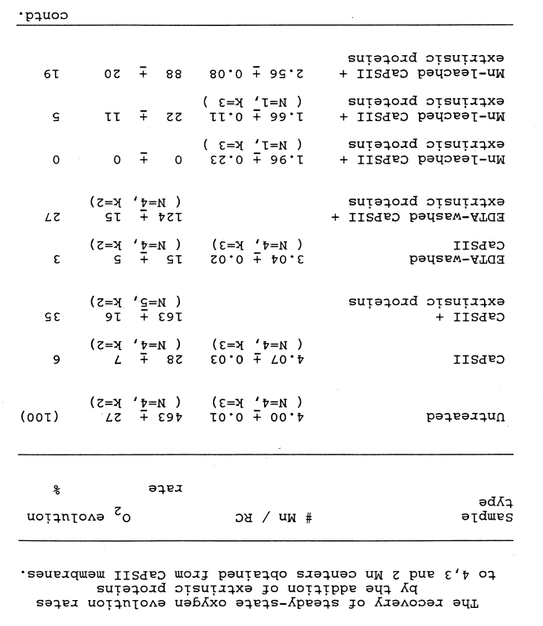
Table 1B. Recovery of steady-state oxygen evolution rates by reconstitution⁵ - key
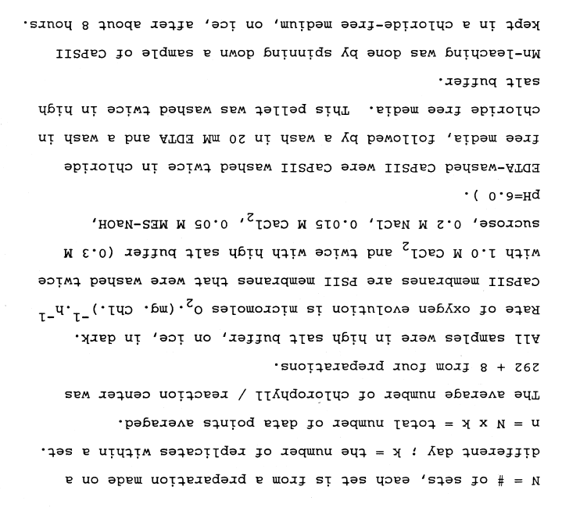
Three extrinsic proteins of 17, 23, and 33 kDa and a Manganese cover a three Manganese center at the water oxidation site. The EPR signal of such a preparation (untreated) shows a linewidth of 20 Gauss. This linewidth is unaffected by removing the 17 and 23 kDa extrinsic proteins (1 M NaCl). The three extrinsic proteins were removed without removing Manganese by an alkaline 1.0M Tris wash (pH = 8.0). The evidence for retention of all 4 Manganese is supported by Atomic Absorption measurements and the unchanged linewidth of 20 Gauss in the EPR spectrum. When the preparation was subjected to divalent-salt washing with 1.0 M CaCl_{2,} all three extrinsic proteins were also released, but the Manganese remained intact. A narrower signal appears in place of the broad 20 Gauss signal. Unlike the Tris treatment, the divalent salt wash renders the Manganese labile when the high salt is removed. This lability is reversible as the preparation could be cycled repeatedly through low and high salt washes, as shown in Figures 3A and 3B. The labile Manganese is susceptible to extraction by EDTA as well. The uncoupled Manganese is shown in Figure 4 in panel B. The chloride addition and depletion cycle is the state of the Manganese cluster between panels A and B, as shown by the model in Figure 4. EDTA extracts only 1 of 4 Manganese.
IV. Electron Paramagnetic Resonance Spectroscopy.
Free radicals, transition metal ions, and defects in materials are materials with unpaired electrons. When exposed to a magnetic field, these electrons orient themselves in the direction of the field, leading to a split in energy levels of the population of these electrons, which increases as the magnetic field increases. The latter is known as the Zeeman effect. Flipping the population distribution across the quantized levels in spectroscopy produces a line from energy absorption. In EPR spectroscopy, microwaves could provide that energy to flip. However, instead of changing the microwave frequency to create the line, their wavelength is held constant, and the magnetic field that splits the energy levels apart is scanned. The theoretical line spectrum is not what we observe but a spread across the field, as seen in Figure 3A as the width of the signal. The intensity of the signal is also proportional to the number of unpaired electrons. A residual signal of low amplitude can be found in untreated preparations. The EPR spectrum is the plot of microwave absorption (or derivative response) as a function of the magnetic field. In this case, the observed signal is shown in the model resulting from one of four Manganese getting uncoupled from its original configuration, where the coupling results in no signal. The uncoupled Manganese resides on a protein, and the model in Figure 4B represents a changed conformation that becomes possible only when the three extrinsic proteins are removed from the membrane protein complex of photosystem II by the Calcium chloride washing of the preparation. A similar wash with a mono cation like Sodium chloride or other halides (data discussed in the publication) does not render the Manganese labile enough to get uncoupled from the other three Manganese. The model presented in the recent work²⁵ does show the asymmetry in the four-manganese catalytic center. A compact three Manganese core could be more biologically relevant, as discussed in the review by Kusunoki³⁶.
V. Flame Atomic Absorption Spectrometry.
The literature cited in methods⁵ describes how to obtain the number of Manganese relative to the number of reaction centers estimated by the Chlorophyll content. Table 2 shows the Manganese stoichiometry adjusted or normalized to the number of Chlorophylls per reaction center.
Table 2. Manganese in Photosystem II: Elemental Analysis by Flame Atomic Absorption Spectrometry⁵
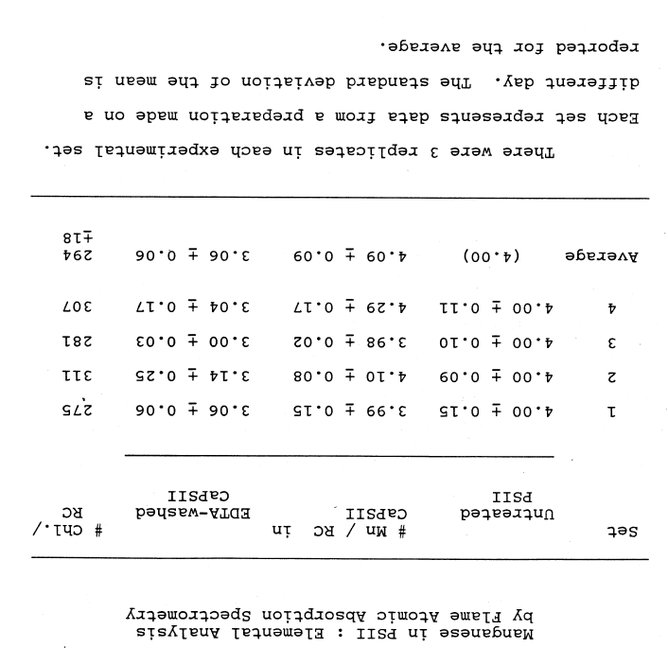
VI. Polarographic measurement of Oxygen Evolution.
Oxygen evolution is assayed by a polarographic Clarke-type electrode using an artificial electron acceptor with a magnetic stirrer keeping the solution homogenous while shining light on it²⁶. The potentiating voltage applied across a platinum cathode and silver anode results in a polarographic current generation at the cathode in the presence of Oxygen amplified and recorded on a chart recorder. The scale of the recorder is calibrated in micromoles of Oxygen. The slope of the light-induced response is calculated and expressed as micromoles of Oxygen evolved per mg. chlorophyll per hour.
VII. Other Biophysical tools.
A general theory for analyzing the EPR spectra monomeric Manganese (II) bound to proteins is presented by Meirovitch and Pupko¹⁰.
A. Transient Absorption (TA) spectroscopy:
TA Spectroscopy provides a window into the dynamic behavior of molecules and energy transfer processes following photoexcitation. It is well suited for investigating fast processes on the picosecond to millisecond timescale. The technique uses a "Pump pulse," a short laser pulse, which induces transitions from the ground to the higher electronic states, creating a population of excited molecules. After a defined delay, a second "Probe pulse," a second laser pulse set to a particular wavelength to monitor specific transitions or a broad spectrum, is used. The probe light is absorbed by both the ground and excited state molecules. The absorption changes are quantified by comparing the intensity of the transmitted probe light to the amplitude before excitation.
Furthermore, a systematic set of delays are applied between the pump and probe pulses to capture the temporal profile of the excited states. The use of this technique to study has been enhanced by developing a series of software tools to perform global, lifetime, and target analyses of in vivo datasets²⁷. When used with stopped-flow techniques, time-resolved spectroscopy has been used to examine the structure-function relationships of redox mediators²⁸.
B. ELDOR / DEER:
Angstrom level resolution of the distance between unpaired electron spins is measured using ELDOR/DEER, which measures the dipolar coupling between the spins. Electron-electron double resonance (ELDOR), also known as double electron-electron resonance (DEER), is a technique that is often used in conjunction with electron paramagnetic resonance (EPR) spectroscopy. A simplified outline of how it works: 1. Preparation step: The sample is placed in a magnetic field to align the spin states of the electrons. The magnetic field causes energy gaps between the spin states to match the energy of the microwave radiation; in other words, they are said to be in "resonance" with the microwaves. 2. First Pulse: An initial microwave pulse is applied that flips the spin states of the electrons. 3. Second Pulse: A second pulse is applied after a certain delay. The second pulse is applied at a different frequency than the first to perturb it to a different electron spin center. The latter introduces a phase shift in some spins, creating an imbalance that establishes an observable echo. 4. Third Pulse: After another delay, a third pulse identical to the first pulse is applied to all the spins, which leads to the formation of a spin echo. 5. Observation: After the third pulse, the resultant echo signal decay is detected as a function of time. This signal, known as the DEER echo, is analyzed to get information about the distances between the two different types of spin systems. The latter makes the technique well-suited to detect conformational changes in proteins bearing paramagnetic centers. Models based on such studies have been reviewed recently²⁹.
C. NMR microscopy and reflectance spectroscopy:
NMR microscopy and reflectance spectroscopy on whole leaves was used to determine chloroplast water content³⁰. The hydrogen nuclei in water yield a strong nuclear magnetic resonance (NMR) signal. This signal can be spatially mapped, representing where water is located within a leaf. The study reports the relative water content between the water in the chloroplasts and the other cellular components of the leaf. The chlorophyll in the leaf strongly absorbs light in the blue (440-470 nm) and red (640-680 nm) regions and reflects more in the green (550 nm) region, which is why leaves appear green. Reflectance spectroscopy measures the amount of light that reflects off a surface, as opposed to the amount of light absorbed or transmitted. A spectrophotometer is used to measure reflected light. Leaves with more water generally reflect more light in the near-infrared region, and this can be used in remote sensing to assess crop health much before the crop sustains damage. SCF-MO calculations were used to obtain the principal components for the g-tensor of hydrogen and fluorine peroxy radicals to develop a general theory that can be used to analyze the ESR spectra to identify peroxy radicals31 chemically.
D. Oxygen K-edge X-ray Absorption Spectroscopy (XAS):
XAS is a powerful tool to determine the electronic structure of oxygen-containing materials and environments in chemistry and biology. XAS operates by focusing high-energy X-rays onto a sample. These X-rays have enough energy to eject core electrons (in this case, the 1s electrons from oxygen atoms) from their atomic orbitals. The latter causes them to be excited into unoccupied states or is wholly ejected from the atom. The "K-edge" refers to the energy at which the 1s electron is excited. Oxygen K edge XAS measures the ability of a sample to absorb X-rays changes as the energy of the X-rays is tuned. As the applied power approaches the binding energy of the 1s electrons of Oxygen ("K edge), the absorption spikes in the spectrum. The resulting spectra can tell us a lot about the unoccupied electronic states that the 1s electron is being excited into, or in other words, reveals the local electronic structure around the oxygen atom. It shows if the Oxygen is in a hydroxyl group (-OH), an oxide (O2-), or bonded with other elements. The method finds applications in diverse fields such as material science, chemistry, geology, environmental science, and biology. The technique has been given different names based on some variations such as XANES (X-ray absorption near edge structure) or NEXAFS (near edge X-ray absorption fine structure), ELNES (near edge energy loss spectroscopy), IXS (inelastic x-ray scattering), XRS (X-ray Raman scattering) or NIXS (non-resonant inelastic X-ray scattering). As discussed in this chapter, transition metal oxides such as Manganese coupled with Oxygen is a particular case of applying this technique. The method is reviewed for various oxides³³. The ability of Manganese to draw electrons away from the Oxygen in Mn-O bonds is crucial for forming Oxygen from water³⁴.
IV. Artificial Photosynthesis.
Artificial Photosynthesis is a promising route to achieving carbon-neutral energy sources. Solar-driven water oxidation that generates hydrogen ions in a bionic leaf is coupled with a bioengineered bacterium to convert carbon dioxide from the air, in a report by Dogutan and Nocera¹². The hurdles to an inexpensive, durable heterogenous catalyst for mimicking water oxidation are due to an insufficient understanding of the reaction mechanisms in a review by Zhang et al. ¹³. The reaction rates at which electron transfer occurs between the light-harvesting complexes (LHC1 and LHC2) and the reaction center (RC) pigments are in the order of pico to femto seconds range. As the last step is the slowest (pico seconds versus femto seconds), it prevents back reactions. McConnell, Li, and Brudvig provide a review of natural and artificial photosynthesis¹⁴. Zhang and Sun¹⁵ review the opportunities and challenges of molecular catalysts. The catalytic turnover rate (TON) and turnover frequency (TOF) define a good water oxidation catalyst. In nature, Water oxidation occurs at a low overpotential (approximately 160 mV) and a high reaction rate (100 – 400 per second). The actual mechanism of water oxidation in Photosynthesis, as to how the O-O bond formation is yet to be determined, and two candidate mechanisms are proposed and lack experimental verification. The candidate mechanisms are a water nucleophilic attack (WNA) and interaction between two M-O intermediate (I2M) pathways to form O-O bonds (oxygen evolution) catalyzed by molecular catalysts. The first molecular water oxidation catalyst (WOC) reported in the 1980s was Ru based, the so-called blue dimer (BD). It had a TON of 13 and TOF of 0.0042 per second. It took three decades to see a breakthrough with a molecular WOC with a TON of 2000 and a TOF of 41 per second. This breakthrough was accomplished using carboxylate groups in the ligands and a unique steric configuration that allowed 7-coordination at the catalytic site. The overpotential was reduced from 370 mV to 180 mV; the TON changed from 0.004 per second to 41 per second, and the TON changed from 13 to 2000¹⁵. This change was inspired by the OEC in PSII containing several carboxylate ligands. Among the challenges to overcome are that current WOCs are noble metal Ruthenium based and not earth-abundant metals. Low stability, high cost, and moderate light absorption limit the commercialization of the technology. A model compound that mimics the biology of the water oxidation site catalytic center protected the catalytic site from the side reaction by binding it to a TiO₂ surface using a chromophoric linker³². The solid-state structure of Manganese oxides plays a crucial role in their efficiency as catalysts for water oxidation. The most promising structural motif is large tunnels reminiscent of proteins with channels and pores³⁵. Computational approaches to guide and interpret experiments that could also lead to generating data that Machine Learning could use to guide the design of artificial Photosynthesis further is reviewed in a Nature briefing³⁸. Metal nanoparticles (NPs) could be analogous to the protein residues controlling the metal-bound biocatalytic center that could be tailored and characterized. The synthetic methods to produce such metal nanoparticles are discussed in the review with a comparison to the parameters for artificial photosynthesis³⁹.
V. Manganese in Superoxide Dismutase
Reactive oxygen species (ROS) result from the ETC in mitochondria. Dismutation is a chemical reaction in which a single compound is simultaneously oxidized and reduced, forming two different products. In the context of Superoxide dismutase (SOD) enzymes, dismutation refers to the enzymatic reaction in which superoxide radicals (O2-) (ROS) are converted into Oxygen (O2) and hydrogen peroxide (H2O2). Superoxide (O2-) is dismutated into molecular Oxygen (O2) through oxidation, and hydrogen peroxide (H2O2) is formed through reduction. Besides mitochondria, SODs, discovered in 1968, use other transition metals and have a wide distribution in other tissues as well with a similar protective function that plays a vital role in a wide range of disease conditions such as cancer of the colon lung and lymphatic system as well as neurodegenerative diseases. Heart and stroke patients often succumb to cell damage and death after blood and Oxygen are restored to ischemic or hypoxic tissue, whose treatment using organometallics is described in a perspective²⁴. The human Mn-SOD (manganese superoxide dismutase) enzyme is a homotetramer, meaning it consists of four identical subunits, each containing a manganese metal ion as a cofactor. The structure of the human Mn-SOD enzyme can be described as follows:
1. Subunit Structure: Each subunit of the Mn-SOD enzyme consists of a single polypeptide chain folded into a compact globular structure. The polypeptide chain comprises approximately 200 amino acid residues. The four subunits come together to form the complete Mn-SOD enzyme.
2. Active Site: The active site of Mn-SOD, where the manganese ion is located, is situated in the interior of each subunit. The manganese metal ion is coordinated by amino acid residues of the protein, forming the catalytic center. The coordination environment surrounding the manganese ion helps facilitate the dismutation reaction of superoxide radicals. The manganese cluster typically consists of two manganese ions, often referred to as the "redox-active" Manganese (Mn3+) and the "catalytic" Manganese (Mn2+), which are bridged by amino acid residues. The exact amino acid residues involved can vary, but commonly, they include histidine and aspartic acid residues. Oxygen-containing ligands, including water molecules or amino acid side chains, often bridge these manganese ions. These bridges stabilize the cluster and influence the reactivity of the manganese ions. The MnSOD active site coordinates with the superoxide substrate, allowing the manganese ions to participate in the dismutation reaction. The manganese cluster plays a role in cycling between different oxidation states, enabling the enzyme to catalyze the conversion of superoxide radicals. The detailed mechanism involves the formation of a manganese-peroxide intermediate that leads to the production of molecular Oxygen and hydrogen peroxide. The manganese cluster is strategically positioned within the active site of MnSOD to accommodate the superoxide substrate. The binding and orientation of the superoxide molecule relative to the manganese ions are critical for the catalytic process. The catalytic mechanism of the manganese cluster in human MnSOD is interesting in how, unlike other Superoxide Dismutases, the one in the mitochondria where the electron transport chain is similar to that in the chloroplast uses Manganese. In contrast, Nickel and Iron is often the catalyst in prokaryotes²³.
3. Secondary Structure: The protein chain of Mn-SOD contains various secondary structures, including alpha helices and beta strands. These structural elements provide stability and contribute to the overall folding of the enzyme.
4. Quaternary Structure: The homotetramer assembly of Mn-SOD is stabilized by non-covalent interactions between the individual subunits. These interactions involve hydrogen bonding, ionic interactions, van der Waals forces, and hydrophobic interactions. The quaternary structure of Mn-SOD is crucial for its stability and enzymatic activity. The precise arrangement and three-dimensional structure of human Mn-SOD have been determined using X-ray crystallography or nuclear magnetic resonance (NMR) spectroscopy. These methods have allowed scientists to visualize and understand the detailed structure and coordination of the manganese cofactor within the Mn-SOD enzyme.
5 Biology In the course of metabolic processes, especially in aerobic (oxygen-utilizing) organisms, an oxygen molecule acquires one (unpaired) electron to form a superoxide molecule which is highly reactive and is known to cause damage that is implicated in a wide array of diseases and conditions, including aging, cancer, cardiovascular diseases, neurodegenerative disorders, and inflammation. Nature has evolved defense mechanisms involving antioxidant enzymes such as superoxide dismutase (SOD), catalase, and various non-enzymatic molecules like vitamins C, E, and glutathione. These antioxidants help neutralize superoxides by converting them into less harmful molecules and maintaining cellular redox balance.
6. SODs Superoxide Dismutases are metalloenzymes differentiated by redox active metal copper (Cu/Zn SOD), MnSOD or FeSOD, and NiSOD, forming three evolutionary families. The FeSODs are found in prokaryotes, and MnSODs are in the mitochondria near the electron transport chain.
6 MnSOD mimetics Recombinant SOD enzymes have been used in some preclinical trials to be effective therapeutic agents; however, being proteins, their scope is minimal. Therefore, non-proteinaceous synthetic low molecular weight mimetics of the SOD enzymes have found wide adoption as pharmaceutical agents to treat various superoxide-related ailments. Essential aspects of chemistry, in particular, redox activity and biochemistry of superoxide and nitric oxide, as well as their interaction with MnSOD mimetics that should be considered for the future design and pharmacological studies of manganese-based therapeutics and even diagnostic tools, are covered in the review by Ivanovic-Burmazovic and Filipovic¹⁶. Since superoxide solutions are unstable due to the fast reaction, characterizing the SOD activity of mimetics requires careful assessment. Pulse radiolysis and stopped-flow measurements are direct methods that follow the decomposition of the superoxide in the UV region ¹⁷⁻¹⁹. Indirect methods (variations of the cytochrome c or NBT/MTS/XTT assays) track the inhibition by the putative SOD mimetic of the reaction between an indicator and in situ generated (usually by xanthine/xanthine oxidase system or 60Co gamma irradiation) superoxide²⁰⁻²¹. A review of the catalytic activity of synthetic Manganese complexes provides insights into catalysis design²².
References
- https://asm.org/Articles/2022/February/The-Great-Oxidation-Event-How-Cyanobacteria-Change# (accessed on 14 Jun 2023)
- Shevela, D., Kern, J.F., Govindjee, G. et al. Solar energy conversion by photosystem II: principles and structures. Photosynth Res 156, 279–307 (2023). https://doi.org/10.1007/s11120-022-00991-y
- Pierre Galka and others, Functional Analyses of the Plant Photosystem I–Light-Harvesting Complex II Supercomplex Reveal That Light-Harvesting Complex II Loosely Bound to Photosystem II Is a Very Efficient Antenna for Photosystem I in State II, The Plant Cell, Volume 24, Issue 7, July 2012, Pages 2963–2978, https://doi.org/10.1105/tpc.112.100339
- Murata, N. The discovery of state transitions in Photosynthesis 40 years ago. Photosynth Res 99, 155–160 (2009). https://doi.org/10.1007/s11120-008-9389-8
- Gopinath R. Mavankal. Biophysical Investigations of Manganese at the Water-Oxidation Site of Spinach Photosystem II. Ph.D. dissertation, University of Southern Mississippi, May 1989. BIORXIV/2023/552559
- Mavankal, G., McCain, D. (1991). Photosystem 2 Remains Capable of Oxygen Evolution After Losing 1/4 of its Initial Manganese Content. Photosynthetica, 25(4), 631-638. Available at: https://aquila.usm.edu/fac_pubs/7156
- Terry M. Bricker. Biochemistry 1992 31 (19), 4623-4628. Oxygen evolution in the absence of the 33-kilodalton manganese-stabilizing protein. DOI: 10.1021/bi00134a012
- Bonke, S.A., Risse, T., Schnegg, A. et al. In situ electron paramagnetic resonance spectroscopy for catalysis. Nat Rev Methods Primers 1, 33 (2021). https://doi.org/10.1038/s43586-021-00031-4
- Luís González, Carlos Bolaño, François Pellissier. Use of Oxygen Electrode in Measurements of Photosynthesis and Respiration. Handbook of Plant Ecophysiology Techniques, Chapter 9, 2001. ISBN: 978-0-7923-7053-6
- Meirovitch, E., and Poupko, R., J. Phys. Chem., 82, 17,1920, (1978).
- Sergio L.C. Ferreira, Marcos A. Bezerra, Adilson S. Santos, Walter N.L. dos Santos, Cleber G. Novaes, Olivia M.C. de Oliveira, Michael L. Oliveira, Rui L. Garcia. Atomic absorption spectrometry – A multi-element technique. TrAC Trends in Analytical Chemistry, Volume 100, Pages 1-6 (2018)/ ISSN 0165-9936. https://doi.org/10.1016/j.trac.2017.12.012.
- Dilek K. Dogutan and Daniel G. Nocera. Artificial Photosynthesis at Efficiencies Greatly Exceeding That of Natural Photosynthesis. Accounts of Chemical Research 2019 52 (11), 3143-3148. DOI: 10.1021/acs.accounts.9b00380
- Hongna Zhang, Tianying Liu, Nicholas Dulock, Benjamin P. Williams, Yuanxing Wang, Boqiang Chen, Haden Wikar, David Z. Wang, Gary W. Brudvig, Dunwei Wang and Matthias M. Waegele. Atomically dispersed Ir catalysts exhibit support-dependent water oxidation kinetics during photocatalysis. Chem. Sci., 2023, 14, 6601-6607. DOI: 10.1039/d3sc00603d
- Iain McConnell, Gonghu Li, and Gary W. Brudvig. j.chembiol.2010.05.005 (2010). Correspondence: gary.brudvig@yale.edu. DOI 10.1016
- Biaobiao Zhang and Licheng Sun. Artificial Photosynthesis: opportunities and challenges of molecular catalysts. Chem. Soc. Rev., 2019, 48, 2216-2264. DOI: 10.1039/C8CS00897CIvana IvanoviĆ-BurmazoviĆ, Milos˘ r. FilipoviĆ,
- Chapter 3 - Reactivity of manganese superoxide dismutase mimics toward superoxide and nitric oxide: Selectivity versus cross-reactivity, Editor(s): Rudi van Eldik, Ivana Ivanović-Burmazović, Advances in Inorganic Chemistry, Academic Press,Volume 64,(2012),Pages 53-95,ISSN 0898-8838,ISBN 9780123964625,https://doi.org/10.1016/B978-0-12-396462-5.00003-9.
- Riley, D. P.; Rivers, W. J.; Weiss, R. H. Anal. Biochem. 1991, 196, 344–349.
- Weiss, R. H.; Flickinger, A. G.; Rivers, W. J.; Hardy, M. M.; Aston, K. W.; Ryan, U. S.; Riley, D. P. J. Biol. Chem. 1993, 268,23049–23054.
- Maroz, A.; Kelso, G. F.; Smith, R. A. J.; Ware, D. C.; Anderson, R. F. J. Phys. Chem. A 2008, 112, 4929–4935.
- Barnese, K.; Gralla, E. B.; Cabelli, D. E.;Valentine, J. S. J. Am. Chem. Soc. 2008, 130, 4604–4606.
- Beyer, W. F. Jr., Fridovich, I. Anal. Biochem. 1987, 161, 559–566.
- Das, Kuhali and Waiba, Satyadeep and Jana, Akash and Maji, Biplab. Manganese-catalyzed hydrogenation, dehydrogenation, and hydroelementation reactions. Chem. Soc. Rev. 2022, vol. 51., 11, 4386-4464. DOI: 10.1039/D2CS00093H http://dx.doi.org/10.1039/D2CS00093H
- Azadmanesh J, Borgstahl GEO. A Review of the Catalytic Mechanism of Human Manganese Superoxide Dismutase. Antioxidants. 2018; 7(2):25. https://doi.org/10.3390/antiox7020025
- Bigham J. N. P. and Wilson J. J. Am. Chem. Soc. 2023, 145, 17, 9389–9409. https://doi.org/10.1021/jacs.3c01984
- Pantazis, DA. Clues to how water splits during Photosynthesis. Nature 2023, vol. 617., 468-9.
- Delieu T. and Walker D. A. An improved cathode for the measurement of photosynthetic oxygen evolution by isolated chloroplasts. New Phytol. (1972) 71, 201-225
- Baikie T. K., Kosmützky D., Lawrence J. M., Gray V., Schnedermann C., Horton R., Collins J. D., Medipally H., Witek B., Nowaczyk M. M., Zhang J., Wey L., Howe C. J., Rao A. Ultrafast In vivo Transient Absorption Spectroscopy. https://arxiv.org/abs/2307.09448v1, https://doi.org/10.48550/arXiv.2307.09448.
- Mtemeri1 L., and Hickey D., Designing Enzymatic Redox Mediators: Quantifying the Impact of Molecular Structure on Biocatalytic Activity, 2022 Meet. Abstr. MA2022-02 1995.
- Lubitz W., Pantazis D. A., and Cox N., Water oxidation in oxygenic Photosynthesis studied by magnetic resonance techniques. FEBS Letters, (2023) vol 597, 1, 6 – 29. https://doi.org/10.1002/1873-3468.14543.
- Carter G. A., and McCain D. C., Relationship of leaf spectral reflectance to chloroplast water content determined using NMR microscopy, Remote Sensing of Environment,Volume 46, Issue 3,1993, 305-310,ISSN 0034-4257,https://doi.org/10.1016/0034-4257(93)90050-8.
- McCain, D.C., and Palke, W. E., Theory of electron spin g-values for peroxy radicals. J. Magn. Resonance, (1975), vol 20, 1, 52-66.
- Young K. J., Brennan B. J., Tagore R., and Brudvig G. W., Photosynthetic Water Oxidation: Insights from Manganese Model Chemistry. Acc. Chem. Res. 2015, 48, 3, 567–574. https://doi.org/10.1021/ar5004175.
- Frati F., Hunault M. O. J. Y., and de Groot F. M. F. Oxygen K-edge X-ray Absorption Spectra. Chemical Reviews 2020 120 (9), 4056-4110. DOI: 10.1021/acs.chemrev.9b00439
- Tesch M. F., Bonke S. A., Jones, T. E, Shaker M. N., Xiao J., Skorupska, K., Mom, R., Melder, J., Kurz P., Knop-Gericke A., Schlogi R., Hocking R. K., Simonov, A.N. Evolution of Oxygen–Metal Electron Transfer and Metal Electronic States During Manganese Oxide Catalyzed Water Oxidation Revealed with In Situ Soft X-Ray Spectroscopy. Angewandte Chemie, (2019), 131, 11, 3464-3470.
- Frey C. E., and Kurz P. Water Oxidation Catalysis by Synthetic Manganese Oxides with Different Structural Motifs: A Comparative Study. Chemistry Europe (2015) 21, 42, 14958-14968. https://doi.org/10.1002/chem.201501367.
- Kusunoki, M., Mono-manganese mechanism of the photosytem II water splitting reaction by a unique Mn4Ca cluster. BBA Bioenergetics (2007), 167, 6, 484-492.
- Andrés, C.M.C.; Pérez de la Lastra, J.M.; Andrés Juan, C.; Plou, F.J.; Pérez-Lebeña, E. Superoxide Anion Chemistry—Its Role at the Core of Innate Immunity. Int. J. Mol. Sci. 2023, 24, 1841. https://doi.org/10.3390/ijms24031841
- Yang, K.R., Kyro, G.W. & Batista, V.S. The landscape of computational approaches for artificial Photosynthesis. Nat Comput Sci 3, 504–513 (2023). https://doi.org/10.1038/s43588-023-00450-1
- Martí, G., Mallón, L., Romero, N., Francàs, L., Bofill, R., Philippot, K., García-Antón, J. and Sala, X. (2023), Surface-Functionalized Nanoparticles as Catalysts for Artificial Photosynthesis. Adv. Energy Mater., 13: 2300282. https://doi.org/10.1002/aenm.202300282
- Goldman, A. D., Weber, J.M., LaRowe, D. E. and Barge, L.M. Electron transport chains as a window into the earliest stages of evolution, Proceedings of the National Academy of Sciences (2023). DOI: 10.1073/pnas.2210924120. doi.org/10.1073/pnas.2210924120

