SERICULTURE AND ITS PRODUCTION TECHNOLOGY WITH NATURAL ENEMIES
Rajesh Aarwe¹, Deependra Singh Rajput¹, Sachin Balpande², Abhishek Shukla², Amit Kumar Sharma², Shrikant Patidar² and Neelesh Raipuria²
¹Institute of Agricultural Sciences, RDVV, Jabalpur (M.P.) India
²Department of Entomology, College of Agriculture, JNKVV, Jabalpur (M.P.) India
Email - drrajeshaarwe@gmail.com

Abstract
Sericulture is an agriculture-based industry, the word which represents the production of silk by means of silkworm rearing. Sericulture is a labor encouragement agriculture industry preferably eliminating joblessness. Further, get better the economic standards of rural people. The “silk” is known as the queen of textiles had a huge importance before pre Vedic epoch. The term ‘silk’ was revealed in Rig-Veda, the Ramayana, and the Mahabharata. It is expected that one of mulberry and its associated activities can provide employment to people either directly or indirectly. The sericulture gets better regular returns all through the year with comparatively fewer expenses and some common inputs.
Keywords: Sericulture, mulberry silkworm, pests, diseases, rearing.
INTRODUCTION
Sericulture or silk production is the breeding as well as management of silkworms for the money-making production of silk or the practice of rearing silkworms for the production of silk is known as sericulture. Sericulture is a significant production in Japan, China, India, Italy, France and Spain. The “silk” is known as the queen of textiles had a huge importance before pre Vedic epoch. The term ‘silk’ was revealed in Rig-Veda, the Ramayana, and the Mahabharata. The silk-producing insects are usually known as serigenous insects. The silkworm is a general name for the silk-producing larvae of silk moths. The silk is a secretion from the salivary glands of silkworm which are found on both surfaces of the alimentary canal of silkworm larvae and this secretion harden into fine threads is termed as silk. The cocoons with which pupae are enclosed by the worms are utilized for silk production.
SILKWORM HISTORY IN THE WORLD
Nowadays there are more than 29 countries in the world working on sericulture; the historical facts demonstrate that silk was discovered in China and later this industry extended to further parts of the world. The previous reference to silk was found in the history of Chou – King (220 BC).
As per the Chinese records, the discovery of silk production from Bombyx mori occurred about 2700 BC. It is thought that Empress Si-lung-Chi was asked by Emperor Huang-ti to find out the reason for the injured mulberry leaves on trees in their backyard. The empress found white worms eating the leaves. The few days afterward she found the worms to have grown very large and the curious queen continued to observe the process till the cocoons were spun by the worms. Subsequent to the formation of shiny cocoons, the queen collected them and preserved them till moths evolved. A cocoon one day accidentally she dropped into her hot cup of tea and silky threads separated from the cocoon, when she tried to get rid of them from the cup; a fine shiny thread was exposed from the cocoons. The historical facts reveal that the silk industry began in China where the resource of silk was kept undisclosed for more than 2,000 years. Later some time, China lost its monopoly in silk production, and sericulture reached Japan via Korea and then to other countries. Sericulture has been rising in India as an agriculture-based industry playing a very important role in the enhancement of the rural economy.
SERICULTURE HISTORY IN INDIA
Western historians revealed mulberry cultivation increased in India about 140 BC from China to way through Tibet.
The cultivation of mulberry and the industry of silk first began in the areas near the rivers Brahmaputra and Ganges, the Aryans revealed the silkworm in sub-Himalayan regions although mulberry cultivation may have come to India from China.
At the beginning of the Christian era, the silk from Kashmir became well-known. This may be true that the Arabs acquired silkworm eggs as well as mulberry seeds from India during the initial days of the Christian era.
At the time of the 4th century AD, when the industry of sericulture was established in India and central Asia, raw silk and silk goods were sold to other countries Persia and Rome.
At the time during 553 AD, sericulture was increased in Constantinople. Step by step, the industry of sericulture developed in venation Republic and was capable to meet the whole require of silk in European by eleventh century.
The silk obtained from Kashmir and Bengal was sold abroad to the European markets at the time during the 14th and 15th centuries, commencing 1761 to 1785 the sale to other countries of Bengal silk to the European markets. The East India Company started to bring up to date the rearing of silkworms and silk reeling techniques.
In 1771, the Chinese Silk was beginning with the purpose of the superiority of Cocoons. The Haitian methods of rearing were introduced by East India between 1717 and 1775.
The effort was made to change local breeds of silkworms by the new varieties of mulberry plant; not including scientific study ultimately is the entire industry to disorder.
In 1870, Louis Pasteur discovered the method of mother moth examination might control pebrine disease.
At Delhi, a silk conference was called by the British Govt. in 1942. The Government launched a determined project which known as the ‘Silk Expansion Scheme’.
In the year 1948, the Country was divided into India and Pakistan. As a result, some silk-producing regions have gone to Pakistan along with East Bengal.
During the time during 19th century when the industry of silk was at hit highest point in France, the outbreak of pebrine wiped out the industry of sericulture not only in France but also in Europe and the Middle East. In India, this disease was reported in Bengal during the 19th century.
PRODUCTION OF SILK IN INDIA
India has the distinct feature of being the only country producing the five known commercial silks, which are, mulberry, tropical tasar, oak tasar, eri, and muga, of which muga with its golden yellow shine is distinctive and a choice of India.
In India, the total silk production during 2021-2022 was 34,903 MT (Anonymous, 2022). The share of mulberry production is the biggest among other types of silk produced in the country.
The cultivation of mulberry silk is mainly in states such as Karnataka, Andhra Pradesh, Assam, West Bengal, Jharkhand, and Tamil Nadu, which are the major silk-producing states in the country. The North East has the unique distinction of being the only area producing four varieties of silk viz., Mulberry, Oak Tasar, Muga, and Eri. Overall, the NE area contributes 18% of India's total silk production.
The main silk-producing states in the country are Andhra Pradesh, Assam, Bihar, Gujarat, Jammu & Kashmir, Karnataka, Chhattisgarh, Maharashtra, Tamil Nadu, Uttar Pradesh and West Bengal (Anonymous, 2022).
The Indian state Karnataka contributed approximately 32% of the total silk production in the country during 2021-22. This was followed by Andhra Pradesh which had contributed to 25% of the overall silk production during 2021-22 (Anonymous, 2022).
MAJOR PROPERTIES OF SILK
1. The silk is shiny, soft, and strong.
2. The silk is made of two proteins which are the inner core is fibroin and the outer cover is sericin.
3. The silk is hard-wearing.
4. The silk can be painted into several colours silk moth Bombyx mori is at present completely cultivated.
5. The silk no longer exists in a wild state and it cannot survive without human care.
GEOGRAPHICAL INDICATIONS OF INDIAN SILK
1. Chanderi Fabric - Madhya Pradesh (M.P.)
2. Orissa Ikat - Odisha
3. Muga Silk - Assam
4. Molakalmuru Sarees - Karnataka (K.N.)
5. Ilkal Sarees – Karnataka (K.N.)
6. Mysore Silk – Karnataka (K.N.)
7. Baluchari Saree – West Bengal (W.B.)
8. Kancheepuram Silk - Tamil Nadu (T.N.)
9. Salem Silk - Tamil Nadu (T.N.)
10. Arani Silk - Tamil Nadu (T.N.)
KINDS OF SILKWORM, VOLTINISM WITH BIOLOGY OF SILKWORM
Kinds of silkworms
There are four types of natural silk, which are marketable known, and produced. Amongst them, mulberry silk is very important and contributes as much as 95% of global production. The additional non-mulberry silks are eri silk, tasar silk as well as muga silk.
Characters | Species | Family | Host plants | Cocoon | Domestication  feasibility in  India
Mulberry  Silkworm | Bombyx mori | Bombycidae | Mulberry | The colour is silvery white. Constant and uniform type with high silk production. | trouble-free and  inexpensive
Eri silkworm | Philosamia ricini  P. Cynthia | Saturniidae | Castor | The color is white or brick red. Neither uniform nor unbroken type with moderate silk production. | infrequent
Tassar silkworm | Antheraea pernyi  A. myliltta  A. yamamai | Saturniidae | Terminalia,  Dalbergia,  Shorea, Zizyphus,  Ficus, etc. | Colour is brown. Constant and uniform type with high silk production. | The moths do not mate and so cannot be cultivated
Muga silkworm | A. assama | Saturniidae | Som  (Machilus bombycina),  Soalu  (Litsaea polyantha) | Shiny golden yellow in color.  Constant and uniform type with less silk production. | Infrequent and confined to Assam
THE WILD SILKS OF INDIA
The Natural Silk
Natural silk is the fiber of insects. It comes from the silkworm cocoon that the silkworm spins around itself to form its cocoon. A single filament from a cocoon can be as long as 1600 meters. It is measured as an animal fiber for the reason that it has a protein structure. Immediately like other animal fibers silk does not conduct heat, and acts as a superb insulator to keep our bodies hot in the cold weather and cool in the hot weather.
The silk has shine, adorn, and strength. There are three grades of silk each is a product of the three dissimilar stages of silk processing. The unwound filament makes the best quality silk and is referred to as reeled silk. It is satiny soft and pure white.
The remaining silk from the reeling process becomes the raw material for carded or combed, spun silk thread. The short fibers left behind after the carding or combing process are used to make noil thread, richly textured nubbly silk.
India generates all three varieties of natural silks that is silk, Tasar silk, Muga silk, and Eri silk.
The Tasar, Eri, and Muga silk are non-mulberry silks which are wild silks and also called Vanya Silks.
ERI SILK, TASAR SILK AND MUGA SILK
The Vanya silks produce creative excitement in designers for novelty, originality, and exclusively naturally and spontaneously.
The Vanya silks represent the rich crafts, ethnicity, and traditions of the North Eastern and tribal zones of Central, eastern India and the Himalayan region.
They are differentiated in looks and feel as they are acquired from the wild silkworms that feed on leaves of castor, kesseru, Payam, som, sualu, oak, Arjun, asan, sal, etc. in the open jungles, absorbing the disproportion of nature, and sparkly it in the silks they produce.
In unparallel surfaces, with normal shine, easy resemblance for natural colorant, light in weight and high in moisture absorbency, and with impenetrable thermal properties warm in winter and cool in summer, products of rich, hygienic climate and nutritious to the vegetation, each of the vanya silks has it possess unique beauty and national culture.
They are renowned in four different forms muga, tropical tasar, oak tasar, and eri. They are the bravura gifts of the natural world to the genius of worldwide designers, to search and create various designs for outfits, lifestyle products, and home furnishings for difficult homes, haute (high-class) fashion design as far as artistic imagination can stretch.
ERI SILK
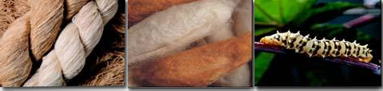
It is also called endi or errandi, this silk is produced from the eri silkworm (Philosamia ricini).
These silkworms mainly feed on the Castor and Kesseru. The eri cocoons are open-ended, and the thread is spun. Fascinatingly, in many parts of the Northeast, eri cocoons are produced for their edible pupae and silk is the outcome. Stylishly designed eri shawls and chaddars are quite trendy because of their thermal properties.
They can be blended with cotton, wool, jute, or even mulberry silk to create foreign fabrics for use in jackets, or suiting material, or for producing a variety of furnishings, making it an inner decorator’s joy. It is also known as non-violent silk as the pupa is allowed to grow and come out as a moth because eri is spun and not reeled.
TASAR SILK
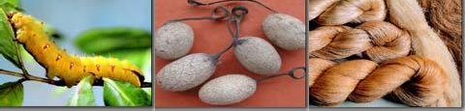
The tasar silk is formed by tasar silkworms (Antheraea mylitta and Antheraea proylei) that nourish mostly on the leaves of Asan, Arjun as well and Oak. India is the second major producer of tasar silk and the exclusive manufacturer of Indian tasar also called tropical tasar which is mostly tended by tribals in the Gondwana belt.
The oak tasar also called temperate tasar is chiefly used for furnishing, dress materials, and sarees.
The Bomkai, Paithani, Ikkat (tie & dye), and Katki are some well-liked fabrics produced by tasar silks. The Bafta is a well-liked blend of tasar along cotton. The Shawls and mufflers are also formed using a blend of oak tasar and other natural fibers similar to wool, cotton, etc.
The tasar silk is best for making jackets for men and women or conventional costumes akin to the ‘salwar-kurta’. This silk can be styled into beautiful dresses, stoles, and scarves. The tasar fabric can also be printed, hand-painted, or, even embroidered into conventional sarees and beautiful dress materials. In fact, in India, it is said that a bride’s trousseau is never complete without a saree made of tasar silk.
MUGA SILK
The pride of India, muga silk is recognized for its natural shining golden color.
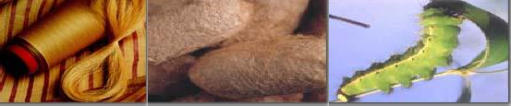
Its production is confined to Assam, border areas of adjoining Northeastern states, and Cooch Bihar in West Bengal. It is produced by the muga silkworms (Antheraea assamensis), which take to eat on Som and Sualu.
The major cost of silks, muga is essentially woven into the cultural background of the people of Assam.
The exciting Sualkuchi sarees and mekhla-chaddars are conventional items made from muga silk.
In current times, fashion designers have created exciting prospects in using muga silk for developing new products and designs. The use of muga thread as a replacement for ‘zari’ in sarees is finding favor with reputed weavers.
CLASSIFICATION OF MULBERRY SILKWORM ON VARIOUS BASES
1. Based on geographical division
a. Japanese
The univoltine or bivoltine produces green, yellow, or colorless cocoon, the larval phase is longer, silk is thick, small in length, and is better adapted to adverse conditions. They generally produce dual cocoons.
b. Chinese
The univoltine, bivoltine, or multivoltine larval growth rate is higher, the feeding rate is higher, the cocoon is egg-shaped, colorless, or golden, and yields much longer fine silk with less diameter.
c. European
The univoltine, eggs are bigger, the cocoon is long, or egg-shaped, colorless or yellow-colored, yielding much longer silk. Larvae have higher feeding rates, the larval phase is longer, and it does not endure higher temperatures and humidity.
d. Indian
The multivoltine takes less time to complete its life cycle, cocoon is small, egg-shaped, yellow or green colored, and yields silk of considerable length.
2. Based on the Number of generations per year (Voltinism)
a. Univoltine
It means refers to insects having one brood or crop or generation per year. Their larvae are of stout size and eat much more food. These generate larger-sized cocoons having 200–300 mg covering weight. In such cocoon yields 800 to 1200 m silk. They show diapause.
b. Bivoltine
It means refers to insects having two broods or crops or generations per year. Their larvae are somewhat of moderate size. The covering weight of the cocoon is 150 – 200 mg. They yield 600 – 800 m of silk.
c. Multi or Polyvoltine
It refers to insects having more than two broods or crops or generations per year. Their larvae are relatively small in size. The covering weight of the cocoon is 100 – 150 mg. They yield 300 – 400 m of silk.
3. Based on the Number of moults
a. Trimoulter
Their larvae moult three times in their larval phase. The weight of the cocoon, shell ratio, and the length of silk acquired from their cocoon are much less.
b. Tetramoulter
Their larvae moult four times in their larval phase. The weight of the cocoon, shell ratio, and the length of silk acquired from their cocoon are relatively better.
c. Pentamoulter
Their larvae moult five times in their larval phase. The weight of the cocoon, shell ratio, and the length of silk acquired from their cocoon are of superior quality.
4. Based on Genetic nature
The pure strain, a hybrid strain, mono hybrid as well as poly hybrid.
BIOLOGY AND MORPHOLOGY OF MULBERRY SILKWORM
The silkworms go through a complete metamorphosis from egg to adult phase.
I. Egg
1. The eggs are laid in clusters underneath mulberry leaves during nighttime.
2. A female lays 300-400 eggs commonly known as silk seeds measuring about 1 to 1.3 mm in length and 0.9 to 1.2 mm in breadth.
3. The eggs are tiny, ovoid, flat, ellipsoid or egg-shaped light, white or yellow, and seed-like in form.
4. At the time of the egg emerging, it turns black and hatch within 10-12 days in the period of summer and 30 days in the period of winter. In the univoltine race, the eggs do not hatch in the period of winter and endure hibernation.
5. One generation is completed in the univoltine race per year, but 2 to 7 generations are completed in the multivoltine race per year.
II. Larva
1. The newly emerged larva is white to dark in color along measures about 3 mm long.
2. There are 3 pairs of thoracic and 5 pairs of abdominal legs which are located on the 3, 4, 5, 6, and 10th abdominal segments.
3. On the dorsal surface of the eighth abdominal segment, the larva carries the caudal horn.
4. The larva moults 4-5 times and turns into maturity in 30-35 days.
5. The full grown-up larva is creamy white in color and measures about 75 mm long.
6. In the female, a pair of milky white spots becomes visible on each of the eighth and ninth segments.
7. In males, a small milky white body becomes visible at the center of the ventral side between the eighth and ninth segments.
8. Cocoon development takes place within 25 hours.
III. Pupa
1. The cocoon is 38 mm in length and 19 mm in breadth. It is egg-shaped and white or yellowish in color.
2. The larva pupates within the cocoon which is made up of a single yarn.
3. The pupa within the cocoon is reddish-brown in color and concerning about 25 mm x 7 mm in size.
4. The pupal period lasts for about 10-15 days.
5. At the time of coming out of the adult, it emits an alkaline fluid that pierces the cocoon and the adult comes out.
IV. Adult
1. The moth of silkworm is a creamy white colour concerning 30 mm in length and has a wingspan of about 40-50 mm in size.
2. The female is bigger and less active than the male.
3. The head is smaller and bears a pair of black compound eyes and the appearance of bipectinate antennae.
4. The mouth parts are vestigial (not well developed) hence the moth does not take food and lives only for about 2 to 3 days.
5. The frontal portion of the thorax is narrower than the posterior.
6. The forewings are provided with dirty colored lines and the body is covered by means of hairs.
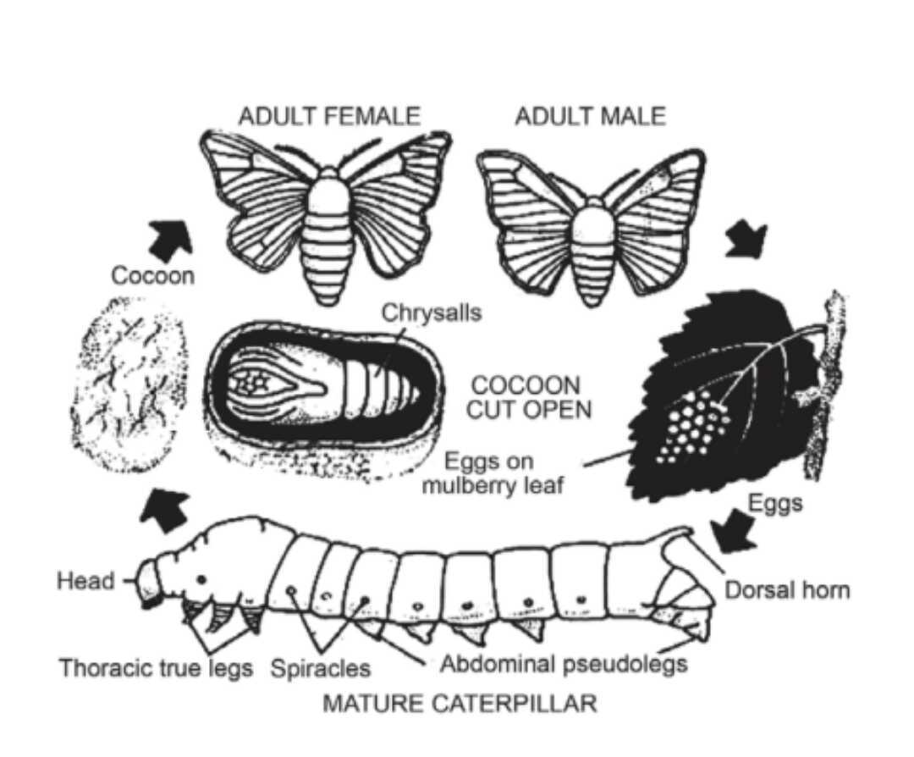
COCOON
- The cocoon is produced from a secretion of two large silk glands (truly the salivary glands), which expand along the within of the body and open by a general duct on the lower lip of the mouthparts.
- The larva moves the head from side to side extremely fast (about 65 times per minute) throwing out the secretion of the silk glands in the form of a yarn.
- The secretion is an obvious sticky liquefied, which on exposure to the air gets hardened into the superior silk fibre.
- The filament producing a cocoon is regular and ranges in length from 700 to 1100 meters.
- The cocoons from which moths have come out are called pierced cocoons.
- These are of lower value because the regular thread cannot be acquired. The pieces are removed by instruments and spun into a thread.
SILKWORMS REARING
The Sericulture is the nurturing of silkworms for the making of raw silk. The most important actions of sericulture comprise food-plant cultivation to give food to the silkworms which spin silk cocoons and reel the cocoons for unwinding the silk thread for value-added profit such as processing and weaving.

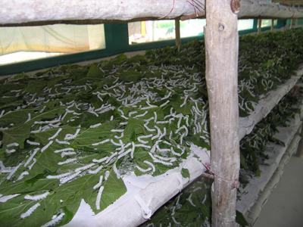
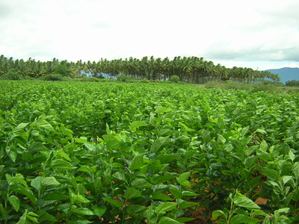
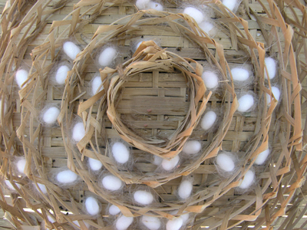
Even though there are a number of commercial species of silkworms, Bombyx mori is the most broadly used. The silk thread is a protein produced from the silk glands of silkworms.
Sericulture is an ideal world suited to improve the rural financial system of the country, as it is practiced as an additional trade to agriculture. The latest research has also shown that sericulture can be developed as an extremely returning agro-based industry.
CULTIVATION OF MULBERRY
Mulberry (Morus spp., Family - Moraceae)
The extensive character of the members of the family Moraceae (especially Morus spp.) is the existence of idioblast, an enlarged epidermal cell in the leaf.
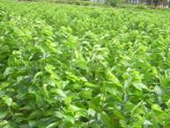
Ecological necessities
Climate
The mulberry can be grown up to 800 m Mean Sea Level. For the most advantageous growth of mulberry and good quality sprouting of the buds, the average atmospheric temperature must be in the range of 13 to 37.7ºC. The best temperature must be between 24 and 28ºC with a relative humidity of 65 to 80 percent and a sunshine period of 5 to 12 hours per day. The mulberry is able to be grown with a rainfall range of 600mm to 2500mm. Beneath the low rainwater conditions, the growth is inadequate and needs supplemental irrigation. On average, 50mm once in 10 days is measured best for mulberry.
Soil
The slightly acidic soils, with pH ranges of 6.2 to 6.8 are free from adverse salts and are best for the good growth of mulberry plants. The saline and alkaline soils are not ideal.
Varieties of mulberry
Irrigated - Kanva 2, MR 2, S 30, S 36, S 54, DD (Viswa), V1
Semi-irrigated - Kanva 2, MR 2
Rainfed - S 13, S 34, RFS 135, RFS 175, S 1635
Propagation of mulberry plant
- The mulberry is mainly propagated by means of cuttings.
- The cuttings may be planted straight away in the main field itself or the nursery may be raised as well as the sprouted and rooted seedlings may be planted in the main field.
- The later method is suitable because of its easy establishment in the main field.
Planting material selection
- Usually, the mulberry plants are raised from semi-hardwood cuttings.
- The cuttings are chosen from a fine-established backyard of 8 to 12 months old.
- The only completely grown thick main stems, free from insects along with disease damage having a diameter of 10 to 12 mm are preferred for the preparation of cuttings.
- The cuttings should be 15 to 20 cm with 3 to 4 lively buds and should have a 45º slanting cut at the base end.
- Care should be taken to create a sharp dirt-free cut at both ends of cuttings without splitting the bark.
- The manually or power-operated mulberry cutter or stem cutting machine is available for rapid cutting of propagation material.
Nursery
Preparation of nursery bed
- Select the 800 sq.m. area of red loamy soil close to the water source for raising seedlings or plantlets for planting one hectare of the main area of the field.
- Application of the 1600 kg of Farm Yard Manure (FYM) @ 20 t/ha and mix up fine with the soil.
- To raise the nursery beds of 4m x 1.5m in size.
- The length may be of suitable size depending upon the slope, irrigation source, etc.
- To provide a drainage channel and keep away from the shaded area.

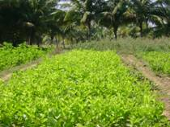
Pre-treatment to the cuttings
- To mix up one kilogram of Azospirillum culture medium in water @ 40 liters.
- Keep the base end of the cuttings for a period of 30 minutes prior to the planting. Azospirillum is applied for the purpose of inducing early rooting.
Planting of nursery
- To apply the VAM @ 100 g/m2 of nursery area.
- To irrigate the nursery bed. Planting of the cuttings in the nursery at the spacing of 15 cm x 7 cm at an angle of 45 degrees.
- To make sure the exposure of one active bud in every cutting.
Management of Nursery
- To irrigate the nursery one time in three days.
- Application of the dust one kg of any one of the following insecticides around the nursery bed to keep away from termite attack. e.g. Quinalphos 1.5D.
- To keep away from root rot and collar rot, drench the soil with carbendazim 50 WP (2 g per liter) or the application of Trichoderma viride 0.5 g per m² using a rose can.
- After weeding, apply the 100 g of urea per m² between 55 and 60 days after planting at the time of weeding.
Age of seedling
The seedlings are prepared for transplanting in the main area of the field after 90 to 120 days of planting.
Methods of planting
  - Paired row planting system
To keep the planting of cuttings or saplings at a spacing of 75 or 105 cm x 90 cm. To raise the intercrops in the wider inter row space which is willing for mechanization also.
Method of planting | Spacing ( in cm )
 | Irrigated | Rainfed
Ridges and furrows | 60 x 60 or 90 x 90 | 90 x 90
Pit system | 90 x 90 | 90 x 90
The number of cuttings per hectare is 27,780 (60 x 60 cm) and 12,345 (90 x 90 cm).
Planting time
- To plant the saplings during the rainy season.
- To keep away from planting during winter and summer months.
Saplings planting
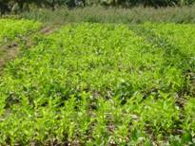
- To plant the saplings with the well-rooted and sprouted at a depth of 15 to 20 cm.
- To earth up and level the area around the saplings.
- To fill the gap during monsoon months.
Management of nutrients
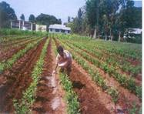
a) Irrigated or semi irrigated crop (kg/ha)
 | Row planting system |  |  | Pit planting system
 | N | P | K | N | P | K
Recommendation | 300 | 120 | 120 | 280 | 120 | 120
Split doses
First crop | 60 | 60 | 60 | 60 | 60 | 60
Second crop | 60 | - | - | 40 | - | -
Third crop | 60 | 60 | 60 | 40 | - | -
Fourth crop | 60 | - | - | 60 | 60 | 60
Fifth crop | 60 | - | - | 40 | - | -
Sixth crop | - | - | - | 40 | - | -
- The fertilizer schedule for the V1 variety is 375:140:140 kg NPK/ha.
- Apply fertilizers as per soil recommendation wherever doable.
- Apply the first dose of fertilizers within the three months after planting.
- To follow a later dose of fertilizer after every leaf harvest and pruning.
- Apply straight fertilizers to reduce the cost.
b) Rainfed crop (Kg/ha)
 | N | P | K
Recommendation | 100 | 50 | 50
First dose | 50 | 50 | 50
Second dose | 50 | - | -
- Apply the first and second doses coinciding with southwest and northeast monsoons in that order.
Application of Biofertilizers
- To apply Azospirillum @ 20 kg per ha in the five split doses. To apply phosphobacterium @ 10 kg per ha in two equal splits.
- To mix up the bio-fertilizers with 50 kg of FYM for a homogeneous supply.
- To make sure irrigation after application.
- Do not mix up bio-fertilizers with inorganic fertilizers.
- To grow and in situ incorporation of sunhemp.
Micro nutrients application
- Apply the recommended major or secondary nutrients based on the deficiency symptoms.
- According to the deficiency symptom of micronutrients appeared then apply various kinds of micronutrients as foliar sprays such as zinc sulphate 5 g, ferrous sulphate 10 g, borax 2.5 g, copper sulphate 2.5 g, manganese 2.5 g and sodium molybdate 100 mg per liter of water using high volume sprayer (spray fluid 500 liters per ha).
- To add the wetting agent like Teepol @ 0.5 ml per lit. for better adherence on the foliage.
Irrigation Methods
- Ridges and furrows method of irrigation
- This is a highly efficient method of irrigation.
- This requires comparatively less amount of water.
- The furrows serve as drainage waterways during heavy rainfall.
- Flat bed method of irrigation
- This method formed the rectangular beds and channels.
- Relatively in this method low water runoff.
- More land is wasted and needs more labor for field preparation.
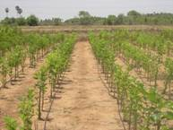
  - Drip method of irrigation
- The most efficient in water use.
- Huge saving in irrigation water.
- To better growth of the crop.
- This is appropriate for undulating terrains.
- The fertilizers can also be applied together with irrigation water.
- The blockage of emitters by physical, chemical and biological impurities.
- The initial cost is very high.
Weed Flora in Cultivation of Mulberry
The general weed flora in the mulberry garden is given below.
Name of weeds
1. Monocotyledonous weeds (Grassy weeds) | 2. Dicotyledonous weeds (Broad leaves)
Cyperus rotundus (Nut grass) | Abutilon indicum (Velvet leaf)
Cynodon dactylon (Bermuda grass) | Amaranthus viridis (Pig weed)
 | Acalypha indica (Copper leaf)
 | Boerhaevia diffusa (Hog weed)
 | Croton sparsiflorus (Croton)
 | Parthenium hysterophorus (Carrot grass)
 | Trianthema portulacastrum (Carpet grass)
 | Tridax procumbens (Tridax)
Integrated Weed Management in Mulberry
Cultural method
- To eliminate the stubbles and roots of weeds while preparing the land.
- To use fine decomposed manure to avoid spreading of weeds.
- To clean the equipments prior to use.
Mechanical method
- To employ country plough after pruning in the inter space.
- To eliminate the weeds by hand hoe.
Chemical method
- To make use of Paraquat (Grammoxone) @ 2-3 litre per hectare area as a post-emergence application.
- To spray of Glycel 7.5 ml with 10 grams of ammonium sulphate per litre of water as post-emergence application. A total of 600 litres of spray fluid is required per hectare area.
- To make use of flooding or deflector or fan-type nozzle for spraying weedicides. Applications of weedicides apply immediately after pruning or within 2 to 3 days after pruning.
Intercropping
- The intercropping through short-duration pulse crop improves the soil, gives extra income, and controls weed growth. To grow crops as intercrop like black gram green gram as well as cowpea.
- Seed rate:-10 kg per ha.
- To sow the intercrop after pruning and earthing up.
Mulching
- The mulching by means of pruned mulberry twigs and additional materials like straw and dried leaves will have the subsequent advantages
- To control the weed growth.
- To conserve the soil moisture by reducing run-off.
- To enhance the infiltration of water.
- To decrease the soil temperature.
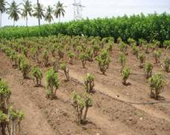
Methods of pruning
i) Bottom pruning
To cut the plants at ground level leaving 10 to 15 cm base, above the ground level. This type of pruning is done once a time in a year.
ii) Middle pruning
Cut the branches at 40 to 60 cm above the ground level. Later than bottom pruning, succeeding cuts are made at 45 to 50 cm height.
iii) Kolar / Strip system
This type of pruning is done in areas where plants are planted closely. The branches are cut at the earth level every time. Therefore, it receives five pruning every year. This type of strict pruning requires heavy fertilization and irrigation.
Harvesting of Leaf
The harvesting method of the leaf is based on the type of rearing technique applied. It is desirable to harvest the leaves for the period of morning hours. There are three types of methods that are adopted for mulberry leaf harvesting.
Picking of Leaf
The particular leaves are harvested with or devoid of petiole. The leaf picking starts 10 weeks past base pruning and subsequent pickings are done at a period of 7 to 8 weeks.
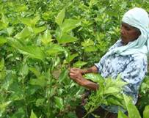
Cutting of branch
The whole branches are cut and fed to the worms. Prior to that, topping is done to ensure uniform maturity of the lower leaves.
Harvest of the whole shoot
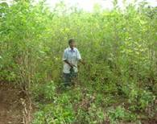
Cut the branches at ground level by bottom pruning. The shoots are harvested at an interval of 10 to 12 weeks and hence 5 to 6 harvests are made in a year.
Harvesting time
It is desirable to harvest the leaves for the duration of morning hours.
Preservation of mulberry leaves
Use a leaf preservation assembly room or wet gunny bags to store the leaves or cover the bamboo basket with wet gunny bags to keep it cool along with fresh.
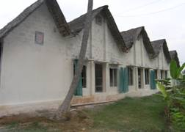
HOUSE FOR NURTURING
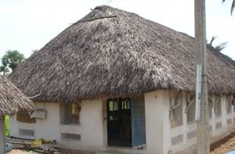
The rearing house
- A separate house is best for rearing silkworms.
- The rearing house should have enough number of windows to allow cross ventilation.
- The prerequisite should be made to make it airtight for the proper disinfection.
- The rearing house has to be built in such a way as to make available an optimum temperature of 26 to 28ºc and RH of 60 to 70% for the growth of silkworms at the lowest operational outlay.
Main principles
The most significant principles to be kept in mind in silkworm-rearing houses are:
To avoid
- Moist condition
- Stability of air
- Undeviating and strong drift of air
- Exposure to bright sunlight with radiation
To ensure
- A similar temperature and humidity
- Good quality ventilation.
Characteristics
- The house of rearing should be built depending on the staining capacity and the method of rearing. The rearing area of 2 sq. ft per dfl for floor rearing and 3 sq. ft per dfl for shoot rearing is the common criteria.
- The house of rearing should have a chief rearing hall, an ante room (8 x 8 ft), and a leaf preservation room. To maintain a best separate chawki room (a must for two- plot rearing system; rearing room of size 10’ x 14’ with a height of 9-10 ft for an acre of garden).
- The house of rearing should face east-west direction.
- The house of rearing should have facilities to maintain the required environmental conditions.
- The growing trees around the house of rearing assist in maintaining a favorable environment.
- The house of rearing should be constructed taking into consideration the following points such as effective disinfection as well as the washable floor, etc.
- The house of rearing is required for 480 sq. ft areas for rearing 100 dfls.
Rearing house preparation
- The rearing room is to be kept ready after disinfection at least 3 to 4 days in advance of the beginning of rearing.
- The preconditioning of the rearing house is necessary that is arrangement of rearing appliances and prerequisite of essential environmental conditions one day in advance.
Preparation in favor of brushing
- Prior to initiation of each rearing, the rearing types of equipment and rearing houses must be carefully washed and disinfected with chlorine dioxide.
- The chlorine dioxide is sprayed on types of equipment, walls, roofs along floors homogeneously to devastate the disease-causing organisms.
- The rooms should be kept shut for about 24 hours after disinfection.
- The doors and windows should be kept open for at least 24 hours before initiation of rearing to avoid traces of decontamination.
- To disinfect the rearing room and rearing appliances, chlorine dioxide can be used. The 500 ml of chloride dioxide is mixed with 50 grams of activator and this is dissolved in 20 liters of water. To do this, 100 grams of lime powder has to be mixed.
Appliances for rearing
Non-recurring (As General)
1. Disinfection mask and protective gum shoes, 2. Sprayer required for disinfection, 3. Room heater, 4. Water air cooler, 5. Kerosene blow lap, 6. Wet and dry thermometer, and 7. Forceps 6”.
Non-recurring (As specific)
1. Egg transportation box, 2. Egg incubation chamber, 3. Loose egg incubation frame, 4. Black box, 5. Chawki rearing trays, 6. Rearing bottom stand, 7. Feeding Stand, 8. Ant wells, 9. Leaf chopping board, 10. Leaf chopping knife, 11. Leaf mat, 12. Bed cleaning nets, 13. Earthen pot, 14. Litter basket, 15. Late age rearing trays, 16. Rearing stand, 17. Shoot rearing rack, 18. Chandrike, 19. Plastic basin, 20. Buckets, 21. Mug, 22. Plastic box, 23. Foam pads, 24. Foot rugs, 25. Leaf chamber for late age, 26. Leaf basket, 27. Cleaning nets.
Recurring
1. Paraffin paper, 2. Formalin, 3. Bleaching powder, 4. Lime powder, 5. Bed disinfectants, 6. Slides and cover slips, 7. Gunny cloth, 8. Cora cloth..
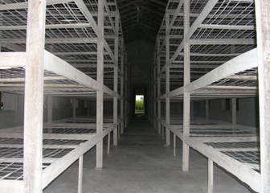 | 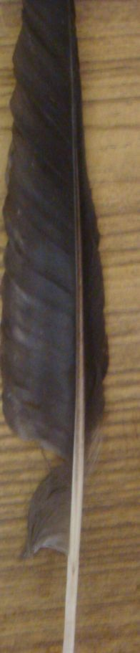 | 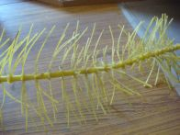 | 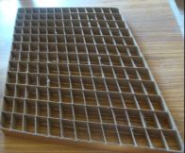
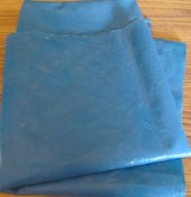 | 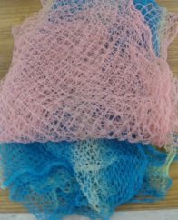 | 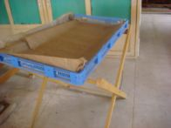 | 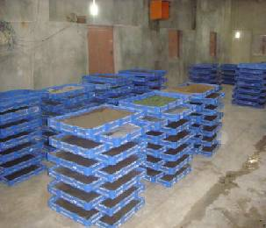

DISINFECTION
- Spray 2 % formalin with 0.3 % slaked lime or 2.5 % chlorine dioxide with 0.5% slaked lime @ 2 L/m2 area for disinfecting the rearing house immediately after final touch of rearing and three days earlier than brushing.
 | 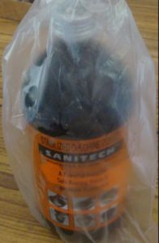 | 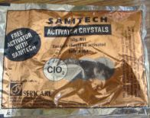
- Dip the rearing equipments in 2 % bleaching powder solution and solar dry earlier than use.
- Dust 5% bleaching powder with slaked lime powder @ 200 g/m² across the rearing house and passages and sprinkle water @ 1 lit / m² ground region.
Incubation of egg and hatching
- The egg sheets have to be spread out as a single layer in a chawki tray.
- A temperature of 25ºC and humidity of 80 percentages are maintained. For this, paraffin papers and wet foam pads may be used.
- When the eggs come to the pinnacle pigmentation stage (about 48 hours earlier than hatching), they should be kept in dark situation with the aid of wrapping them in black paper or by using keeping them in a box (black boxing). On the expected day of hatching, eggs are uncovered to light, early in the morning to make certain uniform hatching. This facilitates the uniform development of the embryo.
- Most of the eggs (90-95 percent) will hatch in about 2-3 hours.
Low-price technique of protection of eggs
- The eggs can be saved in an earthen incubation chamber.
- Draw the diagram and examine how humidity is maintained inside the chamber.
Brushing
- The hatched larvae should not be starved and they have to be brushed on a paraffin paper in a rearing tray or blue polythene sheet (Rearing bed).
- This is completed by using sprinkling chopped smooth mulberry leaves of length 0.5 to at least 1 cm² over the hatched larvae. The larvae crawl onto the leaves.
- After 8 to 10 minutes, the egg sheet is inverted over the rearing tray and lightly tapped.
- Worms which might be connected to the egg sheets have to be gently eliminated from the tray with a feather.
- A rearing bed is prepared and some more chopped leaves, if necessary, are sprinkled.
- To prevent the drying of leaves and to preserve the required humidity in the rearing bed, moist foam pads, and paraffin paper protecting are furnished.
YOUNG AGE SILKWORM (CHAWKI) REARING
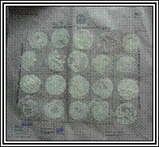
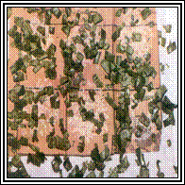 | 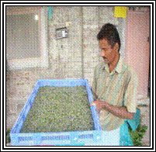
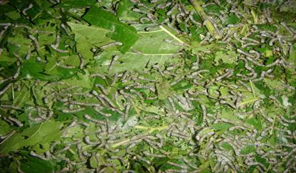

In a tray of 120 cm x 90 cm x 105 cm length, 20 dfls are brushed and reared up to the second stage.
Choice of leaves
- From brushing to the end of the second age, the larvae are fed with soft leaves.
- The leaves are selected from the most important smooth leaf, 3rd or 4th from the top.
- The following 6 to 8 leaves are used to rear the younger age worms up to II moult.
- The dimensions of the chopped leaf are round 0.5 to at least 1.0 sq. cm. at some stage in 2nd age.
- Illustrate with the help of a figure, the choice of leaves from a fully grown branch.
Leaf preservation
- Silkworm grows fine when fed with succulent leaves which might be wealthy in nutrients and moisture.
- The leaves, if not preserved properly, dry up and become fallacious for feeding.
- The harvested leaves must be preserved in clean condition in a moist gunny cloth.
- If the climate is just too warm and dry, the leaves are preserved in a leaf chamber that's coated with gunny cloth.
- The cloth is kept wet with the aid of spraying water at frequent intervals.
Cleaning
- It is the procedure of putting off the silkworm excreta and leftover leaves within the rearing bed.
- Within the first age, one cleaning is given just a day before the worms settle for moulting.
- In the second age, two cleanings are given, one after resuming feeding and the other before the second moult.
- A net with a mesh length of 0.5 x 0.5 cm is spread over the rearing bed and feeding is given.
- The worms crawl slowly through the net and come to fresh leaves.
- The net along with the worms and leaves are transferred to another tray.
- The leftover leaves and muddle are discarded.
Moulting
- On the time of moulting, care ought to be taken not to disturb the worms.
- Accurate detection of moult and preventing or resuming feeds are very important for the uniform growth of silkworms.
- Throughout moult, the rearing bed should be kept thin and dry by using of lime @ 30 – 50 g/m² and should have proper aeration.
LATE AGE SILKWORM REARING
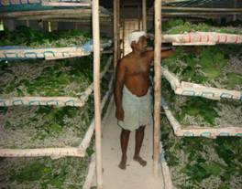 | 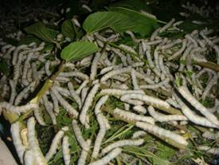

- The 3rd, 4th, and 5th instar larvae are taken to consider late-age worms. They may be reared in bamboo trays. Newspapers are stretch over the trays to soak up excess moisture in leaves and faecal pellets.
- The temperature and humidity requirements step by step come down as the stage advances.
- Leaves of medium maturity (sixth leaf onwards) are fed within the 3rd and 4th age and coarse leaves are fed inside the 5th age.
- Over-matured and yellow leaves should be rejected, because they will result in sickness outbreaks.
Bed disinfectants
Apply bed disinfectants like Resham Jyothi, Vijetha, or Sajeevini @ 4 kgs/one hundred dfls.
Stage (before feeding) | Bed disinfectant (Qty/one hundred dfls) (g)
After 1st moult | 50
After 2nd moult | 150
After 3rd moult | 800
After 4th moult | 1000
On fourth day of very last instar | 2000
Overall | 4000
Moulting
- Cast off the paraffin papers
- Evenly spread the larvae within the rearing bed for 6-8 hours earlier than settling for moult.
- Offer air movement to avoid excess humidity in the room.
- Provide charcoal stoves/warmers to elevate the room temperature during winter.
- Apply lime powder 60 mins earlier than the resumption of feeding each day throughout rainy/winter seasons to reduce the dampness in bamboo trays.
Mounting
- Apply Sampoorna @ 20 ml (dissolved in 4 litre of water) consistent with 100 dfls over the leaves for early and uniform spinning of cocoons.
- After achieving a complete growth within the final instar, the worms stop to feed and are prepared to spin.
- Such worms are slightly translucent and lift their heads to locate an area for spinning.
- Those worms have to be picked up and transferred to a mountage for spinning cocoons.
- Mounting of worms has to not be delayed because the ripened worms will waste silk.
- About 800-900 worms per m² are to be kept on a mountage. For 100 dfls, approximately 30 to 40 chandrakis are required.
- Mountages should be saved under shade in a properly ventilated place.
Care at some stage in spinning
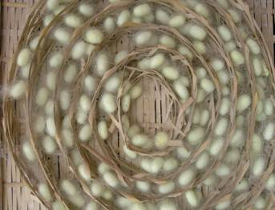
- The high quality of silk depends on the care taken at the time of spinning.
- Mature worms are touchy to temperature, humidity, light, and etc. at the time of spinning.
- The ripe worm requires space equivalent in area to square of the length of its body for spinning.
- Proper spacing avoids wastage of silk for forming an initial web and avoids double cocoons.
- To prevent staining of cocoons, hold mountage in an inclined position so that the urine can also drop to the floor.
Maintenance of humidity
- Fluctuation of humidity causes abrupt thinning and thickening of silk filament.
- A relative humidity of 60-70% is right for spinning.
- Offer the right air flow and straw mats underneath the mountage to quid excreta.
- Provide even as well as mild lights. Flawed lights (shiny light or darkish shadow) cause crowding of larvae to shaded regions leading to double cocoons.
- Eliminate dead worms and non-spinners on the 2nd day of spinning.
- To guard the silkworm from predatory ants, follow lakshman rekha (repellent) at the base of the mountage stand.
Harvesting
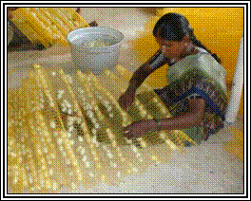 | 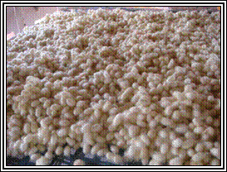

- The silkworms whole spinning in 2 to 3 days however the cocoons have to no longer be harvested at this time because the worms inside are still in the prepupal stage.
- Harvesting must be performed on the fifth day (7th day for bivoltine hybrids) when pupae are absolutely fully formed and hard.
- Do no longer harvest when the pupa is in amber color.
- Dead and diseased worms on the mountages should be eliminated earlier than harvest.
- Marketing of cocoons ought to be achieved on the sixth day (8th day for bivoltine hybrids).
Shoot rearing for late-age worms
Silkworm larvae devour 85% of their meals requirement at some point of the fifth instar. Fifty per cent of the labour input is utilized over the last seven days of rearing.
Rearing house
Provide separate rearing houses for shoot rearing in shady areas. A separate room needs to be provided for young-age worm rearing, leaf storing and a hall for late-age worm rearing.
Shoot rearing rack
- A rearing rack of 1.2m x 11m length is sufficient to rear 50 dfls.
- Provide a 15 cm border on all aspects of the shelf to save you the migration of the larvae.
- Set up the shelves in a three-tier system with 50 cm area among the tiers.
- Fabricate the rack stand with timber, or metallic and the rearing seat with twine mesh/bamboo mat.
Shoot harvesting
- Harvest the shoots at 1 m peak from floor stage at 60 to 70 days after pruning.
- Store the shoots vertically upwards in a darkish cooler room.
- Provide a skinny layer of water (3 cm) in one nook of the storage room and place the cut-off shoots inside the water for moisture retention.
Feeding
- Provide a layer of newspaper on the rearing shelf.
- Disinfect the bed; spread the shoot perpendicular to the width of the bed.
- Place top and bottom ends of the shoots alternatively to make sure same blending of different qualities of leaves.
- Transport of the third instar larvae to shoots at instantly after moulting.
- Watch for feeding speed from the 4th day of the fourth instar. If 90% of larvae have no longer settled for moulting, offer one or two extra feedings.
- Provide three feedings at some stage in rainy/winter months and 4 feedings at some stage in summer rearing.
Spacing
- 18-36 m²/100 dfls.
Bed cleaning
- Bed cleaning is accomplished as soon as all through the second day of the 5th instar following the rope (or) net method.
- In the rope method, spread a 2 m length of rope (numbers) in a parallel row leaving 0.5m on the alternative side.
- After 2 to 3 feedings, the ends of the ropes are pulled to the centre to make it into a bundle.
- In the net cleaning approach, spread a 1.5 cm² length net across the bed.
- After 2 or 3 feedings, the nets are lifted and the old bed is wiped clean and disinfected.
- Transfer the net to a more recent shelf, and spread the net over the shoots; larvae will migrate to the lower layer.
Advantages
- Labour saving up to 70% when in comparison on hour to hour basis with the leaf feeding method.
- Leaf saving up to 15-20% hence, leaf cocoon ratio is much less by 2-3 kg and further cocoon production.
- Better cocoon characters and powerful rate of rearing.
- Superior conservation of leaf quality both for the duration of storage and on the bed.
- More organic matter be counted production (as much as 18 tonnes per ha per year).
- Better hygienic conditions may be maintained.
- Managing of silkworms minimized, hence, contamination and spreading of ailment are decreased.
- Beds cleaning as soon as only once after IV moult.
- Worms and leaves are kept away from the litter, as a result, the probabilities of secondary contamination are minimized.
- Labor-dependent hazard is reduced.
Disadvantages
- Required rearing room floor region is more (by 30%)
- Bed refusals will now not be accessible as a cattle feed.
- Planting materials (cuttings) will now not be available.

IMPORTANT SILKWORM PESTS AND THEIR MANAGEMENT
Pests | Nature of Damage | Management
Common Name- Uzi fly  Scientific Name- Exorista sorbillans  (Tachinidae: Diptera)  (Endo-parasitoid of silkworm) | - The flies lay their eggs on full-grown larvae of silkworms after that hatched eggs become maggots they feed the body contents of caterpillars.  - The matured maggot causes a decrease in the yield of cocoons and cocoon quality.  - Furthermore, causes the death of silkworm larvae.  - The occurrence of creamy white oval eggs on the skin of larvae in the early stage.  - Existence of a black scratch mark on the larval skin.  - The silkworms larvae die prior to they reach the spinning stage (if they are attacked in the initial stage). Later on stage, the pierced cocoon is noticed. | - To prevent fly's access to silkworms by mechanical way.  - To use the fly's proof rooms or doors or ventilators.  - All the cracks and crevices of the rooms should be closed to prevent maggots pupating in the soil.  - To dust the China clay @ 3g per 100 on spinning larvae before mounting.
Common Name- Beetles  Scientific Name-Dermestes cadeverinus)  (Dermestidae: Coleoptera) | - The attraction of adult beetles and grubs is due to the smell of the cocoons.  - They consume the cocoons, enclosed pupae, and frequently the eggs of silkworms.  - The female's beetle lay their eggs in the crevices, organic matter as well as wooden boards.  - The Grubs and adult beetle bore into the cocoons and consumed the dried pupae, attacking pierced and melted cocoons stored within the grainage.  - The existence of small holes (pierced cocoons) in the pupae and abdominal parts is damaged in the adult moths. | - To shutting down cracks and crevices.  - To comprehensive cleaning of rearing room.  - To fumigate the rooms with methyl bromide.  - Store up the pierced cocoons in a separate room.  - To avoid long storage of pierced cocoons.  - To sun dehydrated the pierced cocoons one time in a week.
Ants  (Formicidae: Hymenoptera) | - Ants attack silkworms in rearing trays. | - The legs of the rearing stands should be dipped in ant wells (water + kerosene).  - To use the ash or kerosene at the handles of the mountages at the time of spinning.
Squirrels, Rats, Birds and Lizards | - All this feed on silkworms.  - The mammals devour pupae by biting open the cocoons. | - The rearing rooms should be kept liberated from lizards.  - To set the traps for rat as well as squirrel control.  - To scare the birds from the vicinity.

IMPORTANT SILKWORM DISEASES AND THEIR MANAGEMENT
Diseases and Causal organism | Susceptible stages/Mode  of infection | Damage symptoms | Management
Pebrine disease (Protozoa transmitted) (Nosema bombycis) | Eggs, Larvae, pupae, adults  Mode of infection: Ingestion of spores | - It is a chronic disease.  - Eggs laid by moths are fewer and do not firmly attach to the egg sheet.  - Peeper-like black spots.  - Laying of unfertilized and dead eggs.  - Diseased larvae have poor appetite, retarded growth, undersized and flaccid.  - Larvae are comparatively paler,  - Translucent and delays to moult.  - The silk gland will have white pustules on its surface.  - Dead larvae remain rubbery for some time and then turn black.  - Diseased pupa may develop black markings on the surface.  - The moth appears malformed.  - The wings are stunted and crippled  - The infection spreads to successive generations through eggs of diseased moths (TOT: Transovarial Transmission).  Responsible factor:  - Infected seeds (eggs) | - Mother moth examination.  - Use of disease-free females.  - Sterilization of eggs with 2% formalin.  - Destruction of infected eggs and females.  - Bed disinfectant:  Vijetha powder
Flacherie disease (Bacteria transmitted) (Bacillus bombysepticus) | Larvae  Mode of infection: Ingestion of spores | - Lack of appetite, semisolid excreta, turns into lethargic.  - Skin becomes flaccid body purification and emission of foul scent.  - Larvae vomit gut juice and develop dysentery.  Responsible factor:  - Horrific rearing conditions (excessive temperature and humidity).  - Negative air flow, overcrowding  - Horrific leaves and overfeeding | - Proper incubation of eggs.  - Proper rearing conditions.  - Disinfectant: Slaked lime solution 0.3%  - Bed disinfectant:  Vijetha powder
Grasserie disease (Virus transmitted) (Nuclear Polyhedrosis Virus)  Milky disease | Larvae  Mode of infection: Ingestion of polyhedra (Chrystal virus particle) | - Swelling of the inter-segmental region and easy rupture of pores and skin.  - The integument can be fragile and breaks without difficulty oozing turbid milky fluid.  - Body fluid will become thick and cloudy and they die.  - The larvae do no longer settle for moult and their integument turn out to be shining.  Responsible factor:  - Horrific rearing conditions (excessive temperature and humidity).  - Negative air flow, overcrowding  - Horrific leaves and overfeeding | - Avoidance of harm.  - Disinfection of seed manufacturing unit, home equipment, silkworm rearing house environment, and silkworm egg surface.  - Disinfectant: Slaked lime solution 0.3%  - Bed disinfectant:  Vijetha powder
Muscardine  disease  (Fungal transmitted)  1. White Muscardine (Beauveria bassiana)  - Green Muscardine (Spicaria prasina)  3. Yellow Muscardine  (Iscaria farinosei) | Larvae/ pupae/ adults  Mode of  infection:  Penetration of  skin by  germinating  spores of conidia | - Larvae lose appetite, become inactive, and flaccid on death.  - Hyphae come out from inter-segmental membranes.  - The body becomes too hard.  - Mummified larvae vomit and show diarrhea-like symptoms.  Responsible factor:  - Horrific rearing conditions (excessive temperature and humidity).  - Negative air flow, overcrowding  - Horrific leaves and overfeeding | - Proper rearing conditions.  - Sterilization.  - Formalin 3% or bleaching powder 2% or Slaked lime solution 0.3% as a disinfectant.Bed disinfectant:  Vijetha powder

Research and Training Institutes on Sericulture in India
Central Silk Board (CSB), Bangalore, Karnataka under the Ministry of Textiles, Govt. of India, is a nodal agency. The principle Research & Training Institutes of the CSB provide scientific and technological support for reinforcing production and productiveness for sustainable sericulture through modern approaches.
The main institutes working under CSB are as follows:
1. Central Sericultural Research & Training Institute (CSRTI), Mysore, Karnataka, deals with Mulberry sericulture.
2. Central Sericultural Research & Training Institute (CSRTI), Berhampore, West Bengal, deals with Mulberry sericulture.
3. Central Sericultural Research & Training Institute (CSRTI), Gallandar Pampore, Kashmir, J&K, deals with Mulberry sericulture.
4. Central Tasar Research and Training Institute (CTRTI), Piska-Nagri Ranchi, Jharkhand, deal with Tasar sericulture.
5. Central Muga Eri Research and Training Institute (CMER & TI), Lahdoigarh, Jorhat, Assam, deals with Muga and Eri sericulture.
As a way to offer R&D assist in the post-cocoon sector, the Board has installed a Central Silk Technological Research Institute (CSTRI) in Bangalore. Further, the CSB has also installation of Silkworm Seed Technology Laboratory (SSTL) in Bangalore, Karnataka, Central Sericultural Germplasm Resource Centre (CSGRC) at Hosur, Tamil Nadu, and Seri-Biotech Research Laboratory (SBRL) at Bangalore, Karnataka.
Glossary of Silk or Silkworm
1. Antheraea mylitta, Antheraea pernyi, and Bombyx croesi - Species of wild (undomesticated) moths that produce silk fiber. The silk filament is about three times heavier than that of the cultivated (domesticated) silkworm and is a coarser fiber. It is called tussah. 2. Artificial silk - Fabric that is similar in look to real silk, but is crafted from man-made fibers such as polyester, nylon, or acetate.
3. Bombyx mori - The native (domesticated) variety of silkworms that produces Thai silk.
4. Cellule - A plastic black conical cup used to cover paired moths and female moths for the duration of oviposition.
5. Cocoon - The small, egg-fashioned enclosure that a silkworm spins round itself, by developing silk filaments, to allow it to metamorphose inside to emerge as a moth.
6. De-gumming - The procedure of washing raw silk in heat soapy water to get rid of the sericin. This procedure can lessen the weight of the silk by as much as 25%. De-gummed silk is creamy white in color and quite smooth.
7. Denier - A unit of measurement of the fineness of silk and other fibers. One denier is equal to the weight of a single strand of silk thread of 9,000 meters in length, generally equal to one gram.
8. Dupion (or dupioni) - Yarn crafted from "double" cocoons which are spun by way of two silkworms simultaneously.
9. Fibroin - The protein that makes up the fiber of silk filaments.
10. Floss - Low-grade silk from the outer part of the cocoon. It can also refer to a soft silk yarn with none twist that is often used in embroidery.
11. Loom - A device for weaving threads together to make fabric. Handlooms are normally made basically of timber. Looms usually have a number of peddles to raise and decrease alternate warp threads.
12. Mulberry - The tree whose leaves are the staple food regimen of silkworms. Approximately 200 kilograms of mulberry leaves can be eaten to produce one kilogram of raw silk.
13. Mulberry Silk - An additional name for silk produced by Bombyx mori silkworms because they consume mulberry leaves.
14. Polyvoltine - The word used to explain silkworms that may be harvested numerous times a year. The native variety of silkworms in Thailand is polyvoltine.
15. Raw Silk - Silk thread that has been reeled from cocoons and is still in its natural state. It is composed particularly of fibroin (the filament) with approximately 10-25% sericin (a gluey secretion). Raw silk is golden yellow in color and fairly stiff.
16. Reeling - The procedure of unwinding raw silk filaments from cocoons to generate a raw silk thread.
17. Sericin - A gluey protein produced by silkworms that holds silk filaments together in a cocoon.
18. Sericulture - The system of rearing silkworms to the cocoon stage wherein they can then be reeled.
19. Silkworm - The larval stage of the Bombyx mori moth that generate silk fibers.
20. Skein - A coil of silk thread.
21. Slub - Tiny irregularities within the silk thread created by hand-making the thread.
22. Throwing - The process of taking raw silk threads and twisting them together to form skeins of silk yarn that will ultimately be used for weaving. Different throwing techniques are used to generate warp and weft threads.
23. Tussah - Silk produced by means of wild silkworms; for instance, Antheraea mylitta. Its silk filament is about three times heavier than that of the cultivated silkworm, Bombyx mori, and is a coarser fiber.
24. Weaving - The process of using a loom to interlace weft and warp threads to generate lengths of finished fabric.
25. Weighted silk - Silk that is colored with dye and to which metallic substances have been added throughout the dying process. This adds again weight which is lost throughout de-gumming and also adds body to the fabric. If weighting is not done properly, it reduces the life of the fabric. Pure-dye silk is considered superior.
26. Wild Silk - Silk made by way of wild silkworms; for example, Antheraea mylitta and Antheraea pernyi, additionally referred to as tussah.
27. Yarn - Silk thread that is ready to make use of weaving.
28. Voltinism - It refers to the number of life cycles per year. Depending upon eco race a normal silkworm may additionally have one (Uni), two (Bi), three (Tri), or multiple (more than three) life cycles.
29. Disease-free laying (DFL) - It is defined as a group of eggs laid out by a moth that has been certified as disease-free. Normally it consists of 200 healthy eggs. After emergence from the cocoon male moths immediately couple with female moths. After a time of 24-36 hours female moth lays eggs in about three batches. These eggs are wiped clean washed and examined under the microscope for diseases, specifically pebrine. After a batch is certified as disease-free only it is used for rearing in the field.
30. Chawkie rearing - Initially laid eggs when transferred in the field are hatched underneath supervision in a few selected shrubs for a week. This natal stage of rearing is referred to as Chawkie rearing. After a week the one-week-old larvae are spread all over the forest areas.
31. Grainage - The procedure of Tasar egg making in lay man's terms is known as grainage. It entails the storage of eggs, facilitating male-female coupling, washing cleaning of eggs, and disease checking.
32. Ecorace - Due to agroclimatic variations in the country various silkworms have adapted to local circumstances and have evolved into distinct ecoraces. For example, daba, modal, rally, laria are ecoraces of Tasar. Similarly in the case of Mulberry ecoraces are developed by Central Silk Board to get highest productivity for a particular region.
References
- Anonymous, 2022. https://www.ibef.org/exports/indian-silk-industry#:~:text=The%20total%20silk%20production%20in,previous%20year%20(33%2C770%20MT).

