SMARTHELMETUSINGPICMICROCONTROLLER
Dr.Sivanandan N
Department of Electronics
PSGCollegeof Arts&Science,Coimbatore–641014.
Mail Id:sivanandan@psgcas.ac.in

ABSTRACT:-
One way in which bike riding safety has improved is through the usage of "smart helmets," which are a form of protective headgear worn by the rider. This helmet's primary function is to protect the rider from harm. Use of advanced features such as alcohol detection, accident identification, hands-free operation, and fall detection can help bring this about.
This paper introduces the intelligent helmet, which prevents the rider from beginning the journey unless they are wearing it. Without this helmet, the bike wouldn't be able to attain the appropriate speed, thanks to a simple cable replacement for wirelessly controlling the bike's speed. A breath alcohol sensor checks the rider's BAC whenever the engine is turned on and, if it's too high, the bike slows down. GSM is utilised to increase vehicular safety. A microcontroller board is coupled to vibration sensors embedded in the helmet at strategic locations where the wearer is most likely to take a hit. These sensors detect the impact of the rider's helmet hitting the ground and send that information to the microcontroller board, which in turn controls the bike's functions. Once the data reaches the maximum stress limit, the GSM module will immediately send a message to either an ambulance or a loved one.

INTRODUCTION:-
The popularity of motorcycles with two wheels continues to rise, particularly among young people. People are flocking to the more agile and potent two-wheeled vehicles. As the number of motorcycles on the road increases, so does the potential for accidents involving them. Many mishaps occur daily on the nation's roadways. Reasons for this exist. Around 550 persons per day are killed on Indian roads, and 1600 accidents occur daily on average. Drunk driving and the failure to wear a helmet are major contributors to road fatalities. Under the Motor Vehicle Act, all motorcyclists are required to wear protective headgear when riding. A rider is required to wear a helmet per section 129 of the Motor Vehicle Act of 1988.
Intoxication impairs a cyclist's ability to focus on the road. The motion sickness impairs the rider's ability to see well. The rider's nervousness is numbed and they're motivated to take chances thanks to the booze. All of the aforementioned causes accidents on the road, and their repercussions are often severe. For every 0.05 increase in BAC, the chance of an accident doubles. The situation is made worse by the fact that Indian traffic inspectors lack the proper tools to do their jobs. Laws prohibiting drunk driving and mandating the use of safety equipment have not been effectively enforced.
According to the Motorcycle Act of 1939, a rider who is under the influence of alcohol faces six months in jail for a first violation and a fine of up to 2,000 rupees for a second. If the legislation is enforced strictly, it has a high chance of succeeding, but it rarely does because the hands of the responsible officer are frequently greased by bribes. Due to his inability to perform sober, the drunk driver is on par with a killer. These are the two primary factors that led to the development of the Smart Helmet. The initial procedure will include checking for a helmet and testing for alcohol. After a thorough inspection of the rider's headgear, the bike will be allowed to reach the minimum speed limit, and only then (20 kmph). For the same purpose, IR sensors and MQ3 alcohol sensors are employed.
They presented a smart helmet to address the problem of drivers who refuse to wear helmets despite the law requiring them to do so. There are two stages: first, a helmet detector, and then, an alcohol detector. Only when these two things have been verified will the motorcycle start. A similar function is served by the IR sensor and the MQ-3 alcohol sensor. The bike's top speed is capped by accelerometer, and falls are detected using a vibration sensor. The occurrence of an accident is confirmed by the discovery of a fall. Once a fall is detected, a text is delivered over GSM to the rider's loved ones. A GSM module and vibration sensor are utilised for this.
A reliable alcohol detector built into a system for preventing accidents involving motor vehicles. PIC 16F887 is the brains of the operation, with input from an alcohol sensor and outputs to systems like the throttle and the key. The most important safety feature this system offers is the inability of a highly intoxicated driver to operate a vehicle due to the slow reduction in speed that occurs when the system is disabled. Seventy percent of reported incidents involve impaired drivers, thus this safety measure is crucial.
When it comes to preventing mishaps brought on by people breaking rules or being reckless, this real-time embedded technology uses a simple and inexpensive solution. If the system determines that the rider has been drinking, the vehicle will gradually slow down until it comes to a complete stop. The vibration detector is sensitive enough to detect even the faintest vibrations. It detects the impact and relays the data to a microcontroller, which then notifies the subscriber's mobile device through GSM that an accident has occurred. The primary goal is to protect bicycle riders, promote the use of helmets, reduce the incidence of traffic accidents, and increase compliance with traffic regulations.

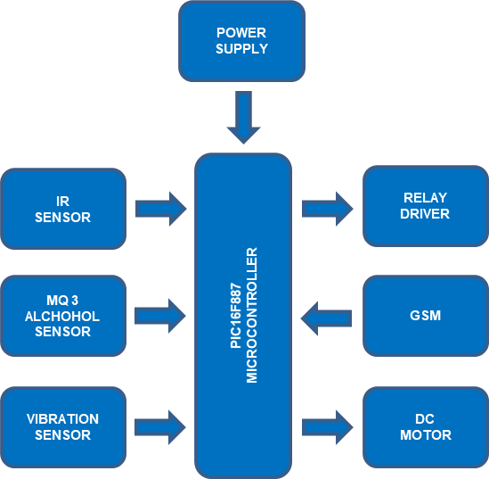
BLOCKDIAGRAM:-
Fig:Block diagram

PIC16F887MICROCONTROLLER:-
Microchip's PIC16F887 microcontroller has 8 bits. Since this 40-pin IC includes 14 channels of 10-bit ADC, it can be used in situations that demand a lot of ADC inputs. The integrated circuit is equipped with SPI, I2C, and UART protocol support as well as two comparators, two timers (8-bit and 16-bit), and a host of other features.
It includes a precise internal oscillator that can be tuned from 8 MHz to 32 kHz and can work at speeds up to 20 MHz when using an external oscillator. The integrated circuit's compatibility with Nano Watt technology makes it possible for it to run in power-saving sleep mode and consume minimal energy. The device's operational voltage range is also quite large, going all the way from 2V to 5.5V, making it work well with battery-operated gadgets.
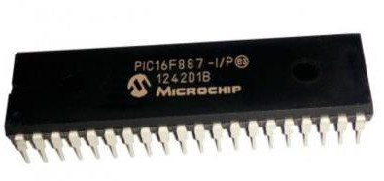
Fig:PIC16F887microcontroller
The IC is excellent for mission-critical and industrial applications because to its safety features, which include Power-on Reset (POR), Brown-out Reset (BOR), Low Current Watchdog Timer (WDT), etc. Using In Circuit Serial Programming (ICSP), the controller can be quickly reprogrammed without having to remove it from the circuit. For this purpose, a PIC microcontroller was chosen. It has an ADC built right in. The microcontroller's primary functions are circuit regulation and status monitoring. When an accident happens, the microcontroller collects signals from the vehicle's vibration sensor, infrared sensor, and alcohol sensor, and uses this information to manage the vehicle's speed and notify authorities through GSM.

POWERSUPPLY:-
The electronic circuits within each device must be able to produce a consistent DC voltage within the constraints of the device's power supply.
A regulated power supply circuit does the process of transforming an unregulated alternating current (AC) or voltage into a limited Direct current (DC) or voltage, keeping the output consistent independent of variations in the input.

RELAY:-
In its most basic form, a Relay is just an electromechanical switch. A manual switch opens and closes a circuit, while a Relay does the same thing automatically between two different circuits. In a relay, however, an electromagnet is switched on and off by an electrical signal rather than a hand switch.
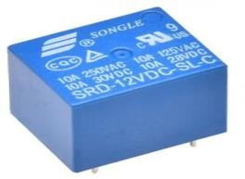
Fig: Relay

A relay can be used with either an alternating current (AC) or direct current (DC) circuit. It is possible for the circuit to be repeatedly broken using AC relays because each time the current is zero, the relay coil becomes demagnetized.
To circumvent this issue, AC relays are built with a unique mechanism to produce continuous magnetism. Electronic circuitry and shaded coil mechanics are two examples of such devices.

DCMOTOR:-
An electric DC motor, also known as a direct current (DC) motor, is a device that converts electrical energy into mechanical energy by use of a magnetic field activated by DC current. A DC motor's stator generates a magnetic field whenever the motor is turned on. Magnets on the rotor are attracted to and repelled by the field, causing the rotor to spin. The commutator, which is coupled to brushes linked to the power source, supplies current to the motor's wire windings, thereby maintaining the rotor's rotation.
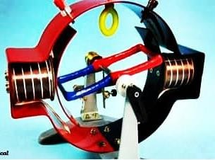
Fig:DCmotor
One of the main advantages of DC motors is that their speed can be precisely controlled, which is essential for industrial machines. As a result of their instantaneous start, stop, and reverse capabilities, DC motors play a crucial role in managing the workflow of manufacturing machinery.

IRSENSOR:-
The infrared (IR) spectrum has numerous applications in both the consumer and commercial sectors. A TV's IR sensor, for instance, deciphers the signals sent from a remote control. Infrared (IR) sensors' primary virtues lie in their low power consumption, straightforward construction, and practical functions.
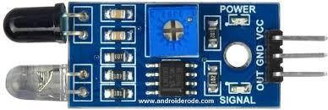
Fig: IRsenor
The human eye is completely blind to infrared (IR) waves. The portions of the electromagnetic spectrum corresponding to infrared radiation (IR) are the visible and microwave parts of the spectrum. These waves typically have lengths of 0.7 m 5 to 1000 m. The infrared (IR) spectrum has three distinct parts: the near-, mid-, and far-infrared.
The near infrared zone has a wavelength of 0.75–3 m, the mid-infrared region has a wavelength of 3–6 m, and the far infrared sector has a wavelength of 6–10 m or more.

VIBRATIONSENSOR:-
In the early 1900s, massive mechanical devices were developed to measure and record tractive and brake effort in the automotive industry. Above a paper scroll, they had two tracing pens, one mounted centrally and the other on a pendulum. There were two drums housing the scroll, each wound by a handle like a clock.
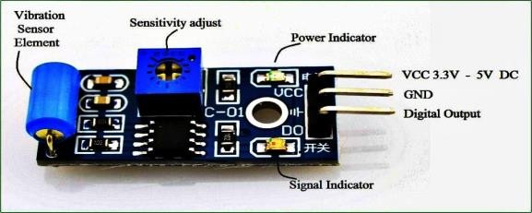
Fig:Vibrationsenor
When first invented, this device replaced the previously unreliable practise of relying on visual observations of acceleration. Vibration sensors of the modern day are electronic devices that utilise piezoelectric or piezo resistive technology. Piezoelectric models are widely utilised for plant monitoring. The amount and frequency of vibration in a system, machine, or piece of equipment can be measured with the help of a vibration sensor. In order to decrease expenses and boost machinery efficiency, maintenance teams can employ vibration sensors to gain insight into conditions within crucial assets that could contribute to equipment failure.

ALCOHOL SENSOR:-
A MQ3 Alcohol Gas Sensor is used to create this component. The semiconductor sensor is inexpensive and sensitive enough to detect alcohol gases with concentrations as low as 0.05 mg/L and as high as 10 mg/L. This sensor relies on SnO2, a sensitive substance whose conductivity is reduced in oxygen-rich air. The higher the concentration of alcohol gases, the higher its conductivity.
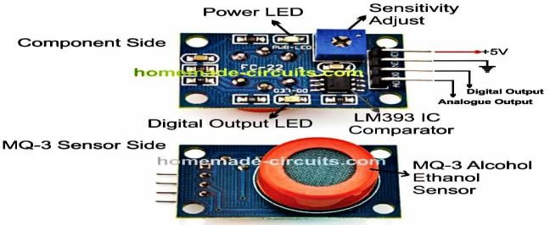
Fig:Alcoholsensor
Despite its extreme alcohol sensitivity, it is surprisingly resistant to smoke, mist, and gasoline. Two types of outputs, digital and analogue, are included in this module. The MQ3 alcohol sensor module is designed for simple integration with Microcontrollers, Arduino Boards, Raspberry Pi, and other similar devices. This breath alcohol sensor works the same as a standard breathalyser in that it measures the amount of alcohol in the breath. It's responsive and sensitive, all at the same time. This alcohol-sensing device generates an analogue resistive output proportional to the amount of ethanol present. It only takes one resistor to complete the drive circuit. An analog-to-digital converter (ADC) with a range of 0-3.3V could serve as a straightforward interface.

GSM:-
Mobile phone users in Europe and other parts of the world rely on the Global System for Mobile communication (GSM) digital mobile network. Of the three digital wireless phone technologies—TDMA, GSM, and code-division multiple access—the Global System for Mobile Communications (GSM) is by far the most used (CDMA). With GSM, information is digitised, compressed, and sent along a channel with two other streams of user information, each in its own time slot. It may function in either the 900 MHz or the 1800 MHz range.
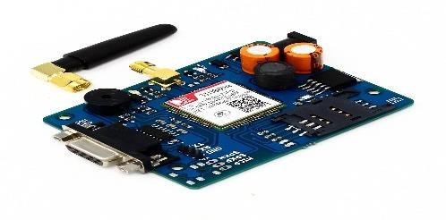
Fig:GSM
In addition to High-Speed Circuit-Switched Data (HSCSD), General Packet Radio Service (GPRS), Enhanced Data GSM Environment (EDGE), and Universal Mobile Telecommunications Service (UMTS), GSM is a key component in the growth of wireless mobile telecommunications (UMTS).

CIRCUITDIAGRAM:-
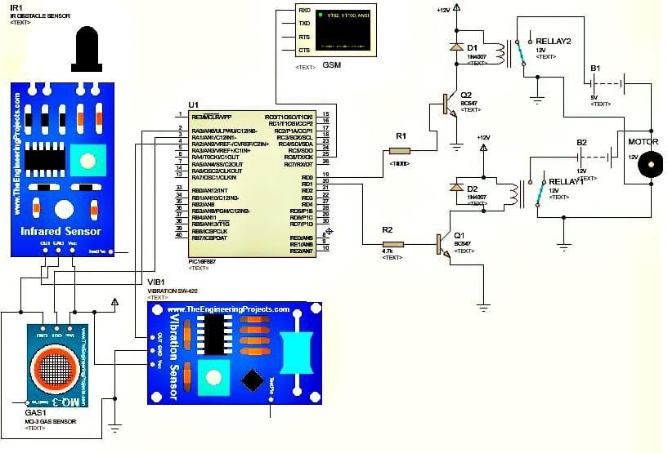
Fig:Circuitdiagram

WORKINGPRINCIPLE:-
The sensors will be used to feed data into the microcontroller, as per the project. The infrared camera is programmed to recognise helmets. The MQ3 gas sensor can tell if someone has been drinking or not. In order to identify accidents, vibration sensors are utilised. As indicated by the data collected by the sensors. Sending messages over GSM requires a connection to the UART protocol. The initial step is to check if the IR sensor detects that a helmet is being worn. The vehicle is going slower than the posted limit if the driver isn't wearing a helmet. Without a helmet, the vehicle can only go as fast as its rider. Another technique involves a gas sensor (MQ-3) that can identify the presence of ethanol. The alcohol concentration in the surrounding environment affects the sensor's surface in a noticeable way. The device can pick up traces of alcohol in the rider's breath. As the resistance value drops, the voltage shifts in response. This modified voltage is then passed into a comparator, which checks to see if it falls inside a set range and adjusts itself accordingly when the alcohol level is below the legal limit. The microcontroller will take action if the voltage from the sensor is higher than the voltage at the output of the current comparator. The speed of the vehicle is slowed to a stop if alcohol is detected at unsafe levels. If the digital vibration sensor detects an emergency situation, such as when the rider has been involved in an accident, it will immediately notify the emergency contact listed in the GSM.
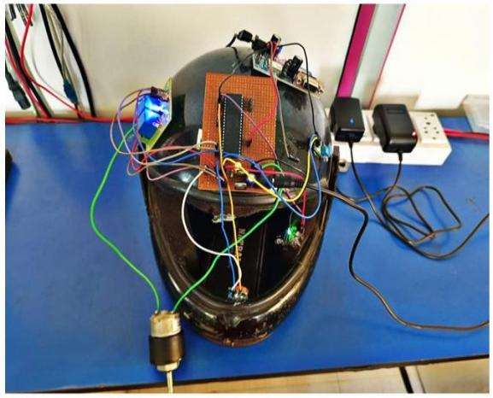
Fig:Prototype

CONCLUSION:-
The government has stepped in and made wearing helmets and not drinking and driving illegal. Only about one in ten cyclists, by some estimates. There is frequent disregard for these regulations. Previous Helmet prototypes could only detect the wearer's headgear, not their intoxication levels. The "Smart Helmet" offered under the proposed system can tell how much alcohol a rider has ingested and whether or not the rider has actually been wearing the helmet. The GSM component is the heart of this setup. The information gathered from the sensors (infrared sensor for detecting helmets, MQ3 for detecting alcohol, and vibration sensor for incident detection) will be evaluated. Riders' safety and compliance with traffic laws are both improved by the suggested approach. The goal of this project is to reduce accidents through the use of GSM and Sensors. The smart helmet's development and use were discussed at length. The Smart Helmet's innovative safety features are based on a microprocessor, a global system for mobile communications (GSM), and a set of sensors designed to protect the driver and trigger a conditional SMS if life is in danger. Only with the rider wearing a helmet would the vehicle go. As a result, fewer people will die. It aids in preventing the moulting of traffic regulations.

FUTURESCOPE:-
- A little camera can be used to record the actions of the drivers. Warning about using mobile phone while riding, excessive speeding or reckless driving alert, and other messages can be transmitted wirelessly from one vehicle to another.
- The rider's data may be viewed and tracked thanks to the incorporation of a number of bioelectric sensors inside the helmet. The bike's fundamental features can be operated by voice commands. The rider can now park their motorcycle without removing their helmet or taking any other precautions for safety. Electric vehicles and mobile devices can be charged using the solar power generated by the bikes' wheels. In the future, AI might be used to create fully autonomous motorcycles that would keep their riders completely out of harm's way.

REFERENCE:-
- Shabina.S. “Smart Helmet using RF and WSN Technology for undergroundmines safety”, Faculty of Communication Engineering, University k_Ramakrishman,Tricky.
- Manjesh N., Sudarshan Raj, Smart Helmet using GSM & GPS Technology forAccidentdetectionandReporting System,International JournalofElectricalandElectronicsResearch,2,4(2014).
- ProfessorChitteP.P.,SalunkeAkshayS.,ThoratAniruddha,NBhosale,SmartHelmet&IntelligentBikeSystem,InternationalResearchJournalofEngineeringandTechnology(IRJET)May2016.
- Smart Lighting System for Vehicle, Prof.S.R.Sawalakhe 1, Ms.Vaishali G.Johary2,Ms.KiranS.InternationalJournalofResearchinAdventTechnology(IJRAT) (E-ISSN: 2321-9637) Special Issue National Conference “CONVERGENCE2017”.
- Mohd Khairul,Afiq Mohd Rasli,Smart Helmet withsensors for accidentprevention,ICEESE,2013.
- S.U.Ahmed,R.UddinandM.Affan,"IntelligentGadgetforAccidentPrevention:SmartHelmet,"2020InternationalConferenceonComputingandInformationTechnology(ICCIT-1441),Tabuk,SaudiArabia,2020,pp.1-4.
- R. K. Sharma, G. Kumar and B. J. S, "Smart Helmet Prototype For SafetyRiding AndAlcohol Detection," 2020IEEE Bangalore Humanitarian TechnologyConference (BHTC),Vijiyapur,India,2020,pp.1-5.
- A.Jesudoss,R.VybhaviandB.Anusha,"DesignofSmartHelmetforAccident Avoidance," 2019 International Conference on Communication and SignalProcessing(ICCSP),Chennai,India,2019,pp.0774-0778.
- N. Nataraja, K. S. Mamatha, Keshavamurthy andShivashankar, "SMARTHELMET,"20183rdIEEEInternationalConferenceonRecentTrendsinElectronics, Information & Communication Technology (RTEICT),Bangalore, India,2018,pp.2338-2341.

- R. Vashisth, S. Gupta, A. Jain, S. Gupta, Sahil and P. Rana, "Implementationandanalysisofsmarthelmet,"20174thInternationalConferenceonSignalProcessing,ComputingandControl(ISPCC),Solan,India,2017,pp.111-117.
- http://www.ijetcse.com/wpcontent/plugins/ijetcse/file/upload/docx/567alcohol
-detection-using-smarthelmet-system-pdf.pdf
- http://www.academia.edu/6541133/Smart_helmet_iee_format
- https://www.asme.org/engineeringtopics/articles/manufacturing-design /engineering-safety-with-smart-helmets
- http://ijeetc.com/ijeetcadmin/upload/IJEETC_5561e8edcb13e.pdf
- http://esatjournals.net/ijret/2016v05/i05/IJRET2016

