Thermal Barrier Coatings Techniques and Materials
¹,Bharath G, Assistant Professor, School of Engineering & Technology, CMR University, Bengaluru.
²,Dr. Devaraj E, Assistant Professor, School of Engineering & Technology, CMR University, Bengaluru.
Abstract
Enhancing combustion energy utilization is the main focus in order to reduce energy waste and fuel consumption, which would ultimately aid in lowering pollution levels. The review of the study is about the thermal barrier coatings (TBCs) as a critical method for minimizing combustion energy losses in ICEs. TBCs, which have multiple layers, are used to protect engine parts from the heat. It is explained in detail how the primary layers' bond coats and top coatings boost engine performance. Two different forms of TBCs, fast heat response coatings and low heat rejection coatings, each have unique benefits for boosting engine performance. The study concentrates on the historical development of TBCs, first in aero plane engines and then in diesel engines, in response to concerns about fuel efficiency. It emphasizes the critical function of the crucial parts of the engine like the piston in an engine's efficiency as well as the potential for TBCs to reduce heat losses and boost overall efficiency. Materials for TBCs are explored, with a focus on Yttria Stabilised Zirconia (YSZ) and other possibilities with reduced thermal conductivity and excellent working temperature stability. Thermal spraying, chemical-vapor deposition, ion implantation, among other methods, are all effective techniques to apply thermal barrier coatings. The advantages and applications of each technique are thoroughly covered in this chapter.
Keywords: Internal Combustion Engine, Yttria Stabilised Zirconia, Thermal Conductivity, Coating Materials, Thermal Spray Coating.
- Introduction
The commitment of many countries of the world towards global climate has led to set ambitious goals for achieving net-zero greenhouse gas emissions by 2050 [1]. As a result, developments in internal combustion engine efficiency are gaining traction, particularly in terms of more efficiently using combustion energy [2, 3]. If the engine does not lose the combustion energy, for instance, more energy can be used despite heat losses to the exhaust, coolant fluid, and cylinder. Increased power transmission to the wheels results in less fuel being used. Improved combustion energy utilisation could therefore help achieve net-zero emission goals. Because lower pollution levels are closely correlated with decreased fuel consumption.
Thermal barrier coatings is being intensively explored for engine applications in recently to achieve minimum losses in the energy produced by combustion. They are coatings with multiple layer that are placed to the surface of a material with the primary goal of providing thermal insulation to the substrate [4]. The bond coat is the first layer of such coating and serves as a intermediate layer between the metallic substrate and the following ceramic layer [5]. The bond coat is characterised by strong resistance to oxidation and increases coating adherence. The second layer is the top coat. This coating, which is made a ceramic substance which possess characteristic of low thermal conductivity, so it serves as layer of high temperature resistance. TBCs have demonstrated promising results when designed as either a quick heat response coating [3, 12–14] or a low heat rejection coating [7–11]. Because of their less thermal conductivity, character of less heat rejection, these coatings cause energy of combustion to be retained inside combustion chamber. This, paired with less cooling due to limited heat transfer, which results in greater efficiency of the engine.
By reducing engine wear, corrosion, oxidation, and excessive heat, coating the metallic parts of diesel and petrol engines enhances performance [15]. However, its primary benefits in Internal Combustion Engines include lower brake specific fuel consumption, increased brake thermal efficiency, and gas emission control [16]. The use of ceramic coating was first employed in the aerospace industries before being applied to ICEs, particularly diesel engines, in the 1970s [17]. The reported increase in performance and decrease in BSFC in engine parts coated with ceramic sparked renewed interest [18]. Previously, piston crown of a compression ignition engine with a thermal barrier coating was introduced utilising the thermal spraying approach with improved results [19]. Currently, experts all over the world are striving tirelessly to develop an automotive engine that does not release harmful substances in its exhaust fumes while maintaining performance. One of these innovations is the use of thermal barrier coating (TBC) within the combustion chamber to improve thermal resistance and stability when working at high leap temperatures. In order to sustain additional thermal stress, the barrier coating material should have a higher thermal coefficient of expansion than the metal substrate [20].
Thermal barrier coating was originally used to improve the performance of aviation engines. Thermal barrier coating for diesel fuelled engines was first proposed in the around 1980s. The petroleum crisis and accompanying increase in fuel costs have made fuel improvement and fuel economy of I.C Engines a primary target for researchers [21]. Thermal barrier coatings are often employed in high-temperature and corrosion-resistant structural parts such as gas turbine engines, diesel engines, and power generating systems to protect metallic components from high-temperature environments. The piston is the most critical part of any engine. Assume it's the heart of the IC engine. During the compression stroke, the piston compresses the fuel and transfers power to the connecting rod via the crankshaft. A petrol engine's expansion stroke wastes 1/3 of total energy owing to coolant and 1/3 due to exhaust. Only one-third of it is used to generate electricity, therefore if it improves engine efficiency, it will reduce heat losses. In theory, reducing loss of heat from the wall of the engine will boost efficiency. The engine's efficiency is close to 40-42%. It's a key issue for the engineer, and solving it helps with thermal barrier coatings.
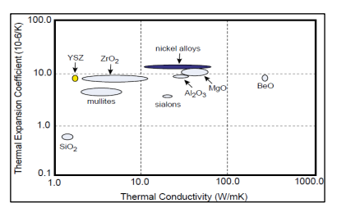
Yttria Stabilised Zirconia (YSZ), Partially Stabilised Zirconia (PSZ), Spinel, Garnets, Alumina, Mullite and other minerals are used as coating materials. The properties of these material are advantageous since it has a very low conductivity and is stable at the nominal operating temperatures frequently seen in applications. Figure 1 depicts various material available for TBC [21]. A coated piston serves to lessen friction, increase thermal efficiency, cut down on particular fuel use, and boost engine output.
Fig 1: Materials used in TBC

- Classifications of Coating Method
Thermal Spraying, Physical-Vapour Deposition, Chemical-Vapour Deposition, and Ion Implantation procedures are the categories under which the coating techniques described and reviewed in this paper fall [22]. Physical-Vapour Deposition (PVD), Chemical-Vapour Deposition (CVD), and Ion-Implantation procedures are used to obtain the minimum thicknesses [23].
  - Thermo-Spraying Technique
In thermal-spraying procedures, powder is heated until it reaches its melting point and then it is deposited in molten state or semi-molten state on a ready-made substrate [23]. Electrical arc or thermal plasma are the heat sources used in this technique. Powder form of materials or a wire made from metals, alloys, ceramics, or polymers are employed [24]. The following are some thermal spraying techniques [25]

    - Atmospheric Plasma Spraying
In the Atmospheric Plasma Spraying (APS) method, feedstock materials are heated and melted using a plasma torch before being sprayed onto a substrate to produce a functional or protective coating. This technique is frequently used to coat various surfaces with coatings that have particular qualities in the manufacturing, aerospace, automotive, energy, and other sectors. Due to its rapid deposition rate, low cost, and high porosity microstructure, which reduces the heat conductivity and coating ability of large components, the APS method is primarily employed [24]. In atmospheric plasma-spraying, particles with a typical diameter of 5 m–50 m are injected using a plasma-jet with a temperature range of 8000 K–14000 K [26]. A high-temperature plasma is created to start the procedure. A plasma is a type of state of matter made up of ionized gas that is heated to extremely high temperatures, usually between 10,000°C and 30,000°C. A high-temperature gas, such as argon or nitrogen, is passed through an electric arc or radiofrequency discharge to produce this plasma. The substance which is to be deposited is added in the stream of plasma, frequently in the nature of powder, wire, or rod. The feedstock material is swiftly melted and partially vaporized by the plasma's intense heat. The pressure of the plasma gas flow is then used to propel the molten or semi-vaporized material in the direction of the substrate. The substance rapidly cools and hardens when it makes contact with the substrate, generating a coating layer. Metals, ceramics, composites, and other materials can all be used to create the substrate.
Benefits of APS:
- Versatility: APS is adaptable for a variety of industrial applications since it can be used to be used in a wide range of materials, like composites, metals, ceramics, polymers, and others.
- High Temperature: Materials that need high melting points, such ceramics and refractory metals, can be deposited in the plasma due to its extraordinarily high temperatures.
- Thick Coatings: APS can be used to make coatings that are reasonably thick, which makes it helpful for situations where a significant volume of material is required.
- Enhancements: Depending on the materials used, coatings made by APS may have special qualities including improved wear resistance, corrosion protection, thermal insulation, or electrical conductivity.
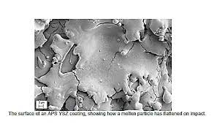
Figure 2 shows how a molten particle flattened upon impact on an APS YSZ coating. [27]
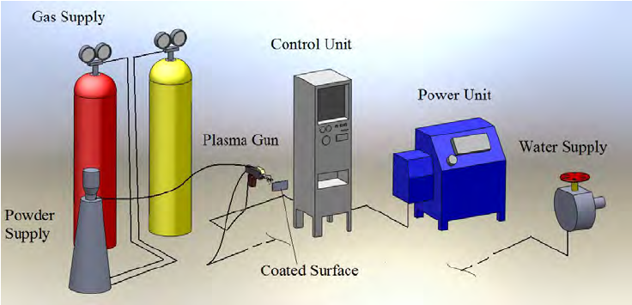
Fig 3: Equipment for Plasma Spray Coating [28].
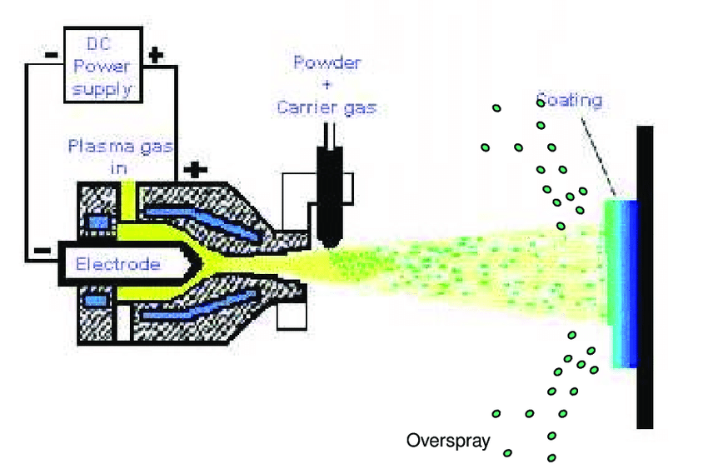
Fig 4: Plasma Sprayer (Gun)[29].

    - High-Velocity Oxy-Fuel (HVOF) coatings:
This procedure falls under the category of flame spraying [30]. A known HVOF systems function at speeds higher than Mach 5 [31]. A high-velocity flame is produced during the combustion of a fuel and oxygen mixture to form High-Velocity Oxy-Fuel (HVOF) coatings, which are advanced thermal spray coatings. To create a top-notch coating, this flame is utilized to drive feedstock materials onto a substrate, usually in the form of fine powder.
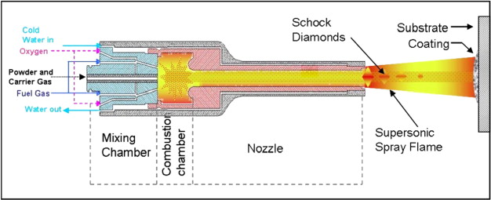
Fig 5: HVOF Gun [32].
A gas fuel (often hydrogen or kerosene) and pure O₂ are mixed together in a combustion chamber to begin the HVOF process. This mixture ignites to produce a high-temperature, high-velocity blaze. The material that will be coated is normally introduced into the high-velocity flame downstream from the combustion chamber in the form of fine powder. The flame's high heat and rapidity accelerate and soften the powder particles. The substrate that needs to be coated is approached quickly by the accelerated powder particles. These particles quickly join together after impact to form a thick, tightly-bonded covering.
High density, low porosity, a high level of adhesion to the substrate, and improved wear and resistance to corrosion are just a few of the outstanding characteristics of HVOF coatings. Additionally, depending on the use, these coatings may have certain qualities like hardness, thermal insulation, or electrical conductivity.
In industries where high-performance coatings are necessary, HVOF coatings are frequently used. Coating industrial pumps and valves, machinery used in the oil and gas industry, automobile parts, and medical devices are just a few examples of common applications.
HVOF coatings provide a number of benefits, including the capacity to produce coatings with a high bond strength and a low porosity that can endure harsh circumstances. Additionally, a variety of materials, like metals, ceramics, and carbides, can be deposited by them.
    - Detonation Gun Coatings:
Conventional flame-spray methods are limited in their capacity to create well-bonded, thick coatings with a porosity of less than 2% [33]. However, the combustion occurs within a tube or barrel into which powders are delivered in detonation guns, resulting in bigger thermal and kinetic energy jets [34]. The powder particles receive more heat and momentum transfer from this arrangement [35]. A supersonic shockwave is produced by the detonation of a fuel and oxygen combination during the thermal spray coating process known as a "detonation gun" (or "D-Gun") coating. Using this shockwave, feedstock materials are propelled onto a substrate to create an extremely dense and wear-resistant covering.
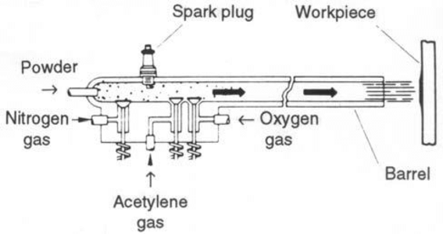
Fig 6: D-Gun [35]
A mixture of a fuel gas (often acetylene) and oxygen is first added to a combustion chamber to start the D-Gun process. This mixture experiences a controlled detonation upon ignition, producing a powerful shockwave. Usually, the substance to be coated is in powder form. The high-pressure shockwave downstream from the detonation chamber is given this powder injection. The detonation's shockwave causes the powder particles to accelerate to extremely high speeds. After being launched onto the substrate, these particles collide and combine to form a thick covering.
The extraordinary qualities of D-Gun coatings, such as their high density, low porosity, great wear resistance, and superior adherence to the substrate, are well known. These coatings are ideal for applications that require exceptional wear and corrosion resistance. D-Gun coatings can be widely used across many different industries, especially where heavy machinery parts, drilling and oilfield equipment, aerospace parts, and parts sensitive to abrasive wear and harsh environments are concerned. D-Gun coatings can be used to create coatings with a fine microstructure, a low oxide content, and great bonding strength, among other benefits. They can also be used with a variety of substances, such as metals, ceramics, and carbides.
    - Electric Arc Coatings:
Two consumable wire electrodes fed into the coating gun and when wire tips are linked to a high direct current (DC) power source, an arc is formed, which melts the wire tips during the coating process [33]. A jet of air is then used to atomize the molten metal and drive it in the direction of the substrate. This coating is energy-efficient since the full input energy is used to melt the metal. Thermal spray coatings that are created using an electric arc as the heat source are referred to as "electric arc coatings." This process involves producing an electrical arc between two disposable electrodes, which are generally formed of the coating material, in order to melt and propel the coating material onto a substrate.
Electrical current is used to form the electric arc between two electrodes. The electrodes melt and vaporize as a result of the tremendous heat produced by the resistance at the point of interaction. One of the disposable electrodes is normally the substance to be applied as a coating. Molten droplets created by the melting electrode are ejected onto the substrate. The arc's force propels the molten droplets it produces towards the substrate, where they are deposited onto the surface. They solidify and adhere to the substrate upon impact, generating a covering.
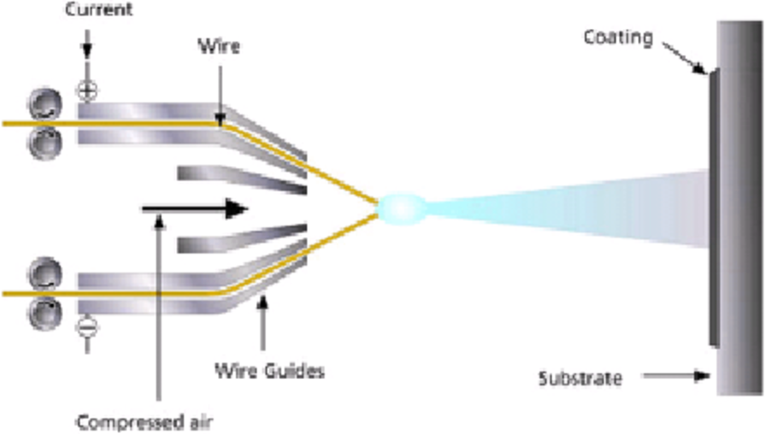
Fig 7: Electric Arc Coating [36]
Depending on the material used and the particular application, electric arc coatings can have a variety of different qualities. These coatings are renowned for their adaptability and are capable of offering qualities including thermal insulation, wear resistance, and corrosion protection.
Industries using electric arc coatings include industry, aerospace, energy, and more. Coating industrial equipment, tools, and turbine parts are frequently used to increase their performance and durability. Electric arc coatings provide a number of benefits, including the ability to apply coatings with strong bonds and little porosity. They can also be used to deposit a wide range of materials, such as metals, alloys, and hard-facing materials.
2.1.5 Cold-Spray Coatings
In the material deposition technique known as cold-spray coating, relatively small particles are propelled at high speeds—typically 300 to 1200 m/s, or 980 to 3940 ft/s—before being impacted to form a deposit on a suitable substrate.
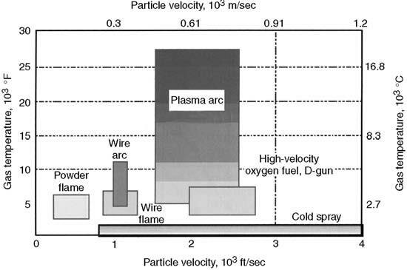
Fig 8: Comparison of common thermal-spray techniques' temperature/velocity regimes with cold-spray technology [28]
The ranges of gas temperatures and particle velocities for cold-spray and various thermal-spray processes are compared in Fig. 8 [28]. When the particle-velocity (Vp) is too low for the particular coating or substrate combination, the feed-stock particles merely reflect from the surface, making it impossible for them to form a continuous coating or deposit. At higher values of (Vp), solid-particle erosion within the surface may occur, similar to shot-blasting of surfaces. When (Vp) exceeds a critical value Vcrit (which varies with particle and substrate material), particles begin to plastically deform, form an overlay coating, and adhere to the substrate [16].
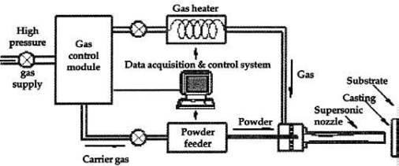
Fig 9: Cold Spray Method System [37]
  - Chemical-Vapour Deposition
High-quality thin films, coatings, and bulk materials are created using the materials processing technique known as Chemical Vapour Deposition (CVD). On the surface of a substrate, it involves the chemical reaction of gaseous precursor compounds to produce a solid substance. In fields including electronics, semiconductor manufacturing, optics, and materials research, CVD is frequently used.
High-purity and high-performance solid materials are produced using this technique [15]. Its primary use is in the production of thin films for the semiconductor sector [23]. During chemical vapour deposition, the substrate is subjected to a number of volatile precursors, which causes surface reactivity or breakdown to produce the desired deposit. Gas flow across the reaction chamber is used to eliminate volatile process by-products [34]. Due to its ability to coat complicated surfaces with strong conformal coverage, this approach is a highly desirable process for producing TBCs [15]. The main disadvantage is that the normal deposition rates are frequently less than 10 m/h. Research was done on plasma and laser as auxiliary energy sources to speed up the deposition speeds.

  - Sol-Gel & Slurry Method
The production of TBCs can be done easily and inexpensively with slurry spraying [38]. Materials can be created using the wet-chemical sol-gel process as gels, powders, or thin films. To create the desired material, a precursor solution (sol) is transformed into a gel-like state, then dried and heated. Slurry is a mixture of powder and liquid that is frequently applied to a surface with a spray gun in several applications. Following sintering in a furnace or with an acetylene torch, the multilayer coating is dried, compacted, and eventually sintering is complete [39]. The benefit of this method is that it can coat intricate geometries, including surfaces inside of pipes that are obscured from view [39]. Slurry-coating can also be applied by immersing the substrate in a ceramic-powder mixture and letting it dry, according to Kawasaki and Watanabe [17]. This procedure is continued until the desired thickness is reached, and then the coating is densified by hot isostatic pressing [39]. A sol-gel coating is applied by spraying or dipping the substrate into the solution, which is then gravitationally drained and evaporated [34]. After that, the dried sol is squeezed during firing to create a strong oxide covering. A sol-gel coating containing ceramic particles is depicted in Fig. 10 [17].
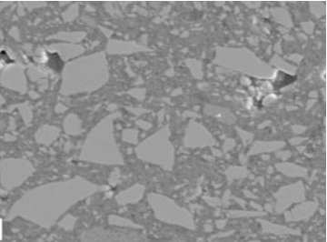
Fig: 10 Sol Gel Covering With Ceramic Particles [17]
  - Physical-Vapour Deposition Method
Physical vapour deposition (PVD) is a method used to deposit thin films or coatings on substrates that is employed in materials science and numerous industries. It is a physical process in which solid materials are transformed into a vapour phase and the vapour is subsequently condensed onto a substrate to create a thin film. PVD is frequently utilised for tasks like boosting the surface qualities of materials, enhancing wear resistance, offering protection against corrosion, and adding ornamental finishes.
Here, material is vaporised from a solid or liquid source in the form of atoms or molecules and transported as a vapour through a gaseous vacuum or low pressure environment to the substrate, where it condenses [35]. But they can also be employed to produce multi-layer coatings, graded composition deposits, incredibly thick deposits, and free-standing structures. The typical film thicknesses deposited by PVD techniques range from a few nanometers to thousands of nanometers. PVD processes come in a variety of forms, such as Electron Beam - Physical Vapour-Deposition (EB-PVD), Vacuum (Evaporation), Sputter, Arc-Vapour, and Ion-Plating [15].
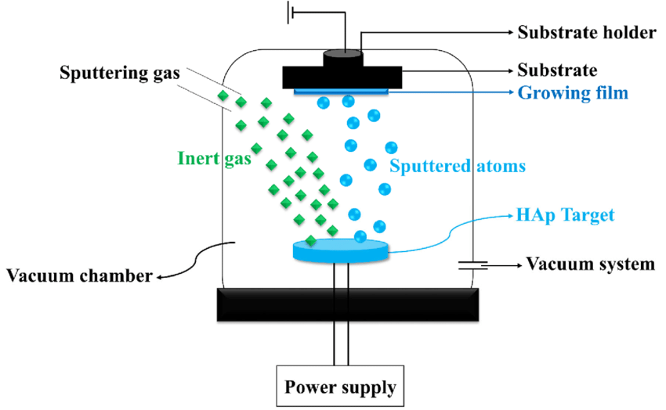
Fig 11: Physical-Vapour Deposition Method [40]

  - Ion-Implantation Method
During the ion-implantation procedure, which is carried out in a vacuum (133 x 10-6 to 1.33 x 10-3 Pa), a beam of ions is steered and propelled towards the substrate. The ions are typically accelerated to an energy level of 100 keV. The ions can reach a maximum depth of 0.25 m and an average depth of 0.1 m [33].
Ion implantation coating is a method of surface modification that improves the characteristics of materials by injecting ions into the substrate's top layer. It is frequently used to enhance wear resistance, corrosion resistance, hardness, and other surface-related qualities of materials in a variety of industries, including electronics, aerospace, and materials research. An accelerator or ion implanter is often used as the first ion source in the procedure. This source produces ions of a chosen element or substance that will be injected beneath the surface of the substrate. Normally, the ions are positively charged. A vacuum chamber is used to contain the substrate (the object to be coated). The removal of gas molecules that can obstruct the ion implantation procedure and ensure that the ions reach the substrate's surface without scattering makes it necessary to create a vacuum. The produced ions are propelled by an electric field to high energies inside the vacuum chamber.
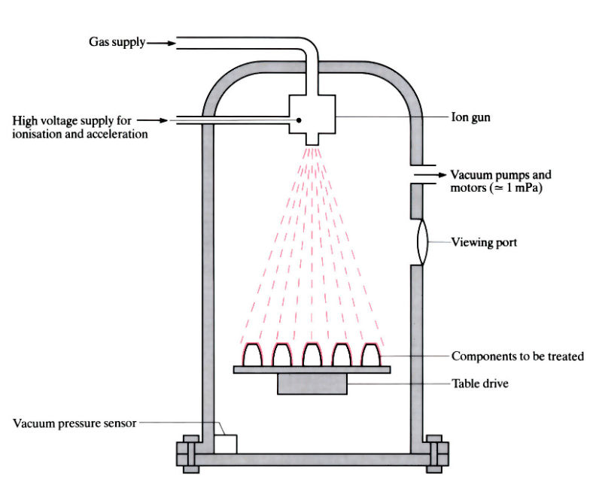
Fig 12: Ion-Implantation Method
The ions must receive enough energy from this acceleration in order for them to be able to permeate the substrate's surface. The substrate is the target of the accelerated ions, which penetrate the material's surface. The energy of the ions and the makeup of the substance determine how far they can go. The ions either cause lattice defects or embed themselves in the substrate's lattice structure. To obtain the desired coating thickness and qualities, the process parameters, including ion species, energy, and dose (the number of ions implanted per unit area), are carefully controlled. The choice of ion species and energy is important since it affects the substrate's chemical and physical changes. The substrate may go through annealing, a carefully regulated heating process, after ion implantation. Annealing promotes diffusion of implanted ions into the substrate, activates dopants, and aids in the healing of radiation damage. For the desired material qualities to be achieved, this stage is extremely crucial.
- Materials for Thermal Barrier Coatings
  - Yttria-stabilized zirconia YSZ
Zirconia was a leading option for YSZ (4 mol% Y2O3) as a TBC material because it was one of the few refractory oxides that could also be manufactured as thick films using the then-famous plasma-spraying process. A series of stricter tests, particularly those conducted under thermal cycling circumstances, led to the discovery of yttria as the ideal stabiliser and composition. When Zr4+ ions were replaced with Y3+ ions in the structure of fluorite, a large point defect concentration was created, which resulted in a narrow spacing between point defects. This was once thought to be the cause of the poor and temperature-independent thermal conductivity of YSZ. [41]
  - Fluorite Oxides
Fluorite-structured materials are a great place to seek for further TBC materials. HfO₂, CeO₂, and ThO₂ are the obvious contenders; Naturally, UO₂ and transuranic oxides with fluorite structures are not included. Additionally, even though doped ceria displays a considerable amount of thermal conductivity, volatilization prevents it from being a feasible option. Measurements of HfO₂ and ThO₂ are equivalent to those of monoclinic ZrO₂. The thermal conductivity, however, can be decreased by co-doping zirconia and hafnia, according to recent study. The most exciting findings are co-doping YSZ with a combination of trivalent ions that are larger than Y3+ and smaller than Y3+ while maintaining the metastable zirconia structure. For compositions in which some of the Zr4+ is substituted with Hf4+, decreases in thermal conductivity have also been noted. The results indicate that these materials need additional research, even though investigations were conducted on porous coatings rather than dense solids, therefore it is unknown whether porosity contributed to the low heat conductivity [41].
  - Pyrochlore Oxides
Since the fluorites don't offer any other good candidate materials, focus has been placed on the pyrochlores, A₂³⁺B₂⁴⁺O₇, because they have worse thermal conductivity than YSZ₃. This family of minerals is also of essential importance because of the close relationship between the fluorite and pyrochlore structures. The pyrochlores are especially appealing due to the fact that several of them are thermally stable and refractory up to temperatures considerably above 1500°C. [41]
Fig 13: Eighth of the pyrochlores, A₂B₂O₇ unit cell, with oxygen in red, B⁴⁺ ions in yellow, and A³⁺ ions in blue. [41]
  - Other Oxides
In addition to fluorites and pyrochlores, many additional oxide compounds have been proposed as suitable low-conductivity materials. These include the garnets (Y₃AlxFe_{5-x}O₁₂), the magnetoplumbite lanthanum hexaaluminate (LaMgAl₁₁O₁₉), and the monazite (LaPO₄). Despite having all very low thermal conductivities, none offer the prospect of compositions with a lower conductivity than the pyrochlores zirconated. In contrast to these other types of oxide, the perovskites, ABO₃, are a class of crystal structures that may sustain a wide range of different ions in solid solution, including ions with huge atomic masses. Many materials can tolerate extremely high temperatures. Despite some members having relatively low thermal conductivity at high temperatures, no other member has yet been found to have conductivity as low as the zirconate pyrochlores [41].
  - Glasses and Nano Crystalline Materials
For a very long time, it was thought that the high-temperature conductivity of silica glass reflected the so-called amorphous limit, or lower limit, to the thermal conductivity of materials at high temperatures. According to the statistics, while amorphous materials can have much worse thermal conductivity than their crystalline counterparts at room temperature, the difference disappears at temperatures considerably above the Debye threshold. Others have promoted the use of nanocrystalline materials, though, as they could be able to lower heat conductivity by incorporating grain boundary scattering as an extrinsic phonon-scattering event. There is now no conclusive data at high temperatures to support the claim that this is an effective method for many materials. There are no grains size affect, according to a first examination of nanocrystalline-stabilized zirconia ceramics. [41]
4.0 Conclusion
Atmospheric plasma spraying is a crucial manufacturing method for covering surfaces with special materials, making it essential in high-tech sectors. High-Velocity Oxy-Fuel (HVOF) coatings are advanced technologies for industrial components, while Detonation Gun (D-Gun) coatings are wear-resistant and long-lasting. Electric arc coatings provide functional or protective coatings on various substrates, offering improved qualities in various industries. Cold spray coating (CVD) creates high-purity, high-performance solid materials, primarily used in the semiconductor industry. Sol-Gel and Slurry Method can coat intricate geometries, while ion implantation coating enhances material properties by injecting ions into the substrate.
The application of ceramic material as a coating layer using the Plasma-Spray and Flame-Spray coating techniques, respectively, was found to raise the temperature in the combustion chamber of ICEs, reduce erosion-corrosion and friction-wear, and improve heat insulation on metallic surfaces after examining the various coating techniques. Thin layer coatings used on combustion chambers, stator blades, and turbine blades have proved successful in the gas turbine industry, according to the literature. In this review, coating methods using plasma and flame spray are suggested.
Zirconia, a refractory oxide, was a potential candidate for YSZ (4 mol% Y₂O₃) as a TBC material. Thermal cycling tests revealed yttria as the ideal stabiliser and composition. However, replacing Zr⁴⁺ with Y³⁺ created a high point defect concentration. Fluorite-structured materials like HfO₂, CeO₂, and ThO₂ are promising for TBC materials. However, doped ceria is not feasible due to volatilization. Co-doping zirconia and hafnia can decrease thermal conductivity, with YSZ co-doping causing significant decreases. Understanding the function of porosity in low thermal conductivity in porous coatings requires more research. The pyrochlores are especially appealing due to the fact that several of them are thermally stable and refractory up to temperatures considerably above 1500°C. Numerous more oxide compounds have also been suggested as potential low-conductivity materials, in addition to fluorites and pyrochlores. The amorphous limit to thermal conductivity, represented by silica glass's high-temperature conductivity, is insignificant at temperatures over the Debye threshold, despite exhibiting poorer thermal conductivity at ambient temperatures.
References:
1. Bouckaert, S.; Pales, A.F.; McGlade, C.; Remme, U.; Wanner, B.; Varro, L.; D’Ambrosio, D.; Spencer, T. Net Zero by 2050: A Roadmap for the Global Energy Sector. 2021. Available online: https://www.iea.org/events/net-zero-by-2050-a-roadmap-for- the-global-energy-system (accessed on 12 June 2022).
2. Somhorst, J.; Uczak De Goes, W.; Oevermann, M.; Bovo, M. (Eds.) Experimental Evaluation of Novel Thermal Barrier Coatings in a Single Cylinder Light Duty Diesel Engine; SAE International: Warrendale, PA, USA, 2019.
3. Uczak de Goes, W.; Somhorst, J.; Markocsan, N.; Gupta, M.; Illkova, K. Suspension plasma-sprayed thermal barrier coatings for light-duty diesel engines. J. Therm. Spray Technol. 2019, 28, 1674–1687. [CrossRef]
4. Tucker, R.C.J. (Ed.) Thermal spray processes. In Thermal Spray Technology; Tucker, R.C.J. (Ed.) ASM International: Almere, The Netherlands, 2013; Volume 5A, ISBN 978-1-62708-171-9. 5. Evans, A.G.; Mumm, D.R.; Hutchinson, J.W.; Meier, G.H.; Pettit, F.S. Mechanisms controlling the durability of thermal barrier coatings. Prog. Mater. Sci. 2001, 46, 505–553. [CrossRef]
7. Tree, D.R.; Oren, D.C.; Yonushonis, T.M.; Wiczynski, P.D. (Eds.) Experimental Measurements on the Effect of Insulated Pistons on Engine Performance and Heat Transfer; SAE International: Warrendale, PA, USA, 1996.
8. Kamo, R.; Mavinahally, N.S.; Kamo, L.; Bryzik, W.; Schwartz, E.E. (Eds.) Injection Characteristics That Improve Performance of Ceramic Coated Diesel Engines; SAE International: Warrendale, PA, USA, 1999.
9. Hejwowski, T.; Wero ́nski, A. The effect of thermal barrier coatings on diesel engine performance. Vacuum 2002, 65, 427–432. [CrossRef]
10. Taymaz, I. The effect of thermal barrier coatings on diesel engine performance. Surf. Coat. Technol. 2007, 201, 5249–5252. [CrossRef]
11. Modi, A.J. (Ed.) Experimental Study of Energy Balance in Thermal Barrier Coated Diesel Engine; SAE International: Warrendale, PA, USA, 2012.
12. Kosaka, H.; Wakisaka, Y.; Nomura, Y.; Hotta, Y.; Koike, M.; Nakakita, K.; Kawaguchi, A. Concept of “temperature swing heat insulation” in combustion chamber walls, and appropriate thermo-physical properties for heat insulation coat. SAE Int. J. Engines 2013, 6, 142–149. [CrossRef]
13. Kawaguchi, A.; Iguma, H.; Yamashita, H.; Takada, N.; Nishikawa, N.; Yamashita, C.; Wakisaka, Y.; Fukui, K. (Eds.) Thermo-Swing Wall Insulation Technology;-A Novel Heat Loss Reduction Approach on Engine Combustion Chamber; SAE International: Warrendale, PA, USA, 2016.
14. Andruskiewicz, P.; Najt, P.; Durrett, R.; Biesboer, S.; Schaedler, T.; Payri, R. Analysis of the effects of wall temperature swing on reciprocating internal combustion engine processes. Int. J. Engine Res. 2018, 19, 461–473. [CrossRef]
15. Ravikumar, T.; Kiran, K.; Ravichandra, V. K. and Chetan, A.C.(2014). Alternative Thermal Barrier Coatings for CI Engines – A Research Review. International Journal of Research in Advent Technology, 2, 5, pp. 2321-9637.
16. Behzad, F.; Navid, N. and Amir, D. (2019). On Coating Techniques for Surface Protection: A Review. Journal of Manufacturing and Materials Processing, 3, 28, pp. 1-23.
17. Kawasaki, A. and Watanabe, R. (2002). Thermal Fracture Behavior of Metal/Ceramic Functionally Graded Materials. Engineering Fracture Mechanics, 69, 14–16, pp. 1713-1728.
18. Miyairi, Y.; Matsumsa, T.; Ozawa, T.; Odcawa, H. and Nakashima, N. (1989). Selective Heat Insulation of Combustion Chamber Wall, for a Diesel Engine with Monolithic Ceramics. SAE Technical Paper, 890141.
19. Isaac, F.O. (2021). Unpublished PhD Dissertation, Ambrose Alli University, Ekpoma.
20. G. R. Kannan, R. Karvembu, and R. J. A. E. Anand, “Effect of metal based additive on performance emission and combustion characteristics of diesel engine fuelled with biodiesel,” Applied Energy, vol. 88, no. 11, pp. 3694–3703, 2011.
21. K. Thiruselvam, Thermal Barrier Coatings In Internal Combustion Engine, Journal of Chemical and Pharmaceutical Sciences
22. Thiruselvam, K. (2015). Thermal Barrier Coatings in Internal Combustion Engine. National Conference on Recent Trends and Developments in Sustainable Green Technologies, 7, pp. 413-418.
23. Nishant V.; Divyansh, M.; Pawan, K.A.; Subhash, G.; Chandan, B.B. and Abhishek, K. (2018). Thermal Analysis of Ceramic Coated Piston Head in Diesel Engine. International Research Journal of Engineering and Technology (IRJET), 5, 5, pp. 3770-3779.
24. Sobhanverdi, R and Akbari, A. (2015). Porosity and Microstructural Features of Plasma Sprayed Yttria Stabilized Zirconia Thermal Barrier Coatings. Ceramics International, 41, 10, pp. 14517-14528.
25. Azadi, M.; Farrahi, G.H. and Moridi, A. (2013). Optimization of Air Plasma Sprayed Thermal Barrier Coating Parameters in Diesel Engine Applications. Journal of Materials Engineering and Performance, 4, pp. 24-30.
26. Fauchais, P.L.; Heberlein, J.V.R. and Boulos, M. (2014). Thermal Spray Fundamentals from Powder to Part, 2nd ed. Boston: Springer International Publishing, pp. 320.
27. Isaac F.O. (2022): A Review of Coating Methods and Their Applications in Compression and Spark-Ignition Engines for Enhanced Performance, FUOYE Journal of Engineering and Technology (FUOYEJET), 7(2), 217-221.
28. Kuldeep, S. and Jakhar, O.P. (2014). The Behaviour of Temperature on Insulated (MgZrO3) Diesel Engine Piston with ANSYS. International Journal of Emerging Technology and Advanced Engineering, 4, 8, pp. 692-695.
29. Keith LeggKeith LeggBruce D. Sartwell, Investigation of Plasma Spray Coatings as an Alternative to Hard Chrome Plating on Internal Surfaces September 2006
30. Khor, K.A.; Murakosh, Y.; Takahashi, M. and Sano, T. (1995). Plasma Spraying of Titanium Aluminide Coatings: Process Parameters and Microstructure. Journal of Materials Processing Technology, 48, pp. 413–419.
31. Taymaz, I.; Çakır, K. and Mimaroğlu, A. (2005). Experimental Study of Effective Efficiency in a Ceramic Coated Diesel Engine. Surface and Coatings Technology, pp. 1182-1185.
32. Safavi, M.S.; Walsh, F.C.; Surmeneva, M.A.; Surmenev, R.A. and Khalil-Allafi, J. (2021). Electrodeposited Hydroxyapatite-Based Biocoatings: Recent Progress and Future Challenges. Coatings,11, 110, pp. 1-62.
33. Davis, J.R. (2004). Handbook of Thermal Spray Technology, USA: ASM International, pp. 347.
34. Beg, R.A.; Bose, P.K.; Ghosh, B.B.; Banerjee, T.K. and Ghosh, A.K. (1997). Experimental Investigation on Some Performance Parameters of a Diesel Engine using Ceramic Coating on the Top of the Piston, 1997 International Congress & Exposition, Detroit, Michigan, USA, pp. 158-163.
35. Donald, M.M. (2010). Handbook of Physical Vapour Deposition (PVD) Processing, 2nd ed. UK: Published by Elsevier Inc., pp. 771.
36. Hathaipat Koiprasert et al, Sealing of thermally-sprayed stainless steel coatings against corrosion using nickel electroplating technique, Songklanakarin Journal of Science and Technology, July 2007.
37. Karger, M.; Vaßen, R. and Stöver, D. (2011). Atmospheric Plasma Sprayed Thermal Barrier Coatings with High Segmentation Crack Densities: Spraying Process, Microstructure and Thermal Cycling Behavior. Surface and Coatings Technology, 206, 1, pp. 16-23.
38. Hocking, M.G.; Vasatasree, V. and Sidky, P.S. (1989). Metallic and Ceramic Coatings, High Temperature and Applications, London, UK, pp. 213.
39. Nguyen, P.; Harding, S. and Ho, S.Y. (2007). Experimental Studies on Slurry Based Thermal Barrier Coatings. Proceedings of the 5th Australasian Congress on Applied Mechanics, pp. 545.
40. Safavi, M.S.; Walsh, F.C.; Surmeneva, M.A.; Surmenev, R.A.; Khalil Allafi, J. Electrodeposited Hydroxyapatite Based Biocoatings: Recent Progress and Future Challenges. Coatings 2021, 11, 110.
41. David R. Clarke†and Simon R. Phillpot, Thermal barrier coating materials, Materials today, June 2005.

