INTRODUCTION OF E-BANKING

INTRODUCTION
The first electronic banking or Internet banking was started in the USA in 1996 such as Citi bank and other banks next in Fargo etc., Singapore – DPS Bank started the internet banking services in 1997.
In India, ICICI was the first bank to launch Internet banking to its clients in 1996. The bank offered lower internet costs and increased awareness of online banking. Now a day’s contribution of Internet banking towards economic development plays a crucial role in developing countries like India. Now banks are no longer restricted to traditional banking instead it is shifted to the virtual banking system. The banks are adopting information technologies-enabled tools and techniques for banking operations which improve in offering the best quality bank services to the customers. In traditional banking, customers must visit the bank branches to avail of any banking services. But now there are many services given by banks like ATMs, Internet banking, and Mobile banking information technology-enabled services are replacing the traditional method of assistance. Today modern banking not only looks for new ways to attract and also to retain customers and gain a competitive advantage over their competitors. 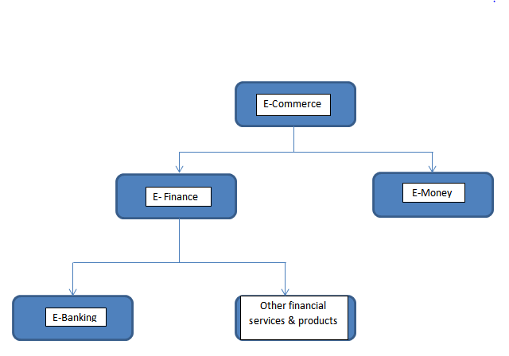
Meaning of E-Banking
E-banking is also called electronic banking, online banking, or Internet banking. E-banking is the use of electronic and telecommunications networks, delivering various banking products and services. The customer can access his / her account and perform many transactions using computers, mobile phones, or any gadgets, etc., In other words, Internet banking is a system allowing individuals to perform backing activities anywhere, anytime via the Internet. E-banking covers many facilities like fund transfer, checking account statements, utility bill payments, opening of bank account, applying for loans, locating nearest ATM, obtaining information on financial products and services, etc., using a smartphone, personal computer, laptop, or personal digital assistant.
Table shows the types of digital payments
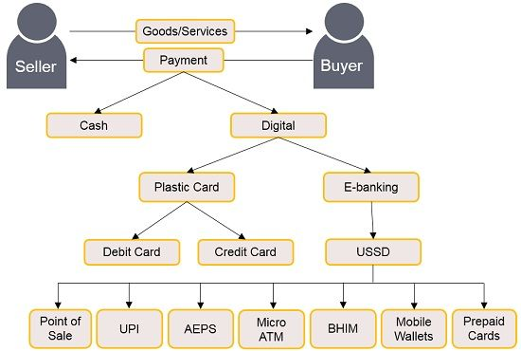

Characteristics of E-banking
1. Provides 24x7 services: It is one of the most important characteristics of E-banking. E-Banking provides customers with an all-time access facility to their bank accounts. Customers can very easily access their accounts anytime, anywhere without any limitations. E-banking also provides convenience to customers as they can do transactions as per their wish.
2. Faster transactions: E-banking provides the facility to transfer funds to its customers, which saves time for customers, and funds get transferred very fast from one account to another account. The whole system of E-banking is automated and works over the Internet.
3. Develops loyalty in customers: E-banking also helps the banks to develop a large number of loyalties to customers. E-banking services are able to serve their customers well at any time. E-banking is able to provide fast and better services to customers.
4. Lower transaction cost: E-Banking is one of the characteristics which reduces the cost when the customer is involved in doing the financial transactions. Electronic transactions are the lowest medium of doing transactions. The manpower work has been because of online banking.
5. Provides better productivity: E-banking has an efficient role in increasing the innovativeness of businesses. The whole financial transaction system is supported by automated software systems. These systems are specially designed for doing transactions of funds.
6. Reduce frauds in transactions: Another important characteristic of e-banking which helps in continuously monitoring customers’ accounts. Customers can easily track each & every transaction of their accounts. The customers can easily track if any of the fraud is done by anyone in financial transactions.

Types of E-banking
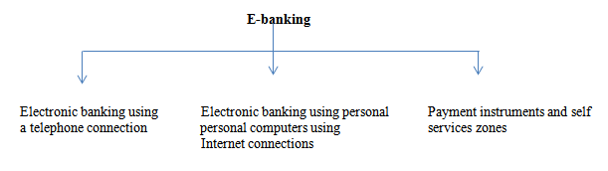
1. Electronic banking using a telephone connection: This is one of the types of E-banking where customers can do E-banking using the telephones by taking instructions. There are two types of telephone connections which are as follows:
• Automated telephone system: Automated telephone Banking System means any device, capable of providing voice response to a Cardholder's request or any banking information for banking services.
• Mobile banking: Mobile banking is also one of the types of services provided by a bank or other financial institution that allows its customers to conduct financial transactions remotely using a mobile device such as a tablet or smartphone.
2. Electronic banking using personal computers using an internet connection
• Home banking: Home banking or Web banking, is a system that enables the customers of a bank or any other financial institution to perform a range of financial transactions through the financial institution's websites or mobile app.
• Internet banking: Online banking, also known as virtual banking, is an electronic system that empowers customers to make a payment to a bank or other financial institution to conduct a financial transaction through the financial institution's websites.
• Mail banking: Mail banking is a service provided by a financial institution to customers which allows them to deposit cheques into their accounts through mail. It is primarily used by branchless banks and customers who live too far from a branch use mail banking.
3. Payment instruments and self-services
• Self-service zone: It is also one of the types of E-banking. Self-service banking is a service where customers can conduct activities and financial transactions using channels and devices without going to a branch.
• Payment card: It is one of the types of E-banking where the customers can make transactions through cards in shops, malls hotels, etc.,
• Electronic wallet: E-wallet is a type of pre-paid account in which a customer can store the money for any future online transaction. An E-wallet is protected with a password, with the help of an E-wallet in payment instruments, in this one can make payments for groceries, flight tickets, and online purchases, among others, etc.,
Services covered under the E-banking
1. Mobile banking: Mobile banking is also called M-banking which is utilized for performing account exchanges or any transactions, credit applications, bill payments, other financial exchanges, balance checks, etc., through mobile phones/ personal digital assistants.
2. Smart cards: A smart card is a card that stores the data on a microchip or microprocessor or memory chip in lieu of the magnetic stripe found on debit cards, credit cards, etc., Smart cards are not utilized for transferring or moving monetary data alone, a smart card can also be encrypted to exchange of data from one party to another.
3. Electronic fund transfer (EFT): EFT is the electronic exchange of money from one bank account to another either with a single financial institution or across multiple institutions through computer-based systems without the direct intervention of bank staff.
4. Electronic clearing services (ECS): ECS is a method of transferring funds electronically and is generally used for bulk transfers. This method is used for funds that are both repetitive and periodic in nature.
5. Internet banking: It is an assistance that is presented by banks that permits account holders to get their recorded information by means of the Internet or the web. Internet banking is also called web banking.
6. Home banking: It is the most common way to exchange money from one's home as opposed to using a bank’s branch. It incorporates making account requests, covering bills, moving cash, and applying for credit cards and direct deposits.
7. Telephone banking: It is another kind of service given by a bank to customers that is to the account holders to get their information of account or any other kinds of information from banks through telephone.
Advantages of E-banking
1. Convenience: It is very easy for the account holder of banks to do financial activities. People do not need to go to the bank to access their bank accounts, customers can conveniently use financial activities any time, where sitting in their homes through the internet.
2. Faster services: Nowadays people don’t have to wait in line to pay their bills or transfer money, which offers quick services, but money transfers are possible only if there is internet.
3. Services quality: E-banking has raised the level of customers' services using Internet banking to make quick, secure, and effortless payments. Using Internet banking apps, the clients may keep track of all accounts-related transactions.
4. 24/7 facility: Clients have access to the E-banking services at any time, anyway. Clients can also access banking services anytime, anywhere in any location.
5. Liquidity: E-banking gives customers access to more readily available finances. Customers can withdraw cash from ATMs at any location.
6. Discounts: The banks give discounts on credit cards, debit cards, etc., by doing online transactions and get numerous discounts from banks through online banking.
7. Transfer assistance: The effective banking system makes it single to transfer money to any person for 365 days a year.
8. Paying bills online: E-banking offers to pay any sort of bills like water supply, electricity bill, telephone, and other services instead of standing in queues.
9. Surveillance services: internet banking has access to update pass book at any time to manage their financial plans and keep track of their transaction.
10. Systematic rules: In E-banking there is a systematic rule each and every person should follow the same rules, and there is no bifurcation between the rich, middle, and poor classes, for each and every customer same rules should be followed.
Disadvantage
1. High start–up cost: Internet banking costs a lot to set up different computers, software, hardware a modern and Internet work. Banking businesses must make significant investments to launch online banking services.
2. Security problems: Hacking of E-banking systems has led to several security problems. Clients could suffer will get financial loss if they lose their login information while making payments.
3. Transaction issues: Sometimes banking servers frequently go down which causes transactions to fail, in emergency cases if we want to do a transaction if the server is slow this will be issued to customers.
4. Long process to use E-banking: In some of the government banks offer E-banking through the completion of an application which is then approved before allowing access to a security password to log in and sometimes takes up a long process too.
5. No cash deposit platform: There are fewer platforms to deposit cash, especially in rural areas, and more people in rural areas don’t know how to deposit cash.
6. Awareness of E-banking: Many people don’t have awareness of E-banking and they are scared to use E-banking because of hacking the account. The banks should take the initiatives to guide the customers.
7. Challengers for beginners: It will be very difficult for customers who newly start to do online banking transactions and it will be very difficult to do and they are worried about losing money too.
References
- Agarwal, R., & Karahanna, E. (2000). Time flies when you’re having fun: Cognitive absorption and beliefs about information technology usage. MIS Quarterly, 24(4), 665–694

- Bass, F. M. (1969). A new product growth for model consumer durables Management Science, 15(5), 215–227.
- Cunningham, L. F., Gerlach, J., & Harper, M. D. (2005). Perceived risk and e-banking services: An analysis from the perspective of the consumer. Journal of Financial Services Marketing, 10(2), 165–179.
- Daniel, E. (1999). Provision of electronic banking in the UK and the republic of Ireland. International Journal of Bank Marketing, 17(2), 72–82.
- Lassar, W. M., Manolis, C., & Lassar, S. S. (2005). The relationship between consumer innovativeness, personal characteristics, and online banking adoption. International Journal of Bank Marketing, 23(2), 176–200.
- Srivastava, R. K. (2007). Customer‟s perception on usage of internet banking. Innovative Marketing, 3(4), 67-73. [2] Haq, S., Khan, M. (2013).
- E-banking challenges and opportunities in the Indian banking sector. Innovative Journal of Business and Management, 2(4), 56-59. [3] Gupta, P., Mishra, C. M. (2012).
- E-banking- New emerging trends in Indian banking industry. Research Journal of Economics and Business Studies, 1(10), 1-3.

