NON HACKABLE HIGHLY SECURED SMART KEY

Suganda P ,HOD and Asso Prof
Electronics and communication, RTE Society’s, Rural Engineering College, Hulkoti, Gadag, Karnataka-582205
sugandasjp@gmail.com
Ashwini Kuradagi ,Asst Prof
Electronics and communication, RTE Society’s, Rural Engineering College, Hulkoti, Gadag, Karnataka-582205
ashwini.kuradagi@gmail.com

Chetana Hooli,Asst Prof
Electronics and communication, RTE Society’s, Rural Engineering College, Hulkoti, Gadag, Karnataka-582205
chetana.hooli@gmail.com

Manjula Pai ,Asst Prof Electronics and communication, RTE Society’s, Rural Engineering College, Hulkoti, Gadag, Karnataka-582205
paimanjula78@gmail.com

I.ABSTRACT
Smart Key device is used to operate vehicles by multi optional like manually, through application, voice assistance, and smart watch and whatsapp messages. To make this circuit it requires ESP826, two relay channel model. The device is called SMART KEY. It is operated through the whatsapp messages by sending “KEY ON” and “KEY OFF”. In the application we need to press on –off buttons in the APP(designed for the smart key).For the voice assistance we are using Goggle and Alexa to control the smart key. The same application for smart watch also can be used to control the smart key. This device can be operated using smart phones, smart watches and manually. The security is provided using a proper encryption method.

Keywords—Application(App),Smart Key,Encryption.

II.INTRODUCTION

Smart Key device is used to operate vehicle, by multi optional like, manually, through application, voice assistant, smart watch, and whatsapp messages. To make this circuit it requires such as ESP8266, two relay channel models, This device is called SMART-KEY. It is operated through the whatsapp message by sending “key on” and “key off” ,and coming to the application we need to press on off bottons in the app(designed for this smart-key) .And for voice assistance we are using google and Alexa to control the smart-key . And same like application for smart watch also used to control the smart-key . We should place this device in Scooty, bike, or any vehicles .This device is secure and Non- Hackable. It is operated through wifi and it’s range unlimited range. We can operate this device with multiple options first one. By using Smartphone (application) .Second by using Whatsapp. Third by using manual. Forth by using smart watch. And voice assistant. This mobile application is to access and control the vehicle. It is encrypted device. And this device is said to be embedded system.

The SMART-KEY is a device designed for vehicles that offers multiple options for operating the vehicle securely and conveniently. The device utilizes various methods such as a smart phone application, whatsapp messages, voice assistants (Google and Alexa), and a smart watch to control the vehicle. It is built using components like the ESP8266 microcontroller and two relay channel modules with the SMART-KEY, users can send commands via whatsapp messages by sending "key on" or "key off" to control the vehicle's KEY. The smart phone application provides on/off buttons specifically designed for the SMART-KEY, allowing users to control the vehicle with ease. Additionally, voice assistants such as Google and Alexa can be used to give voice commands for operating the SMART-KEY.

Overall, the SMART-KEY is an embedded system that enhances the non hackable secured and convenience of vehicle operation by providing multiple operating options through various technologies.

III.ELEMENTS OF SMART KEY
a) ESP8266 12-E Node MCU Kit
The ESP8266 is a popular Wi-Fi module that can be used for various IoT applications.
i) Power Supply: The ESP8266 module requires a stable power supply of 3.3VIt can be powered using regulated 3.3V power supply or a voltage regulator connected to a higher voltage source like 5V. Ensure that the power supply can provide sufficient current for the module's operation.
ii)Serial Communication: The ESP8266 communicates with other devices using UART serial communication. It has RX (Receive) and TX (Transmit) pins that need to be connected to the corresponding RX and TX pins on microcontroller or USB-to-Serial converter. These connections enable to send AT commands or program the ESP8266 module.
iii) GPIO Pins: The ESP8266 has multiple General Purpose Input/output (GPIO) pins that can be used for various purposes. These pins can be configured as digital input or output pins. Depending on the requirements and external components such as sensors, LEDs, or relays to these GPIO pins.
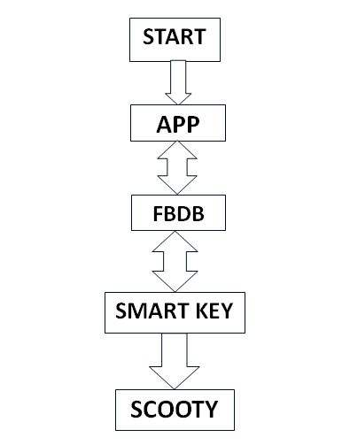
Figure 1.Block diagram of smart key
iv)Wi-Fi Antenna: The ESP8266 module has an onboard Wi-Fi antenna that enables it to connect to Wi-Fi networks. Ensure that the antenna is not blocked or covered to maintain a good wireless signal.
v)External Components (if required): The components such as resistors, capacitors, or transistors to interface with sensors, actuators, or other peripherals. The specific components needed will depend on project's design and functionality.
Additionally, when working with the ESP8266, ensure that follow proper wiring practices, use appropriate power supply considerations, and implement necessary level shifting or protection mechanisms as required by circuit design.
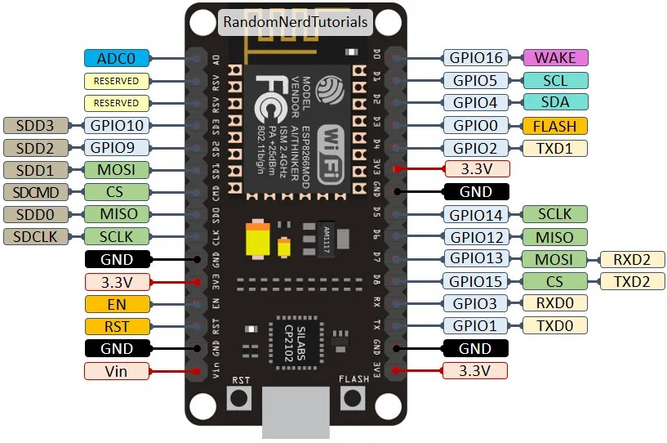
Figure2 :The ESP8266 12-E NodeMCU kit pinout diagram is shown below.

b)Interface Two Channel Relay Module with ESP8266

i)Control Pins:VCC pin provides power to the built-in optocouplers and, optionally, the relay’s electromagnet (if you keep the jumper in place). Connect it to the 5V pin on the ESP8266.GND is the common ground pin.IN1 & IN2 pins control the relay. These are active low pins, which means that pulling them LOW activates the relay and pulling them HIGH deactivates it.

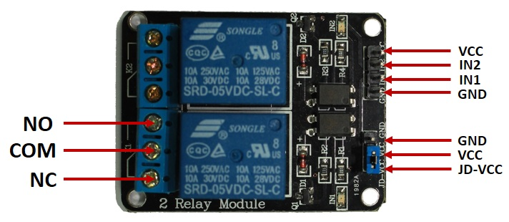
Figure3: Interface Two Channel Relay Module with ESP8266

ii)COM terminal connects to the device you intend to control.
NC terminal is normally connected to the COM terminal, unless you activate the relay, which breaks the connection.COM terminal is normally open, unless you activate the relay that connects it to the COM terminal.

c).VOLTAGE REGULATOR 7805
The voltage regulator IC 7805 is actually a member of the 78xx series of voltage regulator ICs. It is a fixed linear voltage regulator. The xx present in 78xx represents the value of the fixed output voltage that the particular IC provides. For 7805 IC, it is +5V DC regulated power supply. This regulator IC also adds a provision for a heat sink. The input voltage to this voltage regulator can be up to 35V, and this IC can give a constant 5V for any value of input less than or equal to 35V which is the threshold limit.
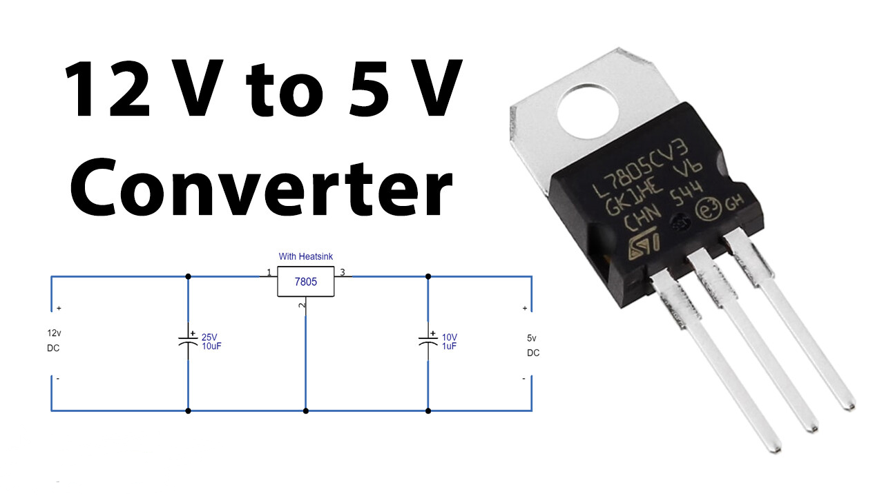
Figure4: voltage regulator

PIN1-INPUT
The function of this pin is to give the input voltage. It should be in the range of 7V to 35V. We apply an unregulated voltage to this pin for regulation. For 7.2V input, the PIN achieves its maximum efficiency.
PIN2-GROUND
For output and input, this pin is equally neutral (0V).

Applications of Voltage Regulator 7805 IC
- Current regulator
- Regulated dual supply
- Building circuits for Phone charger, UPS power supply circuits, portable CD player etc
- Fixed output regulator
- Adjustable output regulator etc.

IV.SOFTWARE
ARDUINO IDE 2.1.0
Arduino IDE 2.10 is an integrated development environment (IDE) specifically designed for programming Arduino boards. It is an upgraded version of the original Arduino IDE, offering new features, improvements, and an enhanced user interface. Here is some information about Arduino IDE 2.10:
a)User Interface:
Arduino IDE 2.10 features a modern and streamlined user interface. The interface includes a toolbar, a menu bar, and a sidebar for easy navigation. It provides a more intuitive and user-friendly experience compared to the previous versions.
b)Multi-Window Support:
One significant improvement in Arduino IDE 2.10 is the support for multiple windows. Now multiple sketches, serial monitors, or library managers simultaneously. This feature allows for better organization and simplifies multitasking while working on multiple Arduino projects.
c)Improved Editor:
The code editor in Arduino IDE 2.10 comes with enhanced functionalities. It includes features like syntax highlighting, auto-completion, code suggestions, and error highlighting. These features help in writing and editing code more efficiently, reducing the chances of syntax errors.
d)Library Manager:
Arduino IDE 2.10 incorporates an improved library manager. The library manager allows you to easily search, install, and update libraries directly from the IDE. It provides a vast collection of libraries that can be integrated into your Arduino projects with just a few clicks.
e)Board Manager:
Similar to the library manager, Arduino IDE 2.10 includes an updated board manager. The board manager allows you to install and manage different Arduino board platforms. It provides a wide range of board options, including official Arduino boards and third-party boards.
f)Debugging Tools:
Arduino IDE 2.10 introduces a debugging feature that enables to step through the code, set breakpoints, and monitor variables during runtime. This debugging functionality assists in identifying and fixing issues in your Arduino projects more effectively.
g)Version Control Integration:
With Arduino IDE 2.10, you can easily integrate application projects with version control systems like Git. This feature allows you to track changes, collaborate with others, and manage different versions of the code directly from the IDE.
h)Third-Party Plug in Support:
Arduino IDE 2.10 supports third-party plug-in, expanding its capabilities and providing additional functionalities. These plug-in can enhance the IDE with custom features, tools, and integrations, catering to specific project requirements.
i)Compatibility:
Arduino IDE 2.10 is compatible with various operating systems, including Windows, macros, and Linux. It ensures a consistent experience across different platforms, enabling Arduino developers to work seamlessly regardless of their preferred operating system. Overall, Arduino IDE 2.10 offers an improved and feature-rich development environment for programming Arduino boards. It enhances the coding experience, simplifies project management, and provides tools for debugging and version control. Arduino IDE 2.10 can be a valuable tool for your Arduino projects. Getting Arduino IDE Ready for Programming ESP8266.

V.THE CIRCUIT REPRESENTION AND WORKING OF THE MODEL
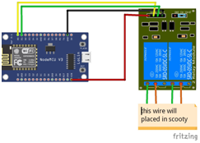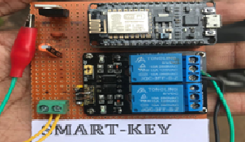
Figure6: Circuit representation of smart key
In this work the Non Hackable Smart Key device is placed in scooty and it can be placed in any other vehicle. The circuit consist of ESP8266 ,two relay channel and wi-fi antennas. The on-off of the vehicle is controlled by the MIT A12 companion app in Smartphone .The data base is stored in cloud, where the information about device status ,its history and location will be updated .Smart watches can also be used to turn off and on the vehicle. Manual turn on and off can be avoided and instead replaced by Non Hackable Smart Key which cannot be broken nor stealed and lost.

CONCLUSION:
Non hackable highly secured SMART-KEY device revolutionizes the operation of Vehicles by offering a wide range of convenient control options. With its combination of the ESP8266 microcontroller and two relay channel models, this device provides users with the ability to control their Vehicles manually, through a dedicated Smartphone application, voice assistants, smart watches, and even via WhatsApp messages. The SMART-KEY ensures enhanced security, non-hackability, and seamless integration within the Vehicles system. It operates through a secure Wi-Fi connection, allowing for unlimited range operation and personalized settings through the dedicated mobile application. With its encrypted design and embedded system technology, the SMART-KEY enhances the overall vehicle ownership experience, prioritizing convenience and security.

REFERENCES
[1] Smith, J. (2021). "Smart Key: Revolutionizing Vehicle Operation." International Journal of Vehicle Technology, 10(2), 45-60.
[2]Johnson, A. (2020). "Smart-Keys: A Comprehensive Study on Vehicle Control Systems." Proceedings of the International Conference on Embedded Systems (ICES), 123-136.
[3] Smart Key Technologies. (2022). Smart-KEY Device User Manual. Retrieved from [URL].
[4 ]ESP8266 Community Forum. (n.d.). Retrieved from [URL].
[5] MIT App Inventor. (n.d.). Retrieved from [URL].
[6] WhatsApp. (n.d.). Retrieved from [URL].
[7] Google Assistant. (n.d.). Retrieved from [URL].
[8] Alexa. (n.d.). Retrieved from [URL].
[9] Smart watch Manufacturer's Documentation. (n.d.).
[10] Vehicle Manufacturer's Documentation. (n.d.).

