Plant Conservation: An Overview

Nalina D.B

The best friend on earth of man is the tree. When we use the tree respectfully and economically, we have one of the greatest resources on the earth."
- Frank Lloyd Wright
Abstract: I
Despite the massive efforts that have been made to conserve plant diversity across the world during the past few decades, it is becoming increasingly evident that our current strategies are not sufficiently effective to prevent the continuing decline in biodiversity. Deforestation or cutting down trees is considered as one of the major problems associated with the conservation of plants. Human conservation efforts primarily concentrate on two strategies: Preserving the conditions, in which plants thrive, and avoiding the death of the plants themselves. The goal of conservation is to protect future resources. However, economic opportunity frequently pushes humans to modify habitats and exploit plants species, often to the brink of extinction. At times, the nature of economics clashes with conservation. Because scarcity makes a resource more desirable to anyone who can still obtain it, incentives grow as supplies decline.
Key words: Natural resources, Forest conservation, Environmental protection, Constitutional provisions, Conservation reserves, Non-timber forest products, Endangered plants, Biodiversity Act.
Introduction: II
The transformed world of 2050 will demand new strategies and new approaches in conservation. ’Plants form the core of what comes to mind when we think about “environment.” Plants are the fabric which covers the soil. They hold the soil in place to reduce erosion and improve water quality. Plants provide our food, materials for shelter, fuel to warm us and replenish the air we breathe. Plants provide food for animals and habitat for wildlife. The environment and its natural resources have to be conserved for our own needs and for future generations. Special efforts have to be made to reduce global warming. Planting of trees is being encouraged. Every year July 1 is observed as the Van Mahotsava day. On this day, trees are planted on a large scale.
Sources of data: III
For secondary data Books, Journals and various websites have been referred.
International perspective: IV
- Plant Conservation: ‘Plant Conservation is a broad group of activities which aims to prevent plants from becoming extinct. It includes the direct conservation of wild populations, collections of plants with gardens, education programmes, invasive species control, recovery and restoration work, research programmes, training… ’BGCI
- Sara Oldfield, Secretary General, Botanic Gardens Conservation International (BGCI): “I think we tend to take plants for granted, particularly in a country which is generally green and where we are not so directly involved in growing our own food any more. I think we are losing that connection with nature… I don’t think we fully understand what we are losing or what the implications will be…. Ten years ago we estimated that 10% of all world tree species were threatened with extinction.”
- The Convention on International trade in endangered species of wild Fauna and Flora, 1973 (CITES): CITES, also known as the Washington Convention, was ratified in 1974 by 80 countries. It became effective in 1975 and now has 182 countries as parties to it. CITES aims to impart moral and legal responsibilities to the member countries to protect endangered species in their respective jurisdictions and prevent transborder trades.
National perspective: V
- The Environment (Protection) Act, 1986: ”environment” includes water, air and land and the inter-relationship which exists among and between water, air and land, and human beings, other living creatures, plants, micro-organism and property;
- The Protection of Plant Variety and Farmers Right Act, 2001 (PPVFR Act): It is an Act of the Parliament of India that was enacted to provide for the establishment of an effective system for protection of plant varieties, the rights of farmers and plant breeders, and to encourage the development and cultivation of new varieties of plants. This act received the assent of the President of India on the 30 October 2001.
- Right of life and Environment protection (Article 21): Article 21 of the constitution provides for the fundamental right of life. It states that no person shall be deprived of his right to life or personal liberty except in accordance with procedures established by law. The words except in accordance with procedures established by law can be interpreted to mean that this provision is subject to exception and is regulated by law which varies from case to case.
- Forest Conservation Act 1980: The purpose of this Act is to foster recognition of the forest as a common heritage and promote sustainable forest development in order to meet the economic, environmental and social needs of present and future generations while giving proper consideration to other potential uses of the territory.
- Section 3A - Penalty for contravention of the provisions of the Act. Whoever contravenes or abets the contravention or any of the provisions of section 2, shall be punishable with simple imprisonment for a period which may extend to fifteen days.

Plant conservation today: VI
Any area owned by the State Government, particularly in the vicinity of national parks or sanctuaries and those areas which link one protected area with another, can be notified by the Government, after having consultations with the local communities as a conservation reserve under the provisions of the Section 36A of the Wild Life (Protection) Act, 1972 for protecting landscapes, seascapes, flora, fauna and their habitat. Management of a conservation reserve is done as per provisions of the Section 36B of the Act.
Section 36A. Declaration and management of a conservation reserve.--(1) The State Government may, after having consultations with the local communities, declare any area owned by the Government, particularly the areas adjacent to National Parks and sanctuaries and those areas which link one protected area with another, as a conservation reserve for protecting landscapes, seascapes, flora and fauna and their habitat:

Excessive reliance on protected areas alone for the conservation of plant diversity: VII
It is generally accepted that systems of protected areas are the underpinning of our efforts to conserve biodiversity, both nationally and globally. However, despite the substantial increase in protected area coverage in recent years, they still provide an inadequate representation of the eco regions and areas considered critical for biodiversity, many of them lack management plans or suffer from inadequate management, lack comprehensive biodiversity inventories and fail to undertake proper threat assessments of key biodiversity such as target species and the necessary actions to contain or eliminate these threats.
- Section – 3 of Biodiversity Act 2002: All foreign national require approval from NBA for obtaining Biological Resources.
- Section - 55: Penalties - imprisonment upto 5 years and or a fine of 10 lakhs or to the extent of damage caused.
- Section – 41 (1) : Every local body shall constitute a Biodiversity Management Committee within its area for the purpose of promoting conservation, sustainable use and documentation of biological diversity including preservation of habitats, conservation of land races, folk varieties and cultivars, domesticated stocks and breeds of animals and microorganisms and chronicling of knowledge relating to biological diversity. Peoples’ Biodiversity Register is a document which contains comprehensive information on locally available Bio-resources including landscape and demography of a particular area or village. Bio-resources mean plants, animals and microorganisms or parts thereof, their genetic material and by-products (excluding value added products) with actual or potential use or value but do not include human genetic material.
Findings: VIII
Non-timber forest products (NTFPs)are useful foods, substances, materials and/or commodities obtained from forests other than timber. Harvest ranges from wild collection to farming. They typically include game animals, fur bearers, nuts, seeds, berries, mushrooms, oils, sap, foliage, pollarding, medicinal plant peat, mast, fuel wood, fish, insects, spices, and forage. Overlapping concepts include non-wood forest products (NWFPs), wild forest products, minor forest produce, special, minor, alternative and secondary forest products Research on NTFPs has focused on their ability to be produced as commodities for rural incomes and markets, as an expression of traditional knowledge or as a livelihood option for rural household needs, as a key component of sustainable forest management and conservation strategies, and for their important role in improving dietary diversity and providing nutritious food, particularly for forest-proximate peoples. All research promotes forest products as valuable commodities and tools that can promote the conservation of forests.

Impacts of NTFPs on plant conservation: IX

The harvest of NTFPs remains widespread throughout the world. People from a wide range of socioeconomic, geographical, and cultural contexts harvest NTFPs for a number of purposes, including household subsistence, maintenance of cultural and familial traditions, spiritual fulfillment, physical and emotional well-being, house heating and cooking, animal feeding, indigenous medicine and healing, scientific learning, and income. Other terms synonymous with harvesting include wild-crafting, gathering, collecting, and foraging. NTFPs also serve as raw materials for industries ranging from large-scale floral greens suppliers and pharmaceutical companies to microenterprises centered upon a wide variety of activities (such as basket-making, woodcarving, and the harvest and processing of various medicinal plants).More than 28000 plant species are currently recorded as being of medicinal use and many of them are found in forest ecosystems. Visits to forest environments can have positive impacts on human physical and mental health and many people have a deep spiritual relationship to forests.
- LAMP Society: Large Area Multi purposes societies Scheme: Tribal people have called for strengthening of Large Area Multi-Purpose Cooperative Societies so that their standard of living is improved. There are 20 LAMPS functioning in the State with the objective to assist the tribes in marketing their products and providing interest-free short and medium term loans.
- Village Forest Committee: With the closure of DFID assisted Western Ghats Forestry and Environment Development Programme and JBIC assisted Eastern Karnataka Afforestation Program; many among the 3,788 VFCs formed under the above schemes became inactive due to non-availability of funds from the Government. Among these VFCs, 1,479 VFCs are covered under National afforestation programme. The state sector scheme “Revitalization of Village Forest Committees” was launched in 2013-14 to initiate revitalization of the inactive VFCs among the balance 2,309 VFCs. Activities under the scheme include maintenance of plantations, raising seedlings for distribution, skill up-gradation training, distribution of solar lights, sarala ole, LPG connections, installation of gobar gas plant, etc. Village Forest Committee is an initiative by KFD to involve residents of forest fringe villages into protecting the Flora and Fauna. At the same time also providing them with monetary and community oriented benefits.
Endangered Plants: X
The World Conservation Union, formerly International Union for the Conservation Health of Nature and Natural Resources (IUCN) has enlisted endangered plants in the Red Data Book. Few endangered plants are listed below:
Pitcher plant, Indian belladonna, Orchids, Nilgiri Lily, Ginkgo biloba (Maiden hair tree). I would like quote two more plants here which are considered as endangered plants.
- The blue Neelakurinji flowers, which blooms once every 12 years seen at Mandalapatti hill in Kodagu district."
- Mappia foetida', a tree known for its anti-cancer properties.
Emerging issues and challenges: XI
- Loss of biodiversity is a growing trend in virtually all Earth ecosystems. The Millennium Ecosystem Assessment document shows that losses of biodiversity and the related changes in the environment have been more rapid in the past 50 years than ever before in human history (MEA 2005). Human activities have increased the extinction rate by at least 100 times more than the natural rate (MEA 2005). Rangelands, like other
ecosystems, are vulnerable to loss of biodiversity through five major threats: habitat destruction, over exploitation of species, introduction of exotic species, pollution and global warming.
- Conserving plants in these turbulentand rapidly changing times is challenging, but nevertheless essential to the well-being of humans and all organisms on our planet. Plants supply our food, fiber, and medicines, regulate our climate, clean water and protect our soils, provide flood protection, underpin many cultures, and provide landscapes that restore and connect us to nature. Yet they face multiple interacting stressors and require urgent attention and decisive action that is effective, inclusive, and just.
- Human interference - Humans have converted forest to agricultural and urban uses, exploited species, fragmented wildlands, changed the demographic structure of forests, altered habitat, degraded the environment with atmospheric and soil pollutants, introduced exotic pests and competitors, and domesticated favored species. Through human interference and encroachment many samplings can be destroyed.

Forest fire, Hunting, Climate changing, Grazing and Browsing.
Need for Reformation: XI
- As we are aware of the benefits we get from plants, we have to preserve them. We know that plants have a deep impact on the ecosystem. So if they are not conserved there will be an imbalance in the ecosystem, which will directly affect human beings. Humans are dependent on plants, so they need to be conserved.
- There should be protected areas for them like wild life sanctuaries, biosphere reserves and national parks in a country. Another way to protect the plants is to prohibit grazing, like activities that may cause the extinction of plants. Moreover, converting the cultivation area into construction area should be prohibited.
Conclusion: XII
Conservation of plants is very important for enriched biodiversity that helps in balancing the
ecosystem. Plants are the backbone of life on Earth and depend in the environment in many ways. It is our responsibility to conserve plants and save them from extinction. We should recover from all deforestation activities done by humans by planting trees. In order to achieve a more satisfactory relationship between society and its environment, timely provision should be made for the changes that human activities and competition over use of resources may bring about in order to minimize potential conflicts. It is important to conserve non-renewable resources, because if we use them too quickly there will not be enough. Most natural resources are limited. This means they will eventually run out. A perpetual resource has a never-ending supply.
Be as useful as a tree! Give life to others; be shelter to everyone; grant fruits to all! Be good like a tree!
Mehmet Murat ildan
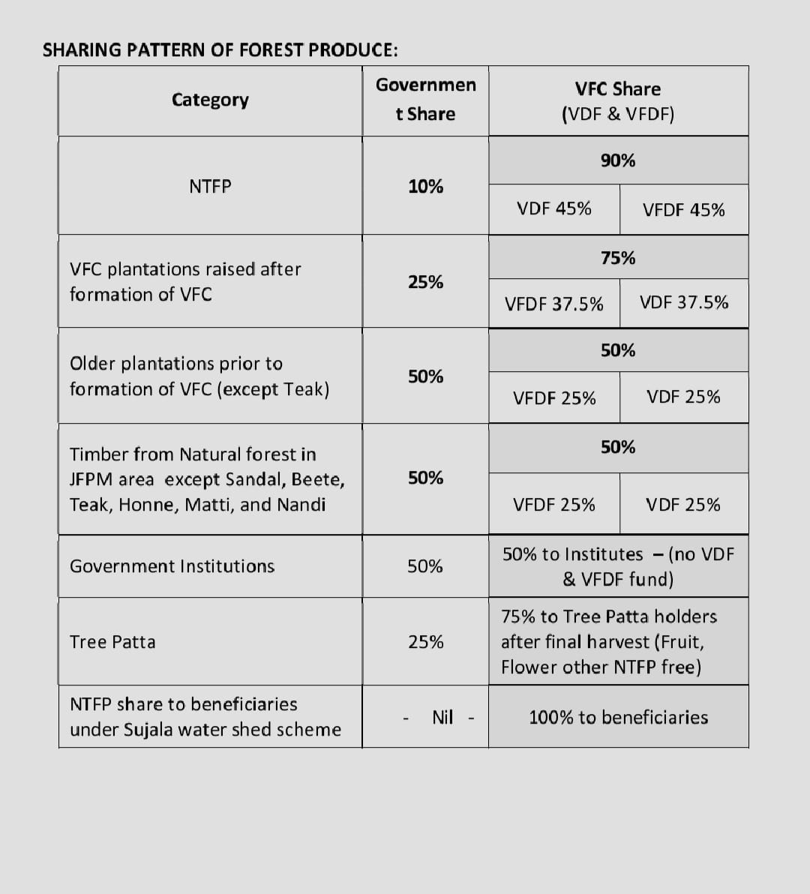

References: XIII
- Vedantu.com
- https://www.frontierin.org
- Dr. J.N. Pandey – Constitutional Law of India
Central Law Agency - Allahabad
57th Edition -2020
- Lawinsider.com
- Blog.ipleaders.in
- www.legalservice.com
- Aranya.gov.in/aranyacms/
- Sahakara.kar.gov.in
- Karnatakatourism.org
- Indianexpress.com
- Agardenthroughtime.wordpress.com
- Sciencedirect.com

B.A.L,LL.B,LL.M ,Guest faculty of School of Law, University of Mysore
Thrive - To grow vigorously : flourish
Brink - The threshold of danger. 4Incentives - An incentive is something that encourages people to do something. 5Erosion - the process of the gradual wearing away of land masses.”
Replenish - to make full or complete again, as by supplying what is lacking, used up, etc.
BGCI - It is ‘an international organization that exists to ensure the worldwide conservation of threatened plants, the continued existence of which are intrinsically linked to global issues including poverty, human well-being and climate change’.
PPVFR - The Protection of Plant Variety and Farmers Right Act, 2001
Foster - encourage the development of (something, especially something desirable).
Ins. by s. 3, ibid. (w.e.f. 15-3-1989).
Vicinity – The area near or surrounding a particular place.
Section 36A – Constitution of central zoo authority.
Section 36B – The state government shall constitute a conservation reserve management committee to advise the chief wild life warden to conserve, manage and maintain the conservation reserve.
NBA – National Biodiversity Authority
Biodiversity Management Committee - The main function of the BMC is to prepare People's Biodiversity Register in consultation with the local people.
Cultivars - A plant variety that has been produced in cultivation by selective breeding.
Chronicling - to make a record or give details of something.
NTFPs – Non- timber forest products
"Glossary of Forestry Terms in British Columbia" (PDF). Ministry of Forests and Range (Canada). March 2008. Retrieved 2009-04-06.
"FAO – Forestry, Non-wood forest products".
“Minor Forest Produce (MFP) “. Arthapedia.
Foraging -relying on food provided by nature through the gathering of plants and small animals, birds, and insects;
The State of the World's Forests 2020. Forests, biodiversity and people – In brief. Rome: FAO & UNEP. 2020. Doi: 10.4060/ca8985en. ISBN 978-92-5-132707-4. S2CID 241416114
DFID – Department for International development :
JBIC – Japan Bank for International Cooperation: Funds where JBIC's support would be highly effective or significant for the development and securement of resources.
KFD - Karnataka Forest Department: The Karnataka Forest Department has the primary mandate of protecting the forests and wildlife, conserving the rich biodiversity of the state and ensuring that the ecological balance of the forest eco-systems is maintained.
IUCN - International Union for the Conservation Health of Nature and Natural Resources: IUCN's objectives are to influence, encourage and assist societies throughout the world to conserve the integrity and diversity of nature and to ensure that any use of natural resources is equitable and ecologically sustainable.
Rangelands - A rangeland is an open area that is suitable for grazing life stock.
Turbulent - moving very strongly and suddenly.
Underpin - to give support, strength.

