ARTIFICIAL INTELLIGENCE AND MACHINE LEARNING IN HEALTHCARE
Dr Fatima Khatoon^{1*}, Mirza Shoeb Baig¹, Dr Syed Mohammed Kazim², Dr M A Aleem², Dr Nabeela Fatima²
¹Department of Pharmacy, Nizam Institute of Pharmacy, Deshmukhi, Telangana, India-508284
²Department of Pharmacy Practice, Nizam Institute of Pharmacy, Deshmukhi, Telangana, India-508284
Corresponding Author:
Dr Fatima Khatoon
Department of Pharmacy Practice,
Nizam Institute of Pharmacy, Deshmukhi.
Email: fak89867@gmail.com
Phone: +91-9505547994

ABSTRACT:
Healthcare is one of the numerous industries that has changed with the help of artificial intelligence. This study aims to discuss the effect of AI and machine learning on disease diagnosis, treatment optimization, and healthcare management. AI possesses potential to decipher and spot issues for analysis and treatment of medical conditions. Large datasets can be analyzed efficiently with fewer mistakes. Prediction and forecasting have become a revolutionary asset to determine the medical condition of patients. AI has provided increased assistance to medical professionals with the provision of tools that have increased the speed and scope of operations.
Keywords: Artificial Intelligence, Machine Learning, Nephrology, Cardiovascular imaging, Ophthalmology, Orthopedics, Internet Of things.
- INTRODUCTION:
Artificial intelligence has transformed the usage and application of computer science in healthcare systems. Right from diagnosis of diseases up to the treatment procedure, AI has enabled increased performance efficiency by combining human potential with computer science through its several components, one of whom is machine learning. Healthcare is vital to human survival and requires efficiency with no affordability of errors. The introduction of AI into the healthcare sector first started in the year 1976 with the development of a computer algorithm for assessment of reasons for abdominal pain.
AI has become a significant component in current circumstances in almost every human activity with its potential. This increased usage of AI has also been significantly evident in healthcare. It has aided analysis of data, medical records and other datasets creating efficient administrative and recommendation procedures. It has led to the development of incredible decision support systems (DSS) which help medical professionals to analyze and choose the best for their patients.
Figure-1: OT Setup [Adapted from National Cancer Institute]
Forecasting has been another key area that has witnessed a breakthrough with the help of this technology. Machine learning algorithms are utilized for risk prediction to ensure early intervention. Treatment optimization is another area witnessing increased efficiency with the help of AI based algorithms. AI and machine learning-based procedures have also furthered the use of medical imaging for predicting, assessment and understanding of the issue at hand. It has become a core use case in treatment and detection of cancer.
- AI and Machine learning in Nephrology:
Nephrology is complex and non-linear in nature. Newly developed AI based models have played a key role in nephrology. There is no room for deduction and reasoning due to the complexity of the subject of nephrology. Early intervention can be made possible with the help of contemporary AI based models which makes treatment effective and easier.
Prediction of injuries before significant biochemical changes is a function of these newly developed models. Increase in accuracy of results and analysis of medical conditions is made possible with adoption of machine learning algorithms. Prospective developments promise improved and more efficient derivation of results based on real-time factors. This can enable more appropriate measures and recommendations. A patient centered approach is adopted. Medical procedures can be improved significantly.
- Kidney transplantation:
AI alongside its branch of machine learning has become a core tool in kidney transplantation. Radiological evaluation of allografts is carried out in an improved and efficient manner with the help of AI technologies. The utility of these systems has increased the accuracy of the results derived. New models have aided graft survival prediction. Determination of optimum dosage of immunosuppression can be carried out with the help of these models.
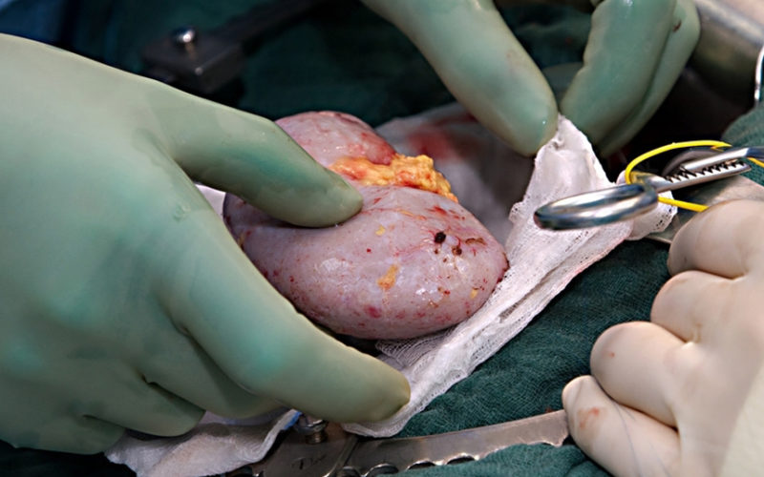
Figure-2: Kidney during transplantation [Adapted from NU Hospital]
- Acute kidney injury:
AKI is a critical issue in nephrology. Early recognition and proper supervision are key in determining positive outcomes. AI enables both by providing advanced tools for detection. Predictive models can trigger alerts for medical professionals to ensure early detection. These models have continued to demonstrate accurate and improved performance than traditional models.
- Chronic kidney disease:
Chronic kidney disease affects almost 11-13% of the global population. Therefore, it is a significant healthcare challenge. Management of CKD can be improved with AI. Early detection, recognition of patterns, risk prediction is among the various functions of the models developed based on AI. Real-time analysis can be crucial to enabling positive outcomes. Treatment responses can be made more compatible and effective.
- Dialysis:
AI/ML models require extensive data training making them very suitable for dialysis care. Large amounts of data are generally in this procedure. This can lead to many opportunities for research and analysis. Routine use of these models can be less than often, but this doesn't limit the potential to generate other use cases.
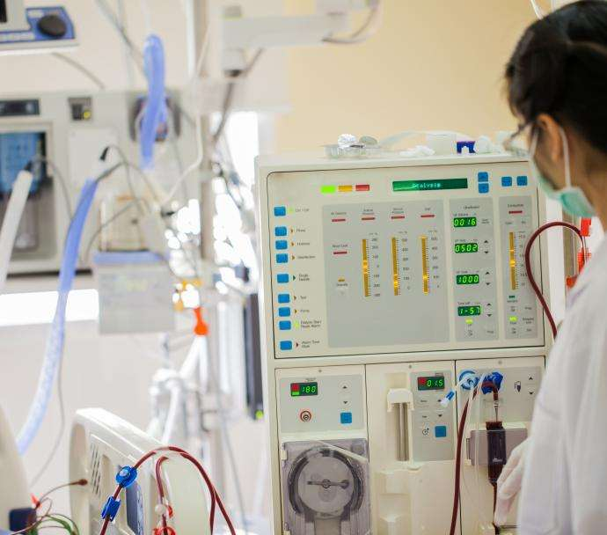
Figure-3: Dialysis Setup [Adapted from American Kideney Fund]
- Nephropathology:
The models of AI/machine learning are under research stage when it comes to nephropathology. But there has been indication of great potential and improved data performance in these models. It can provide incredible tools for the development of more streamlined procedures and accurate outcomes.
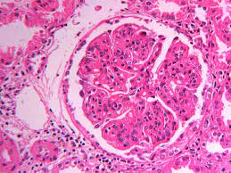
Figure-4: Non Lupus Full House Nephropathy [Adapted from nephropathology.com]
- AI and Machine learning in cardio-vascular imaging:
Cardiovascular imaging is quite time consuming and involves several functions. The models developed based on AI/ML mainly carry out data-driven activities. This function can be combined with human knowledge to derive accurate outcomes from the analysis.
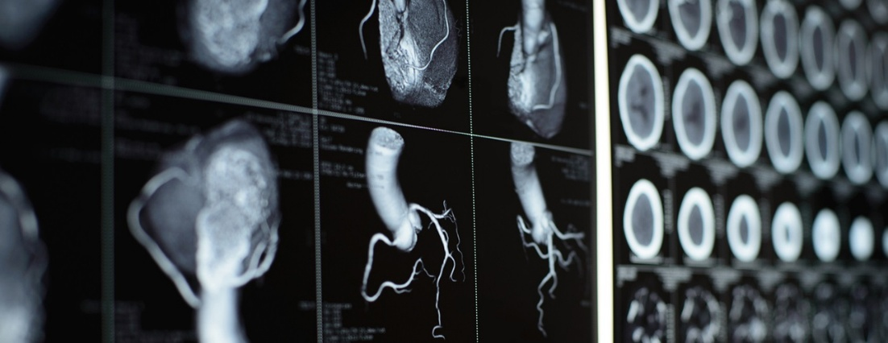
Figure-5: Imaging Techniques [Adapted from John Hopkins Medicine]
  - Electrocardiography:
There is an increasing use of AI in ECG due to the incredible potential it provides. Interpretation, risk prediction and detection are core functions of these models. Different aspects of ECG can be improved with these models. Cost-effectiveness is another big advantage of these models. AI has shown 99% accuracy in controlled datasets.
  - Magnetic Resonance Imaging (MRI):
MRI has become a core procedure in healthcare. AI has led to improvement of quality of these scans. Repetitive tasks are supported with tools resulting in efficiency. AI is still in the early application stage for routine usage in hospitals and other medical centers.
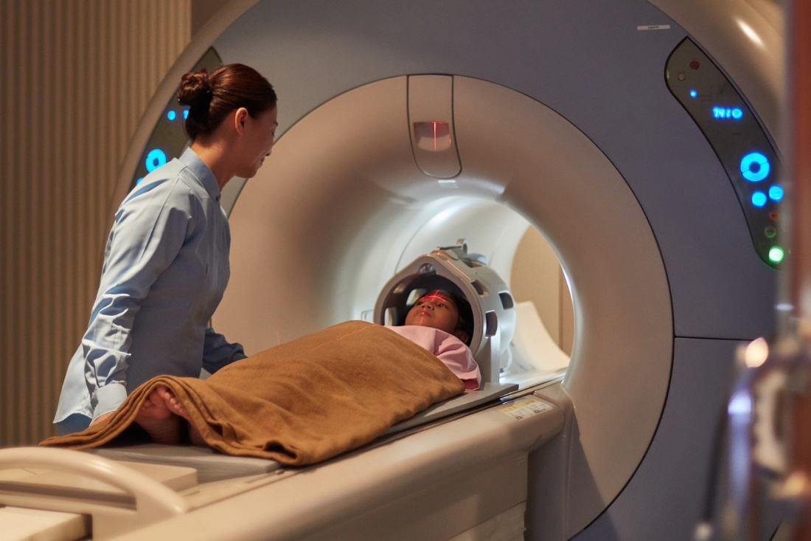
Figure-6: MRI [Adapted from UK Research and Innovation]
  - Computed Tomography:
CT scan provides a wide scope of usage for detection with imaging. It has a wide diagnostic application. Both dosage and image quality can be managed with the use of machine learning models. This eliminates the need for any compromise between these two components. Improved reports can be derived with the help of these models.
- Artificial Intelligence in Ophthalmology:
Application of AI in Ophthalmology is not a new subject. It's been carried out for decades. The clinician makes the machine learn characteristics of the disease to enable disease identification. AI has enabled large scale screening with minimal resource requirements.
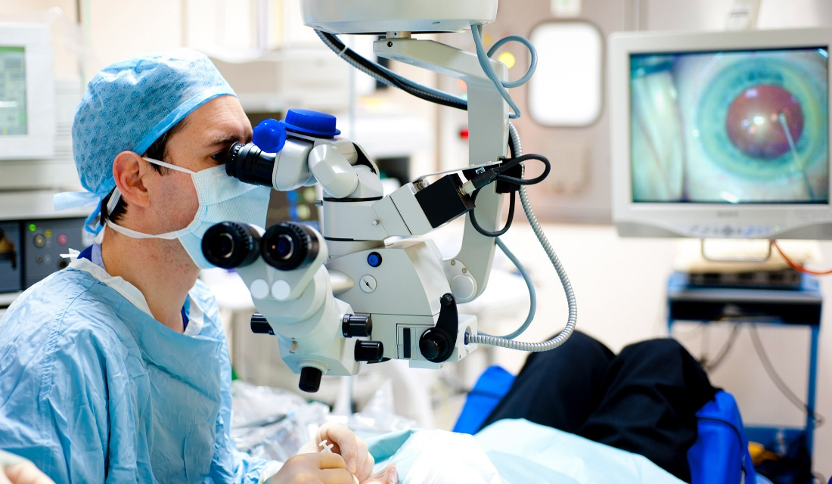
Figure-7: Use of AI in ophthalmology [Adapted from American Society of Retina Specialists]
  - Retina:
One of the key uses of AI is pattern recognition. AI algorithms have portrayed incredible efficiency in imaging and dealing with sensitivity issues. The challenges involved in detection and supervision of issues related to retina are dealt with by employing these models and algorithms.
  - Cornea and Anterior Segment:
Cornea opacity is one of the leading causes of blindness worldwide. Delay in detection of disease related to this area can lead to complications and even loss of vision in extreme cases. Imaging and screening are key functions in relation to diseases related to cornea. New developments in AI algorithms have led to increased manageability and performance. Improvement of diagnostic accuracy is another key function of these AI models. Improvement of therapeutic effects of these medical procedures has been possible with these algorithms.
- Artificial intelligence in Orthopedics:
Effective utilization of datasets in orthopedics can create space for optimum outcomes and improved procedures. Usefulness or compatibility of treatments is also made possible with the help of ML based models. Robotics have been used by orthopedic surgeons for decades. For example, ROBODOC uses AI using prepared surgical plans based on imaging.
  - Spine:
AI provides incredible advantages in data processing and imaging. This can be combined with medical care leading to positive outcomes medically. Predictive outputs generated by these models can be very helpful for medical professionals. Drastic changes in lifestyles have led to a spike in spinal diseases. Determination of etiology is key for prevention of diseases. Machine learning can hold wide potential in determining etiology. EHR is a core factor in positive medical procedures. AI enables data-driven decision making. Imaging quality is enhanced with the help of these AI models.
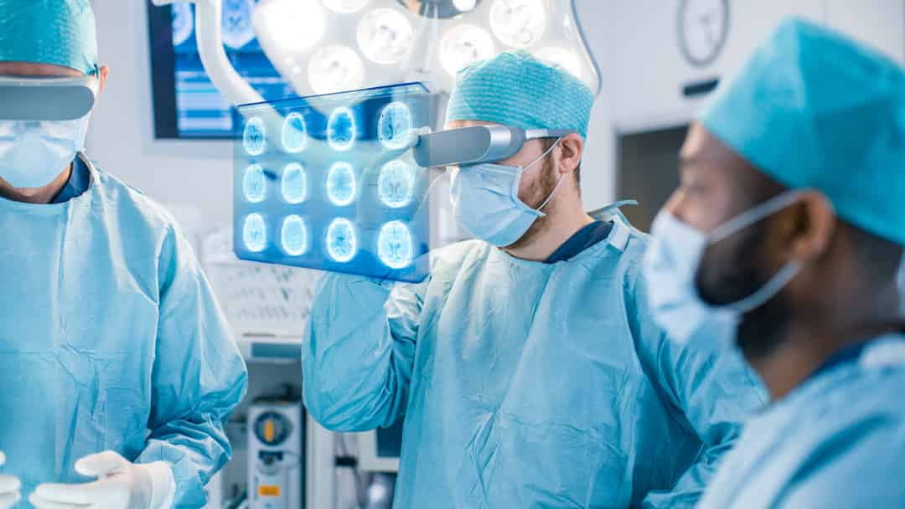
Figure-8: Orthopedic Applications of Artificial Intelligence [Adapted from Journal of Orthopedic Experience and Innovation]
  - Joints:
AI promotes efficient practice, tailored medical care, and increase in accuracy, and better incisions. There are lesser complications in AI assisted models than traditional models. There is a steady improvement in joint surgery care and outcome delivery due to robotics and AI. Accuracy ensures proper treatment. Elimination of human errors and risk factors is made possible.
  - Arthritis:
AI can be critical in ensuring quality medical care for arthritis patients. It is the second most prevalent autoimmune disease around the world. Precision is a key advantage of usage of AI. Algorithms and machine learning can assist physicians throughout the medical procedure. Early detection, diagnosis, and treatment is made possible with AI. Analysis of data is the best way to create value. Evaluating large sets of data efficiently can be difficult for humans. AI brings speed and accuracy aiding medical care in the best way possible.
  - Trauma:
Image screening assistance, prediction, operative robotics are some of the key functions of machine learning specifically related to trauma orthopedics field. Emergency departments can effectively utilize the use cases of machine learning base models. Various factors must be considered by the medical professionals to ensure proper healing and positive outcomes of the medical procedure. Identification of fractures or any other issues can be done effectively by applying imaging techniques aided by AI. The power of machine learning models lies in its ability to analyze data and to learn analysis metrics
- Internet of Things [IOT]:
The Internet of Things has enabled a wide scope of operations which were not previously performable. IOT enables devices to have led to the possibility of remote monitoring of patients. This has increased the quality of healthcare provided by enabling convenient follow-up. Superlative care is a crucial part of ensuring a speedy recovery. Physicians are empowered with increased communication in a convenient manner with their patients.
Figure-9: Smart Medical Devices and Equipments [Adapted from Sptel]

Efficiency and accuracy are the core of all the operations made possible through IOT. Another advantage that IOT has brought forward is minimization of cost. New developments like wearables like fitness bands lead to personalized care. It has become easier for physicians to monitor a patient's medical condition.
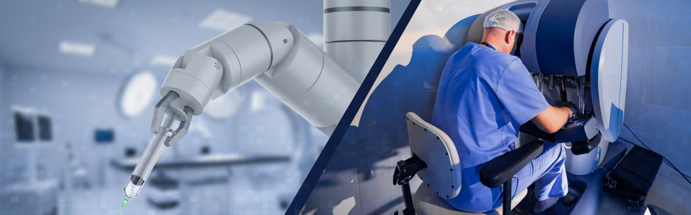
Figure-10: IOT in diagnosis and treatment [Adapted from Sptel]
Hospitals are provided with many tools and resources to ensure smooth functioning. Monitoring devices, sensors, temperature control devices are some of the use cases of IOT. It has truly redefined the standards for operational success in the health care sector.
- Conclusion:
It is an undisputed fact that AI has been the most transformative technologies in recent years for the healthcare sector. It has enabled incredible breakthroughs in medical science. These transformations have aided speed, accuracy, efficiency and effectiveness in the medical care provided to the patients.
There is an incredible level of cost reduction for the patients because of streamlined and optimized medical procedures. There is lesser chance of human error. This means greater chance of recovery, quality medical care, improved treatment responses and delivery of effective healthcare.
A patient-oriented healthcare approach becomes a more possible reality due to the tools provided by AI. Hospitals and medical centers are provided with incredible tools to ensure effective functioning. There is a steady increase in scope for research and development because of the immense opportunities that AI provides. Further application and integration of AI and machine learning models has statistically proven to be favorable in terms of successful operations in the health care systems.
AI provides scope for increased control and supervision in the ever-important field of health care. It can be said it is a new beginning of excellent potential and new avenues to improve and revolutionize health care with the aid of artificial intelligence and machine learning.
REFERENCES:
- Salimi M, Parry JA, Shahrokhi R, Mosalamiaghili S. Application of artificial intelligence in trauma orthopedics: Limitation and prospects. World Journal of Clinical Cases. 2023 Jun 6;11(18):4231.
- Kumar K, Kumar P, Deb D, Unguresan ML, Muresan V. Artificial intelligence and machine learning based intervention in medical infrastructure: a review and future trends. InHealthcare 2023 Jan 10 (Vol. 11, No. 2, p. 207). MDPI.
- Jamali A, Shekhar A, Dungy D, Stewart S. Patient-Reported Outcomes of Kinematic vs Mechanical Alignment in Total Knee Arthroplasty: A Systematic Review and Meta-analysis of Randomized Controlled Trials.
- Momtazmanesh S, Nowroozi A, Rezaei N. Artificial intelligence in rheumatoid arthritis: current status and future perspectives: a state-of-the-art review. Rheumatology and Therapy. 2022 Oct;9(5):1249-304.
- Davenport T, Kalakota R. The potential for artificial intelligence in healthcare. Future healthcare journal. 2019 Jun;6(2):94.
- Secinaro S, Calandra D, Secinaro A, Muthurangu V, Biancone P. The role of artificial intelligence in healthcare: a structured literature review. BMC medical informatics and decision making. 2021 Dec;21:1-23.
- Lisacek-Kiosoglous AB, Powling AS, Fontalis A, Gabr A, Mazomenos E, Haddad FS. Artificial intelligence in orthopaedic surgery. Bone & Joint Research. 2023;12(7):447-54.
- Honavar SG. Artificial intelligence in ophthalmology-Machines think!. Indian Journal of Ophthalmology. 2022 Apr;70(4):1075.
- Zhou S, Zhou F, Sun Y, Chen X, Diao Y, Zhao Y, Huang H, Fan X, Zhang G, Li X. The application of artificial intelligence in spine surgery. Frontiers in Surgery. 2022 Aug 11;9:885599.
- Yang J, Ji Q, Ni M, Zhang G, Wang Y. Automatic assessment of knee osteoarthritis severity in portable devices based on deep learning. Journal of Orthopaedic Surgery and Research. 2022 Dec;17(1):1-8.
- Bird A, Oakden-Rayner L, McMaster C, Smith LA, Zeng M, Wechalekar MD, Ray S, Proudman S, Palmer LJ. Artificial intelligence and the future of radiographic scoring in rheumatoid arthritis: a viewpoint. Arthritis Research & Therapy. 2022 Dec;24(1):1-0.
- Hunter OF, Perry F, Salehi M, Bandurski H, Hubbard A, Ball CG, Morad Hameed S. Science fiction or clinical reality: a review of the applications of artificial intelligence along the continuum of trauma care. World Journal of Emergency Surgery. 2023 Mar 6;18(1):16.
- Siontis KC, Noseworthy PA, Attia ZI, Friedman PA. Artificial intelligence-enhanced electrocardiography in cardiovascular disease management. Nature Reviews Cardiology. 2021 Jul;18(7):465-78.
- Joseph JP. Can Alternative MRI Techniques Help Enhance CyberKnife Treatment Imaging?.
- Stephens K. AI Uses Lung CT Data to Predict Mortality Risk. AXIS Imaging News. 2023 Jul 26.
- Schmidt-Erfurth U, Sadeghipour A, Gerendas BS, Waldstein SM, Bogunović H. Artificial intelligence in retina. Progress in retinal and eye research. 2018 Nov 1;67:1-29.
- Rampat R, Deshmukh R, Chen X, Ting DS, Said DG, Dua HS, Ting DS. Artificial intelligence in cornea, refractive surgery, and cataract: basic principles, clinical applications, and future directions. Asia-Pacific journal of ophthalmology (Philadelphia, Pa.). 2021 Jul 7;10(3):268.
- Nasseef OA, Baabdullah AM, Alalwan AA, Lal B, Dwivedi YK. Artificial intelligence-based public healthcare systems: G2G knowledge-based exchange to enhance the decision-making process. Government Information Quarterly. 2022 Oct 1;39(4):101618.
- Glover WJ, Li Z, Pachamanova D. The AI-enhanced future of health care administrative task management. NEJM Catalyst Innovations in Care Delivery. 2022 Mar 3;3(2).
- Beam AL, Manrai AK, Ghassemi M. Challenges to the reproducibility of machine learning models in health care. Jama. 2020 Jan 28;323(4):305-6.
- Ahmad MA, Eckert C, Teredesai A. Interpretable machine learning in healthcare. InProceedings of the 2018 ACM international conference on bioinformatics, computational biology, and health informatics 2018 Aug 15 (pp. 559-560).
- Ngiam KY, Khor W. Big data and machine learning algorithms for health-care delivery. The Lancet Oncology. 2019 May 1;20(5):e262-73.
- Ghaffar Nia N, Kaplanoglu E, Nasab A. Evaluation of artificial intelligence techniques in disease diagnosis and prediction. Discover Artificial Intelligence. 2023 Jan 30;3(1):5.
- Rea G, Sverzellati N, Bocchino M, Lieto R, Milanese G, D’Alto M, Bocchini G, Maniscalco M, Valente T, Sica G. Beyond Visual Interpretation: Quantitative Analysis and Artificial Intelligence in Interstitial Lung Disease Diagnosis “Expanding Horizons in Radiology”. Diagnostics. 2023 Jul 10;13(14):2333.
- Morris MX, Song EY, Rajesh A, Asaad M, Phillips BT. Ethical, legal, and financial considerations of artificial intelligence in surgery. The American Surgeon. 2023 Jan;89(1):55-60.
- Ahmad A, Tariq A, Hussain HK, Gill AY. Equity and Artificial Intelligence in Surgical Care: A Comprehensive Review of Current Challenges and Promising Solutions. BULLET: Jurnal Multidisiplin Ilmu. 2023 May 28;2(2):443-55.
- Gupta R, Park JB, Bisht C, Herzog I, Weisberger J, Chao J, Chaiyasate K, Lee ES. Expanding cosmetic plastic surgery research with ChatGPT. Aesthetic Surgery Journal. 2023 Aug;43(8):930-7.
- Miller R, Farnebo S, Horwitz MD. Insights and trends review: artificial intelligence in hand surgery. Journal of Hand Surgery (European Volume). 2023 May;48(5):396-403.
- Ting DS, Ang M, Mehta JS, Ting DS. Artificial intelligence-assisted telemedicine platform for cataract screening and management: a potential model of care for global eye health. British Journal of Ophthalmology. 2019 Nov 1;103(11):1537-8.
- Zhang H, Niu K, Xiong Y, Yang W, He Z, Song H. Automatic cataract grading methods based on deep learning. Computer methods and programs in biomedicine. 2019 Dec 1;182:104978.
- Niel O, Bastard P. Artificial intelligence in nephrology: core concepts, clinical applications, and perspectives. American Journal of Kidney Diseases. 2019 Dec 1;74(6):803-10.
- Loftus TJ, Shickel B, Ozrazgat-Baslanti T, Ren Y, Glicksberg BS, Cao J, Singh K, Chan L, Nadkarni GN, Bihorac A. Artificial intelligence-enabled decision support in nephrology. Nature Reviews Nephrology. 2022 Jul;18(7):452-65.
- Aneja S, Chang E, Omuro A. Applications of artificial intelligence in neuro-oncology. Curr Opin Neurol. 2019 Dec;32(6):850-856. doi: 10.1097/WCO.0000000000000761. PMID: 31609739.
- Pedersen M, Verspoor K, Jenkinson M, Law M, Abbott DF, Jackson GD. Artificial intelligence for clinical decision support in neurology. Brain communications. 2020;2(2):fcaa096.
- Dimitriadis I, Zaninovic N, Badiola AC, Bormann CL. Artificial intelligence in the embryology laboratory: a review. Reproductive biomedicine online. 2022 Mar 1;44(3):435-48.

