Nanotechnology in Animal Husbandry: Pioneering Advancements in Dairying

Somveer  PhD Research Scholar  Dairy Engineering Division  National Dairy Research Institute  Karnal, Haryana, India  somveer.berwal20@gmail.com | Amrita Pramanik  PhD Research Scholar  Animal Biotechnology Division  National Dairy Research Institute  Karnal, Haryana, India  amritapramanik2020@gmail.com | Manisha Kumari  Teaching Associate  Dairy Engineering Division  College of Dairy Science and Technology, RAJUVAS  Bikaner, Rajasthan, India  mishameena7@gmail.com

Abstract
The agricultural farm animal (Livestock) production system is under a massive burden to provide adequate food to the rapidly growing human population. The emergence of new diseases and climate change has enhanced burdens on the animal production system. Nanotechnology, an application of materials at the nano scale, offers opportunities to improve animal production, growth and health by providing better therapeutics, diagnostics, vaccines, adjuvants, animal feed and others feed additives, and even helping animal reproduction. The implementation of nanotechnology in the dairy industry holds the potential for a forthcoming revolution. This chapter discusses the exciting examples of the selected application of nanotechnology in animal husbandry and dairy processing industry to realize the benefits and potential challenges of emerging nanotools that promise increase in food production from farm animals and shelf-life extension for dairy products in a sustainable manner. Moreover, reducing particle size through nanotechnology can enhance the properties of bioactive compounds in dairy products.

Keywords: Nanotechnology, Agriculture, Dairying, Animal Husbandry and Farm animals.

- INTRODUCTION
The term ‘nano’ is derived from the Greek word meaning ‘the dwarf’ and is generally used combined with other words such as nanometre, nanobots, nanotechnology (NT), etc. [1,24]. NT is the science and technology of small things of small things with new changes in their chemical and physical structure, and also higher reactivity and solubility [1,25]. Nanomaterials have unique physical, chemical, and biological properties compared with non-nanomaterial counterparts. Due to the smaller size, molecules are biologically more active and soluble and having more stable structure and are less affected by oxidative inactivation and other underlying factors. NT's objective is to generate materials on a nanoscale, possessing at least one dimension ranging from 1 to 100 nanometers [1], concerning various sizes of biological structures. (Fig. 1). These ultrastructure materials having higher surface-area ratio, called nanoparticles (NPs). N Nanoparticles (NPs) can be readily synthesized from a range of substances, encompassing metals, flowers, leaves, and chemicals [21]. At the ultramicroscopic scale, NPs attain distinct physical, chemical, and biological attributes, opening novel avenues for investigating the structural, cellular, and molecular mechanisms within mammalian cells [2].
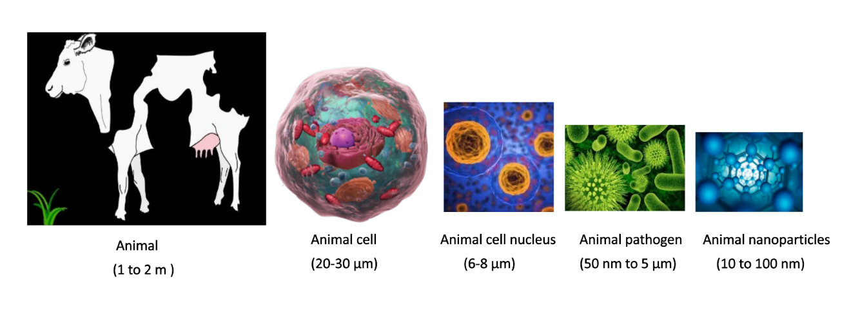
Fig. 1: Size of different biological structures in farm animals [21]

NT, the manipulation of matter at the nanoscale, has emerged as a game-changing technology with a broad range of applications in numerous industries. NT has made their mark on agriculture, changing animal husbandry practices and dairy farming methods over the past years. This chapter explores the various applications of NT in enhancing animal health, nutrition, and overall productivity in the milieu of modern agricultural practices. NT having numerous applications in veterinary medicine including disease diagnosis, treatment, animal breeding, drug delivery, and improving and boosting animal origin food product. It offers a wide range of new nanomaterials and NPs including Nano chips, nanosenser, gold NPs, liopsoms, quantum dot, magnetic Nanoparticles etc for disease diagnosis, vaccination, pathogen detection, animal breeding and provide polymeric NPs, carbon nanotube, Nano shell dendrites, etc for delivering antimicrobial NPs and nano medicine for treatment of disease.
Numerous domains within agricultural animal production hold promise for the application of nanotechnology (NT) to enhance both animal well-being and food yield. Over an extended span, domesticated animals including cattle, goats, sheep, pigs, buffalo, and poultry have functioned as vital food sources, contributing meat, milk, and related items for human dietary needs. Projections indicate a global human population of around 9 billion by 2050, necessitating a substantial increase, possibly two to threefold, in global agricultural output to meet the escalating demands of the expanding populace. It is expected that the human will reach approximately 9 billion by 2050, requiring a doubling or even tripling of global agricultural production to adequately cater to the perpetually expanding human populace's food demands. [3]. Hence, we need to adopt the modern technologies, like Nanotechnology in the field of the Animal Husbandry, to enhance the productivity of domestic animals. Over recent years, there has been a growing enthusiasm to investigate the potential of NT in enhancing animal health and production. In this context, our attention is directed towards several NT applications within the realms of Animal Husbandry and Dairying. (Fig. 2).

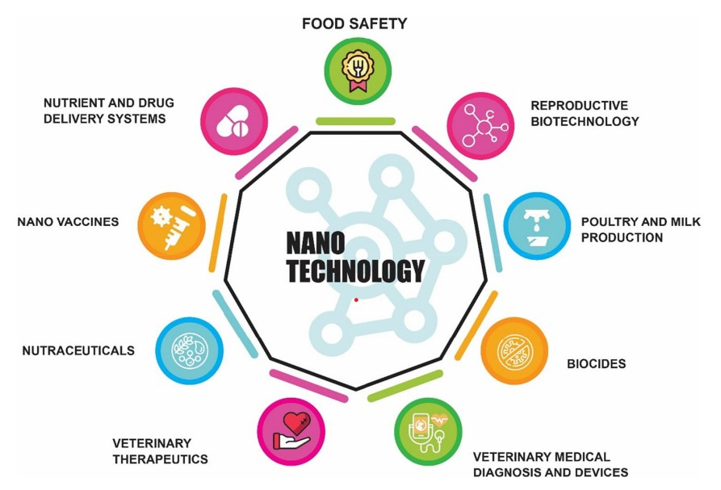

Fig. 2: Applications of nanotechnology in the field of animal production and veterinary medicine [26]

- IMPROVEMENT IN ANIMAL HEALTH
Farm animals in good health contribute to increased animal productivity, ensuring a consistent and safe food supply, reduced reliance on antibiotics and vaccines, and steady trade of animal products. Consequently, prioritizing effective healthcare and disease prevention can lead to substantial cost savings by eliminating the need for treatment and eradication of disease. One of the most noticeable examples is an outbreak of the foot and mouth disease (FMD), a catastrophic viral illness that effects cattle, buffalo, goats, sheep, and pigs, which costs 11 billion US dollars to the outbreak countries, primarily India and China [4]. Additionally, animal products such as milk, meat, and their products, including hide are not accepted by disease-free importing nations such as USA and Europe, this restriction also leads to substantial losses in the animal trade industry. Notably, these nanoparticles (NPs) share a similar size scale with disease-causing viruses (nanometres in size) and similarity offers the potential to create efficient diagnostic and therapeutic approaches for specific diseases. [2]. Therefore, NT is considered as an attractive option to improve veterinary medicine, animal health, and drug delivery. The utilization of nanominerals and nanoemulsion technologies brings numerous advantages to the production and application of cattle and poultry feed, such as reduced expenses, decreased reliance on additives, and the incorporation of growth-promoting and immune-modulating properties [27]. Nanominerals can also inhibit harmful pathogens in feed, regulate the process of rumen fermentation, even address the reproductive problems in cattle and sheep herds. Nanominerals have also been used to treat the several animal diseases. For instance, Nanozinc oxide has the potential to increase the growth rate, immunity, and reproductive performance of farm animals and birds, as well as lower the incidence of diarrhoea in piglets [28]. Studies have revealed that Nanozinc has the ability to enhance milk yield and decrease the count of somatic cells in dairy cows affected by recessive mastitis.
- VETERINARY DIAGNOSTICS
Establishing the rapid, accurate, and highly responsive detection of disease-causing pathogens that is fundamental to effectively treating and eradicating those diseases In recent times, the progress in nanotechnology (NT) has brought about a transformative shift in veterinary diagnostics. For example, nanoparticles (NPs) based on iron oxide can now be employed to track the dispersion of a medication within the body by utilizing magnetic resonance imaging (MRI)[5]. Also, a specific drug can be labelled with fluorescent Nanoparticles to identify where it is located within the target cells [6]. Moreover, NP-based diagnostic chips are made available to rapidly analyse a large number of samples [7]. Nanoparticle (NP)-based diagnostic chips require less time, a minute quantity of initial material (like blood or serum), fewer consumables, and yield more precise outcomes in contrast to conventional laboratory techniques like polymerase chain reactions and enzyme-linked immunosorbent assays (ELISAs). [22]. Several examples of NP-based veterinary diagnostics are outlined in Table 1.

Table 1: Some innovative applications of NP-based veterinary diagnostics [22]

Animal Species | Nanoparticle-based diagnostic tool | References
Poultry | Quantum dot-based 3D-printed immunoassay to detect avian influenza (H7N9) virus | Xiao et al. (2019) [31]
Pig | Nano-polymerase chain reaction assay to detect the epidemic porcine diarrhea virus | Wanzhe et al. (2015) [32]
Poultry | Gold NPs-coated polyvinylidene difluoride membrane to detect avian flu antibodies in serum | Emami et al. (2012) [33]
Cattle | NPs-based array of sensors (NA-NOSE) to detect volatile organic compounds linked to bovine tuberculosis in breath | Peled et al. (2012)  [34]
Domestic and Wild ruminants | NPs-based biosensor assay to detect the Mycobacterium avium subsp. paratuberculosis (MAP), the causative agent of Johne’s disease (JD), in fecal samples | Kumanan et al. (2009) [35]
Chicken and Goat | Quantum dot-based fluoro-immunoassay to detect antibodies of chicken Newcastle and goat pox virus in serum | Yuan et al. (2009)  [36]

- VETERINARY THERAPEUTICS AND VACCINE DELIVERY
Investment in the field of research and development activities of veterinary medicine will create ample access to the best drugs and vaccines to treat diseases. NT has opened new avenues in veterinary therapeutics by developing a smart drug delivery system that ensures the efficient delivery of drugs to the target tissues [2]. The smart drug delivery system ensures maximum absorption and low irritation at the target site, and also has maximum therapeutic activity for an adequate duration [8]. In recent years, several NPs such as polymeric NPs, carbon nanotubes, liposomes, dendrimers, nanoshells, nanopores, and magnetic NPs have been used for targeted delivery of drugs to treat veterinary diseases [9]. A wide range of antibiotics such as penicillin, amoxicillin, streptomycin, tetracycline, and gentamycin are frequently used drugs in veterinary medicine. In farm animals, particularly in poultry and pigs, the antibiotics are not only used to kill pathogenic bacteria but also used as growth promoters [10]. Humans exposed to antibiotics through the consumption of antibiotics-treated milk and meat products may increase the incidence of antibiotics resistance [11]. NT can play an important role in developing effective and nontoxic antimicrobial agents to overcome the excessive use of antibiotics in farm animals. Vaccines, antigenic components of pathogens, are regularly used to protect animals from the occurrence of a disease state. The vaccine stimulates the body’s immune system to produce specific antibodies against a particular pathogen [12]. The efficacy of vaccines is highly dependent upon antigen type, route of delivery, and vaccine composition. With vaccines, the adjuvants (immunological agents) are often injected to augment the body’s immune response that provides stronger and long-lasting immunity to a particular disease [13]. New vaccine candidates like synthetic peptides and recombinant proteins are sensitive to degradation, and commonly use aluminium-based adjuvants could not protect these new classes of vaccines from early degradation [14]. NPs can be used to engineer the adjuvants in such way that vaccines have longer bioactivity with reduced dose to provoke a specific immune response. Various forms of NPs such as liposomes, polystyrene nanobeads, and immune-stimulating complexes can be used to engineer the adjuvants [14]. A few examples of NP-based therapeutics in veterinary are summarized in Table 2. Many drugs, biological molecules, and nutrients can acquire novel physicochemical properties by using NT, such as improved bioavailability, higher mobility and cellular uptake, controlled sustained release of the drug at the target site, lower toxicity compared with other compounds, improved enzymatic actions, and increased mucoadhesive properties. [29]

Table 2: Examples of NP-engineered therapeutics and vaccines in veterinary medicine [29]

Animal species | Nanoparticle-based therapeutic and vaccine
Cattle | Liposome-based streptomycin delivery for the treatment of brucellosis disease
 | Intra-nasal delivery of ring-shaped NPs for the treatment of respiratory syncytial virus
 | Transdermal delivery of liposomes-based diclofenac as an anti-inflammatory and analgesic drug
Sheep | Polystyrene nanobeads to deliver foot and mouth disease vaccine
 | DNA chitosan nanospheres to deliver Newcastle disease vaccine
 | Liposome-based staphylococcal mastitis vaccine
 | Liposome-based bovine leukemia virus vaccine
Horse | Liposome-based delivery of diamidine for the treatment of babesiosis disease
 | Micelle-based delivery of ivermectin for the treatment of Strongylus vulgaris
 | Water-based NPs adjuvant vaccine against Rhodococcus equi pneumonia
 | Liposome-based delivery of Toxoplasma gondii vaccine
Pig | Dendrimer-based delivery of foot and mouth vaccine
 | Polymeric E. coli fimbriae vaccine

- IMPROVEMENT IN ANIMAL PRODUCTION
Reproductive efficiency plays a pivotal role in livestock farming systems, significantly impacting farms' productivity, profitability, and long-term sustainability. The ability of farm animals to reproduce effectively directly influences the efficiency of milk and meat production. Farm animals are reared to produce large quantities of milk, eggs, meat, fiber, and hide at the lowest possible cost. Efficient farm production requires good management practices that include adequate nutrition and good health, and the adaptation of animals to specific production conditions. In the past few decades, the fast-growing demand for animal origin food has massively changed the farm animal production system, which is supported by the mechanization of agriculture and technological developments. Nanotechnologies can also be applied to increase the production potential of farm animals. For example, supplementation of NP-coated feed, called nanofeed, to promote animal growth and yield, and to fortify milk, eggs, and meat products [7]. At present, NT in animal production systems is in its budding stage, there is great potential in the coming years that NT will be extensively used to boost farm animal production.
- ANIMAL NUTRITION
In an animal production system, approximate 40-50% of operating costs are due to animal feed [23]. The feed industry’s aim is to increase the efficiency of feed and its additives. Nutritional deficiency significantly decreases the production potential of animals, and nutrient-deficient animals are more prone to disease [23]. The animal feed industry should formulate animal feed with NPs with the following aims: (a) improvement of overall feed efficiency, (b) increased production levels and quality of animal products (milk, eggs, and meat), (c) use of NPs having antioxidant and immune-modulatory properties to improve health, (d) reducing the requirement of antibiotics as growth promoters, as these may have negative effects on human health, and (e) removing unpleasant smells (boar taint) of animals products, particularly in meat of pigs [15]. Several studies suggested that nanoform of feed can be used to enhance its nutritive value and to promote animal growth [15]. Some of the examples of nanofeed additives are summarized in Table 3.

Table 3: Commonly used nanoparticle additives in farm animal feed [8]

Animal Species | Nanoparticles | Application
Sheep, goat and poultry | Selenium | Stimulation of rumen microbial and enzyme activity
 |  | Enhancing the semen quality
 |  | Enhancing the immune response
Ruminants, pig and poultry | Zinc | Improving feed conversion ratio that promotes growth
 |  | Enhancing the immune response
Pig | Chromium | Anti-diarrheal
 |  | Improving carcass quality, particularly lean meat production
 |  | Enhancing the immune response
Poultry | Copper | Stimulating the metabolic rate in broilers during embryonic development
 |  | Strengthening immunological biocompatibility
Poultry | Montmorillonite-Composite | Reducing aflatoxin toxicity
Farm animals, including poultry | Nano-polystyrene with polyethylene glycol linkers and mannose targeting biomolecules | Binding and removal of foodborne pathogens in animal feed

- ANIMAL REPRODUCTION
Reproduction is a natural way to increase the population of livestock in which sex cells (oocyte and sperm) are united to form an embryo that develops into a new generation of animal. Since many decades, humans have been exploiting the best genotype and phenotype parent animals to produce next-generation animals that are intended to produce more food (milk and meat) for human consumption. In farm animal reproduction, artificial insemination with frozen semen is the most commonly used method that assists faster and wider multiplication of elite animal production traits. Recently, NPs have been used to study the physiological interaction between sperm and oocyte to understand the physiology of the fertilization process [16, 17]. Application of NPs to assess the physical and physiological characteristics of sperm such as motility, directionality, and intactness of acrosome can be helpful in predicting the suitability of semen in assisted reproductive techniques (ART) and thus ensuring successful fertilization. Furthermore, NP-based magnetic purification method of bull semen has demonstrated separation of damaged and defective sperm, thereby improving fertilization ability both in vitro and in vivo [18, 19]. Recently, the potential applications of NPs as antioxidants and protective agents were investigated as supplement in semen extender to protect sperm during cryopreservation stress [20]. NT can be coupled with gamete biology and semen cryopreservation methods to enhance the reproduction potential of animals. Nanobiosensors are being validated and used for disease detection and estrus management, as well as to detect the hormonal levels, and considered a promising tool in the reproductive management [30].

- NANOTECHNOLOGY FOR DAIRY PROCESSING
Nanotechnology offers a wide range of applications in the dairy industry, providing opportunities to improve various aspects of dairy production, processing, and product quality. The advantages of using nanomaterials in the dairy industry are discussed (Fig. 3). Nanomaterials can be used as encapsulating agents for vitamins, antioxidants, flavours, minerals, and other nutrients, which are important for fortifying milk and milk products [37]. They also have a role in developing novel packaging materials and biosensors to protect against disease-causing microorganisms. Nanomaterials can be beneficial for various other applications such as protecting milk products from spoilage and oxidation [38].
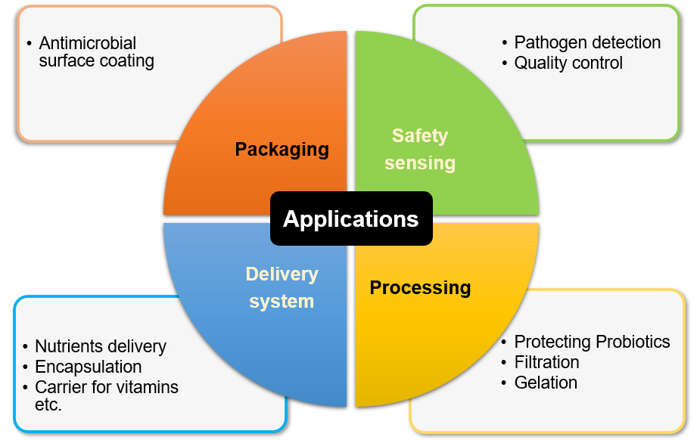
Fig. 3 Applications of nanotechnology in dairy industry [38]

By integrating nanotechnology into the dairy industry, producers can enhance product quality, safety, and processing efficiency, contributing to the advancement of the dairy sector in a sustainable and responsible manner. Some of the key applications include:

- Nutrient Delivery and Fortification
Nanotechnology enables the nanoencapsulation of nutrients and bioactive compounds, enhancing their stability during processing and digestion. This allows for the development of fortified dairy products with improved nutritional value, such as nano-encapsulated vitamins, minerals, or antioxidants in milk, yogurt, or cheese. Nano-emulsions can be utilized to create stable and homogenous mixtures of immiscible liquids, which can enhance the texture and sensory attributes of dairy products. For example, nano-emulsions can be employed in ice cream to provide a smoother and creamier mouthfeel [39]. Nanotechnology can be utilized to reduce the fat content in dairy products without compromising taste and texture. Nanostructured fat substitutes can mimic the mouthfeel of fats, providing healthier alternatives to consumers. The delivery system functions as a conduit for conveying the functional ingredient to the target object of action. It is imperative for the delivery system to safeguard the functional ingredient against chemical or biological degradation throughout processing, storage, and utilization [40].

- Food Safety and Quality
Nano-sensors and nanomaterials play a crucial role in detecting contaminants, pathogens, or spoilage indicators in dairy products [38]. This ensures better food safety and quality throughout the dairy supply chain, reducing the risk of foodborne illnesses and spoilage. Nanosensors demonstrate the capacity to monitor temporal variations in temperature and humidity, detect gases emanating from oxidative food spoilage and pathogenic microorganism contamination within packages, while also enabling colour changes in the package as a means to convey pertinent information regarding these alterations [41].

- Extended Shelf Life & Smart Packaging
Nanotechnology can extend the shelf life of dairy products by inhibiting the growth of spoilage microorganisms and maintaining product freshness for a longer duration. Nanotechnology offers opportunities for advanced dairy product packaging. Nanocomposite materials can provide better barrier properties, reducing oxygen and moisture permeability, thus extending the shelf life and preserving the quality of dairy products. Nano-packaging in dairy products aims to safeguard the contents and extend the shelf life of such products. Commonly investigated nanoparticles used in this context encompass copper, zinc oxide, silver, and titanium dioxide, all of which demonstrate notable antimicrobial properties when employed in dairy product packaging (Table 17.3) [38].

Table 4: Nanoparticles incorporated packaging for dairy products [37]

Product | Nanoparticle | Target microorganisms | References
Butter | Zinc NPs coated-packaging film | - | Contreras et al. (2010) [42]
Soft white cheese | Titanium NPs/Chitosan/Poly (vinyl alcohol) (CS/PVA/TiO₂ nanocomposite) | Staphylococcus aureus, Pseudomonas aeruginosa, Escherichia coli and Candida albicans | Youssef et al. (2015) [43]
Dairy products | Copper NPs | Pseudomonas spp. | Longano et al. (2012) [44]
Soft ripened cheese | TiO₂ coated HDPE-based food packaging | Reduction in activity of organic materials | Gumiero et al. (2013) [45]
Soft cheese and milk powder | 1% nano-silver and 0.1% TiO₂ | Enterobacter spp. | Metak and Ajaal (2013) [46]

- Improved Dairy Processing
Nanotechnology can optimize dairy processing techniques. For instance, the use of nanofiltration or ceramic nanomembranes facilitates more efficient separation of components from milk, leading to improved processing efficiency and higher-quality dairy products. Nanotechnology can be employed to create unique nanoscale tags or markers for dairy products, enhancing their traceability and authentication to prevent counterfeiting and ensure product integrity [47]. Furthermore, the ongoing development of smart packaging employing nanotechnology has introduced innovative functionalities for food preservation. This smart packaging incorporates diverse nanosensors and nanodevices, enabling consumers to access real-time information regarding the condition of the food enclosed within. Equipped with nanosensors, the packaging is designed to monitor both internal and external factors affecting food products, pellets, and containers across the entire supply chain [48].
- POTENTIAL CHALLENGES ASSOCIATED WITH NANOPARTICLES
The safety aspect of nanoparticles is a significant concern due to the increased contact surface area resulting from the nanoscale materials, leading to potential toxic effects in the body. However, the regulation and knowledge surrounding these nanomaterials are currently lacking. While some researchers and research committees acknowledge the usefulness of this technology, further investigations are necessary to ensure the safety of these nanomaterials [49]. The human body may be exposed to nanoparticles through various systems such as the respiratory, digestive, and skin systems, as shown in figure 4. Ingestion of nanoparticles has been linked to heightened oxidative stress, free radical production, DNA mutations, and potential harm to human health [50].
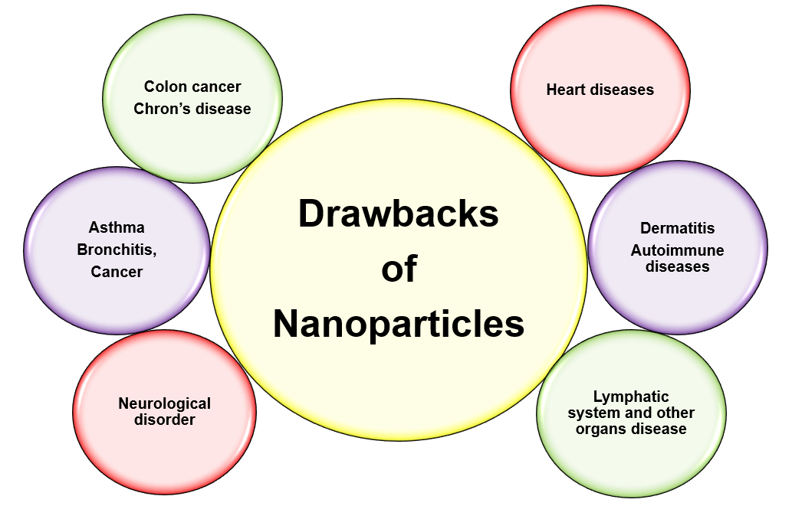
Fig. 4 Potential challenges associated with nanoparticles [49]

- CONCLUSION
Nanotechnology has great potential to enhance the production and health of agricultural farm animal. Existing research studies have clearly revealed that the practicality of Nanotechnology in, enhanced feed efficiency, precise diagnostic tools, targeted drug delivery, enhanced vaccine response, and increased fertility in agricultural animals. Individuals within the nanotechnology field, encompassing scientists, engineers, and biologists, should sustain their ongoing initiatives. Additionally, securing substantial financial resources for research and development is imperative for their progress. A multitude of uses exist for these inventive nanoparticles within the animal sector, and the current examination aimed to aid in directing attention toward scientific methodologies while also identifying potential applications for these technologies. Nanotechnology has reformed scientific research in the disciplines of animal and veterinary sciences. This chapter aimed to emphasize these purposes and pinpoint potential prospects for forthcoming applications.

Nanotechnology is assuming a crucial function in areas like ensuring food safety, disease diagnosis, medical treatment, vaccine manufacturing, efficient nutrient and drug delivery mechanisms as alternatives to antibiotics, reproductive biotechnology, and the poultry industry. The significant expansion of the contact surface area in nanoparticles gives rise to significant safety apprehensions. Nanoparticles can enter the human body through various routes such as inhalation, ingestion, and skin contact. Consequently, it is essential to establish a suitable regulatory body to tackle these concerns and supervise the secure usage, implementation of nanoparticles and oversee the safe utilization and uses of nanoparticles.

REFERENCES

[1] Roco, M. C. (2003). Nanotechnology: convergence with modern biology and medicine. Current Opinion in Biotechnology, 14(3), 337-346.
[2] Scott, N. R. (2005). Nanotechnology and animal health. Revue Scientifique Et Technique-Office International Des Epizooties, 24(1), 425.
[3] Sekhon, B. S. (2014). Nanotechnology in agri-food production: an overview. Nanotechnology, Science and Applications, 31-53.
[4] Knight-Jones, T. J., and Rushton, J. (2013). The economic impacts of foot and mouth disease-What are they, how big are they and where do they occur? Preventive Veterinary Medicine, 112(3-4), 161-173.
[5] Soenen, S. J., Himmelreich, U., Nuytten, N., Pisanic, T. R., Ferrari, A., and De Cuyper, M. (2010). Intracellular nanoparticle coating stability determines nanoparticle diagnostics efficacy and cell functionality. Small, 6(19), 2136-2145.
[6] Ajmal, M., Yunus, U., Matin, A., and Haq, N. U. (2015). Synthesis, characterization and in vitro evaluation of methotrexate conjugated fluorescent carbon nanoparticles as drug delivery system for human lung cancer targeting. Journal of Photochemistry and Photobiology B: Biology, 153, 111-120.
[7] Craighead, H. (2006). Future lab-on-a-chip technologies for interrogating individual molecules. Nature, 442(7101), 387-393.
[8] El Sabry, M. I., McMillin, K. W., and Sabliov, C. M. (2018). Nanotechnology considerations for poultry and livestock production systems-A review. Annals of Animal Science, 18(2), 319.
[9] Muktar, Y., Bikila, T., and Keffale, M. (2015). Application of nanotechnology for animal health and production improvement: a review. World Appl Sci J, 33(10), 1588-1596.
[10] Selokar, N. L., Dua, S., Kumar, D., Sharma, B., and Saini, M. (2020). Application of Nanotechnology in Agricultural Farm Animals. Biogenic Nano-Particles and their Use in Agro-ecosystems, 1-8.
[11] Bartlett, J. G., Gilbert, D. N., and Spellberg, B. (2013). Seven ways to preserve the miracle of antibiotics. Clinical Infectious Diseases, 56(10), 1445-1450.
[12] Pulendran, B., and Ahmed, R. (2011). Immunological mechanisms of vaccination. Nature Immunology, 12(6), 509-517.
[13] Awate, S., Babiuk, L. A., and Mutwiri, G. (2013). Mechanisms of action of adjuvants. Frontiers In Immunology, 4, 114.
[14] Underwood, C., and Van Eps, A. W. (2012). Nanomedicine and veterinary science: The reality and the practicality. The Veterinary Journal, 193(1), 12-23.
[15] Hill, E. K., and Li, J. (2017). Current and future prospects for nanotechnology in animal production. Journal Of Animal Science And Biotechnology, 8(1),1-13.
[16] Vasquez, E. S., Feugang, J. M., Willard, S. T., Ryan, P. L., and Walters, K. B. (2016). Bioluminescent magnetic nanoparticles as potential imaging agents for mammalian spermatozoa. Journal Of Nanobiotechnology, 14, 1-9.
[17] Feugang, J. M., Youngblood, R. C., Greene, J. M., Willard, S. T., and Ryan, P. L. (2015). Self-illuminating quantum dots for non-invasive bioluminescence imaging of mammalian gametes. Journal of Nanobiotechnology, 13, 1-16.
[18] Odhiambo, J. F., DeJarnette, J. M., Geary, T. W., Kennedy, C. E., Suarez, S. S., Sutovsky, M., and Sutovsky, P. (2014). Increased conception rates in beef cattle inseminated with nanopurified bull semen. Biology Of Reproduction, 91(4), 97-1.
[19] Durfey, C. L., Swistek, S. E., Liao, S. F., Crenshaw, M. A., Clemente, H. J., Thirumalai, R. V., Steadman, C. S., Ryan, P. L., Willard, S. T., and Feugang, J. M. (2019). Nanotechnology-based approach for safer enrichment of semen with best spermatozoa. Journal Of Animal Science And Biotechnology, 10(1), 1-12.
[20] Falchi, L., Khalil, W. A., Hassan, M., and Marei, W. F. (2018). Perspectives of nanotechnology in male fertility and sperm function. International Journal of Veterinary Science and Medicine, 6(2), 265-269.
[21] Charitidis, C. A., Georgiou, P., Koklioti, M. A., Trompeta, A. F., and Markakis, V. (2014). Manufacturing nanomaterials: from research to industry. Manufacturing Review, 1, 11.
[22] Bai, D. P., Lin, X. Y., Huang, Y. F., and Zhang, X. F. (2018). Theranostics aspects of various nanoparticles in veterinary medicine. International Journal Of Molecular Sciences, 19(11), 3299.
[23] Wanapat, M., Cherdthong, A., Phesatcha, K., and Kang, S. (2015). Dietary sources and their effects on animal production and environmental sustainability. Animal Nutrition, 1(3), 96-103.
[24] Chakravarthi, V. P., and Balaji, N. (2010). Applications of nanotechnology in veterinary medicine. Veterinary World, 3(10), 477.
[25] Troncarelli, M. Z., Brandão, H. M., Gern, J. C., Guimarães, A. S., and Langoni, H. (2013). Nanotechnology and antimicrobials in veterinary medicine. Formatex, 13, 543-556.
[26] Ali, A., Ijaz, M., Khan, Y. R., Sajid, H. A., Hussain, K., Rabbani, A. H., Shahid, M., Nasser, O., Ghaffar, A., Naeem, M. A., Zafar, M. Z., Malik, A. I., and Ahmed, I. (2021). Role of nanotechnology in animal production and veterinary medicine. Tropical Animal Health and Production, 53, 1-14.
[27] El-Sayed, A., and Kamel, M. (2020). Advanced applications of nanotechnology in veterinary medicine. Environmental Science and Pollution Research, 27, 19073-19086.
[28] Hassan, A. A., El-Ahl, R. M. S., Oraby, N. H., El-Hamaky, A. M., and Mansour, M. K. (2021). Zinc nanomaterials: Toxicological effects and veterinary applications. In Zinc-Based Nanostructures for Environmental and Agricultural Applications (pp. 509-541). Elsevier.
[29] Osama, E., El-Sheikh, S. M., Khairy, M. H., and Galal, A. A. (2020). Nanoparticles and their potential applications in veterinary medicine. Journal of Advanced Veterinary Research, 10(4), 268-273.
[30] Monerris, M. J., Arévalo, F. J., Fernández, H., Zon, M. A., and Molina, P. G. (2012). Integrated electrochemical immunosensor with gold nanoparticles for the determination of progesterone. Sensors and Actuators B: Chemical, 166, 586-592.
[31] Xiao, M., Huang, L., Dong, X., Xie, K., Shen, H., Huang, C., and Tang, Y. (2019). Integration of a 3D-printed read-out platform with a quantum dot-based immunoassay for detection of the avian influenza A (H7N9) virus. Analyst, 144(8), 2594-2603.
[32] Yuan, W., Li, Y., Li, P., Song, Q., Li, L., and Sun, J. (2015). Development of a nanoparticle-assisted PCR assay for detection of porcine epidemic diarrhea virus. Journal of Virological Methods, 220, 18-20.
[33] Emami, T., Madani, R., Rezayat, S. M., Golchinfar, F., and Sarkar, S. (2012). Applying of gold nanoparticle to avoid diffusion of the conserved peptide of avian influenza nonstructural protein from membrane in Western blot. Journal of Applied Poultry Research, 21(3), 563-566.
[34] Peled, N., Ionescu, R., Nol, P., Barash, O., McCollum, M., VerCauteren, K., and Haick, H. (2012). Detection of volatile organic compounds in cattle naturally infected with Mycobacterium bovis. Sensors and Actuators B: Chemical, 171, 588-594.
[35] Kumanan, V., Nugen, S. R., Baeumner, A. J., and Chang, Y. F. (2009). A biosensor assay for the detection of Mycobacterium avium subsp. paratuberculosis in fecal samples. Journal of Veterinary Science, 10(1), 35-42.
[36] Yuan, P., Ma, Q., Meng, R., Wang, C., Dou, W., Wang, G., and Su, X. (2009). Multicolor quantum dot-encoded microspheres for the fluoroimmunoassays of chicken newcastle disease and goat pox virus. Journal of Nanoscience and Nanotechnology, 9(5), 3092-3098.
[37] Smykov, I. T. (2020). Nanotechnology in the Dairy Industry: Benefits and Risks. The ELSI Handbook of Nanotechnology: Risk, Safety, ELSI and Commercialization, 223-275.
[38] Poonia, A. (2019). Recent trends in nanomaterials used in dairy industry. Nanoscience for Sustainable Agriculture, 375-396.
[39] Silva, H. D., Cerqueira, M. Â., and Vicente, A. A. (2012). Nanoemulsions for food applications: development and characterization. Food and Bioprocess Technology, 5, 854-867.
[40] Weiss, J., Takhistov, P., and McClements, D. J. (2006). Functional materials in food nanotechnology. Journal of Food Science, 71(9), R107-R116.
[41] Syed, M. A. (2014). Advances in nanodiagnostic techniques for microbial agents. Biosensors and Bioelectronics, 51, 391-400.
[42] Contreras, M. P., Avula, R. Y., and Singh, R. K. (2010). Evaluation of nano zinc (ZnO) for surface enhancement of ATR–FTIR spectra of butter and spread. Food and Bioprocess Technology, 3, 629-635.
[43] Youssef, A. M., El-Sayed, S. M., Salama, H. H., El-Sayed, H. S., and Dufresne, A. (2015). Evaluation of bionanocomposites as packaging material on properties of soft white cheese during storage period. Carbohydrate Polymers, 132, 274-285.
[44] Longano, D., Ditaranto, N., Cioffi, N., Di Niso, F., Sibillano, T., Ancona, A., Conte, A., Nobile, M. A., and Torsi, L. (2012). Analytical characterization of laser-generated copper nanoparticles for antibacterial composite food packaging. Analytical And bioanalytical Chemistry, 403, 1179-1186.
[45] Gumiero, M., Peressini, D., Pizzariello, A., Sensidoni, A., Iacumin, L., Comi, G., and Toniolo, R. (2013). Effect of TiO2 photocatalytic activity in a HDPE-based food packaging on the structural and microbiological stability of a short-ripened cheese. Food Chemistry, 138(2-3), 1633-1640.
[46] Metak, A. M., and Ajaal, T. T. (2013). Investigation on polymer based nano-silver as food packaging materials. International Journal of Chemical and Molecular Engineering, 7(12), 1103-1109.
[47] Kuswandi, B. (2017). Environmental friendly food nano-packaging. Environmental Chemistry Letters, 15(2), 205-221.
[48] Biji, K. B., Ravishankar, C. N., Mohan, C. O., and Srinivasa Gopal, T. K. (2015). Smart packaging systems for food applications: a review. Journal of Food Science and Technology, 52, 6125-6135.
[49] Cockburn, A., Bradford, R., Buck, N., Constable, A., Edwards, G., Haber, B., hepbur, P., Howlett, J., Kampers, F., Klein, C., Radomski, M., Stamm, H., Wijnhoven, S., and Wildemann, T. (2012). Approaches to the safety assessment of engineered nanomaterials (ENM) in food. Food and Chemical Toxicology, 50(6), 2224-2242.
[50] Handford, C. E., Dean, M., Spence, M., Henchion, M., Elliott, C. T., and Campbell, K. (2015). Awareness and attitudes towards the emerging use of nanotechnology in the agri-food sector. Food Control, 57, 24-34.

