COMPREHENDING NANOTECHNOLOGY: A GUIDE TO NANOMEDICINE

Ms. Sashisaroj T Tiwari
Assistant Professor
Department of Radiology
School of Paramedics and Allied Health Sciences
Centurion University of Technology and Management, Odisha - India

KEYWORDS
Nano-Medicine, Nanoparticles, Nano robots, Nanotechnology, MRI, Ultrasound, Nanobots, Targeted medicine, Drug delivery, Nanoscience, Cancer treatment, Blood Clot, Quantum Dots, Dendrimers, Liposomes, Metal Nanoparticles

INTRODUCTION
The nanotechnology in development of novel medicines is becoming a segment of research study. Furthermore, apart from their utility in the creation of innovative methodologies, Nanotechnology possesses the potential to augment traditional techniques (1-2).It is important to differentiate between the fields of Nanotechnology & Nanoscience. Nanoscience pertains to investigation of structures & molecules at Nano scale, which ranges from 1 to 100 nm. On the other hand, nanotechnology refers to the practical applications of Nano science, such as the development of devices and other related technologies. Nanotechnology is been recognized as a key enabling technology, that possesses the ability to introduce innovative and inventive medical remedies to effectively address deficiencies in the healthcare industry. (3-4). The dimensions of nanomaterial’s range from 10 nm to 100 nm & their substantial surface area renders them as an appealing substance intended for utilization in biological contexts. The size of nanoparticles are smaller than that of the blood cells and nearly equivalent in size to DNA, which affords them superior performance and unique physical, optical & chemical properties which enable their utilization in the medical field for treatment and diagnosis These Nano materials possess the ability to traverse through various organs within the body and effectively penetrate targeted tissues. By conjugating drug molecules with nanoparticles, abnormal tissues such as cancer cells can be subjected to targeting for the purpose of diagnostics. (1,2, 5) . Several types of nanoparticles has been utilized for identification and visualization of cancer through medical imaging techniques. due to their diverse biological applications. (6) These Nano materials possess unique, optical, chemical & magnetic characteristics that enable that facilitate the creation of imaging probes with exceptional contrast, heightened sensitivity, regulated bio distribution, and enhanced spatial imaging in USG, MRI, SPECT & PET Techniques.(7). The utilization of nanotechnology has been implemented to augment immune responses towards antigens for efficacious vaccination, to administer pharmaceuticals to a precise location and dispense them at a regulated pace, and to precisely and expeditiously detect and identify ailments at a reduced expense. These applications demonstrate the potential of nano materials in various medical fields (8) thus nanomaterials have the ability to overcome limitations in traditional therapeutic and diagnostic agents. They are increasingly being used in medicine and pharmaceuticals, offering excellent prospects.

HISTORY
The term 'nano' is derived from the Greek prefix 'dwarf' and denotes a minute size of one thousand millionth of a meter (10^-9 m). The notion of nanotechnology was first introduced by the distinguished American physicist and Nobel Prize recipient, Richard Feynman in year 1959. This seminal event took place at the annual gathering of the American Physical Society, where Feynman delivered a lecture entitled "There's Plenty of Room at the Bottom" at the esteemed California Institute of Technology (Caltech).he is considered the father of modern nanotechnology. (9). The term "nanotechnology" was introduced and established by Norio Taniguchi, a Japanese scientist, in 1974, following a period of fifteen years. Taniguchi's definition of nanotechnology highlights its primary focus on the manipulation of materials through the actions of a single atom or molecule, which encompasses various processes such as separation, consolidation, and deformation (10) The term "nanomedicine" was introduced in 1999, coinciding with the publication of Nanomedicine: Basic Capabilities, the first of two volumes authored by American scientist Robert A. Freitas Jr. on the subject(11)
NANOMEDICINE
The use of nanotech for medical purpose is been termed as Nanomedicine. It’s an interdisciplinary field of science. The European Science foundation (ESF) have defined Nanomedicine as “The discipline of utilizing molecular tools and knowledge to diagnose, treat, and prevent diseases and traumatic injuries, alleviate pain, and enhance human.
Aim of Nanomedicine is comprehensive monitoring, defense, repair, construction, control and improvement of all human biological systems, working from the molecular level using engineered devices and nanostructures ultimately to achieve medical benefits.
Nanomedicine possesses extensive applications in the field of medicine and is therefore regarded as a groundbreaking solution for bridging gaps in healthcare. These applications are made feasible through the utilization of nanoparticles or Nano robots (11).

NANOPARTICLES
Nanoparticles are defined as a particle of matter that is between 1 and 100 nanometres (nm) in diameter. Nanoparticles are broadly classified into 3 categories based on their structural makeup such as organic type, inorganic type and carbon based nanoparticles (12-13).
Figure 2 : Types of Nanoparticles
- Organic Type: made up of organic compounds those are converted to organic nanomaterial. E.g. Liposomes, Dendrimers, Polymers etc.
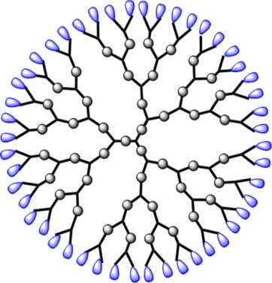
  - Liposomes- they are diminutive, spherical vesicles that contain lipid bilayers surrounding an aqueous inner phase. Typically, these nanoparticles are comprised of cholesterol or phospholipids and are utilized to encapsulate various active drugs. Upon reaching the intended site, they merge with the cell membrane and release the molecules, thus they are useful in targeted drug delivery and cancer treatment (13).
Figure 4: Dendrimers

  - Dendrimers – These are artificial macromolecules with 3D network containing a high number of functional groups measuring 2-20nm. They have 3 layers namely, the inner layer, the molecular core (site for branching), & outer layer. Additionally they has properties such as viscosity, micellar and solubility. That make them useful for drug delivery or gene therapy, they are also used as antibacterial, antifungal, and anticancer agent(15,16).

- Inorganic Type: These nanomaterial’s lack carbon atoms in them. They are classified into metal-based, metal oxide-based and quantum dots.
  - Metallic - These nanoparticles have an ability to combine and form large structures due to large amount of energy on the surfaces. Gold (Au), aluminum (Al), cadmium (Cd), iron (Fe), cobalt (Co), zinc (Zn), copper (Cu), lead (Pb), & silver (Ag), these Metallic substances are commonly employed in the synthesis of nanoparticles. Metal nanoparticles have excellent UV sensitivity, thermal, electrical, catalytic, and antibacterial properties. Metallic nanoparticles are of 4 type’s metallic Nano platelets, metallic nanowires, metallic nanoparticles, and metallic nanostructures (14).
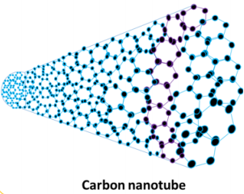
  - Quantum Dots – QDs are minute crystals of nanoscale, which act as an electron transporter, QDs emit light in a multitude of colors with a significantly high level of energy under UV light exposure. These QDs are useful for fluorescent biological labels (17, 18).
Figure 6: Carbon nanotubes
  - Metal Oxides – They are composed of negative oxygen ions and positive metallic ions. E.g. Aluminum oxide (Al2O3), Silicon dioxide (SiO2), Titanium oxide (TiO2) etc. which are used in electro-analysis for biomolecules detection (14).

- Carbon based: They are extensive family of carbon allotropes, which consist of 0D fullerenes, 1D carbon nanotubes (CNTs), 2D Graphene, and 3D Nanodiamonds & Nano horns.
  - Nanotubes – Carbon nanotubes are hexagonal shaped arrangements of carbon atom made of single/ or double wall carbon that are rolled into long tubes. They have broad range of durability, thermal conductivity, electrical and lightweight properties. They are further categorized as single walled nanotubes (SWNTs), and multi walled nanotubes (MWNTs).they can be used in electronic nanodevices, hydrogen storage, biosensors, and touch screens etc. (19,21)
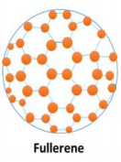
  - Fullerene – It is an The allotrope belonging to the carbon family belonging to Buckminsterfullerene family. Fullerenes are utilized in various chemical applications for successful drug delivery where drug molecules get entrapped in the fullerene mesh due to their mesh-like structure. Fullerene comprises interconnected carbon atoms bonded by single or double bonds (19,20)
Figure 7: Fullerene

NANOROBOTS
Tiny machines used to cure or diagnose a disease in humans or in any organism. They perform a task at a Nanoscale (10-9).
Design and working (22)
The various components in nanorobots include:
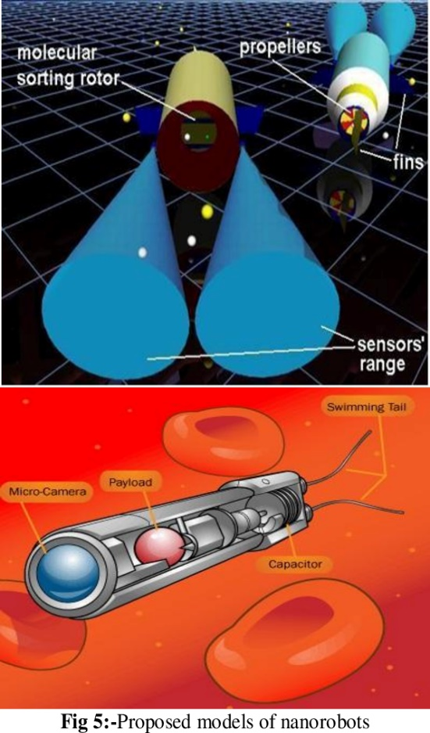
Molecular sorting motor – This is a type of nanomechanical device that exhibits the ability to selectively bind and release molecules from solutions, as well as transport these molecules against significant concentration gradients. The device is composed of carbon nanotubes
Figure 8: Molecular Sorting motor, Propellers and fins of Nanorobots
Propellers – It is employed to propel forward against the flow of blood
Fins – The device is equipped with propellers and its a surface that serves the purpose of providing stability, generating lift and thrust, or facilitating steering while in motion through water, air, or other fluid media.
Sensors – It is fitted internally & externally with nanorobot to obtain the directional movement signal. They are also called as detectors it’s a device that quantifies a physical parameter and transforms it into a signal that can be interpreted by an observer or electronic equipment
Figure 9: Nanorobots payload unit and micro camera
Payload – Is the void section that holds a small dosage of medication or drug that is utilized to traverse the bloodstream and deliver the medication to the site of infection or injury.
Micro camera – It is a miniature camera that serves as a means to operate and direct the nanorobot during manual navigation within the body
Electrodes – The electrodes function as a battery by utilizing the electrolytes present in the bloodstream. Additionally, its capable of eradicating cancer cells through the generation of an electric current, which results in the heating and subsequent destruction of the malignant cells.
Lasers – It’s used to destroy the harmful materials like, blood clots, arterial plaque or cancer cells.
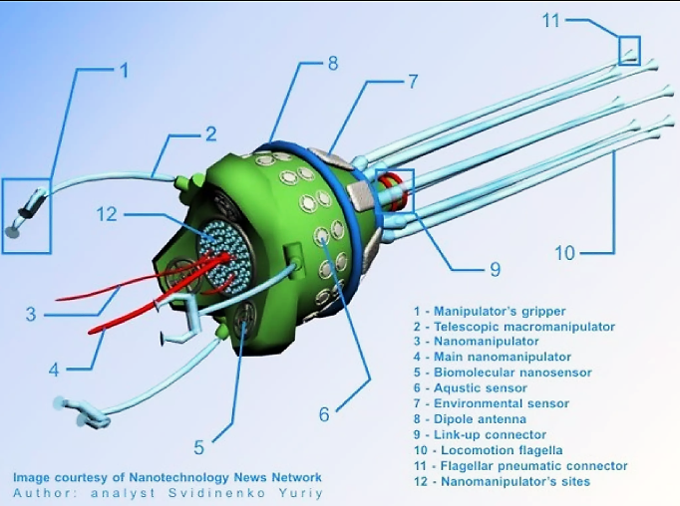
Ultrasonic signal generators – The nanorobots employ these generators to selectively target and eliminate renal calculi
Figure 10: Components of Nanorobots
Swimming Tail – It provides a means for propulsion for the nanorobot to get inside the body as they travel against blood flow..
Powering and Navigation of Nanorobots
Nanotechnology uses both external and internal power sources. Some nanorobots are designed to use patients body as a medium to generate power, others contain small power source on the surface of the robots itself.
Nanorobots can get the power directly from the bloodstream or create chemical reactions with blood to burn it for energy. Nanorobots can also use patient’s body heat to create power; the power generation is a result of seebeck effect (a phenomenon that arises from the junction of two dissimilar conductors at two distinct temperatures). The metallic conductors exhibit thermocouple behavior, wherein they generate a voltage when their junctions are subjected to different temperatures.
Figure 11: Types of Nanorobots

APPLICATION OF NANOTECHNOLOGY
Nanomedicine finds its application in diverse domains of medicine, including 1) Diagnostic, 2) Therapeutic, 3) Immunization, and Vaccine Production.
Figure 12: Application of Nanomedicine in Healthcare
The applications are as follows:
Diagnosis and Treatment of Cancer : These nanorobots contains a chemical biosensors for detection of the tumor cells in early stages of cancer development within a patient‘s body. These sensors search the intensity of E-cadherin signals (23). Different metallic nanoparticles are more sensitive in detecting tumor cells since they can combine with the cancer specific antibodies and penetrates the cancerous cell more easily(19,24). Nanocomposites that contain more than one type of nanoparticle such as platinum, copper, silver, gold and cobalt are more effective in detecting cancer cells. Nanomaterial’s of various kinds have demonstrated encouraging outcomes in clinical scenarios. To deliver anticancer drugs to the specific location in cancer tissues securely and efficiently, nanomaterials are usually linked with anticancer drugs (19).
Removal of Kidney stone: Nanorobots are equipped with ultrasonic signal generators that enable them to precisely target and administer sonic frequencies to the kidney stone, resulting in its destruction23).
Destruction of Blood clot / Removal of Arteriosclerosis: Nano polymers, such as Polyvinyl Alcohol, have the potential to serve as a coating material for implantable devices that come into contact with blood, such as artificial hearts, vascular grafts, and catheters. This coating can be utilized to disperse clots or prevent their formation. Nanorobots can be used to treat conditions like arteriosclerosis by physically chipping away the plaque along artery wall. Lasers/ special blades (activated by continuous or single pulse) present in the Nanobots used to destroy the harmful materials like arterial plaque, blood clots or cancer cells (23).

Tissue repair and replacement/Gene therapy: The advancement of biomimetic scaffolds featuring nanostructures has been shown to augment migration, cellular proliferation, & homing effects through the emulation of the natural bone hierarchy and extracellular matrix. Which promotes regeneration of injured tissues (25,26). Nanoparticle-based targeted labeling technology has enabled rapid assessment of bone quality & identification of early cartilage defects (25, 27). Nanoparticles and extracellular vesicles which is employed as drug delivery vehicles, allow for minimized dosage, increased half-time thereby achieving targeted therapy for various types of osteochondral lesions. (Biocompatible nanomaterial’s increase the adhesion, durability, and life span of implants (25).
Diabetes Monitoring: The Nanorobots contain Nano biosensors to monitor blood glucose levels. These sensors transmit the information through RF Signal to the mobile phones of patients regarding their blood glucose level once every two hours.
Other Applications:
- Drug Delivery: Nano-scale drug delivery systems (nano-DDS) like Metal based nanoparticles (e.g. Gold, Silver, Cd-Se etc.), Lipid based nanoparticles (Liposome & Neosomes), Polymer based Dendrimers, Chitosan and Biological nanoparticles like arginylglcylaspartic acid (RGD) peptides are widely used for the purpose of drug delivery. This are quite stable and helps in controlled and targeted drug release thus reducing side effects and increasing patient safety.
Figure 14: Advantage of Nano-scale drug delivery system
Drug discovery - The utilization of high throughput arrays and ultra-sensitive labeling and detection technologies has been employed to enhance the efficiency and precision of identifying genes and genetic materials that are essential for drug discovery and development.
- Diagnostic/Imaging Application: Super paramagnetic iron oxide nanoparticles for MRI scanning, Magnetic iron oxide nanoparticles is used for detecting Alzheimer’s plaque
- Colloidal gold particles due to their stability are used to rapidly test for pregnancy & HIV.
- Quantum dots, such as nano zinc and cadmium, are semiconductor nanoparticles that have been utilized for the labeling of biological molecules. These nano crystals have found applications in medical diagnostics, high throughput drug screening and targeted therapeutics.
- Nanotechnology in treating and diagnosing infectious disease – Nanobots function similar to WBCs in the body that eliminates the infection within a minute in patient, microbivore nanorobots designed such that antibodies attach to the bacteria the nanorobot is seeking. Modulation of Immune Response by Nanoparticles (NPs) for Efficient Vaccination, The activation of the cell-mediated immune response is a crucial objective in enhancing the effectiveness of therapeutic agents. Nanoparticles (NPs) can serve as a carrier to transport encapsulated vaccines (antigenic proteins) to specific locations and gradually release them over an extended period to enhance the immune response. Nanoparticles (NPs) that have undergone suitable surface modifications possess the capability to interact with biomolecules, including proteins and DNA. The distinctive physical and chemical characteristics of NPs enable precise, swift, sensitive, and cost-effective diagnostics (28-30).
- Thermography: Nanomaterial’s like Nanosized iron oxides, gold coated silica nanoparticles and hafnium oxide nanoparticles are used to generate the heat to destroy cancer cells.

ADVANTAGES & DISADVANTAGES OF NANOTECHNOLOGY
ADVANTAGES | DISADVANTAGES
Improved drug - Enhance the stability, bioavailability, and solubility of drugs. This can result in the administration of lower dosages, thereby mitigating the potential for toxicity and adverse effects. (31) | Nanotoxicity - certain nanoparticles can accumulate within the body and cause harm to organs and tissues(33)
Targeted therapy - nanoparticles engineered to target specific cells or tissues in the body, particularly in cancer therapy. Thus reducing the risk of damage to healthy cells and tissues (32). | Ethical issue - Ethical concerns also surround the use of Nanomedicine, particularly in genetic engineering and enhancement (34)
Precision medicine - enables targeted drug delivery. Thus reducing the risk of side effects and maximizes the therapeutic effect of drug. | Limited Knowledge - We don't know enough about how nanoparticles affect the human body se need to study more to for better understanding of nanomedicine.(35)
Regenerative medicine - deliver growth factors and other regenerative agents to damaged tissues, promoting tissue repair and regeneration. | Regulatory challenges - The implementation of nanomedicine in humans is subject to rigorous regulatory approval, which can hinder the advancement and execution of novel therapies (36)
Early diagnosis - facilitated by nanotechnology based imaging techniques, such MRI, CT scans, | Cost - The development and production of nanoparticles is a costly endeavor

CONCLUSION
Nanomedicine offers numerous advantages in disease diagnosis, prevention and treatment. Nanomedicine possesses the capacity to bring about a significant transformation in the field of medicine and enhance the well-being of patients despite the disadvantages. In order to fully realize Nanomedicine ongoing research and further development are needed.
REFERENCES
- Swain, S.; Sahu, P.K.; Beg, S.; Manohar Babu, S. Nanoparticles for Cancer Targeting: Current and Future Directions. Curr. Drug Deliv. 2016, 13, 1290–1302. [CrossRef]
- Zhang, W.; Lu, Y.; Zang, Y.; Han, J.; Xiong, Q.; Xiong, J. Photodynamic Therapy and Multi-Modality Imaging of Up-Conversion Nanomaterial Doped with AuNPs. Int. J. Mol. Sci. 2022, 23, 1227. [CrossRef]
- Bleeker, E. A., de Jong, W. H., Geertsma, R. E., Groenewold, M., Heugens, E. H., Koers-Jacquemijns, M., et al. (2013). Considerations on the EU definition of a nanomaterial: science to support policy making. Regul. Toxicol. Pharmacol. 65, 119–125. doi: 10.1016/j.yrtph.2012.11.007
- Ossa, D. (2014). Quality Aspects of Nano-Based Medicines SME Workshop: Focuson Quality for Medicines Containing Chemical Entities London. Available onlineat: http://www.ema.europa.eu/docs/en_GB/document_library/Presentation/2014/04/WC500165444.pdf
- Jarvie, H.; Stephen, K.; Dobson, P. Nanoparticle. Encyclopedia Britannica. 2019. Available online: https://www.britannica.com/ science/nanoparticle (accessed on 10 March 2023).
- Chapman, S.; Dobrovolskaia, M.; Farahani, K.; Goodwin, A.; Joshi, A.; Lee, H.; Meade, T.; Pomper, M.; Ptak, K.; Rao, J.; et al Nanoparticles for cancer imaging: The good, the bad, and the promise. Nano Today 2013, 8, 454–460. [CrossRef]
- Baetke, S.C.; Lammers, T.; Kiessling, F. Applications of nanoparticles for diagnosis and therapy of cancer. Br. J. Radiol. 2015, 88, 20150207. [CrossRef]
- K. Blecher, A. Nasir, and A. Friedman, Virulence 2, 395 (2011)
- Feynman, R.P. There’s plenty of room at the bottom. Eng. Sci. 1960, 23, 22–36.
- Taniguchi, N.; Arakawa, C.; Kobayashi, T. On the basic concept of nano-technology. In Proceedings of the International Conference on Production Engineering, Tokyo, Japan, 26–29 August 1974.
- Viseu, Ana. "nanomedicine". Encyclopedia Britannica, 23Sep.2020,https://www.britannica.com/science/nanomedicine. Accessed 22 August 2023
- S. Khan, M. K. Hossain, In Nanoparticle-Based Polymer Composites. Woodhead, London; 2022, 15.
- H. S Y. Khan, S. Z. Ali Shah, M. N. Khan, A. A. Shah, Catalysts 2022, 12, 1386. https://doi.org/10.3390/catal12111386
- X. F. Zhang, Z. G. Liu, W. Shen, S. Gurunathan, Int. J. Mol. Sci. 2016, 17, 1534. https://doi.org/10.3390/ijms17091534
- Dendrimers. Available online: https://www.cd-bioparticles.net/biodegradable-polymers/dendrimers?page=2 (accessed on 1 January 2023).
- Zhang, M.; June, S.M.; Long, T.E. Principles of Step-Growth Polymerization (Polycondensation and Polyaddition). In Polymer Science: A Comprehensive Reference, 10 Volume Set; Elsevier: Amsterdam, The Netherlands, 2012; Volume 5, pp. 7–47. [CrossRef]
- Ren, L.; Wang, L.; Rehberg, M.; Stoeger, T.; Zhang, J.; Chen, S. Applications and Immunological Effects of Quantum Dots on Respiratory System. Front. Immunol. 2022, 12, 5665. [CrossRef] [PubMed]
- Xu, Y.-M.; Tan, H.W.; Zheng, W.; Liang, Z.-L.; Yu, F.-Y.; Wu, D.-D.; Yao, Y.; Zhong, Q.-H.; Yan, R.; Lau, A.T.Y. Cadmium telluride quantum dot-exposed human bronchial epithelial cells: A further study of the cellular response by proteomics. Toxicol. Res. 2019, 8, 994–1001. [CrossRef] [PubMed]
- Alrushaid N, Khan FA, Al-Suhaimi EA, Elaissari A. Nanotechnology in Cancer Diagnosis and Treatment. Pharmaceutics. 2023; 15(3):1025. https://doi.org/10.3390/pharmaceutics15031025
- Javanbakht, S.; Namazi, H. Doxorubicin loaded carboxymethyl cellulose/graphene quantum dot nanocomposite hydrogel films as a potential anticancer drug delivery system. Mater. Sci. Eng. C 2018, 87, 50–59. [CrossRef]
- Amreddy, N.; Ahmed, R.A.; Munshi, A.; Ramesh, R. Tumor-Targeted Dendrimer Nanoparticles for Combinatorial Delivery of siRNA and Chemotherapy for Cancer Treatment. Drug Deliv. Syst. 2019, 2059, 167–189. [CrossRef]
- https://roboticsbiz.com/nanorobots-key-components-and-substructures/
- Cavalcanti A, Shirinzadeh B, Kretly L C. Medical nanorobotics for diabetes control. Nanomedicine: Nanotechnology, Biology and Medicine, 4(2), 2008, 127-138.
- Leja, M.; Line, A. Early detection of gastric cancer beyond endoscopy—New methods. Best Pract. Res. Clin. Gastroenterol. 2021, 50–51, 101731. [CrossRef]
- Qiao, K., Xu, L., Tang, J. et al. The advances in nanomedicine for bone and cartilage repair. J Nanobiotechnol 20, 141 (2022). https://doi.org/10.1186/s12951-022-01342-8 13).
- Lei Y, Xu Z, Ke Q, Yin W, Chen Y, Zhang C, et al. Strontium hydroxyapatite/chitosan nanohybrid scaffolds with enhanced osteoinductivity for bone tissue engineering. Mater Sci Eng C Mater Biol Appl. 2017;72:134–42.
- Surender Esther M, Comby S, Cavanagh BL, Brennan O, Lee TC, Gunnlaugsson T. Two-photon luminescent bone imaging using europium nanoagents. Chem. 2016;1(3):438–55.
- Qasim M, Lim DJ, Park H, Na D. Nanotechnology for diagnosis and treatment of infectious diseases. J Nanosci Nanotechnol. 2014 Oct;14(10):7374-87. doi: 10.1166/jnn.2014.9578. PMID: 25942798.
- N. L. Rosi and C. A. Mirkin, Chem. Rev. 105, 1547 (2005).
- . F. E. Andre, R. Booy, H. L. Bock, J. Clemens, S. K. Datta, T. J. John, B. W. Lee, S. Lolekha, H. Peltola, T. A. Ruff, M. Santosham, and H. J. Schmitt, Bull. World Health Organ. 86, 140 (2008).
- Hemphill A, Müller N, Müller J. Comparative pathobiology of the intestinal protozoan parasites Giardia lamblia, Entamoeba histolytica, and Cryptosporidium parvum. Pathogens. 2019;8(3):116.
- Khan W, Rahman H, Rafiq N, Kabir M, Ahmed MS, Escalante PD. Risk factors associated with intestinal pathogenic parasites in schoolchildren. Saudi J Biol Sci. 2022;29(4):2782-2786.
- Opara KN, Udoidung NI, Opara DC, Okon OE, Edosomwan EU, Udoh AJ, et al. The impact of intestinal parasitic infections on the nutritional status of rural and urban school-aged children in Nigeria. Int J MCH AIDS. 2012;1(1):73.
- Pfuhler S, Elespuru R, Aardema MJ, Doak SH, Maria Donner E, et al. Genotoxicity of nanomaterials: refining strategies and tests for hazard identification. Environ Mol Mutagen. 2013; 54(4):229-239.
- Levecke B, Montresor A, Albonico M, Ame SM, Behnke JM, Bethony JM, et al. Assessment of anthelmintic efficacy of mebendazole in school children in six countries where soil-transmitted helminths are endemic. PLoS Negl Trop Dis. 2014; 8(10):e3204.
- Elespuru R, Pfuhler S, Aardema MJ, Chen T, Doak SH, et al. Genotoxicity Assessment of Nanomaterials: Recommendations on Best Practices, Assays, and Methods. Toxicol Sci. 2018; 164(2):391-416.

