COMPARATIVE ANALYSIS OF METHYLENE BLUE AND GIEMSA STAINS TO STUDY THE BARR BODY FROM BUCCAL EPITHELIAL CELLS IN FORENSIC FACET
Vaishnavi Katakwar ¹, Archana Mahakalkar ² , Virendra Shende ³
1,2,3 Department of Forensic Biology ,Government Institute of Forensic Science, Nagpur, Maharashtra, India.
Correspondence Author and Address: Dr. Archana Mahakalkar, archanasap79@gmail.com

ABSTRACT:

In Forensic Science, determining sexual identity is critical. There are various methods for determining sex or gender identification. This can be accomplished by identifying "Barr Body" in various body tissues and cells that are only seen in females. Along with Barr Body identification, there are various other ways of sex determination that are costly and time intensive, such as PCR, Karyotyping, AMEL identification, and so on. Barr Body Identification is a simple, quick, and low-cost procedure that produces better results. The Present study's objectives are to examine the effective stain for determining Barr Bodies from buccal epithelial cells; to determine the existence of Barr Bodies in Males and Females; and to determine the significance of Barr Bodies in the identification of sex of an individual in Forensic Science. In this study, two Buccal smears were obtained from each of 120 college students (60 males and 60 females) and stained with Giemsa and Methylene Blue and observed under a digital compound microscope. T-test was used for statistical analysis to compare the existence of Barr bodies in two stains. P0.05 was the statistical significance. Giemsa stain was shown to be more efficient than Methylene Blue in determining Barr Bodies from buccal epithelial cells. Barr bodies in buccal epithelial smears were shown to be the easiest way for determining sex, with an accuracy of 93.33-95.88%.
Keywords: Barr Body, Sex determination, buccal epithelial, Sex chromatin, Giemsa stain, Methylene Blue stain, Forensic Significance, etc.
INTRODUCTION:
Barr Body is an inactive single X-chromosome found in the nuclei of most female somatic cells, and its presence is often used to perform sex determination tests in the identification of an individual in the Forensic Science [1]. The phenomenon of Barr Body was first described in nerve cells of female cats by Dr. Murray Barr and Ewart Bertram in 1949 [2]. Barr Bodies are small, well-defined bodies that stain strongly with nuclear dyes such as, haematoxylin and eosin (H and E), thionine, Papanicolaou, Feulgen, Cresyl-violet, Giemsa, aceto-orcein, and fluorescent stains such as acridine orange [3]. It is found in a high proportion in female nuclei but is absent in male nuclei. A Barr body is approximately 1µ in diameter. The average size has been estimated to be 0.7 × 1.2 µ in buccal mucosa nuclei and sections of several human tissues. Barr bodies are most commonly found on the nucleus periphery. However, a small number of Barr bodies are found in other parts of the nucleus, and many of these are located near a nucleolus [4].
The X-inactivation method was discovered by Mary F. Lyon, a British geneticist. According to the Lyon hypothesis, during early embryonic life one of the X chromosome is inactivated and other remains activated in each somatic cell of female. X-inactivation results in clumped chromatin known as Barr bodies, which are generally thought to be inactive. Lyonization describes the formation of Barr bodies [5]. The hypothesis's key elements were first, that each cell of a female mammal had only one active X chromosome and that the observed hetero-pyknotic X was the inactive one; second, that this inactivation occurred in early embryonic life; and third, that the inactivated X of a particular cell could be of either maternal or paternal origin, and that this was determined at random. All descendants of a specific cell line would reflect the parent cell's inactivation, resulting in mosaic females in terms of X chromosome constitution, corresponding to the observed varied phenotype [6]. Sex identification can be done by the study of X and Y chromosomes in the cells which are not going through active division. Buccal smears, skin biopsy, blood, ligament, hair root sheath and tooth pulp can be use to validate presence or absence Barr bodies. [7]
Forensic Significance of Barr Bodies:
The determination of a person's gender is an important aspect in forensic science. Gender determination methods have included the use of craniofacial morphology, tooth dimensions, and DNA analysis. Blood, sperm, hair, buccal epithelial cells, pulp fibroblasts, cervical cells, skin, and saliva stains found in various parts of the body or on harmful weapons at crime scenes and disaster sites can also be used to identify gender. Gender can be validated using cytological techniques such as polymerase chain reaction (PCR), karyotyping, fluorescent body (Y chromatin), Davidson body in polymorphonuclear leukocytes, AMEL identification, and Barr bodies (X chromatin). However, PCR and karyotyping are prohibitively expensive and cannot be used. As a result, Barr body demonstration for gender determination using exfoliative cytology is considered as one of the simplest and easiest methods [3].
Barr body is a facultative heterochromatic body that appears as a dark-staining, peripheral nuclear structure in the somatic cell nucleus of normal females during interphase but is absent in males. The distribution of Barr body in a single cell when there is more than one X chromosome in the chromosomal structure can be understood using the Lyon inactivation hypothesis. The analysis of Barr bodies in cell nuclei from readily available tissues such as buccal mucosa, hair root, and blood cells allows for a preliminary description of an individual's sex chromosome status, hermaphroditism, gonadal, and some complicated anomalies, whereas the use of amniotic fluid aids in a prenatal sex diagnosis [3].

MATERIALS AND METHODOLOGY:

An experiment-based study was conducted in the month of March, 2022 after getting approval from Institute’s Ethical Committee. Oral Buccal Smear samples were collected from 120 college students of age range between 18-25. Among them 60 were males and 60 were females.
Sample Collection:

Subjects were first asked to rinse their mouth with mouth wash and then with normal drinking water. After washing mouth, two oral buccal smear samples were collected using sterile tooth-pick by scraping the buccal mucosa of the subject with a tooth-pick on glass slide containing 1-drop of distilled water (Figure 1). These samples were allowed to air-dried at room temperature for 1-2 minutes. All the samples were collected from the subjects with their written consent.
Sample Preparation:
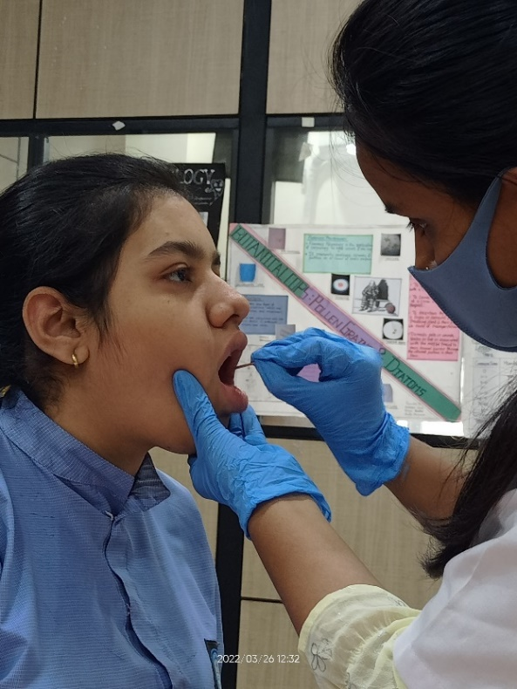
One of the samples from 2 samples, was stained with working solution of Giemsa Stain and other stained with Methylene Blue. Both the stained samples were allowed to air-dried at room temperature for 10-15 minutes. After drying, sample stained with Giemsa was directly observed unde
Figure 1: Sample collection

compound microscope. While sample stained with Methylene blue was washed under running water and then covered with coverslip and observed under compound microscope. All the 240 samples slide was observed under Cilika BT-E Benchtop Biological Digital Microscope.
Inclusion Criteria: The study included cell in which the Barr body was attached to a nucleolus by a thin chromatin thread near nuclear membrane. At the nuclear membrane, the Barr body can have many configurations, such as flattened, convex.
Exclusion Criteria: The study excluded degenerating, folded, and overlapping nuclei. Barr bodies can also be seen near the nucleus's centre; however, they cannot be separated from nucleoli were eliminated. Folded cells with the cell membrane covering the nucleus and Extruded nuclei from the cell were not taken into consideration.
Statistical Analysis: Statistical t-test was done for comparing the difference between presence of Barr bodies in two stains using the calculated mean and standard deviation. The statistical significance was calculated P<0.0001.
RESULT:
The prepared sample slides were analysed with both the stains, Giemsa and Methylene Blue. In the male samples, Barr body positive cells were absent in both the Giemsa and Methylene Blue stain (Table 1). Figure 2 and figure 3, shows the presence of Barr body positive cells in females with both Giemsa and Methylene Blue stain respectively. The percentage of Barr body positive cells in males was found to be 0% while in females, the percentage of Barr body positive cells were 91.66% and 86.66% in both Giemsa and Methylene Blue stain respectively (Graph 1). For the statistical analysis, mean and standard deviation was calculated for the Barr body positive cells in Giemsa and Methylene Blue stained sample slides of females. T-test was applied to compare the variance between Giemsa and Methylene Blue stain. The p-value was found to be less than 0.0001. By conventional criteria, this difference was considered to be statistically significant (Table 2). The sensitivity of Giemsa was 100% and the specificity was 92.30% and, the overall accuracy for Giemsa stain was found to be 95.83%. For Methylene Blue, the sensitivity, the specificity and the accuracy were found to be 100%, 88.24% and 93.33% respectively. The sex determination efficacy was found considerably better with Giemsa than Methylene Blue (Table 3).

Table 1: Total no. of Barr bodies observed in both stains
Groups | No. of Individuals | Total no. of Barr Bodies in two stains
 |  | Giemsa Stain | Methylene Blue Stain
Females | 60 | 55 | 52
Males | 60 | 0 | 0

Table 2: Result of t-test statistics
Stains | Group | Mean | Standard Deviation | Standard error of mean. | P – Value
Giemsa | Female | 5.42 | 3.82 | 0.35 | P<0.0001
Methylene Blue | Female | 2.72 | 2.53 | 0.20
P value <0.0001 which is statistically significant

Table 3: Sensitivity, Specificity and Accuracy of Giemsa and Methylene Blue for Sex determination
 | Giemsa | Methylene Blue
Sensitivity | 100% | 100%
Specificity | 92.3% | 88.24%
Accuracy | 95.83% | 93.33%

Graph 1: Percentage of Barr Bodies in Males & Females
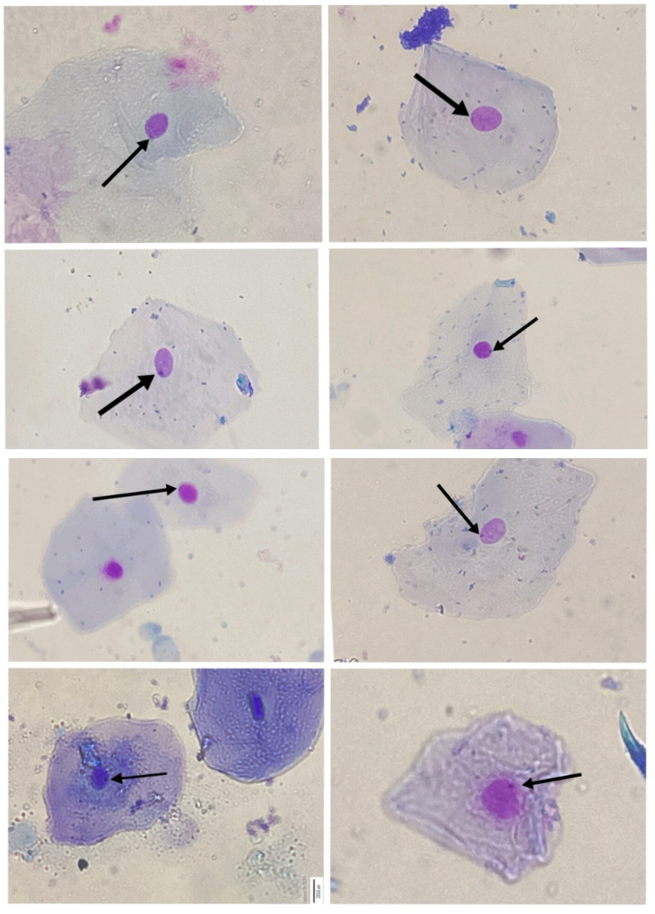
Figure 2: Barr bodies in Giemsa staining
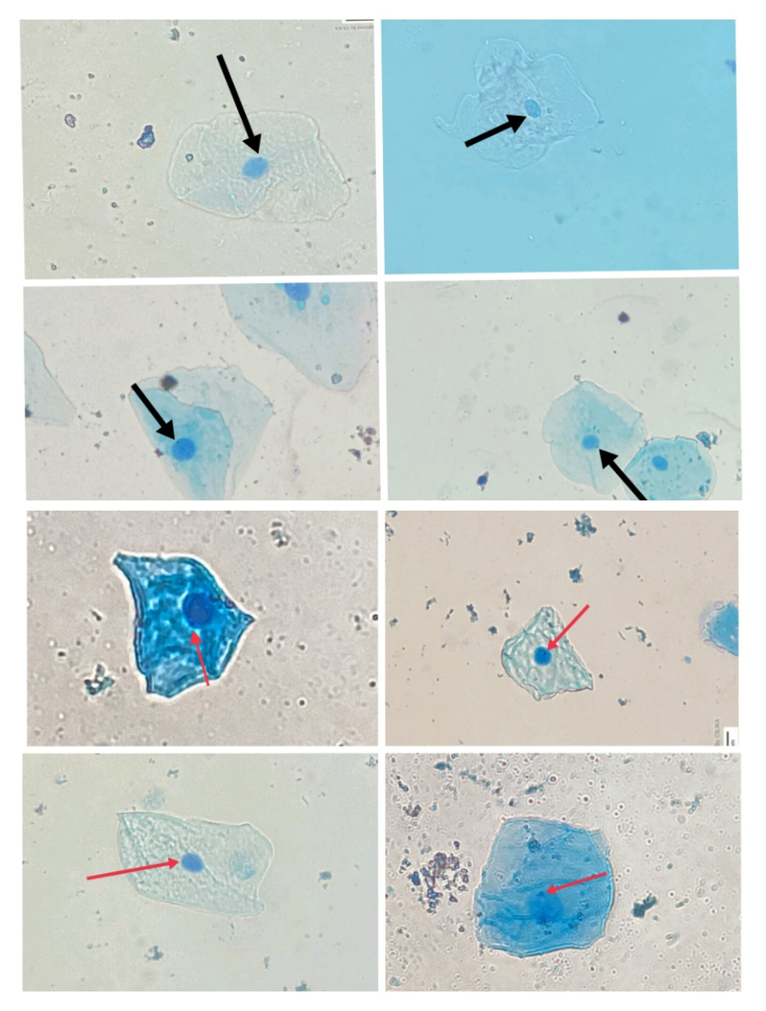
Figure 3: Barr bodies in Methylene Blue staining
DISCUSSION:
In Forensic Science personal identification of both living and dead plays an important role. Sex or gender determination is an important aspect in individualization. There are various biological materials such as blood, semen, saliva, buccal epithelial cells, etc. that can serve as a means of sex determination. Sex determination from buccal epithelial cells is one the easiest and quick method. In this method, presence of Barr body is used to identify the sex of an individual.
In 1949, Barr and Bertram first discovered the concept of Barr Bodies. They found presence of Barr body which was distinct from nucleolus of the nucleus of neuron cells of female cat. In their study they found that nerve cells of mature female cats contained a well-developed nucleolar satellite which was located adjacent to the nucleolus and was much deeply stained than nucleolus. While the nerve cells of mature male cats contained a poorly developed nucleolar satellite infrequently [2]
Barr body detection was launched for the 1968 Olympics and was largely welcomed as the solution to gender misrepresentation in sports. The cytological assessment of buccal smear was reported as easiest, rapid and dignified test [8].
Giemsa and Methylene Blue Preparations can be made with extreme ease and buccal smears were stained rapidly within minutes. Dark stained Barr body’s appearance confirms the sex determination. In present study, the sensitivity of Giemsa was 100% and the specificity was 92.30%. the overall accuracy for Giemsa stain was found to be 95.83%. For Methylene Blue, the sensitivity, the specificity and the accuracy were found to be 100%, 88.24% and 93.33% respectively. The efficacy of Giemsa was better than Methylene Blue in our study. The same result was seen in the study of Htun et al. 2017, where the sensitivity was 96% and a specificity was100 % for Giemsa. Giemsa's overall accuracy was 98%. The sensitivity, specificity, and accuracy of Methylene Blue were all 92%, 96% and 94%, respectively. Both male and female gender identification efficacy was significantly better with Giemsa than Methylene Blue [9].
Present study shows, the identification of Barr bodies in males was negative whereas in females the identification of Barr bodies was positive, which was found to be similar with the study of Talari et al. 2017 [3].
The chromosomal changes in disorders like Klinefelter's syndrome 47 chromosomes (XXY), 48 chromosomes (XXXY), 49 chromosomes (XXXXY) in males and triple-X (XXXXY) in females are the method's limitations. Males with Klinefelter's syndrome have varying quantities of Barr bodies in their nuclei, resulting in a false positive result. In the nuclei of triple-X females, there are two Barr bodies, but in normal females, there is only one Barr body. When two Barr bodies are present, it might be difficult to tell the difference between a triple-X female and a variation of Klinefelter's syndrome XXXY [10].
In present study, absence of Barr body was observed in males with both the Giemsa and Methylene Blue stain. Whereas, in Females presence of Barr bodies were observed in both the Giemsa and Methylene Blue stain with 91.66% and 86.66% respectively. The efficacy and accuracy with Giemsa stain was found to be better than Methylene Blue stain in sex determination using Barr body.
CONCLUSION:
Sex determination is an integral part in individualisation in the Forensic Science. DNA analysis is the most accurate and time-consuming method for sex determination. But Barr bodies analysis for sex determination is the simplest, cheapest and rapid method one can employ. Sex determination using Barr bodies in Buccal epithelial smears is the easiest method providing 93.33-95.88% accuracy.
Present study shows that Giemsa and Methylene blue can also be used in analysis of Barr bodies in sex determination. The present study shows that the efficacy of Giemsa stain is better than Methylene Blue in sex determination. For the future research it is recommended that the study should be carried out on large scales using some other stains along with Giemsa and Methylene blue for better assessment of sex determination using Barr body.

[1] | Biswas G. Review of Forensic Medicine and Forensic Toxicology: 2015; 3:59.
[2] | Bertram E., Barr M. A Morphological Distinction between Neurones of the Male and Female, and the Behaviour of the Nucleolar Satellite during Accelerated Nucleoprotein Synthesis. Nature:1949;163:676-677.
[3] | Talari A. Bashamalla R. Rao V. G.Taneeru S.Yeluri S.Madala J. K. Cytological assessment of Barr body in buccal scrapes: A comparative study," Pierre Fauchard Academy: 2017; 31: 9-13.
[4] | Mittwoch U. SEX CHROMATIN, Medical Genetics :1967;1: 50-76.
[5] | Lyon M. Lyon hypothesis. Nature 1961;190: 372-373.
[6] | Harper P. S. Mary Lyon and the hypothesis of random X chromosome inactivation. Human Genetics; 2011: 130: 169-174.
[7] | Bhoyar L.Z. Mahakalkar A. L. A forensic review on sex determination methods for teeth, Int. J. of Life Sciencess; 2021: 45-54.
[8] | Ritchie R., Reynard J. Lewis T. Intersex and the Olympic Games, Royal Society of Medicine. 2008;101: 395-399.
[9] | Htun K. S., Naing T.Ye L. A.Thein Z. Gender Determination from Barr bodies using Giemsa and Methylene Blue Stains in buccal mucosal smears. 2017
[10] | Sahana A.Ashok K. P.(): Aceto-Orcein Squash technique for Barr bodies detection. RGUHS; 2017; 9:15-22.

References:

