An array of Spiral Patch Antenna For WLAN, WiMAX And Wi-Fi Application

Antara Ghosal¹, Anurima Majumdar², Avali Ghosh³, Sisir Kumar Das, Annapurna Das
Guru Nanak Institute of Technology
^{1,2,3} Department of Electronics and Communication Engineering, Guru Nanak Institute of Technology, Kolkata, India
¹antara.ghosal@gnit.ac.in

Abstract
In this chapter a microstrip patch antenna with array of spiral slots is analyzed. The slotted patch antenna can be used for WLAN, WiMAX, Wi-Fi, S-band application. The antenna is fed by a coaxial probe. The work comprises of two structures. First two square spiral patch antenna is introduced with tuning arms. Secondly, these slotted spiral patches are used as an array element for the final structure. There are four array elements on the final structure. The antenna is modeled and simulated using Ansoft HFSS Simulator software. The parametric study like the reflection coefficient, radiation pattern, gain and current distribution of the proposed structure is obtained. The simulated and experimental results are in good agreement with each other. Experimental results are obtained using Network Analyzer.
Keywords: Microstrip antenna, coaxial probe, multiband antenna.

Introduction

Due to the high demand for the design of antennas which can be used over multiple bands due to their properties are wireless communication systems. For the application of WLAN, WiMAX and WiFi standards microstrip antennas are preferred. Microstrip antennas are preferable for their compact size, light weight, low profile, and low fabrication cost. Due to the low profile design of patch antenna, there is a huge scope to be used for WLAN, WiMAX and WiFi application. These lead to design of multiband and wideband antennas for LTE, GSM frequency band (850, 900, 1800, 1900, 2100 MHz), WLAN standard (2.4-2.48, 5.15-5.35, 5.72-5.85, 5.49-6.45 GHz), WiMAX standard (2.5-2.69, 3.4-3.69, 5.25-5.85 GHz), Wi-Fi (2.4-2.485, 5.15-5.85 GHz), Bluetooth (2.4-2.5 GHz). Also, for X-band (8-12 GHz) , L-band (1-2 GHz) and S-band (2-4 GHz) wireless applications, multiband with broadband characteristics of microstrip antennas are in high demand with good performances. The main objective of this chapter is to design an antenna which can be used for different communication standards.
In this chapter, a patch antenna with array of square spiral is developed to support WLAN (5.49-6.45 GHz), WiMAX (3.3-3.7 GHz), WiFi (5.15-5.85 GHz) and S-band (2-4 GHz) application. The proposed antenna consists of an array four square spirals with coaxial probe fed. Initially, a square spiral patch antenna is modeled which is capable of operating at triple frequencies. To increase the number of operating frequencies and gain, array of spiral square slots are considered. The performance of the single square spiral patch and a patch antenna with array four square spirals are compared. Ansoft HFSS software is used for simulation of the proposed structure.

Literature Survey
C. A. Balanis, et all [1] discussed the basics of microstrip patch antenna. The design procedure of rectangular and cicular patch antenna and their different parameters are discussed here. R. Garg, et all [2] discussed designing of any types of microstrip antennas here. Different types current techniques for broadbanding, polarization, multiband, high bandwidth of micrstrip antennas has been discussed here in details. Sisir K Das, et all [3] proposed here the design parameters of a basic rectangular and circular microstrip antenna and different measurement techniques. Also, the formulation of different antenna parameters has been discussed here. K. L. Wong, [4] discussed dfiierent types of multifrequency, multiband, boadband microstrip antennas. Different types of techniques are proposed here to obtain the multi frequency response and bandwidth enhancement process. J.T Bernhard, et all [5] proposed a single arm square spiral patch antenna with two tuning arms. The antenna can operate at dual frequencies and is suitable for portable communication device and phased arrays application. P. Rajalakshmi, et all [6] presented a microstrip antenna with octagonal slot on patch a Modified Hexagonal Complementary Spiral Resonator (MHCSR) loaded at bottom of the substrate. The antenna can be used for triple band operations. There are many authors, who have described the methods of calculation of input impedance of a rectangular patch. Vishal Asnani, et all [7] proposed a compact I-shaped microstrip antenna with rectangular slot on patch. Symmetrical parasitical elements on ground plane and an extended microstrip line is there for better performance. This extended feed line and the slot on the patch is responsible for bandwidth enhancement. Sajeela Bibi, et all [8] proposed a bi-layered microstrip antenna for dual band operation. A partial reflecting surface is used under the antenna layer to increase the gain and bandwidth. This type of antenna can be used for high gain Machine to Machine communication. Izzat Fatima, et all [9] proposed a triple band circularly polarized antenna with rectangular strips on patch and slots on the ground plane. The antenna can operate at triple frequency with wideband properties. Jangampally Rajeshwar Goud, et all [10] presented a microstrip antenna with U-slot for uplink and downlink communication. This antenna can operate at triple band and can be used to cover GSM and LTE bands. This antenna can be used as MIMO antenna. C Rajshri, et all [11] described an wineglass shaped CPW fed wideband microstrip antenna is described having DGS with woodpile structure. This antenna produces three resonant frequencies with maximum present bandwidth of 3 GHz. Uma Shankar Modani, et all [12] proposed a literature survey on multifrequency antenna. Different types of techniques are used for multiband operation like insertion of slots on patches. Also, different types of patch shapes, multiple stacked patches, multiple or parasitic patches are used for multifrequency or multiband operation. S. Murugan, et all [13] proposed a microstrip patch antenna for wireless application. Here an elliptical patch with coaxial probe as feed point is considered. The antenna can operate at triple frequencies.

Antenna Design

A rectangular patch is designed using cavity model [1-3]. A s the substrate is very thin, the field of the interior region does not vary with z. Here the resonant mode is TM_{mn} and the field components are Ez, Hx and Hy, where m= 0,1,2,… and n=0,1,2,…. The resonance frequency of this modes are expressed by
(1)
For L>W, the lowest order resonant frequency for TM₁₀ mode (m=1. n=0) is
(2)
For W>L, the lowest order resonant frequency for TM₀₁ mode (m-0, n=1) is
(3)
For a square patch L=W is considered for same resonance frequency.
First a square patch is designed using a coaxial probe feed. The patch is designed for resonance frequency of 2.1 GHz. For the design, both width (W) and length (L) are chosen as 37 mm. Glass epoxy is chosen as dielectric substrate. The height of the substrate is 1.6 mm.
In this chapter, next, this square patch is modified with some slots. After introducing slots on this square patch the spiral structure is formed. This spiral structure can operate at multiple frequencies by adding some tuning elements. First a simple spiral structure is designed which can operate at dual frequency. The width of the slots is taken as 3 mm. After that two adjacent arms are added along x-axis in inner arms as tuning elements to obtain triple frequency operation. This structure is shown in Fig. 1 (a). Then two more tuning elements are added at outer arms according to x-axis. This model and hardware is shown in Fig 1 (b). Therefore, the antenna with symmetrical tuning elements at the outermost arms of the spiral once produces triple frequency response and from another side if two more tuning arms are added then the same antenna can be used for wideband operation. The area of the square patch is kept same but the total metal of the patch is reduced by introducing slots. Ansoft HFSS is used for modeling and simulation, where these tuning elements which are capacitively coupled between successive spiral arms are used for multi-frequency operation as well as wideband operation.
After that this model is used as the array element of the final slotted structure. Coaxial probe is used as feed. The probe position is same at (0,0,0). Ansoft HFSS simulator software is used for modeling and simulation for the structure as shown in Figure 1 and Figure 2. Here capacitavley coupled tuning elements between successive spirals arms are used for multifrequency operation.
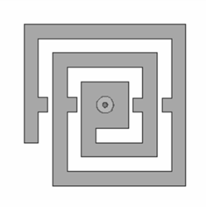
(a) (b)
Figure 1 Square Spiral
(a) Tuning arm at the outermost spiral arm (b) tuning arm at outer and inner spiral arm

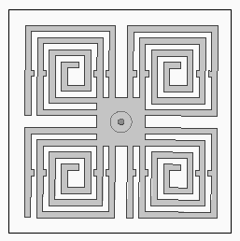
Figure 2 Proposed antenna with array of square spiral
The design parameters are W=L= 33.7 mm, h=1.6 mm, and substrate permittivity (εr) = 4.4. The coaxial probe position is optimized at (0, 0, 0) for best impedance matching with 50 ohm. FR4_epoxy is used as substrate of the patch antenna. At first, two symmetrical tuning arms are added at the outermost spiral arms which are shown in Figure 1 (a). This antenna produces three distinct resonant frequencies. Next, two more tuning arms are added in the inner arms which is shown in Figure 1 (b). This structure can be used for wideband operation. Finally, this structure is used as an array element of the proposed patch antenna which is shown in Figure 2. This proposed antenna can operate at six frequencies. For the proposed antenna W=L=33.7 mm, h=1.6 mm. Here the slot width is 1 mm. The square spiral is created on the patch following the same manner as of the Figure 1 (b). Also tuning arms are there.

Simulation results
For Figure 1 (a) triple frequency response is obtained at 1.58 GHz, 2.02 GHz, and 2.47 GHz with reflection coefficient <-15 dB. But for Figure 1 (b), the wide bandwidth is achieved at 1.9 GHz with 26 % bandwidth. The simulated and measured results are shown in Figure 3(a) and Figure 3(b). The figure 3 shows the simulated and measured result of reflection coefficient of the proposed antenna of Figure 1(a) and (b). From this response it is observed that this modified structure can operate at single frequency of 1.9 GHz with reflection coefficient of -18.03 dB and wide bandwidth. The bandwidth of 26.3% is obtained at 10 dB return loss (1.7-2.2 GHz). These measured and simulated responses of this structure are also in good agreement.

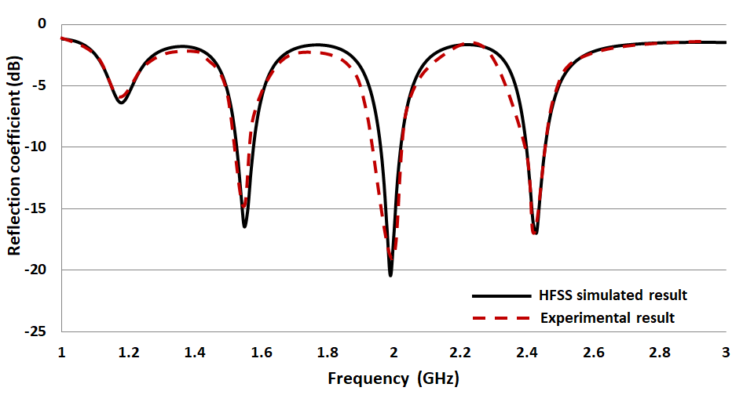
(a)
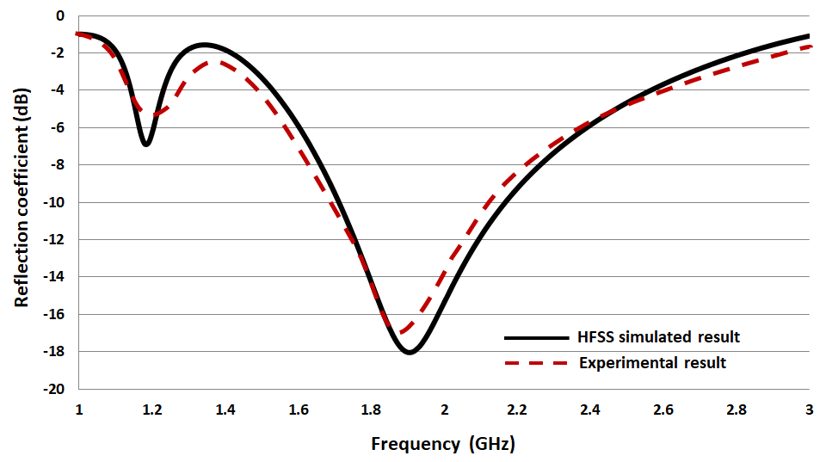
(b)
Figure 3 Simulated and Measured Reflection-coefficient (S11) vs. Frequency (dB) responses
(a) S₁₁ for the design of Figure 1(a) (b) S₁₁ for the design of Figure 1 (b)

From the above design of proposed antenna shown in Figure 2, multi frequency response is obtained at 2.79 GHz, 3.03 GHz, 3.7 GHz, 3.97 GHz, 5.37 GHz, and 6.17 GHz with reflection coefficient of -20 dB, 14.3 dB, 30.9 dB, 16.7 dB, 15.9 dB, and -31 dB respectively which is shown in Figure 4. Simulated and measured results are found in good agreement.

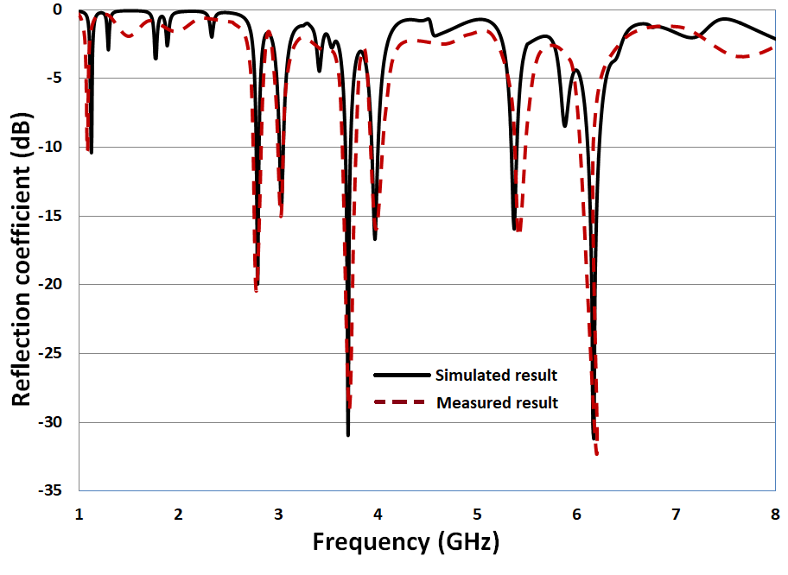

Figure 4 Reflection coefficients (dB) vs. Frequency (GHz) response of proposed antenna of Figure 2

To know the significance of the proposed hexa band antenna, a comparative study is carried out and is described in Table 1. It is observed that these proposed structures have the advantage over the other antenna in rspect to the model. Using the array of spiral structures, changes the peformance of the antenna.

Table 1: Comparisons of proposed work and previously reported work

Reference | Size (mm.) | Operable frequencies (GHz) | Reflection coefficient:S11(dB) | Substrate | Application
[6] | 18*22 | 0.9  2.4  5 | -15  -18  -14 | FR_4 epoxy | Wi-Fi, WLAN application
[5] | 24*27 | 2.8  3.03 | -10  -14 | RT Duroid | Portable communication devices
[8] | 35.5*40 | 3.5  5 | -21  -23 | RT Duroid | WiMAX, WLAN
Proposed Antenna | 33.7*33.7 | 2.79  3.03  3.7  3.97  5.37  6.17 | -20  14.3  30.9  16.7  15.9  -31 | FR_4 epoxy | UMTS, S-band wireless application,WiMAX standard, Wi-Fi, WLAN standard

The radiation pattern of the final configuration is shown in Figure 4. The radiation pattern is obtained at six frequencies. Out of six frequencies, the radiation patterns of three frequencies are shown in Figure 4. The simulated and measured radiation patterns are obtained in xz-plane (ϕ=0º) and yz-plane (ϕ=90º) at 2.79 GHz, 3.7 GHz, and 6.17 GHz. From the radiation pattern it can be observed that the antenna gives unidirectional radiation patter. Also it can be observed that there is a good agreement between simulated and measured result.
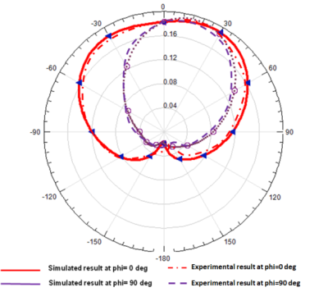
(a)
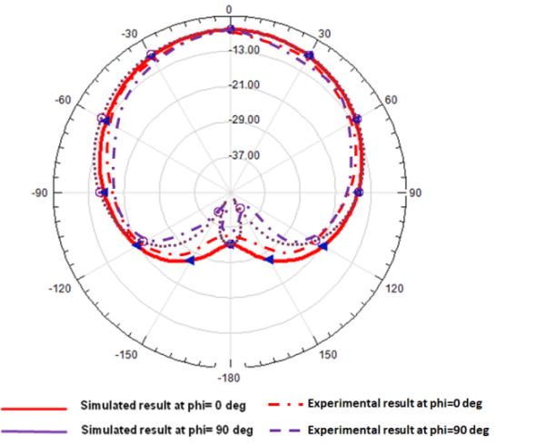
(b)
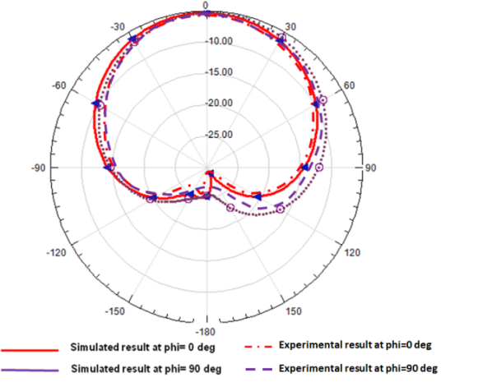
(c)

Figure 4 Radiation Pattern of the proposed Antenna at (a) 2.79 GHz, (b) 3.7 GHz, and (c) 6.17 GHz

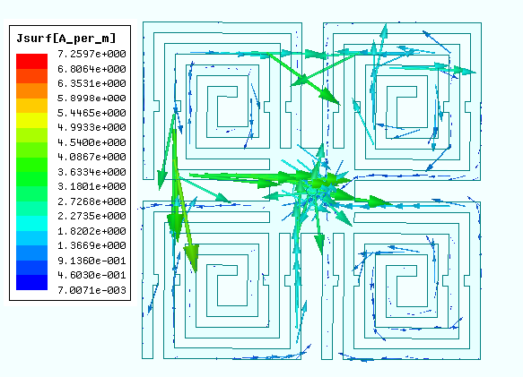
Figure 5 Surface current distributions

The current distribution is shown in Figure 5. From the current distribution it can be observed that current flow is maximum at the center around the coaxial probe. Also there is a large amount of current flow is observed at left side and upper side of the patch. As we can see from figure 5 as the current flows towards the centre the current intensity is higher. The bandwidth is hence increased. If the slot with or the intermediate space is modified the current distribution and path flow will also be modified resulting in increased or decreased bandwidth.

CONCLUSION
From the test results and from the simulation and the modeling of the hardware of the proposed antenna, a good impedance matching is observed near the frequencies 12.79 GHz, 3.03 GHz, 3.7 GHz, 3.97 GHz, 5.37 GHz, and 6.17 GHz. The reflection coefficient and radiation patterns which are obtained, suggest that this single configuration can be used for multiband operation in wireless communication systems.

Acknowledgment
Author acknowledge Guru Nanak Institute of Technology for experimental support

References
- C. A. Balanis, Antenna Theory - Analysis and Design (2nd Edition).
- R. Garg, P, Bhartia, I. Bahl, A. Ittipiboon.Microstrip Antenna Design Handbook.
- Antenna and Wave Propagation, First Edition, Sisir K Das and Annapurna Das, Tata-McGraw-Hill Education Pvt. Ltd., 2013.
- K. L. Wong “Compact and Broadband Microstrip Antennas” New York: J. WileyAnd Sons.2002.
- Bernhard, J.T, "Compact single-arm square spiral microstrip antenna with tuning arms," Antennas and Propagation Society International Symposium, 2001. IEEE, vol.2, no., pp.696-699 vol.2, 2001.
- P. Rajalakshmi, N. Gunavathi, "Compact Modified Hexagonal Spiral Resonator-Based Tri-Band Patch Antenna with Octagonal Slot for Wi-Fi/WLAN Applications", PIER C, Vol. 106, 2020.
- V.Asnani, S.Baudha, "Triple band microstrip patch antenna useful for Wi-Fi and WiMAX, " IETE Journal. Res., 2019.
- Sajeela Bibi, Rashid Saleem, AsimQuddus, SabihurRehman, and M. Farhan Shafique, "Dual-Band Antenna for High Gain M2M Communication Using PRS", ACES JOURNAL, Vol. 32, No. 11, November 2017, pp. 994-1000.
- Izzat Fatima, Aqsa Ahmad, Saqib Ali, Mudassir Ali, M.Iram Baig, "Triple-Band Circular Polarized Antenna for WLAN/Wi-Fi/Bluetooth/WiMAX Application", Progress In Electromagnetics Research C, Vol. 109, pp. 65–75, 2021.
- Jangampally Rajeshwar Goud, Nalam V. Koteswara Rao, Avala Mallikarjuna Prasad, "Design of Triple Band U-Slot MIMO Antenna for Simultaneous Uplink and Downlink Communications", Progress In Electromagnetics Research C, Vol. 106, pp. 271–283, 2020.
- Rajshri C. Mahajan, Vibha Vyas, "Wideband microstrip antenna for the detection of solutes in water", Engineering Reports, Wiley & Sons Ltd., 2020.
- Uma Shankar Modani and Anshul Jain, "A Literature Review of Multi-Frequency Microstrip Patch Antenna Designing Techniques" International Journal of Research in Engineering, IT and Social Sciences, ISSN 2250-0588, Volume 07 Issue 06, June 2017.
- S. Murugan, B. Rohini, P. Muthumari, and M. Padma Priya, "Multi-Frequency T-Slot Loaded Elliptical Patch Antenna for Wireless Applications", ACES JOURNAL, Vol. 33, No. 2, February 2018, pp. 212-215.

