PROTECTED CULTIVATION IN AGRICULTURE
D.Swathi, Shanthi.B, T.Jyotsna, Y.DurgaVenkat Hemu
M.Sc Student,Department of Agronomy,School of Agricutural sciences Malla Reddy University,Hyderabad.
PROTECTED CULTIVATION IN AGRICULTURE
Abstract:
A significant challenge has been presented by the green revolution, various new biotics, and a biotic stress. By offering a fully regulated environment, protected cultivation techniques lessen these pressures. Thinking about protected farming is necessary given the rising food need. The most effective way for meeting the goals of protected horticulture is the greenhouse. The cultivation of many houses has become an important Indian agricultural policy.
Keywords: Green house, nutrient film technique, controlled environment
INTRODUCTION
Protected cultivation is defined as a cropping strategy where a plant's growth and development are influenced by a regulated microclimate. As agriculture has developed, many protected cultivation techniques have been widely employed in industrial farming. Greenhouse farming is one of these protective cultivation techniques. It is useful to have plastic, artefact, internet, and shade houses, among other things. A green house is a framed or inflatable building that is lined with a clear or semi-transparent material, allowing crops to grow to full maturity within under the conditions of at least a partially controlled environment. Crop production is affected by the genetics of the cultivar, the environment in which it grows, and management techniques. The five fundamental elements of light, temperature, humidity, carbon dioxide, and nutrients can be used to describe the environment of a plant.
What is Protected Cultivation?
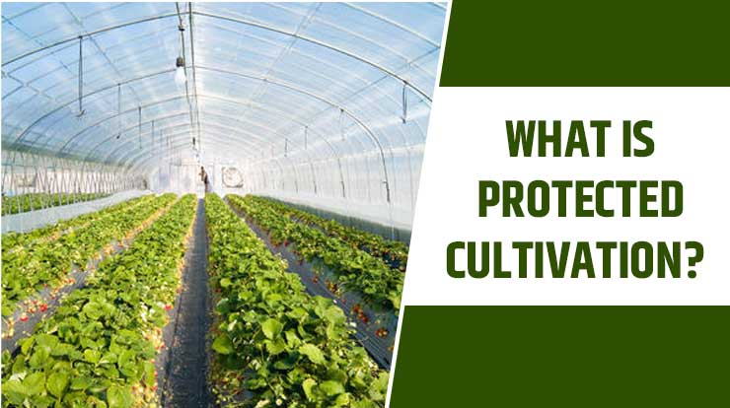
Protected cultivation is a farming technique in which crops develop in a regulated setting. In this farming system, every critical factor—including temperature, humidity, light, and others—is controlled in accordance with the crop's requirements for growth. All of the required farming conditions are simply controlled as needed. The agricultural technique is safer and produces a lot of food under uniform conditions. To protect the crop from bad weather, protected agriculture methods are totally, partially, or modified. There are many different types of protected agriculture available, including mulching, raised beds, trellising, drip irrigation, insect-proof net houses, greenhouses with forced ventilation, polyhouses with natural ventilation, insect-proof net houses,
and shade net houses. Two processes are offered by these protected cultivation types: an independent process, and an integrated process.
Importance of protected cultivation
• Due to controlled conditions there's higher germination, plant growth and crops mature quicker Improved quality & amount of manufacture with long period of time
• Use of water is optimized and there's reduction in its consumption by 40-50%• Effective utilization of inputs
• Incidence of sickness and pests is reduced or eliminated
Crops will be full-grown throughout the year.
• Crop is shielded from cold, wind
• Due to controlled conditions there's higher Crop is schielded from cold, wind, storm, rain & frost due to controlled conditions there higher germination, plant growth and crops mature quicker Improved quality & amount of manufacture with long period of time Use of water is optimized and there's reduction in its consumption by 40-50%• Effective utilization of inputs• Incidence of sickness and pests is reduced or eliminated Crops will be full-grown throughout the year. Best technology for industrial production of high worth crops like flowers, medicinal plants, etc.• Can be used for star drying of farm manufacture Crop cultivation underneath inclement weather conditions Certain crops cultivated year spherical to satisfy the market demands. High worth and top quality, even organic, crops full-grown for export markets Income from little land holdings exaggerated many fold. Successful nurseries from seeds or by vegetative propagation ready as and once necessary More Self-employ opportunities for educated youth on farm Manipulation of microclimate and bug proof feature of the greenhouse for plant breeding and, thus, the evolution of recent varieties and production of seeds. Cold and water are kept away from the crop
• There is higher efficiency because of the controlled conditions. Due to controlled conditions, crops are protected from cold, wind, storm, rain, and frost. As a result, plants grow faster and reach maturity sooner. longer period of time with improved quantity & quality of manufacture Utilization of water is maximized, and consumption is reduced by 40–50%.Utilizing inputs effectively
• Reducing or eliminating the prevalence of disease and pests All year long, crops will reach full maturity. Best technology for drying farm products in the star method, which is used to produce high-value crops like flowers and medicinal plants. Agricultural production in adverse weather To meet the demands of the market, some crops are grown continuously .crops that are fully grown and of
exceptional value, even those that are organic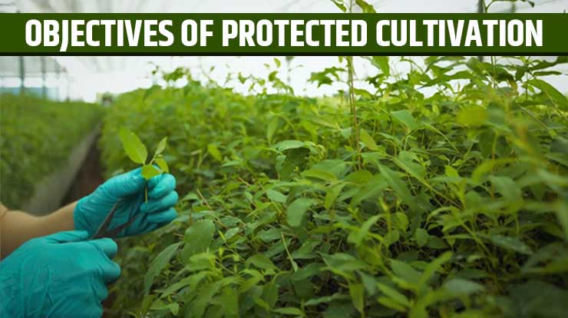
- Look at the objectives of protected cultivation, which are listed below, to see why it is now a popular farming technique in India. • The farming method's main goal is to protect the plants from abiotic stress, whether physical or non-living organisms like temperature, excess/deficit water, hot and cold waves, and biotic factors like pest and disease incidences, etc. Protected cultivation in India easily adjusts all the natural conditions. • With this method, the use of pesticides in crop production is kept to a minimum, maintaining the quality of crops.
• The technique highlights the superior worth and quality of horticulture crops. Protected farming produces disease-free yield and genetically superior transplants by propagating the healthy, uniform, and disease-free planting material, which increases germination percentages and improves hardening.
• By enhancing yields, improving quality, extending the effective harvest period, and expanding production areas, protected cultivation aims to change the natural environment and achieve optimal crop productivity.
• There are also specific objectives and benefits in certain geographic locations for limiting rainfall and hail damage as well as reducing high sun radiation by shading.
• This approach preserves the quality of crops by using fewer pesticides during crop production.
• The method emphasizes the high value and quality of horticulture crops.
By propagating the healthy, uniform, and disease-free planting material, protected farming produces disease-free yield and genetically superior transplants, which increases germination percentages and improves hardening. • Protected cultivation aims to change the natural environment and achieve optimal crop productivity by increasing yields, improving quality, extending the effective harvest period, and expanding production areas.
• In certain geographical areas, there are also specific goals and advantages for limiting hail and rain damage as well as lowering high sun radiation through shading.
Type of Protected structure
1. Net houses
2. Plastic low tunnels/row covers
3 Plastic mulch
4. Trench mulch
5. Floating plastic covers
6. Green houses
7. Poly houses
8 Shade houses
9. Rain shelters
1.Net houses
→ Shade nets and insect-proof nets are examples of these simple framed structure types. Perforated plastic shade nets are used to block solar radiation and prevent scorching and wilting of plants. These nets are offered in three colors black, green, and white—as well as various shading levels—from 25 to 75 percent. When compared to plants that aren't shaded, leafy vegetables and ornamental greens grow much faster under shade nets, especially when the sun is strong. There are various intensities of perforations for insect-proof nylon nets, ranging from 25 to 60 mesh.

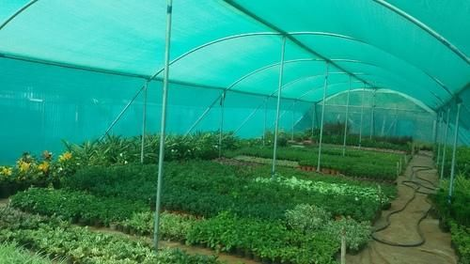
2. Plastic low tunnels /row covers
These structures are placed in an open field to cover plant rows with transparent plastic film stretched over steel hoops that are spaced appropriately along the TOWS and are about 50 cm high. It is made of 30–40 micron thick polyethylene film without UV stabilization, which is in situ perforated as the temperature rises. In temperate and tropical regions, row covers used in vegetable production serve different purposes. The primary benefit of these covers in northern India is the ability to grow vegetables, particularly cucurbitaceous crops, earlier than usual during the winter. The crop continued to grow despite the cold weather.

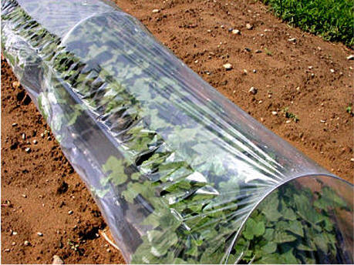
3 Plastic mulch
Plastic mulching is the practice of covering the area around a plant to improve growth conditions by weed control, better CO exchange, in situ moisture conservation, and soil moisture maintenance. By preventing fruit contact with the soil, it enables the production of cleaner crop products. It is skilled in insect management techniques, such as the use silver and yellow colored film to effectively ward off aphids and whiteflies, respectively. Plastic films made of linear low density polyethylene (1.1.DPE) and low density polyethylene (LDPE) are frequently used for mulching.
4. Trench mulch
Trench is a straightforward and affordable structure for growing in the coldest winter conditions, even at 15°C. Utilizing the heat of the sun and the soil, trench cultivation creates an environment conducive to the growth of specific leafy vegetables. Trenches can be constructed in a variety of lengths for large-scale production. Metal pipes or wooden poles are used to hold plastic sheets. Trench cultivation has been discovered to be a sustainable method for year-round vegetable production in cold climates.
5. Floating plastic covers
o protect vegetables from frost, snow, and cold temperatures, a large open field is covered with transparent plastic sheeting.
6. Green houses
According to the framed structure, transparent material, and its transparency, a large portion of sunlight is absorbed by vegetable plants. Vegetable plants inside polyhouses also emit long wave thermal radiations, for which the covering material has a lower transparency, which leads to the trapping of solar energy and an increase in temperature of 10–12° C. This phenomenon is commonly referred to as the "green house effect." The forcing of vegetables in cold climates is caused by the increase in greenhouse temperature. By supplying cooling equipment, the temperature in the polyhouse will be lowered during the summer.
Commercial polyhouses use carefully monitored The year-round production of desired vegetables is made possible by factors such as temperature, relative humidity, CO, photoperiod, soil temperature, plant nutrients, etc. The greenhouses are fully climate-controlled.
7. Poly houses
In contrast to the poly house, which offers a more stable environment, crops grown in open fields are subject to the world's environmental conditions as well as insect and pest attack. There are two categories of polyhouses: a) naturally ventilated polyhouses
Except for the provision of adequate ventilation and a logger system to essentially prevent damage from weather aberration and other natural agents, these polyhouses lack any environmental control systems.
By regulating light, temperature, humidity, carbon dioxide levels, and the type of root medium, an environmental controlled polyhouse can help to extend the growing season or allow Meson production.
8. Shade houses
A shade house is a building that is covered in agro nets or another type of woven material to allow air, moisture, and sunlight to pass through the gaps as needed. It develops a suitable microclimate that is beneficial to plant growth. Net house or shade net house are other names for it. Shade house applications
aids in the cultivation of vegetables, spices, medicinal plants, flower and foliage plants, and flowering plants. used for raising forest species, as well as fruit and vegetable nurseries and other uses. improves the quality of drying various agricultural products. used to ward off pest attacks. safeguards against climatic disturbances like wind, rain, hail, and frost. used to produce graft saplings and lower mortality rates during the hot summer months. used to make tissue harder
9.RainShelters

The Department of Agriculture has started a pile project to promote rain shelter farming as a low-cost alternative to polyhouse farming in an effort to increase domestic vegetable production and strengthen the concept of family farming.

The project, which is expected to cost Rs 1 crore, aims to establish 200 rain shelters throughout the State. The partially covered low-cost structure uses G1 pipes or wooden or bamboo poles for the framework and transparent UV stabilized polythene film for the roof to shield the plants from harsh weather conditions like sweltering summers and torrential rain. When it comes to installing foggers and sprinklers to control the temperature, a greenhouse with covered sides will cost more than one with open sides.

Protected Cultivation Structures
Protected Cultivation practices are a type of cropping where the microenvironment around the plant body is partially or completely controlled according to the needs of the plant during its growth phase in order to maximize yield and conserve resources. Due to factors like a growing population, climate change, shrinking land holdings, increased demand for high-quality fresh horticultural produce, and increased pressure on land and water resources, we are compelled to use modern crop production techniques like protected cultivation. To increase national productivity and produce quality, it is necessary to convert at least a portion of the more than 9.2 million ha of land currently used for vegetable cultivation to protected cultivation. Only about 40,000 ha of horticultural crops are currently grown in protected areas, and out of those 40,000 ha, niche markets of the big cities of the country is regularly inviting attention of the vegetable and flower growers for diversification from traditional ways of crop cultivation to such modern methods. Even the unemployed educated youths who are not attracted or interested in traditional agriculture are also showing good interest and can be further motivated for this kind of modern agricultural technologies.
Strategies for Protected Cultivation
For every major farming issue, there is only one solution, and that is Protected cultivation. With this method, farmers can solve all the uncertain and varying climatic conditions, climate change, improper uses and low productivity of natural resources, nutritional security in topographic and climatic, bad areas, polluted environment due to pesticide use, etc. The farming method generally refers to providing favourable conditions for plant’s productive growth and enhancement of production level artificially. This method controls the climate conditions by covering the plant not to withstand higher or low temperatures or humidity and other adverse farming factors. But get enough light for photosynthesis, optimum fertilisation and watering, and other best growth and production factors.

Status of Protected Cultivation in India

Protected cultivation is a relatively new technique in India, as we all know, but it quickly gained popularity there due to its straightforward methodology. The Indo-Israel project, which was started in 1998 at the Indian Agricultural Research Institute (IARI) in New Delhi, is responsible for this high-tech protected farming of vegetables and high-value horticultural crops. The farming has been refined and upgraded using this technique over the last ten years to lower costs and better suit local conditions. These days, almost all farmers accept this method of farming and use it extensively. Protected cultivation gradually expanded its presence in the Indian agricultural industry.

Area Under Protected Cultivation in India

India has embraced this new farming method in the last ten years, and today almost all Indian states use it. According to the report, there were over 275,000 hectares worldwide and approximately 110 ha in India under protected cultivation by the end of the 20th century. This area grew by 10% over time. Gujarat, Andhra Pradesh, West Bengal, Tamil Nadu, Punjab, Haryana, and Maharashtra are the states that consistently increased the amount of land under protected farming from 2007 to 2012. Till 2012, protected cultivation was allowed on a sizable area of 5,730.23 hectares in Gujarat and 4,720.72 hectares in Maharashtra.

Benefits of Protected Cultivation
Protected cultivation has some advantages, which are listed in the following section:
• With the help of environmental control, plants can grow throughout the year. This means that crops can be grown in hot climates even though they cannot be grown in open fields.
This method's microcosm technique enables the high-quality yield that is free from pathogens, chemical residue, and insect attack. It provides production or yield based on the maximum level per unit area, per unit input, and per unit volume.
• The educated rural farmers in the farming sector can also generate self-employment using this method.
• These are some important aspects of protected cultivations that can help you learn more about them.
Advantages of protected cultivation
When compared to open field conditions, protected vegetable production can use less water and chemicals to produce high-value vegetables. The following are the comparative benefits: Vegetable production all year long. It is possible to grow different crops on the same plot of land. Vegetable production in unfavorable climates can be overcome using a variety of protected production techniques. The production of high-quality, healthy vegetable seedlings for sowing in open fields in order to support early crop, robust, and resistant crops. Producing vegetables out of season will increase growers' profits. When protected vegetable cultivation is used, production and productivity per unit of land, water, energy, and labor can both increase. It encourages the creation of pristine and high-quality goods. Vegetable cultivation is made possible by it.
✰ Disease free seed production of costly vegetables becomes easy under protected structures.
✰ The potential of polyhouse production technology to meet the demand of producing good nutrition and healthy foods and quality vegetables free from pesticides can be fully exploited.
✰ Controlled environmental conditions are used for early raising of nurseries, off season production of vegetables, their seed production and protecting the valuable germplasm.
✰ Vegetable crops can be grown under adverse weather conditions round the year and off-season.
✰ Management and control of insect-pests, diseases and weeds is easier.
Limitations of protected cultivation
The manual or hand pollination of parthenocarpic hybrids or varieties of cross-pollinated vegetables like cucurbits .Expensive, short-lived, and inaccessible cladding materials. Inadequate access to tools and equipment, common PHM procedures, and power in rural areas. The price of the structure initially seems prohibitive. Farmers with zero risk budgets are reluctant to adopt it. The absence of insurance programs. Lack of cluster/cooperative
approach and market linkage
Conclusion
Exotic (non-native) and off-season vegetables, export-quality cut flowers, and quality seedlings are all produced in greenhouses for commercial purposes. When grown in a greenhouse, the economic returns from high-value agricultural products can be significantly increased.
References
- Chandra, P. 2001. Protected cultivation in vegetable crops: current status, problems and future strategies. In: Emerging Scenario in Vegetable Research and Development (Eds.
G. Kalloo and Kirti Singh). Research Periodicals and Book Publishing House (India). Pp. 242-249.
Choudhary, B.R., Sharma, S.K. and Janakiram, T. 2015. Cultivation of cucurbits in arid Rajasthan fetches more. Indian Horticulture (May-June), 60(3):22-24.
- Hickman, G.W. 2011. A review of current data on international production of vegetables in greenhouses.
www.cuestaroble.com.
- Kalia, P. and Yadav, R.K. 2015. Enhancing small farmers’ income through off-season vegetable production under temporary low height polyhouse protections. New Age Protected Cultivation (July-Dec. issue). Pp. 30-33. More, T.A. 2010. Arid Horticulture-Making greater strides. Agricultural Spectrum, I(X): 26-29. Sabir, N. and Singh, B. 2013. Protected cultivation of vegetables in global arena: A review. Indian Journal of Agricultural Sciences, 83(2):123-135.
- Samadia, D.K. 2008. Hi-tech approaches for vegetable and seed production under Hot Arid region of India. In: Hi-tech Production of Arid Horticulture, More et al. (ed.). ICAR-CIAH, Bikaner. Pp. 1-10.
- Singh, B. 2014. Protected cultivation of horticultural crops in India: Challenges and opportunities. In: 3rd International Conference on Agriculture and Horticulture held at Hyderabad from 27-29 Oct., 2014.
- Singh, B. and Kumar, M. 2009. Evaluation of summer squash varieties under plastic low tunnels during their off season cultivation. Indian Journal of Horticulture, 66(1):135-136.
- Singh, B. and Sirohi, N.P.S. 2006. Protected cultivation of vegetables in India: Problems and future prospects. Acta Horticulture, 710:339-342.
- Singh, B. and Solanki, R. 2014. Protected cultivation technologies for vegetable cultivation .

