TABLE OF CONTENTS
- Overview
- History Timeline
- History of Awadh
- Introduction
- Construction Material
- Construction techniques.

Imambara complex -The monument of Awadh architecture
1 Deeksha Singh 2. Anamika Yadav 3. Pratik Bhattacharya
- OVERVIEW
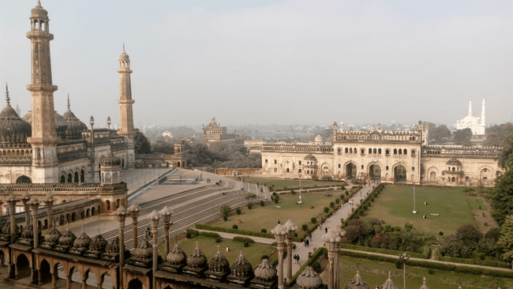
Architecture is the art and science of designing and constructing buildings, spaces, and environments that fulfill both functional and aesthetic needs. Its primary purpose is to create spaces that enhance the quality of human life, facilitate various activities, and respond to cultural, social, and environmental contexts. Architecture has a rich history that spans millennia from ancient civilizations like the Egyptians and Greeks to the Renaissance and modern architecture, the field has evolved significantly. Different regions and periods have produced distinct architectural styles. These styles are characterized by specific design elements, construction techniques, and cultural influences.
History refers to the study of past, encompassing all records human events, societies, cultures, and civilizations. history of Islamic Architecture opens in the same region where some four thousand years ago the Indus valley folks had built the earliest known civilization. An episode in the history of India and Islam, a triumph without result. Here is a very significant example of history as well as architecture Known as Bara Imambara.
The term “Imam Bara” typically refers to a type of Shia Muslim Congregation Hall and shrine, and one of the most famous Imam Baras in India is in Lucknow, Uttar Pradesh. The Bara Imambara is a significant historical and architectural landmark in Lucknow, Known for its
Fig 1
Source: - Author
grandeur and historical importance. The Imam Bara complex is an excellent example of Mughal architecture with a blend of Indo-Islamic style(Fig 1). It is renowned for its central hall, which is one of the largest arched construction without support beams. The mail hall also known as “Asfi mosque”. The bara Imam bara is serves as a place of worship and for Shia Muslim during religious ceremonies, especially during Muharram. Especially when procession organized. Efforts have been made to preserve and maintain the historical integrity of the bara Imam bara. It has been designated as a protected monument by the archeological survey of India. The Bara Imam bara stands as a testament to the architectural prowess of its time and continues to be an important cultural and historical landmark in Lucknow, attracting visitors from all over the world.
CHARACTERSTICS OF BARA IMAMBARA
Bara Imambara located in Lucknow is a historical monument known for its architectural beauty and cultural significance. Here is history timeline of Bara Imambara-
Construction Commences (1784): Asaf-ud-daula, the Nawab of Awadh(oudh), commissioned the construction of Bara Imambara in 1784. He initiated this project as a part of a famine relief program during the 18 centuries.
Construction of Bara Imambara: The main architect behind the construction of Bara Imambara was Kifayat-ullah, a renowned architect of the time. The construction of the complex took seven years to complete, from 1784 to 1791.
Purpose of Construction: The Bara Imambara was primarily built to provide employment to the famine-stricken population of Awadh during of a severe famine. The Nawab wanted to offer employment to people and provide them with food in exchange for their labor.
Unique Design: The Bara Imambara is known for its unique architectural features, including the central hall that is one of the largest arched constructions in the world without any support beams and pillars.
Historical Significance: The Bara Imambara is not only a marvel of architecture but also holds historical importance. It served as a place for religious and social gatherings, especially during muharram and other Islamic festivals.
Continued Use: Despite its historical significance, the Bara Imambara contines to be used for a religious and cultural event. It is a popular destination for tourist and devotees alike.
Maintenance & Restoration: Over the years, there have been efforts to maintain and restore the Bara Imambara to preserve its architectural beauty and historical significance.

HISTORY OF AWADH
Awadh & Awadh Architecture:
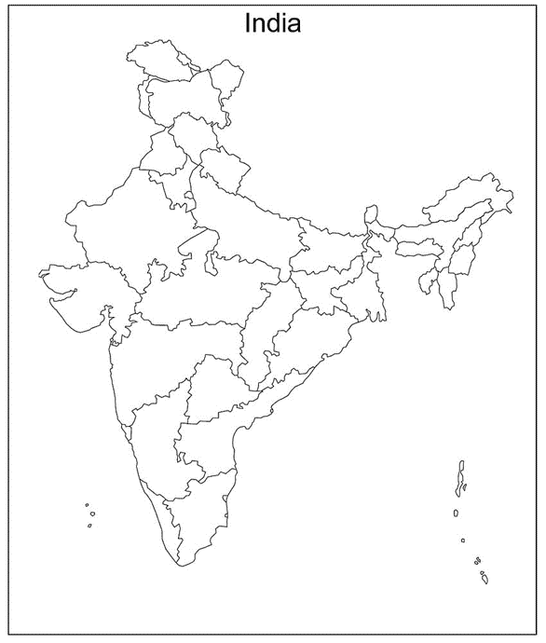
Asafuddaula the fourth nawab of Awadh shifted his capital to Lucknow (fig 2). Under his patronage and direction, Lucknow became the center of a poetic school, a sophisticated lifestyle, and also a religious expression that’s surpassed most of the developments that had hitherto occurred in the subcontinent at that time. He was keen to develop Lucknow as new cultural center.

Source: - Map of India Fig 2

Source: - Map of India
Source: - Author

In the final part of the eighteenth century the leaders of Awadh made an undeniable court and capital at Lucknow. It equaled and, surprisingly, outperformed the Mughal capital for its political assumptions and the abundance and imperativeness of its creative universes. The social world class of the Awadh court both developed the current types of court life and furthermore made new schools of verse, music, dance, show and craftsmanship. A significant number of the styles and types of the Mughal court were embraced and enhanced with territorial varieties.
The year 1784 could have passed as some other year throughout the entire existence of Awadh (in present-day Uttar Pradesh) notwithstanding a horrible starvation that struck the locale that year. So extreme were its belongings that the everyday citizens, except even the greater part of the aristocrats were diminished to penury. Individuals had no positions and no food to eat. Around then, the Nawab of Awadh, Asaf-ud-Daulah, concocted a splendid approach to creating work for the rich and the poor the same. He would have rather not given out free gives to jobless specialists and accepted that individuals expected to make money and not rely upon good cause, so he chose to construct the greatest supplication corridor in the country, an imam bara. The imam bara would require numerous laborers and every one individuals dealing with it and their families would be taken care of by the Nawab. The Nawab utilized in excess of 20,000 people for the development of the complex. Before long, they began their work — digging, laying blocks, cutting stone, and wood, conveying earth. It is said that the commoners would erect the walls during the day, and on each fourth evening, the aristocrats would cut down whatever was built. For their endeavors, the honorability likewise got installments. This guaranteed that the work endured and commoners didn't starve while the untalented blue-bloods were additionally utilized and their truly necessary secrecy completely kept up with — this was the Nawab's approach to ensuring that nobody in his realm was at any point unemployed. ( Indeed, very clever and liberal this Nawab was!)
The starvation endured eleven long years. What's more, to keep on producing business, the development likewise went on for the period the starvation endured. Notwithstanding the dreary structure and breaking, the Bara Imambara, likewise called the Asafi Imambara after the Nawab, ended up being grand. It was neither a mosque nor a catacomb, yet was intended to be a request lobby where the local area could gather for grieving during Muharram. It matched Mughal engineering, and even today, the imambara is swarmed with swarms who get confused by the loftiness and flawlessness of this super landmark. This Imam bara is also known as Asafi Imam bara and it is the most important religious monument of Shia Muslims of Lucknow. BaraImambara, Romi Gate, Daulat Khana and Bibiyapur Kothi are the most prominent constructions done by him. Gradually the Imambaras became the primary religious and social centers of the Shias. It is also part of the Shia’s religious as well as social performances. The Shia kings and nobles built many large Imamabaras for public use. Some of these are very small while others are large monumental buildings and complexes. The building took many years in its completion. Near about two hundred laborers’, masons and skilled men worked for years on this building. It cost one and a half crore rupees. Kifayatullah Shah Jhanadabadi was the main architect of the Imambaras.

PLACES IN IMAMBARA
6.1 Asfi Imam Bara Complex:
The “BARA” means Big so we called Baraimam bara and it known as bhul bhuliysa in local language. The great or bada imambara is enclosed with the decorative gateways. the Imambara complex is full of beauty and art. It gives the best example of the sustainable architecture and the Lucknowi architecture. Sustainability reflected in buildings of the Imambara complex like these building made by the all local and food material. The hue forecourt shows the greenery and hall widows made such as, that they gave natural lighting.

4. Second Gateway
2. Asfi mosque
3. Sahi baoli
1. Bada Imambara
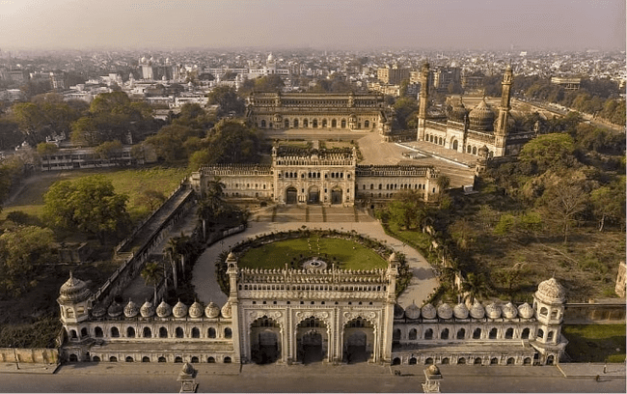

5.Main gateway

Fig - Bada Imambara complex view
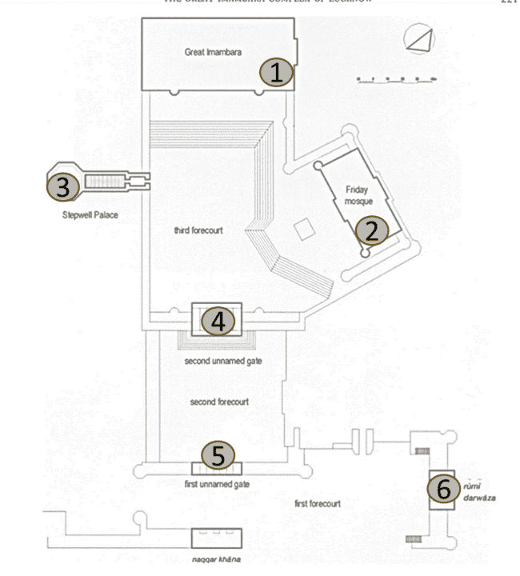

Fig - Bada Imambara complex Plan
The historian writer P.C.Mukherje, said “On the whole, the building art of Lucknow as of Indo -Saracenic in general, has some principles of its own…they aim to produce not only useful, but ornamental and tastefully regulated buildings which while filling all the wants of native life have such a margin left as to allow the means of luxury and to supply a beautiful sight.”
Fig 3 of plan and the view of the Immabara complex shows the full planning of the complex. The two-entrance gateway located in center which are very decorative. In the complex of Imambara there is one Asfi mosque, Sahi Baoli, center hall and the Bhul Bulaiya. The entry point of Bhool Bhulaiya is from the left side of the main building. On the east of the main building is a three-storey building, which is called the summer house. The western gate of Asifi Imamabaras is called Romi Darwaza or Turkish Gate and it is said that it is a copy of one of the gates of Constantinople (Qustuntunia). “Bara imam bara is complex with many architecture Awadhi monuments.”
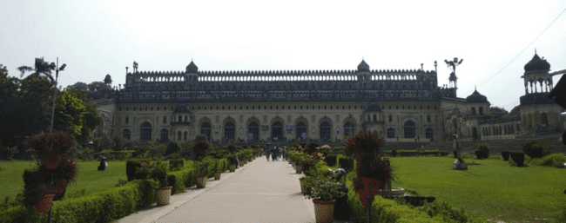
The monumental buildings such as tombs, Imambaras, and mosques reflect the traditional elements of architecture. The ethnicity of ancient architectural elements used in religious monuments has stayed the same over the years. In this style of architecture, the buildings have intricate details within the domes, tall minarets with cupolas, fish as a decorative element in the entrance gate, a high plinth base, cloisters, arches, arcades, and kiosks. The architectural confetti of the Mughal empire in Lucknow came from 1775 to 1800 under the Nawabs-Asaf -Ud-Daula and Sadat -Ali- Khan.
Entrance gateway
In imam bara complex there have two entrances gateway on North- south axis (Fig 4). Gateways have triple arched and 9 cups. The entrance gateways carry each other like this the firs gateway leads form the first courtyard to the second.
Source: - Author
Front side of main entrances gateway

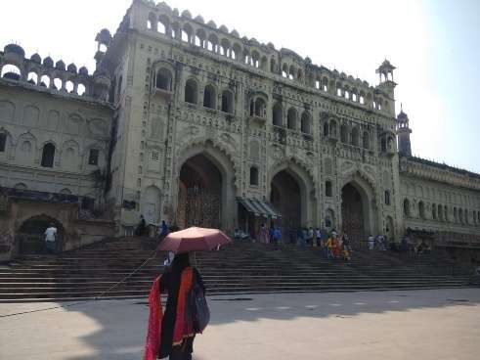
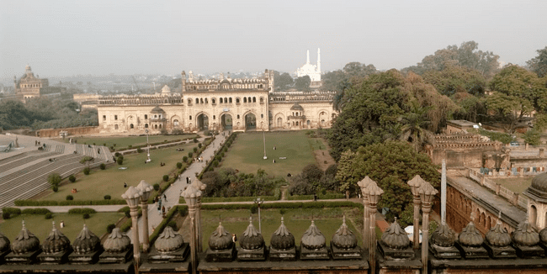
In imam bara complex there have two entrances gateway on North- south axis (Fig 4). Gateways have triple arched and 9 cups. The entrance gateways carry each other like this the firs gateway leads form the first courtyard to the second. Second courtyard is square in plan. Second gateway is like first, lead to the main court with the Imam bara placed on the south end of the quadrangle.
Source: - Author
Front side of main 2nd entrances gateway

Fig: Back side of Second entrances gateway
Source: - Author
The image of the entrance gateway shows the beauty of the gate in which we see the art and
artists work together. The entrance gateways use for safety propose. The triple arched gateway protects the entire complex as the soldier were standing at top of the gateway and look after the place.
Halls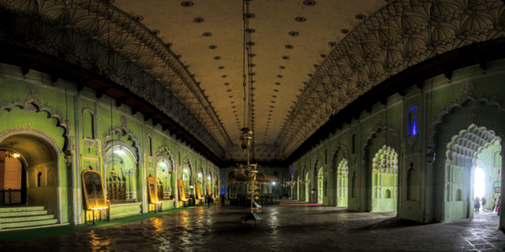

Source: - Google image
Fig 6
The fundamental structure of the imambara is a three-storeyed structure developed on a raised stage that one can enter through one of the two curved passages isolated by a green patio. It is one of the building miracles of that period. There are three corridors under the one rooftop -China dish, Perisan hall and Khrbooza Hall or Melon Hall also known as Indian hall. The Persians Hall known as central hall; it is said to be the largest vaulted chamber in the world. Except for the galleries in the interior, there is no woodwork in the entire structure. It is now used by Shia Muslims for the purpose of Azadar.
Central hall - The focal lobby (Fig 9) is the biggest. The corridor has the length of 50m and width of 16m. The roof is built at the level of 15m. The primary component of the roof is that there are no sections to help it. Likewise, no shafts, iron bars or a brace were utilized to help the roof. The eight different lobbies are little and encompass the focal one. Bara Imambara has perhaps of the biggest lobby on the planet, with an exceptional element being that it has no outside help of wood, iron, or stone pillars. As a matter of fact, the top of its focal corridor is a consequence of interlocking blocks with no bar or support for petitioning heaven purposes, it was concluded that a major focal lobby would be worked with next to no sections or points of support! It is an extremely huge design, and building it by customary means would have expected segments to bear the heap of the roof, including the mammoth vault. For such an enormous construction, the shortfall of support points sounded beyond difficult. However at that point the extraordinary modeler who was dealing with the imambara had a brainwave and he chose to make eight chambers so that every one of them have different rooftop levels and loan backing to one another.
- The space above and beneath these chambers resembles an enchanted labyrinth that upholds the enormous vault on top of the Imambara.
- The famous Idioms – “Diwaro ke bhi Kaan Hote Hai,” this idiom is famous because the center hall walls in second floor are such that the voice whisper at one corner heared at another corner of the wall. the acoustic is equally marvelous of the hall.
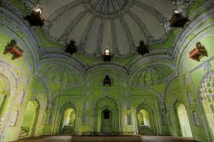
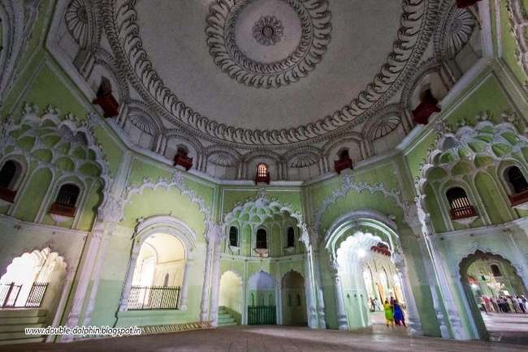
6.3.2 China hall (Fig 7): It is square in plan became octagonal at in mid-level and 16 sides at top level. It is one of the standing places for queen. This hall made as such that queen was saw every person or function but the persons did not see the queen. 6.3.3 Khabooza hall or Indian Hall (Fig 8): This hall roof look like watermelon and the decoration also reflects like Kharbooza. The roof of halls is common and flat and one piece. In this hall the entrance is big or larger than the others hall.
Source: - Google image Fig 8
Source: - Google image Fig 7
China hall
Indian hall

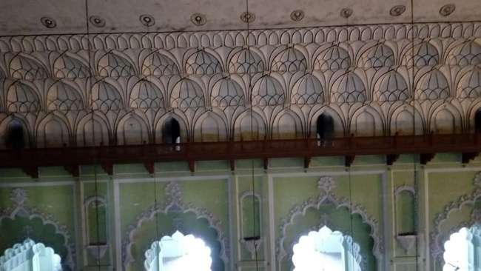
c
The decorative ceiling
The cantilever balcony with wooden railing is built in all four sides of the hall.
The arch entrance gives aesthetic look to the hall and provide full sunlight into the hall. No need to the artificial light.

Source: - Google image Fig 9
Central or Perisan hall

Construction techniques and Materials for halls:
Bara Imambara is primarily constructed using bricks and lime mortar. The massive centrals hall is also constructed with bricks. It is said that no wood or iron was used in the construction of main hall. The central hall is one of the most striking features of bara Imambara. This is the largest arched construction in the world without any supporting beams or pillars. The central arch is known as basket of flowers due to its unique design. The central hall’s arches and domes are constructed in a way that they support each other through their weight and design, creating a self-supporting structure. The interiors of the Bara Imambara are adorned with intricate stucco work, which is a plaster based decorative technique. Stucco was used to create elaborate designs and patterns on the walls and ceilings. The construction of the Bara Imambara is considered an architectural marvel due to its innovative techniques that allowed for the creation of large, open spaces without the use of conventional supports like beams or columns.
Bhool Bhulaiya
This extraordinary structural plan brought forth the renowned Bhul Bhulaiyya(Fig 10 and 11), which is an organization of tight paths that, when haggled accurately, wind their direction to the upper floor, driving at last to the housetop overhang. This peculiar maze has around 1,000 ways and 489 indistinguishable entryways. A few sections have impasses, some have steep drops and some others lead to the entry of leave focuses.
Just a single path prompts the roof gallery. On the off chance that one gets into the maze, it would be not difficult to lose all sense of direction in its various paths and it could take some time before one has sorted the exit plan! Hence, perhaps of the biggest existing labyrinth in India, the Bhul Bhulaiyya, however made for pragmatic purposes, has turned into the gem of the imambara!
Inside three tremendous lobbies named China Lobby, Persian Corridor, and Kharboza Lobby lays the feature of Bara Imambara, a progression of mazes known as BhulBhulaiya. Bhulbhulaiya (Maze), an astonishing labyrinth of 20 feet thick walls.
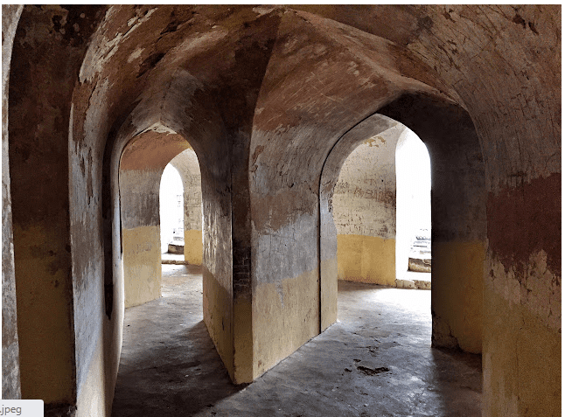
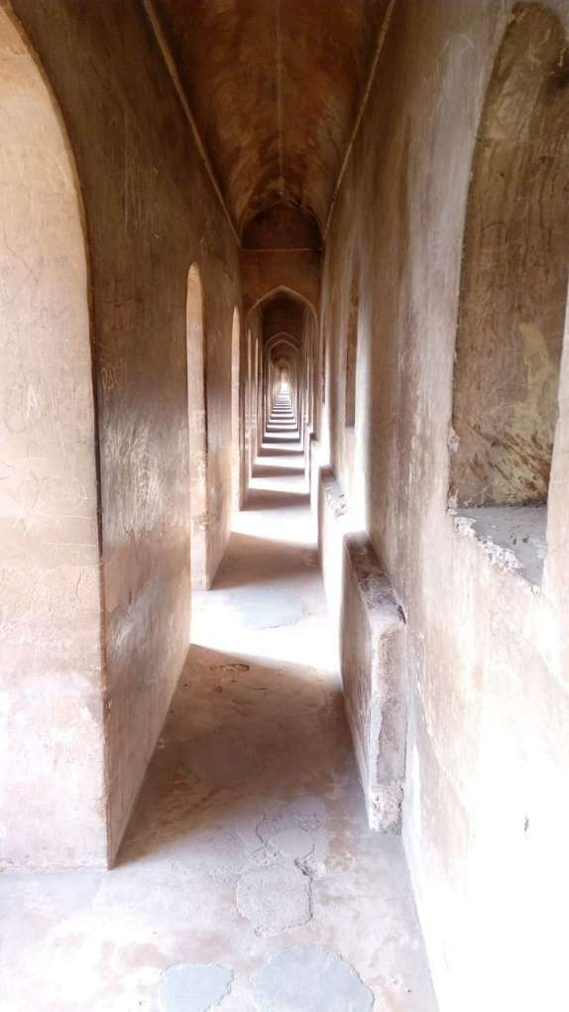
Picture below show the gate or entry pattern in the internal side at bhul bhuldiya . the below picture shows the gallery of the bhul bhulaiya.
Source: - Author fig 11
Source: - Author
Construction Techniques and Materials
Like the remainder of Imambara complex, Bhool Bhulaiya is basically is developed utilizing blocks and lime mortar. The labyrinth's walls and segments are made of block, and the format is planned with a serious level of accuracy.
Complex Layout is primary development method of Bhool bhulaiya. This format is additionally extremely befuddling and that is the intriguing reality about it. The path is intended to cross, backtrack on themselves, and lead to impasses, making it incredibly trying for guests to get themselves out without help.
Traps doors and false passage are incorporated into the maze to add to the confusion.
The Bhool Bhulaiya have multiple levels or stories, with staircase connecting them. Visitors may move up and down without even realizing it. The maze intentionally kept dimly lit, with minimum natural light entering through small windows. The construction includes features that enable sound to carry across different parts of the maze. While the primary material that was used in Bhool bhulaiya is brick but the decoration in the bhool bhulaiya was done by stucco on the walls and the ceilings. The design of the maze is carefully orchestrated to ensure that it remains a challenging and perplexing experience. The passage are designed to loop back on themselves, have hidden junctions, and include optical illusions.

Sahi Baoli
The landmark has a five-story Baoli or step well and is otherwise called Shahi Hammam. The step well is straightforwardly associated with Gomti. On the left of the principal building is the impeccable seven-level Shahi Baoli, out of the five stories, three are lowered in water while two are above. at first dug as a well during the development. As it was an enduring wellspring of water, a visitor house was worked around it later. During the times of the nawabs, the intensity stricken residents of Lucknow went to Shahi Baoli in the late spring a very long time for its cool wind. The baoli is at a point of 45 degrees to the fundamental door of the imambara.
Is intriguing that it offers a mystery perspective on the guests! Due to the point where it was developed, and the arrangement of one of the windows of the structure, the water of the Baoli mirrors the shadow of the guests.
At the point when the English came to India, the watchmen of the Nawab could see the red outfits of the English fighters at the primary entryway reflected free water of the baoli — similar as the CCTVs that watch over individuals' doors nowadays.
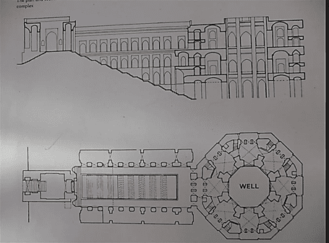
In fig 12 the arrangement and part of the Sahi Baoli, which shows that the arrangement of shi baoli is in octagonal and the well as encircled by the void lobbies, in both side the chenaging rooms or rest space for sahi people groups. the part (Fig 12) addresses the all floors of sahi baloi and shows the subtleties of its curves. Fig 13 shows the material and the one-point viewpoint of the Shai baoli.
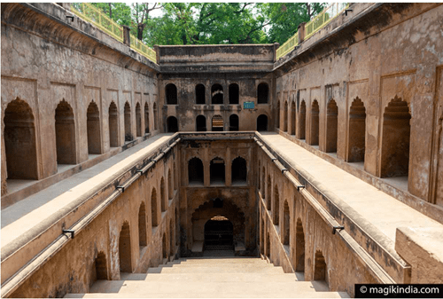

Source: - Google image Fig 12
Source: - Author Fig 13
Perspective View of Sahi Baoli

Plan and section of tsahi baoli .

Brick is the primary construction material used for Shahi Baoli like other elements of Imambara complex. It is a step well that means it consist of a series of steps that leads to down to water reservoir. It was designed to allow to access water during the hot days of the year. This Baoli is symmetrical and organized manner. It has arch openings in walls. These arches was not designed only for aesthetical or architectural purpose but to support the structure. There is a well chamber at the bottom of the Baoli to store enough amount of water for the usage in hot days. It may have a system to drawing water such as pulley or winch. Shahi Baoli have some decorative elements in it. It has intricate stucco work, carvings, ornamental designs on the arches and walls that adds aesthetic appeals to the structure. The stepwell as name suggested includes steps that provide access to the water at the bottom. For the maintenance they use stucco, lime plaster to enhance and maintain its appearance over the time.
Asafi Mosque
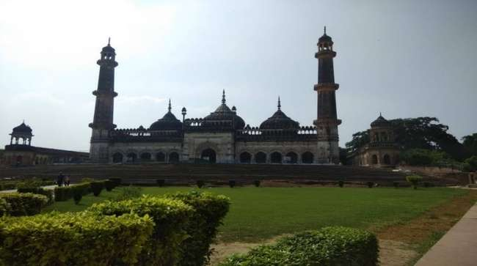
On the right side of the primary structure is a stairwell that prompts a plinth on which stands the three-domed Asafi mosque (Fig 14). Encircled by complex minarets, the mosque has two enormous petition corridors and eleven angled entryways. The mosque faces Mecca, the holiest city in Islam. It was additionally worked as a component of help measures. With formed vaults and minarets, the mosque gives a most marvelous look and a large number of individuals of Lucknow come here on Friday to offer namaz.
The Asfi Mosque
Source: - Author fig 14
There is likewise a tale about how a mystery burrow was made in the mosque, which goes the whole way to Delhi. It is accepted that this mystery burrow was subsequently fixed by the English after a portion of their troopers went searching for regal fortune there and never returned.
Asafi Masjid was built inside the bara imambara by Nawab Asaf-ud-Daulah..No iron material was utilized in the development of the mosque. The mosque is situated to one side of the bara imambara entryway.

Rumi Darwaza
The Rumi Darwaza (Fig 15) known as Turkish Gate, The Rumi Darwaza, which stands sixty feet tall. The darwaza is distinct from the Mughals in terms of architectural style and materials used. The design consists of a big arch and on top of that, there is a half-spherical dome resting on half-octagonal plan. The gate is built using thin burnt clay bricks and lime-crushed brick aggregate mortar (Lakhori and Surkhi respectively, which was prevalent during the rule of Nawabs in the 18th century). The gate boasts of intricate carvings of flowers.
Source: - Author Fig 15
The 60-foot-tall gateway has a close resemblance with the Sublime Porte, Bab-i-Humayun in Turkey and is referred to as The Turkish Gate.
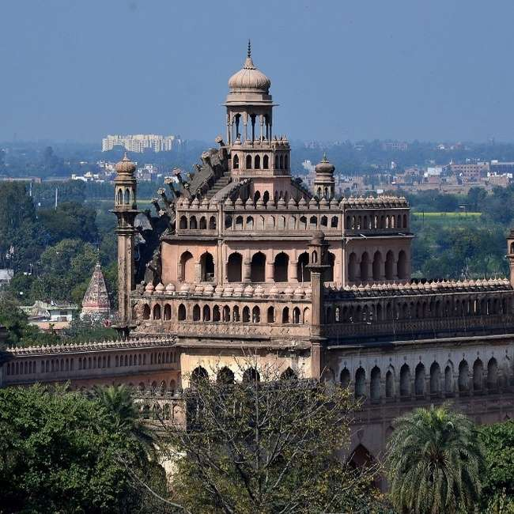
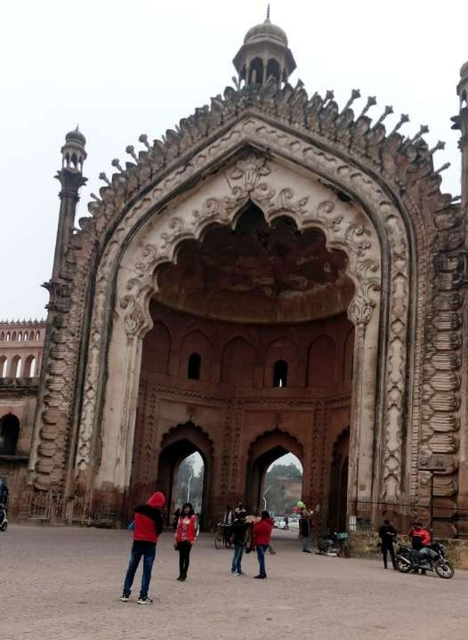
Turret
Kiosk
Octagonal
Chattriya
Cusped arches
Recessed arches
Lotus Patel

Front view
Back side view of top of rumi darwaza
Source: - Author Fig 16
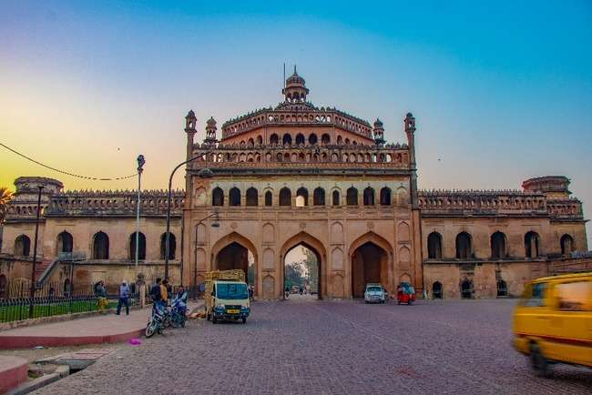

Back side view of rumi darwaza

Construction techniques and materials of Rumi Darwaza
Red Sandstone: The primary construction material used for the Rumi Darwaza is red sandstone. Red sandstone was a favored choice in Mughal architecture due to its durability and aesthetic appeal. It is known for its ability to be intricately carved, and the rumi Darwaza features extensive stone carvings.
Arch and Dome: The central arch of the Rumi Darwaza is a massive semi-circular structure that showcases Mughal architectural prowess. The arch is constructed using red sandstone blocks and intricately decorated with floral and geometric designs, including Persian calligraphy.
Octagonal Towers: On either side of the central arch, there are imposing octagonal towers that are constructed using red sandstone as well. These towers add symmetry and balance to the structure and are crowned with chhatris (small domed pavilions) that are also made of red sandstone.
Limestone Plaster: The exterior of the Rumi Darwaza is coated with a layer of white limestone plaster. This plaster not only adds to the aesthetic appeal of the structure but also provides protection against weathering.
Skilled artisans and craftmen were instrumental in the construction of the Rumi Darwaza. These craftsmen were experts in stone carving and architectural detailing, and their craftmanship is evident in the intricate designs and fine detailing throughout the gateway.
CONCLUSION
Bara Imambara in Lucknow, remains a culturally and historically significant monument. In present scenario the Bara imambara play an essential role in various aspects:
- Its cultural and historical significance is that it stands as a Lucknow’s rich cultural heritage and history. This is a reminder of a nawabi era of Lucknow and the architectural marvel of that era.
- The monument attracts the tourism from all over the world. People come to study it’s unique architectural feature such as Shahi Baoli, Asafi mosque and Bhool Bhulaiya.
- The construction Techniques used in Bara Imambara, Specially in bhool Bhulaiya, remain awe-inspiring. These elements of the complex is a part of study for architects and the historians.
- Asafi masque is still a place of worship for people of Lucknow. It serves as a religious place for the local community.
- The presence of such historical places has a positive economic impact on the region as it generates the income through tourism and provide employment opportunities.
- Preserving and restoring the historical monuments like Bara Imambara is crucial. Conservation efforts are going on ensure that this cultural treasure remains intact for future generations.
- ASI has started the process of restoration of Iconic Rumi Darwaza. This will be completed within 5 to 6 months.
- Movement of traffic is stopped under the three arches of the structure.

REFERENCES
- https://www.tribuneindia.com/news/schools/a-monument-with-no-pillars-101891
- https://www.tutorialspoint.com/bara_imambara/bara_imambara_architecture.htm
- https://timesofindia.indiatimes.com/city/lucknow/what-makes-imambara-a-green-building/articleshow/47089758.cms
- https://www.lucknowportal.com/item/bara-imambara-lucknow/
- https://www.adotrip.com/blog/imambara-lucknow
- https://www.tornosindia.com/asafi-imambara/
- https://www.re-thinkingthefuture.com/case-studies/a10928-bara-imambara-lucknow-uttar-pradesh/
- https://www.researchgate.net/publication/327267368_The_Architecture_of_the_Imamabadas_in_Lucknow_Imambada_Sibtainabad
- https://magikindia.com/en/lucknow-city-nawabs/
- https://www.taleof2backpackers.com/bara-imambara-lucknow/
- https://www.metmuseum.org/art/collection/search/456921
- https://www.tourmyindia.com/states/uttarpradesh/bara-imambara.html
- https://www.sid-thewanderer.com/2015/07/bhool-bhulaiya-bada-imambara-in-lucknow.html
- https://www.jstor.org/stable/25482443?typeAccessWorkflow
- https://www.thehindu.com/news/national/other-states/asi-begins-restoration-work-of-iconic-rumi-darwaza-in-lucknow/article66250734.ece

