Title - Using AI Machine Learning and Big Data to calculate perioperative risk – the future is here

Authors – Dr. Farah Husain¹, Dr. Salman Durrani², Dr. Nazia Husain³

- Senior Specialist Anaesthesia, Department of Anaesthesia and Intensive Care, Lok Nayak Hospital, and Maulana Azad Medical College, New Delhi, India
- Specialist Orthopaedic, Department of Orthopaedics, Dr. Baba Saheb Ambedkar Medical College and Hospital, New Delhi, India
- Associate Professor, Paediatric Cardiology, Ann & Robert H Lurie Children’s Hospital, Chicago, Illinois, USA

Corresponding Author: Dr. Farah Husain
Email: farah.husain.durrani@gmail.com

Introduction
Artificial Intelligence (AI) systems have slowly, yet steadily ingrained themselves as an integral part of our daily routines in such a way that we sometimes do not even notice their presence. From Siri, to Alexa, to our Netflix movie choices or Amazon choices, AI has entered our homes in a big way. John McCarthy, an American Cognitive scientist along with Minsky, Nathanial Rochester, and Claude E. Shannon, introduced the term “artificial intelligence” at the famous Dartmouth conference, in 1956, where AI became a new field ⁽¹⁾.
Concepts of Artificial Intelligence
AI is when a machine learns to behave as smartly as a human. It is the machine’s capability to respond in a manner like human intelligence that mimics cognitive functions, such as learning and problem solving. Where humans can be overwhelmed by voluminous and complex data, AI models have the intrinsic capacity to provide valuable insights based on extensive analysis and computation.

When healthcare related data arrives in increasing volumes from electronic health records (EHR) of multiple healthcare and research centres, at very high velocities it creates an information explosion. The use of AI becomes extremely beneficial in interpreting this Big Data and providing relevant healthcare information (Figure 1).
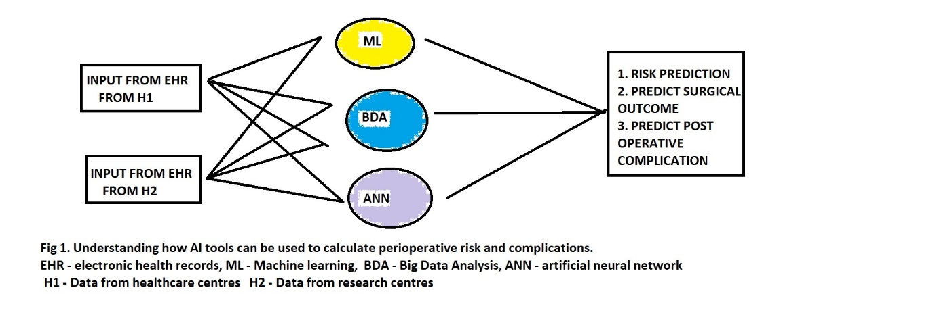

Machine Learning

Machine learning (ML) is one subcategory of AI, where computer learns from data in order to perform a concrete task through appropriate algorithms by identifying hidden patterns (correlations) without being programmed to do so. ML is defined as a series of mathematical algorithms that enable the machine to “learn” the relationship between the input and output data without being explicitly instructed on how to do so. By broadly classifying ML into supervised, unsupervised, and reinforcement learning, it becomes useful for various clinical applications ⁽²⁾.

ML is the most widely applied arm of AI in medicine, confers the ability to analyse large volumes of data, find associations, and predict outcomes with ongoing learning by the computer (Figure 2). It involves:
- Algorithm creation
- Testing and analyses
- Ability to perform cognitive functions (association between variables)
- Pattern recognition
- Prediction of outcomes

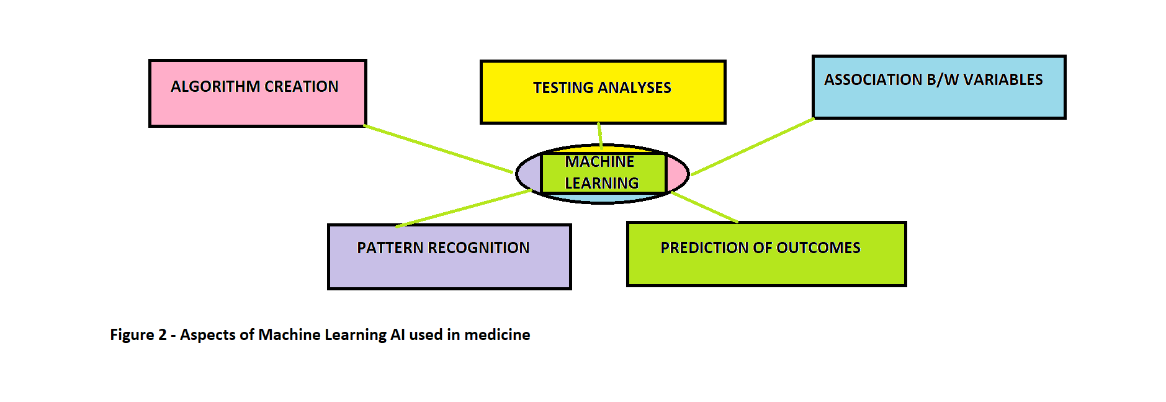Various ML models have been developed to answer single, relevant clinical questions by using representative data, such as using perioperative data to predict postoperative mortality and postinduction hypotension by analysing preoperative and induction data ^{(3,4)}.

Big Data

Big Data sets are too large or complex sizes are generally beyond the capacity of regularly used software tools to capture and process within an acceptable time limit. It is divided into three parts; Structured, Unstructured, and Semi-Structured Data. Big Data Analytics (BDA) refers to large data volumes that can be generated and processed while being used by digital information systems for making predictive, descriptive, and prescriptive analysis. Advancements in BDA have helped in improved decision-making in critical development areas such as healthcare, job opportunities, state of economy, state security, and predicting natural disaster and optimal resource management.

Clinical applications of AI: The perioperative period

The suggested areas for AI application in anaesthesia today include risk assessment and clinical treatment strategies. AI supported closed loops have been designed for pharmacological maintenance of anaesthesia and hemodynamic management. Computers are set to become indispensable tools not only for delivery of anaesthetics (example, target controlled infusions, bispectral (BIS) index guided hypnosis, BIS guided autonomous systems, and closed loop fluid management) but also for providing help in day-to-day clinical care and decision-making in anaesthesia. Understanding the use of AI in perioperative management can help the anaesthesiologist in making relevant clinical decisions.

Perioperative Risk assessment and Predictive Models using ML

Peri-operative risk assessment helps to reduce the risk of unexpected complications, achieve a targeted perioperative optimization, curate the anaesthesiologic management, and help provide the patient with a precise informed consent ⁽⁵⁻⁸⁾.

Research is bringing forth the use of ML tools for perioperative risk stratification based on analysis of millions of perioperative data and its analysis to manage expected and unexpected complications. ML systems could collect a large amount of data and interpret it accurately as the choice of the variable is selected by the model itself, allowing the discovery of new factors and make new interpretations of already known items to predict the risk. Clinical decision support system may therefore become knowledge based with built in algorithms that provides additional and foolproof cognitive aids to the anaesthetist ⁽⁹⁾. This type of “risk prediction” is especially useful for counselling, optimization, and planning the anaesthetic management of individual cases with rare co-morbidities and development of warning score systems.

Anaesthesia and perioperative risk assessment appear to be excellent fields to develop and apply ML systems ^{(10,11)}. Even though validated and routinely used risk scores ⁽¹²⁻¹⁴⁾ have been created for risk assessment they have their limits mainly due to the lack of tailored predictions. There is new research being done in the field of AI and ML suggesting that predicting perioperative complications can become more accurate and thereby improve patient outcome significantly. In the context of perioperative decision support, Tourani et al used the logistic regression model to understand if the use of intraoperative data improved the performance of 30-day postoperative risk models and found AI helped with risk prediction ⁽¹⁵⁾. Brennan et al assessed the accuracy and user-friendliness of the MySurgeryRisk algorithm for preoperative risk assessment. They compared the accuracy of perioperative risk assessment between physicians’ assessment and using the MySurgeryRisk tool, and reported that the algorithm’s predicting ability improved perioperative outcome ⁽¹⁶⁾. Several studies evaluated intraoperative variables, as electroencephalography (EEG) pattern, or intraoperative vital signs, for a real-time prediction of overly deep sedation, post-induction, and intraoperative hypotension ^{(17,18)}.

The application of ML techniques for creating predictive models of perioperative complications is in continuous expansion and the availability of interpretations and predictions in real time could allow us to enter a new era of anaesthesia, the future is here ⁽¹⁹⁻²¹⁾.

Using Big Data Analytics to assess perioperative risk

Big data was originally associated with three key concepts: volume, variety, and velocity ⁽²²⁾. But its analysis presented with challenges in processing and sampling, and thus a fourth concept, “veracity” was introduced. Veracity refers to the insightfulness of the data being collected. Big data analytics refers to the application of predictive analytics, or certain other advanced data analytic methods that extract value from big data. Its use in healthcare is rapidly being researched to improve patient outcome, with an estimated global spending on BDA having reached $215.7 billion in 2021⁽²³⁾. BDA has been used in healthcare for providing clinical risk intervention and predictive analytics ⁽²⁴⁾. The integration of analytical models and big data techniques does pose a challenge in real-time clinical practise due to the complexity of real-time data processing. Therefore, a viable alternative is utilizing data-friendly ML models built on top of various features derived from data engineering approaches ⁽²⁵⁾. By applying these models on a distributed streaming data processing framework, the real-time perioperative risk prediction is calculated after aggregating and transforming the EHR data from different sources ⁽²⁶⁾.
The recent evolution of BDA techniques makes it possible to develop a real-time platform to dynamically analyse the surgery risk from large-scale patients’ information. Feng Z et al have created an Intelligent Perioperative System (IPS), a real-time system that collects EHR data, performs data integration with variable generation, calculates a surgical risk score prediction and provides the physician with a risk score visualisation ⁽²⁶⁾.

Clinical applications of Machine Learning in Orthopaedics Surgery
AI and ML in orthopaedic surgery has gained mass interest over the last decade and the recent use of ML in orthopaedic surgery has focused on clinical decision support such as risk assessment ⁽²⁷⁾. Harris et al, have reported that ML was moderately accurate in predicting 30-day mortality and cardiac complications after elective primary joint replacement ⁽²⁸⁾. The orthopaedic literature shows that ML continuously outperforms more traditional legacy risk-stratification measures such as ASA classification, Charlson Comorbidity Index, and modified 5-item frailty index, in predicting complications following a variety of orthopaedic procedures ^{(29,30)}. ML algorithms are also able to identify safe candidates for specific orthopaedic procedures like anterior cervical fusion and discectomy ⁽³¹⁾. Navarro et al created a valid ML algorithm that predicted the length of stay and costs before planning a primary total knee replacement ⁽³²⁾.

In most cases, ML has proven to be just as effective, if not more than prior methods of risk prediction. With the help of deep learning algorithms, such as artificial neural networks (ANN), AI in orthopaedics has been able to improve diagnostic accuracy and speed, bring forth immediate attention of the physician to a critical patient, decrease elements of human error, reduce the strain on healthcare personnel, and improve overall patient care ⁽³³⁾. By using ML methods to make more accurate outcome predictions, orthopaedic surgeons can improve their decision-making ability, and plan a more efficient way to utilize healthcare resources such as reduced hospital stay etc ⁽³⁴⁾. The use of ANN allows for the identification of nonlinear patterns making predictions more accurate ⁽³⁵⁻³⁷⁾.

Conclusion
The use of these new AI technologies to analyse perioperative complications has been tested in almost all types of surgery (general, cardiac, orthopaedic, neurosurgical, vascular). AI Technologies are becoming more and more prevalent in health-care settings. Both clinical and organizational decision-making processes can take advantage of these technologies.
ML methods were used mainly to predict the following outcomes: mortality, cardiovascular complications, acute kidney injury, surgical complications, intensive care unit admission, respiratory complications, length of stay, venous thromboembolism, neurological complications, sepsis, pain, and post-operative nausea and vomiting. As stated before, most of studies considered preoperative variables, like demographic, medical history, clinical and laboratory values evaluation, to calculate perioperative risk.

With its surging trend of interest, AI and ML is expected to see an increase in use with risk assessment, outcomes assessment, imaging, and basic science applications in different fields such as anaesthesia and orthopaedics. Furthermore, because ML and BDA provides physicians the unique opportunity to understand their patients better. Physicians should be trained to use these methods effectively in order to reduce risk of perioperative complications and improve patient care.

References
- Ardi MY. Artificial intelligence: past and future. Commun ACM. 2012; 55(1):5
- Hashimoto DA, Walkowski E, Gao L, Meireles O, Rosman G.Artificial intelligence in anesthesiology. Anesthesiology. 2020;132:379-94.
- Lee CK, Hofer I, Gabel E, Baldi P, Cannesson M. Development and validation of a deep neural network model for prediction of postoperative in hospital mortality. Anesthesiology. 2018; 129:649-2.
- Kendale S, Kulkarni P, Rosenberg AD, Wang J. Supervised machine-learning predictive analytics for prediction of postinduction hypotension. Anesthesiology. 2018; 129:675-688.
- Bose S, Talmor D. Who is a high-risk surgical patient? Curr Opin Crit Care. 2018; 24(6):547-553.
- Rajkomar A, Dean J, Kohane I. Machine Learning in Medicine. N Engl J Med. 2019; 380(14):1347-1358.
- Wijeysundera DN. Predicting outcomes: Is there utility in risk scores? Can J Anaesth. 2016; 63(2):148–158.
- Chakravarthy M. Modifying risks to improve outcome in cardiac surgery: an anesthesiologist's perspective. Ann Card Anaesth. 2017; 20(2):226–233.
- Singh M, Nath G. Artificial intelligence and anesthesia: A narrative review. Saudi J Anaesth 2022;16: 86-93.
- Gambus P, Shafer SL. Artificial Intelligence for Everyone. Anesthesiology. 2018 ;128(3): 431-433.
- Liu Q, Ma L, Fan SZ, Abbod MF, Lu CW, Lin TY, Jen KK, Wu SJ, Shieh JS. Design and evaluation of a real time physiological signals acquisition system implemented in multi-operating rooms for anaesthesia. J Med Syst. 2018; 42(8):148.
- Mayhew D, Mendonca V, Murthy BVS. A review of ASA physical status - historical perspectives and modern developments. Anaesthesia. 2019;74(3):373–379.
- Nashef SA, Roques F, Michel P, Gauducheau E, Lemeshow S, Salamon R. European system for cardiac operative risk evaluation (EuroSCORE). Eur J Cardiothorac Surg. 1999; 16(1): 9-13.
- 6. Kheterpal S, Tremper KK, Heung M, Rosenberg AL, Englesbe M, Shanks AM, Campbell DA Jr. Development and validation of an acute kidney injury risk index for patients undergoing general surgery: results from a national data set. Anesthesiology. 2009; 110(3): 505-515.
- Tourani R, Murphree DH, Melton-Meaux G, Wick E, Kor DJ, Simon GJ. The value of aggregated high-resolution intraoperative data for predicting post-surgical infectious complications at two independent sites. Stud Health Technol Inform. 2019; 264: 398–402.
- Brennan M, Puri S, Ozrazgat-Baslanti T, Feng Z, Ruppert M, Hashemighouchani H, Momcilovic P, Li X, Wang DZ, Bihorac A. Comparing clinical judgment with the MySurgeryRisk algorithm for preoperative risk assessment: a pilot usability study. Surgery. 2019; 165(5): 1035– 1045.
- Lundberg SM, Nair B, Vavilala MS, Horibe M, Eisses MJ, Adams T, Liston DE, Low DK, Newman SF, Kim J, Lee SI (2018) Explainable machine-learning predictions for the prevention of hypoxaemia during surgery. Nat Biomed Eng. 2018; 2(10):749–760.
- Kang AR, Lee J, Jung W, Lee M, Park SY, Woo J, Kim SH. Development of a prediction model for hypotension after induction of anaesthesia using machine learning. PLoS One. 2020; 15(4): e0231172.
- Bellini V, Valente M , Bertorelli G, Pifferi B, Craca M , Mordonini M, Lombardo G , Bottani E , Rio PD, and Bignami E. Machine Learning in perioperative medicine: a systematic review. Journal of Anes, Analgesia and Critical Care. 2022; 2:2
- Hyland SL, Faltys M, Hüser M, Lyu X, Gumbsch T, Esteban C, Bock C, Horn M, Moor M, Rieck B, Zimmermann M, Bodenham D, Borgwardt K, Rätsch G, Merz TM. Early prediction of circulatory failure in the intensive care unit using machine learning. Nat Med. 2020; 26(3):364–373.
- Alimadadi A, Aryal S, Manandhar I, Munroe PB, Joe B, Cheng X. Artificial intelligence and machine learning to fight COVID-19. Physiol Genomics. 2020 52(4):200–202.
- The 5V’s of Big Data. Watson Health Perspectives. 17 September 2016
- Taylor P. Big Data and business analytics revenue worldwide 2015-2022. Statista 2023
- Huser V, Cimino JJ. Impending challenges for the use of Big data. International Journal of Radiation Oncology, Biology, Physics. 95(3): 890-894.
- Collin GS, et al. Transparent reporting of a multivariable prediction model for individual prognosis or diagnosis (tripod): the tripod statement. BMC Medicine. 2015; 13(1):1.
- Feng Z, Bhat RR, Yuan X, Freeman D, Baslanti T, Bihorac A, and Li X. Intelligent Perioperative System: Towards Real-Time Big Data Analytics in Surgery Risk Assessment. DASC PICom Dataom CyberSciTech; 2017: 1254-1259.
- Poduval M, Ghose A, Manchanda S, Bagaria V, Sinha A. Artificial Intelligence and Machine Learning: A New Disruptive Force in Orthopaedics. Indian J Orthop. 2020; 54: 109–122.
- Harris AHS, Kuo AC, Weng Y, Trickey AW, Bowe T, Giori NJ. Can Machine Learning Methods Produce Accurate and Easy-to-use Prediction Models of 30-day Complications and Mortality After Knee or Hip Arthroplasty? Clin Orthop Relat Res. 2019; 477:452–460.
- Kunze KN, Polce EM, Nwachukwu BU, Chahla J, Nho SJ. Development and Internal Validation of Supervised Machine Learning Algorithms for Predicting Clinically Significant Functional Improvement in a Mixed Population of Primary Hip Arthroscopy. Arthroscopy. 2021; 37:1488–1497.
- Kunze KN, Polce EM, Rasio J, Nho SJ. Machine Learning Algorithms Predict Clinically Significant Improvements in Satisfaction After Hip Arthroscopy. Arthroscopy. 2021; 37:1143–1151.
- Wang KY, Suresh KV, Puvanesarajah V, Raad M, Margalit A, Jain A. Using Predictive Modeling and Machine Learning to Identify Patients Appropriate for Outpatient Anterior Cervical Fusion and Discectomy. Spine (Phila Pa 1976) 2021; 46:665–670.
- Navarro SM, Wang EY, Haeberle HS, Mont MA, Krebs VE, Patterson BM, Ramkumar PN. Machine Learning and Primary Total Knee Arthroplasty: Patient Forecasting for a Patient-Specific Payment Model. J Arthroplasty. 2018; 33: 3617–3623.
- Lalehzarian SP, Gowd AK, Liu JN. Machine learning in orthopaedic surgery. World J Orthop. 2021;12(9):685-699.
- Visweswaran S, Cooper GF. Patient-specific models for predicting the outcomes of patients with community acquired pneumonia. AMIA Annu Symp Proc. 2005;759–763.
- Di Capua J, Somani S, Kim JS, Phan K, Lee NJ, Kothari P, Cho SK. Analysis of Risk Factors for Major Complications Following Elective Posterior Lumbar Fusion. Spine (Phila Pa 1976) 2017; 42:1347–1354.
- Lee NJ, Kothari P, Phan K, Shin JI, Cutler HS, Lakomkin N, Leven DM, Guzman JZ, Cho SK. Incidence and Risk Factors for 30-Day Unplanned Readmissions After Elective Posterior Lumbar Fusion. Spine (Phila Pa 1976) 2018; 43:41–48.
- Dreiseitl S, Ohno-Machado L. Logistic regression and artificial neural network classification models: a methodology review. J Biomed Inform. 2002; 35:352–359.

