IMMENSE ROLE OF NANOPARTICLES IN DRUG DELIVERY
MISS. PAWAR VAISHNAVI VIJAY
K. T. PATIL COLLEGE OF PHARMACY, OSMANABAD

ABSTRACT
Nanotechnology is the study of molecules also called Nanoparticles. The field of nanotechnology has grabbed attention due to its uses in various fields like Oncology, Data mining, Quantitative Structure-Activity Relationship (QSAR), Drug Delivery, etc. Nowadays Nanotechnology is vastly utilized in the medical field in the drug delivery system. Nanoparticles such as Metal Nanoparticles, Polymeric micelle, Stimuli-responsive micelle, Polymeric nanoparticles, Dendrimers, and carbon Nanotubes are used in drug transmission. In following review, we will briefly overlook the types of nanoparticles and the Role of Polymeric Nanoparticles in Cancer therapy.
KEYWORDS
Metal Nanoparticles, Mesoporous Silica System, Polymeric Micelle, Polymeric Nanoparticles, Dendrimers, Carbon Nanotubes.
INTRODUCTION
Nanotechnology is the branch that deals with structures and molecules on nanometer scale ranging in between from 1nm-100 nm or technology which utilizes devices on nanoscale is known as in Nanotechnology. Nano in the Greek means 'dwarf'. Nanotechnology was a concept introduced by Richard Feynman in his lecture 'There is Plenty of Room at the Bottom' in 1959[23]. Nanotechnology is applied in areas like bioimaging, bio-detection, and drug delivery. Nanoparticles that are used as drug transmitting vehicles are of very low dimension. The dimension of the nanoparticle should be <100 nanometers in one dimension. For example, Nano molecules used in anticancer drug molecules including Doxorubicin, and CPG oligonucleotide have been successfully loaded on DNA nanostructure. To acquire drug delivery, it is important to understand the interaction of nanomaterial with the biological surrounding, targeting cell surface receptors, drug release, multiple drug administration, stability of therapeutic agent, and molecular mechanism of impulsing involved in the pathology of disease under study [1]. Various nanoparticles such as paclitaxel, doxorubicin, 5-fluorouracil, and dexamethasone have been successfully formulated. Drug efficacy of nanoparticles is reduced due to various factors like instability of the drug inside the cell, unavailability due to multiple targeting or chemical properties of delivering molecule, damage in the signaling pathway, or drug degradation. The efficacy of therapeutic treatment can be maximized in numerous ways because nanoscale intelligent systems can rapidly detect and respond to disease states. Nanotechnology has been developed in the field of medicine, engineering, physics and medicine. The drug loaded in the nanoparticle formulation releases a high dose for a prolonged period and the proliferation of vascular smooth muscles is completely inhibited.[2][3][5]
- Key properties of nanoparticles are:
- Nanoparticles should have minimum range of about 1-100 nm.
- Nanoparticles are arranged via methods that exhibit fundamental control over physio-chemical aspects.
- Nanoparticles can be merged to form bigger structure.[2]

- Advantages of nanotechnology in the field of pharmacy:
- Increase contact area.
- Enhance miscibility.
- Increase rate of dissolution.
- Increase in oral bioavailability.
- Minimum amount of doses which lead to reduce the quantity of doses.
- Avoidance of drug from degradation.
- More rapid onset of therapeutic action.
- Achievement of drug targeting.
- Passive targeting of drugs towards the lymphocytes available in the liver and spleen.[3]

Aspect | Past Nanotechnology | Present Period | Future Nanotechnology
Technology | Emulsion-based preparation of microparticles | Microfabrication | Micro manufacturing
Examples | Liposomes  Polymer micelles  Dendrimers  Nanoparticles  Nanocrystals  Microparticles | Microchip systems Microneedle transdermal delivery systems  Layer-by-layer arranged systems  Nano dispersed particles | Nano/micro machines for improving production
Table 1. Examples of drug delivery technologies in relation to the current nanotechnology. [4]

DISCOVERY AND FURTHER STUDIES
Nanoparticles were first used in the 4th century A.D. The best example is the Lycurgus Cup from British Museum, which describes the achievement in glass industry[3]. In 1857, Michael Faraday studied 'Ruby gold' and concluded that ruby gold can make the most interesting nanoparticles. In 1986, Binning and Rohrer got the Noble Prize for the structure of a Scanning Tunneling Microscope (STM).
The American physicist and Nobel prize laureate Richard Feynman introduced the concept of nanotechnology in 1959, during the annual meeting of the America Physical Society, Feynman presented a lecture entitled "There's Plenty of Room at the Bottom" at the California Institute of Technology (Caltech)[3]. After the lecture of Richard Feynman in 1959 the new idea came into existence after fifteen years by Japanese scientist Nori Taniguchi. Nori Taniguchi define the term nanotechnology in 1974[6]. Nori Taniguchi defined nanotechnology as 'Nanotechnology mainly consists of the processing of separation, consolidation, and deformation of material by one atom or one molecule[6]. In 2006, Paul Rothmund developed the ‘Scaffolded DNA origami' by enhancing the complexity and size of self-assembled DNA nanostructure in a 'one-pot reaction.'
Hence, nowadays nanotechnology is used in various fields like Oncology, Data mining, Quantitative Structure-Property Relationships (QSPR), Quantitative Structure-Activity Relationships (QSAR), Absorption Distribution Metabolism, Excretion, and Toxicity (ADMET).[6]
TYPES OF NANOPARTICLES
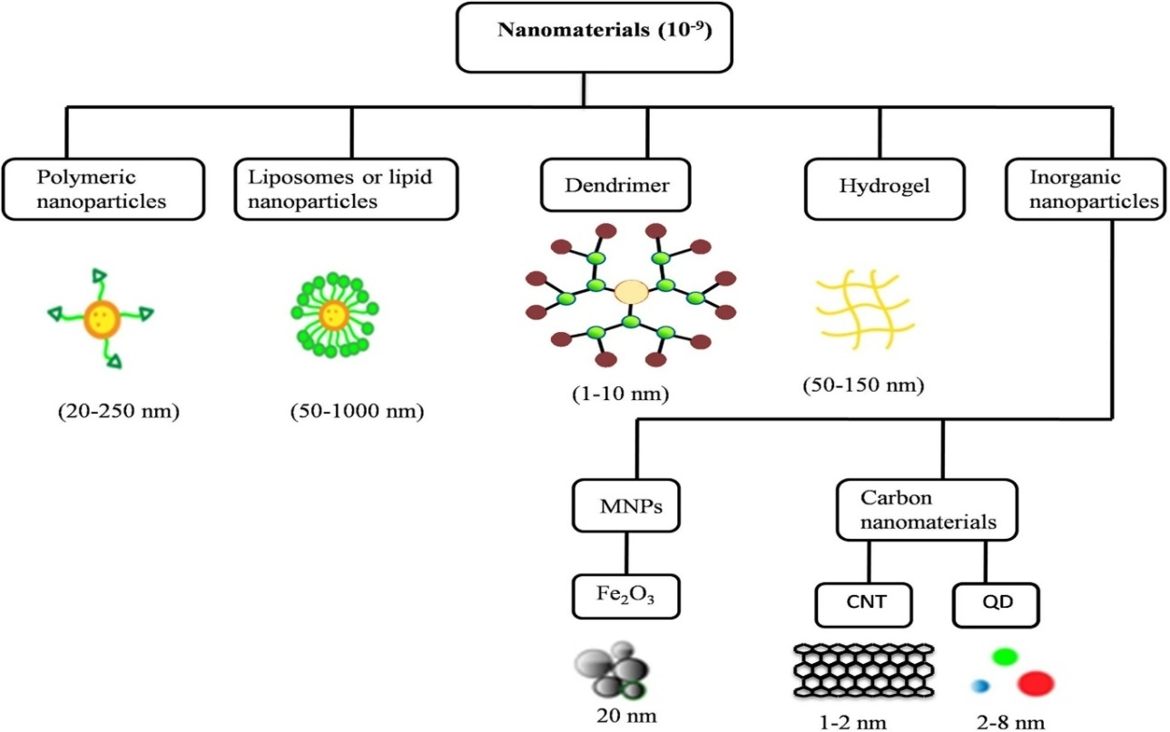
Fig. 1. Types Of Nanomaterials.[22]
1. Inorganic Nanoparticles
They are the particles obtained from metal oxide or metallic composition ranging in nanometer scale. The conventional preparation way of inorganic nanoparticle preparation is the sol-gel route. Inorganic molecules such as metal salt, metal halide, or inorganic alkaloid are prepared by condensation or hydrolysis reaction into appropriate metal oxide order. The method of synthesis of inorganic nanoparticles is microemulsion processing. Inorganic nanoparticles consist of quantum dots and metal nanoparticles. Metal nanoparticles are obtained from gold and silver, and also from metal oxide based on iron, titanium, cerium, and alumina. [2][7]
There are two types of inorganic nanoparticles:
- Metal Nanoparticles.
- Mesoporous Silica System
- Metal Nanoparticles
Metal Nanoparticles were started in 1971. Metal Nanoparticles were utilized in different biochemical uses such as DNA observation, Vehicle for delivering drugs, visualizing the cellular component, probes for electric microscopes, etc. Metallic nanoparticles like gold and silver show many optical and electronic properties. The gold nanoparticles are attached with specific oligonucleotides it can detect the complementary DNA threads by the change in the color. Silver works as an antimicrobial agent. Silver microparticles are utilized to avoid the action of broad-spectrum antibiotics. Silver catheters and vascular grafts are also used to minimize sepsis in burn therapy. Nowadays magnetic nanoparticles are utilized as a contrast media for Magnetic Resonance Imaging (MRI).[2][24]
- Mesoporous Silica System
Mesoporous materials are used for the coating of drugs and organic materials. Mesoporous materials such as Santa Barbara Amorphous (SBA), Mesoporous Silica Nanoparticle (MSN), and Hollow Mesoporous Sphere (HMS) were used for drug delivery. The group mesoporous material with longer pore size such as Santa Barbara Amorphous consist SBA-15, SBAH-6, SBA-1, SBA-3, MSU, and HMS. Hollow Mesoporous Sphere (HMS) are another group of important mesostructured that are used in drug delivery. In a research, researchers found that HMS exhibited much more storage capacity than MCM-41. MCM-48, MCM-41, and SBA-51 are bioactive materials for drug delivery systems. Mesoporous Silica Nanoparticles (MSN) have characteristics like:
- The particle size of MSN ranges in between 50-300nm allowing effortless endocytosis by living animal and plant cells without any toxicity.[2]
- MSN is more stable to heat, pH, mechanical stress and hydrolysis induce degradation, compared to other based drug carriers.[2]
- The uniform pore size distribution of MSN is very narrow, and the pore diameter can be turned between 2-6nm.[2]
- Large surface area and large pore volume MSN allow high loading of drug molecules.[2]
2. Organic Nanoparticles
Organic nanoparticles are group of organic particles consisting imaginary uncountable numbers of unique shape. Organic nanoparticles are also developed by non-covalent intermolecular interaction. Organic nanoparticles are more unstable in nature. Organic nanoparticles are important for application that requires the observation of physiochemical gradation, particle binding interaction, and stimuli-resulted effects. Organic nanoparticles have attracted widespread attention for various applications like disease diagnosis and cancer therapy.[2]
- Polymer in Drug Delivery.
Advantages in polymer science resulted to tremendous growth of several Novel Drug Delivery systems. Polymers used in drug transmission must be biocompatible. Biocompatibility is the capability of the substance to attack on the host at specific sites and specific applications. Biodegradable polymers must have specific requirements such as:
- Mechanical power has to mitigate the need of specific applications[2]
- Processibility using available equipment[2]
- Solubility in different solvents[2]
- Chemical, Structural, and application adaptibility[2]
- Economically acceptable stability.[17]

Articial decomposable polymers |  | Natural decomposable polymers
Polyesters | Poly oxalates | Starch | Albumin
Poly orthoesters | Poly imino carbonates | Hyaluronic acid | Dextran
Polyanhydrides | Polyurethanes | Heparin | Chitosan
Polydioxanones | Poly phosphazenes | Gelatin | –
Poly(a-cyanoacrylates) | –
Table 2. Classification of biodegradable polymers used in drug delivery system.[2]

The polymers used in the drug transmission system are:
- Polymeric Micelles
- Stimuli-Responsive Micelle
- Polymeric Nanoparticles
- Dendrimers

- Polymeric Micelle
A polymeric micelle is an amphiphilic block copolymer. They have a core-shell structure. These amphiphilic co-polymers are in dynamic equilibrium. Polymeric micelles are the self-construction of amphoteric polymer with water absorbent and water repellant units. The micelle size ranges from 10 to 100 nm. When Poly micelle is combined with metal nanoparticles it can be used in various biocompatibility, pharmacokinetics, adhesion, targetability, and longevity.[22][9]
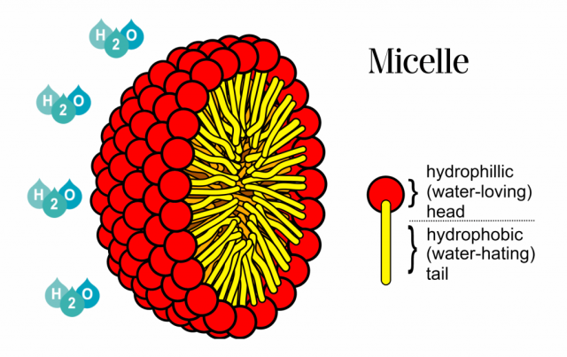
Fig 2. Structure of Polymeric micelle.[22]
- Stimuli-Responsive Micelle
Stimuli-responsive micelle has impressive properties as a capable drug delivery system. Stimuli-reactive micelle has an amphiphilic structure. Stimuli-responsive micelle is recently used in sensing and biosensing. They can also be used for the preparation of photonic crystals. Stimuli-responsive micelle act as building blocks in photonic crystals.[10]
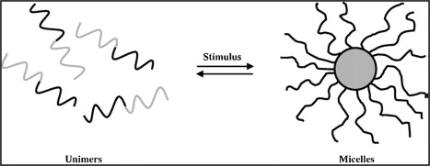
Fig. 3. Stimuli Responsive Micelle.[2]

- Polymeric Nanoparticles
Polymeric Nanoparticles consist of water absorbent and water repellant polymer chains. Hydrophilic polymers consist PEG, PVP or polysaccharides. They are colloidal solid particles with a size ranging from 10-100 nm. Polymeric nanoparticles are branched, rounded figures made up of biodegradable and non-biodegradable polymers. In polymeric nanoparticles drug molecules can be covered within particles, physically stucked on the surface, or chemically attacheded to the surface particles.[3][11]
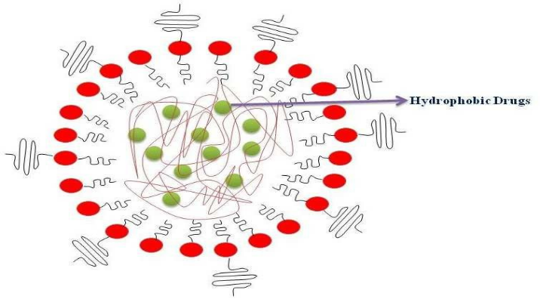
Fig.4. Polymeric Nanoparticle.[22]

- Dendrimers
Dendrimers are nanoparticles, radially symmetric, well-defined, homogenous, and monodisperse structures that have typically identical cores, inner shells or outer shells. A scientist named Tomalia first coined the term dendrimer in 1985. A dendrimer structure consists of the focal core, building blocks, and multiple peripheral functional groups. Dendrimer play role in drug delivery by following ways:
- Entrapping of molecules inside the dendrimer.
- Drug particles can be covalently bonded on the outer surface.
Dendrimer has biological properties like solubility, low cytotoxicity, electrostatic interaction, polyvalency, self-assembling, and chemical stability.[12][3]
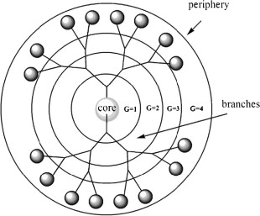
Fig. 5. Structure of Dendrimer.[2]
3.Carbon Nanotubes
Carbon nanotubes have a unique tubular structure. The carbon arrangement of shells in nanotubes resembles to honeycomb arrangement. Nanotubes have good Young's modulus and tensile strength due to resemblance with graphite-like arrangement of atoms of in the shell. At specific heat carbon nanotube systems are intent on preferably by phonons. Carbon nanotubes are highly sensitive, so they are suitable for the preparation of semiconductors.[2][3][13]
Properties of Carbon Nanotubes:
- Carbon Nanotubes have high thermal conductivity.
- Carbon Nanotubes have high electric conductivity
- Carbon Nanotubes must be elastic.
- Carbon Nanotubes should have high tensile strength.
- Carbon Nanotubes should be highly flexible.
- They should have a minimum growth factor.
- Carbon Nanotubes are good electron field source.
- Carbon Nanotubes should have high axial strength due to the presence of carbon-carbon sp² bonding.[25]

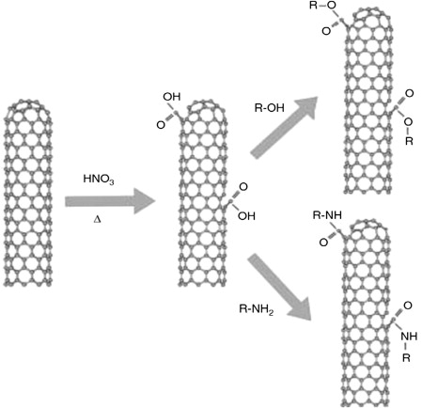
Fig.6. Functionalization of Carbon Nanotubes through Oxidation.[2]
USE OF POLYMERIC NANOPARTICLES IN CANCER TREATMENT
Cancer is nothing but the abnormal growth of body cells. Cancer is treated by mainly four methods that are Surgery, Radiation, Chemotherapy, and immunotherapy. Mainly drug delivery system/targeted drug delivery system is used to manage cancer patients. The targeted drug delivery system works on basis of Polymeric Nanoparticles. Polymeric Nanoparticles act as drug carriers. Anticancer agents are encapsulated either within or on the surface of polymeric nanoparticles.[14][15][18][20][21] Nanoparticle act in cancer patients by targeting the cancerous cell. Targeting is done by 2 processes:
- Active site of Targeting.
- Passive site of Targeting.
A) Active Targeting
In active site of targeting the chemotherapeutic agents directly interact with defective cells. Nanoparticles are designed in such a manner that nanoparticles target cancerous cells. Target drug delivery system work on three components that is Anticancer drug, Targeting moiety penetration enhancer, and carrier. Nanoparticles in active targeting are commonly made up of metals, lipids, and polymers. When the nanoparticle binds to the receptor, the cell undergoes receptor phagocytosis.
- Specific Receptor Targeting
Folate Receptor:
Researchers found in the study that the patient suffering from cancer has overexpressed the number of folate receptors. The folate receptor provides a target for many anticancer drugs. Scientists have developed a nanoparticle-mediated with folic acid. The doxorubicin-polyethylene glycol folate conjugate micelle was prepared. It was targeting the folate receptor and the result was it causes tumor suspension.
Luteinizing Releasing Hormone Receptor:
Luteinizing Release Hormone Receptors are overexpression in breast cancer, ovarian cancer, and prostate cancer. The nanoparticles are combined with the drug Docetaxel. Aptamers in nanoparticles detect cancerous cells. Aptamers are the targeting molecule present outside the nanoparticle.
- Antibody-Mediated Targeting
Nanoparticles are conjugated with antibodies to show action against specific tumor antigens. Antibodies are used in their original form for cancer treatment. Malignant cells need iron in very high amounts. Iron acts as a cofactor for DNA synthesis. Nanoparticles act as drug carriers and transferrin receptors provide a binding site to antibodies. Antibody-mediated targeting improves anticancer activity and reduces exposure of cancerous cells to healthy cells.

Nanoparticle | Neoplastic  drug | Targeting agent | Various polymers involved | Outcome
Polymeric nanoparticle | Paclitaxel | Folic acid | 1.Polyethylene glycol  2. Polylactic acid | Increased drug concentration in tumor
Dendrimer |  | Folic acid | Poly amidoamine | Enhanced cellular uptake
Nano shell | Docetaxel | Folic acid | Biodegradable polymer | Sustained release and targeted delivery
Dendrimer | Small interfering RNA (siRNA) | Luteinizing releasing hormone (LRH) | (propylene imine) and polyethylene glycol | High specificity
Nanoparticle | Paclitaxel | Folic acid | Poly(D, L-lactide glycolide) | Blockage of P-glycoprotein
Polymer micelle | Doxorubicin | Folic acid | PEG-co-poly(lactic-co-glycolic acid) | Enhanced tissue uptake and cytotoxicity
Polymer micelle | Doxorubicin | Folic acid | PEG-poly(aspartate hydrazone doxorubicin) | Enhanced endocytotic cellular uptake
Table 3. Nanoparticle Used in Cancer Therapy.[15]

B) Passive Transport
Cancerous cells do not perform apoptosis. Nutritional agents get continuously sucked by the cancerous cell. Hence the size of the tumor is enhanced.Pore size of cancer cells is between 100- 780nm. So, the nanoparticles below 100-780nm can pass the pore, and efflux of the nanoparticle occurs. Nanoparticles accumulate by increased permeability and retention effect due to diffusion into the cell.[15 ]

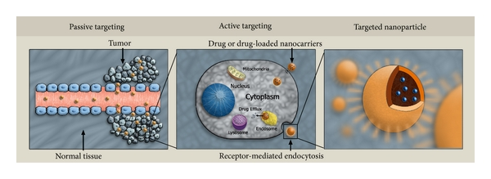
Fig. 7 Active and Passive Targeting.[15]

CONCLUSION
This review enlightened, the importance and utilization of nanoparticles in drug delivery. The Nanoparticles work as a drug carrier in the drug delivery system. Polymeric Nanoparticles play an important role in the treatment of cancer. Nanotechnology is an emerging and advanced technology for drug delivery.

ACKNOWLEDGEMENT
The author is gratefully acknowledged for the support from the PrincipaL, A.S.P.M's K.T.Patil College of Pharmacy, Osmanabad for supporting and providing necessary facilities.

REFERENCES
- Suri SS, Fenniri H, Singh B. Nanotechnology-based drug delivery systems. Journal of occupational medicine and toxicology. 2007 Dec;2:1-6.

- Safari J, Zarnegar Z. Advanced drug delivery systems: Nanotechnology of health design A review. Journal of Saudi Chemical Society. 2014 Apr 1;18(2):85-99.

- Maravajhala V, Papishetty S, Bandlapalli S. Nanotechnology in development of drug delivery system. International journal of pharmaceutical sciences and research. 2012 Jan 1;3(1):84.

- Park K. Nanotechnology: What it can do for drug delivery. Journal of controlled release: official journal of the Controlled Release Society. 2007 Jul 7;120(1-2):1.

- Sahu T, Ratre YK, Chauhan S, Bhaskar LV, Nair MP, Verma HK. Nanotechnology-based drug delivery system: Current strategies and emerging therapeutic potential for medical science. Journal of Drug Delivery Science and Technology. 2021 Jun 1;63:102487.

- Bayda S, Adeel M, Tuccinardi T, Cordani M, Rizzolio F. The history of nanoscience and nanotechnology: from chemical–physical applications to nanomedicine. Molecules. 2019 Dec 27;25(1):112.

- Stevanović M, Lukić MJ, Stanković A, Filipović N, Kuzmanović M, Janićijević Ž. Biomedical inorganic nanoparticles: preparation, properties, and perspectives. InMaterials for Biomedical Engineering 2019 Jan 1 (pp. 1-46). Elsevier.

- Lemarchand C, Gref R, Couvreur P. Polysaccharide-decorated nanoparticles. European Journal of Pharmaceutics and Biopharmaceutics. 2004 Sep 1;58(2):327-41.

- Perumal S, Atchudan R, Lee W. A review of polymeric micelles and their applications. Polymers. 2022 Jun 20;14(12):2510.

- Wei M, Gao Y, Li X, Serpe MJ. Stimuli-responsive polymers and their applications. Polymer Chemistry. 2017;8(1):127-43.

- Prabhakar C, Krishna KB. A review on polymeric nanoparticles. Research Journal of Pharmacy and Technology. 2011;4(4):496-8.

- Abbasi E, Aval SF, Akbarzadeh A, Milani M, Nasrabadi HT, Joo SW, Hanifehpour Y, Nejati-Koshki K, Pashaei-Asl R. Dendrimers: synthesis, applications, and properties. Nanoscale research letters. 2014 Dec;9:1-0.

- Ajayan PM, Zhou OZ. Applications of carbon nanotubes. Carbon nanotubes: synthesis, structure, properties, and applications. 2001 Mar 9:391-425.

- Tabatabaei Mirakabad FS, Nejati-Koshki K, Akbarzadeh A, Yamchi MR, Milani M, Zarghami N, Zeighamian V, Rahimzadeh A, Alimohammadi S, Hanifehpour Y, Joo SW. PLGA-based nanoparticles as cancer drug delivery systems. Asian Pacific Journal of Cancer Prevention. 2014;15(2):517-35.

- Sutradhar KB, Amin ML. Nanotechnology in cancer drug delivery and selective targeting. International scholarly research notices. 2014;2014.

- Ng KK, Zheng G. Molecular interactions in organic nanoparticles for phototheranostic applications. Chemical Reviews. 2015 Oct 14;115(19):11012-42.

- Pillai O, Panchagnula R. Polymers in drug delivery. Current opinion in chemical biology. 2001 Aug 1;5(4):447-51.

- Zhang G, Zeng X, Li P. Nanomaterials in cancer-therapy drug delivery system. Journal of biomedical nanotechnology. 2013 May 1;9(5):741-50.

- Rajabi M, Srinivasan M, Mousa SA. Nanobiomaterials in drug delivery. InNanobiomaterials in Drug Delivery 2016 Jan 1 (pp. 1-37). William Andrew Publishing.

- Tang M, Lei L, Guo S, Huang W. Recent progress in nanotechnology for cancer therapy. Chin J Cancer. 2010 Sep 1;29(9):775-80.

- Masood F. Polymeric nanoparticles for targeted drug delivery system for cancer therapy. Materials Science and Engineering: C. 2016 Mar 1;60:569-78.

- https://en.wikipedia.org/wiki/Nanoparticle#:~:text=A%20nanoparticle%20or%20ultrafine%20particle,nm%20in%20only%20two%20directions.

- Hu Q, Li H, Wang L, Gu H, Fan C. DNA nanotechnology-enabled drug delivery systems. Chemical reviews. 2018 Feb 21;119(10):6459-506.

- Jamkhande PG, Ghule NW, Bamer AH, Kalaskar MG. Metal nanoparticles synthesis: An overview on methods of preparation, advantages and disadvantages, and applications. Journal of drug delivery science and technology. 2019 Oct 1;53:101174.

- Applications of Carbon Nanotubes - AZoNano.com
https://www.azonano.com/article.aspx?ArticleID=4842

