Chapter Title:
Transdermal Patches; an Architect of the Future Drug Delivery
Raktimava Das Sarkar Gouranga Sundar Roy
Department of Pharmaceutics, Department of Pharmacognosy,
Bengal School of Technology, Bengal School of Technology,
Sugandha, Chinsurah, Hooghly, West Bengal, Sugandha, Chinsurah, Hooghly, West Bengal,
Pin-712102 Pin-712102
Email ID- raktimava100@gmail.com Email ID- gsroy1104@gmail.com

Aryama Bose Rashmi Ghosh
Department of Pharmaceutics, Department of Pharmaceutical Technology,
Bengal School of Technology, Bengal College of Pharmaceutical Sciences and Research,
Sugandha, Chinsurah, Hooghly, West Bengal, BASU, Gandhar Sarani, Durgapur, West Bengal,
Pin-712102 Pin-713212
Email ID-aryamabose29@gmail.com Email ID- rashmi05rx@gmail.com

Adrika Mondal
Department of Pharmaceutics,
Bengal School of Technology,
Sugandha, Chinsurah, Hooghly, West Bengal,
Pin-712102
Email ID- mondal.adrika11@gmail.com

ABSTRACT
From topical Poultice to novel skin penetrating applications came at the mid of 20th century with Transdermal Patch. The transdermal novel patch evolved with an intention to justify a slow but uniform release, than an irregular old fashioned uncontrolled poultice and similar applications. With the model invention of measuring the release pattern; now, a handful of many release-kinetics measurer are existent. From the laboratory scale to pilot and terminally, commercial transdermal identity of patches exists with many Pharmacophore. FDA has guidelines to qualify and quantify manufacture and quality assured Topical Transdermal Drug for New Drug Delivery System and Abbreviated New Drug Delivery System. In our lab, subsequent to few earlier attempts; we are working on HERBAL-TRANSDERMAL-PATCH (HTDP) formulations. Generally herbal pharmacophore exists in a group of similar structural entities; with different potentials of disease reliever mechanisms. One single 2x2 square centimetre patch with herbal extract can manage 5.0 millilitres of the soft extract. Accommodating an extract as 5 ml; a release of more than 80%; in 12.0 hours, is a comfortable optimum herboceutical for the patient? But the chemical proteinous moiety is not a choice for oral Leaf administration as old as, more than 5000 B.C.; since older than Vedic Era, of the acquaintances of its Ethno-botanical existence, as for example. We all know that protein, water soluble, in this case, must prove, in very near future, about its recognition as HTDP.

- INTRODUCTION
History and Evolution of Transdermal Patches
The origins of transdermal patches revert back to long time past when humans discovered the potential of applying medicinal substances to the skin for therapeutic purposes. Historical records indicate that various cultures, including ancient Egyptians, Greeks, and Native Americans, used poultices and ointments to treat ailments topically. However, the concept of transdermal drug delivery as we understand it today began to take shape in the mid-20th century. In the 1970s, the pioneering work of Dr. Alejandro Zaffaroni and his team at ALZA Corporation (now a part of Johnson & Johnson) laid the foundation for modern transdermal patches.
One of the earliest successful transdermal patches was the Scopoderm patch, which was developed in the 1970s towards the relief of long journey ailments. This patch delivered the medication scopolamine through the skin, providing relief without the need for oral medications. The success of the Scopoderm patch sparked interest in transdermal drug delivery and set the stage for further advancements in the field. In the following years, significant progress was made in refining transdermal patch technology. Researchers explored different materials and adhesive formulations to enhance patch adherence and drug permeation. They also investigated methods traditionally towards the drug outcoming and duration of drug outcoming from the forms of medicament, ensuring optimal therapeutic levels.
The introduction of the nitroglycerin patch in the 1980s revolutionized the treatment of angina, a condition characterized by chest pain due to insufficient blood supply to the heart. The nitroglycerin patch delivered along the place required to outcoming of the medicament, providing consistent relief to patients.
Another milestone in transdermal patch development came with the introduction of the nicotine patch in the 1990s. This patch offered a breakthrough in smoking cessation therapy by delivering nicotine through the skin, reducing withdrawal symptoms, and aiding in tobacco addiction recovery. Since then, transdermal patches have continued to evolve and diversify. They have been developed for action mediated profile, just as hormones’ medication ,pain management, contraception, and treatment of functional disorders, as Parkinson's disease or disease as Alzheimer.
Brief overview of transdermal patches and their significance in drug outcome.
Transdermal patches, are designated drug outcome for administer medications trans dermacometric transport. They offer an easy and not pushed way of the outcome of the desired drug, allowing for sustained release of therapeutic substances into the bloodstream over an extended period. Transdermal patches have gained significant importance in the field of pharmaceuticals due to their numerous advantages. Representative key favour of transdermal representative medication is their ability to provide controlled and consistent drug delivery. The patches are designed to release the medication at a predetermined rate, ensuring a steady and reliable concentration of the drug in the body. This controlled release feature helps maintain therapeutic levels of the medication, reducing fluctuations and enhancing treatment efficacy. Transdermal patches also offer improved patient compliance compared to other forms of drug administration. They eliminate the need for frequent dosing or injections, making it easier for patients to adhere to their medication regimens. This is particularly beneficial for individuals with chronic conditions who require long-term therapy. Transdermal patches provide a convenient and discreet option, allowing patients to continue their daily activities without interruption.
Transdermal patches bypass the gastrointestinal system, which can be advantageous in certain cases. They avoid the liver’s metabolomics, allowing drugs to directly enter the bloodstream. This can be beneficial for drugs that are slightly come inwards through the GIT or are susceptible to degradation in the stomach acid. Transdermal patches also offer the advantage of minimizing systemic side effects. The controlled release of medication through the skin can help reduce peaks and troughs in drug concentration, minimizing adverse reactions associated with rapid fluctuations. Additionally, transdermal delivery can reduce gastrointestinal side effects, as the medication bypasses the digestive system. Moreover, transdermal patches provide a non-invasive and needle-free drug delivery option, which can be particularly advantageous for patients who have a fear of injections or difficulties with oral medication administration. This makes transdermal patches suitable for a wide range of patient populations, including children and the elderly.[1,2,3]
Mechanism of action and their advantages over other forms of drug administration.
Transdermal patches are a fascinating innovation in the realm of drug delivery. Unlike traditional methods of taking medication, such as swallowing a pill or receiving an injection, transdermal patches enable the absorption of drugs through the skin. This unique approach offers several advantages over other forms of administration. To understand how transdermal patches work, we need to picture a miniature, drug-filled reservoir nestled within the patch. This reservoir contains the medication in a concentrated form. The patch consists of layers designed for specific purposes: a backing layer to protect the drug and provide structural support, an adhesive layer to affix the patch to the skin, and a release liner that is removed prior to application. When a transdermal patch is applied to the skin, the medication begins to permeate through the layers and is gradually released. The drug molecules traverse the outermost layer of the skin, called the stratum corneum, and make their way into the bloodstream. From there, they can travel to the intended target within the body to produce the desired therapeutic effect.
Representative single notable easiness of transdermal patches is their ability to provide controlled and sustained drug delivery. Unlike oral medications that can undergo rapid metabolism or injections that can result in sudden peaks followed by drops in drug levels, transdermal patches release the medication gradually and consistently. This controlled release ensures a steady concentration of the drug in the bloodstream, optimizing its therapeutic efficacy. Another advantage is the convenience and improved patient compliance associated with transdermal patches. Once applied, the patch continues to deliver medication for a predetermined duration, eliminating the need for frequent dosing. This ease of use promotes adherence to the prescribed treatment regimen, particularly for individuals who may struggle with remembering to take oral medications or who have difficulty with injections.
Transdermal patches also offer the benefit of bypassing the gastrointestinal system. When drugs are ingested orally, they take their entry in stomach and liver prior to float into bloodstream. This "first-pass metabolism" can reduce the amount of active drug available to exert its therapeutic effects. With transdermal patches, drugs can be directly absorbed into the bloodstream, avoiding the potential loss of potency associated with oral administration. Moreover, transdermal patches can minimize systemic side effects. By maintaining only similar amount of the drug in the bloodstream, they help reduce peaks and troughs in drug levels. This can minimize the occurrence of adverse reactions that may arise from sudden fluctuations in drug concentration. Additionally, since the medication bypasses the gastrointestinal tract, it can decrease the likelihood of gastrointestinal side effects commonly associated with oral medications. Transdermal patches also offer a non-invasive and needle-free option for drug delivery. For individuals who have a fear of needles or have trouble swallowing pills, transdermal patches provide a more comfortable and user-friendly alternative. This makes them particularly suitable for various patient populations, including children, the elderly, and individuals with certain medical conditions.[1,3,4]
- COMPONENTS
The different components ofa transdermal patch are having backing layer, reservoir tank of drug, sticking bordered patch which is fixed at ectoderm, and also a release-liner.
The backing layer is an integral part of a transdermal patch. It acts as the sturdy foundation, providing structural support and protection to the patch. Typically made of a flexible and impermeable material such as polyester or polyethylene,the backing support layer shields the drug reservoir and other delicate components from external factors like moisture, air, and physical damage. It also ensures that the patch remains intact and adheres securely to the skin throughout its application.
DrugReservoirTank is the core element of the transdermal patch. It contains the medication or active pharmacophore(API) in a concentrated form. The reservoir is carefully formulated to maintain a stable drug concentration and release it in a controlled manner over the desired duration. It can take various forms, such as a gel, matrix, or a layered system, depending on the specific drug and release requirements.
Back supporting Adhesive Layer is responsible for attaching the transdermal patch to the skin. It is designed to provide a secure and long-lasting bond without causing irritation or discomfort. The adhesive should have appropriate viscosity and tackiness to adhere to the skin effectively. Common adhesive materials used in transdermal patches include acrylic-based adhesives or silicone-based polymers. The adhesive layer ensures that the patch stays in place during daily activities while allowing for comfortable removal when needed.
The release liner, also known as the protective – out slow – coming out, is a temporary covering that motherly care the adhesive layer before the patch applied. Typically made of a non-stick material like silicone-coated paper or plastic, the release liner prevents the adhesive from prematurely sticking to unintended surfaces. It is deleted just prior the patch medicated on the skin, ensuring a clean and smooth application.
Thus, a transdermal patch consists of the backing layer for structural support, the drug reservoir for holding the medication, the adhesive layer for secure attachment to the skin, and the release liner for protecting the adhesive until application. Each component plays a crucial role in the functionality and effectiveness of the transdermal patch, allowing for controlled drug delivery and providing a convenient and reliable method of administering medications.
Description of each component’s contribution to the patch's functionality.
The backing layer of a transdermal patch provides strength and protection to the patch structure. It acts as a robust foundation, shielding the drug reservoir and other delicate components from external elements like moisture, air, and physical damage. The backing layer ensures the patch remains intact during use and securely adheres to the skin, allowing for effective drug delivery without compromising the individuality of the patch.
The drug-reservoir-tank is the central component of a transdermal patch, containing the medication in a concentrated form. It is formulated to control the outcoming the drug over a specific period.The reservoir's design and composition, such as the type of gel or matrix used, act as, regulating the drug's release rate. The reservoir allows for sustained and controlled delivery of the medication, ensuring a consistent therapeutic effect over the desired duration.
Sticking adhesive layer is the guardian for adhering the transdermal patch to the skin. It provides a secure and reliable attachment while maintaining patient comfort. The adhesive should have the right balance of stickiness and flexibility to adhere to the skin effectively, allowing the patch to stay in place during daily activities. The adhesive layer's compatibility with the skin is crucial to minimize any potential irritation or allergic reactions.
The release liner, also known as the protective liner, safeguards the adhesive layer until the patch is ready for application. It prevents the adhesive from prematurely sticking to unintended surfaces, such as during storage or handling. The release liner is carefully designed to be easily removable, allowing for a smooth and hassle-free application of the patch to the skin.
Together, these components work harmoniously to ensure the functionality of the transdermal patch. Of the back support, it provides structural strength and protection, the drug reservoir controls the release of medication, the adhesive layer facilitates secure attachment to the skin, and the release liner safeguards the adhesive until use. By collaborating seamlessly, these components enable the transdermal patch to deliver medication in a controlled, convenient, and patient-friendly manner.
Transdermal Entities in Different Existences
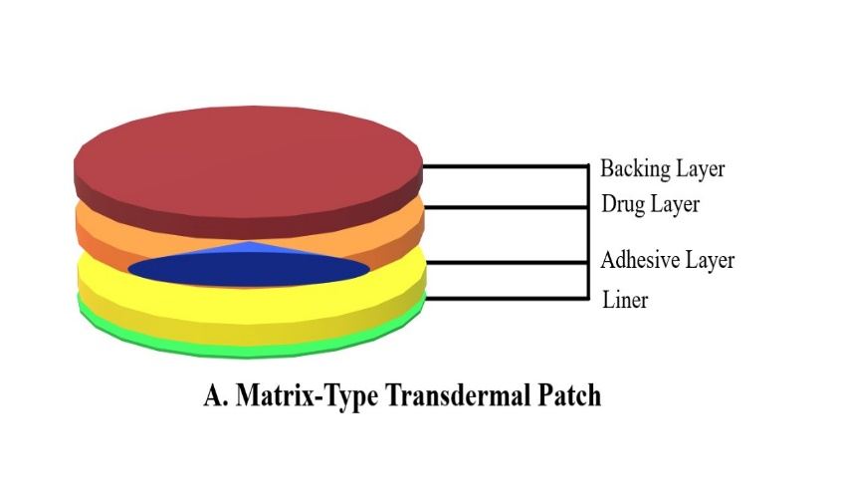 | 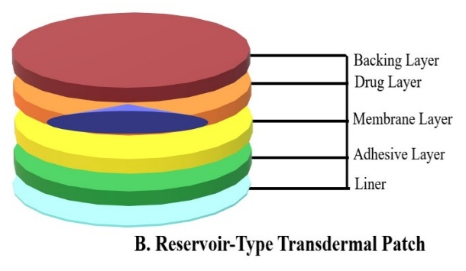
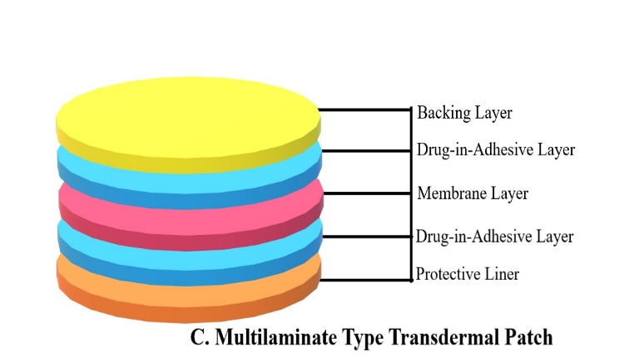 | 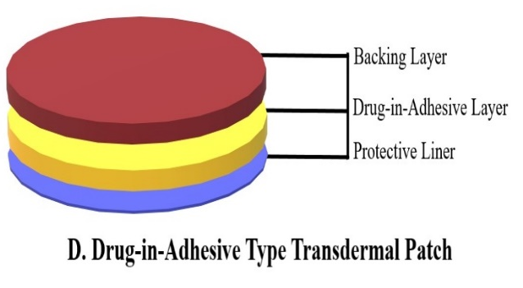
Figure 1: Types of Transdermal Patch
- Matrix-Type Transdermal Patch: This is the most basic type of transdermal patch. It is composed of aSingle layer containing both the medication & the adhesive. The medication is uniformly distributed within the adhesive layer, which is then applied to the skin. Drug-component diffuses from the sticking support through the skin and flowing towards bloodstream. These patches have a relatively simple design and are used for medications that can easily permeate the skin.
- Reservoir-Type Transdermal Patch: Reservoir patches consist of multiple layers, including a backing layer, drug reservoir, rate-controlling membrane, and adhesive layer. The drug reservoir in this type of patch is a separate compartment that contains the medication. The rate-controlling membrane controls the release of the drug from the reservoir into the adhesive layer, which then delivers the medication to the skin. Reservoir patches are suitable for drugs that have low skin permeability or those that need precisely monitor the out-coming, from the reservoir-tank.
- Multilaminate-Type-Transdermal Patch: This type of patch make with numerous layers, each one has a definite functional purpose. Layers classed as Back-Support, Drug-Content-Tank, Outcome-Modified-Film, Sticking-Performing-Support, and protectant. The drug reservoir is typically located between the rate-controlling membrane and the adhesive layer. The rate-controlling membrane controls the release of medication by regulating its diffusion through the patch. Multi-layer matrix patches are commonly used for drugs that require a more controlled release profile.
- Drug-in-Adhesive-Transdermal-Patch: Here, the medication is mixed with the sticking formator itself. The drug-in-adhesive formulation ensures that the drug is uniformly distributed within the adhesive. This design eliminates the need for a separate drug-reservoir-tank or outcome performing film. The sticking layer adheres toCorneum, and the drug outcomes gradually transcorneum fashion. These patches are often used for drugs that require a relatively high dose or prolonged release.[4,5]
- DESIGN AND FORMULATION
When designing and formulating transdermal patches, several factors are taken into consideration to ensure their effectiveness and safety. Here's an overview of the key factors:
- Drug Properties: The properties of the drug being delivered play a crucial role in patch design. Factors such as the drug's molecular weight, lipophilicity (ability to dissolve in fats), and solubility are considered. Lipophilic drugs tend to have better permeation through the skin, while hydrophilic drugs may require specific formulation approaches to enhance their penetration.
- Skin Permeation: The permeability of the skin is a critical consideration. Skin corneum is the barricade to the outer last layer. And acts as a barricade for the penetration ofDrug. Understanding the skin's characteristics, such as thickness and lipid composition, helps determine the optimal formulation and delivery strategies to enhance drug permeation.
- Formulation Components: The selection of formulation components is essential to achieve the desired drug release profile and patch stability. The drug reservoir, adhesive layer, backing layer, and drug delivery membrane (if used) must be carefully chosen based on compatibility with the drug, skin adhesion, and controlled drug release.
- Patch Design: The design of the transdermal patch is vital to ensure proper adhesion, patient comfort, and ease of application. Changeable items such as the size,shape, and flexibility belonging to patch are considered to optimize contact with the skin, minimize irritation, and allow freedom of movement for the patient.
- Release Kinetics: Controlling the outcoming of the drug the transdermal patch is critical to achieve the desired therapeutic effect. The formulation may incorporate rate-controlling membranes, polymers, or excipients that govern the release kinetics. This ensures a consistent and controlled delivery of the drug over a specified period.
- Permeation Enhancers: Some transdermal patches may include permeation enhancers to modernise drug’s penetration through trans-cornea route. These enhancers can temporarily alter the barrier properties of the skin, increase its hydration, or remodify the lipid structural-stratum-cornea. The choice and concentration of permeation enhancers are carefully determined to ensure efficacy and safety.
- Patient Factors: Consideration is given to factors specific to the patients, such as age, skin condition, and lifestyle. These factors can influence the patch design and formulation to accommodate variations in skin permeability, sensitivity, and patient preferences.
- Safety and Biocompatibility: The safety and biocompatibility of the patch materials are critical considerations. Patch components should not cause skin irritation, allergic reactions, or systemic toxicity. Extensive testing and evaluation are performed to note about safely integral patch formulation.
In the development and design of transdermal drug delivery systems, various considerations come into play, including drug characteristics, permeation enhancers, patch size, and adhesive selection. These factors significantly impact the effectiveness and safe conclusion of the system.
- Drug Characteristics: The properties of the drug being delivered play a crucial role in determining the feasibility of transdermal delivery. We expect that low Mol. W., and greater fat – dissolvable characters, including solubility influence the drug's ability to permeate the skin barrier. Ideally, pharmacophore may have a small mol. wt, high fat affinity, and sufficient solubility in the chosen formulation to achieve effective permeation.
- Permeation Enhancers: Transdermal drug delivery often requires the use of permeation enhancers to facilitate drug absorption through the skin. Permeation enhancers can modify the skin barrier properties by altering its lipid structure or increasing drug solubility. Careful consideration should be given to selecting safe and effective permeation enhancers to optimize drug delivery without causing skin irritation or systemic side effects.
- Patch Size: The size of the transdermal patch is an essential consideration for several reasons. Firstly, the patch should be large enough to accommodate the required drug dose. Drug amount in Transdermal Patch and surface-area of the Transdermal Patch determine drug delivery rate. Secondly, the patch size should be user-friendly, ensuring convenient application and adherence. However, excessively large patches may hinder flexibility and comfort.
- Adhesive Selection: The adhesive used in transdermal patches serves to remain connected to patch and skin. The adhesive should possess adequate tackiness to ensure patch adherence during wear but should also allow for easy removal without causing discomfort or skin damage. Friendliness of drug and remaining items of the patch formulation, as well as skin biocompatibility, are critical factors to consider in adhesive selection.[7,8,9]
Several novel technologies and innovations have emerged in recent years, revolutionizing transdermal patch design. Some of them are briefly described as below:
- Microneedle Patches: Microneedle patches consist of tiny, painless microneedles that penetrate the outermost layer of the skin, creating microchannels for drug delivery. These patches can encapsulate a wide range of drugs and enable enhanced permeation through the skin. Microneedle patches offer advantages such as improved drug bioavailability, minimal invasiveness, and the potential for controlled and sustained release of therapeutics.
- Wearable Electronics and Smart Patches: Integration of electronics and sensing capabilities into transdermal patches has led to the development of wearable electronics and smart patches. These patches can monitor physiological parameters, such as heart rate, temperature, or glucose levels, and deliver drugs based on real-time feedback. They have the potential to revolutionize personalized medicine by enabling continuous monitoring and tailored drug delivery.
- Hybrid Systems: Hybrid systems combine different drug delivery technologies to optimize transdermal delivery. For example, combining transdermal patches with iontophoresis (application of an electric field) or sonophoresis (application of ultrasound) can enhance drug permeation. These hybrid systems offer improved control over drug release, increased drug loading capacity, and enhanced delivery efficiency.
- 3D Printing: 3D printing technology has expanded into the field of transdermal patch design, allowing precise fabrication of patches with customized drug-loading patterns, geometries, and release profiles. It enables the incorporation of multiple drugs, personalized dosages, and complex architectures within a single patch. 3D-printed transdermal patches offer versatility and flexibility in drug delivery.
- Nanotechnology: Nanotechnology has revolutionized transdermal patch design by enabling the formulation of drug-loaded nanoparticles or nanovesicles. These nanocarriers can penetrate the skin barrier more effectively and deliver drugs to specific targets. They offer advantages such as improved drug stability, sustained release, and the potential for targeted and controlled delivery.
- Hydrogel-based Patches: Hydrogels, three-dimensional networks of hydrophilic polymers, have gained attention in transdermal patch design. They possess excellent water retention capacity, allowing for prolonged drug release and enhanced drug permeation. Hydrogel-based patches offer advantages such as improved patient comfort, flexibility, and the effectiveness to incorporate innumerable drugs.
- MECHANISMS OF DRUG DELIVERY
SKIN PHYSIOLOGY
Skin, the ectoderm consisting three-main-layers: the outermost layer called stratum cornea, next epidermis; terminally, we have dermis.
- EPIDERMIS: It is the outermost skin’s stratum and serves as a resistant-barrier opposite to outer environment.
It consists of multiple sub-stratum, including:
- Stratum Corneum: The Stratum Corneum is the outermost layer of the epidermis. Composed of flattened, dead skin cells known as corneocytes. These corneocytes are filled with keratin, a tough and fibrous protein. The Stratum Corneum acts as the primary barrier against water loss, pathogens, and physical damage. It prevents substances from easily entering or leaving the skin. The shedding of dead cells from this layer is a continuous process, with new cells from the lower layers replacing them.
- Stratum Lucidum: The Stratum Lucidum is a translucent layer found only in areas of thick skin, such as the palms and soles. It consists of flattened, densely packed keratinocytes that lack distinct organelles and nuclei. The presence of this layer enhances the skin's ability to withstand pressure and wear.
- Stratum Granulosum: The Stratum Granulosum lies beneath the Stratum Lucidum (if present) or directly below the Stratum Corneum. It contains 3 to 5 layers of keratinocytes. Within this layer, the keratinocytes produce and accumulate granules of keratin. These granules release lipids that contribute to the waterproofing of the skin.
- Stratum Spinosum: The Stratum Spinosum is located below the Stratum Granulosum and is several cell layers thick. It gets its name from the appearance of keratinocytes that appear spiny due to cell-to-cell connections called desmosomes. These desmosomes provide structural support and strength to the epidermis. The Stratum Spinosum also houses Langerhans cells, a type of immune cell that helps protect against pathogens and allergens.
- Stratum Basale (Stratum Germinativum): Barricade of the skin’s Stratum-Basale-Layer is at the last phase of epidermis; resides on basement; away from the epidermis; with one layer of column-type; or there can be ball-type keratinocytes. This layer is responsible for the continuous cell renewal and regeneration of the epidermis. New cells are constantly produced through mitosis in the Stratum Basale and then pushed upwards towards the skin's surface. Melanocytes are also present in this layer, producing melanin, the pigment responsible for skin colour and UV protection.
- DERMIS: The dermis lies beneath the epidermis and is composed of connective tissue, blood vessels, nerves, and various cell types.
It contains two main layers:
- Papillary Dermis: The upper layer characterized by papillae that extend into the epidermis, forming fingerprints and enhancing grip.
- Reticular Dermis: The deeper and thicker layer containing collagen and elastin fibres, which provide strength, elasticity, and support to the skin.
Functions of the dermis include: Providing nourishment to the epidermis through blood vessels. Regulating temperature by controlling blood flow. Housing sensory nerve endings for touch, pressure, temperature, and pain. Housing hair follicles, sebaceous glands, and sweat glands.
- HYPODERMIS (Subcutaneous Tissue): The hypodermis lies below dermis, composing Adipose-Fatty –Tissue; also ConnectiveTissue. It serves several essential functions, such as: Insulating the body, regulating temperature, and conserving energy. Cushioning and protecting internal organs and structures. Connecting the skin to underlying tissues.

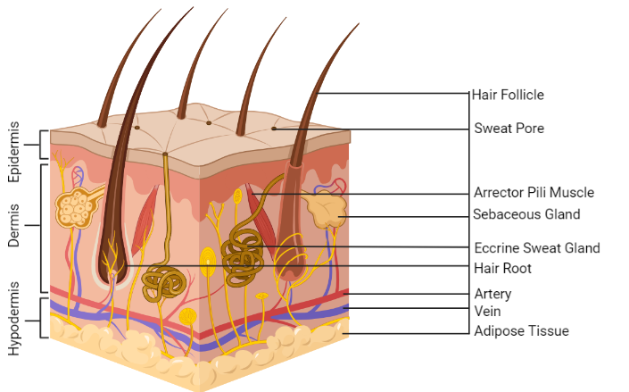
Figure 2: Layers and Component of Skin
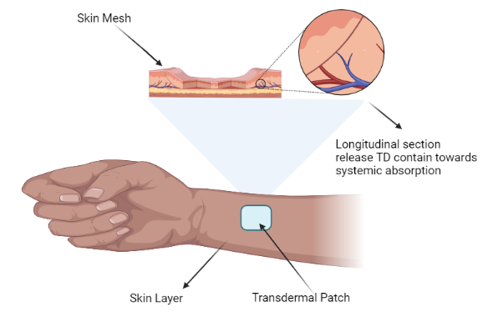
Figure 3: Slow Release of Medication from Transdermal Patch Applied on Skin

One common approach is to use patches or gels that contain the drug. These formulations are designed to enhance drug penetration through the skin. One way this is achieved is by formulating the drug in a manner that allows it to dissolve or disperse in the skin's lipid (fatty) layers. By doing so, the drug can pass through the intercellular spaces between the skin cells, ultimately reaching the underlying layers.[31,32]
Another method involves using chemical enhancers. These are substances that can modify the properties of the skin temporarily, making it more permeable to drugs. Chemical enhancers can disrupt the lipid structure of the stratum corneum, temporarily reducing its barrier function. This allows the drug molecules to diffuse more easily through the skin.
Physical methods can also be employed to enhance drug delivery through the skin. For instance, devices like iontophoresis and sonophoresis use electrical currents and ultrasound waves, respectively, to increase skin permeability. These methods create temporary channels in the skin, facilitating the passage of drugs.
Furthermore, the size and characteristics of drug molecules have important action in their ability to penetrate skin. Smaller, lipophilic (fat-soluble) molecules tend to cross the skin more easily than larger, hydrophilic (water-soluble) ones. However, certain strategies, such as using carriers or encapsulating the drug in nanoparticles, can help overcome these challenges by altering the properties of the drug molecules.[10,11,12,13]
The various pathways of drug penetration, including diffusion and iontophoresis.
- Diffusion: Diffusion is the passive movement of drug molecules from, a high drug amount (the drug formulation) to a low drug solvated area/concentration (the skin and underlying tissues). In transdermal drug delivery, diffusion occurs through two main pathways: the transcellular pathway and the intercellular pathway.
- Transcellular Pathway: Here, drug molecules penetrate through individual skin cells, known as keratinocytes. The drug molecules must dissolve in the lipids present in the cell membranes to traverse them effectively. The lipophilic nature of the drug molecules allows them to dissolve in the lipid bilayers and pass through the hydrophobic core of the cell membrane. Once inside the keratinocyte, the drug molecules can move through the cytoplasm and reach the other side of the cell membrane. They continue to diffuse through successive keratinocytes until they reach the underlying layers of the skin.
- Intercellular Pathway: The intercellular pathway involves drug molecules moving through the intercellular spaces between the skin cells. The primary barrier in this pathway is the stratum corneum, the outermost layer of the skin composed of dead keratinocytes and lipids. The drug molecules must navigate through the narrow spaces between the cells, which are filled with lipids. The lipophilic drug molecules can dissolve in these intercellular lipids, allowing them to diffuse through the stratum corneum. The intercellular pathway is a crucial route for drug penetration as it constitutes the major barrier in transdermal drug delivery.
- Iontophoresis: Iontophoresis is a technique that employs electrical currents to facilitate the delivery of charged drug molecules through the skin. The process involves applying a small electric current to the skin using electrodes. The electric field generated by the current influences the movement of charged drug molecules. Iontophoresis can be divided into two categories based on the polarity of the applied current:
- Cathodal Iontophoresis: In cathodal iontophoresis, a negative electrode (cathode) is placed near the drug formulation on the skin's surface. The negatively charged drug molecules (anions) in the formulation are repelled by the cathode. The repulsive force pushes the drug molecules towards the skin, facilitating their penetration through the skin layers. Cathodal iontophoresis is commonly used for delivering negatively charged drugs.
- Anodal Iontophoresis: Anodal iontophoresis involves placing a positive electrode (anode) near the drug formulation on the skin. The positively charged drug molecules (cations) in the formulation are repelled by the anode. This repulsion propels the drug molecules into the skin, aiding their penetration through the skin layers. Anodal iontophoresis is typically employed for delivering positively charged drugs.
During iontophoresis, the electrical current also alters the barrier properties of the skin temporarily. The electric field disrupts the lipid structure of the stratum corneum, leading to the creation of transient channels called electropores. These electropores increase the permeability of the skin, allowing for enhanced penetration of the drug molecules.
- EVALUATION PARAMETERS
- Drug Content Uniformity: Drug content uniformity is the measurement of the consistency of drug distribution within the transdermal patch. It ensures that each patch contains the specified amount of medication, providing consistent dosing to the patient. This parameter is critical because a non-uniform drug distribution can lead to variations in drug delivery, potentially resulting in underdosing or overdosing.
Testing Method: Drug content uniformity is typically determined by cutting several patches from different parts of a production batch and extracting the drug from each patch. The drug is then quantified using a validated analytical method, such as high-performance liquid chromatography (HPLC) or ultraviolet-visible (UV-Vis) spectroscopy.
- In vitro Release Rate: In vitro release rate studies evaluate how quickly and consistently the drug is released from the transdermal patch over time. This information helps establish the patch's release profile, ensuring that the drug is delivered at the desired rate to achieve therapeutic effects.
Testing Method: In vitro release rate studies involve placing the patch in a suitable dissolution apparatus that simulates the skin environment. The release medium, usually a buffer or simulated physiological fluid, is agitated to mimic the skin's conditions. Samples are collected at specific time points, and the drug concentration in the release medium is measured using validated analytical methods.
- Adhesion Properties: Adhesion testing assesses the ability of the patch to stick to the skin and remain in place during normal wear. Proper adhesion is essential to ensure consistent drug delivery and avoid accidental detachment during use.
Testing Method: Adhesion tests are conducted using a peel adhesion test apparatus. The patch is attached to a surface, and a controlled force is applied to peel it off at a specific angle and speed. The force required to remove the patch is measured, and adhesion properties are evaluated based on the results.
- Skin Irritation: Skin irritation testing determines whether the transdermal patch causes any adverse reactions or skin sensitivities when applied to the skin. It is crucial to ensure that the patch does not cause harm or discomfort to patients.
Testing Method: Skin irritation studies are typically performed on animal subjects, such as rabbits or guinea pigs, as well as human volunteers in some cases. The patch is applied to a specific area of the skin for a defined duration, and the site is examined for signs of irritation, such as redness, swelling, or itching.
- Permeation Studies: Permeation studies evaluate the ability of the drug to pass through the skin barrier and enter the bloodstream. This information is crucial to assess the patch's overall effectiveness in delivering the drug systemically.
Testing Method: Permeation studies are usually conducted using in vitro diffusion cells, where the patch is placed between the donor and receptor compartments, simulating the skin's barrier. The drug permeating through the skin is collected and quantified at specific time intervals using validated analytical methods.
- Physical Appearance: Physical appearance evaluation ensures that the transdermal patch is free from defects, discoloration, or other visual imperfections that might impact its performance or patient acceptability.
Testing Method: Visual inspection is the primary method for assessing the patch's physical appearance. It involves examining the patches under adequate lighting conditions to identify any defects or abnormalities.
- Patch Thickness and Weight: Measuring the thickness and weight of the patches helps ensure consistency in manufacturing and aids in proper handling and application by patients.
Testing Method: Thickness is usually measured using a micrometer or calliper at multiple points across the patch, and the average thickness is calculated. The weight is determined by weighing individual patches on a sensitive balance.
- Water Vapor Transmission Rate (WVTR): WVTR testing assesses the transdermal patch's ability to allow water vapor to pass through. Proper WVTR is essential for maintaining skin health and comfort during patch use.
Testing Method: WVTR is typically measured using specialized equipment that measures the water vapor transmission through the patch. The patch is placed over a diffusion cell, and the water vapor permeating through the patch is quantified over a specific time period.
- Residual Solvent Content: Residual solvent content testing ensures that the final transdermal patch product does not contain harmful levels of solvents used in the manufacturing process.
Testing Method: Residual solvent content is analyzed using validated analytical techniques, such as gas chromatography (GC) or liquid chromatography (LC).
- Microbiological Testing: Microbiological testing is conducted to determine whether the transdermal patch is free from microbial contamination that could pose a risk of infection upon application.
Testing Method: Microbiological testing involves taking samples from the patch and subjecting them to appropriate microbial testing methods, such as microbial enumeration and identification.
- Stability Testing: Stability studies evaluate the transdermal patch's shelf life and performance under various environmental conditions over a specified period. It ensures that the patch remains effective and safe throughout its intended use.
Testing Method: Stability studies involve storing the patches under controlled temperature and humidity conditions for specific time periods. Samples are periodically taken for evaluation of drug content, physical appearance, and other relevant parameters.
- Drug-Excipient Compatibility: Drug-excipient compatibility testing assesses whether the drug and the patch's excipients are chemically compatible. It ensures that there are no adverse interactions that could affect the drug's stability or efficacy.
Testing Method: Various techniques, such as differential scanning calorimetry (DSC) or Fourier-transform infrared (FTIR) spectroscopy, are used to study the interactions between the drug and excipients.[14,15,16,29,30]
- APPLICATIONS
Transdermal patches have revolutionized the field of medicine, offering a unique and effective mode of drug delivery. These patches adhere to the skin and gradually release medication into the bloodstream, bypassing the digestive system and providing numerous advantages over traditional oral or injectable routes. Let's delve into the diverse therapeutic areas where transdermal patches have demonstrated remarkable success.
- Pain management stands out as one of the primary domains benefiting from transdermal patches. Chronic pain conditions such as osteoarthritis, fibromyalgia, and neuropathic pain can be effectively treated with patches containing analgesic agents like opioids or nonsteroidal anti-inflammatory drugs (NSAIDs). The steady release of medication through the patch ensures a consistent pain relief, allowing patients to regain control over their lives.
- Hormone replacement therapy (HRT) is another area where transdermal patches have excelled. Women undergoing menopause often experience symptoms like hot flashes, mood swings, and decreased bone density due to declining hormone levels. Transdermal patches containing oestrogen and progesterone can deliver these hormones steadily, mimicking the natural hormone production and alleviating menopausal symptoms.
- The cardiovascular realm has also witnessed significant advancements with transdermal patches. Nitro-glycerine patches, for instance, have proven effective in treating angina pectoris, a condition characterized by chest pain resulting from insufficient blood flow to the heart. By releasing nitro-glycerine through the skin, these patches relax and widen the blood vessels, improving blood supply to the heart and reducing angina episodes.
- Neurological disorders, such as Parkinson's disease, have found relief through transdermal patches. Medications like rotigotine, a dopamine agonist, can be delivered through patches to alleviate motor symptoms associated with Parkinson's. This non-invasive approach provides continuous drug release, ensuring a more stable therapeutic effect and improving patients' quality of life.
- Psychiatric conditions, including depression and attention deficit hyperactivity disorder (ADHD), have also benefited from transdermal patches. Patches containing antidepressants like selegiline have shown promise in managing depressive symptoms. Similarly, methylphenidate patches have provided a controlled and sustained release of medication for individuals with ADHD, improving attention span and reducing impulsivity.[17,18,19,20]
Some examples of specific drugs and conditions for which transdermal patches have shown efficacy.
- Fentanyl Patch (Duragesic): This opioid analgesic patch is used for managing chronic pain, particularly in cancer patients or those with severe pain conditions.
- Estradiol Patch (Climara, Vivelle-Dot): Transdermal estradiol patches are commonly prescribed for hormone replacement therapy (HRT) in menopausal women to alleviate symptoms like hot flashes, vaginal dryness, and mood swings.
- Scopolamine Patch (Transderm Scōp): These patches are utilized to prevent motion sickness and treat nausea and vomiting associated with travel or other conditions.
- Nitroglycerin Patch (Nitro-Dur): Nitroglycerin patches are used to relieve angina symptoms in patients with coronary artery disease by dilating blood vessels and improving blood flow to the heart.
- Rivastigmine Patch (Exelon): This patch is employed for the treatment of mild to moderate Alzheimer's disease and Parkinson's disease dementia, delivering a steady dose of the medication to improve cognitive function.
- Rotigotine Patch (Neupro): It is a dopamine agonist patch used to manage symptoms of Parkinson's disease and restless legs syndrome by providing a continuous release of medication.
- Methylphenidate Patch (Daytrana): This patch is prescribed for children with attention deficit hyperactivity disorder (ADHD) to improve attention and reduce hyperactivity and impulsivity.
- Lidocaine Patch (Lidoderm): Lidocaine patches are applied to the skin to relieve localized pain, such as post-herpetic neuralgia (pain following shingles), by numbing the area.
- Nicotine Patch (Nicoderm CQ, Habitrol): These patches are utilized as part of smoking cessation programs to help individuals quit smoking by delivering a controlled dose of nicotine to reduce withdrawal symptoms and cravings.
- MARKETED PRODUCTS AVAILABLE
There are various marketed products available that are commercially used; some of them are mentioned in Table 1, below:
Table 1: Marketed Products
Sl. No. | Brand Name | Primary API | Therapeutic Use
1 | Powergesic® | Diclofenac | Pain Relieving
2 | Estradot® | Oestradiol | Oestrogen deficiency symptoms
3 | Enokon® | Borneol 1% | Topical Analgesic
4 | Sumifun® | Herbal Phytoconstituent | Bone pain Reliever and Muscle and Joint Soreness
5 | Transderm Scop® | Scopolamine | Motion sickness and Nausea
6 | MQ® Motion Sickness | Scopolamine | Motion sickness
7 | Bodywise® | Salicylic Acid | Acne and Pimple healing
8 | NUA® Cramp Comfort | Natural Ingredients | Pain Reliever, Heat Patch for Peroid Pain
9 | Sirqna® | Herbal Phytoconstituent | Feminine Pain Reliever
10 | Bupreplast® | Buprenorphine | Migraine and Pain Reliever
11 | Neupro Patch® | Rotigotine | Parkinson's disease and Restless Legs Syndrome.
12 | Dicloplast® | Diclofenac | Osteoarthritis, Sprain, Strain
13 | Nicoderm CQ® | Nicotine | Smoking Cessation
14 | Habitrol® | Nicotine | Smoking Cessation

- CHALLENGES AND LIMITATIONS
- Drug Compatibility: Transdermal patches require drugs that can penetrate the skin barrier effectively. Factors such as molecular size, charge, and lipophilicity impact the drug's ability to pass through the skin. Larger or hydrophilic molecules may have difficulty crossing the skin barrier, limiting the range of drugs that can be delivered via transdermal patches.
- Skin Irritation: Some individuals may experience skin irritation or allergic reactions at the site of patch application. This can be attributed to the adhesive used in the patch or the drug formulation itself. Skin irritation can range from mild redness and itching to more severe reactions. In some cases, this may necessitate discontinuation of the patch or the use of additional measures, such as applying a barrier cream or using a different patch formulation.
- Variable Absorption: The absorption of drugs through the skin can be influenced by various factors. Skin condition, such as dryness or damage, can affect the permeability of the skin and consequently impact drug absorption. Factors like temperature, hydration levels, and individual variations in skin physiology can also influence drug absorption, leading to variability in therapeutic outcomes.
- Drug Loading Capacity: Transdermal patches have a limited capacity to hold drugs. The drug reservoir within the patch has a finite volume, which restricts the use of high-dose medications or drugs requiring large volumes. For drugs with short half-lives or those needing to be administered in large amounts, frequent patch changes may be necessary to maintain therapeutic levels.
- Slow Onset and Offset of Action: Transdermal patches provide a controlled and sustained release of drugs, resulting in a slower onset of action compared to other routes of administration. This delay in drug absorption can be a limitation in situations where rapid therapeutic effects are required. Additionally, the slow elimination of the drug from the body after patch removal can extend the duration of the therapeutic effect, which may not always be desirable, particularly in cases of adverse effects.
- Limited Range of Molecules: Transdermal delivery is most effective for small, lipophilic molecules that can pass through the skin's lipophilic stratum corneum layer. Hydrophilic drugs or larger molecules, such as proteins and peptides, face challenges in crossing the skin barrier. Overcoming these challenges requires the development of innovative techniques and delivery systems to enhance the permeation of these molecules.
- Site Dependency: The site of patch application can impact drug absorption and efficacy. Some patches may require specific application sites, such as the upper arm or abdomen, for optimal drug delivery. This site dependency can limit the flexibility and convenience for patients, especially if repeated applications are needed or if certain areas are not suitable due to skin sensitivity or irritation. It may also necessitate the rotation of application sites to avoid local skin irritation or the accumulation of residual drug.
- Cost: Transdermal patches can be more expensive compared to oral medications. The complexity of their formulation, manufacturing processes, and specialized delivery systems contribute to the higher cost. This can impact affordability and access to certain therapeutic options, particularly in regions with limited healthcare resources or where insurance coverage is limited.[21,22,23,24,25]

- SAFETY, EFFICACY, AND PATIENT CONSIDERATIONS
- Safety Profile:

- Localized Adverse Reactions: The most common adverse events associated with transdermal patches are localized skin reactions at the application site. These can include mild irritation, redness, itching, or rash. These reactions are typically mild and transient, resolving once the patch is removed.
- Systemic Side Effects: Compared to oral medications, transdermal patches can minimize systemic side effects by delivering medication directly into the bloodstream, bypassing the gastrointestinal system. This reduces the likelihood of gastrointestinal disturbances, such as nausea or stomach upset.
- Reduced Risk of Drug Interactions: Transdermal patches generally have a lower risk of drug interactions compared to orally administered drugs. By avoiding the first-pass metabolism in the liver, drug interactions that occur during the hepatic metabolism are minimized.
- Controlled Drug Release: The controlled release of medication from transdermal patches helps maintain steady and consistent drug levels in the bloodstream, reducing the risk of sudden peaks or troughs that can contribute to adverse effects.
- Compliance and Dosing Accuracy: Transdermal patches offer the advantage of simplified dosing regimens and improved patient compliance. The patches are typically designed for once-daily or less frequent application, reducing the risk of missed doses or medication errors.

- Efficacy Profile:

- Sustained Therapeutic Effect: Transdermal patches provide a sustained and controlled release of medication over an extended period, maintaining therapeutic drug levels in the body. This can result in continuous symptom relief and improved therapeutic outcomes.
- Reduced Fluctuations in Drug Levels: The controlled release of medication through transdermal patches helps minimize fluctuations in drug levels compared to oral medications, which can have peak and trough effects. This contributes to more stable and predictable therapeutic responses.
- Improved Bioavailability: For certain drugs, transdermal delivery can improve bioavailability by bypassing the first-pass metabolism in the liver. This allows a higher proportion of the drug to reach the systemic circulation, potentially enhancing efficacy.
- Tailored Dosing: Transdermal patches can be designed to deliver drugs in specific doses and release rates, allowing for customized therapy based on individual patient needs. This tailored dosing approach can optimize therapeutic outcomes and improve patient response.
- Non-Invasive Administration: Transdermal patches offer a non-invasive route of drug administration, eliminating the need for injections or swallowing of medications. This can enhance patient comfort, convenience, and acceptance of treatment.

Factors influencing patch adherence, skin sensitivity and lifestyle considerations.
- Skin Sensitivities:
- Skin Irritation: Some individuals may experience skin irritation or allergic reactions in response to the adhesive or drug formulation present in the patch. This can manifest as redness, itching, or a rash at the site of application. It is important for individuals to monitor their skin for any signs of irritation and inform their healthcare provider if they experience discomfort.
- Skin Sensitivity: Certain individuals have inherently sensitive skin, which can make them more prone to developing reactions or discomfort when using transdermal patches. Skin conditions such as eczema or psoriasis can further contribute to skin sensitivity and may require careful monitoring during patch use.
- Allergies: Allergies to specific ingredients or materials used in the patch, such as adhesives or drug components, can cause allergic reactions. It is important for individuals to inform their healthcare provider about any known allergies or previous reactions to certain substances to ensure suitable alternatives are considered.

- Lifestyle considerations:
- Physical Activity: Individuals engaged in vigorous physical activities, such as exercise or sports, may find that the patch does not adhere well due to sweating, friction, or movement. This can lead to patch detachment or reduced drug delivery efficacy. It may be necessary to explore additional measures, such as using additional adhesives or considering alternative dosing options, to ensure drug delivery during such activities.
- Water Exposure: Some patches may not be designed to withstand exposure to water, limiting their use during activities like swimming, bathing, or showering. Water exposure can affect patch adhesion or compromise drug delivery, reducing patch efficacy. It is important to follow the manufacturer's instructions regarding water exposure and consider alternate dosing methods if required.
- Clothing and Cosmetics: Certain clothing fabrics or cosmetics, such as lotions or oils, can interfere with patch adhesion. It is important to ensure that the application site is clean, dry, and free from any substances that may hinder patch adherence. In some cases, adjusting the application site or timing of patch application may be necessary to avoid interference from clothing or cosmetic products.
- Environmental Factors: Environmental factors such as heat, humidity, or extreme cold can affect patch adhesion and drug delivery. High humidity or excessive sweating can compromise the adhesive properties of the patch, leading to detachment. Extreme temperatures can affect the stability of the drug formulation. Individuals should be mindful of these factors and take appropriate precautions, such as applying the patch to areas less prone to sweating or storing patches in appropriate conditions.

- Patient Education and Support:
- Proper Application Technique: Ensuring that individuals understand the correct application technique for transdermal patches is crucial. Healthcare professionals should provide clear instructions on proper cleansing of the application site, appropriate pressure during patch application, and adherence to recommended patch change intervals. Demonstrating the correct technique and allowing individuals to practice under supervision can enhance adherence.
- Patch Handling: Proper handling of patches is important to prevent damage and ensure effectiveness. Individuals should be educated on avoiding excessive touching or folding of the patch and instructed on proper storage to maintain the integrity of the adhesive and drug formulation.
- Patient Engagement: Engaging patients in discussions about their preferences, concerns, and experiences with transdermal patches can help address any issues that may affect adherence. Open communication between patients and healthcare providers allows for addressing questions or misconceptions, identifying potential barriers to adherence, and finding solutions that work best for the individual. Patient engagement in decision-making regarding patch usage can enhance their sense of ownership and commitment to therapy.[26,27,28]

- FUTURE PERSPECTIVES AND INNOVATIONS
- Personalized Medicine:
Transdermal patches can contribute to personalized medicine by tailoring drug delivery to individual patient needs.
- Dosing Optimization: Transdermal patches can be designed to deliver precise doses of medication, allowing for personalized dosing regimens based on a patient's specific requirements.
- Pharmacokinetic Variability: The controlled and sustained release of drugs through transdermal patches helps minimize pharmacokinetic variability among individuals, ensuring consistent therapeutic drug levels and optimizing treatment outcomes.
- Individualized Drug Selection: Transdermal patches provide an alternative route of drug administration, allowing for personalized drug selection based on patient characteristics, such as allergies, preferences, or co-morbidities.

- Combinational Therapies:
Transdermal patches can be utilized in combination therapy approaches, delivering multiple drugs simultaneously for enhanced therapeutic effects.
- Synergistic Drug Combinations: Transdermal patches enable the co-administration of drugs with complementary mechanisms of action, enhancing therapeutic outcomes by targeting multiple pathways or disease processes simultaneously.
- Improved Treatment Compliance: Combination therapy through transdermal patches reduces the need for separate drug administrations, simplifying treatment regimens and enhancing patient compliance.
- Dose Optimization and Drug Interactions: By controlling drug release rates and minimizing systemic exposure, transdermal patches can help optimize dosing and minimize potential drug interactions in combination therapies.
- Targeted Drug Delivery:
Transdermal patches can facilitate targeted drug delivery, allowing drugs to be delivered directly to specific sites or tissues within the body.
- Localized Therapeutic Effects: Transdermal patches can be designed to release drugs at specific application sites, enabling localized therapeutic effects for conditions like pain, inflammation, or dermatological disorders.
- Transdermal Microneedle Patches: Microneedle patches, which contain small needles that painlessly penetrate the skin, can be used for targeted drug delivery to deeper skin layers or even into the systemic circulation.
- Site-Specific Drug Release: By selecting appropriate application sites, transdermal patches can target specific areas or tissues where drug delivery is required, optimizing therapeutic efficacy while minimizing systemic exposure and potential side effects.

- Herbal Transdermal Patch
A herbal transdermal patch is a type of patch that delivers herbal or plant-based ingredients through the skin. It is designed to be applied to the skin, allowing the active components of the herbs to be absorbed into the bloodstream over a period of time. These patches typically consist of several layers. The outer layer is often made of a flexible and adhesive material that adheres to the skin. This layer helps to keep the patch in place during use. The inner layers contain the herbal ingredients, which are usually in the form of extracts, oils, or powders. These layers may also include other components such as stabilizers, enhancers, or permeation agents to facilitate the absorption of the herbal compounds into the skin.
The transdermal delivery system of these patches allows for the gradual release of the herbal ingredients into the bloodstream. The patches are usually applied to clean and dry skin in areas where there is minimal hair growth, such as the upper arm, shoulder, or back. The adhesive layer ensures that the patch remains in place for the recommended duration, typically ranging from a few hours to several days, depending on the specific patch.The herbal ingredients in these patches can vary widely, depending on their intended purpose. For example, some patches may contain herbs known for their pain-relieving properties, such as arnica or capsaicin, and are used for localized pain management. Others may include herbs known for their calming or sleep-promoting effects, like lavender or chamomile, and are used to support relaxation or improve sleep quality.
The concept behind herbal transdermal patches is based on the principle that certain active components of herbs can be absorbed through the skin and reach the bloodstream, bypassing the digestive system. This method of delivery is believed to offer advantages such as sustained release of the herbal compounds, avoiding potential issues associated with oral administration (e.g., digestive breakdown or liver metabolism), and providing localized effects. It's important to note that while herbal transdermal patches are generally considered safe, it's advisable to consult with a healthcare professional before using them, especially if you have any underlying medical conditions or are taking medications. They can provide guidance on the appropriate use, potential interactions, and any specific precautions to consider.

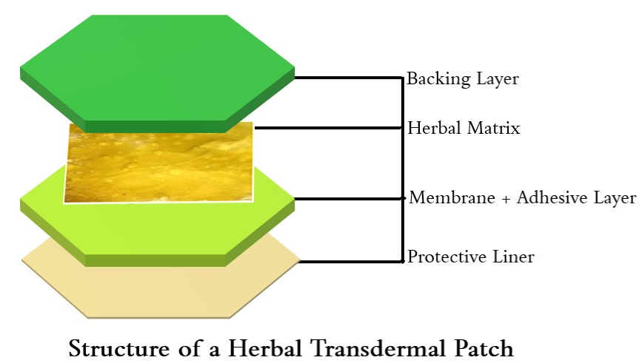
Figure 4: Structural layers of Herbal Transdermal Patch
Quantitative Estimation of Secondary Metabolites
Only for the Herbal Transdermal Patch, we need to consider estimating the Total content of the secondary metabolites of the phytoconstituents that is the absolute component of any herbal product. For the herbal transdermal patch, we need to perform the pharmacologically active phytoconstituents by first preparing the Calibration Curve of Standard Compound which are different for various type of phytoconstituent. The different components must be carefully selected for the evaluation. Then the Quantification is calculated by UV-Visible Spectroscopy and from the Standard Curve by using Straight-line equation. The list of compounds that are used for different phytoconstituent content evaluation are mentioned in Table 2, as follows;

Table 2: Phytoconstituents and Corresponding Standard Reference Compounds used
Sl. No. | Phyto-Constituents | Standard Reference Compounds
1 | Alkaloids | Caffeine, Typtophan or other similar biosynthetic pathway precursor.
2 | Phenols | Gallic Acid
3 | Flavonoids | Quercetin
4 | Terpenoids | Rutin
5 | Glycosides | Standard Marker like Digoxin
6 | Saponins | Diosgenin is compound used as a representative sapogenin.
7 | Tannins | Tannic Acid or Catechin

- CONCLUSION
A quick recap of the key points covered in the chapter.
- Transdermal patches are a mode of drug delivery that adhere to the skin and gradually release medication into the bloodstream, bypassing the digestive system (Especially first-pass effect).
- Transdermal patches have been successfully utilized in various therapeutic areas, including pain management, hormone replacement therapy, cardiovascular disorders, neurological conditions, psychiatric illnesses, and smoking cessation.
- Specific examples of drugs and conditions where transdermal patches have shown efficacy include fentanyl for chronic pain, estradiol for hormone replacement therapy, nitro-glycerine for angina, and rotigotine for Parkinson's disease.
- Transdermal patches offer advantages such as sustained drug release, reduced gastrointestinal side effects, improved patient compliance, and controlled drug delivery.
- Challenges and limitations of transdermal patches include drug compatibility, skin sensitivities, variable absorption, limited drug loading capacity, slow onset and offset of action, limited range of molecules, site dependency, and cost.
- The safety profile of transdermal patches is generally favourable, with localized skin reactions being the most common adverse event. Transdermal delivery can also reduce systemic side effects and the risk of certain drug interactions.
- The efficacy profile of transdermal patches includes sustained therapeutic effects, reduced fluctuations in drug levels, improved bioavailability for some drugs, tailored dosing, and non-invasive administration.
- Factors influencing patch adherence include skin sensitivities, such as irritation and allergies, as well as lifestyle considerations like physical activity, water exposure, clothing and cosmetics, and environmental factors.
- Patient education and support, including proper application techniques, patch handling guidance, and patient engagement, play a crucial role in improving patch adherence and overall efficacy.
- Transdermal patches have potential applications in personalized medicine, combination therapies, and targeted drug delivery, allowing for tailored drug delivery, synergistic effects, and localized therapeutic effects.

- REFERENCES

- Ahmed OA, Afouna MI, El-Say KM, Abdel-Naim AB, Khedr A, Banjar ZM. Optimization of self-nanoemulsifying systems for the enhancement of in vivo hypoglycemic efficacy of glimepiride transdermal patches. Expert opinion on drug delivery. 2014 Jul 1;11(7):1005-13.
- Al Hanbali OA, Khan HM, Sarfraz M, Arafat M, Ijaz S, Hameed A. Transdermal patches: Design and current approaches to painless drug delivery. Acta Pharmaceutica. 2019 Jun 30;69(2):197-215.
- Ale I, Lachapelle JM, Maibach HI. Skin tolerability associated with transdermal drug delivery systems: an overview. Advances in therapy. 2009 Oct;26:920-35.
- Baldwin CM, Keating GM. Rotigotine transdermal patch: a review of its use in the management of Parkinson’s disease. CNS drugs. 2007 Dec;21:1039-66.
- Chaudhuri KR. Crystallisation within transdermal rotigotine patch: is there cause for concern?. Expert opinion on drug delivery. 2008 Nov 1;5(11):1169-71.
- Chung SJ, Asgharnejad M, Bauer L, Ramirez F, Jeon B. Evaluation of rotigotine transdermal patch for the treatment of depressive symptoms in patients with Parkinson’s disease. Expert opinion on pharmacotherapy. 2016 Jul 23;17(11):1453-61.
- Cilurzo F, Gennari CG, Minghetti P. Adhesive properties: a critical issue in transdermal patch development. Expert opinion on drug delivery. 2012 Jan 1;9(1):33-45.
- Deshwal S, Verma N. Optimization techniques in transdermal drug delivery system. International Journal of Pharmaceutical Sciences and Research. 2012 Aug 1;3(8):2362.
- Dhillon S. Rivastigmine transdermal patch: a review of its use in the management of dementia of the Alzheimer’s type. Drugs. 2011 Jun;71:1209-31.
- Emre M, Bernabei R, Blesa R, Bullock R, Cunha L, Daniels H, Dziadulewicz E, Förstl H, Frölich L, Gabryelewicz T, Levin O. Drug profile: transdermal rivastigmine patch in the treatment of Alzheimer disease. CNS neuroscience & therapeutics. 2010 Aug;16(4):246-53.
- Frampton JE. Rotigotine transdermal patch: a review in Parkinson’s disease. CNS drugs. 2019 Jul 1;33(7):707-18.
- Hadgraft J, Lane ME. Drug crystallization–implications for topical and transdermal delivery. Expert opinion on drug delivery. 2016 Jun 2;13(6):817-30.
- Hong I, Gabay M, Lodolce A. Safety concerns involving transdermal patches and magnetic resonance imaging (MRI). Hospital Pharmacy. 2010 Oct;45(10):771-8.
- Isaac M, Holvey C. Transdermal patches: the emerging mode of drug delivery system in psychiatry. Therapeutic advances in psychopharmacology. 2012 Dec;2(6):255-63.
- Ita KB. Transdermal drug delivery: Progress and challenges. Journal of Drug Delivery Science and Technology. 2014 Jan 1;24(3):245-50.
- Kalia YN, Guy RH. Modeling transdermal drug release. Advanced drug delivery reviews. 2001 Jun 11;48(2-3):159-72.
- Keleb E, Sharma RK, Mosa EB, Aljahwi AA. Transdermal drug delivery system-design and evaluation. International journal of advances in pharmaceutical sciences. 2010 Jul 1;1(3).
- Kurz A, Farlow M, Lefevre G. Pharmacokinetics of a novel transdermal rivastigmine patch for the treatment of Alzheimer’s disease: a review. International journal of clinical practice. 2009 May;63(5):799-805.
- Lampert A, Seiberth J, Haefeli WE, Seidling HM. A systematic review of medication administration errors with transdermal patches. Expert opinion on drug safety. 2014 Aug 1;13(8):1101-14.
- Mathews L, Roy A. Management of pain using transdermal patches-a review. MANAGEMENT. 2016;9(6).
- Pastore MN, Kalia YN, Horstmann M, Roberts MS. Transdermal patches: history, development and pharmacology. British journal of pharmacology. 2015 May;172(9):2179-209.
- Prabhakar D, Sreekanth J, Jayaveera KN. Transdermal drug delivery patches: A review. Journal of Drug Delivery and Therapeutics. 2013 Jul 17;3(4):231-21.
- Rapoport AM, Freitag F, Pearlman SH. Innovative delivery systems for migraine: the clinical utility of a transdermal patch for the acute treatment of migraine. CNS drugs. 2010 Nov;24:929-40.
- Riviere JE, Papich MG. Potential and problems of developing transdermal patches for veterinary applications. Advanced Drug Delivery Reviews. 2001 Sep 1;50(3):175-203.
- Sabbagh F, Kim BS. Recent advances in polymeric transdermal drug delivery systems. Journal of controlled release. 2022 Jan 1;341:132-46.
- Sharma N. A brief review on transdermal patches. Organic & Medicinal Chemistry International Journal. 2018;7(2):58-62.
- Sharma PK, Panda A, Pradhan A, Zhang J, Thakkar R, Whang CH, Repka MA, Murthy SN. Solid-state stability issues of drugs in transdermal patch formulations. AAPS PharmSciTech. 2018 Jan;19:27-35.
- Tanner T, Marks RJ. Delivering drugs by the transdermal route: review and comment. Skin Research and Technology. 2008 Aug;14(3):249-60.
- Thomas BJ, Finnin BC. The transdermal revolution. Drug discovery today. 2004 Aug 1;9(16):697-703.
- Winblad B, Machado JC. Use of rivastigmine transdermal patch in the treatment of Alzheimer's disease. Expert opinion on drug delivery. 2008 Dec 1;5(12):1377-86.
- Wohlrab J, Kreft B, Tamke B. Skin tolerability of transdermal patches. Expert Opinion on Drug Delivery. 2011 Jul 1;8(7):939-48.
- Yilmaz EG, Ece E, Erdem Ö, Eş I, Inci F. A Sustainable Solution to Skin Diseases: Ecofriendly Transdermal Patches. Pharmaceutics. 2023 Feb 8;15(2):579.

