Role of Plant Virus and Virus like particles in Biotechnology
Vasudha Sharma¹, Yashika Dhir¹ and Sunny Dhir^{1*}
Department of Biosciences & Technology, Maharishi Markandeshwar (Deemed to be University), Mullana, Ambala
1. Introduction
Viruses are minute life forms which act as infectious agents that occur solely within the cell and multiply in animal cells, plant cells, or bacterial cells. Viruses mostly contains either of the nucleic acid, may be RNA or DNA, which is encased in a sheath of protein that shields the viral genes [1]. Viruses are simple biological systems that can evolve highly effective strategies for damaging cells, communicating their genes, and replicating themselves [2]. Most known viral classes can be genetically manipulated to make recombinant viruses that express foreign proteins. Mostly viruses also have a viral encasing that protects the nucleocapsids by including membrane lipids and proteins of the host cell as well as glycoproteins of virus that shield viral destruction outside of the cell and aid in virus adhesion to the membranes of the host cell. Over 5000 viruses have been thoroughly stated. However, until the 1950s, there was no advancement in identification of virus and its propagation. When cell culture technology was developed [3, 4]. Animal viruses, because of their influence on the health of animals as well as humans, and bacterial viruses are commonly used as a framework to investigate fundamental concepts in biological sciences and virology, have received a lot of attention. Plant viruses and algal viruses, despite of their agricultural importance, are a viral class that has received little attention.
Plant Viruses
Like all other viruses, plant viruses are obligatory cytosolic infectious agents that are incapable for reproduction on their own [5]. The fact that many plant viruses affect both crop and ornamental plants makes them of significant economic significance. They all include ribonucleic acid (RNA), but the bulk of them do not have the fatty membrane that is present in many animal viruses. RNA viruses are considered to move from one cell to another through specialised mechanisms that plants have for transferring mRNAs through plasmodesmata. The most significant method of spreading plant viruses is by insect bites, particularly those caused by aphids and plant hoppers. Tobacco mosaic virus (TMV), one among the most popular thoroughly researched viruses, is mechanically propagated by contact with infected sap. Martinus Beijerinck first discovered tobacco mosaic virus in 1898. [6] Plant viruses have gained prominence in the recent past for various biotechnological implementations. Plant viruses are ideal for vaccine manufacturing because they are recognised by the congenital immune response via PAMPs (pathogen associated molecular pattern) receptors [7], while not being harmful to animals including mammals. Plant viruses can induce cellular as well as humoral immunity [8, 9] furthermore, when given through mucosal surfaces, a humoral immune response [10] or parenteral [11] routes. In gene therapy, recombinant viruses have been employed to deliver specific genes into higher organisms. Improvements in viral studies and molecular biology have lately enabled the construction of levels for the synthesis of virus-like particles (VLPs) as vaccinations which are hostile to emerging disorders and carrier of viruses for gene therapy.
Virus-like particles (VLPs)
Virus-like particles (VLPs) are group of two or more associated polypeptide chains that form complexes which not only look but also behave like true natural viruses however, they lack the viral DNA. VLPs are made up of structural proteins associated to viruses that self-build in reintegration systems. They have been used as medication and transducing vector and, more recently, as tools in Nanobiotechnology. VLPs have so far mimicked a variety of viruses, including those with one or more capsid proteins and may be lipid envelope is present (Table -1.)
VLPs are being developed for preventive vaccinations:
VIRUS | FAMILY | RECOMBINANT  PROTEINS | ENVELOPE | PRODUCT | REFERENCE
Adeno-associated virus (AAV) | Parvoviridae | VP1, VP2, VP3 | NO | NONE | [12]
Ebola Virus | Filoviridae | VP40 and Glycoprotein | Yes there are two proteins | Preclinical | [13]
Goose haemorrhagic polyomavirus | Polyomaviridae | VP1, VP2 | NO | NONE | [14]

The manipulation of viruses and virus-like particles (VLPs) has opened up a novel pathway for novel applications in the field of biotechnology. Plant viruses and VLPs are among the most exciting fields of research and application. These tiny organisms, which are frequently regarded as disease-causing agents, have been repurposed and designed to function as effective instruments for a variety of biotechnological projects. This chapter examines the various functions of plant viruses and VLPs in biotechnology, ranging from understanding molecular processes to creating novel uses.

2. Applications of Plant Virus and VLPs in Biotechnology
2.1. Role of Plant Virus-Based Nanoparticles in Biotechnology
Plant virus-based nanoparticles (PVNPs) have emerged as potential biotechnology tools due to their distinct features and wide range of uses. PVNPs are nanoparticles generated from plant viruses, which are naturally occurring nanoscale entities capable of self-assembling into well-defined shapes. These nanoparticles have several benefits that make them appealing for a variety of biotechnological applications: PVNPs are non-toxic and biocompatible in general, making them appropriate for application in a wide range of biological systems, including plants, animals, and people. Plant viruses have well-defined and homogeneous structures, as do bacteria. Tobacco mosaic virus (TMV) and potato virus X (PVX) are attractive drug delivery platforms due to their high aspect ratios. Shape of TMV and PVX is rod-shaped with capsid proteins encasing RNA genomes of single strand that as drug delivery devices have demonstrated considerable promise. Icosahedral shape is present in cowpea mosaic virus (CPMV), which provides distinct advantages being nanoparticle [15]. Heterologous open reading frames are being expressed by modifying the plant virus genome. Deciphered virus vectors, for instance, were created first using TMV [16] and PVX [17; Fig.1].
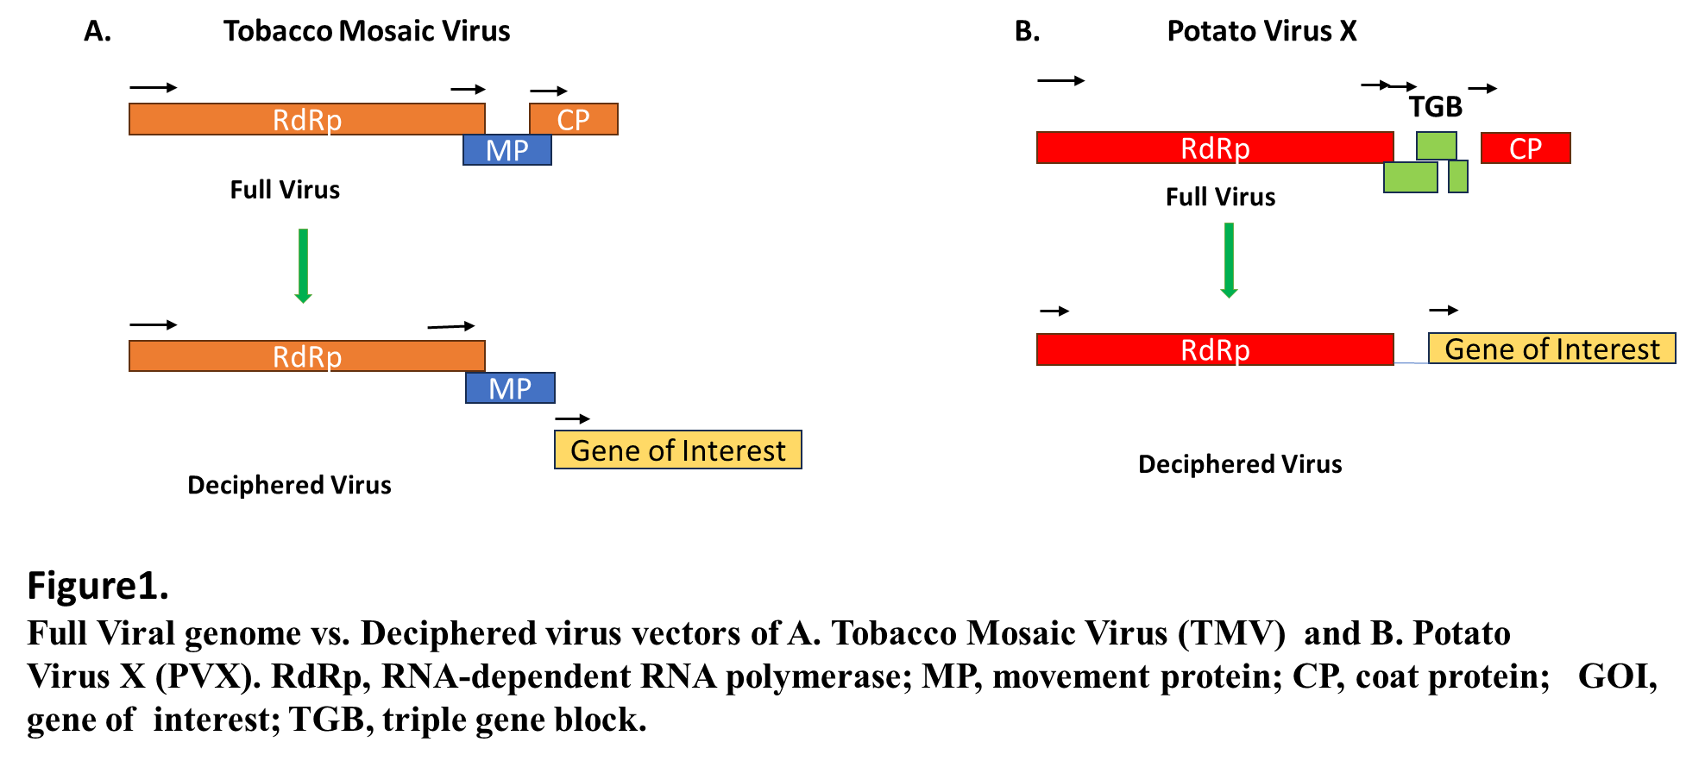
VLPs and VNPs can also be developed using plant viruses in order to exploit them as epitope display systems for the manufacturing of vaccine and scaffolds for the amalgamation of medicines or compounds used in diagnostics (Fig.2). Plant viruses based VNPs and VLPs are advantageous since they are not harmful to animals including humans and therefore avoid any undesired aftereffects.
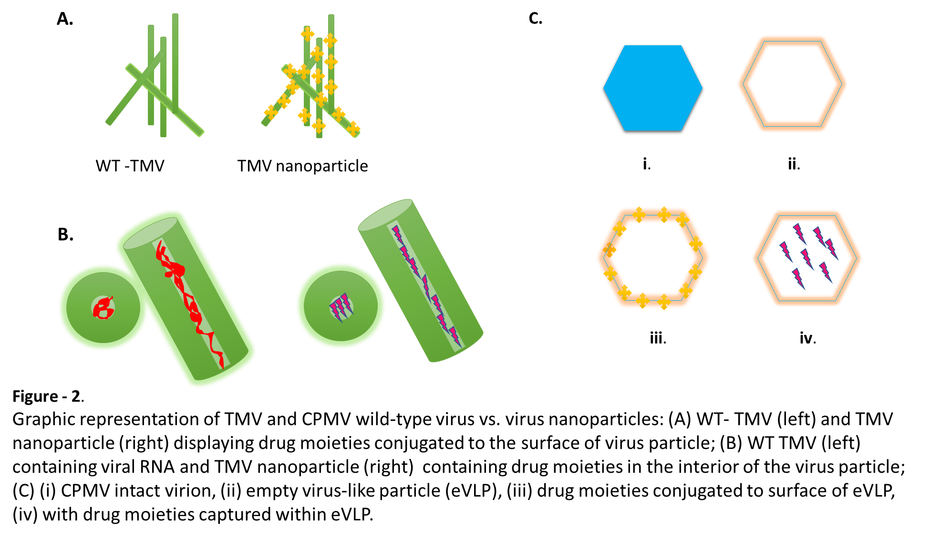
VNPs are compositions of virus-based nanomaterials that can be utilised as the basis for novel nanomaterials with a range of molecular characteristics [18]. VNPs are highly symmetrical auto-gathering systems. They are beneficial because of things like their resilience and ability to be produced quickly. Several self-assembling strategies were utilised for packaging ligands like small chemical modifiers, peptides, proteins, or even additional nanostructures within VNPs coupled with different chemistries [19, 20].
Utilisation of TMV in Diagnostic imaging and Therapeutics
The flat and rounded form of TMV discs produces a large aspect ratio. Because of their flexuous rod-like forms, TMV particles approach blood vessel walls, increasing the possibility that they will invade sick body regions while gathering inside tumour tissues [21, 22]. A developing area of biomedicine called molecular imaging makes it easier to see, identify, and assess biological processes in vivo. Magnetic resonance imaging (MRI), computed tomography (CT), positron emission tomography (PET), and optical imaging are a few of these imaging technologies that allow for the surveillance of biochemical and cellular activity in both healthy and pathological circumstances in living subjects. A particular molecular imaging method should ideally be able to provide the best ratios of signal to noise at the desired location while reducing toxicity [23] .VLPs have a shorter half-life in circulation and less retention times than manufactured nanoparticles, which lessen the likelihood of side effects and make them more advantageous for molecular imaging technologies [24] Successful imaging, targeting atherosclerosis, and thrombosis has been done by utilizing TMV [25]. When TMV was given to mice, it comprised cargo mRNA that encoded the green fluorescent protein (GFP), which induced an immunological reaction against GFP. This demonstrated the viability of using this technology for the development of vaccines [26]. Additionally, TMV has been modified to exhibit the iLOV protein, a luminescent probe [27].
Table 2 gives a few instances of how modified TMV is used for the treatment of diseases.
Applications of TMV in medicine
MODIFICATIONS | OUTCOMES | REFERENCES
On the surface of TMV particles, coronavirus murine hepatitis virus spike protein peptides were displayed. | Mice was protected against murine hepatitis virus challenge. Also antibody titre was increased. | [28]
The 11 amino acid epitope of the foot and mouth disease virus (FMDV) VP1 protein and the extreme C-terminus of the TMV CP were joined together. | Animals were shielded from the FMDV threat with the aid of this nanoparticle. | [29]

Cowpea Chlorotic Mottle Virus (CCMV) and CPMV Implications in Biotechnology for Medical Use:
The spontaneously reproducing virus CPMV has been created as a vector for the generation of either peptides or polypeptides in plants. Reproducing and non-replicating viral vectors for expression based on CPMV have been produced in addition to using it to present peptides [30]. The non-replicating expression technique is based on a CPMV RNA-2 variant that has been deactivated [31]. High-quality, pure anti-HIV-1 antibodies were produced in plants using this CPMV non-replicating technology [32]. In a mouse model, Patel et al. (2018) employed radiation and CPMV nanoparticles to slow the growth of an ovarian tumour [33]. This combined therapy may one day serve as an in situ tumour vaccine because it was able to enhance the number of tumour infiltrating lymphocytes (TILs). Plant VLPs built on the CCMV can be used to administer mRNA. For instance, utilising lipofectamine transfection, CCMV was effectively employed for delivering amplified yellow fluorescent protein (EYFP) mRNA to mammalian BHK-21 cells [34].
2.2Virus-Like Particles in Plant-Based Vaccine Development
Virus-like particles (VLPs) are non-contagious, self-assembled entities that resemble viruses but do not multiply or cause disease. They are a necessary component in the creation of vaccines based on plants, which show various benefits over classical vaccine techniques. Due to its potential to revolutionise vaccine manufacture and dissemination, plant-based vaccine are used extensively. Many conventional vaccines must be transported and stored in cold storage to keep them stable. In some instances, it has been demonstrated that plant-based VLP vaccines are more stable at warmer temperatures, which lessens the reliance on the cold chain for distribution and storage. This is especially helpful in areas without easy access to refrigerated facilities [35, 36]. Plant-based vaccine production using VLPs is a cost-effective and scalable approach because plants can be grown in controlled environments, providing a stable and reproducible system for VLP production. Additionally, plant-based production eliminates the need for specialised cell culture facilities required for traditional vaccine production methods, which can be costly and limited in capacity. VLPs outperform vaccinations based on whole organism formulations or subunit antigens in terms of protection, antigenicity, antigen stability, and manufacturing, and have thus gained substantial popularity as a premier vaccine platform [37]. VLPs can be made to surface-display particular antigens. The pathogens, such as viruses, can serve as the source of these antigens. When these antigen-displaying VLPs are ingested into the body, they set off a powerful immune response that results in the creation of antibodies and memory cells that offer defence against the actual disease. VLPs are a great antigen presentation platform for vaccine development because of this. While disabled or dead pathogens still generate strong immune responses and are the primary source of defence for many infectious diseases, the possibility of attenuated pathogen reversal or insufficient inactivation of dead pathogen vaccines remains a severe safety concern. VLPs are non-infectious and lack viral nucleic acid, making them a secure vaccine alternative than weakened or inactivated viruses. VLPs derived from palatable plants present a unique and economical method of developing gut mucosal immunity by oral administration [38]. Influenza A H1N1 HA enveloped VLP and VLP NVCP non-enveloped VLPs are one of the examples of Plant-derived VLP-based vaccinations that have progressed to the human clinical investigation stage, as well as approved by the FDA plant-derived human medications.

2.3 Plant Viruses: First Generation Vectors
Using plant viruses as transient expression vectors had numerous benefits over transgenic systems, including the ability to be used with different plant species [39]. A gene-replacement approach in which the GOI substituted the CP of the brome mosaic virus (BMV) was characterised as the first viral-based vector to be reported. [40] However, the recombinant virus was only able to infect injected cells because it was lacking the CP, which prevented it from spreading. In following studies with TMV-based vectors, the GOI was put ahead of the intrinsic CP gene and controlled by an additional sub genomic RNA promoter. However, the structure was unsteady, and homologous recombination resulted in a deletion of the inserted sequence and the reversion of the virus to its wild-type state [41].
Plant Viruses in Second-Generation Vectors and Recombinant Expression Technology
Despite the efficacy of vectors made of viruses based on a full genomic sequence in producing recombinant proteins, structures with substantial inserts shown fragility and little widespread dispersion. [42, 43]. These disadvantages influenced the development of next-generation vectors, during which the genome of the virus was divided into a replication unit containing the structural elements essential for gene expression and replication, and plant invasion was initiated externally. Recombinant GOI was used in this method to replace the viral MP and/or CP genes, and the carrier virus was injected into plants as part of Agrobacterium's T-DNA delivery [44] and also through biolistic bombardment [45]. Potato virus X (PVX) and TMV [46] were the first monopartite RNA viruses to be used as deconstructed viruses.
2.4 The Delivery of CRISPR Reagents by Plant Viruses
Since the early days of genetic engineering, Viruses of plants have been employed as carriers to express heterologous genes. The ability to manipulate the viral genome in plants to express heterologous proteins and RNAs has been made possible by the development of molecular biology and high-throughput sequencing technology. Numerous recent studies have highlighted the prospective for employing plant viral vectors as transient means of distribution for CRISPR-Cas reagents in plants [47]. Plant viruses are currently the most effective alternate method in which plant cells were infected with CRISPR-Cas reagents.. Recent advancements in GE technology have compelled researchers to using viral vectors to successfully transfer GE chemicals into plant cells.
2.4.1 Geminiviruses and Genome Editing: What Role Can They Play?
The biggest viral family, Geminiviridae, is composed of circular, single-stranded (ss) DNA viruses that invade a diverse range of hosts, including cereal and fibre crops such as cotton fibres, grain, wheat, cucurbits, tomatoes, and many ornamental and weed species worldwide. [48,49,50] and presently create a significant danger to global food security. Vectors produced from geminiviruses have been widely employed to produce proteins, vaccines, and to silence genes using functional genomic techniques [51]. According to GE, geminivirus-based replicons have garnered a lot of attention and successfully applied genome-editing techniques[52] Geminiviruses are exceptional in the ways listed below, making them attractive vectors for plant genome editing: (1) being able to simultaneously infect a large variety of plants from different kinds; (2) beginning of replication inside hosts requires a relatively small amount of proteins; (3) The intergenic region's native promoter and any user-specific inducible or constitutive promoters control its expression [52] (4) autonomously reproduce inside the host through replication that is based on homologous recombination (HR) [53]. Geminiviruses have been modified to serve as vectors for the production of heterologous proteins in plants [54].
Challenges and Limitations in using Plant Virus and Virus-Like Particle in Biotechnology
Biotechnology based on plant viruses and virus-like particles (VLPs) has showed considerable potential in a number of applications, but it also has a number of drawbacks. Plant viruses and VLPs' stability is a significant problem. The activity and integrity of these particles may be impacted by environmental factors as temperature, humidity, and pH. For practical applications, stability during storage and delivery is essential. It can be challenging to obtain substantial yields of plant viruses and VLPs. These particles are frequently produced in plants using a temporary expression technique, which may produce lower yields than conventional recombinant protein expression systems. Also plant viruses and VLPs can be difficult to purify. There is a possibility of recombination with wild-type plant viruses when employing plant viruses for biotechnology, which could result in the development of novel viruses with unknown features and possibly unforeseen environmental effects.

REFERENCES
- Roldão A, Silva AC, Mellado MCM, Alves PM, Carrondo MJT. Viruses and Virus-Like Particles in Biotechnology: Fundamentals and Applications. Comprehensive Biotechnology. 2011:625–49. doi: 10.1016/B978-0-08-088504-9.00072-6.
- Greene SE, Reid A. Viruses Throughout Life & Time: Friends, Foes, Change Agents: A Report on an American Academy of Microbiology Colloquium San Francisco // July 2013. Washington (DC): American Society for Microbiology; 2013. Available from: https://www.ncbi.nlm.nih.gov/books/NBK559437/ doi: 10.1128/AAMCol.Jul.2013
- Enders J.F., Weller T.H., Robbins F.C. Cultivation of the lansing strain of poliomyelitis virus in cultures of various human embryonic tissues. Science. 1949;109(2822):85–87
- Kretzmer G. Industrial processes with animal cells. Applied Microbiology and Biotechnology. 2002;59(2–3):135–142.
- Gergerich, R.C., and V. V. Dolja. 2006. Introduction to Plant Viruses, the Invisible Foe. The Plant Health Instructor. DOI: 10.1094/PHI-I-2006-0414-01
- Bos L. Beijerinck’s work on tobacco mosaic virus: Historical context and legacy. Philosophical Transactions of the Royal Society B: Biological Sciences. 1999;354(1383):675–685
- Ruffing M., Zentgraf H., Kleinschmidt J.A. Assembly of viruslike particles by recombinant structural proteins of adeno-associated virus type 2 in insect cells. Journal of Virology. 1992;66(12):6922–6930.
- Yusibov V., Mett V., Davidson C., Musiychuk K., Gilliam S., Farese A., MacVittie T., Mann D. Peptide-based candidate vaccine against respiratory syncytial virus. Vaccine. 2005;23:2261–2265. doi: 10.1016/j.vaccine.2005.01.039.
- Kemnade J.O., Seethammagari M., Collinson-Pautz M., Kaur H., Spencer D.M., McCormick A.A. Tobacco mosaic virus efficiently targets DC uptake, activation and antigen-specific T cell responses in vivo. Vaccine. 2014;32:4228–4233. doi: 10.1016/j.vaccine.2014.04.051.
- Brennan F.R., Bellaby T., Helliwell S.M., Jones T.D., Kamstrup S., Dalsgaard K., Flock J.-I., Hamilton W.D.O. Chimeric plant virus particles administered nasally or orally induce systemic and mucosal immune responses in mice. J. Virol. 1999;73:930–938. doi: 10.1128/JVI.73.2.930-938.1999
- Brennan F., Jones T., Longstaff M., Chapman S., Bellaby T., Smith H., Xu F., Hamilton W., Flock J.-I. Immunogenicity of peptides derived from a fibronectin-binding protein of S. aureus expressed on two different plant viruses. Vaccine. 1999;17:1846–1857. doi: 10.1016/S0264-410X(98)00485-X
- Melito P.L., Qiu X., Fernando L.M. The creation of stable cell lines expressing Ebola virus glycoproteins and the matrix protein VP40 and generating Ebola virus-like particles utilizing an ecdysone inducible mammalian expression system. Journal of Virological Methods. 2008;148(1–2):237–243.
- Zielonka A., Gedvilaite A., Ulrich R. Generation of virus-like particles consisting of the major capsid protein VP1 of goose hemorrhagic polyomavirus and their application in serological tests. Virus Research. 2006;120(1–2):128–137
- Venkataraman S, Hefferon K. Application of Plant Viruses in Biotechnology, Medicine, and Human Health. Viruses. 2021 Aug 26;13(9):1697. doi: 10.3390/v13091697
- Gleba Y., Klimyuk V., Marillonnet S. Magnifection—A new platform for expressing recombinant vaccines in plants. Vaccine. 2005;23:2042–2048.
- Lindbo J.A. TRBO: A High-Efficiency Tobacco Mosaic Virus RNA-Based Overexpression Vector. Plant Physiol. 2007;145:1232–1240. doi: 10.1104/pp.107.106377.
- Steinmetz N.F. Viral nanoparticles as platforms for next-generation therapeutics and imaging devices. Nanomedicine. 2010;6:634–641. doi: 10.1016/j.nano.2010.04.005.
- Young M., Debbie W., Uchida M., Douglas T. Plant Viruses as Biotemplates for Materials and Their Use in Nanotechnology. Annu. Rev. Phytopathol. 2008;46:361–384. doi: 10.1146/annurev.phyto.032508.131939.
- Steinmetz N.F., Evans D.J. Utilisation of plant viruses in bionanotechnology. Org. Biomol. Chem. 2007;5:2891–2902. doi: 10.1039/b708175h.
- Roldão A, Mellado MC, Castilho LR, Carrondo MJ, Alves PM. Virus-like particles in vaccine development. Expert Rev Vaccines. 2010;9:1149–76. doi: 10.1586/erv.10.115
- Sokullu E., Abyaneh H.S., Gauthier M.A. Plant/Bacterial Virus-Based Drug Discovery, Drug Delivery, and Therapeutics. Pharmaceutics. 2019;11:211. doi: 10.3390/pharmaceutics11050211.
- Shukla S., Ablack A.L., Wen A.M., Lee K.L., Lewis J.D., Steinmetz N.F. Increased Tumor Homing and Tissue Penetration of the Filamentous Plant Viral Nanoparticle Potato virus X. Mol. Pharm. 2013;10:33–42. doi: 10.1021/mp300240m
- Chung Y.H., Cai H., Steinmetz N.F. Viral nanoparticles for drug delivery, imaging, immunotherapy, and theranostic applications. Adv. Drug Deliv. Rev. 2020;156:214–235. doi: 10.1016/j.addr.2020.06.024.
- Steinmetz N.F. Viral nanoparticles as platforms for next-generation therapeutics and imaging devices. Nanomedicine. 2010;6:634–641. doi: 10.1016/j.nano.2010.04.005
- Park J., Gao H., Wang Y., Hu H., Simon D.I., Steinmetz N.F. S100A9-targeted tobacco mosaic virus nanoparticles exhibit high specificity toward atherosclerotic lesions in ApoE−/− mice. J. Mater. Chem. B. 2019;7:1842–1846. doi: 10.1039/C8TB02276C
- Grasso S., Santi L. Viral nanoparticles as macromolecular devices for new therapeutic and pharmaceutical approaches. Int. J. Physiol. Pathophysiol. Pharmacol. 2010;2:161–178.
- Chapman S., Faulkner C., Kaiserli E., Garcia-Mata C., Savenkov E.I., Roberts A.G., Oparka K.J., Christie J.M. The photoreversible fluorescent protein iLOV outperforms GFP as a reporter of plant virus infection. Proc. Natl. Acad. Sci. USA. 2008;105:20038–20043. doi: 10.1073/pnas.0807551105.
- Koo M., Bendahmane M., Lettieri G.A., Paoletti A.D., Lane T.E., Fitchen J.H., Buchmeier M.J., Beachy R.N. Protective immunity against murine hepatitis virus (MHV) induced by intranasal or subcutaneous administration of hybrids of tobacco mosaic virus that carries an MHV epitope. Proc. Natl. Acad. Sci. USA. 1999;96:7774–7779. doi: 10.1073/pnas.96.14.7774
- Wu L., Jiang L., Zhou Z., Fan J., Zhang Q., Zhu H., Han Q., Xu Z. Expression of foot-and-mouth disease virus epitopes in tobacco by a tobacco mosaic virus-based vector. Vaccine. 2003;21:4390. doi: 10.1016/S0264-410X(03)00428-6.
- Sainsbury F., Cañizares M.C., Lomonossoff G.P. Cowpea mosaicVirus: The Plant Virus–Based Biotechnology Workhorse. Annu. Rev. Phytopathol. 2010;48:437–455. doi: 10.1146/annurev-phyto-073009-114242
- Porta C., Spall V.E., Loveland J., Johnson J.E., Barker P.J., Lomonossoff G.P. Development of Cowpea Mosaic Virus as a High-Yielding System for the Presentation of Foreign Peptides. Virology. 1994;202:949–955. doi: 10.1006/viro.1994.1417
- Sainsbury F., Sack M., Stadlmann J., Quendler H., Fischer R., Lomonossoff G.P. Rapid Transient Production in Plants by Replicating and Non-Replicating Vectors Yields High Quality Functional Anti-HIV Antibody. PLoS ONE. 2010;5:e13976. doi: 10.1371/journal.pone.0013976
- Patel R., Czapar A.E., Fiering S., Oleinick N.L., Steinmetz N.F. Radiation Therapy Combined with Cowpea Mosaic Virus Nanoparticle in Situ Vaccination Initiates Immune-Mediated Tumor Regression. ACS Omega. 2018;3:3702–3707. doi: 10.1021/acsomega.8b00227
- Azizgolshani O., Garmann R.F., Cadena-Nava R., Knobler C.M., Gelbart W.M. Reconstituted plant viral capsids can release genes to mammalian cells. Virology. 2013;441:12–17. doi: 10.1016/j.virol.2013.03.001
- Chen Q, Tacket CO, Mason H, Mor T, Cardineau GA, Arntzen C. Subunit vaccines produced using plant biotechnology. In: Levine MM, ed. New Generation Vaccines. New York: Informa Healthcare USA, Inc., 2009:306-15.
- Chen Q. Expression and manufacture of pharmaceutical proteins in genetically engineered horticultural plants. In: Mou B, Scorza R, eds. Transgenic Horticultural Crops: Challenges and Opportunities - Essays by Experts. Boca Raton: Taylor & Francis
- Tacket CO, Pasetti MF, Edelman R, Howard JA, Streatfield S. Immunogenicity of recombinant LT-B delivered orally to humans in transgenic corn. Vaccine. 2004;22:4385–9. doi: 10.1016/j.vaccine.2004.01.073.
- Yusibov V, Hooper DC, Spitsin SV, Fleysh N, Kean RB, Mikheeva T, et al. Expression in plants and immunogenicity of plant virus-based experimental rabies vaccine. Vaccine. 2002;20:3155–64. doi: 10.1016/S0264-410X(02)00260-8.
- Hamamoto, H., Sugiyama, Y., Nakagawa, N., Hashida, E., Matsunaga, Y., Takemoto, S., et al. (1993). A new tobacco mosaic-virus vector and its use for the systemic production of angiotensin-I-converting enzyme-inhibitor in transgenic tobacco and tomato. Biotechnology 11, 930–932. doi: 10.1038/nbt0893-930
- French, R., Janda, M., and Ahlquist, P. (1986). Bacterial gene inserted in an engineered RNA virus: efficient expression in monocotyledonous plant cells. Science 231, 1294–1298.
- Dawson, W., Lewandowski, D., Hilf, M., Bubrick, P., Raffo, A., Shaw, J., et al. (1989). A tobacco mosaic virus-hybrid expresses and loses an added gene. Virology 172, 285–292.
- Shivprasad, S., Pogue, G. P., Lewandowski, D. J., Hidalgo, J., Donson, J., Grill, L. K., et al. (1999). Heterologous sequences greatly affect foreign gene expression in tobacco mosaic virus-based vectors. Virology 255, 312–323.
- Avesani, L., Marconi, G., Morandini, F., Albertini, E., Bruschetta, M., Bortesi, L., et al. (2007). Stability of Potato virus X expression vectors is related to insert size: implications for replication models and risk assessment. Transgenic Res. 16, 587–597.
- Gleba, Y., Marillonnet, S., and Klimyuk, V. (2004). Engineering viral expression vectors for plants: the ‘full virus’ and the ‘deconstructed virus’ strategies. Curr. Opin. Plant Biol. 7, 182–188.
- Komarova, T., Skulachev, M., Zvereva, A., Schwartz, A., Dorokhov, Y. L., and Atabekov, J. (2006). New viral vector for efficient production of target proteins in plants. Biochemistry 71, 846–850.
- Lindbo, J. A. (2007). TRBO: a high-efficiency tobacco mosaic virus RNA-based overexpression vector. Plant Physiol. 145, 1232–1240.
- Xu C.L., Ruan M.Z., Mahajan V.B., Tsang S.H. Viral delivery systems for CRISPR. Viruses. 2019;11:28. doi: 10.3390/v11010028.
- Mahmood M., Naqvi R., Irfan N., Amin I., Mansoor S. First report of Cotton leaf curl Multan virus infecting Millettia pinnata in Pakistan. New Dis. Rep. 2022;46:e12116. doi: 10.1002/ndr2.12116.
- Mahmood M.A., Ahmed N., Hussain S., Muntaha S.T., Amin I., Mansoor S. Dominance of Asia II 1 species of Bemisia tabaci in Pakistan and beyond. Sci. Rep. 2022;12:1528. doi: 10.1038/s41598-022-05612-1.
- Nawaz-ul-Rehman M.S., Fauquet C.M. Evolution of geminiviruses and their satellites. FEBS Lett. 2009;583:1825–1832. doi: 10.1016/j.febslet.2009.05.045.
- Lozano-Durán R. Geminiviruses for biotechnology: The art of parasite taming. N. Phytol. 2016;210:58–64. doi: 10.1111/nph.13564
- Baltes N.J., Gil-Humanes J., Cermak T., Atkins P.A., Voytas D.F. DNA replicons for plant genome engineering. Plant Cell. 2014;26:151–163. doi: 10.1105/tpc.113.119792
- Richter K.S., Serra H., White C.I., Jeske H. The recombination mediator RAD51D promotes geminiviral infection. Virology. 2016;493:113–127. doi: 10.1016/j.virol.2016.03.014.
- Lozano-Durán R. Geminiviruses for biotechnology: The art of parasite taming. N. Phytol. 2016;210:58–64. doi: 10.1111/nph.13564.

