Paper Title:- Rain Detector Arduino Project with Buzzer

Pravin Walmik Patil
Dep. Electricl engineering
G.H Raisoni Institute of Engineering &business Management Jalgaon
pravin.patil.ee@ghriemjal.raisoni.net

Roshani D Wani
Dep. Electricl engineering
G.H Raisoni Institute of Engineering &business Management Jalgaon
roshani.wani.ee@ghriemjal.raisoni.net

Namrata santosh Patil
Dep. Electricl engineering
G.H Raisoni Institute of Engineering &business Management Jalgaon
namrata.patil.ee@ghriemjal.raisoni.net

Suryakant Sadashiv Kandhare
Dep. Electricl engineering
G.H Raisoni Institute of Engineering &business Management Jalgaon
suryakant.kandhare.ee@ghriemjal.raisoni.net

Sachin Rajaram Chavan
Dep. Electricl engineering
G.H Raisoni Institute of Engineering &business Management Jalgaon
sachin.chavan.it@ghriemjal.raisoni.net

Ajay Nitin Saindane
Dep. Electricl engineering
G.H Raisoni Institute of Engineering &business Management Jalgaon ajay.saindane.etc@ghriemjal.raisoni.net

ABSTRACT
This project presents an Arduino-based rain detection system designed to monitor and respond to rainfall events. The system employs a combination of sensor technologies, including a raindrop sensor module and a weather sensor, to accurately detect rain and measure its intensity. The Arduino microcontroller processes the sensor data and triggers appropriate actions based on the rainfall conditions.
The raindrop sensor module is employed to detect individual raindrops, providing real-time information about the onset and duration of rain. Additionally, a weather sensor, such as a humidity and temperature sensor, complements the raindrop sensor by monitoring the overall atmospheric conditions.
The Arduino board receives data from these sensors and employs an algorithm to interpret the information. When rainfall is detected, the system can activate various outputs, such as controlling automatic window closures, alerting homeowners, or activating irrigation systems
Keywords—component; formatting; style; styling; insert (key words)

INTRODUCTION

Rain detectors, also known as rain sensors or rain gauges, play a crucial role in monitoring weather patterns and optimizing water usage in various applications. These devices utilize different technologies to detect rain or moisture, providing essential data for meteorological studies, agriculture, and automated systems. This report explores the working principles, applications, advantages, limitations, and future developments of rain detectors

EASE OF USE

. Background:
Rain detectors are devices designed to measure the amount of rainfall or detect the presence of moisture. They have been used for centuries to understand weather patterns and agricultural needs. Modern rain detectors have evolved significantly, incorporating advanced technologies to provide accurate and real-time data.

Types of Rain Detectors:
The template is used to format your paper and style the text. All margins, column widths, line spaces, and text fonts are prescribed; please do not alter them. You may note peculiarities. For example, the head margin in this template measures proportionately more than is customary. This measurement and others are deliberate, using specifications that anticipate your paper as one part of the entire proceedings, and not as an independent document. Please do not revise any of the current designations.

PREPARE YOUR PAPER BEFORE STYLING

Abbreviations and Acronyms
The abbreviation for "Rain Detector" is "RD."
An acronym for "Rain Detector" could be "RAD" (Rainfall Alert Device) or "RDS" (Rain Detection System).
A rain detector is a device used to detect the presence or onset of rain. It can employ various sensing methods, such as optical sensors, conductivity sensors, or acoustic sensors, to detect raindrops or changes in environmental conditions associated with rain.
The rain detector can be part of a larger weather monitoring system or used in standalone applications, such as automated irrigation systems, weather stations, or home automation setups. When rain is detected, the device can trigger specific actions like activating sprinklers or sending alerts to users.
The specific design and features of a rain detector can vary based on its intended application and complexity, ranging from simple rain sensors used in automotive windshield wipers to sophisticated weather monitoring systems used by meteorological agencies.

Units
- The units of measurement used in a rain detector typically depend on the type of sensor and the specific application. Here are some common units of measurement used in rain detectors:
- Rainfall Rate : The rate at which rainwater falls, usually measured in millimeters per hour (mm/h) or inches per hour (in/h).
- Rainfall Accumulation : The total amount of rainwater collected over a specific period, measured in millimeters (mm) or inches (in).
- Rain Intensity : The intensity of rainfall at a given moment, often measured in millimeters per minute (mm/min) or inches per minute (in/min).
- Rainfall Duration : The length of time during which rain is detected, measured in minutes or hours.
- Rain Frequency : The frequency of rain events, measured in occurrences per unit of time (e.g., rain events per hour).
- Raindrop Size Distribution : In some advanced rain detectors, raindrop size distribution is measured in micrometers (µm) or millimeters (mm).
Keep in mind that the specific units used may vary depending on regional preferences and the type of rain etection technology implemented in the rain detector.

Equations
The equation for a rain detector can vary depending on the type of rain sensor used. Here are a few examples of equations for different rain detection methods:
1. Conductivity-based Rain Detector : In a conductivity-based rain detector, two electrodes measure the electrical conductivity of rainwater. The equation to calculate rain intensity (I) based on the electrical resistance (R) can be:
I = k / R where k is a constant that depends on the sensor's characteristics.
2. Optical Rain Detector : Optical rain detectors use infrared or laser beams to detect raindrops passing through the beam. The equation to determine rain intensity might be:
I = N / t where N is the number of raindrops detected per unit of time (t).
3. Acoustic Rain Detector : Acoustic rain detectors use microphones or piezoelectric sensors to detect raindrops' sound impact. The equation to calculate rain intensity could be:
I = A *f where A is the amplitude of the sound signal and f is a frequency-related factor.
It's important to note that these are simplified examples, and real rain detectors can be more complex, involving calibration, signal processing, and additional factors to account for environmental conditions and sensor characteristics. The specific equation will depend on the rain detector's design and the method it employs to detect rainfall.

Working Principle:

Rain detectors function based on specific principles unique to their technology. Optical rain sensors rely on light scattering, acoustic gauges on sound intensity, and capacitive sensors on capacitance changes. These principles allow rain detectors to accurately detect and quantify rainfall.

Applications:

- Meteorology : -
Rain detectors are fundamental instruments in weather stations, providing essential data for rainfall analysis, forecasting, and climate studies.
- Agriculture :-
In agriculture, rain detectors help optimize irrigation systems by providing real-time rainfall data. This enables farmers to make informed decisions about watering schedules, conserving water resources.
- Smart Irrigation Systems :-
Rain detectors integrated into irrigation systems can automatically halt watering when rainfall is detected, preventing overwatering and saving water.
- Urban Planning :-
Rain detectors aid in managing urban drainage systems by providing information on rainfall intensity, which helps prevent flooding and design effective drainage solutions.
- Environmental Monitoring :-
Rain detectors contribute to environmental monitoring, including tracking rainfall in sensitive ecosystems and watersheds.

Advantages and Limitations:
a. Advantages:
- Accurate Rainfall Data: Rain detectors provide precise and reliable rainfall measurements.
- Water Conservation: They help conserve water resources by optimizing irrigation practices.
- Automated Systems: Integration with automated systems enhances efficiency and reduces manual intervention.
b. Limitations:
- Environmental Factors: External factors like wind or debris may affect the accuracy of certain rain detector types.
- Maintenance: Some sensors may require periodic cleaning and calibration to ensure accurate readings.

Future Development :-

Ongoing research focuses on enhancing rain detector accuracy, reducing susceptibility to environmental factors, and improving data transmission methods. Advancements in materials and miniaturization may lead to more compact and cost-effective rain detection solutions.

Program:-
void setup() {
//on pin12 we have the rain sensor so this is an input
pinMode(12, INPUT);
//on pin 13 we have buzzer so this is an output
pinMode(13, OUTPUT);
}
void loop() {
//when rain sensor gives LOW signal it means that it rains
if(digitalRead(12) == LOW){
//for half a second we turn the buzzer on
digitalWrite(13, HIGH);
delay(500);
//for half a second we turn the buzzer off
digitalWrite(13, LOW);
delay(500);
//so we have the beep-beep signal like an alarm
}
}

Figures and Tables

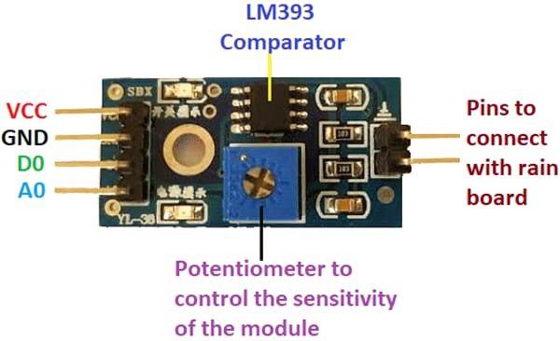

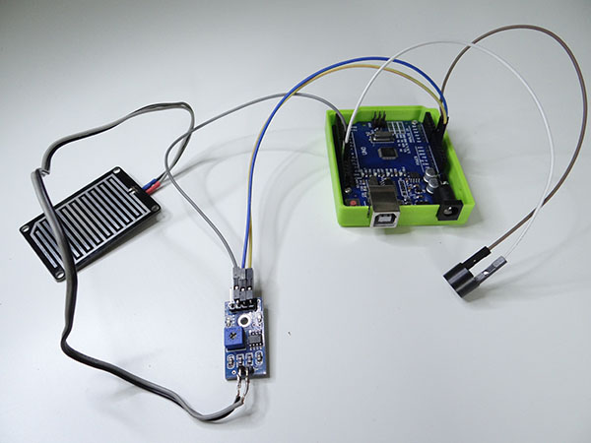

Table :-

Sr no | Name of Componantes | Quantity
1 | Arduno UNO Board | 1
2 | Rain sensor | 1
3 | Buzzer | 1
4 | Jumper wires | -

IX Conclusion :-

Rain detectors are indispensable tools in meteorology, agriculture, and automated systems, providing vital rainfall data for various applications. With ongoing technological advancements, rain detectors are expected to become more efficient and play an increasingly significant role in water resource management and climate studies.

REFERENCES
1 ectronicshub.org/rain-alarm-project/#:~:text=Rain%20Alarm%20Project%20Block%20Diagram,-The%20block%20diagram&text=The%20three%20main%20components%20of,will%20then%20activate%20the%20Buzzer.

